React Hands-On

9.ReactJs-Hol

Code:

App.js

import React from 'react';

// ListofPlayers Component

const ListofPlayers = () => {

// Declare an array with 11 players and store details of their names and scores using the map feature of ES6

const players = [

{ name: "Mr. Jack", score: 50 },

{ name: "Mr. Michael", score: 70 },

{ name: "Mr. John", score: 40 },

{ name: "Mr. Ann", score: 61 },

{ name: "Mr. Elisebeth", score: 61 },

{ name: "Mr. Sachin", score: 95 },

{ name: "Mr. Dhoni", score: 100 },

{ name: "Mr.virat", score: 84 },

{ name: "Mr. Jadeja", score: 64 },

{ name: "Mr. Raina", score: 75 },

{ name: "Mr. Rohith", score: 80 }

];

return (

<div>

<h2>List of Players</h2>

<h3>All Players:</h3>

{players.map((player, index) => (

<p key={index}>{player.name} - {player.score}</p>

))}

<h3>Players with score below 70:</h3>

{players.filter(player => player.score < 70).map((player, index) => (

<p key={index}>{player.name} - {player.score}</p>

))}

</div>

);

};

// IndianPlayers Component

const IndianPlayers = () => {

const teamPlayers = ["Player1", "Player2", "Player3", "Player4", "Player5", "Player6", "Player7", "Player8"];

// Display the Odd Team Player and Even Team players using the Destructuring features of ES6

const [p1, p2, p3, p4, p5, p6, p7, p8] = teamPlayers;

const oddPlayers = [p1, p3, p5, p7];

const evenPlayers = [p2, p4, p6, p8];

// Declare two arrays T20players and RanjiTrophy players and merge using ES6

const T20players = ["Kohli", "Rohit", "Dhawan", "Rahul"];

const RanjiTrophyPlayers = ["Pant", "Shaw", "Gill", "Iyer"];

const mergedPlayers = [...T20players, ...RanjiTrophyPlayers];

return (

<div>

<h2>Indian Players</h2>

<h3>Odd Team Players:</h3>

{oddPlayers.map((player, index) => (

<p key={index}>{player}</p>

))}

<h3>Even Team Players:</h3>

{evenPlayers.map((player, index) => (

<p key={index}>{player}</p>

))}

<h3>Merged Players (T20 + Ranji Trophy):</h3>

<p>{mergedPlayers.join(", ")}</p>

</div>

);

};

// Main App Component

const App = () => {

const flag = true; // Change to false to see IndianPlayers component

return (

<div>

<h1>Cricket App</h1>

{flag ? <ListofPlayers /> : <IndianPlayers />}

</div>

);

};

export default App;

Output:

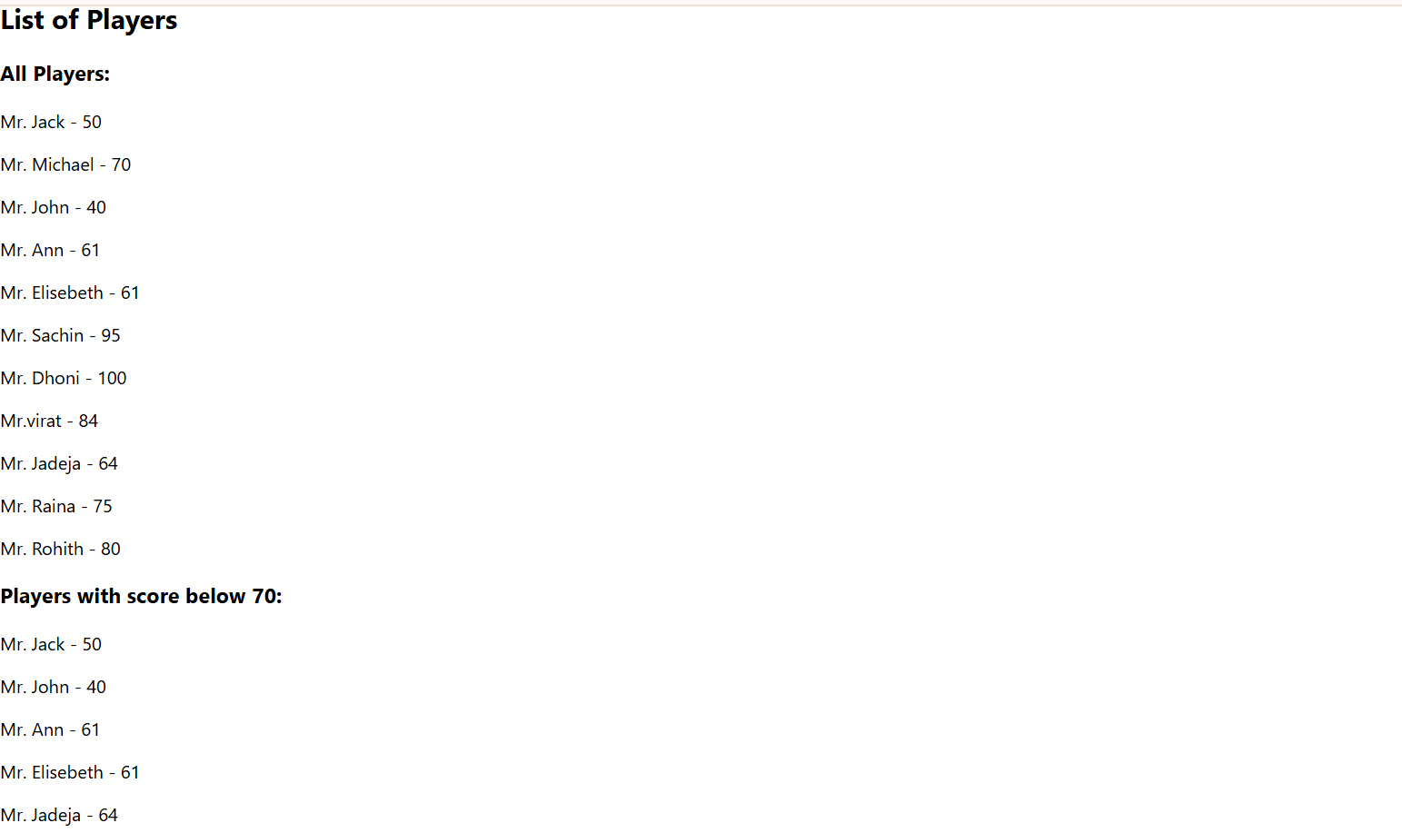

10.Reactjs-Hol

Code:

App.js

import React from 'react';

const OfficeSpaceRentalApp = () => {

const offices = [

{ Name: "DBS", Rent: 50000, Address: "Chennai" },

];

const element = "Office Space";

const jsxatt = <img src="https://images.unsplash.com/photo-1497366216548-37526070297c?w=300&h=200&fit=crop" width="25%" height="25%" alt="Office Space" />;

return (

<div className="p-8">

<h1 className="text-3xl font-bold text-center mb-8">{element}, at Affordable Range</h1>

{offices.map((ItemName, index) => {

let colors = [];

if (ItemName.Rent <= 60000) {

colors.push('text-red-500');

} else {

colors.push('text-green-500');

}

return (

<div key={index} className="bg-white border rounded-lg p-6 mb-4 shadow">

{jsxatt}

<h2 className="text-xl font-semibold mt-4">Name: {ItemName.Name}</h2>

<h3 className={`text-lg font-bold ${colors[0]}`}>Rent: Rs. {ItemName.Rent}</h3>

<h3 className="text-gray-600">Address: {ItemName.Address}</h3>

</div>

);

})}

</div>

);

};

export default OfficeSpaceRentalApp;

Output:

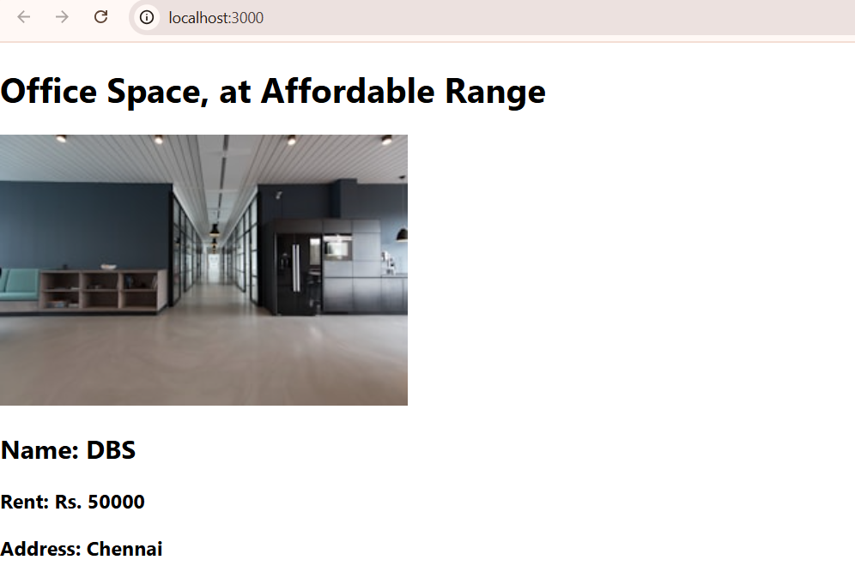

11.Reactjs.hol

Code:

App.js

import React, { useState } from 'react';

function App() {

// State for the counter

const [count, setCount] = useState(0);

// --- Counter Functions ---

const increment = () => {

setCount(prevCount => prevCount + 1);

};

const sayHello = () => {

console.log("Hello! This is a static message.");

};

const handleIncrement = () => {

increment(); // First method

sayHello(); // Second method

};

const handleDecrement = () => {

setCount(prevCount => prevCount - 1);

};

// --- Argument Passing ---

const sayMessage = (message) => {

alert(message);

};

// --- Synthetic Event Example ---

const handlePress = (event) => {

// 'event' is a SyntheticEvent

console.log(event);

alert("I was clicked");

};

// --- Currency Converter ---

const CurrencyConverter = () => {

const [rupees, setRupees] = useState(0);

const handleSubmit = (event) => {

event.preventDefault();

const euro = rupees * 0.011; // Simplified conversion rate

alert(`${rupees} INR is equal to ${euro.toFixed(2)} EUR.`);

};

return (

<div>

<h3>Currency Converter</h3>

<form onSubmit={handleSubmit}>

<input

type="number"

placeholder="Enter Indian Rupees"

onChange={(e) => setRupees(e.target.value)}

/>

<button type="submit">Convert</button>

</form>

</div>

);

};

return (

<div>

<h2>Counter</h2>

<p>Count: {count}</p>

[cite_start]{/* The "Increase" button invokes multiple methods [cite: 19] */}

<button onClick={handleIncrement}>Increase</button>

<button onClick={handleDecrement}>Decrement</button>

<hr />

[cite_start]{/* Button that takes "welcome" as an argument [cite: 22] */}

<h2>Argument Passing</h2>

<button onClick={() => sayMessage('Welcome')}>Say Welcome</button>

<hr />

[cite_start]{/* Button that demonstrates a synthetic event [cite: 23] */}

<h2>Synthetic Event</h2>

<button onClick={handlePress}>Press Me (Synthetic Event)</button>

<hr />

[cite_start]{/* Currency converter component [cite: 24] */}

<CurrencyConverter />

</div>

);

}

export default App;

Output

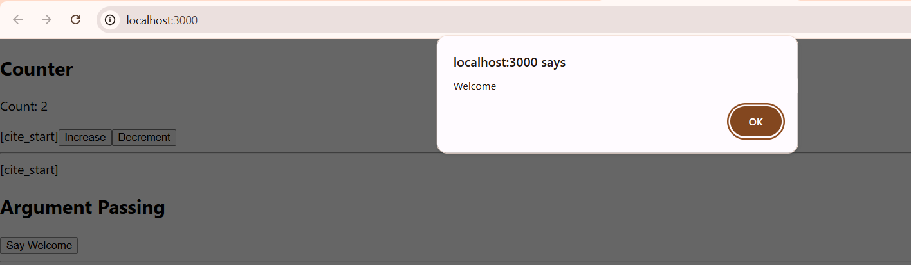

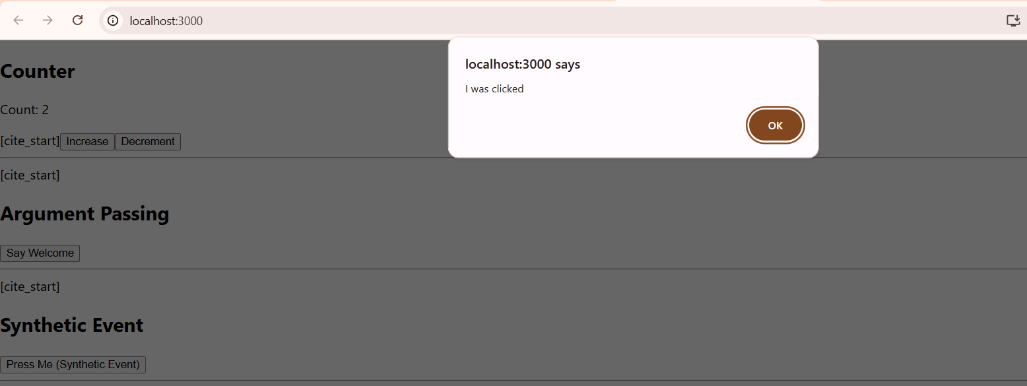

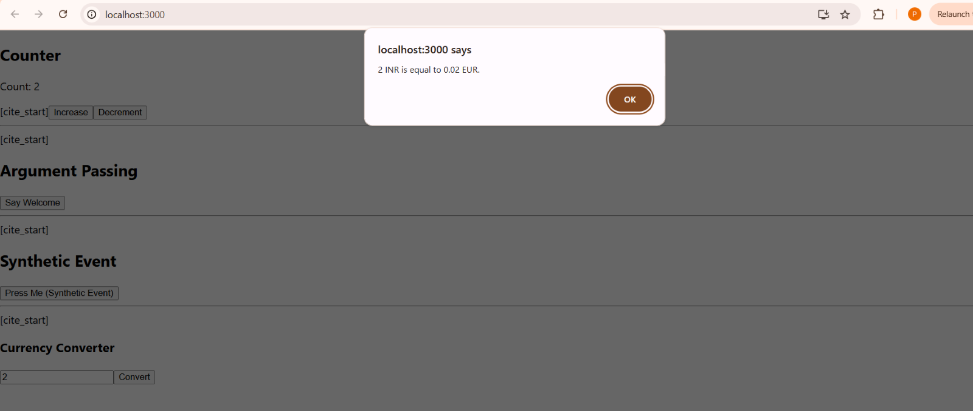

12.Reactjs-hol

Code:

App.js

import React, { useState } from 'react';

function UserGreeting(props) {

return <h1>Welcome back!</h1>;

}

function GuestGreeting(props) {

return <h1>Please sign up.</h1>;

}

function Greeting(props) {

const isLoggedIn = props.isLoggedIn;

if (isLoggedIn) {

return <UserGreeting />;

}

return <GuestGreeting />;

}

function LoginButton(props) {

return (

<button onClick={props.onClick}>

Login

</button>

);

}

// Logout button component

function LogoutButton(props) {

return (

<button onClick={props.onClick}>

Logout

</button>

);

}

// Main App component

export default function App() {

// State to track login status

const [isLoggedIn, setIsLoggedIn] = useState(false);

// Handler for the login button click

const handleLoginClick = () => {

setIsLoggedIn(true);

};

// Handler for the logout button click

const handleLogoutClick = () => {

setIsLoggedIn(false);

};

// Use a variable to store the button element

let button;

if (isLoggedIn) {

button = <LogoutButton onClick={handleLogoutClick} />;

} else {

button = <LoginButton onClick={handleLoginClick} />;

}

return (

<div>

{/* The Greeting component renders based on the isLoggedIn state */}

<Greeting isLoggedIn={isLoggedIn} />

{/* The correct button is rendered */}

{button}

</div>

);

}

Output:

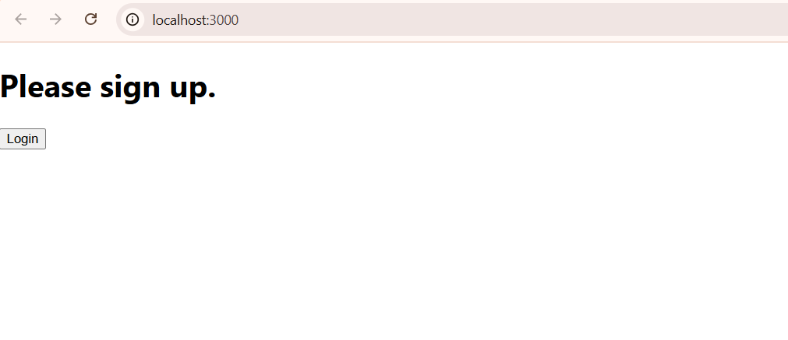

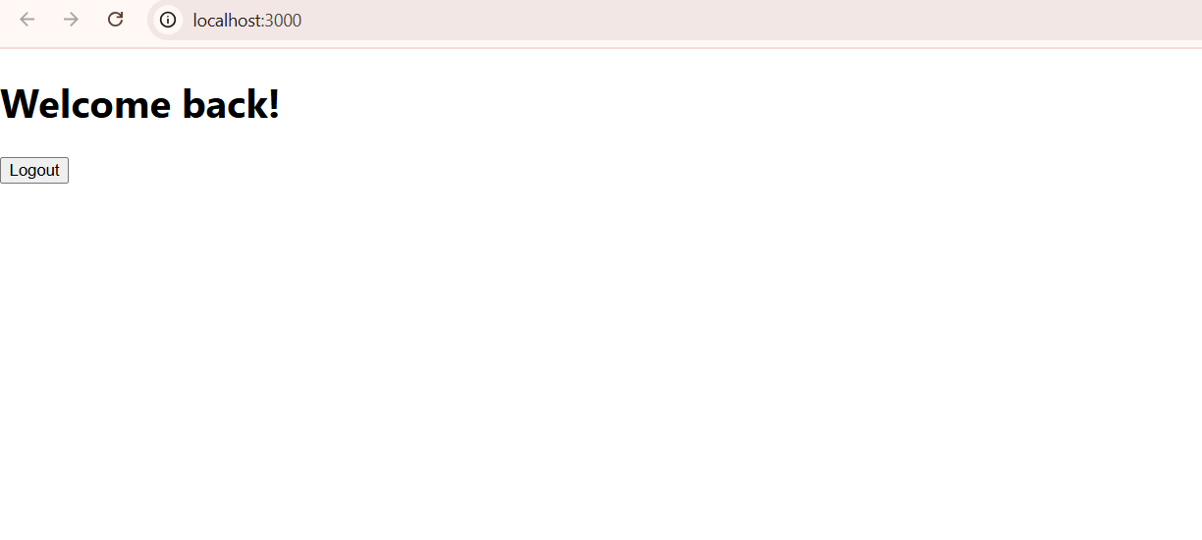

13.Reactjs-hol

Code:

import React from 'react';

// --- Data for the sections ---

// This data mimics the content shown in the image.

const courseData = [

{ id: 1, name: 'Angular', date: '4/5/2021' },

{ id: 2, name: 'React', date: '6/3/20201' },

];

const bookData = [

{ id: 1, title: 'Master React', detail: '670' },

{ id: 2, title: 'Deep Dive into Angular 11', detail: '800' },

{ id: 3, title: 'Mongo Essentials', detail: '450' },

];

const blogData = [

{

id: 1,

title: 'React Learning',

author: 'Stephen Biz',

text: 'Welcome to learning React!',

},

{

id: 2,

title: 'Installation',

author: 'Schewzdenier',

text: 'You can install React from npm.',

},

];

function CourseDetails({ courses }) {

return (

<div style={styles.section}>

<h2 style={styles.sectionTitle}>Course Details</h2>

{courses.map(course => (

<div key={course.id}>

<h3 style={styles.courseTitle}>{course.name}</h3>

<p style={styles.courseDate}>{course.date}</p>

</div>

))}

</div>

);

}

// Component to display Book Details

function BookDetails({ books }) {

return (

<div style={styles.sectionWithBorder}>

<h2 style={styles.sectionTitle}>Book Details</h2>

{books.map(book => (

<div key={book.id} style={styles.bookItem}>

<p style={styles.bookTitle}>{book.title}</p>

<p style={styles.bookDetail}>{book.detail}</p>

</div>

))}

</div>

);

}

// Component to display Blog Details

function BlogDetails({ blogs }) {

return (

<div style={styles.sectionWithBorder}>

<h2 style={styles.sectionTitle}>Blog Details</h2>

{blogs.map(blog => (

<div key={blog.id}>

<h3 style={styles.blogTitle}>{blog.title}</h3>

<p style={styles.blogAuthor}>{blog.author}</p>

<p style={styles.blogText}>{blog.text}</p>

</div>

))}

</div>

);

}

// --- Main App Component ---

// This component brings all the sections together.

function App() {

return (

<div style={styles.page}>

<div style={styles.container}>

<CourseDetails courses={courseData} />

<BookDetails books={bookData} />

<BlogDetails blogs={blogData} />

</div>

</div>

);

}

export default App;

Output:

