**ASSIGNMENT-10:**

1. Create a generic method sortList that takes a list of comparable

elements and sorts it. Demonstrate this method with a list of Strings

and a list of Integers.

Code:

import java.util.ArrayList;

import java.util.Collections;

import java.util.List;

public class GenericSorter {

// Generic method to sort a list of comparable elements

public static <T extends Comparable<T>> void sortList(List<T> list) {

Collections.sort(list);

}

public static void main(String[] args) {

// Demonstration with a list of Strings

List<String> stringList = new ArrayList<>();

stringList.add("Banana");

stringList.add("Apple");

stringList.add("Orange");

stringList.add("Mango");

System.out.println("Before sorting (Strings): " + stringList);

sortList(stringList);

System.out.println("After sorting (Strings): " + stringList);

// Demonstration with a list of Integers

List<Integer> integerList = new ArrayList<>();

integerList.add(42);

integerList.add(5);

integerList.add(16);

integerList.add(8);

System.out.println("\nBefore sorting (Integers): " + integerList);

sortList(integerList);

System.out.println("After sorting (Integers): " + integerList);

}

}

Output:

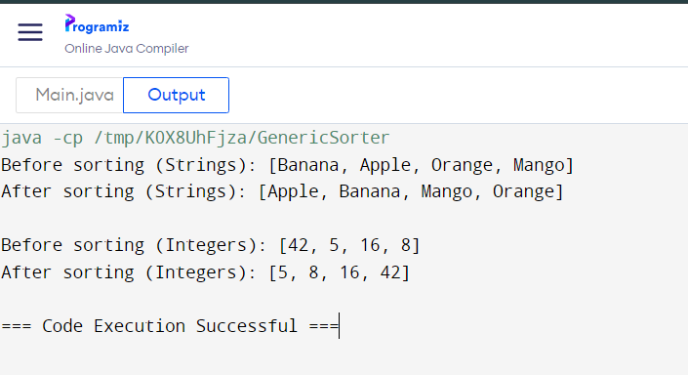

**Generic Method Declaration**:

* <T extends Comparable<T>> specifies that the method accepts any type T that implements the Comparable<T> interface. This ensures that the elements in the list can be compared to each other.
* The method sortList(List<T> list) takes a list of elements of type T and sorts it using Collections.sort.

**Demonstration**:

* A list of Strings (stringList) is created and populated with some values. The sortList method is called to sort this list.
* Similarly, a list of Integers (integerList) is created, populated, and sorted using the same sortList method.

2. Write a generic class TreeNode&lt;T&gt; representing a node in a tree

with children. Implement methods to add children, traverse the tree

(e.g., depth-first search), and find a node by value. Demonstrate this

with a tree of Strings and Integers.

Code:

import java.util.ArrayList;

import java.util.List;

import java.util.Optional;

public class TreeNode<T> {

private T value;

private List<TreeNode<T>> children;

// Constructor to initialize the node with a value

public TreeNode(T value) {

this.value = value;

this.children = new ArrayList<>();

}

// Getter for the node's value

public T getValue() {

return value;

}

// Getter for the list of children

public List<TreeNode<T>> getChildren() {

return children;

}

// Method to add a child node

public void addChild(TreeNode<T> child) {

children.add(child);

}

// Method for depth-first search (DFS) traversal

public void traverse(TreeNode<T> node) {

System.out.println(node.getValue());

for (TreeNode<T> child : node.getChildren()) {

traverse(child);

}

}

// Method to find a node by value using DFS

public Optional<TreeNode<T>> findNode(TreeNode<T> node, T value) {

if (node.getValue().equals(value)) {

return Optional.of(node);

}

for (TreeNode<T> child : node.getChildren()) {

Optional<TreeNode<T>> result = findNode(child, value);

if (result.isPresent()) {

return result;

}

}

return Optional.empty();

}

// Main method to demonstrate the TreeNode class

public static void main(String[] args) {

// Demonstration with a tree of Strings

TreeNode<String> rootString = new TreeNode<>("Root");

TreeNode<String> child1String = new TreeNode<>("Child 1");

TreeNode<String> child2String = new TreeNode<>("Child 2");

TreeNode<String> grandChildString = new TreeNode<>("Grandchild");

rootString.addChild(child1String);

rootString.addChild(child2String);

child1String.addChild(grandChildString);

System.out.println("Tree traversal (Strings):");

rootString.traverse(rootString);

Optional<TreeNode<String>> foundNodeString = rootString.findNode(rootString, "Grandchild");

System.out.println("Found node: " + foundNodeString.map(TreeNode::getValue).orElse("Not Found"));

// Demonstration with a tree of Integers

TreeNode<Integer> rootInt = new TreeNode<>(10);

TreeNode<Integer> child1Int = new TreeNode<>(20);

TreeNode<Integer> child2Int = new TreeNode<>(30);

TreeNode<Integer> grandChildInt = new TreeNode<>(40);

rootInt.addChild(child1Int);

rootInt.addChild(child2Int);

child1Int.addChild(grandChildInt);

System.out.println("\nTree traversal (Integers):");

rootInt.traverse(rootInt);

Optional<TreeNode<Integer>> foundNodeInt = rootInt.findNode(rootInt, 40);

System.out.println("Found node: " + foundNodeInt.map(TreeNode::getValue).orElse(-1)); // orElse(-1) as a default value

}

}

Output:

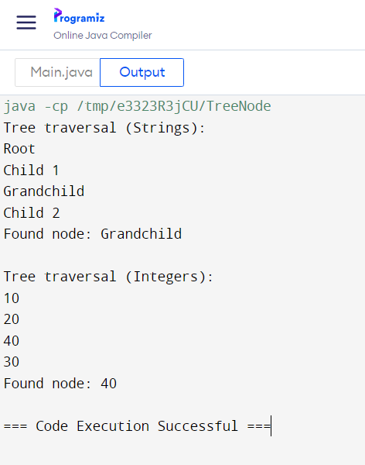

3. Implement a generic class GenericPriorityQueue&lt;T extends

Comparable&lt;T&gt;&gt; with methods like enqueue, dequeue, and peek.

The elements should be dequeued in priority order. Demonstrate

with Integer and String.

Code:

import java.util.ArrayList;

import java.util.List;

public class GenericPriorityQueue<T extends Comparable<T>> {

private List<T> heap;

public GenericPriorityQueue() {

this.heap = new ArrayList<>();

}

// Method to enqueue an element into the priority queue

public void enqueue(T value) {

heap.add(value);

heapifyUp(heap.size() - 1);

}

// Method to dequeue the highest priority element (smallest element)

public T dequeue() {

if (heap.isEmpty()) {

throw new IllegalStateException("Queue is empty");

}

T root = heap.get(0);

T lastItem = heap.remove(heap.size() - 1);

if (!heap.isEmpty()) {

heap.set(0, lastItem);

heapifyDown(0);

}

return root;

}

// Method to peek at the highest priority element without removing it

public T peek() {

if (heap.isEmpty()) {

throw new IllegalStateException("Queue is empty");

}

return heap.get(0);

}

// Helper method to maintain heap order after enqueuing (bubble up)

private void heapifyUp(int index) {

T current = heap.get(index);

int parentIndex = (index - 1) / 2;

while (index > 0 && heap.get(parentIndex).compareTo(current) > 0) {

heap.set(index, heap.get(parentIndex));

index = parentIndex;

parentIndex = (index - 1) / 2;

}

heap.set(index, current);

}

// Helper method to maintain heap order after dequeuing (bubble down)

private void heapifyDown(int index) {

T current = heap.get(index);

int size = heap.size();

while (true) {

int leftChild = 2 * index + 1;

int rightChild = 2 * index + 2;

int smallest = index;

if (leftChild < size && heap.get(leftChild).compareTo(heap.get(smallest)) < 0) {

smallest = leftChild;

}

if (rightChild < size && heap.get(rightChild).compareTo(heap.get(smallest)) < 0) {

smallest = rightChild;

}

if (smallest == index) {

break;

}

heap.set(index, heap.get(smallest));

index = smallest;

}

heap.set(index, current);

}

// Method to check if the queue is empty

public boolean isEmpty() {

return heap.isEmpty();

}

public static void main(String[] args) {

// Demonstration with Integer

GenericPriorityQueue<Integer> intQueue = new GenericPriorityQueue<>();

intQueue.enqueue(5);

intQueue.enqueue(3);

intQueue.enqueue(8);

intQueue.enqueue(1);

System.out.println("Peek (Integer): " + intQueue.peek());

while (!intQueue.isEmpty()) {

System.out.println("Dequeue (Integer): " + intQueue.dequeue());

}

// Demonstration with String

GenericPriorityQueue<String> stringQueue = new GenericPriorityQueue<>();

stringQueue.enqueue("apple");

stringQueue.enqueue("banana");

stringQueue.enqueue("cherry");

stringQueue.enqueue("date");

System.out.println("\nPeek (String): " + stringQueue.peek());

while (!stringQueue.isEmpty()) {

System.out.println("Dequeue (String): " + stringQueue.dequeue());

}

}

}

Output:

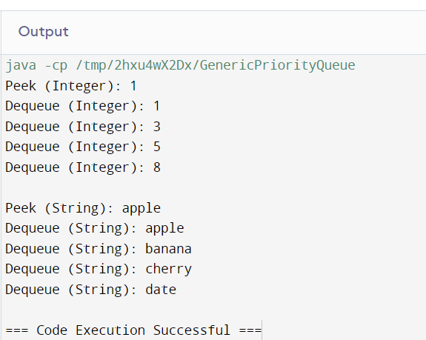

4. Design a generic class Graph&lt;T&gt; with methods for adding nodes,

adding edges, and performing graph traversals (e.g., BFS and DFS).

Ensure that the graph can handle both directed and undirected

graphs. Demonstrate with a graph of String nodes and another graph

of Integer nodes.

Code:

import java.util.*;

public class Graph<T> {

private Map<T, List<T>> adjacencyList;

private boolean isDirected;

// Constructor to initialize the graph as directed or undirected

public Graph(boolean isDirected) {

this.adjacencyList = new HashMap<>();

this.isDirected = isDirected;

}

// Method to add a node to the graph

public void addNode(T node) {

adjacencyList.putIfAbsent(node, new ArrayList<>());

}

// Method to add an edge between two nodes

public void addEdge(T from, T to) {

adjacencyList.get(from).add(to);

if (!isDirected) {

adjacencyList.get(to).add(from);

}

}

// Method to perform Breadth-First Search (BFS)

public void bfs(T startNode) {

Set<T> visited = new HashSet<>();

Queue<T> queue = new LinkedList<>();

queue.add(startNode);

visited.add(startNode);

while (!queue.isEmpty()) {

T node = queue.poll();

System.out.println(node);

for (T neighbor : adjacencyList.get(node)) {

if (!visited.contains(neighbor)) {

visited.add(neighbor);

queue.add(neighbor);

}

}

}

}

// Method to perform Depth-First Search (DFS)

public void dfs(T startNode) {

Set<T> visited = new HashSet<>();

dfsHelper(startNode, visited);

}

// Helper method for DFS using recursion

private void dfsHelper(T node, Set<T> visited) {

visited.add(node);

System.out.println(node);

for (T neighbor : adjacencyList.get(node)) {

if (!visited.contains(neighbor)) {

dfsHelper(neighbor, visited);

}

}

}

// Main method to demonstrate the Graph class

public static void main(String[] args) {

// Demonstration with a graph of Strings (undirected)

Graph<String> stringGraph = new Graph<>(false);

stringGraph.addNode("A");

stringGraph.addNode("B");

stringGraph.addNode("C");

stringGraph.addNode("D");

stringGraph.addEdge("A", "B");

stringGraph.addEdge("A", "C");

stringGraph.addEdge("B", "D");

stringGraph.addEdge("C", "D");

System.out.println("BFS traversal (Strings):");

stringGraph.bfs("A");

System.out.println("\nDFS traversal (Strings):");

stringGraph.dfs("A");

// Demonstration with a graph of Integers (directed)

Graph<Integer> intGraph = new Graph<>(true);

intGraph.addNode(1);

intGraph.addNode(2);

intGraph.addNode(3);

intGraph.addNode(4);

intGraph.addEdge(1, 2);

intGraph.addEdge(1, 3);

intGraph.addEdge(2, 4);

intGraph.addEdge(3, 4);

System.out.println("\nBFS traversal (Integers):");

intGraph.bfs(1);

System.out.println("\nDFS traversal (Integers):");

intGraph.dfs(1);

}

}

Output:

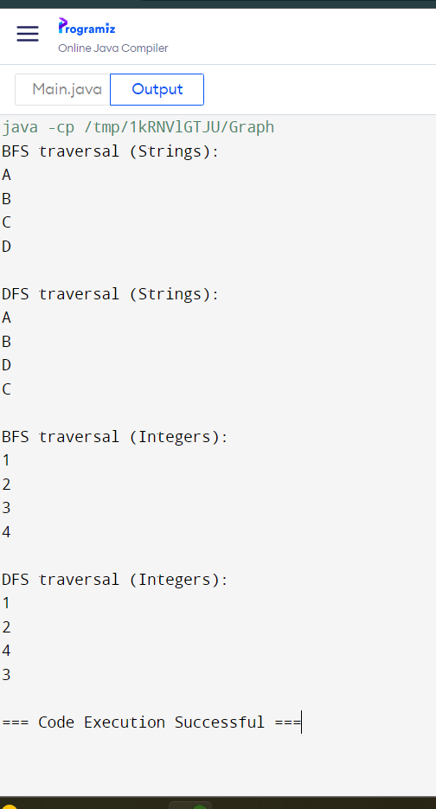

5. Create a generic class Matrix&lt;T extends Number&gt; that represents a

matrix and supports operations like addition, subtraction, and

multiplication of matrices. Ensure that the operations are type-safe

and efficient. Demonstrate with matrices of Integer and Double.

Code:

import java.util.Arrays;

public class Matrix<T extends Number> {

private T[][] data;

private int rows;

private int cols;

public Matrix(T[][] data) {

this.data = data;

this.rows = data.length;

this.cols = data[0].length;

}

// Add two matrices

public Matrix<T> add(Matrix<T> other) {

if (this.rows != other.rows || this.cols != other.cols) {

throw new IllegalArgumentException("Matrices must have the same dimensions for addition.");

}

T[][] result = (T[][]) new Number[rows][cols];

for (int i = 0; i < rows; i++) {

for (int j = 0; j < cols; j++) {

result[i][j] = (T) addNumbers(this.data[i][j], other.data[i][j]);

}

}

return new Matrix<>(result);

}

// Subtract two matrices

public Matrix<T> subtract(Matrix<T> other) {

if (this.rows != other.rows || this.cols != other.cols) {

throw new IllegalArgumentException("Matrices must have the same dimensions for subtraction.");

}

T[][] result = (T[][]) new Number[rows][cols];

for (int i = 0; i < rows; i++) {

for (int j = 0; j < cols; j++) {

result[i][j] = (T) subtractNumbers(this.data[i][j], other.data[i][j]);

}

}

return new Matrix<>(result);

}

// Multiply two matrices

public Matrix<T> multiply(Matrix<T> other) {

if (this.cols != other.rows) {

throw new IllegalArgumentException("Matrices must have compatible dimensions for multiplication.");

}

T[][] result = (T[][]) new Number[this.rows][other.cols];

for (int i = 0; i < this.rows; i++) {

for (int j = 0; j < other.cols; j++) {

result[i][j] = (T) multiplyAndSumRows(this.data[i], getColumn(other.data, j));

}

}

return new Matrix<>(result);

}

// Helper methods for basic arithmetic operations

private Number addNumbers(Number a, Number b) {

if (a instanceof Integer) {

return a.intValue() + b.intValue();

} else if (a instanceof Double) {

return a.doubleValue() + b.doubleValue();

} else {

throw new UnsupportedOperationException("Type not supported for addition");

}

}

private Number subtractNumbers(Number a, Number b) {

if (a instanceof Integer) {

return a.intValue() - b.intValue();

} else if (a instanceof Double) {

return a.doubleValue() - b.doubleValue();

} else {

throw new UnsupportedOperationException("Type not supported for subtraction");

}

}

private Number multiplyAndSumRows(Number[] row, Number[] column) {

Number sum = 0;

for (int i = 0; i < row.length; i++) {

sum = sum.doubleValue() + row[i].doubleValue() * column[i].doubleValue();

}

return sum;

}

private Number[] getColumn(T[][] matrix, int col) {

Number[] column = new Number[matrix.length];

for (int i = 0; i < matrix.length; i++) {

column[i] = matrix[i][col];

}

return column;

}

// Method to print the matrix

public void printMatrix() {

for (T[] row : data) {

System.out.println(Arrays.toString(row));

}

}

public static void main(String[] args) {

Integer[][] intData1 = { {1, 2, 3}, {4, 5, 6}, {7, 8, 9} };

Integer[][] intData2 = { {9, 8, 7}, {6, 5, 4}, {3, 2, 1} };

Matrix<Integer> intMatrix1 = new Matrix<>(intData1);

Matrix<Integer> intMatrix2 = new Matrix<>(intData2);

System.out.println("Integer Matrix Addition:");

Matrix<Integer> intAddResult = intMatrix1.add(intMatrix2);

intAddResult.printMatrix();

System.out.println("\nInteger Matrix Subtraction:");

Matrix<Integer> intSubtractResult = intMatrix1.subtract(intMatrix2);

intSubtractResult.printMatrix();

System.out.println("\nInteger Matrix Multiplication:");

Matrix<Integer> intMultiplyResult = intMatrix1.multiply(intMatrix2);

intMultiplyResult.printMatrix();

Double[][] doubleData1 = { {1.1, 2.2, 3.3}, {4.4, 5.5, 6.6}, {7.7, 8.8, 9.9} };

Double[][] doubleData2 = { {9.9, 8.8, 7.7}, {6.6, 5.5, 4.4}, {3.3, 2.2, 1.1} };

Matrix<Double> doubleMatrix1 = new Matrix<>(doubleData1);

Matrix<Double> doubleMatrix2 = new Matrix<>(doubleData2);

System.out.println("\nDouble Matrix Addition:");

Matrix<Double> doubleAddResult = doubleMatrix1.add(doubleMatrix2);

doubleAddResult.printMatrix();

System.out.println("\nDouble Matrix Subtraction:");

Matrix<Double> doubleSubtractResult = doubleMatrix1.subtract(doubleMatrix2);

doubleSubtractResult.printMatrix();

System.out.println("\nDouble Matrix Multiplication:");

Matrix<Double> doubleMultiplyResult = doubleMatrix1.multiply(doubleMatrix2);

doubleMultiplyResult.printMatrix();

}

}

Output:

