**DAY 2 LAD**

**EASY**

**1.program**

#include<iostream>

using namespace std;

void display(char = '*' , int = 3);

int main()

{

int count = 5;

cout<<"No argument passed :";

display();

cout<<"First argument passed: ";

display('#');

cout<<"Both arguments passed: ";

display('$', count);

return 0;

}

void display(char c, int count)

{

for(int i = 1; i <= count; ++i)

{

cout<< c;

}

cout ;

}

**OUTPUT**

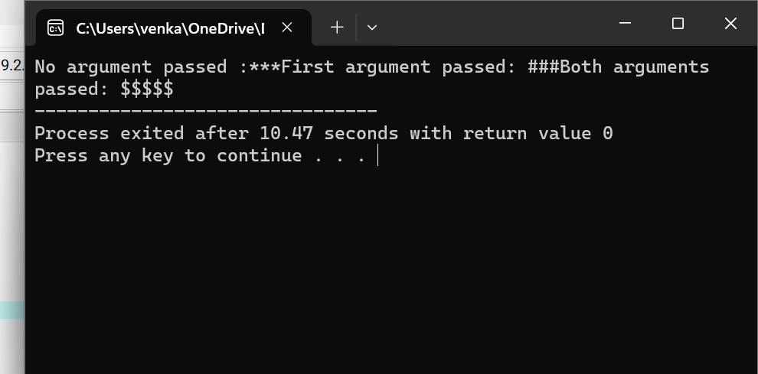

**2.program**

#include<iostream>

using namespace std;

int validates(string username)

{

int special = 0, l = username.length();

if(1 == 0|| 1 > 30)

return 0;

for(int i = 0; i < 1; i++)

{

char s = username.at(i);

if ( s == '.')

return 0;

if(isalnum(s))

continue;

else

{

if (s == '_' || s == '.')

{

special++;

if(special > 1)

return 0;

}

else

return 0;

}

}

return 1;

}

int main()

{

if(validates("abhi123"))

cout<< "valid username";

else

cout <<"Invalid Username";

return 0;

}

**OUTPUT**

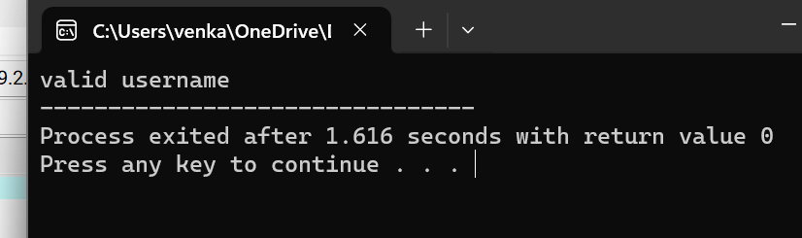

**3.PROGRAM**

#include<iostream>

using namespace std;

int main()

{

int age;

cin >> age;

if(age >= 18)

{

cout << "You are eligible for voting :";

}

else

{

cout << "You are not eligible for voting :";

}

return 0;

}

**OUTPUT**

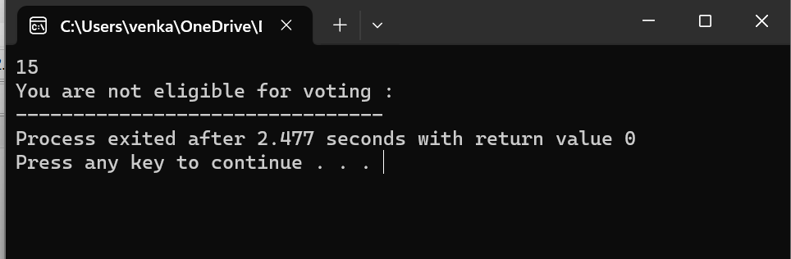

**4.program**

#include<iostream>

using namespace std;

int main()

{

float p, r, t, si;

cout<<"Enter principle Amount :";

cin>>p;

cout<<"Enter Rate of interest :";

cin >>r;

cout<<"Enter the time period :";

cin >>t;

si = (p*r*t)/100;

cout<<"\nSimple Interest Amount: " <<si;

cout ;

return 0;

}

**OUTPUT**

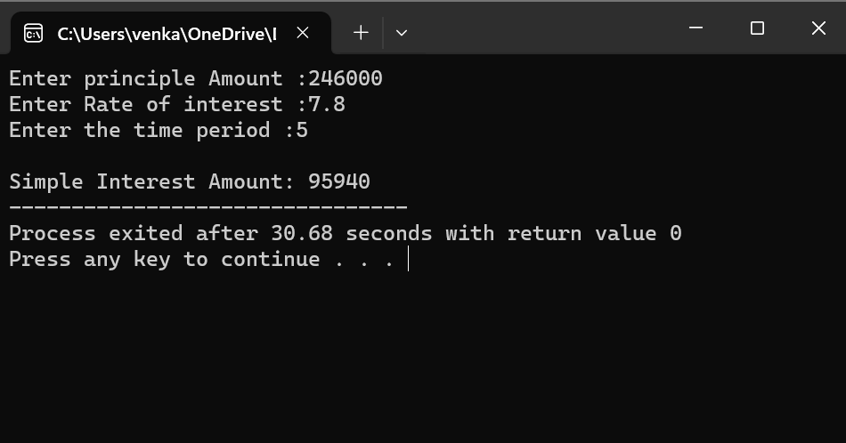

**5.program**

#include<iostream>

#include<string>

using namespace std;

int main()

{

string str,temp;

int i =0,j;

cout<< "Enter a string to check for P alindrome :";

cin>>str;

temp = str;

j = str.length()-1;

while(i<j)

{

swap(str[i],str[j]);

i++;

j--;

}

if(temp == str)

{

cout<<"The string is a palindrome:";

}

else

{

cout<<"The string is a not a palindrome:";

}

return 0;

}

**OUTPUT**

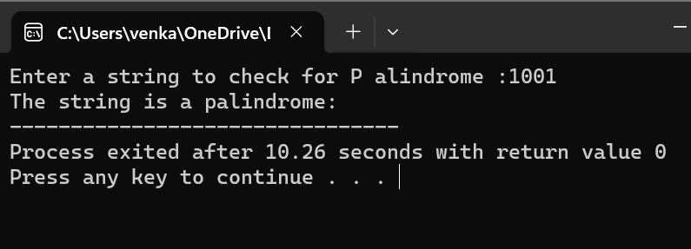

**MEDIUM**

**1.PROGRAM**

#include <iostream>

using namespace std;

void add(int a ,int b )

{

cout << "sum = " << (a + b);

}

void add(double a , double b)

{

cout << "sum = " << (a + b);

}

int main()

{

add(10,2);

add(5.3 ,6.3);

return 0;

}

**OUTPUT**

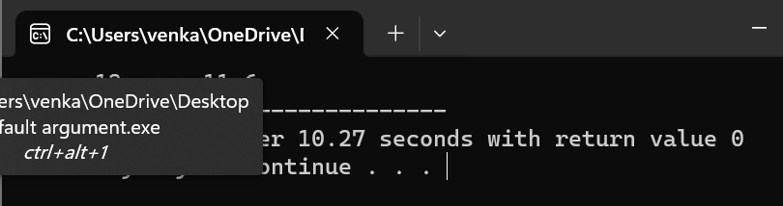

**2.program**

#include<iostream>

using namespace std;

class Room

{

public:

double length;

double breadth;

double height;

double calculateArea()

{

return length * breadth;

}

double calculateVolume()

{

return length * breadth * height;

}

};

int main()

{

Room room1;

room1 . length = 42.5;

room1 . breadth = 30.8;

room1 . height = 19.2;

cout<<"Area of Room = "<<room1 . calculateArea();

cout<<"Volume of Room = "<<room1 . calculateVolume();

return 0;

}

**OUTPUT**

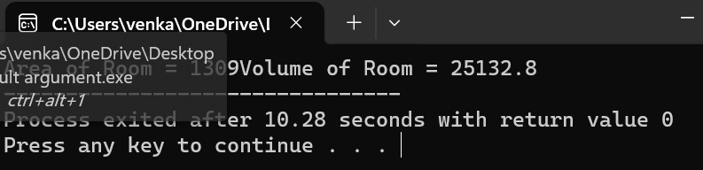

**3.PROGRAM**

#include <iostream>

using namespace std;

int main()

{

int a[10][10], b[10][10], mult[10][10], r1, c1, r2, c2, i, j, k;

cout << "Enter rows and columns for first matrix: ";

cin >> r1 >> c1;

cout << "Enter rows and columns for second matrix: ";

cin >> r2 >> c2;

while (c1!=r2)

{

cout << "Error! column of first matrix not equal to row of second.";

cout << "Enter rows and columns for first matrix: ";

cin >> r1 >> c1;

cout << "Enter rows and columns for second matrix: ";

cin >> r2 >> c2;

}

cout << endl << "Enter elements of matrix 1:" << endl;

for(i = 0; i < r1; ++i)

for(j = 0; j < c1; ++j)

{

cout << "Enter element a" << i + 1 << j + 1 << " : ";

cin >> a[i][j];

}

cout << endl << "Enter elements of matrix 2:" << endl;

for(i = 0; i < r2; ++i)

for(j = 0; j < c2; ++j)

{

cout << "Enter element b" << i + 1 << j + 1 << " : ";

cin >> b[i][j];

}

for(i = 0; i < r1; ++i)

for(j = 0; j < c2; ++j)

{

mult[i][j]=0;

}

for(i = 0; i < r1; ++i)

for(j = 0; j < c2; ++j)

for(k = 0; k < c1; ++k)

{

mult[i][j] += a[i][k] * b[k][j];

}

cout << endl << "Output Matrix: " ;

for(i = 0; i < r1; ++i)

for(j = 0; j < c2; ++j)

{

cout << " " << mult[i][j];

if(j == c2-1)

cout << endl;

}

return 0;

}

**OUTPUT**

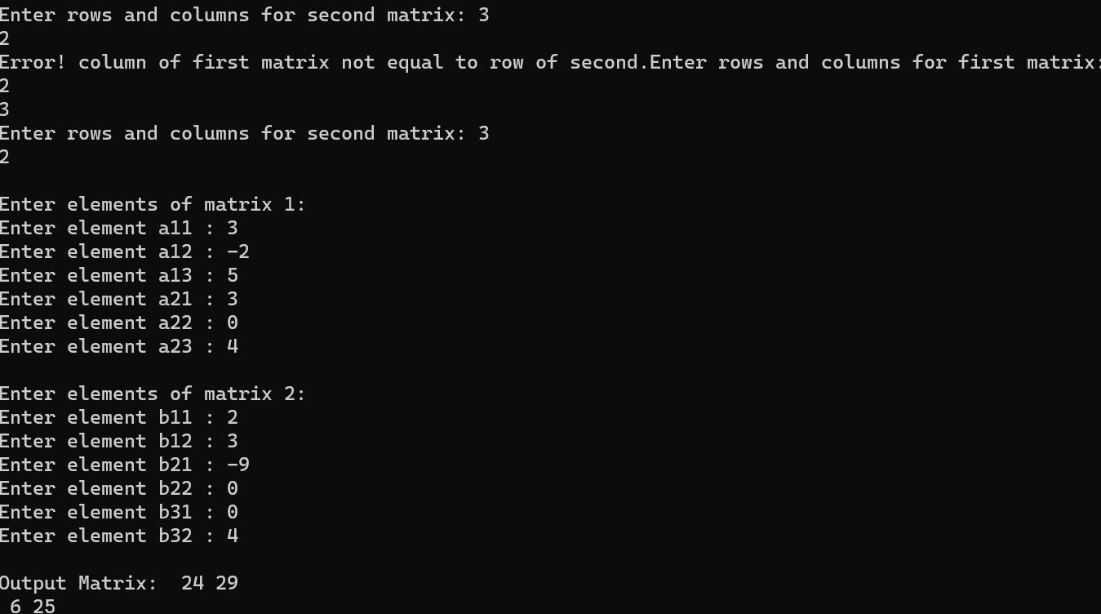

**4.PROGRAM**

#include <iostream>

using namespace std;

class test {

int objNo;

static int objCnt;

public:

test()

{

objNo = ++objCnt;

}

~test()

{

--objCnt;

}

void printObjNumber(void)

{

cout << "object number :" << objNo << "\n";

}

static void printObjCount(void)

{

cout << "count:" << objCnt<< "\n";

}

};

int test::objCnt;

int main()

{

test t1, t2;

test::printObjCount();

test t3;

test::printObjCount();

t1.printObjNumber();

t2.printObjNumber();

t3.printObjNumber();

return 0;

}

**OUTPUT**

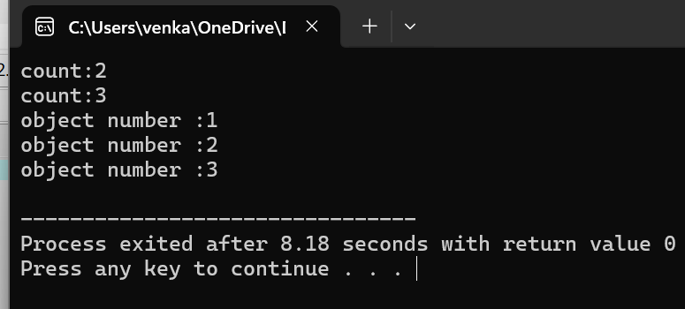

**HARD**

**1.PROGRAM**

#include <iostream>

using namespace std;

void swap(int x, int y)

{

int temp = x;

x = y;

y = temp;

}

int main()

{

int a = 40;

int b = 50;

cout << "Before swap: a = " << a << " b = " << b << endl;

swap(a, b);

cout << "After swap: a = " << a << " b = " << b << endl;

return 0;

}

**OUTPUT**

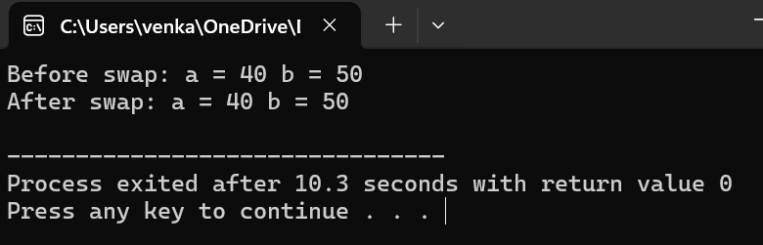

**2.PROGRAM**

#include <bits/stdc++.h>

using namespace std;

class Fibonacci

{

public:

int a, b, c;

void generate(int);

};

void Fibonacci::generate(int n)

{

a = 0;

b = 1;

cout << a << " " << b;

for (int i = 1; i <= n - 2; i++)

{

c = a + b;

cout << " " << c;

a = b;

b = c;

}

}

int main()

{

int n = 9;

Fibonacci fib;

fib.generate(n);

return 0;

}

**OUTPUT**

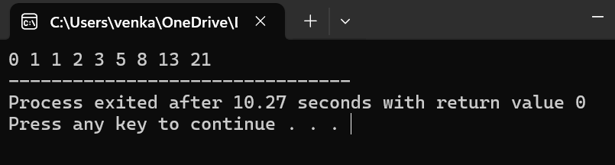

**3.PROGRAM**

#include<iostream>

using namespace std;

int main()

{

int i;

float mark, sum=0, avg;

cout<<"Enter Marks obtained in 5 Subjects: ";

for(i=0; i<5; i++)

{

cin>>mark;

sum = sum+mark;

}

avg = sum/5;

cout<<"\nGrade = ";

if(avg>=91 && avg<=100)

cout<<"A1";

else if(avg>=81 && avg<91)

cout<<"A2";

else if(avg>=71 && avg<81)

cout<<"B1";

else if(avg>=61 && avg<71)

cout<<"B2";

else if(avg>=51 && avg<61)

cout<<"C1";

else if(avg>=41 && avg<51)

cout<<"C2";

else if(avg>=33 && avg<41)

cout<<"D";

else if(avg>=21 && avg<33)

cout<<"E1";

else if(avg>=0 && avg<21)

cout<<"E2";

else

cout<<"Invalid!";

cout<<endl;

return 0;

}

**OUTPUT**

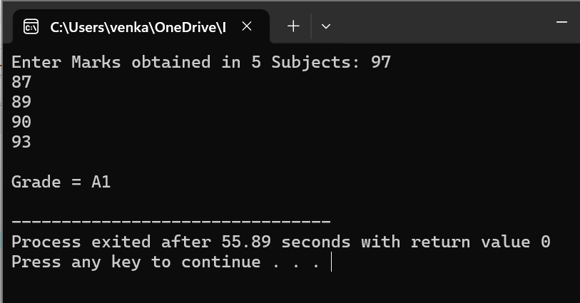

**4.program**

#include <iostream>

using namespace std;

class Complex_num

{

int x, y;

public:

void inp()

{

cout << " Input two complex number: " << endl;

cin >> x >> y;

}

Complex_num operator + (Complex_num obj)

{

Complex_num A;

A.x = x + obj.x;

A.y = y + obj.y;

return (A);

}

Complex_num operator - (Complex_num obj)

{

Complex_num A;

A.x = x - obj.x;

A.y = y - obj.y;

return (A);

}

void print()

{

cout << x << " + " << y << "i" << "\n";

}

void print2()

{

cout << x << " - " << y << "i" << "\n";

}

};

int main ()

{

Complex_num x1, y1, sum, sub;

x1.inp();

y1.inp();

sum = x1 + y1;

sub = x1 - y1;

cout << "\n Entered values are: \n";

cout << " \t";

x1.print();

cout << " \t";

y1.print();

cout << "\n The addition of two complex (real and imaginary) numbers: ";

sum.print();

cout << "\n The subtraction of two complex (real and imaginary) numbers: ";

sub.print2();

return 0;

}

**OUTPUT**

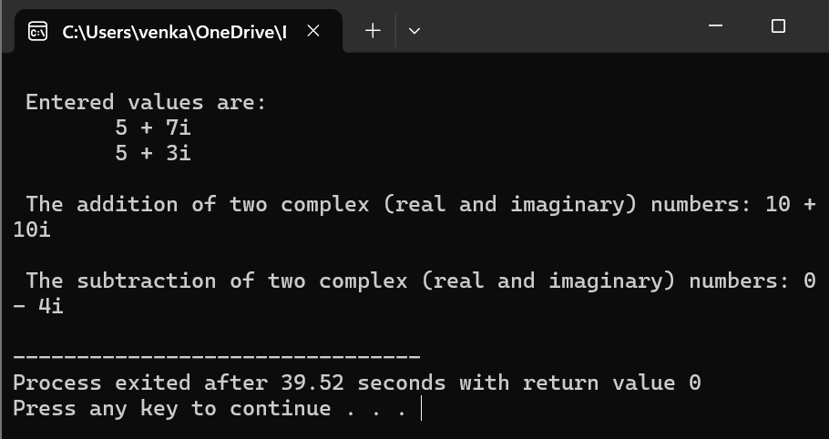

**5.PROGRAM**

#include <iostream>

using namespace std;

int main()

{

int pay;

int sum;

cout<<"please enter your income"<<endl;

cin>>pay;

if(pay<=180000)

{

sum=pay*0.05;

}

else if(pay>180000 && pay<=300000)

{

sum=pay*0.07;

}

else if(pay>300000 && pay<=500000)

{

sum=pay*0.1;

}

else if(pay>500000 && pay<=750000)

{

sum=pay*0.12;

}

else if(pay<750000)

{

sum=pay*0.15;

}

cout<<"your imcome tax is "<<sum<<endl;

}

**OUTPUT**

