POWER BI DATA ANALYTICS PROJECT
SUPPLY CHAIN ANALYSIS DASHBOARD
Executive Report on Revenue, Product, Inventory, Manufacturing and Supplier Performance

Prepared by
Reddimigari Prasanth Kumar Reddy
Tool Used
Microsoft Power BI
Report Type
Business Intelligence / Data Analytics Project Submission

Table of Contents
1. Executive Summary
2. Introduction
3. Business Problem
4. Objectives of the Analysis
5. Dashboard Overview
6. Company-Wide KPI Analysis
7. Dashboard Filters
8. Visualization-wise Analysis — Executive Overview
9. Visualization-wise Analysis — Product Comparison
10. Visualization-wise Analysis — Inventory & Manufacturing
11. Visualization-wise Analysis — Supplier Performance
12. Key Operational Observations
13. Key Insights
14. Business Recommendations
15. Conclusion
16. Final Dashboard Summary

1. Executive Summary
This report presents a structured analysis of the Supply Chain Analysis Dashboard developed in Microsoft Power BI. The dashboard consolidates revenue, units sold, orders, stock, lead time, defect rate, supply-chain cost, manufacturing cost, shipping cost, and production data across three product categories — Skincare, Haircare, and Cosmetics.
At the company level, the dashboard reports Total Revenue of 577.60K, Total Units Sold of approximately 46K, 4,922 Total Orders, Total Stock of 4,777, an Average Lead Time of 15.96 days, and an Average Defect Rate of 2.28%. Skincare is the largest contributor across revenue, units sold, inventory value, and several production measures, while Cosmetics is consistently the most cost- and quality-efficient category.
The analysis translates each dashboard page into business questions, factual observations, and practical recommendations. Findings are based strictly on patterns visible in the supplied dashboard screenshots and are presented as observations for further investigation rather than confirmed causes.

2. Introduction
Supply chain performance affects revenue generation, inventory availability, production planning, quality, and logistics cost. A consolidated dashboard helps decision-makers view these measures together instead of reviewing separate, disconnected reports.
This Power BI dashboard provides interactive filters for Product Type, Supplier, Location, and Transportation. Its visuals compare three product categories and show how revenue, sales volume, inventory, manufacturing, shipping, lead time, and quality measures vary across the product portfolio.

3. Business Problem
A business handling multiple products and supply-chain activities needs a consistent way to monitor sales, inventory, manufacturing, delivery, quality, and cost. Without a consolidated view, it is difficult to identify which product categories contribute most to revenue, where inventory is concentrated, how manufacturing output compares with units sold, and where supply-chain costs are highest.
This dashboard addresses that reporting need by combining these measures into interactive Power BI pages, allowing a user to move from overall KPIs down to product- and supplier-level detail.

4. Objectives of the Analysis
- Evaluate revenue and units sold across product types.
- Compare inventory, manufacturing cost, shipping cost, lead time, and defect rate by product.
- Review production volume and compare it against units sold.
- Monitor overall supply-chain KPIs such as orders, stock, lead time, and defect rate.
- Compare supplier cost, quality, and delivery performance.
- Provide data-supported observations and practical areas for further investigation.

5. Dashboard Overview
The dashboard is organized into four analytical pages, shown in the screenshots throughout this report: Executive Overview, Product Comparison, Inventory & Manufacturing, and Supplier Performance.
Dashboard Page | Main Purpose | Key Visuals
Executive Overview | High-level supply-chain performance | KPI cards; revenue, units sold, inventory, supply-chain cost, lead time and defect-rate charts
Product Comparison | Detailed comparison across products | Revenue, units sold, inventory, manufacturing cost, defect rate, shipping cost and a detailed SKU-level table
Inventory & Manufacturing | Production and manufacturing analysis | Inventory, manufacturing lead time, manufacturing cost, production volume and production vs. units sold
Supplier Performance | Supplier cost, quality and speed comparison | KPI cards; supplier cost, defect-rate and lead-time charts; supplier detail table

6. Company-Wide KPI Analysis
KPI | Value | Business Meaning
Total Revenue | 577.60K | Overall revenue represented in the dashboard.
Total Units Sold | 46K | Total product units sold; the detailed table shows 46,099.
Total Orders | 4,922 | Total orders represented in the executive overview.
Total Stock | 4,777 | Total stock level represented in the executive overview.
Average Lead Time | 15.96 days | Average lead time across the dashboard data.
Average Defect Rate | 2.28% | Average defect-rate value displayed in the executive overview.

Interpretation: the executive overview provides a compact snapshot of sales, order volume, inventory, delivery time, and quality. These values are the starting point for drilling into product- and supplier-level differences in the remaining sections.

7. Dashboard Filters
- Product Type: Cosmetics, Haircare, and Skincare.
- Supplier: Supplier 1 through Supplier 5.
- Location: Bangalore, Chennai, Delhi, Kolkata, and Mumbai.
- Transportation: Air, Rail, Road, and Sea.
The screenshots show these filters as interactive slicers. The supplied screenshots do not include enough filtered results to draw separate supplier-, location-, or transportation-level conclusions beyond the product-level visuals analyzed below.

8. Visualization-wise Analysis — Executive Overview
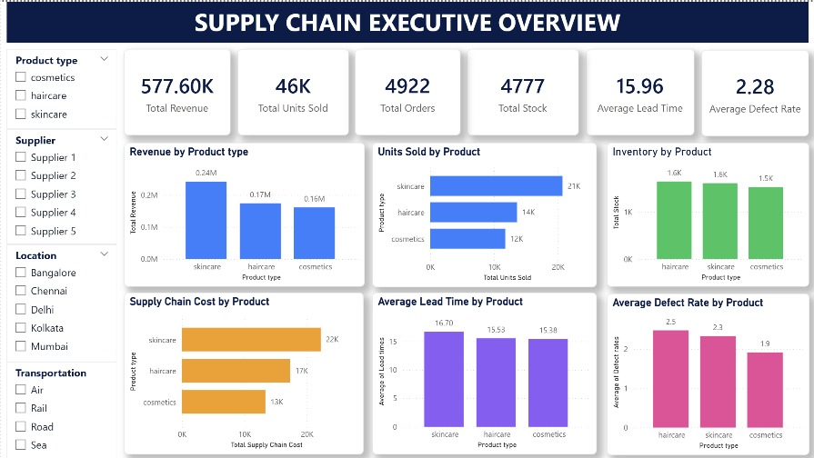
Figure 1. Executive Overview dashboard

Revenue by Product Type
The chart shows approximately 0.24M revenue for Skincare, 0.17M for Haircare, and 0.16M for Cosmetics. Skincare is the largest revenue contributor of the three categories.

Units Sold by Product
Skincare records approximately 20.7K units sold, followed by Haircare at 13.6K and Cosmetics at 11.8K. This ranking mirrors the revenue chart.

Inventory by Product
Inventory is approximately 1,644 for Haircare, 1,608 for Skincare, and 1,525 for Cosmetics — Haircare carries the largest displayed inventory level.

Supply Chain Cost by Product
Displayed supply-chain cost is approximately 22K for Skincare, 17K for Haircare, and 13K for Cosmetics, making Skincare the highest-cost category.

Average Lead Time by Product
Average lead time is approximately 16.70 days for Skincare, 15.53 days for Haircare, and 15.38 days for Cosmetics — a relatively close range across the three products.

Average Defect Rate by Product
Displayed defect-rate values are approximately 2.5 for Haircare, 2.3 for Skincare, and 1.9 for Cosmetics; Cosmetics records the lowest value.

9. Visualization-wise Analysis — Product Comparison
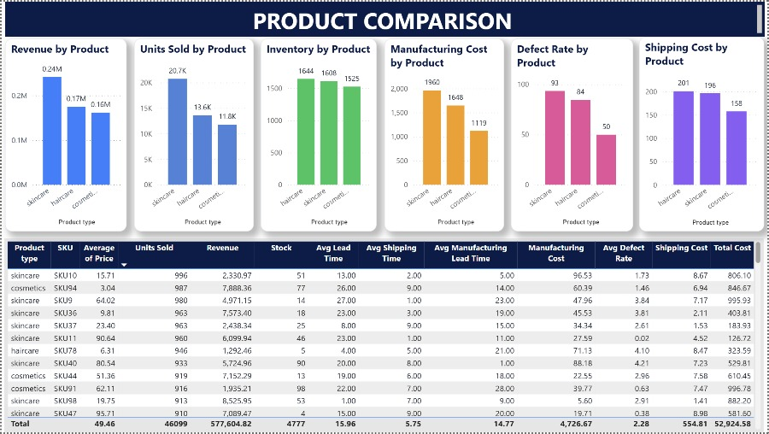
Figure 2. Product Comparison dashboard

Revenue and Units Sold
Skincare contributes approximately 0.24M in revenue and 20.7K units sold, ahead of Haircare (0.17M / 13.6K) and Cosmetics (0.16M / 11.8K).

Inventory and Manufacturing Cost
Inventory values are 1,644 (Haircare), 1,608 (Skincare), and 1,525 (Cosmetics). Manufacturing cost is highest for Skincare (approximately 1,960), followed by Haircare (1,548) and Cosmetics (1,119).

Defect Rate and Shipping Cost
The defect-rate chart displays approximately 93 for Skincare, 84 for Haircare, and 50 for Cosmetics; the screenshot alone does not establish whether these are counts, percentages, or another underlying measure. Shipping cost is highest for Skincare (approximately 201) and lowest for Cosmetics (158).
The detailed product table (visible in the figure above) provides row-level data including Product, SKU, Average Price, Units Sold, Revenue, Stock, Lead Time, Shipping Time, Manufacturing Lead Time, Manufacturing Cost, Defect Rate, Shipping Cost, and Total Cost. The total row shows Average Price 49.46, Units Sold 46,099, Revenue 577,604.82, Stock 4,777, Average Lead Time 15.96, Average Shipping Time 5.75, Average Manufacturing Lead Time 14.77, Manufacturing Cost 4,726.67, Average Defect Rate 2.28, Shipping Cost 554.81, and Total Cost 52,924.58.

10. Visualization-wise Analysis — Inventory & Manufacturing
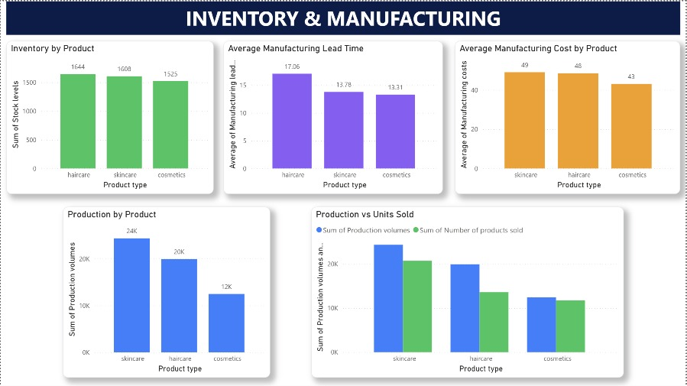
Figure 3. Inventory & Manufacturing dashboard

Inventory and Manufacturing Lead Time
Inventory is highest for Haircare (1,644), followed by Skincare (1,608) and Cosmetics (1,525). Average manufacturing lead time is approximately 17.06 days for Haircare, 13.78 days for Skincare, and 13.31 days for Cosmetics — Haircare has the highest displayed manufacturing lead time.

Manufacturing Cost and Production Volume
Average manufacturing cost is approximately 49 for Skincare, 48 for Haircare, and 43 for Cosmetics. Production volume is approximately 24K for Skincare, 20K for Haircare, and 12K for Cosmetics, with Skincare showing the largest production volume.

Production vs. Units Sold
Production volume exceeds units sold for all three displayed product categories. The gap appears largest for Skincare, followed by Haircare, while Cosmetics shows the smallest difference. The screenshot supports this comparison but does not establish whether the gap represents ending inventory, work-in-process, timing differences, or another operational factor.

11. Visualization-wise Analysis — Supplier Performance
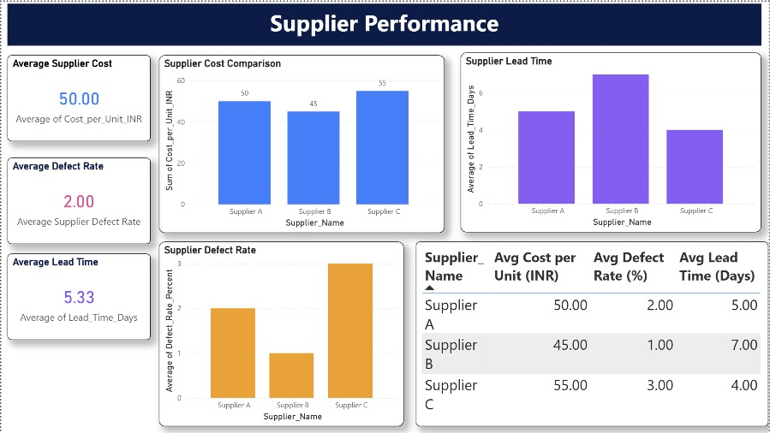
Figure 4. Supplier Performance dashboard

Supplier Cost, Defect Rate and Lead Time
The dashboard compares Supplier A, Supplier B, and Supplier C on cost per unit, defect rate, and lead time, and reports an average supplier cost of 50.00 INR, an average defect rate of 2.00%, and an average lead time of 5.33 days across the three suppliers.
Supplier | Avg Cost per Unit (INR) | Avg Defect Rate (%) | Avg Lead Time (Days)
Supplier A | 50.00 | 2.00 | 5.00
Supplier B | 45.00 | 1.00 | 7.00
Supplier C | 55.00 | 3.00 | 4.00

Supplier B has the lowest displayed average cost and defect rate, but the highest displayed lead time. Supplier C has the highest displayed average cost and defect rate, but the shortest displayed lead time. Supplier A falls between the other two suppliers on every displayed measure. These observations describe the values shown in the supplied dashboard screenshot; they do not establish the reasons for the differences or whether one supplier is operationally preferable overall.

12. Key Operational Observations
- Skincare is the largest displayed contributor for revenue, units sold, supply-chain cost, manufacturing cost, shipping cost, and production volume.
- Haircare has the highest displayed inventory and manufacturing lead time.
- Cosmetics has the lowest displayed defect-rate value and the lowest manufacturing and shipping costs among the three products.
- Production volume is higher than units sold for every product category shown in the production comparison.
- No single supplier leads on every measure: Supplier B is cheapest and most reliable, Supplier C is fastest, and Supplier A is balanced across all three measures.

13. Key Insights
- Skincare is the strongest product category by revenue and unit sales, at approximately 0.24M revenue and 20.7K units sold.
- Haircare has the highest displayed inventory (1,644) and the highest average manufacturing lead time (approximately 17.06 days).
- Cosmetics has the lowest displayed defect rate (approximately 1.9 on the Executive Overview) and the lowest manufacturing cost (approximately 1,119 on the Product Comparison page).
- Supply-chain cost is concentrated most heavily in Skincare (approximately 22K), followed by Haircare (17K) and Cosmetics (13K).
- Shipping cost is highest for Skincare (approximately 201) and lowest for Cosmetics (158).
- Production volume exceeds units sold across all three product categories, with the widest gap in Skincare.
- At the company level, the dashboard reports 577.60K revenue, approximately 46K units sold, 4,922 orders, 4,777 stock, 15.96 days average lead time, and 2.28% average defect rate.
- Supplier B offers the best combination of cost and quality; Supplier C offers the fastest delivery at a higher cost and defect rate.

14. Business Recommendations
Area | Dashboard Observation | Recommended Action
Product Performance | Skincare leads revenue and unit sales. | Monitor Skincare demand and supply availability closely, since changes in this category can materially affect overall results.
Inventory | Haircare has the highest displayed inventory (1,644). | Review Haircare inventory against recent demand and replenishment requirements to confirm stock levels match actual consumption.
Manufacturing Lead Time | Haircare has the highest manufacturing lead time (~17.06 days). | Review Haircare's manufacturing workflow and production scheduling to identify opportunities to reduce processing time.
Quality | Cosmetics has the lowest defect rate; Haircare and Skincare are higher. | Investigate the process differences behind these gaps and track quality measures consistently across categories.
Shipping Cost | Skincare has the highest shipping cost (~201). | Review transportation mode, shipment volume, and route-level costs for Skincare before making logistics changes.
Production Planning | Production exceeds units sold for all three categories. | Compare production, sales, and inventory movement over time to confirm production levels are aligned with demand.
Supplier Sourcing | Supplier B is cheapest and most reliable; Supplier C is fastest but costliest and least reliable. | Route standard-volume orders to Supplier B where lead time allows; reserve Supplier C for urgent, time-critical orders.

15. Conclusion
The Supply Chain Analysis Dashboard provides a consolidated Power BI view of revenue, sales volume, orders, inventory, lead time, defect rate, manufacturing, shipping, production, and supplier performance across Skincare, Haircare, and Cosmetics.
The dashboard shows clear product-level differences. Skincare is the largest displayed contributor to revenue, units sold, supply-chain cost, manufacturing cost, shipping cost, and production volume. Haircare has the highest displayed inventory and manufacturing lead time, while Cosmetics records the lowest displayed manufacturing and shipping costs and the lowest defect-rate value on the Executive Overview.
The Production vs. Units Sold view also shows production volume above units sold for every product category. This pattern should be examined together with inventory and time-period data before drawing conclusions about excess production or demand planning. At the supplier level, no single supplier dominates on cost, quality, and speed together — sourcing decisions should be made based on order priority.
Overall, the dashboard provides a useful foundation for monitoring supply-chain performance and identifying areas for further investigation. The observations and recommendations in this report are based on visible patterns in the supplied screenshots; additional historical, supplier-level, location-level, and transportation-level analysis would be required to establish causes and quantify operational impact.

16. Final Dashboard Summary
Category | Key Displayed Finding
Revenue | 577.60K total; Skincare approximately 0.24M
Units Sold | 46K total; detailed table shows 46,099
Orders | 4,922
Stock | 4,777 total
Average Lead Time | 15.96 days
Average Defect Rate | 2.28%
Highest Inventory | Haircare — 1,644
Highest Manufacturing Lead Time | Haircare — approximately 17.06 days
Highest Production | Skincare — approximately 24K
Highest Shipping Cost by Product | Skincare — approximately 201
Best Supplier on Cost & Quality | Supplier B — 45.00 INR/unit, 1.00% defect rate
Fastest Supplier | Supplier C — 4.00-day average lead time

Note: values are transcribed from the supplied Power BI screenshots. Where a chart label is rounded, this report retains the rounded value shown in the visual. Supplier-, location-, and transportation-specific performance beyond what is shown in the dashboard visuals is not inferred from the slicers alone.

