Software Architecture Document (SAD)
CoreProof — Autonomous Core Banking API Modernization Agent

1. System Overview
CoreProof is an agentic pipeline that automates the discovery, specification, and code generation stages of legacy core banking API modernization. The system follows a layered, agent-orchestrated architecture: a React frontend for visibility and control, a Spring Boot backend that orchestrates a set of specialized AI agents, a pluggable LLM API layer for the AI reasoning tasks, and an immutable audit log that records every action and human approval decision.
Overall architecture approach: modular, agent-based orchestration with mandatory human-in-the-loop approval gates between every stage, and strict separation between read-only legacy data access and any generated output.

2. Architecture Diagram
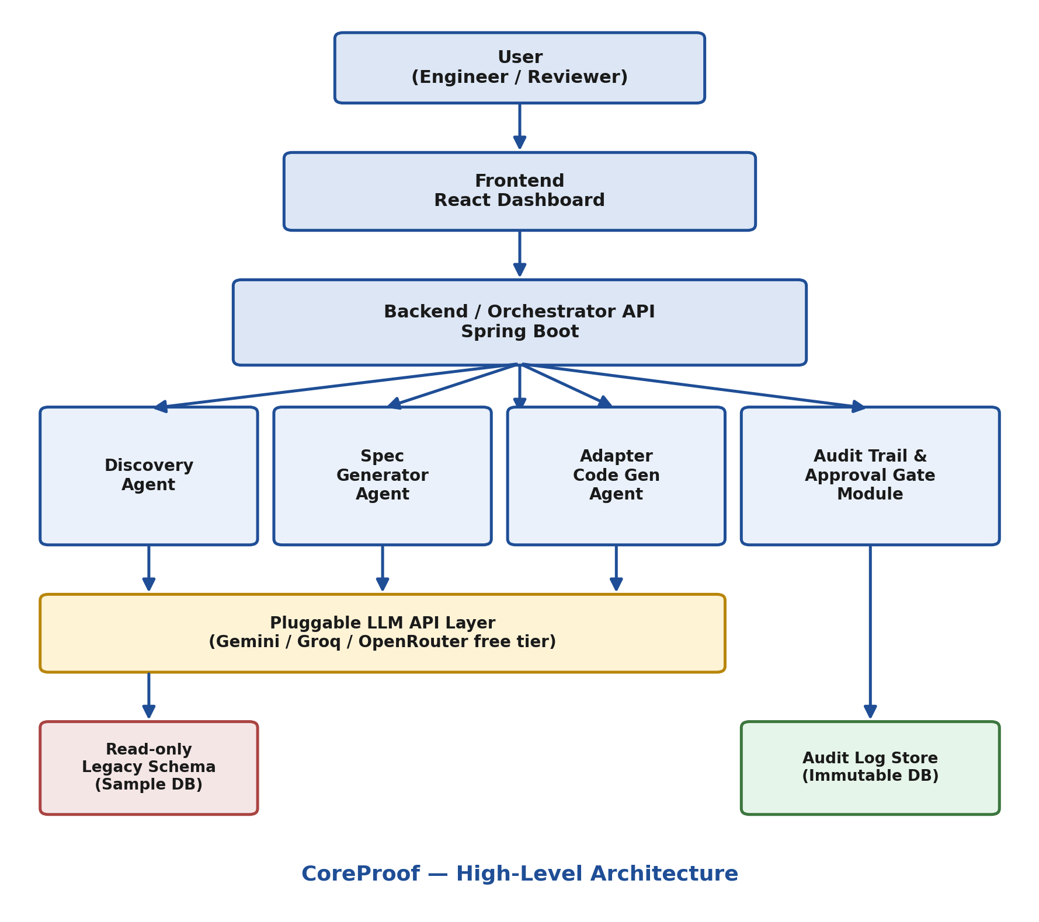
Figure 1: CoreProof high-level system architecture

3. Technology Stack
Layer | Technology
Frontend | React
Backend | Java (Spring Boot)
AI / Agent Layer | Pluggable LLM API (Gemini free tier / Groq free tier / OpenRouter free models) — assumption pending your confirmation
Database | PostgreSQL (schema samples, pipeline runs, audit log)
Authentication | JWT
Hosting | Render / AWS Free Tier (for MVP/demo deployment)
Note: the AI/Agent Layer is intentionally abstracted behind a single interface (LLMClient) so the underlying provider (Gemini, Groq, OpenRouter, or a local Ollama model) can be swapped without changing agent logic.

4. Major Components / Modules

Discovery Agent
Connects to a read-only sample legacy schema, extracts tables, columns, relationships, and stored procedure logic, and outputs a structured schema summary.

Spec Generator Agent
Consumes the Discovery Agent's structured output and produces a draft OpenAPI 3.0 specification.

Adapter Code Generation Agent
Consumes the approved OpenAPI spec and generates working Spring Boot REST controller and service code.

Audit Trail & Approval Gate Module
Intercepts every stage transition, requires explicit human approval before proceeding, and writes an immutable log entry for each action.

Orchestrator (Backend API)
Coordinates the sequential handoff between agents, enforces approval gates, and exposes REST endpoints consumed by the frontend dashboard.

Frontend Dashboard
Displays pipeline run status, pending approvals, and generated artifacts; allows users to download outputs.

5. Data Flow
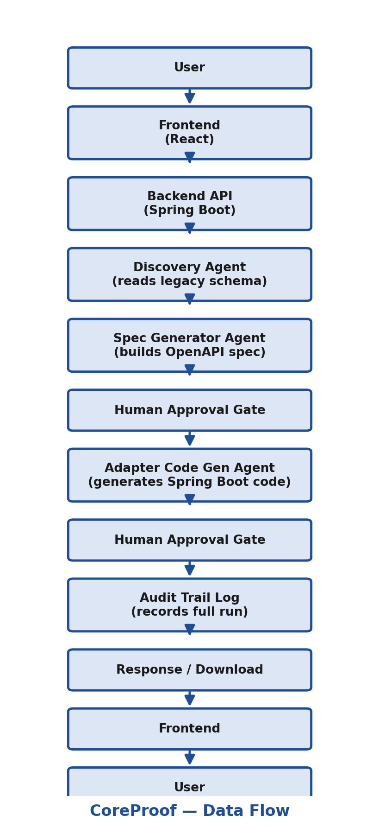
Figure 2: CoreProof end-to-end data flow, including human approval gates

6. Database Design
Database used: PostgreSQL
Key tables: PipelineRun, AgentStageResult, ApprovalRecord, AuditLogEntry (see Figure 3 below).
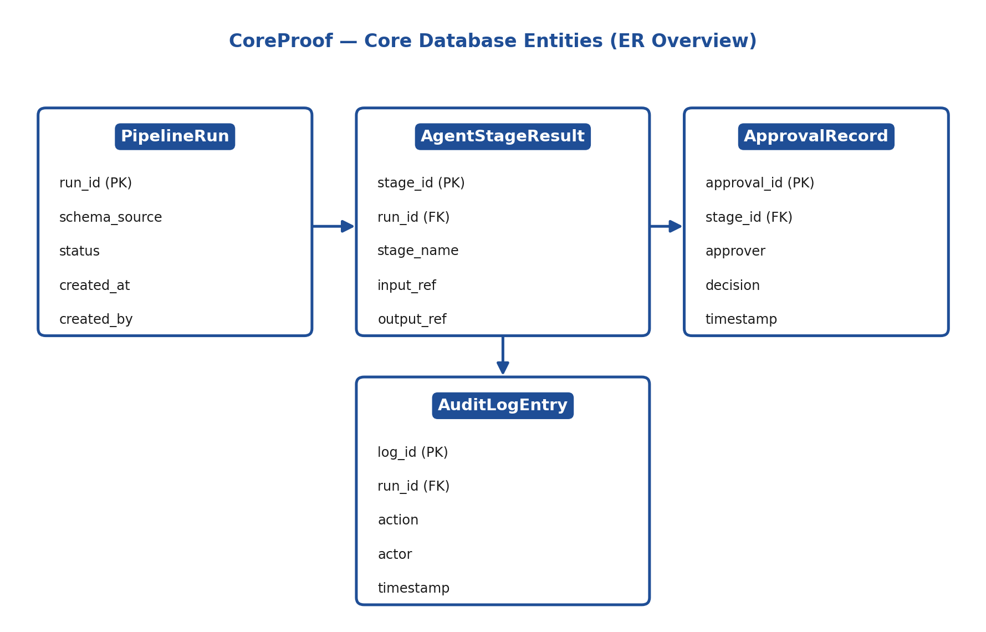
Figure 3: Core database entities and relationships
Table | Purpose
PipelineRun | One record per end-to-end pipeline execution (schema source, status, creator)
AgentStageResult | One record per agent stage output within a run (discovery, spec, code)
ApprovalRecord | One record per human approval decision tied to a stage
AuditLogEntry | Immutable, append-only log of every action taken during a run

7. API Design
API | Method | Purpose
/api/runs | POST | Start a new pipeline run with a schema source
/api/runs/{id} | GET | Get current status and stage results for a run
/api/runs/{id}/discover | POST | Trigger the Discovery Agent for a run
/api/runs/{id}/spec | POST | Trigger the Spec Generator Agent
/api/runs/{id}/generate | POST | Trigger the Adapter Code Generation Agent
/api/runs/{id}/approve | POST | Record a human approval decision for the current stage
/api/runs/{id}/audit | GET | Retrieve the full audit trail for a run

8. System Design Concepts Applied
Concept | Where It Was Applied | Why It Was Used
Modular Design | Each agent (Discovery, Spec Generator, Adapter Generator) is a separate service module | Improves maintainability and allows independent testing/replacement of agents
Authentication | Login/approval actions on the dashboard | Ensures only authorized reviewers can approve pipeline stages
Audit Logging | AuditLogEntry table + Audit Trail module | Required for banking-grade traceability and regulatory compliance
Human-in-the-loop Gating | Between every agent stage transition | Prevents unreviewed AI output from propagating to the next stage or production
Read-only Data Access | Discovery Agent's connection to legacy schema | Prevents any accidental write to sensitive legacy banking data
Pluggable Provider Pattern | LLM API Layer (LLMClient interface) | Allows switching between free-tier LLM providers without changing agent logic
Note: only concepts actually implemented in the MVP are listed above; concepts not yet implemented (e.g., caching, load balancing) are addressed in Section 12 (Future Architecture Improvements).

9. Scalability & Performance
- Current MVP handles one pipeline run at a time per user session; each agent call is synchronous
- If traffic increases, the Orchestrator can be scaled horizontally behind a load balancer, since agent calls are stateless API requests
- Database can scale via read replicas for the AuditLogEntry table, which is append-only and read-heavy for compliance review
- Long-running agent tasks (e.g., large schema discovery) can be moved to an async job queue in a future iteration

10. Security Considerations
- Authentication: JWT-based login for all dashboard users
- Authorization: Role-based access — only designated approvers can act on the Approval Gate
- Password protection: Passwords hashed (bcrypt) before storage
- API security: All endpoints require a valid JWT; sensitive endpoints (approve, audit) require elevated role
- Input validation: Schema uploads and API inputs validated before being passed to any agent
- Data protection: No direct write access to production/live legacy databases; all legacy access is read-only

11. Limitations
- MVP supports SQL-based sample schemas only; real COBOL/mainframe parsing is not yet implemented
- Only one adapter output language supported (Spring Boot / Java) in this version
- Pipeline runs are handled synchronously; no queuing system for concurrent large-scale runs
- LLM output quality depends on the free-tier provider's capability and rate limits

12. Future Architecture Improvements
To support 10x or 100x more users:
- Introduce an async job queue (e.g., RabbitMQ/Kafka) so agent tasks run independently of the request/response cycle
- Add caching for repeated schema discovery results on the same sample schema
- Introduce load balancing across multiple orchestrator instances
- Add database indexing on PipelineRun.status and AuditLogEntry.run_id for faster dashboard queries
- Support pagination for audit trail retrieval on large, long-running pipelines
- Add COBOL/mainframe parsing support and multi-language adapter generation (Node.js, Python)

