**Project Part 4B**

**I am using MariaDB in windows to do my project**

**Screenshots of tables:**

**step 1 :** Add a new column of type ‘ENUM’ to Products

Before adding ENUM.

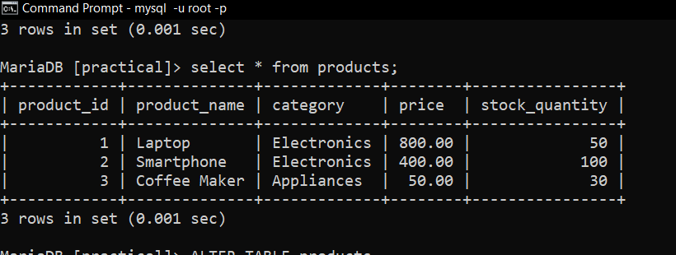

After adding ENUM.

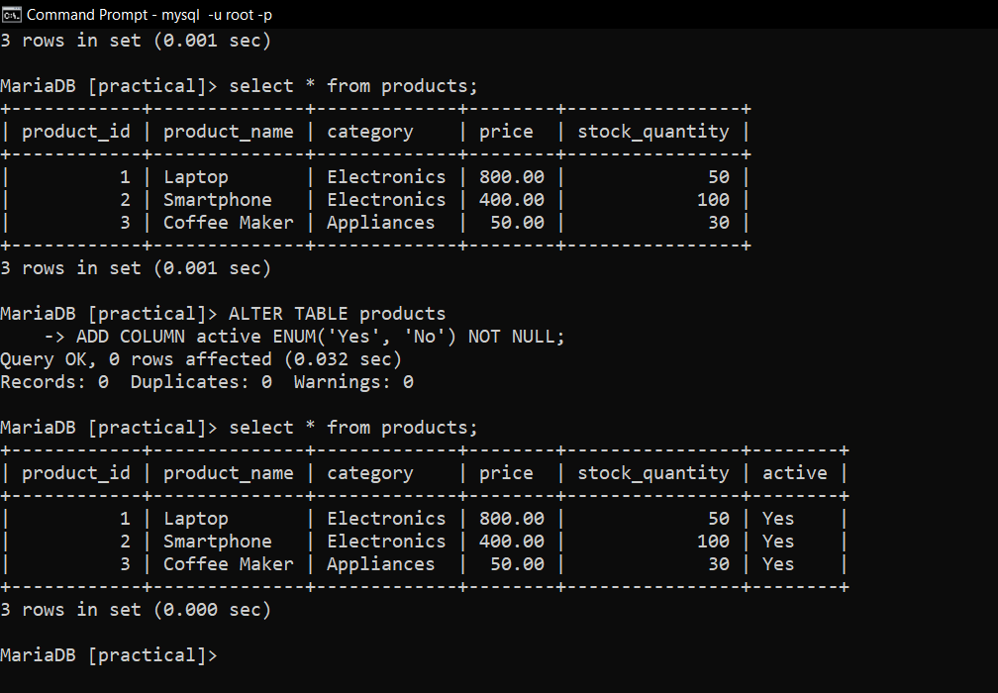

Step 2 A: . Insert a new record of data into products table

Before Insert.

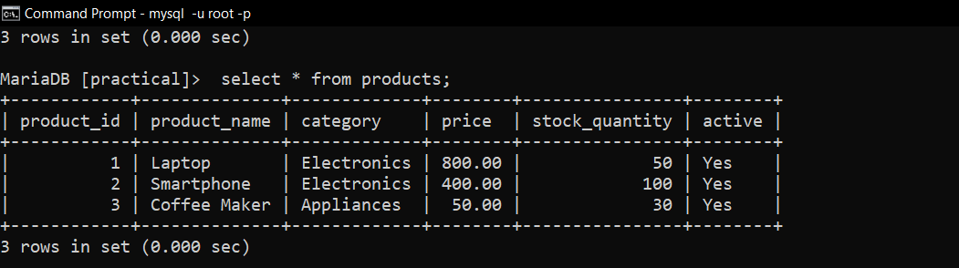

After insert.

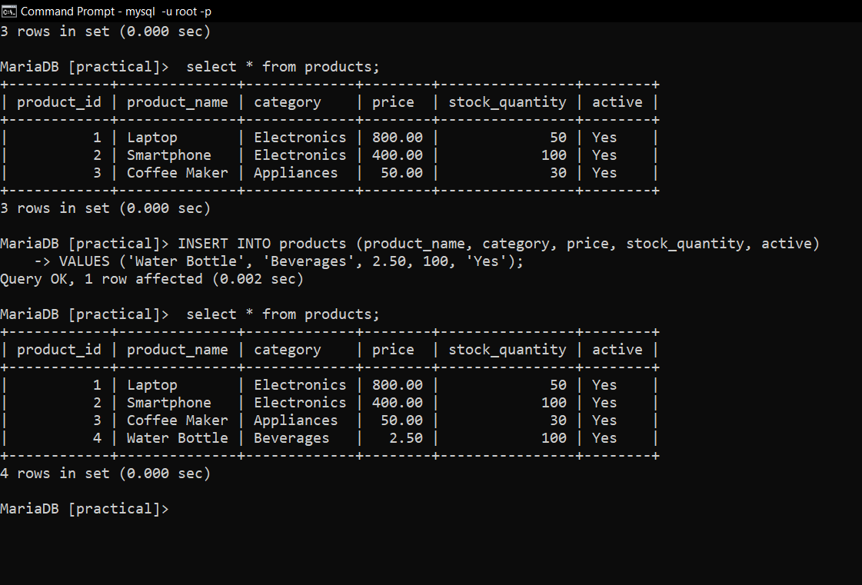

Step 2 B : modify your insert to include a valid entry so that the data works properly.

Before Modify

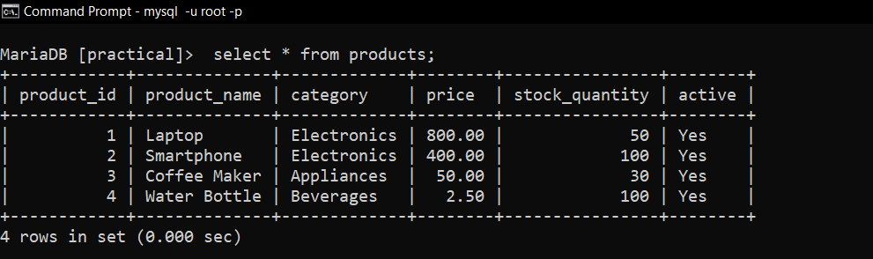

After modification:

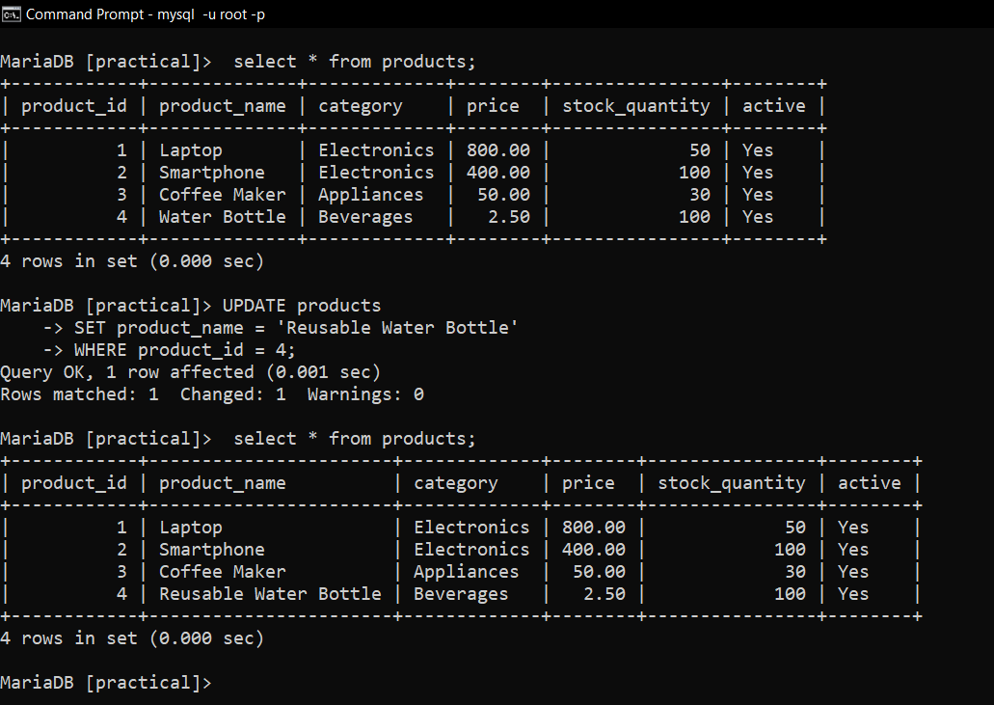

step 3:

Before:



After 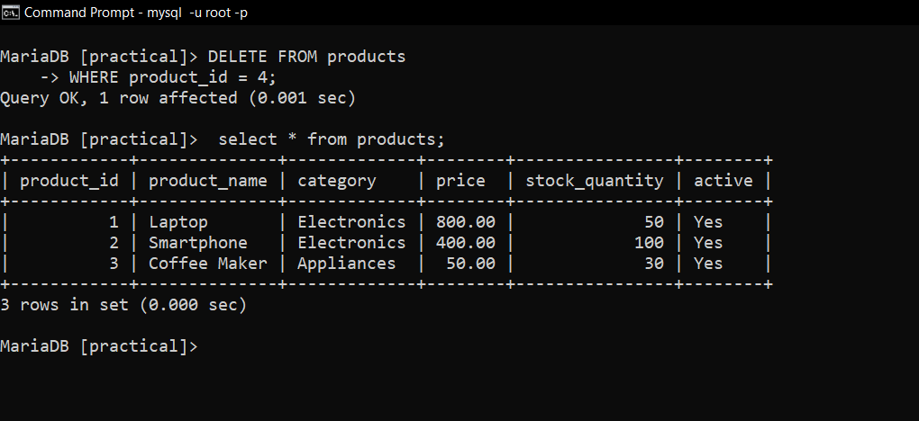:

Step 4:Demonstrate the use of the 'AUTO_INCREMENT' constraint

Before: 

After :

Using this query :

**ALTER TABLE orders**

**ADD COLUMN order_id INT AUTO_INCREMENT PRIMARY KEY;**

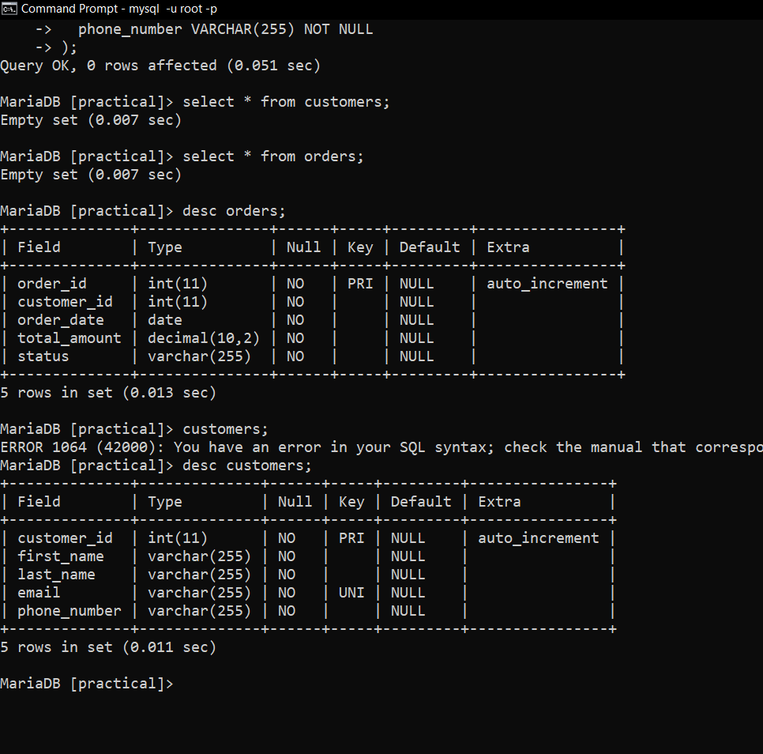

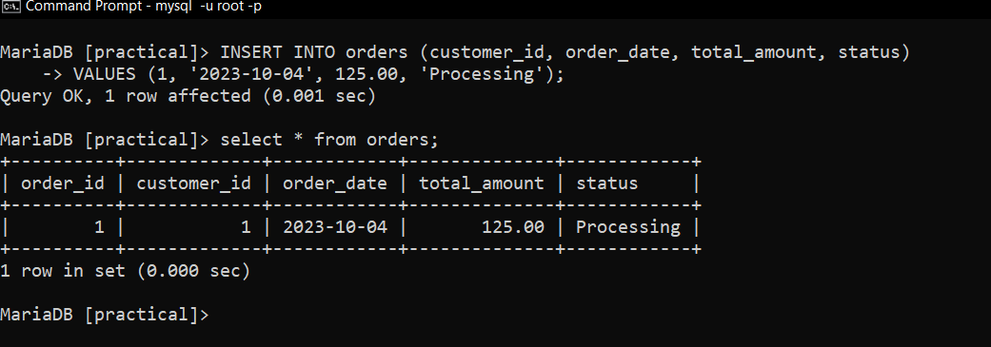

Step 5: Demonstrate the use of the 'DEFAULT' constraint

Before:

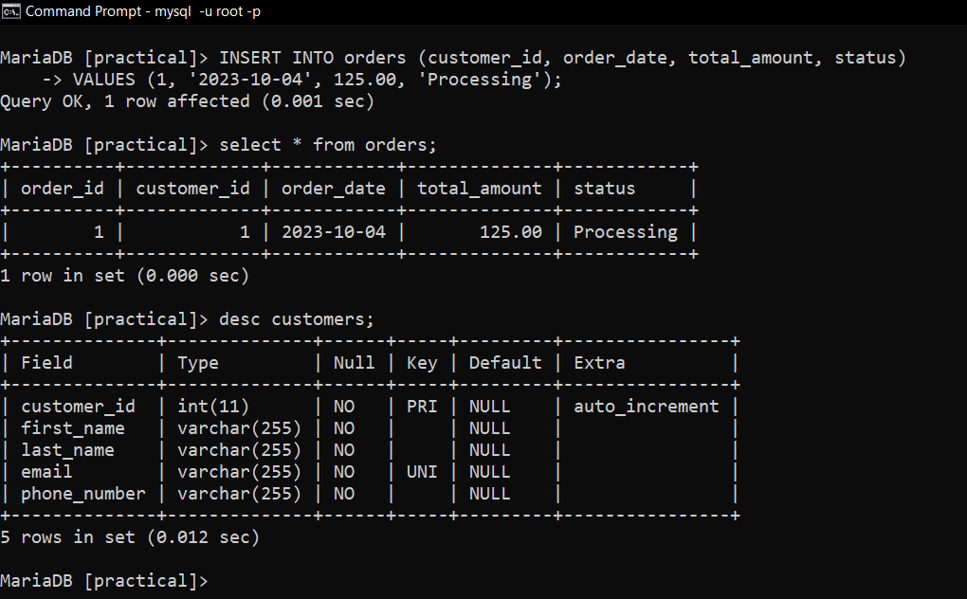

After:

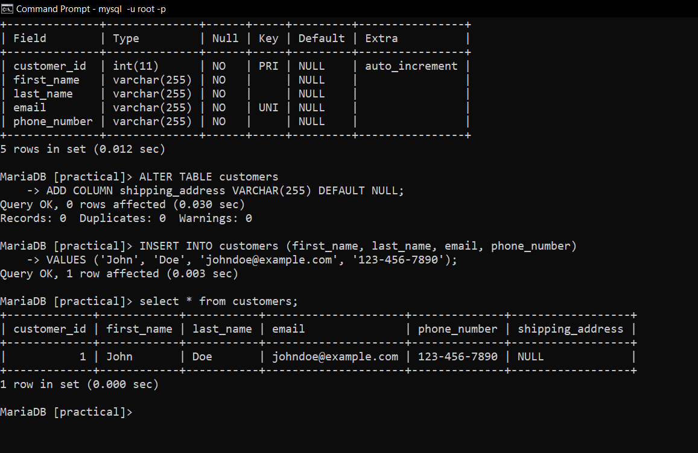

Step 6: Select a subset of the rows and columns from one table

