SOFTWARE DEFECT REPORT
Quality Assurance Bug Tracking Document
Bug #1: Duplicate Catalog Displayed in Buyer Page After CSV Upload
Defect ID | WC-DEF-005
Module | Seller / Buyer
Severity | Medium
Priority | Medium
Preconditions | 1. User logged in as a Seller.  2. Valid CSV file with catalog details available for upload.
Steps to Reproduce | 1. Login to the application as a Seller.  2. Navigate to the Catalog section.  3. Upload a CSV file containing catalog details.  4. Navigate to the Buyer page.  5. Check the uploaded catalog.
Expected Result | The uploaded catalog should be displayed only once on the Buyer page.
Actual Result | The same catalog is displayed twice on the Buyer page after uploading the CSV file from the Seller page.  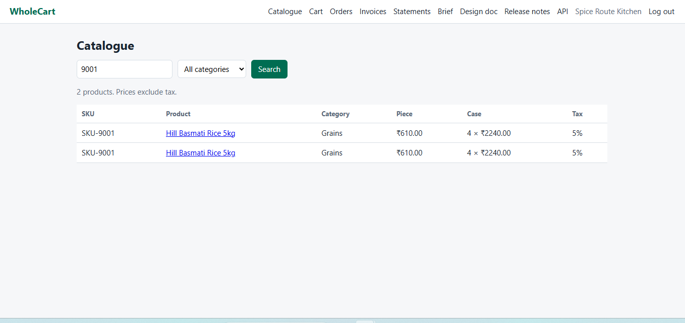

Bug #2: Order Number Displayed in Seller Portal Does Not Match Buyer Order History
Defect ID | WC-DEF-006
Module | Orders / Order History
Severity | Major
Priority | P1
Preconditions | 1. Buyer places an order successfully.  2. Seller receives the corresponding sub-order.  3. Both buyer and seller accounts are accessible.
Steps to Reproduce | 1. Login as Buyer (Café Dosa Corner).  2. Navigate to Order History.  3. Note the Order Number displayed.  4. Logout.  5. Login as Seller (FreshFarm Foods).  6. Open Seller Order List.  7. Locate the same order.  8. Compare the Order Number displayed in the Seller view with the Buyer view.
Expected Result | The same sub-order should display the identical order number in all system views.  Example:  Buyer View: WC-01005-1  Seller View: WC-01005-1
Actual Result | Different order numbers are displayed for the same order in Buyer and Seller views.  Example:  Buyer View: WC-01005-1  Seller View: WC-01006-1
