WholeCart Software Defect & Bug Report
Consolidated QA Defect Tracking Document
Bug #1: Catalogue Does Not Refresh When Search Is Cleared
Defect ID | WC-DEF-001
Module | Catalogue / Search
Severity | Medium (Provisional)
Priority | P2 (Provisional)
Preconditions | • User is logged in and can access the product catalogue.  • Products matching a valid SKU are available.
Steps to Reproduce:
1. Open the WholeCart product catalogue.
2. Enter a valid SKU in the search field.
3. Click Search.
4. Verify that the matching product is displayed.
5. Clear the SKU from the search field using Backspace or Delete.
6. Observe the catalogue without clicking Search again.
Expected Result: The catalogue should return to its normal, unfiltered listing when the search field is cleared, if automatic refresh is the intended behavior.
Actual Result: The previously filtered product remains displayed after the search field is cleared. The user must click Search again to refresh the results.
Evidences:
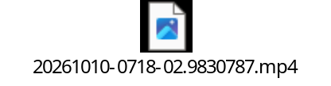
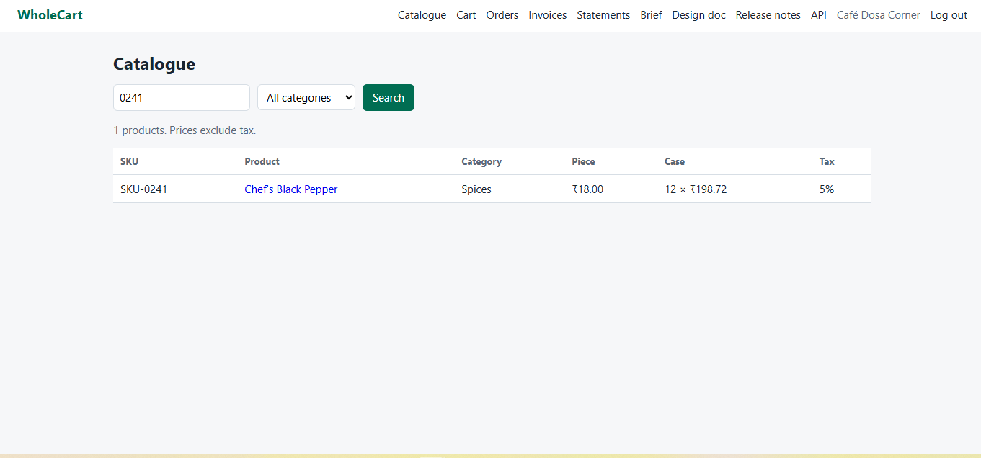
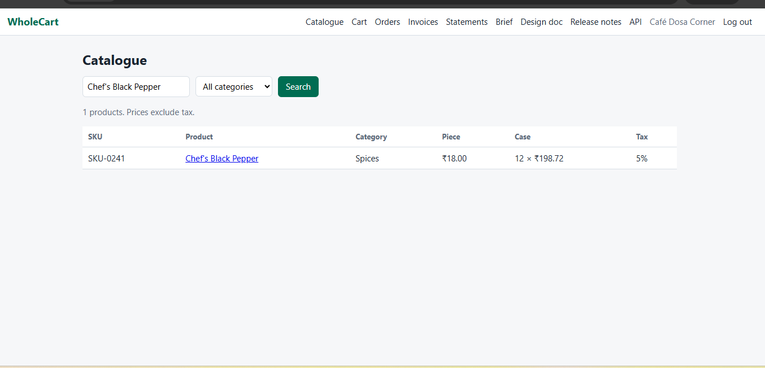
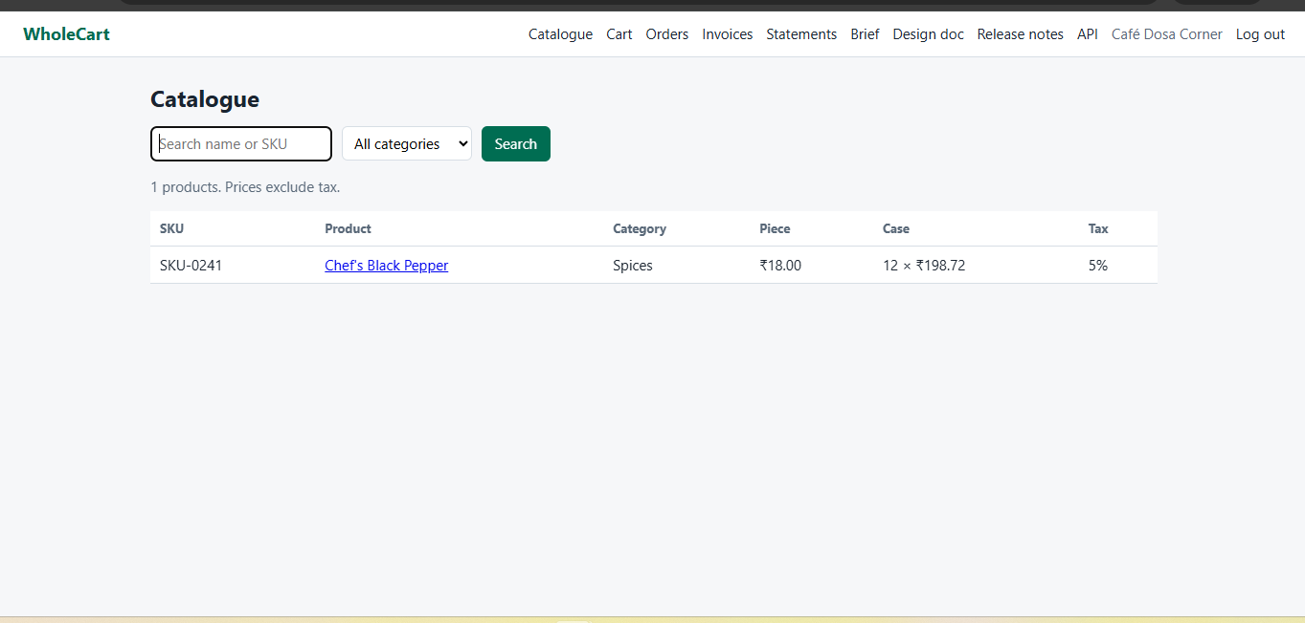

Bug #2: SKU Search Ignores the Selected Category Filter
Defect ID | WC-DEF-002
Module | Catalogue / Search / Category Filter
Severity | Major (Provisional)
Priority | P1 (Provisional)
Preconditions | • User is logged in and the product catalogue is available.  • Products exist in at least two categories, such as Grains and Spices.  • The SKU of a product belonging to Spices is known.
Steps to Reproduce:
1. Open the WholeCart product catalogue.
2. Select the Grains category.
3. Enter the SKU of a product belonging to Spices.
4. Click Search.
5. Observe the returned products and their categories.
Expected Result: Search results should respect both the selected category and the SKU. A Spices product should not appear while the Grains category is selected.
Actual Result: The product matching the Spices SKU appears even though the selected category is Grains.
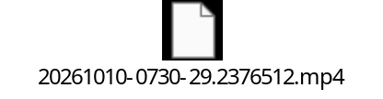

Bug #3: Invoice Date Is Later Than Delivery Date
Defect ID | BUG-001
Module | Order Management / Invoice
Severity | Medium
Status | Needs verification
Preconditions | • Order ID: WC-01005-1  • Order placed: October 1, 2026, at 02:16:34  • Delivery scheduled: October 1, 2026, 11:00–14:00  • Order status: Delivered  • Invoice ID: INV-00005  • Invoice date: October 2, 2026
Steps to Reproduce:
1. Open order WC-01005-1.
2. Verify the delivery date and delivered status.
3. Click the invoice link.
4. Check the invoice date.
5. Compare it against the delivery date and the invoice-generation policy.
Expected Result: If the business rule requires invoicing on or before delivery, the invoice date must not be later than October 1, 2026.
Actual Result: The invoice date is October 2, 2026, one calendar day after the scheduled delivery date.
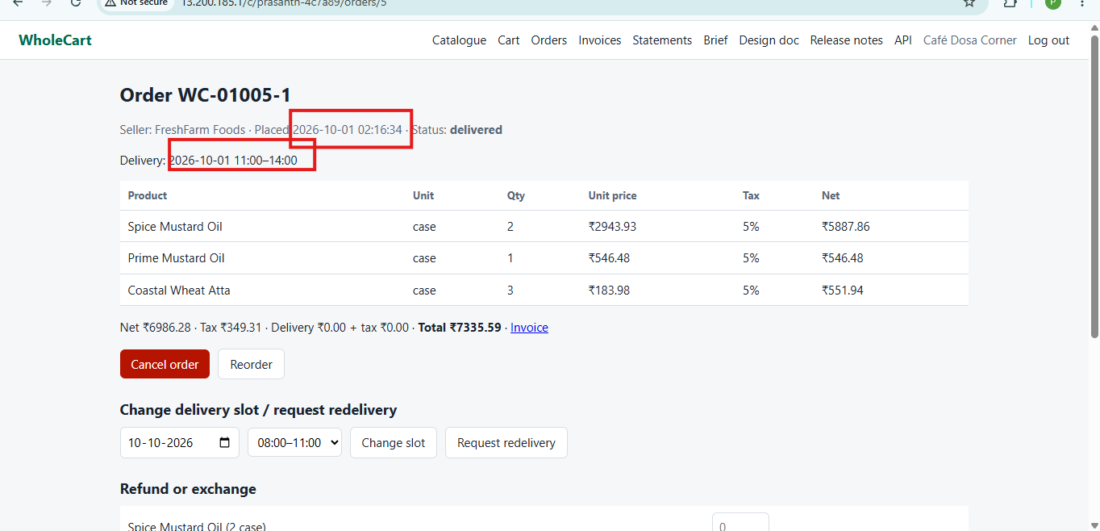

Bug #4: Delivery Rescheduling Option Is Available for a Delivered Order
Defect ID | BUG-002
Module | Order Management / Delivery
Severity | Medium
Status | Needs verification
Preconditions | • Order ID: WC-01005-1  • Order status: Delivered  • Original delivery date: October 1, 2026  • The interface displays a new delivery slot for October 10, 2026, from 08:00–11:00.  • The interface shows 'Change slot' and 'Request redelivery' options.
Steps to Reproduce:
1. Open order WC-01005-1.
2. Verify that its status is Delivered.
3. Locate the delivery slot controls.
4. Select October 10, 2026, and 08:00–11:00.
5. Click Change slot.
6. Observe whether the application changes the original delivery schedule, creates a redelivery request, or rejects the action.
7. Repeat in a test environment using Request redelivery, if appropriate.
Expected Result: The application should enforce the defined workflow for delivered orders. If ordinary rescheduling is prohibited after delivery, Change slot should be disabled or rejected. If redelivery is supported, the system should create a separate redelivery request with appropriate status/confirmation.
Actual Result: The supplied order screen displays delivery slot controls even though the order is marked Delivered. Whether these controls permit an invalid action has not yet been established.
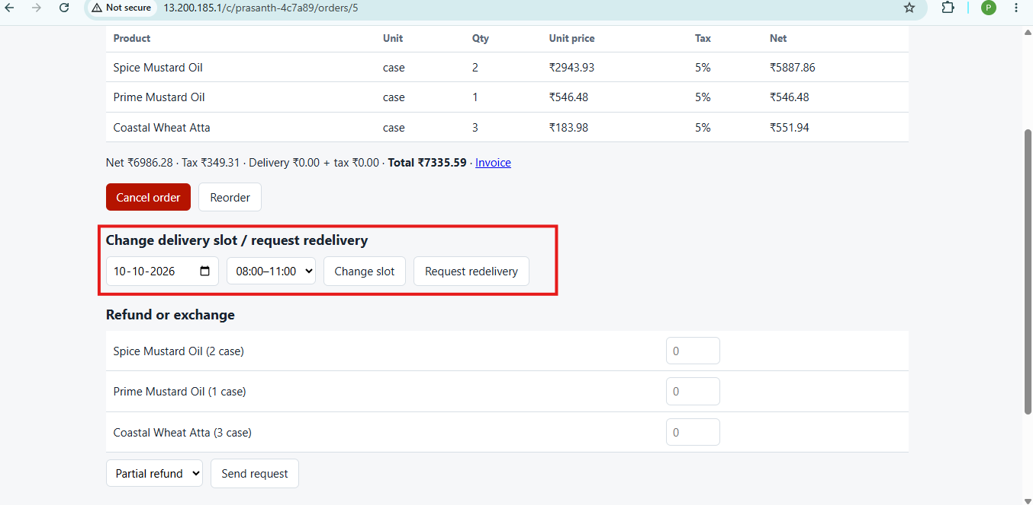

Bug #5: Delivery Slots Are Not Displayed When Clicking 'Show Slots' Button
Defect ID | WC-DEF-003
Module | Checkout / Delivery Options
Severity | Major (if slot selection is mandatory for checkout)
Priority | High
Preconditions | • User has added products from multiple sellers to the cart (e.g., WholeCart Direct and Coastal Beverages).  • User has navigated to the Checkout page.  • Same-day afternoon delivery is expected to be available when the order is placed before 10:00 AM.
Steps to Reproduce:
1. Log in to the WholeCart application.
2. Add products from WholeCart Direct and Coastal Beverages to the cart.
3. Navigate to the Checkout page.
4. Locate the Delivery Date and 'Show slots' option.
5. Click 'Show slots'.
6. Observe whether the available delivery time slots are displayed.
Expected Result: Clicking 'Show slots' should display the available delivery slots for the selected delivery date. If the order meets the same-day delivery cutoff time, eligible afternoon and evening slots should be selectable.
Actual Result: Clicking 'Show slots' does not display the delivery slots, preventing the user from selecting a delivery time.
