===============================================================================
INSTALL PYTHON PACKAGE
===============================================================================
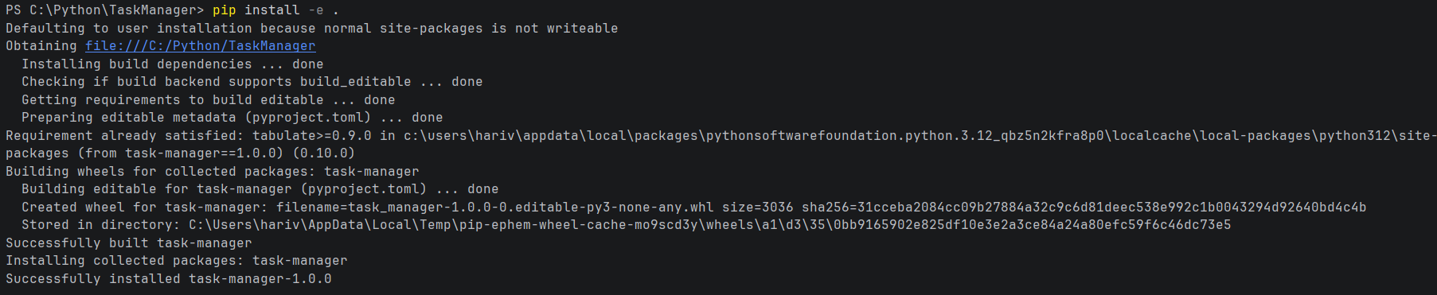

===============================================================================
USAGE
===============================================================================
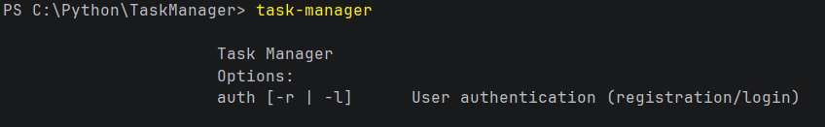

===============================================================================
New User Registration
===============================================================================
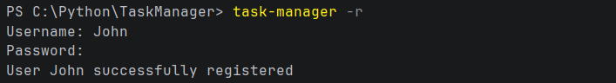

===============================================================================
Login
===============================================================================
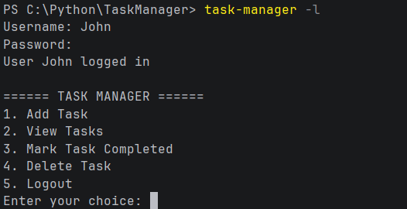

===============================================================================
Add Tasks
===============================================================================
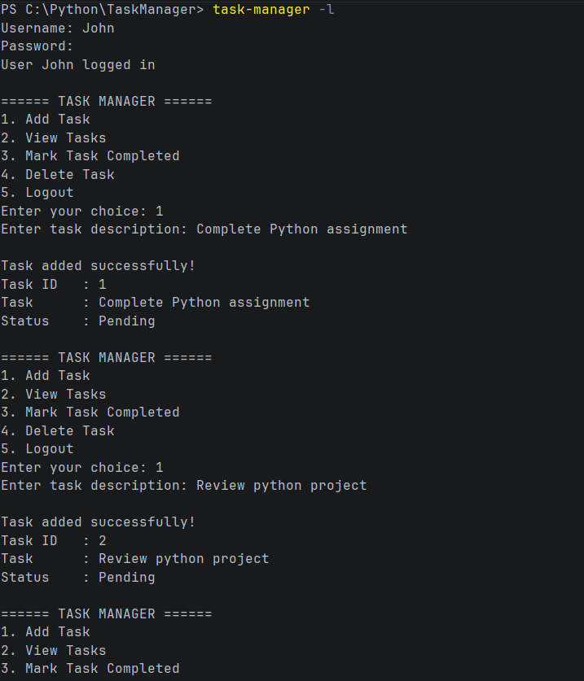

===============================================================================
View Tasks
===============================================================================
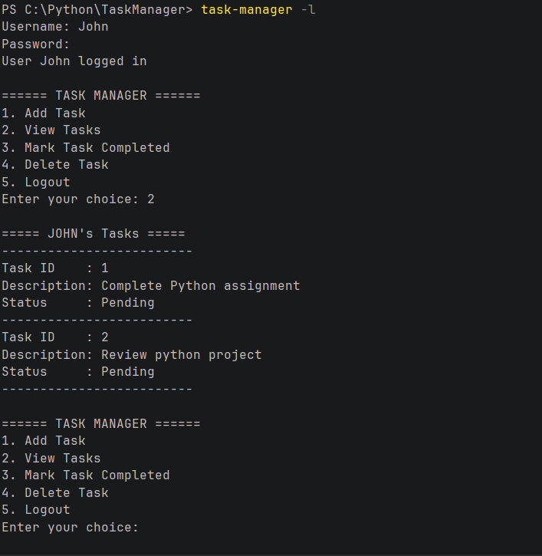

===============================================================================
Mark Tasks as completed
===============================================================================
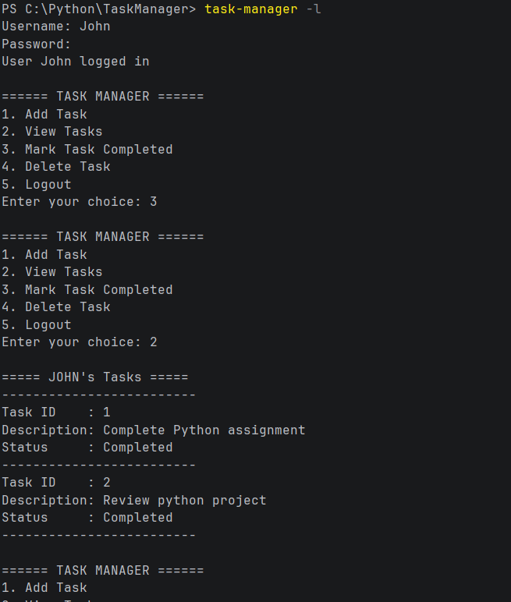

===============================================================================
Delete Task
===============================================================================
