===============================================================================
INSTALL PYTHON PACKAGE
===============================================================================
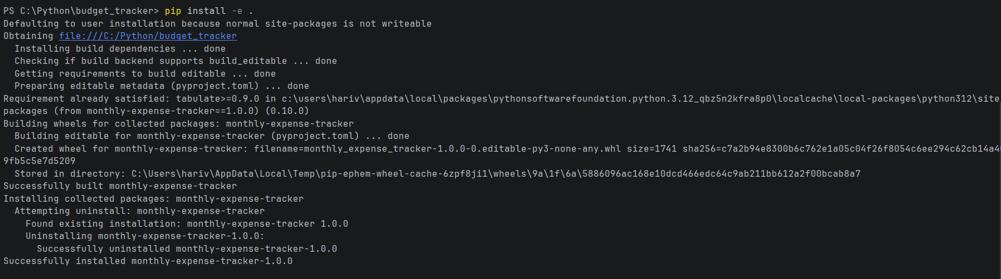

===============================================================================
USAGE
===============================================================================
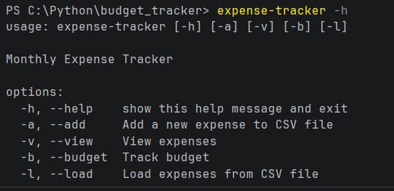

===============================================================================
ADD EXPENSES
===============================================================================
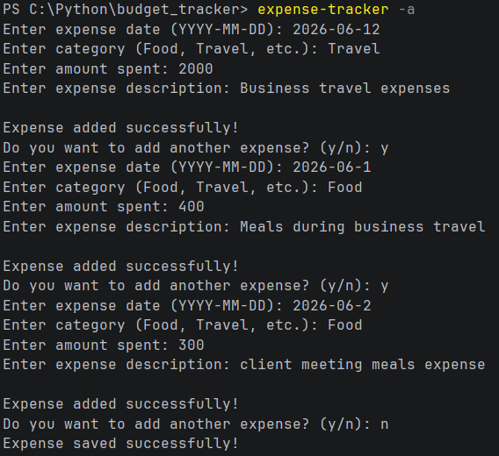

===============================================================================
VIEW EXPENSES
===============================================================================
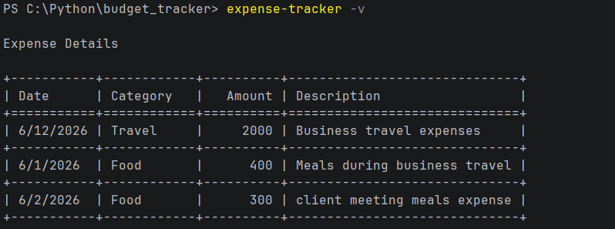
===============================================================================
LOAD EXPENSES TO CSV FILE
===============================================================================
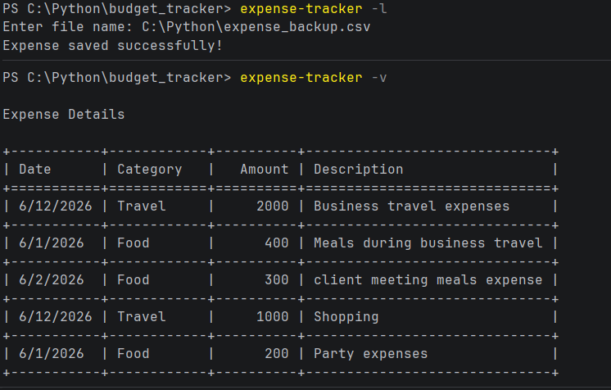

===============================================================================
SET AND TRACK BUDGET
===============================================================================
