Exercise 1: Configuring a Basic Spring Application

Scenario:

Your company is developing a web application for managing a library. You need to use the Spring Framework to handle the backend operations.

1. Create a Maven Project.
2. XML Configuration.

Example :

<?xml version="1.0" encoding="UTF-8"?>

<beans xmlns="http://www.springframework.org/schema/beans"

xmlns:xsi="http://www.w3.org/2001/XMLSchema-instance"

xsi:schemaLocation="

http://www.springframework.org/schema/beans

http://www.springframework.org/schema/beans/spring-beans.xsd">

<!-- Define the repository bean -->

<bean id="bookRepository" class="com.library.repository.BookRepository" />

<!-- Define the service bean and inject repository -->

<bean id="bookService" class="com.library.service.BookService">

<property name="bookRepository" ref="bookRepository"/>

</bean>

</beans>

1. Define Service and Repository Classes

package com.library.repository;

public class BookRepository {

public void fetchBooks() {

System.out.println("📚 Fetching list of books from the database...");

}

}

Example –

package com.library.service;

import com.library.repository.BookRepository;

public class BookService {

private BookRepository bookRepository;

public void setBookRepository(BookRepository bookRepository) {

this.bookRepository = bookRepository;

}

public void listBooks() {

System.out.println("📖 BookService: Listing all books...");

bookRepository.fetchBooks();

}

}

1. Main Class to Run the Application

package com.library;

import com.library.service.BookService;

import org.springframework.context.ApplicationContext;

import org.springframework.context.support.ClassPathXmlApplicationContext;

public class LibraryManagementApplication {

public static void main(String[] args) {

ApplicationContext context = new ClassPathXmlApplicationContext("applicationContext.xml");

BookService service = context.getBean("bookService", BookService.class);

service.listBooks();

}

}

OUTPUT :

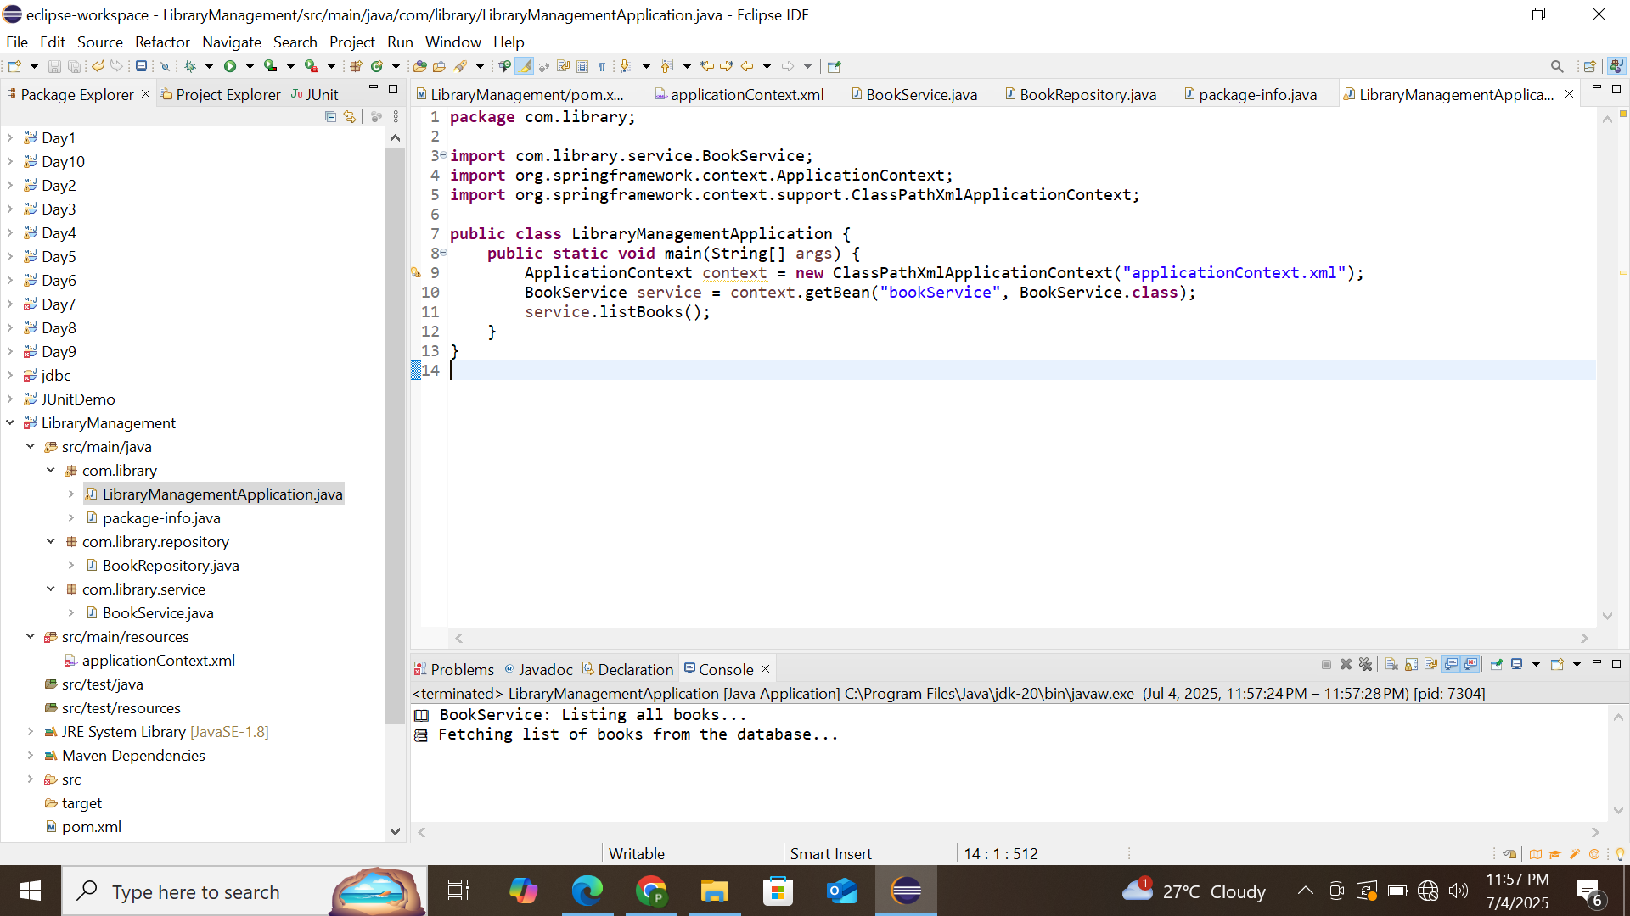

Exercise 2: Implementing Dependency Injection

Scenario:

In the library management application, you need to manage the dependencies between the BookService and BookRepository classes using Spring's IoC and DI.

1. Update applicationContext.xml

<?xml version="1.0" encoding="UTF-8"?>

<beans xmlns="http://www.springframework.org/schema/beans"

xmlns:xsi="http://www.w3.org/2001/XMLSchema-instance"

xsi:schemaLocation="

http://www.springframework.org/schema/beans

http://www.springframework.org/schema/beans/spring-beans.xsd">

<!-- Define BookRepository Bean -->

<bean id="bookRepository" class="com.library.repository.BookRepository" />

<!-- Define BookService Bean and inject BookRepository -->

<bean id="bookService" class="com.library.service.BookService">

<property name="bookRepository" ref="bookRepository"/>

</bean>

</beans>

1. Update BookService.java

package com.library.service;

import com.library.repository.BookRepository;

public class BookService {

private BookRepository bookRepository;

public void setBookRepository(BookRepository bookRepository) {

this.bookRepository = bookRepository;

}

public void listBooks() {

System.out.println("📖 BookService: Listing all books...");

bookRepository.fetchBooks();

}

}

1. Keep BookRepository.java Simple

package com.library.repository;

public class BookRepository {

public void fetchBooks() {

System.out.println("📚 Fetching books from the repository...");

}

}

1. Run LibraryManagementApplication.java

package com.library;

import com.library.service.BookService;

import org.springframework.context.ApplicationContext;

import org.springframework.context.support.ClassPathXmlApplicationContext;

public class LibraryManagementApplication {

public static void main(String[] args) {

ApplicationContext context = new ClassPathXmlApplicationContext("applicationContext.xml");

BookService bookService = context.getBean("bookService", BookService.class);

bookService.listBooks();

}

}

OUTPUT :

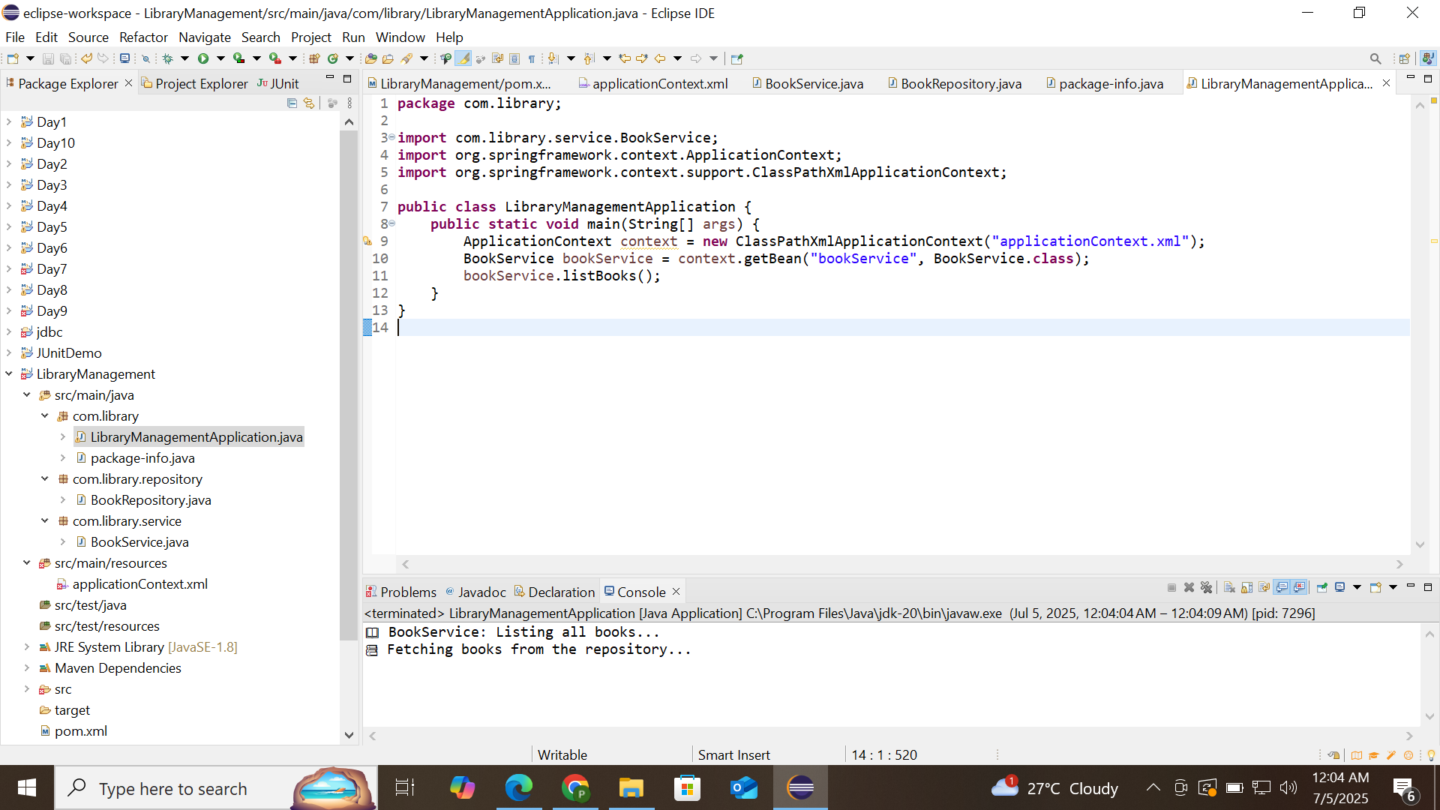

Exercise 4: Creating and Configuring a Maven Project

Scenario:

You need to set up a new Maven project for the library management application and add Spring dependencies.

OUTPUT:

