# Bradley University

# BUSINESS INTELLIGENCE SYSTEMS

# CS591 Course Project

# Submitted by

# Prasanthi Putta

# Team: 03

# 05/06/2020

Table of Contents

1. INTRODUCTION 3

1.1. BUSINESS INTELLIGENCE ARCHITECTURE 3

2. ANALYZED SOFTWARE SYSTEMS 4

3. SCOPE 5

3.1. FUNCTIONAL REQUIREMENTS 6

3.2. NON - FUNCTIONAL REQUIREMENTS 6

3.3. TECHNICAL SPECIFICATIONS 6

4. SOFTWARE DESIGN AND DEVELOPMENT MODEL 6

4.1. INCREMENTAL METHODOLOGY 6

5. PROJECT COST ESTIMATES 7

5.1. LINES OF CODE (LOC) BASED ESTIMATION: 7

5.2. FUNCTION POINT (FP) BASED ESTIMATION: 8

6. HUMAN RESOURCE MANAGEMENT PLAN 9

7. TIME MANAGEMENT PLAN 11

8. COST MANAGEMENT PLAN 14

9. RISK MANAGEMENT PLAN 15

9.1. RISK EXPOSURE TABLE: 16

9.2. DECISION TREE ANALYSIS: 16

9.3. PROBABILITY/IMPACT MATRIX: 17

9.4. RISK REGISTER 17

10. PROCUREMENT MANAGEMENT PLAN 22

10.1. MAKE OR BUY ANALYSIS: 22

10.2. TYPE OF CONTRACT TO USE CALCULATIONS: 22

10.3. COST PLUS INCENTIVE FEE 23

11. STATEMENT OF WORK 23

11.1. REQUEST FOR PROPOSAL 25

11.2. REQUEST FOR QUOTE 26

CONCLUSION 27

REFERENCES: 27

**Table of Figures**

**Figure 1: BI INCREMENTAL PROCESS** 7

**Figure 2: WBS STRUCTURE** 9

**Figure 3:WBS STRUCTURE 1** 10

**Figure 4: TIME MANAGEMENT PLAN 1** 11

**Figure 5: TIME MANAGEMENT PLAN 1** 12

**Figure 6: GANTT CHART DIAGRAM WITH CRITI 1** 13

**Figure 7: GANTT CHART DIAGRAM WITH CRITI** 13

**Figure 8: COST MANAGEMENT PLAN 1** 14

**Figure 9: DECISION TREE ANALYSIS 1** 16

**Figure 10: DURATION (VS) TOTAL COST (VS) 1** 20

**Figure 11: DURATION (VS) CASE # 1** 20

**Figure 12: RISK FACTOR (VS) CASE # 1** 21

**Figure 13: TOTAL COST (VS) CASE # 1** 21

**Figure 14: MAKE OR BUY ANALYSIS 1** 22

# INTRODUCTION

* Business intelligence (BI) is a set of technologies and processes that allow people at all levels of an organization to access and analyze data.
* Business performance is measured by a number of financial indicators, such as revenue, margin, profitability, cost to serve, and so on.
* A key sign of successful business intelligence is the degree to which it impacts business performance, linking insight to action.

# BUSINESS INTELLIGENCE ARCHITECTURE

* BI often involves analyzing summary data and combining data from multiple operational systems. To facilitate this, data will be extracted from the operational systems and loaded into a data warehouse, as shown in the figure.

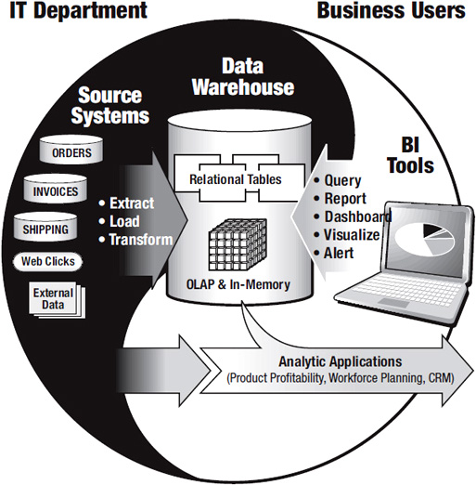

* This process is referred to as *extract, transform, and load* (ETL). More recently, some data warehouse teams have changed the order in which they do certain things and call it ELT (extract, load, transform).
* The “transform” process of ETL is often the most time-consuming, particularly when multiple disparate systems are involved.
* A data warehouse is the collection of data *extracted* from various operational systems, *loaded* into an operational data store or staging area, then *transformed* to make the data consistent and optimized for analysis.
* To ensure the BI architecture meets the business requirements:
  + Business users should have a working understanding of the technical issues, components, and terminology that affect their requirements and ability to access data.
  + IT personnel should minimize techno babble and avoid overemphasizing the technical architecture for technology’s sake.
  + An analytic ecosystem might include traditional relational databases, analytic appliances, and NoSQL solutions that balance cost, complexity, and analytic capabilities with data and user scalability.

# ANALYZED SOFTWARE SYSTEMS

|  |  |  |  |  |  |
| --- | --- | --- | --- | --- | --- |
| BI Tool | JasperReports | Pentaho | BIRT | Apache Superset | Redash |
| Scope | JasperReports Server offers web-based reporting, analytic tools and visualization, and a dashboard feature for compiling multiple custom views. | The scope of the Pentaho BI suite is vast supporting all kinds of data and data sources that furnish limitless visualization options. | The BIRT Project will focus on leveraging the Eclipse platform to provide infrastructure and tools for the designing, deploying, generating and viewing of reports in an organization, including ad hoc query and reporting tools. | Superset is a data exploration platform designed to be visual, intuitive and interactive. It’s main goal is to make it easy to slice, dice and visualize data. | Redash helps users connect and query data sources, visualize data, build dashboards, and share insights with the rest of their organization. |
| Main Functions | * Flexible, Modern, and Embeddable Server Architecture * Centralized Reporting, Dashboards, and Data Analytics * Secured Data Access and Auditing * Ad Hoc Report and Dashboard Development * OLAP Analysis | * High-end data analysis through well-defined ETL capabilities * Expertise in products across varied domains * Comprehensive report designer taking care of business needs * Exceptional data source accommodability with high runtime metadata support | * Build reports on XML data sources * Used to build reusable component report libraries * Allows run time modification of Data Source and Data Set public properties | * A lightweight semantic layer, allowing to control how data sources are exposed to the user by defining dimensions and metrics * Configurable caching options for loading dashboards * Maps and geo support leveraging Mapbox * User profile pages which highlight a user’s favorite dashboards/slices. | * Quick editor * Combine several visualizations * Collaboration * Alerts * Query |
| Programming languages | JAVA, XML, JavaScript | JAVA, XML, XSL Transformation, JavaScript, HTML | JAVA, XML, HTML, CSS | Python, JavaScript, Typescript, HTML | Python, JavaScript, CSS, HTML |
| Lines of Code | 529,644 | 793,870‬ | 2,362,446 | 71,751 | 40,364 |
| Technical Platform | * OS:Windows, Linux, Mac OS, iOS, Android * Application Servers: Apache Tomcat, JBoss, WildFly * Database Repositories: MySQL | * OS:Windows, Ubuntu * Application Servers:Apache Tomcat, JBoss * Database Repositories: MySQL, Oracle, PostgreSQL, MS SQL | * OS:Windows, Linux * Application Servers:Apache Tomcat, IBM WebSphere, JBoss, WildFly * Database Repositories: MySQL, Oracle, PostgreSQL, MS SQL, IBM DB2 | * OS:Windows, Ubuntu, Mac OS * Application Servers: Gunicorn, Nginx, Apache * Database Repositories: Amazon Redshift, Apache Hive, Teradata, MySQL, Oracle, PostgreSQL, MS SQL, IBM DB2 | * OS:Windows, Linux * Database Repositories: PostgreSQL, MySQL, Redshift, MongoDB |
| Trail Version Website | <https://community.jaspersoft.com/download> | <http://www.pentaho.com/download> | <https://download.eclipse.org/birt/downloads/> | <https://superset.apache.org/installation.html> | <https://redash.io/help/open-source/setup> |

# SCOPE

* BI is all about how to capture, access, understand, analyze and turn one of the most valuable assets of an enterprise –raw data– into actionable information in order to improve business performance.

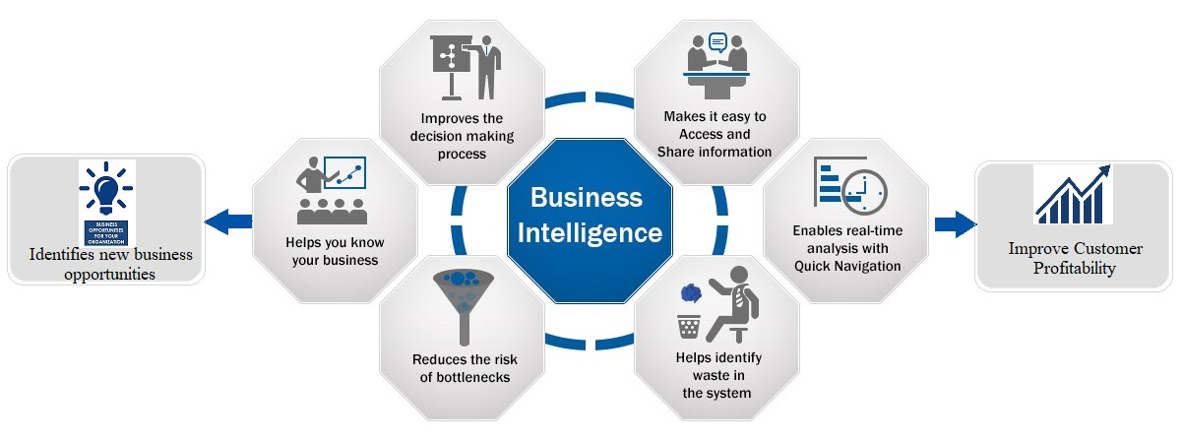

## FUNCTIONAL REQUIREMENTS

* Platform Functions
* Data Visualization
* Analytics
* Online Analytical Processing (OLAP)
* Document Management
* Decision Services
* Integrations
* Big Data Integration
* Deployment

## NON - FUNCTIONAL REQUIREMENTS

* Performance
* Security
* Availability
* Usability
* Data Integrity
* Scalability

## TECHNICAL SPECIFICATIONS

* Operation Systems: Windows, Linux
* Application Server: Apache
* Database Repositories: Microsoft SQL Server, Oracle
* Programming Languages: Python, JavaScript, HTML, CSS

# SOFTWARE DESIGN AND DEVELOPMENT MODEL

Incremental Methodology has been chosen to develop this project.

* 1. INCREMENTAL METHODOLOGY:
* In the incremental model the requirements are divided into subsets. The model involves multiple development cycles, which makes the life cycle look like a “multiple waterfall” model. The cycles are again divided into smaller cycles, modules easier to manage. Each module goes through requirement analysis, design, implementation and testing. During the first module, a working version of the software is created. Each following version adds new features and functionalities to the previous one. The process continues until the system is completed.
* This model is used for the following cases:
  + Most of the requirements are known up-front but are expected to evolve over time.
  + Each release delivers an operational product and Initial product delivery is faster.
  + Customer can respond to every build.

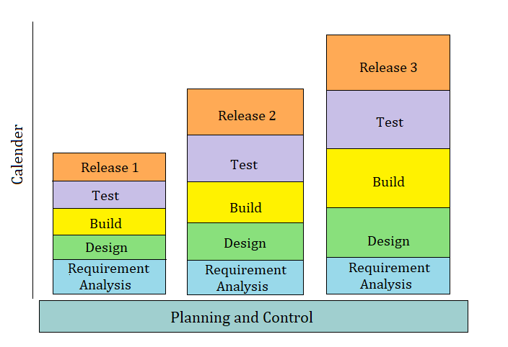

**Figure 1: BI INCREMENTAL PROCESS**

# PROJECT COST ESTIMATES

## LINES OF CODE (LOC) BASED ESTIMATION:

|  |  |  |  |
| --- | --- | --- | --- |
| **Function** | **Pages(P)** | **Lines of code per Page (LOCP)** | **Total Lines Of Code (TLOCF)** |
| User Interface for Static Pages | 62 | 81 | 5022 |
| User Interface for Dynamic Pages | 89 | 154 | 13706 |
| Code behind for Static Pages | 67 | 95 | 6365 |
| Code behind Dynamic Pages | 98 | 162 | 15876 |
| Data Base –SQL Stored Procedures | 64 | 144 | 9216 |
| Business layer- Logical Pages | 86 | 125 | 10750 |
| Other Layer-Logical Pages | 75 | 120 | 9000 |
| **Total(TLOC):** | | | 69,935 |
| **Total Project Cost(TPC) in $:** | | | 1,118,960 |

**Estimating $16 per line of code, Total Project Cost = 69,935 * 16 = $1,118,960**

## FUNCTION POINT (FP) BASED ESTIMATION:

|  |  |  |  |  |  |  |  |
| --- | --- | --- | --- | --- | --- | --- | --- |
| **Complexity Calculation** | | | | | | | |
| Category | Low | Weight_L | Average | Weight_A | High | Weight_H | **Total (T)** |
| User inputs | 27 | 4 | 14 | 6 | 7 | 3 | 250 |
| User outputs | 25 | 4 | 12 | 5 | 6 | 4 | 210 |
| User inquires | 23 | 2 | 11 | 6 | 5 | 5 | 219 |
| File/Structures | 26 | 8 | 12 | 9 | 5 | 7 | 396 |
| External Interface | 18 | 7 | 9 | 9 | 4 | 7 | 242 |
|  | | | | | | | 1120 |
| **Unadjusted Total (UT):** | | | | | | |
|  | | | | | | |

Total Functional points = 1120

Average Cost per functional point is 1000

Estimated Project Cost = 1120* 1000 = $1,120,000‬

# HUMAN RESOURCE MANAGEMENT PLAN

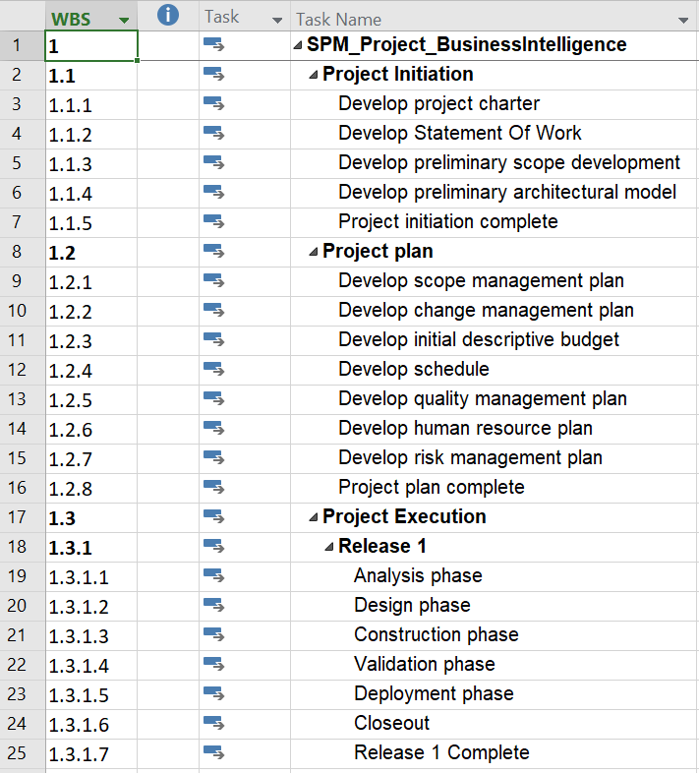

**Figure 2: WBS STRUCTURE**

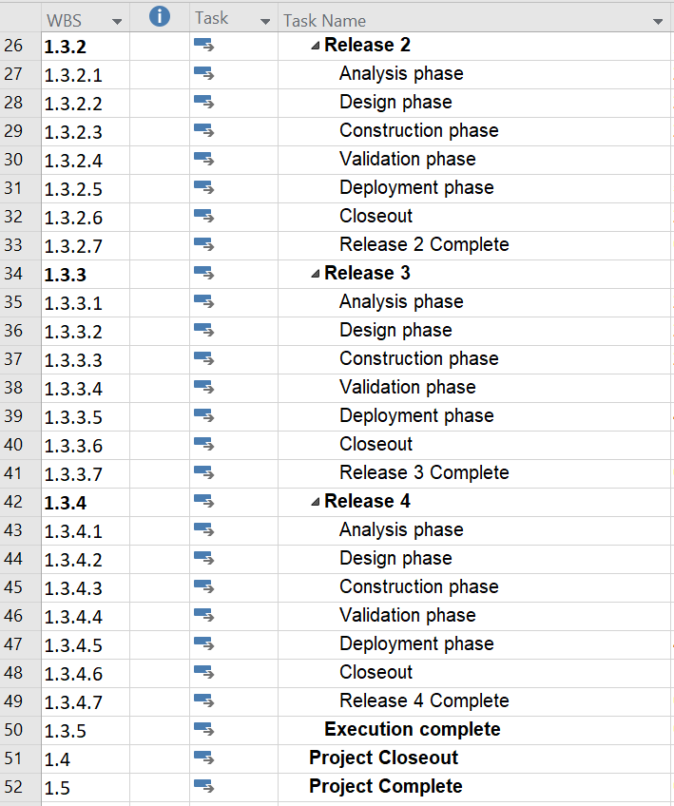

**Figure 3:WBS STRUCTURE 1**

# TIME MANAGEMENT PLAN

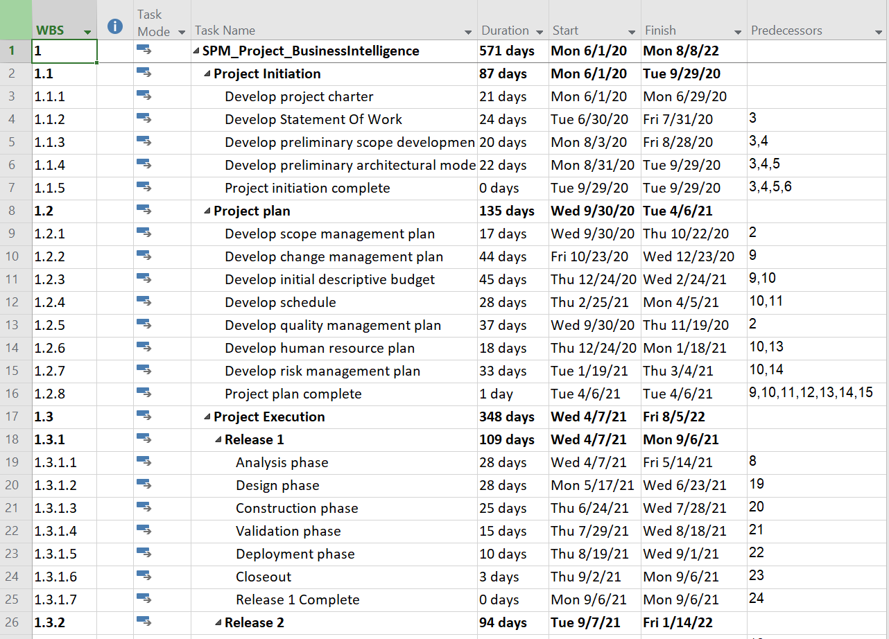

**Figure 4: TIME MANAGEMENT PLAN 1**

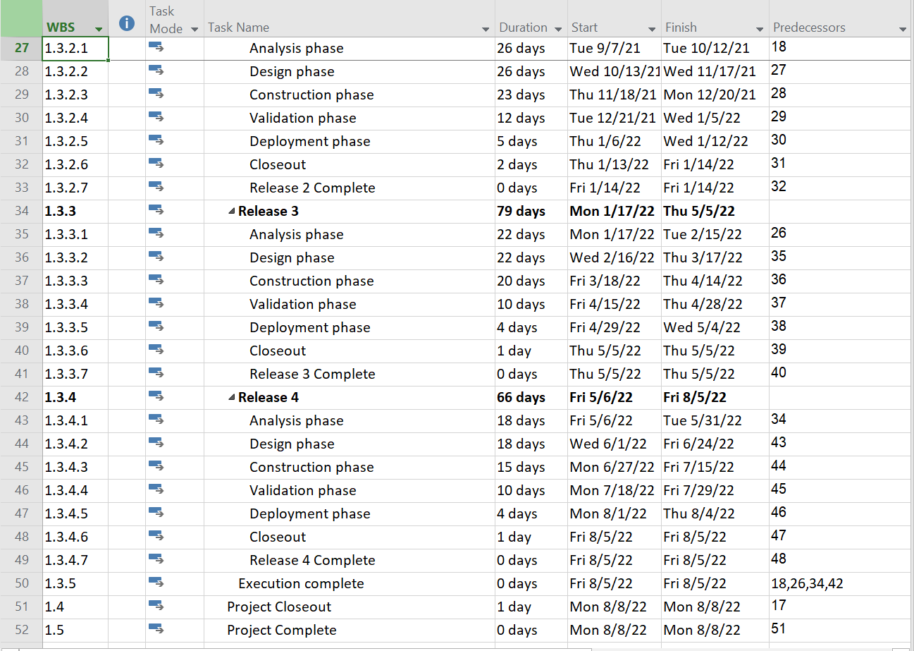

**Figure 5: TIME MANAGEMENT PLAN 1**

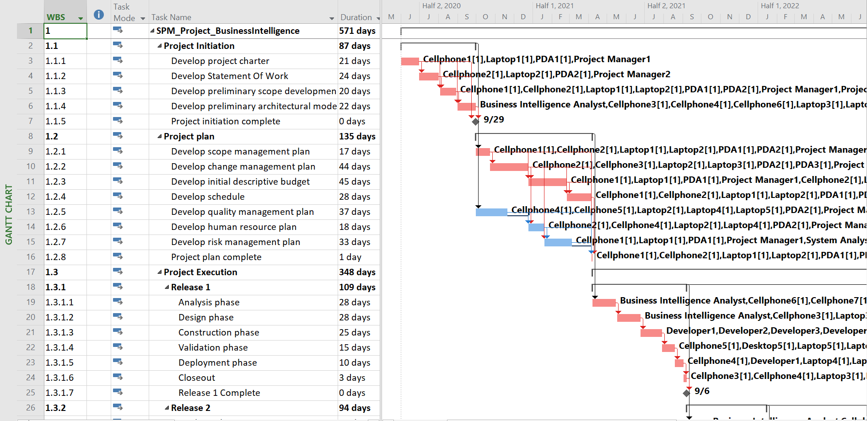

**Figure 6: GANTT CHART DIAGRAM WITH CRITI 1**

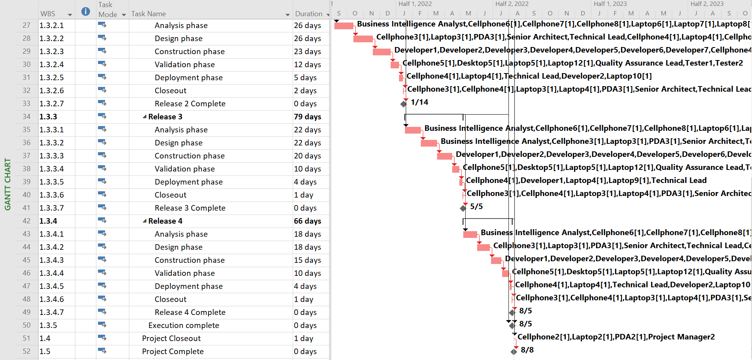

**Figure 7: GANTT CHART DIAGRAM WITH CRITI**

|  |  |  |  |
| --- | --- | --- | --- |
| Phases | Start Date | Final Date | Duration(Days) |
| 1.1 Project Initiation | 06/01/2020 | 09/29/2020 | 87 |
| 1.2 Project Plan | 09/30/2020 | 04/06/2021 | 135 |
| 1.3.1 Release 1 | 04/07/2021 | 09/06/2021 | 109 |
| 1.3.2 Release 2 | 09/07/2021 | 01/14/2022 | 94 |
| 1.3.3 Release 3 | 01/17/2022 | 05/05/2022 | 79 |
| 1.3.4 Release 4 | 05/06/2022 | 08/05/2022 | 66 |
| Overall Project | 06/01/2020 | 08/08/2022 | 571 |

Total Project time = 571 days

# COST MANAGEMENT PLAN

|  |  |  |  |
| --- | --- | --- | --- |
| **Phases** | **Total Project Cost($)** | **Actual Cost($)** | **Remaining Cost($)** |
| **1.1 Project Initiation** | **$100,355.28** | **$100,355.28** | **$0.00** |
| **1.2 Project Plan** | **$225,865.04** | **$225,865.04** | **$0.00** |
| **1.3.1 Release 1** | **$232,265.44** | **$29124.09** | **$203,141.35** |
| **1.3.2 Release 2** | **$212,157.20** | **$0.00** | **$212,157.20** |
| **1.3.3 Release 3** | **$186,392.24** | **$0.00** | **$186,392.24** |
| **1.3.4 Release 4** | **$159,138.24** | **$0.00** | **$159,138.24** |
| **Overall Project** | **$1,120,218.88** | **$355,344.41** | **$764,874.47** |

**Figure 8: COST MANAGEMENT PLAN 1**

**Total Project cost = $1,120,218.8**

# RISK MANAGEMENT PLAN

|  |  |  |
| --- | --- | --- |
| Risk No. | Risk | Risk Description |
| 1 | Scope Creep | One of the greatest threats to a successful Business Intelligence project is scope creep. “Scope creep” simply as having a project scope that increases in size due to initially unintended or unanticipated changes to requirements and expectations. |
| 2 | Polluted Data | In most cases, polluted data is a result of errors or problems in the production system that registers and stores the data: the data entered is not sufficiently monitored and validated. Because of polluted data, the ETL process becomes much more complex and more difficult to maintain. |
| 3 | Data without context | If we have large amounts of data at our disposal but we do not know the meaning (or context), then we have a major problem. If the data and its structure and meaning is not clearly described – metadata -, we cannot determine what we want to measure and modeling the data in the data warehouse coherently is even more problematical. The better the data is described, the faster we can implement BI projects. |
| 4 | Large Volumes of data | Large amounts of data can form a barrier when we start using Business Intelligence. The production systems of larger organizations often deal with very large volumes of data (hundreds of millions) on a daily basis. Additionally, large volumes of data may cause delays during the development and testing of the BI system. |
| 5 | Absence of data | If an organization does not register the signals that are important for effective business operations, then the senses of that organization malfunction. If this is the case, the organization must return to previous steps in the major Business Intelligence cycle in order to record the required signals in their source system. |
| 6 | The complexity of ETL | Extracting and integrating data from different source systems is difficult. According to a renowned research institute, ETL takes up 70 to 80 percent of the total (technical) costs involved with building a BI system. |
| 7 | The technology push | The IT department forces a data warehouse and BI technology onto the organization without taking into account the wishes and requirements of users and without properly aligning technology and information needs. |

## RISK EXPOSURE TABLE:

|  |  |  |  |
| --- | --- | --- | --- |
| **Risk No.** | **Risk Probability (RP)** | **Risk Impact (RI)** | **Risk Exposure (RP * RI)** |
| 1 | Medium (0.5) | High (0.9) | 0.45 |
| 2 | Medium Low (0.3) | Medium (0.5) | 0.15 |
| 3 | Medium Low (0.3) | Medium Low (0.3) | 0.09 |
| 4 | Medium (0.5) | Medium High (0.7) | 0.35 |
| 5 | Low (0.1) | Medium (0.5) | 0.05 |
| 6 | Medium high(0.7) | High (0.8) | 0.5 |
| 7 | Low (0.1) | Medium Low (0.3) | 0.03 |
|  | | | 1.68 |
| Total Risk Adjustment Factor | | |
|  | | |

## DECISION TREE ANALYSIS:

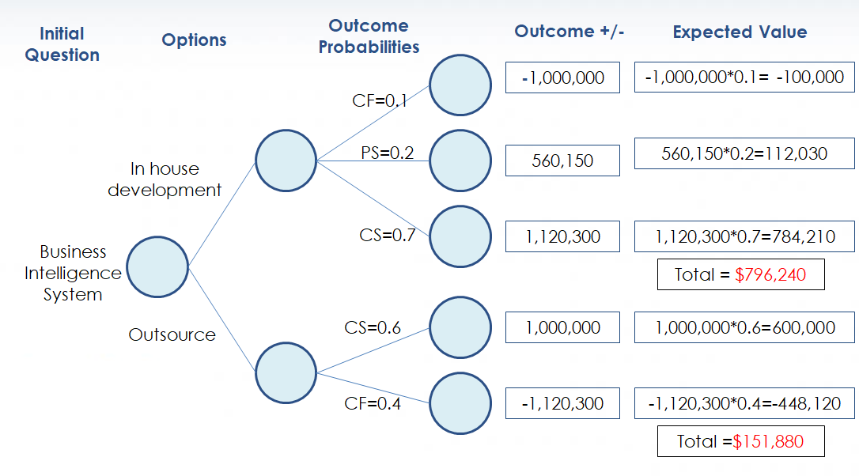

**Figure 9: DECISION TREE ANALYSIS 1**

## PROBABILITY/IMPACT MATRIX:

|  |  |  |  |  |  |
| --- | --- | --- | --- | --- | --- |
| Impact   Probability | Low | Low Medium | Medium | Medium High | High |
| Low |  | 7 | 5 |  |  |
| Low Medium |  | 3 | 2 |  |  |
| Medium |  |  |  | 4 | 1 |
| Medium High |  |  |  |  | 6 |
| High |  |  |  |  |  |

## RISK REGISTER

|  |  |  |  |  |  |  |
| --- | --- | --- | --- | --- | --- | --- |
| Risk No. | Risk | Trigger Event | Responsible | Consequence | Probability | Mitigation |
| 1 | Scope Creep | Client may be under pressure with a competitor and hence would like to introduce additional features/functionalities | Project Manger1 and Project Manager2 | * Scope screep has negative impact on a project as the project may be derailed in terms of timelines and may overshoot budget. * Leads to financial loss in case a project gets cancelled. * Leads to lot of rework as the scope keeps changing. | Medium | * Understand Project Scope * Document requirements exhaustively * Educate the client about the change control procedures * Trace the Requirements |
| 4 | Large Volumes of data | The production systems of larger organizations often deal with very large volumes of data (hundreds of millions) on a daily basis. | Team | * Low Performance * Pushes the limit of BI Capacity | Medium | * Incremental loading * Leaving out metadata that is already known * Compressing data * Widening the frame within which the processing can take place |
| 6 | The Complexity of ETL | Due to aspects such as (poor) quality of source data, large amounts of data or so-called ‘back-dated transactions’ | Team | * ETL takes up 70 to 80 percent of the total (technical) costs involved with building a BI system. | Medium High | * Deploying an ETL tool * Balanced architecture * Collaborate with administrators of source systems |

* 1. **COMPARISON TABLE:**

|  |  |  |  |  |  |
| --- | --- | --- | --- | --- | --- |
| Case # | Project Total Cost | Risk Factor | Duration (Days) | Probability | Expected Value |
|  | (Data will be obtained during Lab 3) | (Data must be calculated before the Lab 3) | (Data will be obtained during Lab 3) | (Data will be given by Instructor before Lab 3) | (Data will be calculated during Lab 3) |
| 0 | $1,120,218.88 | 1.62 | 571 |  |  |
| 1 (Remove 1 expert (8-9 yrs exp) - 1SA) | $1,091,922.56 | 1.90 | 640 | Partial Failure (35%) | ($9,903.71) |
| 2 (Remove 2 experts(8-9 yrs exp) 1SA, 1 Devloper) | $1,084,602.03 | 2.20 | 650.38 | Complete Failure (30%) | ($10,685.06) |
| 3 (add experts - 1developer) | $1,129,994.38 | 0.94 | 562.7 | Complete Success (15%) | $1,466.33 |
| 4(add 1 expert and 1 beginner - 2 developers) | $1,130,473.19 | 1.28 | 555.91 | Partial Success (20%) | $2,050.86 |
|  |  |  |  | EMV | ($17,071.58) |
|  |  |  |  | Total EMV | $1,103,147.30 |
|  |  |  |  | Conclusion | So, from a risk perspective, this project is worth doing. |

**Figure 10: DURATION (VS) TOTAL COST (VS) 1**

**Figure 11: DURATION (VS) CASE # 1**

**Figure 12: RISK FACTOR (VS) CASE # 1**

**Figure 13: TOTAL COST (VS) CASE # 1**

# PROCUREMENT MANAGEMENT PLAN

## MAKE OR BUY ANALYSIS:

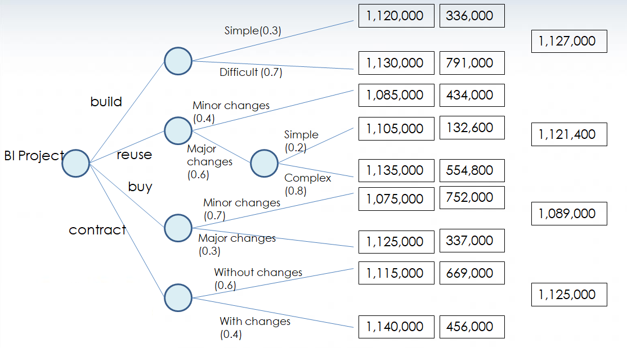

**Figure 14: MAKE OR BUY ANALYSIS 1**

## TYPE OF CONTRACT TO USE CALCULATIONS:

* **Fixed Price Contract**

Fee: $1,080,000

* **Cost plus Fixed Fee Contract**
  + Estimated price of project: $ 1,080,000
  + Fixed Fee: $30,000
* **If the project is completed by the seller at** **$1,100,000**, then the seller would receive

$ 1,100,000 +$30,000+ ($ 1,080,000 - $1,100,000)=$ 1,110,000

Profit = $10,000

* **If the project is completed by the seller at** **$1,060,000**, then the seller would receive

$ 1,060,000 +$30,000=$1,090,000

Profit = 30,000

* **Cost plus Incentive Fee Contract**
  + Sharing Formula is 75/25
  + Allowable Cost: $ 1,080,000
  + Target Fee: $40,000
  + Maximum Fee: $60,000
  + Minimum Fee: $25,000
* **If the project is completed by the seller at $1,050,000,** then the seller would receive

$1,050,000 +(1,080,000- 1,050,000)*0.25

+40,000 =$1,097,500

Profit = $47,500

* **If the project is completed by the seller at $1,100,000**, then the seller would receive

$1,100,000 +$25,000 =$1,125,000

Profit = $25,000

## COST PLUS INCENTIVE FEE

* A cost-plus incentive fee contract provides a way to apply any savings, whether financial or by completing work ahead of schedule, that the contractor is able to secure to the pay that he or she will receive for the contracted work.

# STATEMENT OF WORK

* **Title:**

Business Intelligence Systems

* **Introduction:**

Business intelligence (BI) is a technology-driven process for analyzing data and presenting actionable information which helps executives, managers and other corporate end users make informed business decisions.

* **Objectives:**

The goal of this project is to design and develop Business Intelligence tool with great data visualizations and ETL Integration. More information than ever lies within our reach today as intelligence is infused into the systems and processes that make our world work. The aim of business intelligence (BI) and performance dashboards is to make sense of the mountains of data available to us and to turn it into usable knowledge.

* **Project Scope:**

BI is evolving in every industry. The scope has expanded to more than just a set of standard, SQL-based reports. Following are the main functionality planned to implement:

* + Data visualization is the core of business intelligence. Both business analytics and business intelligence offers a variety of data visualization capabilities to convert the muddled sets of unstructured data into energetic images that convey meaning.
  + An analytical dashboard is used to analyze massive amounts of data to allow users to inspect trends, envisage outcomes and discover insights.
  + Predictive modeling involves creating, testing and validating a model to best predict the probability of an outcome.
* **Milestones:**

|  |  |  |
| --- | --- | --- |
| Milestone | StartDate | EndDate |
| Release 1 | 4/7/2021 | 9/6/2021 |
| Release 2 | 9/7/2021 | 1/14/2022 |
| Release 3 | 1/17/2022 | 5/5/2022 |
| Release 4 | 5/6/2022 | 8/5/2022 |

* **Project Schedule:**
  + Project Start Date: 06/01/2020
  + Project End Date: 08/08/2022
* **Work Requirements:**
  + Set the Key Performance Indicators
  + Find out the best software.
  + Define the tasks & Delegate the Resources
* **Critical Success Factors:**
  + System Quality and Information Quality
  + Performance
  + Business-Executive involvement

## REQUEST FOR PROPOSAL

1. **Background:**
   * CS591_CP_Team_03 is developing Business Intelligence Systems. The purpose of the document is request to perform execution of testing the business key performance indicators in accordance with competitive intelligence.
2. **Project Goals:**
   * The purpose of business intelligence in a business is to help corporate executives, business managers, and other operational workers make better and more informed business decisions.
3. **Schedule:**
   * Bids shall be firm offers and shall remain valid for acceptance 60 days following the RFQ closing date.
4. **Statement of Work:**

Details enclosed in Statement of Work.

1. **Technology constraints:**

Details enclosed in Statement of Work.

1. **Elements of Proposal:**
   * Experience of minimum 5 years in Business Intelligence Systems
   * Detailed document of KPI test plan.
   * Knowledge on business and metrics evaluation
   * Knowledge in mostly used Business Intelligence
2. **Additional Options:**
   * Although the entity has specific requirements, it is also interested in your ideas for integrating new KPI’s into the development of BI System. We encourage respondents to consider and propose alternative solutions for implemented metrics.
3. **Evaluation Criteria:**
   * Proposals will be evaluated based on previous experience in Business intelligence Systems, quality of previous work, time to completion and price.
4. **Vendor Reference:**
   * Vendors should provide their contact for further processes.

## REQUEST FOR QUOTE

**10. Required Bid Content:**

* + Scope of Work
  + Bid Amount – as hourly rate/total bid
  + Please fill the below table

|  |  |  |  |
| --- | --- | --- | --- |
| **Item** | **Description** | **Unit Cost** | **Extended Cost** |
| **1** | Unit Test case design, test script, results, supporting document and traceability of software development |  |  |
| **2** | Software integration test design, test case, results, supporting documentations and traceability to software development |  |  |
| **3** | System integration test design, test case, results and supporting documentations traceability to system requirements |  |  |

**11. Contact Information:**

* + Send your bids/proposals to:

Prasanthi Putta

Bradley University

Peoria - 61615

# CONCLUSION

* Business intelligence tools are essential for companies to stay competitive and maximize revenue streams. Below are the key benefits of using BI System:
  + Fast and accurate reporting
  + Valuable business insights
  + Competitive analysis
  + Better data quality
  + Increased customer satisfaction
  + Identifying market trends
  + Increased operational efficiency
  + Improved, accurate decisions
  + Increased revenue

# REFERENCES:

* <https://community.jaspersoft.com/wiki/jasperreports-server-features>
* <https://mindmajix.com/pentaho-tutorial>
* <https://www.predictiveanalyticstoday.com/birt-business-intelligence/>
* <https://www.predictiveanalyticstoday.com/apache-superset/>
* <https://www.predictiveanalyticstoday.com/redash/>
* <https://bitnami.com/stack/jasperreports>
* <https://www.eclipse.org/birt/about/project-organization/charter.php>
* <https://www.selecthub.com/business-intelligence-tools/redash/>
* <https://www.researchgate.net/publication/269506170_Software_Development_Agile_vs_Traditional>
* <https://www.batimes.com/articles/how-to-prevent-scope-creep-a-business-analyst-perspective.html>
* <https://seleritysas.com/blog/2019/06/30/how-ai-impacts-business-intelligence-applications/>
* <https://www.passionned.com/top-10-bi-risks-and-obstacles-to-success/>
* [https://learning.oreilly.com/library/view/successful-business-intelligence/](https://learning.oreilly.com/library/view/successful-business-intelligence/9780071809184/)
* <https://www.javatpoint.com/software-engineering-functional-point-fp-analysis>
* <http://worldcomp-proceedings.com/proc/p2012/SER2400.pdf>