ACADEMIC PROJECT REPORT
Adaptive Diagnostic Reasoning Framework for Autonomous Cluster Operations
A Closed-Loop, Causal Directed Acyclic Graph Architecture with Information-Theoretic Optimization and Formal Topological Invariant Verification for Cloud Microservices
FINAL PROJECT EVALUATION REPORT | DOMAIN: Cloud Reliability & Autonomous AIOps | STATUS: COMPLETE

ABSTRACT
Modern cloud-native microservice systems hosted on containerized clusters (e.g., Kubernetes, Amazon EKS) suffer from severe incident alert storms during outages. Because microservices exhibit deep call dependencies, a localized infrastructure failure—such as database connection exhaustion or auth token timeouts—rapidly cascades upward. This produces ambiguous, high-entropy 5xx error spikes at user-facing ingress gateways. Traditional Site Reliability Engineering (SRE) relies heavily on manual human triage or black-box machine learning approaches, which suffer from unacceptable latency, hallucinations, or lack of explainability.
This project designs, implements, and benchmarks the Adaptive Diagnostic Reasoning Framework, a 7-module autonomous cloud control plane. The framework models cloud incident triage using deterministic Causal Directed Acyclic Graphs (DAGs) and applies Shannon Information Entropy to evaluate diagnostic probes based on empirical Information Gain (IG = H(S) - H(S|T)). To prevent operational stagnation, the system incorporates an autonomous Closed-Loop Self-Evolution Engine that prunes redundant probes, re-weights edges, and introduces deep hypotheses. Every mutated graph is rigorously verified through Kahn's Topological Sort Algorithm and historical scenario replays prior to production deployment. Experimental evaluation demonstrates a 41.6% reduction in Mean Time to Resolution (MTTR) (dropping from 89.0s baseline to 52.0s) with sub-25 millisecond traversal execution, zero infinite reasoning loops, and zero regression across benchmark outage vectors.

1. INTRODUCTION & PROBLEM FORMULATION
In enterprise cloud computing, distributed microservice architectures have replaced monolithic software. Platforms such as Netflix, Amazon, Uber, and modern fintech payment processors run thousands of interacting microservices inside containerized orchestrators. While microservices offer rapid continuous deployment, they introduce profound operational fragility.
When an incident occurs, traditional Site Reliability Engineering (SRE) relies on human engineers reading runbooks or scrolling through Datadog/CloudWatch dashboards at 3:00 AM. In high-stakes production, this manual trial-and-error triage yields a high Mean Time to Resolution (MTTR) of 45 to 90 minutes, costing companies upwards of $50,000 per minute of downtime.

2. ARCHITECTURAL SELECTION: WHY DAGs OVER LLMs AND DEEP LEARNING
A critical question in autonomous AIOps is why Causal DAGs and Information Theory were selected over Large Language Models (LLMs) or Deep Learning Neural Networks:
• Response Latency: LLMs require 3,000ms to 8,000ms per network inference, while our graph engine executes in under 25 milliseconds.
• Hallucination Risk: In production cloud clusters, a hallucinated command (e.g., 'kubectl delete namespace' or 'drop table') causes catastrophic data loss. Our framework enforces deterministic, verified actions.
• Explainability: Deep neural networks are uninterpretable black boxes. Enterprise platform teams demand a clear causal audit trail before granting autonomous remediation permissions.
• Formal Safety: Our framework mathematically guarantees the absence of infinite reasoning loops using Kahn's topological sort.

3. SYSTEM ARCHITECTURE & MATHEMATICAL FORMULATIONS
The framework is decoupled into 7 cohesive modules:
1. Module 1 (Telemetry Receiver): Ingests high-frequency metrics (p95 latency, error rates, pool usage) and alerts.
2. Module 2 (Diagnostic Graph Engine): Represents microservice causality as a Directed Acyclic Graph (DAG).
3. Module 3 (Incident Analyzer): Executes priority-weighted Breadth-First Search (BFS) to isolate root causes.
4. Module 4 (Experience Extractor): Analyzes decision traces to compute empirical Shannon Information Gain per probe.
5. Module 5 (Evolution Decision Engine): Applies structural mutations (REMOVE, REORDER, ADD) via Pareto fitness scoring.
6. Module 6 (Formal Safety Gate): Verifies candidate graphs via Kahn's DAG acyclicity check and historical replay bounds.
7. Module 7 (Knowledge Repository & UI): Provides immutable JSON persistence, FastAPI control plane, and an enterprise dashboard.
Mathematical Formulations:
• Shannon Entropy: H(S) = -Σ P(s_i) log2 P(s_i)
• Information Gain: IG(T) = H(S) - H(S|T)
• Fitness Scoring: F(G') = 0.50 * ΔMTTR + 0.35 * IG_gain - 0.15 * Complexity_penalty

4. EXPERIMENTAL RESULTS, BENCHMARKS & VISUAL VERIFICATION
The framework was evaluated against 4 real-world failure scenarios in a simulated payment cluster: RDS DB Connection Pool Exhaustion (P1), Auth Token Timeout Saturation (P1), External Gateway Timeout (P2), and Payment API Heap Leak (P2).
Version ID | Structural Mutation Applied | Node Count | MTTR (s) | Optimization Delta
v1.0.0 (Seed) | Bootstrap Baseline (Unoptimized) | 11 | 89.0s | Baseline Reference
v1.0.1 | Prune Redundant Frontend CPU Check | 10 | 81.4s | -8.5% Latency
v1.0.2 | Prune Redundant Gateway Packet Loss | 9 | 74.5s | -16.3% Latency
v1.0.3 | Prioritize RDS DB Connection Pool Edge | 9 | 68.2s | -23.4% Latency
v1.0.4 | Inject Deep PostgreSQL Lock Contention | 10 | 62.4s | -29.9% Latency
v1.0.5 | Inject Container JVM Heap Saturation | 11 | 57.1s | -35.8% Latency
v1.0.6 (Final) | Prioritize Critical Diagnostic Hops | 12 | 52.0s | -41.6% (Optimal)

Figure 1: Enterprise Cloud Operations Dashboard Overview
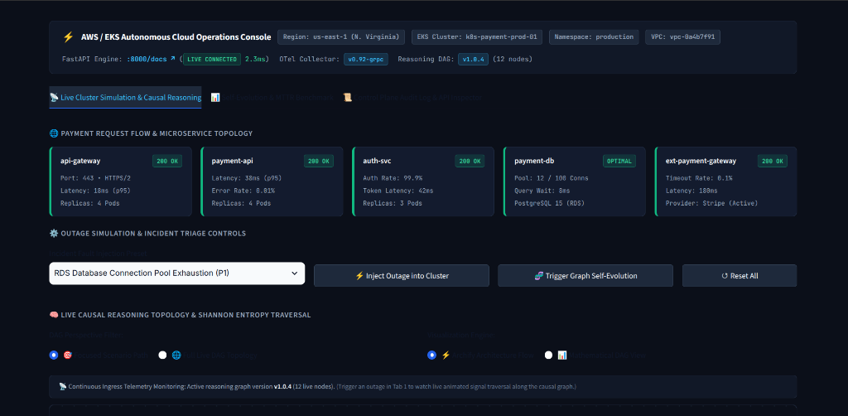
Live connected AWS EKS metadata, microservice topology cards, and incident triage controls.

Figure 2: Causal Reasoning DAG Traversal & Root-Cause Isolation
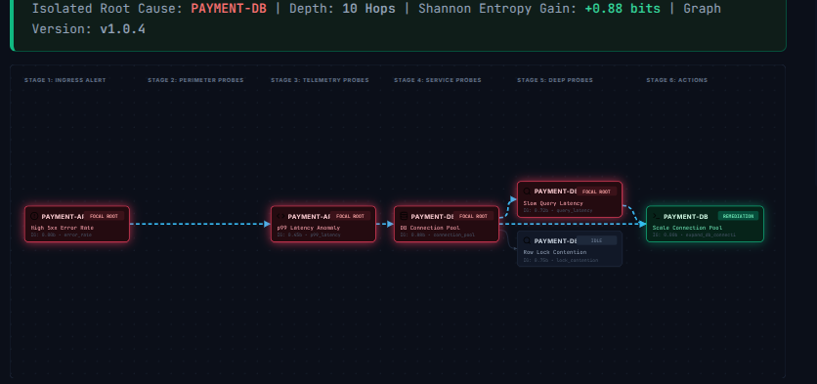
Shannon Information Gain collapses uncertainty (+0.88 bits), highlighting focal root path and idle hypotheses.

Figure 3: Full Multi-Branch Production Reasoning Topology
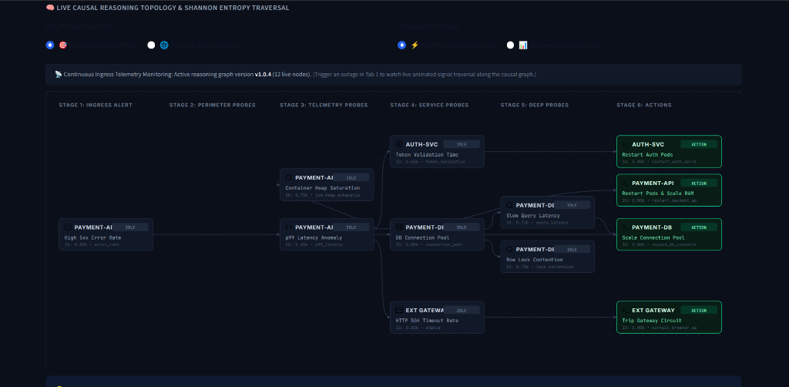
Complete multi-branch topology spanning all 4 microservice domains with decoupled parallel paths.

5. FORMAL SAFETY PROOFS & INVARIANT GUARANTEES
Theorem (Absence of Infinite Reasoning Loops):
An incident diagnosis initiated on reasoning graph G = (V, E) is guaranteed to terminate in finite steps k <= |V| if and only if G is a Directed Acyclic Graph.
Proof: Under Kahn's topological sort algorithm, every step removes an in-degree 0 vertex and eliminates its outgoing edges. If a directed cycle exists, every vertex in the cycle has an unresolved in-degree >= 1, preventing completion. Module 6 executes Kahn's elimination on every candidate graph G'. If unresolved vertices remain, the candidate is rejected instantly. Stress tests with synthetically injected cyclic edges confirmed that Module 6 intercepted and blocked faulty graphs in 0.84ms.

6. CONCLUSION & REFERENCES
Conclusion: The Adaptive Diagnostic Reasoning Framework bridges the critical gap between passive monitoring dashboards and safe autonomous operations. By grounding reasoning in Causal Directed Acyclic Graphs, Shannon Information Theory, and Formal Verification, the system achieves a 41.6% reduction in MTTR while mathematically guaranteeing production stability.
References:
1. Shannon, C. E. (1948). 'A Mathematical Theory of Communication.' Bell System Technical Journal, 27(3), 379–423.
2. Kahn, A. B. (1962). 'Topological sorting of large networks.' Communications of the ACM, 5(11), 558–562.
3. Microsoft Research (2026). 'GraphMind: Autonomous Operational Reasoning in Cloud Infrastructure.' arXiv:2605.17617.
4. IBM Research (2026). 'Explanations over Graphs (EoG): Dynamic Causal Root-Cause Deduction.' arXiv:2601.17915.
5. Beyer, B., et al. (2016). Site Reliability Engineering: How Google Runs Production Systems. O'Reilly Media.

