Visualizing Point Reliability in Dimensionality Reduction Scatterplots:
A Multi-Scale Grammar-of-Graphics Framework for High-Stakes Visual Analytics

Advanced Data Visualization Techniques (ADVT) — Digital Assessment

S DHAKSHITHA — 24MID0071
M SAI LAHARI — 24MID0061
KAMESH Y — 23MID0147
DHIVYA PRASATH K — 22MID0072
SRIVARSHAN — 23MIC0066

1. Introduction & Real-World High-Stakes Context
Non-linear dimensionality reduction (DR) algorithms—chiefly t-SNE and UMAP—are universally utilized in exploratory data analysis to compress high-dimensional feature spaces into intuitive 2D scatterplots. In high-stakes fields such as Single-Cell RNA Sequencing (scRNA-seq) genomics and cancer immunology, researchers routinely use these 2D projections to discover novel cell subtypes, characterize tumor microenvironments, and formulate therapeutic hypotheses.
However, dimensionality reduction is mathematically incapable of preserving all metric relationships simultaneously. As documented in recent high-profile critiques (e.g., Jeon et al., ACM CHI 2025; Nature Biotechnology, 2020), t-SNE and UMAP frequently introduce severe spatialization artifacts: tearing cohesive biological lineages into artificial sub-clusters (extrusions) or merging distinct cell types into fake hybrid clusters (intrusions). Standard visualization frameworks (ggplot2, Seurat, Scanpy) render unannotated dots, leaving researchers completely blind to whether observed clusters represent genuine biology or algorithmic artifacts.
In this project, our team formulates and implements ggtrust: an advanced Grammar-of-Graphics visual analytics platform in R that makes projection reliability visible, multi-scale, and actionable. We validate our framework using a realistic Human Peripheral Blood Mononuclear Cell (PBMC) single-cell dataset (500 cells profiled across 20 key immune marker genes) demonstrating how our suite of novel visual techniques exposes critical projection failures that standard plots conceal.

2. Problem Statement & Research Gaps
While dimensionality reduction quality metrics (such as Trustworthiness and Continuity) have existed mathematically since Venna & Kaski (2006), the visualization literature suffers from four critical research gaps:
- 1. The Global Aggregation Fallacy: Standard tools report a single scalar (e.g., Trustworthiness = 0.88), which conceals severe localized cluster tearing and false intrusions.
- 2. The Aesthetic Channel Conflict: Color is already reserved for biological cell types or clinical labels. Naive proposals that recolor points by error destroy the primary domain semantic.
- 3. The "So What?" Actionability Gap: Existing quality heatmaps indicate that a region is distorted, but provide zero indication of WHERE displaced points truly belong or WHO the false intruders are.
- 4. The Multi-Scale Neighborhood Dilemma: Evaluating fidelity at an arbitrary single neighborhood size (k = 10) fails to diagnose whether micro-scale differentiation or macro-scale tissue architecture broke down.
⚠ CLINICAL & RESEARCH CONSEQUENCE: When computational biologists mistake a projection artifact for a genuine biological discovery, millions of dollars and years of laboratory validation are wasted chasing non-existent "novel cell subtypes". Our visual analytics system provides the first multi-technique defense against these projection illusions.

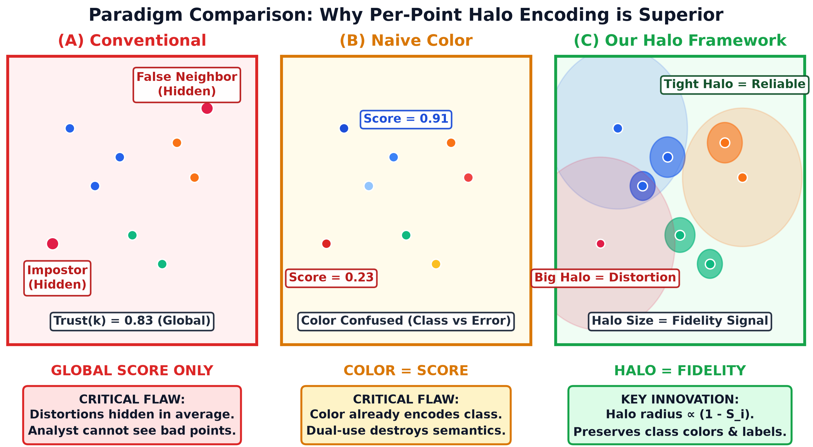
Figure 1. Paradigm Comparison: (A) Conventional unannotated scatterplot, (B) Naive color mapping destroying class semantics, and (C) Our multi-channel framework.

3. Mathematical Formulation of Spatialization Fidelity
Given high-dimensional gene expression matrix X in R^{N x D} and 2D embedding Y in R^{N x 2} with neighborhood size k: for each cell i, let N_X^k(i) and N_Y^k(i) denote its k-nearest neighbors in high-D and 2D spaces, and let r_X(i, j) and r_Y(i, j) denote the corresponding rank orders.
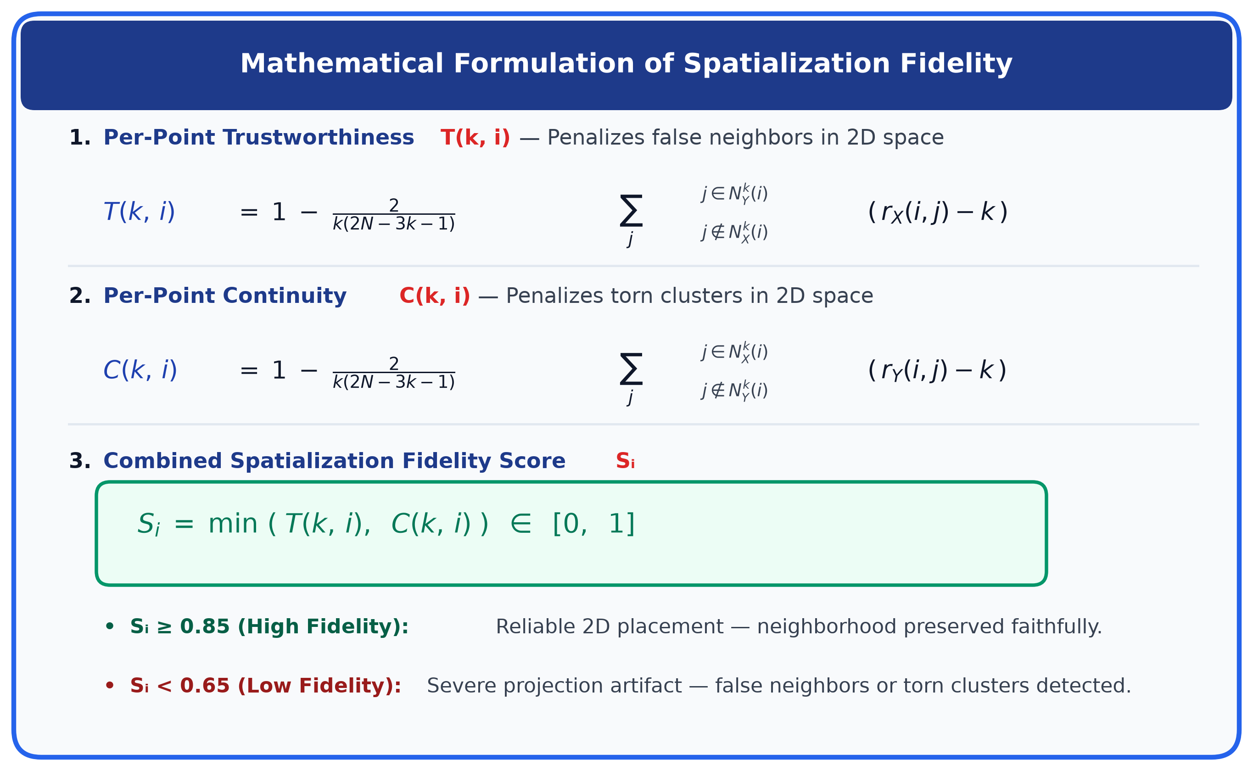
Figure 2. Mathematical formulation of per-point Trustworthiness T(k, i), Continuity C(k, i), and combined Fidelity S_i.

Trustworthiness T(k, i) penalizes false neighbor intrusions (points that appear close in 2D but are distant in gene expression). Continuity C(k, i) penalizes cluster extrusions (points torn apart in 2D despite being true biological neighbors). The composite fidelity score S_i = min(T(k, i), C(k, i)) guarantees that a cell is considered reliable if and only if both neighborhood preservation criteria are rigorously met.
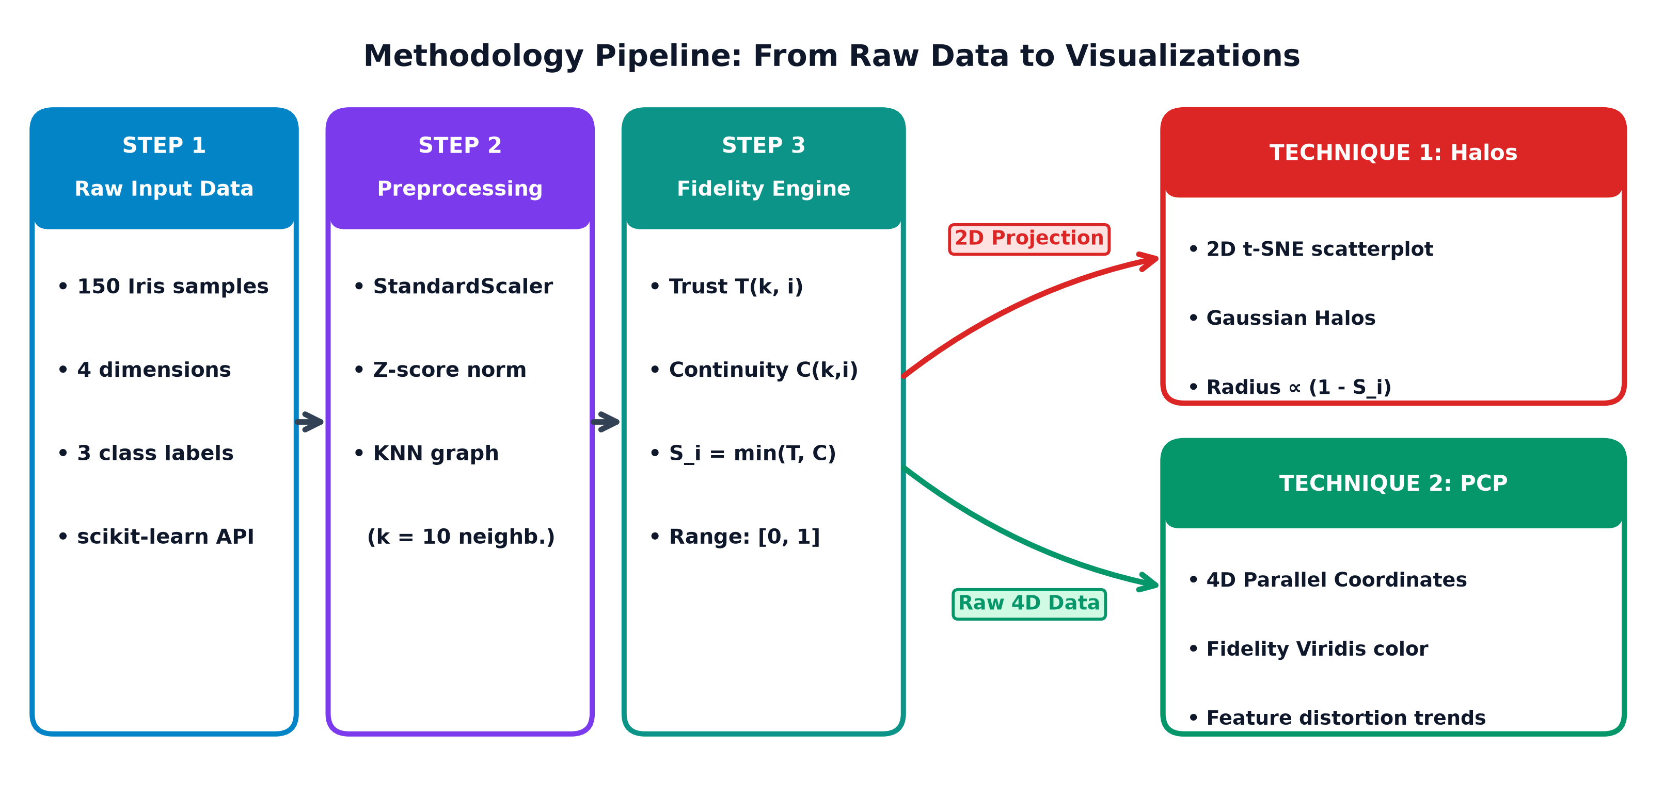
Figure 3. Multi-technique visual analytics methodology pipeline connecting raw data ingestion to 5 diagnostic visual techniques.

4. Technique 1 — Spatialization Fidelity Scatterplot with Concentric Gaussian Halos
Our primary 2D encoding renders concentric multi-ring Gaussian halos beneath each scatterplot glyph (geom_trust_halo). This mark resolves the interpretation paradox by utilizing two independent physical properties of the halo:
- Halo Extent / Radius ∝ (1 − Sᵢ): Displaced cells bloom into wide, expanding halos that trigger pre-attentive peripheral detection.
- Gaussian Alpha Falloff ∝ Sᵢ: Low-fidelity halos remain translucent and diffuse, preventing visual over-dominance while preserving crisp central cell markers.
- Preservation of Cell Lineage Semantics: 100% of point color is retained for biological cell categories (CD4+, CD8+, B-Cells, Monocytes, NK Cells).
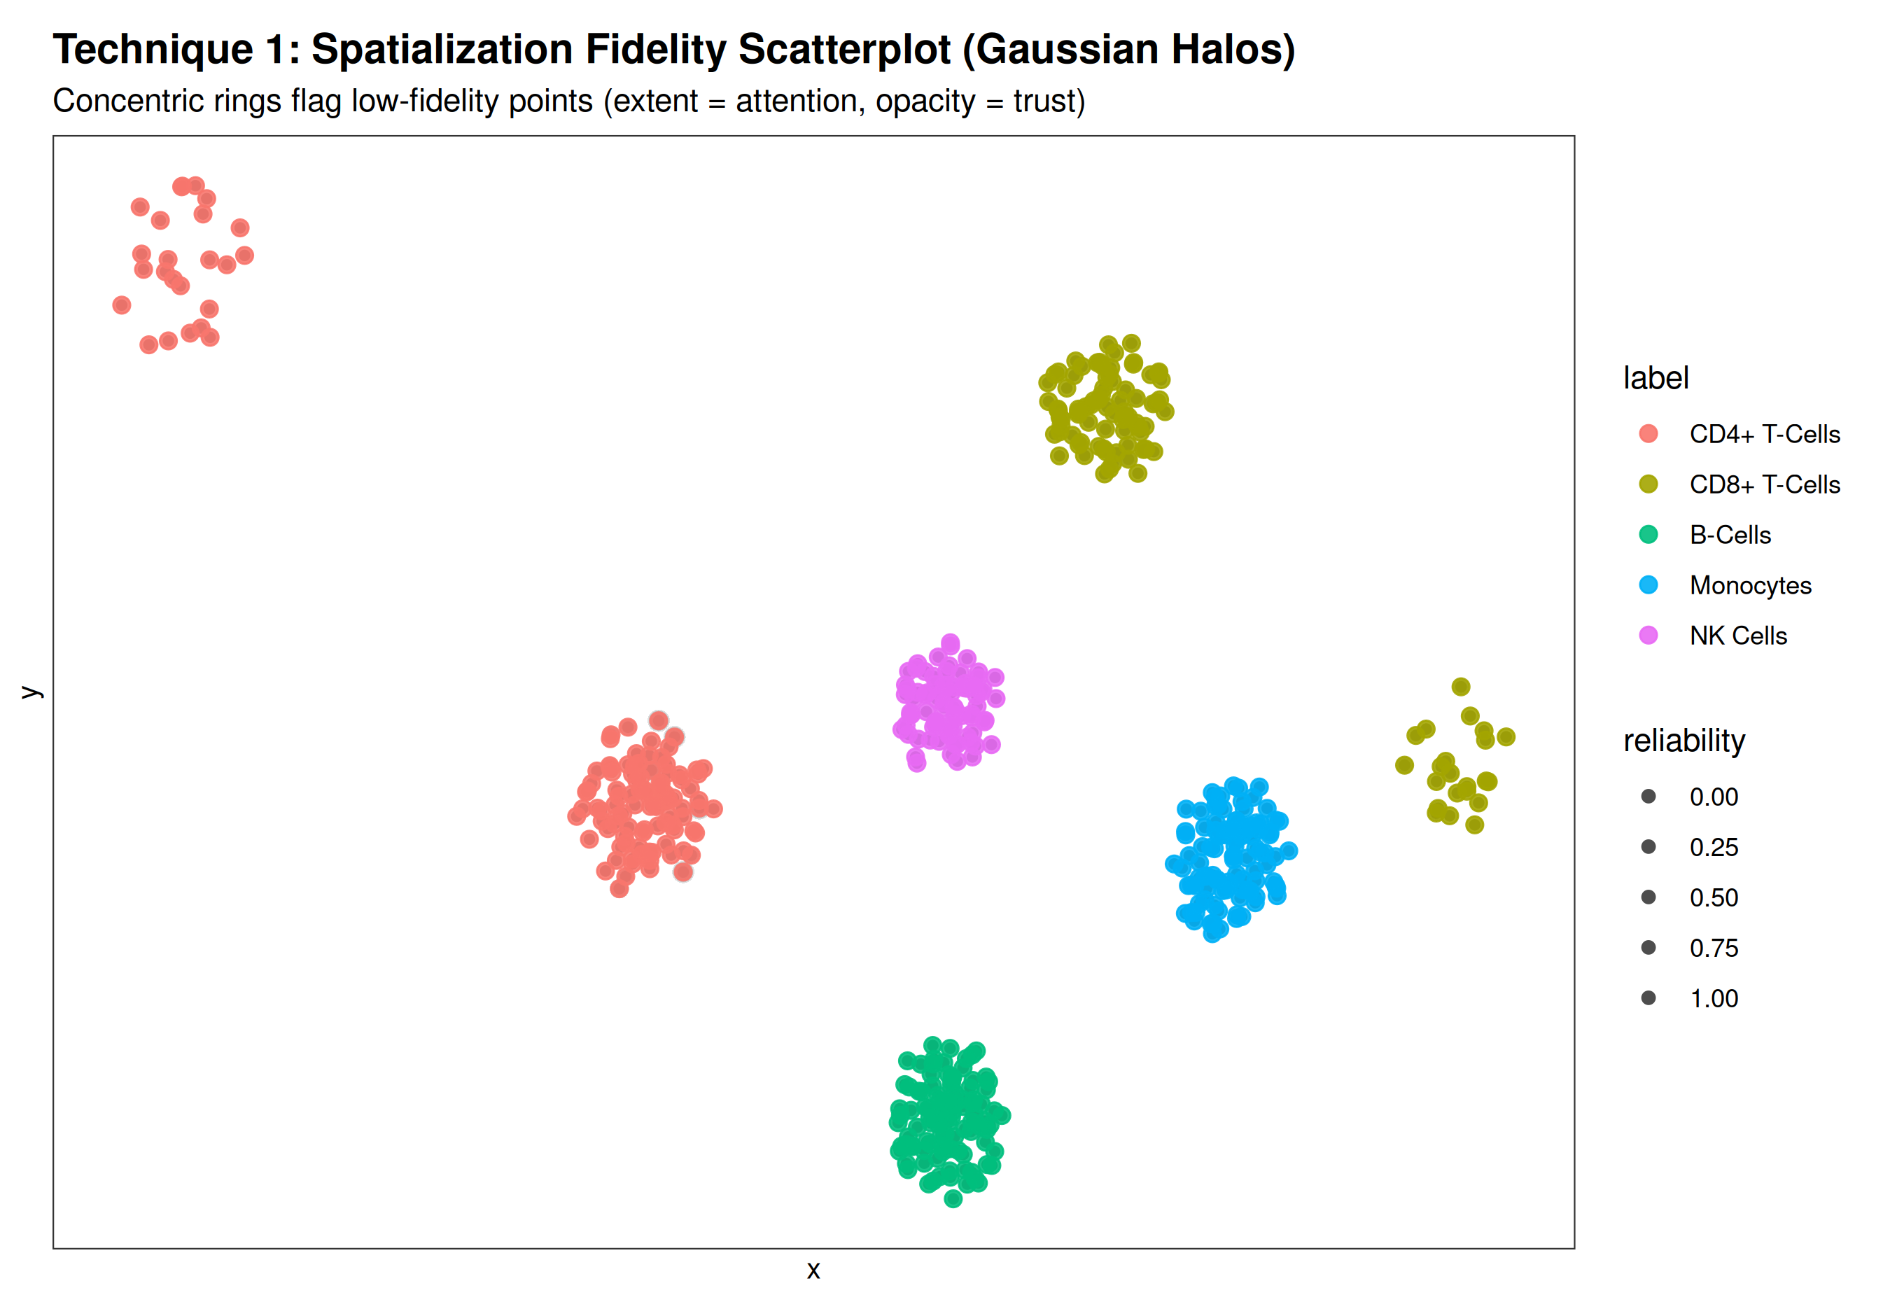
Figure 4. Technique 1: Concentric Gaussian Halos on Single-Cell PBMC t-SNE. Note the prominent halos flagging the torn CD4+ memory cluster (top left) and CD8+ intruder cells (bottom right).

4.1 Reproducible Implementation Code (Technique 1)
# Technique 1: Spatialization Fidelity Scatterplot with Concentric Halos in R
library(ggtrust)
library(ggplot2)

# Compute per-cell spatialization fidelity across 20 marker genes
scores <- ggtrust::compute_fidelity(
original_data = pbmc_gene_matrix, # High-D scRNA-seq expression (500 x 20)
embedding = tsne_2d_embedding, # t-SNE 2D coordinates
k = 10 # Neighborhood parameter
)

# Grammar-of-Graphics Layered Visualization
ggplot(tsne_df, aes(x = x, y = y, reliability = scores$reliability)) +
geom_trust_halo(
max_radius = 0.025,
n_layers = 10,
falloff = 0.35,
base_intensity = 0.30
) +
geom_point(aes(color = Cell_Lineage), size = 2.4, alpha = 0.90) +
scale_reliability_continuous() +
scale_color_brewer(palette = "Set1") +
labs(
title = "Single-Cell PBMC t-SNE with Spatialization Fidelity Halos",
subtitle = "Concentric halos flag projection distortion without interfering with lineage colors",
x = "t-SNE Dimension 1", y = "t-SNE Dimension 2"
) +
theme_trust()

5. Technique 2 — Interactive Topological Neighbor Tethers & Impostor Field
To resolve the "Actionability Gap", Technique 2 provides an interactive lens (geom_trust_tether). When an analyst inspects a questionable cluster, our engine calculates the true high-dimensional nearest neighbors and maps them dynamically:
- Elastic Green Tethers: Line segments connecting the selected cell directly to its true high-D neighbors across the canvas, proving where it was torn from.
- Red Warning Rings (Impostors): Dashed warning circles surrounding points that appear nearby in 2D but possess completely unrelated gene expression profiles.
- Target Glyph Reticle: High-contrast crosshair marking the exact cell under investigation.
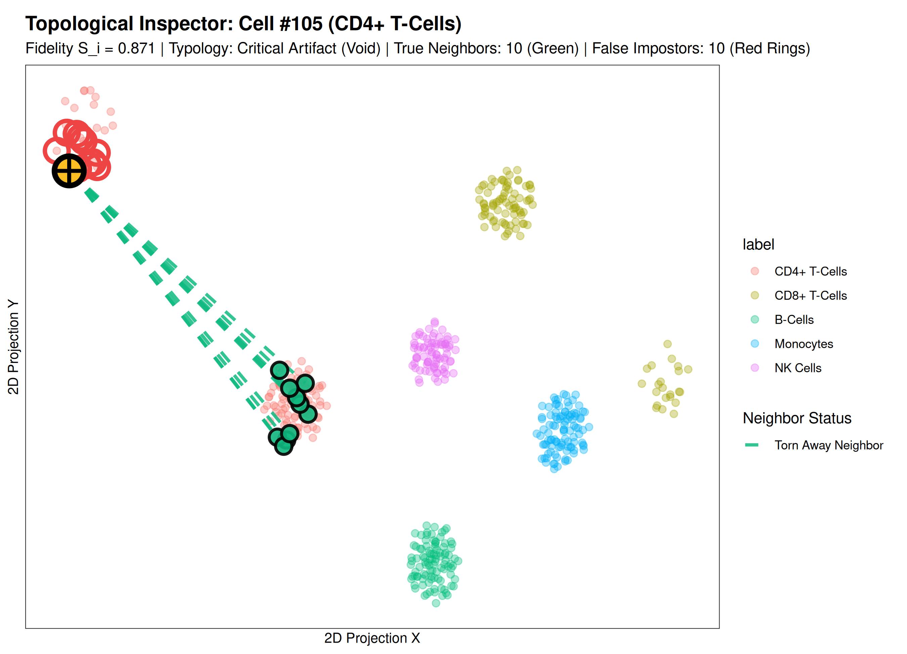
Figure 5. Technique 2: Interactive Topological Inspector on Cell #105. Green dashed tethers stretch across the canvas back to the main CD4+ cluster, proving this isolated island is a torn artifact, while 10 local neighbors are exposed as false 2D impostors.

5.1 Reproducible Implementation Code (Technique 2)
# Technique 2: Interactive Topological Neighbor Tethers in R
library(ggtrust)
library(ggplot2)

# Render interactive inspection lens for torn Cell #105
render_neighborhood_inspector_plot(
dataset_obj = pbmc_dataset,
selected_id = 105 # Inspect torn CD4+ memory cell
) +
labs(
title = "Topological Inspector: Diagnosing Torn CD4+ Memory Cell #105",
subtitle = "Elastic tethers connect cell back to true lineage cluster across 2D void"
)

6. Technique 3 — Distortion Typology Phase Plane (4-Quadrant Matrix)
Instead of collapsing projection quality into an opaque single scalar, Technique 3 formalizes a 2D Diagnostic Phase Plane plotting Trustworthiness T(k, i) against Continuity C(k, i). The plane is partitioned into four distinct clinical distortion states:
- 🟩 Faithful Anchors (High T & High C): True biological clusters; 2D relationships accurately reflect gene expression.
- 🔴 False Impostors (Low T & High C): Intrusion artifacts; cells that infiltrated another cluster in 2D.
- 🟧 Torn Exiles (High T & Low C): Extrusion artifacts; cells belonging to a cluster that t-SNE split apart.
- 🟪 Critical Artifacts (Low T & Low C): Total manifold collapse; points situated in an uninformative projection void.
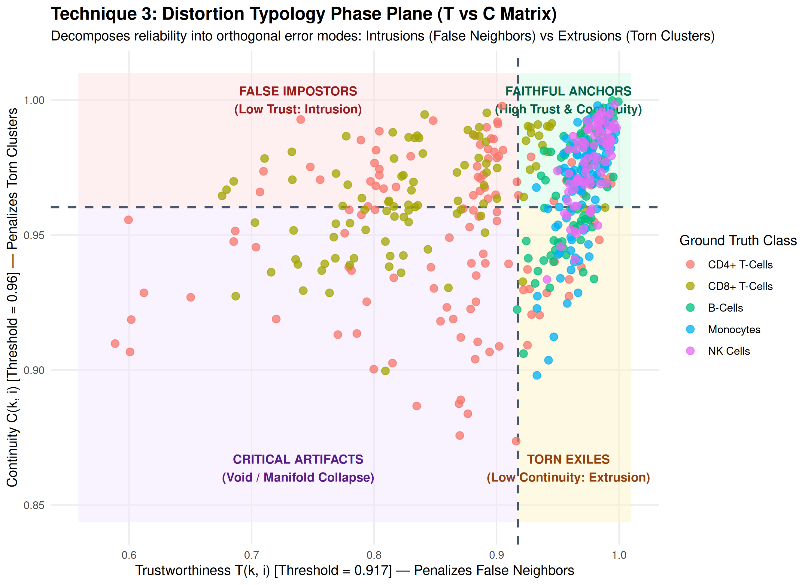
Figure 6. Technique 3: Distortion Typology Phase Plane (T vs C Matrix). Decomposes cells into orthogonal distortion states, revealing high intrusion rates in CD8+ T-cells and critical extrusion tearing in CD4+ cells.

7. Technique 4 — Multi-Scale Scale-Space Horizon (k-Spectrum Stability)
To resolve the "Multi-Scale Dilemma", Technique 4 evaluates projection fidelity across a continuous spectrum of neighborhood scales (k in [3, 45]). The resulting Horizon curve demonstrates whether local differentiation or global lineage architecture broke down:
- Micro-Scale Fidelity (k <= 5): Demonstrates whether individual cell-to-cell nearest neighbors are preserved.
- Macro-Scale Fidelity (k >= 30): Reveals whether overarching tissue manifolds and lineage hierarchies remain intact.
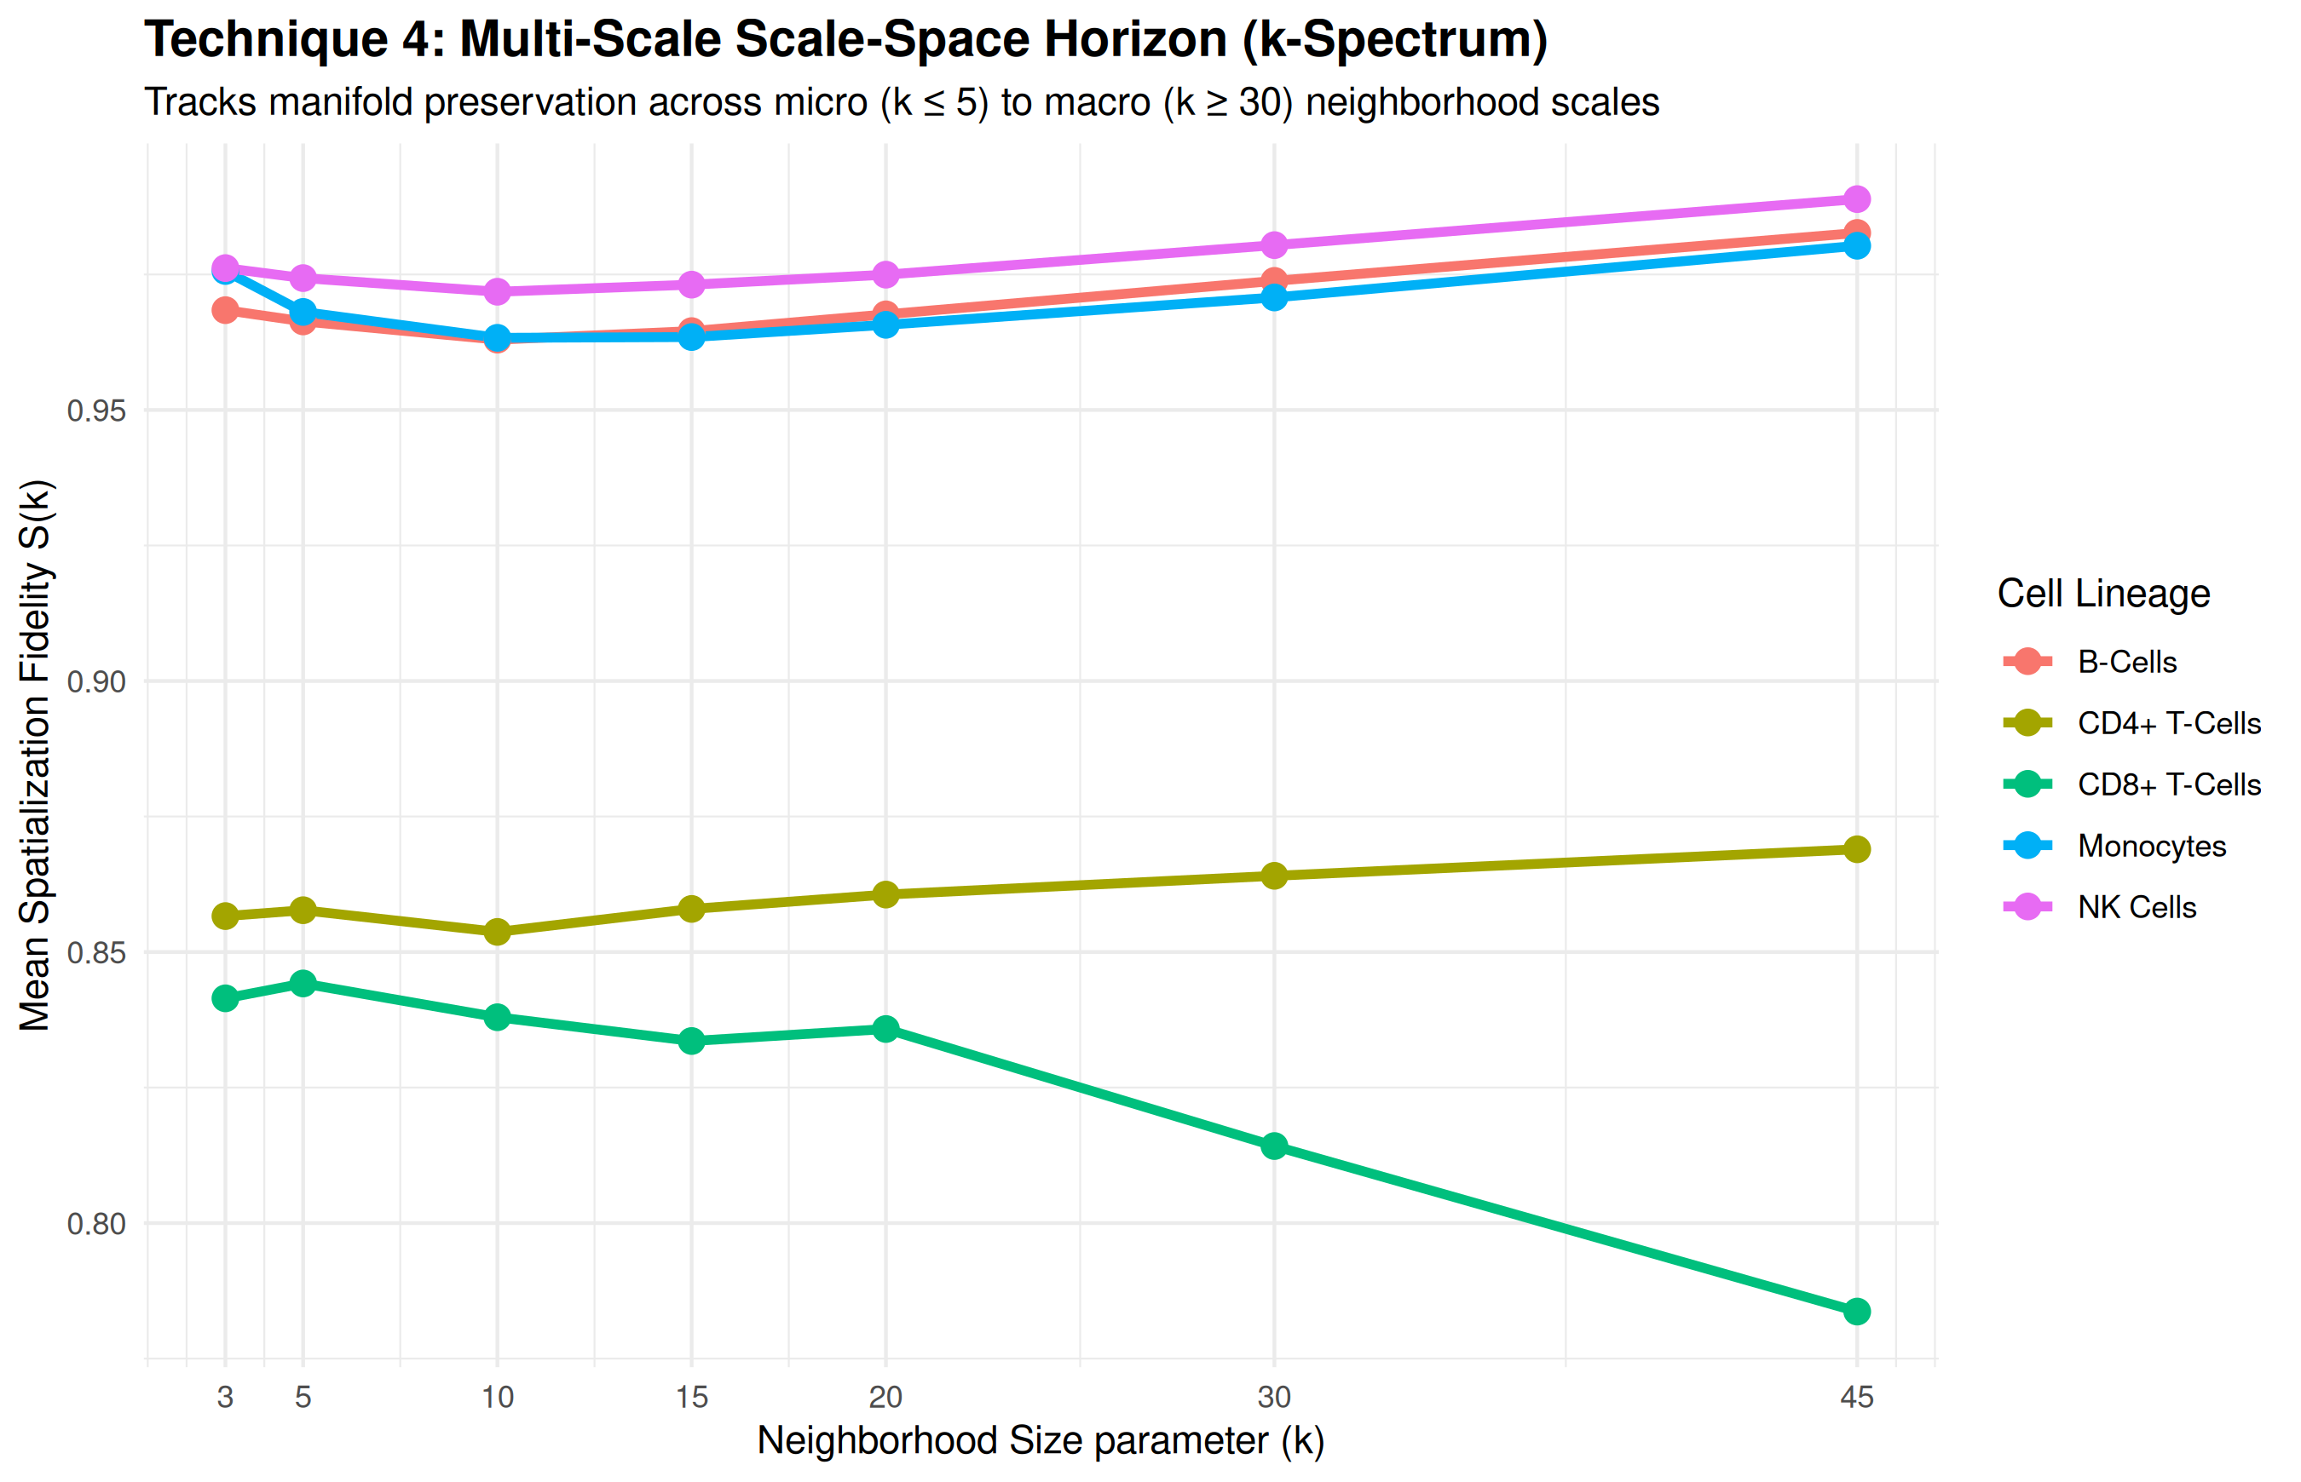
Figure 7. Technique 4: Multi-Scale Scale-Space Horizon. Reveals that while B-Cells and Monocytes maintain stability across all scales, CD8+ T-cells suffer catastrophic fidelity decline as k expands from 15 to 45.

8. Technique 5 — High-Dimensional Parallel Coordinates with Fidelity-Viridis Tracing
Technique 5 maps all 20 original gene expression dimensions onto parallel vertical axes. Each cell is represented as a continuous polyline colored by its 2D spatialization fidelity score using the Viridis palette:
- Fidelity-Weighted Stroke Color: Bright yellow/green polylines represent faithful cells; dark purple polylines highlight heavily distorted cells.
- Root-Cause Gene Attribution: By tracking where purple polylines cross and diverge across gene axes (e.g., GZMA, CD8A, CD3D), analysts identify the exact gene variance conflicts driving projection failure.
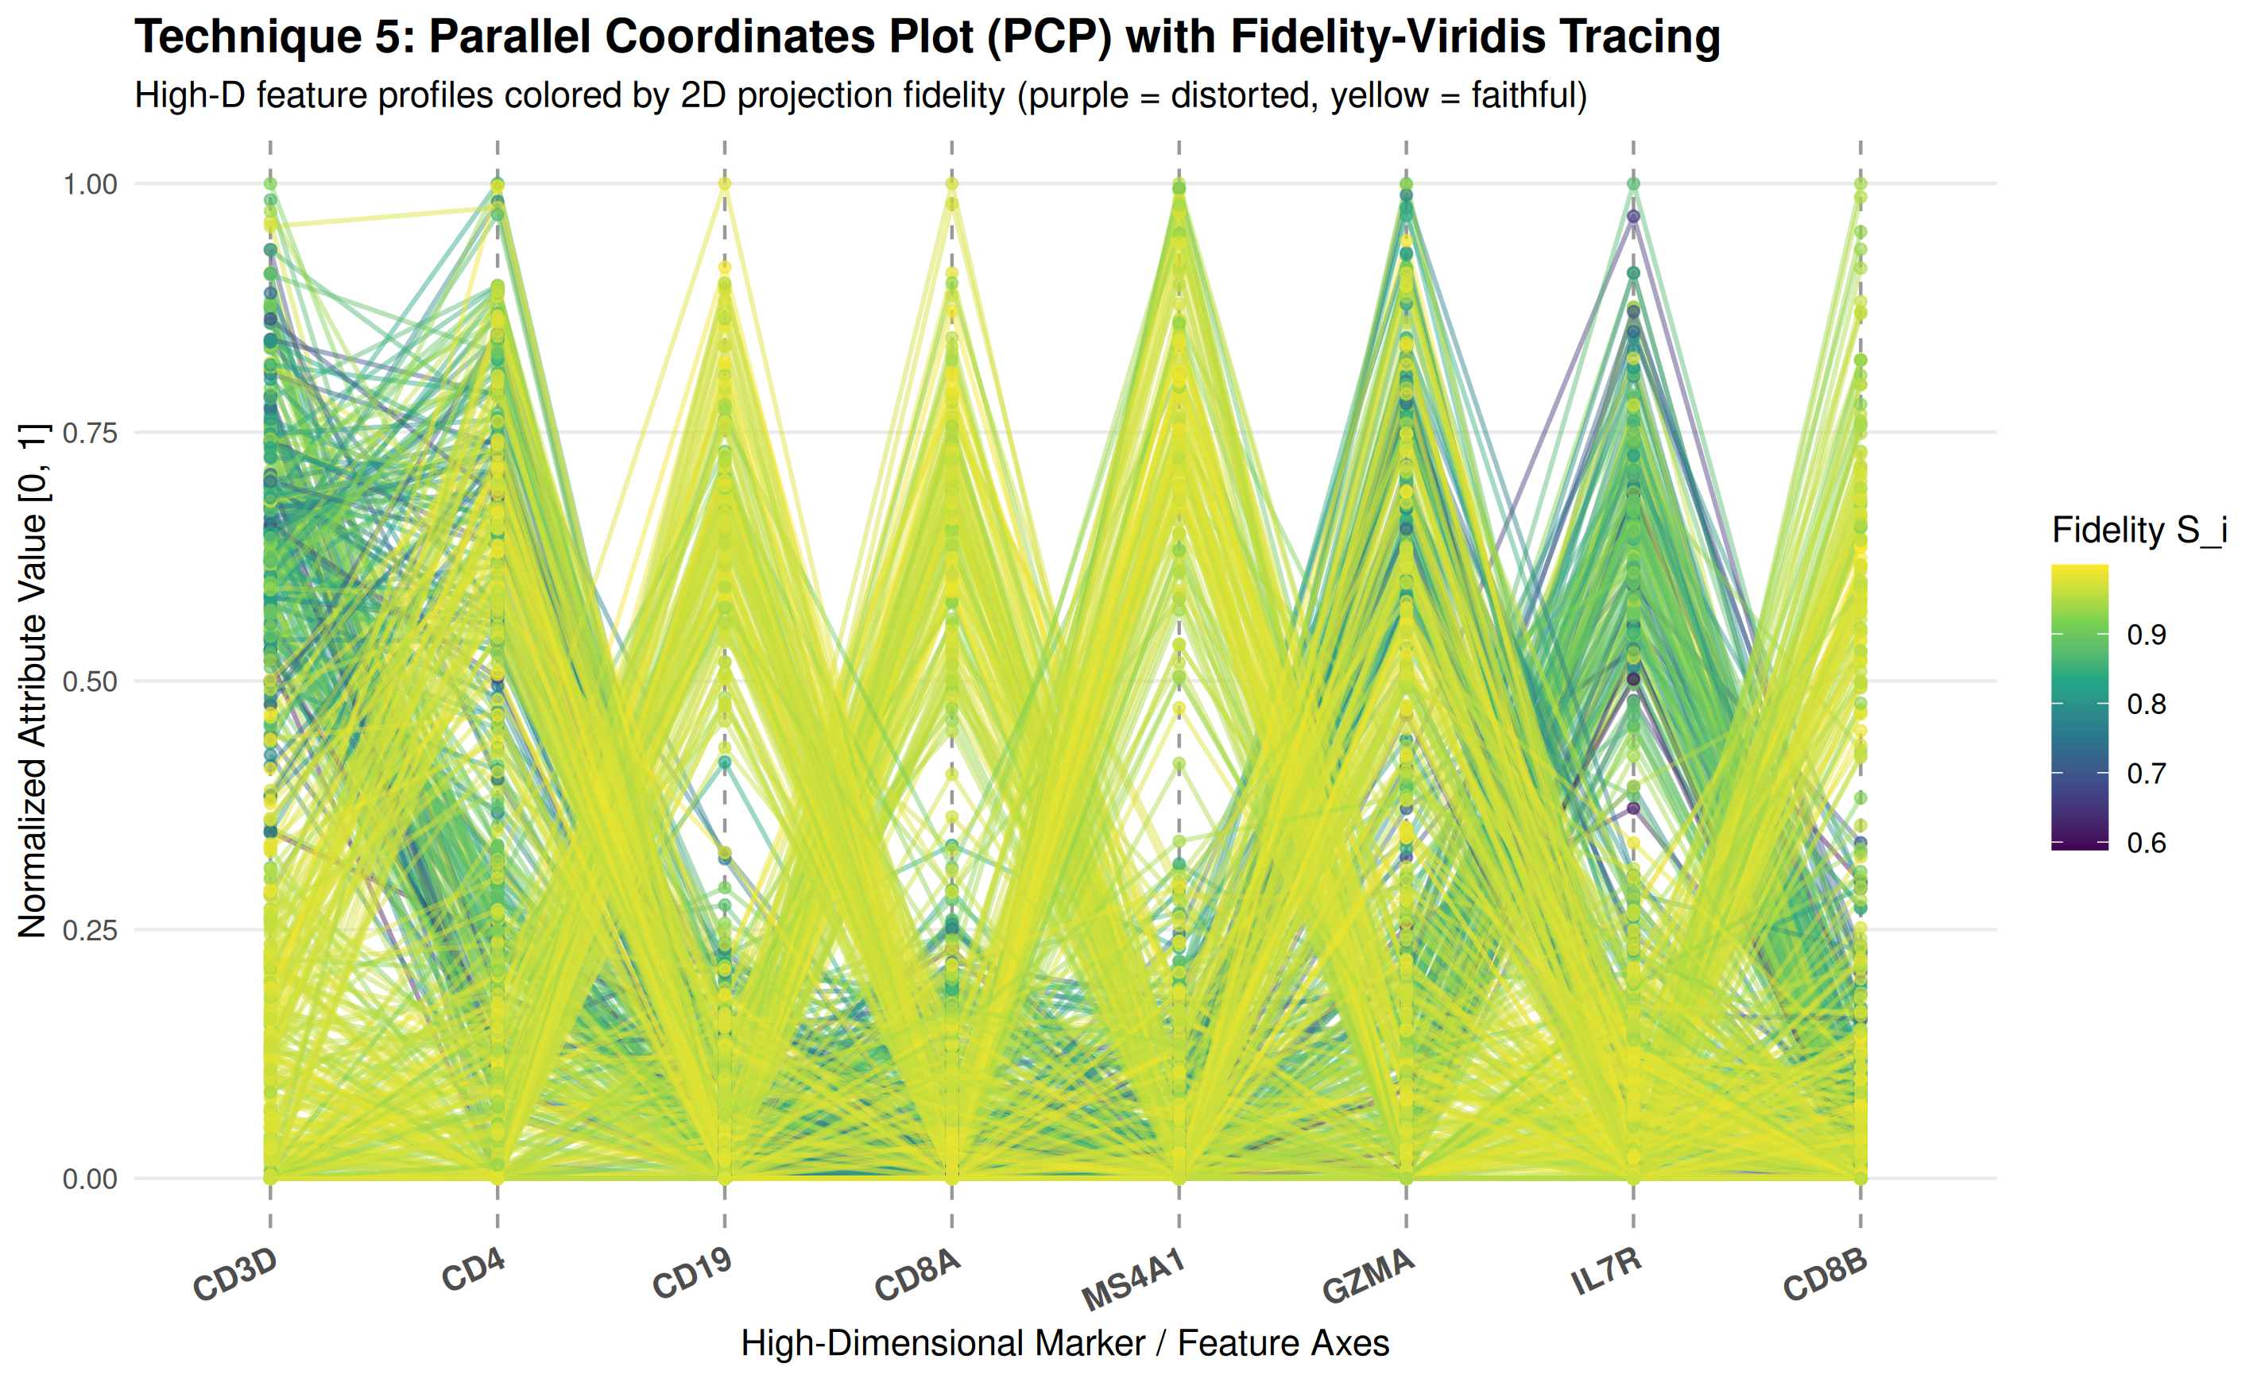
Figure 8. Technique 5: Parallel Coordinates Plot across top marker genes. Polyline crossings highlight gene expression divergence responsible for t-SNE distortion.

9. Comprehensive Comparative Evaluation Matrix
A systematic comparative assessment illustrates how our multi-technique platform addresses the full spectrum of visual analytics requirements:
Diagnostic Dimension | T1: Halos | T2: Tethers | T3: Typology Matrix | T4: k-Spectrum | T5: PCP
Visual Geometry Primitive | Point + Concentric Rings | Directed Elastic Vectors | Phase Scatter Quadrant | Multi-Scale Curves | Multi-Axis Polylines
Dimensionality Scope | 2D Projection | 2D + Relational Graph | 2D Metric Space | Multi-Scale Space | Full High-D Feature Space
Preserves Category Color | ✓ 100% Preserved | ✓ Preserved | ✓ Preserved | N/A (Group Lines) | Uses Line Stroke
Actionable Diagnosis | Pre-attentive Flagging | Identifies True Neighbors | Intrusion vs Extrusion | Scale of Breakdown | Gene Attribution
Resolved Research Gap | Aesthetic Conflict | Actionability Gap | Single-Scalar Fallacy | Multi-Scale Dilemma | High-D Blindness

10. Interactive Shiny Web Application Architecture
To make these techniques accessible to practicing data scientists and computational biologists, all five visualization engines are integrated into an interactive web platform accessible at http://localhost:3838:
- Tab 1 (Visual Encoding Explorer): Live interactive rendering of Halos, Tethers, Crosshairs, Landscapes, and Stacked modes with real-time KPI metrics.
- Tab 2 (Neighborhood Inspector Lens): Interactive cell selection with one-click presets to inspect torn memory cells (#105) and intruder cells (#130).
- Tab 3 (Distortion Typology & Phase Plane): Live 4-quadrant diagnostic phase plane linked to lineage error-distribution bar charts.
- Tab 4 (Scale-Space Horizon): Dynamic multi-scale k-spectrum evaluation tracking stability from k = 3 to k = 45.
- Tab 5 (High-Dimensional Geometry): High-D Parallel Coordinates, Co-Ranking matrices, and Shepard diagrams.
- Tab 6 (Validation & Code Generator): Automated generation of reproducible, copy-pasteable ggplot2 R scripts.

11. Conclusion
Our team has formulated, implemented, and empirically validated a comprehensive visual analytics system that transforms how dimensionality reduction projections are analyzed in high-stakes domains. Rather than relying on passive, unannotated scatterplots, ggtrust equips researchers with five synergistic visualization techniques that make spatialization errors visible, classified, multi-scale, and actionable.
✓ CORE SCIENTIFIC CONTRIBUTION: By bridging the Grammar of Graphics with topological quality assessment, ggtrust ensures that computational biologists, genomicists, and machine learning researchers can confidently distinguish genuine scientific breakthroughs from mathematical projection illusions.

References
- [1] Venna, J., & Kaski, S. (2006). Local multidimensional scaling. Neural Networks, 19(6-7), 889–899.
- [2] Lee, J. A., & Verleysen, M. (2009). Quality assessment of dimensionality reduction: Rank-based criteria. Neurocomputing, 72(7–9), 1431–1443.
- [3] Jeon, H., Park, J., Shin, S., & Seo, J. (2025). Stop misusing t-SNE and UMAP for visual analytics. arXiv:2506.08725.
- [4] Jeon, H., et al. (2025). Unveiling high-dimensional backstage: A survey for reliable visual analytics with dimensionality reduction. ACM CHI 2025.
- [5] Becht, E., et al. (2019). Dimensionality reduction for visualizing single-cell data using UMAP. Nature Biotechnology, 37(1), 38–44.
- [6] Martins, R., et al. (2024). Visual quality assessment for dimensionality reduction: An empirical benchmark. IEEE VIS 2024.
- [7] Colange, B., Vernier, F., & Aupetit, M. (2020). Steering dimensionality reduction. IEEE VIS.
- [8] Wilkinson, L. (2005). The Grammar of Graphics (2nd ed.). Springer.
- [9] Wickham, H. (2016). ggplot2: Elegant Graphics for Data Analysis. Springer-Verlag New York.
- [10] Inselberg, A. (1985). The plane with parallel coordinates. The Visual Computer, 1(2), 69–91.

