AUTOMATED RESUME RANKING AND ENHANCING RECRUITMENT EFFICIENCY USING ADVANCED NLP AND SENTENCE-BERT

¹S. Sivaharini, PG Student (MCA), Department of Computer Applications,
HITS (Deemed to be University), Chennai-603 103. Mail ID: sivaharinisankar15@gmail.com

²Dr. S. Jaya, MCA., M.Phil., Ph.D., Assistant Professor, Department of MCA,
HITS (Deemed to be University), Chennai-603 103. Mail ID: jaisundar11@gmail.com

Abstract
The digitalization of the recruitment systems has greatly accelerated the number of resumes that organizations receive, which makes the manual methods of screening a resume quite inefficient, time-consuming and prone to subjective bias. The current Applicant Tracking System (ATS) use mostly utilizes the technique based on key-searching and rule-based approach to filtering through the applications and retrieving the results; such systems are unlikely to retrieve the semantic background and essence of skills, experience, and work requirements in candidates. Consequently, there is a possibility of a highly qualified candidate being left out on the basis of lexical differences and not necessarily on the basis of suitability. To address these drawbacks, this paper introduces a framework of automated resume ranking and job recommendation by using progressive Natural Language Processing (NLP) and transformer-based deep learning methods. The suggested system applies Sentence-BERT (SBERT), a state-of-the-art transformer, in generating dense semantic embedding of resumes and real job descriptions to semantically compress them, allowing semantic similarity to be computed upon them. The system accepts the resumes in popular PDF and word document format and does automated extraction and preprocessing of the text. The job descriptions obtained via the actual recruitment sites are handled in parallel to form an empty semantic representation space. The cosine similarity is used to calculate relevance scores between resume embeddings and job description embeddings to enable the system to rank job roles in semantic relevance. The proposed framework, in contrast to traditional classification-based methods, implemented ranking-based analysis methodology, which is more in line with the actual recruitment processes, which do not focus on binary decisions but shortlisting the candidates in a ranked list. Through a large-scale experimental study, it has been proven that the suggested SBERT-based model performs much better than the conventional machine learning models and the LSTM-based deep learning architectures. The system has a Top-5 job recommendation accuracy of over 95 percent and a Top-10 accuracy of almost 99 percent, which underscores its efficiency in intelligent shortlisting of candidates. The proposed framework will improve the efficiency, minimize the manual work, human bias, and decision consistency through automation of resume screening and ranking.
Keywords: Resume Ranking, Recruitment Automation, Sentence-BERT, Semantic Similarity, Natural Language Processing, Job Recommendation System, Transformer-based Deep Learning.

Introduction
The fast growth of information technology and the adoption of online platform have greatly changed the way recruitment and hiring are done in industries. Organizations are now strongly dependent on online job portals, networking sites and corporate career sites to draw talent. This has made the recruiters to end up receiving hundreds or even thousands of resumes when it comes to one job opening. Although this digital transformation has made accessibility more accessible and has widened the talent pool, it has also created significant challenges in terms of effective screening, evaluation and shortlisting of the most appropriate candidates within limited time periods. Resume screening is not available as a viable option in large-scale recruitment processes and as a result of high time consumption, cost of operation as well as being prone to human prejudice and unreliability. Resume screening is an automated process that is used by many organizations because of increased number of applications. Conventional ATS solutions are mostly based on rule-based engine and search key algorithms, according to which resumes are filtered by pre-determined skill sets and job descriptions or a set of certain words. Even though such systems enhance processing speed, they do not always render contextual meaning and semantic affiliations to resume content. Such differences as terminology, synonyms, abbreviations, and differences in the style of writing can result in incorrect screening outcomes where a qualified candidate is turned down whereas a less qualified profile is shortlisted. The inability is a weakness of the keyword-based methods of capturing the actual relevance between the candidate profiles and the job requirements. NLP and deep learning have seen new advances in the past, which have created the possibility of more intelligent and context-sensitive text analysis methods. Previous studies in automated resume analysis have discussed the old machine learning algorithms like Naive Bayes, Support Vector Machines and Decision Trees regarding how to classify and categorize a resume using these algorithms. Later on, resumption text sequential patterns were learned using deep learning models including Convolutional Neural Networks (CNN) and Long Short-Term Memory (LSTM) networks. Nonetheless, these models tend to be memory intensive in terms of labelled data, feature engineering and fail to capture the semantic meaning of long unstructured texts like resumes and job descriptions. Transformer-based language models have recently become a potent source of dealing with these challenges. Transformer-based models, especially BERT and its variants, have shown spectacular results in a broad variety of NLP tasks, due to
their ability to better reason about contextual and semantic information compared to other models. Sentence-BERT (SBERT) is an extension of BERT that aims at providing meaningful sentence-level and document-level embeddings that are easy to compare with each other with similarity metrics. SBERT is very applicable in semantic matching tasks, such as resume job matching and ranking, by virtue of this ability. In this regard, this paper will suggest an automated resume ranking and job suggestion system based on Sentence-BERT to improve the efficiency of recruitment. The proposed system takes in resumes in popular PDF or Word formats, automatically extracts the textual information in these resumes, and projection resumes and real-world job descriptions into a common semantic embedding space. Relevance between candidate profiles and the job requirements is measured using the cosine similarity and job roles are ranked based on this and Top-N recommendations are generated. Considering the fact that the traditional classification-based system is founded on binary decisions, the proposed one is based on a ranking-based evaluation, which is much closer to the reality of recruitment processes, where recruiters shortlist candidates based on ranked lists instead of binary decisions. Through superior transformer-based NLP algorithms, the proposed system will minimize human effort, bias, enhance accuracy in screening, bring a scalable and smart solution to the modern recruitment websites.

LITERATURE REVIEW
Sentence-BERT Reimers and Gurevich introduced Sentence-BERT, a semantic embedding model based on Siamese BERT networks and efficient at estimating the similarity of sentences and document-level similarity. The method enhances the accuracy of semantic matching by a significant margin over the traditional BERT embeddings; nevertheless, it is very computationally demanding to generate embedding and deploy at large scale. [1]. Devlin et al. presented BERT, a deep bidirectional transformer language understanding model that models text contextual relationships. The model was able to perform most NLP tasks on the state of the art, although its inference cost and model size are prohibitive to real-time use without optimization. [2]. Zhang et al. suggested an automatic system of resume screening based on NLP pre-processing and conventional machine learning classifiers. The model was more efficient when compared to manual screening, but it would use keyword-based representations and would not be able to understand the semantic meaning. [3].

The system of recruitment recommendations developed by Al-Otaibi and Ykhlef is based on deep learning, resumes, and job descriptions. This strategy was better at recommendation accuracy than classical models, but was not suited to long unstructured documents and the large volumes of labelled training data needed to be trained. [4]. Bansal et al. have provided an extensive review of job recommendation systems and have categorized content-based, collaborative and combined systems. The paper has identified gaps in the research in semantic understanding and scalability, especially in the context of unstructured data of the recruitment process. [5]. A survey carried out by Liu et al. on pre-trained language
models in NLP applications proved that the transformer-based models are more successful than traditional deep learning methods. Nevertheless, the research highlighted the issues associated with computational complexity and domain adaptation. [6].

Lops et al. talked about content-based recommender systems and how they could be used in recommendation cases of personalization. Although efficient in user profile-item matching, the method does not contain deep semantic reasoning unless the representation learning is well developed. [7]. Venkatesh and Prasanna suggested a smart system of recruitment with the help of artificial intelligence through NLP to analyse resumes. The system enhanced automation and minimised manual labour, however, limitation of features of the handcrafted system hindered flexibility across domains. [8]. Huang et al. enhanced semantic textual similarity tasks by transformer-based embeddings. The model obtained higher similarity scores than the traditional embeddings but had to have fine-tuning to domain specific tasks. [9].

Zhang and Wang suggested a semantic job-resume matching system based on transformer-based representation learning. Their strategy was more accurate in matching but when they found job descriptions with little context, performance decreased. [10]. The method used by Raza and Ding to discuss explainable AI approaches in recruitment systems to enhance transparency and trust. Although the framework made the interpretation easier, it added new complexity and computational cost. [11]. Mikolov et al. compared the developments in neural text representations of match and recall tasks. The paper has highlighted the main drawback of sparse representations in comparison with distributed embeddings, but the latter were not scalable to large datasets.[12].

Sharma et al. used the deep learning models including CNN and LSTM to classify and rank resumes. The models scored moderately on accuracy improvement but had a problem with semantic interpretation of varying resume formats. [13]. Liu et al. suggested a semantically similar job recommendation system based on the use of transformers. The method enhanced the accuracy of recommendations, but the complexity of training and the time taken in inference was a challenge to deploy. [14]. Uddin and Kim compared issues and opportunities of automated recruitment systems. The research noted that there were concerns regarding fairness, bias, and scalability and proposed improved semantic models. [15].

Vaswani et al. presented the transformer architecture using self-attention mechanisms. The model transformed NLP making it able to process information in parallel, learn in context but demanded large data and computation resources. [16]. Sun et al. suggested a semantic matching model of recruiting through BERT-based embeddings. This system enhanced the accuracy of resume-job matching, but did not provide ranking-based assessment to match the actual recruitment processes. [17].

Gupta and Choudhary came up with an NLP and deep learning based intelligent resume ranking system. The model has shown better classification accuracy although it was based on domain-specific preprocessing rules. [18]. Li and Zhang examined the use of large language models in human resource management. The paper has promising findings in the automation of recruitment, but ethical and computing issues were also found. [19].

Kumar et al. suggested an AI-based recruitment system based on semantic matching based on transformers. The strategy had a high matching rate, yet it was difficult to combine it with real-life ATS systems. [20]. The writer highlighted the fast increase of the internet of things (IoT) in connecting clever gadgets and sensors, generating large volumes of statistics which are efficaciously managed via massive records analytics throughout domains including healthcare, finance, and transportation. Blockchain has been extensively explored as a comfortable and immutable framework for keeping sensitive medical facts, ensuring records integrity and privacy thru decentralized mechanisms [21].

PROPOSED METHODOLOGY
The suggested system is systematic in order to automatize the process of ranking and job recommendation of the resumes by making use of a sophisticated method of Natural Language Processing. It starts by gathering resumes and job descriptions according to publicly accessible datasets. Resumes are usually provided in PDF and word formats whereas a job description entails practical role demands and duties.
The text extraction is carried out automatically in the first phase in order to extract the contents of PDF and DOCx documents. A cleaned text is then obtained which is free of special symbols, formatting and any unwarranted space to obtain standardized text that can be utilized further in the processing.
At the second step, Sentence-BERT (SBERT) transformer-based deep learning model converts both resume and job description texts into dense semantic representations, as it is able to encode contextual and semantic relationships at sentence and document scales. Using projections of both resumes and job descriptions into a common embedding space, semantically related material can be placed closer together than otherwise irrespective of vocabulary disparities, making comparisons between them more meaningful than the more conventional keyword-based methods.
Then, cosine similarity is used to calculate scores of relevance between resume and job description embeddings. Using these scores, job positions are ranked in order of decreasing positions and Top-N job recommendations are made to each candidate. Ranking metrics used to evaluate the performance of the system include Top-1, Top-3, Top-5, and Top-10 accuracy, which offer realistic evaluation in line with the recruitment process.
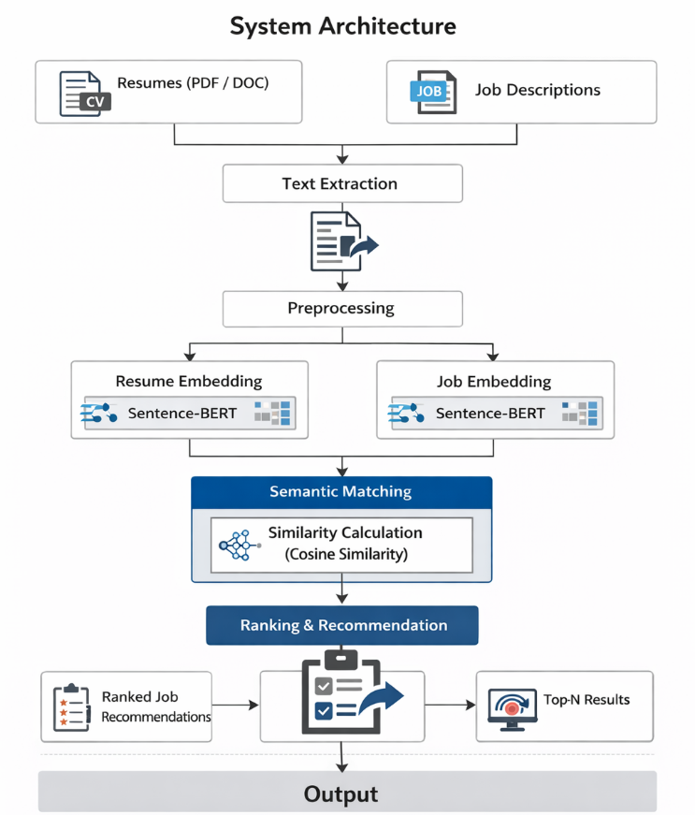
Fig 1. System Architecture
The Figure 1 shows the resume submission and job description are input into the system which extracts the resume and job description information, pre-processes it and converts it into embeddings. The resulting embeddings are then used to administratively output the system's top N job placements at once.

PROPOSED SYSTEM
The proposed intelligent and automated system will produce new resume and job ranking systems through automated natural language processing (NLP) techniques and advanced transformer neural networks. This new resume and job ranking system will go beyond traditional applicant tracking systems (ATS) by evaluating candidates based on their qualifications versus candidates based upon an individual’s resume to determine the applicant’s fit for the job requirements. Thus, this intelligent, automated resume and job ranking system will replace the manual processing that occurs when an employer receives multiple applications for one position. The primary benefit of the proposed system is to radically change how resumes are analysed and job opportunities are presented by creating a totally automated method of evaluating job applicants by using semantic similarity to automate resume analysis and job ranking, thereby allowing for faster, equitable and more accurate employment decisions to be made by all employers participating in the recruitment process.
The architecture of the proposed system consists of many different modules that work together to create one automated recruitment process. For instance, resumes will be uploaded into the resume ingestion module through the use of common file formats such as PDF or Word. An automated text extraction module will convert unstructured resumes into machine-readable text. Afterward, a series of preprocessing steps will take the machine-readable text and normalize and clean the text for analysis. At the same time as resumes are being processed, real-world job postings will also be processed to create an accurate representation of each job requirement. At the heart of the proposed system is the Sentence-BERT (SBERT) model. The SBERT model has the ability to create semantic embeddings (similarity measures) of resumes and job descriptions using a shared conceptual embedding space. Once semantic embeddings of resumes and job descriptions have been created, the relative relevance can be computed using cosine similarity measures against the resumes and job descriptions so that job roles can be ranked and the Top-N recommendations can be generated for prospective candidates. Finally, the proposed system will feature a web-based application developed with Flask that will help ensure the usability of the proposed system and allow recruiters and candidates to interact with the proposed system in real-time.

DATA COLLECTION
Data collection is one of the keys to developing and evaluating automated recruitment systems because model performance is highly dependent upon how good quality and relevant the data is. For this reason, the study’s data collection is representative of real-life recruitment scenarios using actual candidate resumes and real job descriptions. To achieve the level of diversity, realism and reproducibility required to be able to show meaningful results, the study uses two publicly available data sets. The first data set is comprised of dozens of resumes spanning various fields and careers including, but not limited to information technology (IT), finance, health care, education, sales and management. The resumes contain unstructured text (e.g., professional summaries, education, skills, work experience, certifications and projects) and were originally created in formats such as PDF and Microsoft Word. Text was extracted from each resume to ensure it reflects how the vast majority of resumes are constructed in the real world. This makes the live data set useful for evaluating an automated screening system.The second data set contains examples of actual job descriptions (created from public job posting sites) that were collected as real examples in supporting the creation of an automated screening system. The job descriptions contain the various information required to create an accurate job description (i.e., job title, skills required, responsibilities, qualifications and experience levels). This data set, provided in CSV format, is publicly available and licensed for research use.

4.2 DATASET FEATURES AND ATTRIBUTES
The success of an automated resume ranking/job recommendation system is highly contingent on the feature extraction quality/richness from both the candidate resumes and job descriptions. The feature extraction from these datasets is performed on the unstructured textual data found within the candidate resumes and job descriptions, both types of data are extremely rich in semantic detail, which supports the intelligent matching process with semantic analysis. The use of transformer-based semantic embeddings allows the system to learn meaningful representations of the raw text automatically rather than rely on manually developed features as seen in traditional systems.
The resumes contain a wide range of candidate-related information such as; professional summaries, educational background, technical/soft skills, prior experience, certifications, projects, and domain-specific language, which collectively represent each person's professional expertise/trajectory. Since resumes can be presented in many different layouts and formats, traditional approaches to feature extraction tend to fail due to the nature of unstructured data, whereas semantic embedding models enable a model to represent/learn contextual relationships about the resume's contents without requiring any manual labeling of the data.
Likewise, job descriptions contain many, if not all, of the key features used for recruitment such as job title, required skills, job responsibilities, education required, years of experience required, and industry-specific keywords. All job descriptions have been obtained from real-world job postings, therefore maintaining a high level of relevance to the actual job pool of applicants and increasing overall matching accuracy. By utilizing Sentence-BERT to create dense semantic vectors of both the resume and job descriptions has maintained the original contextual meaning of both documents and will allow for accurate similarity measurements between both reports due to the fact that the similarity measurements are based on contextual matches rather than simple keyword matches. To summarize, transforming the raw data into transformer-generated feature sets through the use of semantic embedding models produces scalable and highly robust feature representations that increase overall accuracy in the matching of resumes to job descriptions and improve the overall effectiveness of automated resume ranking for real-world recruitment applications.

4.3 PERFORMANCE EVALUATION
This section of the study evaluates the results of the automated resume ranking system compared with the recommendation for job placement and discusses whether or not using semantic matching increases the ability to automate the hiring process. As the system is ranked on job role ranking rather than strictly classification, it is the ranking-based evaluation metrics that are applied in order to measure actual recruitment practices in a more precise way. The analysis starts by producing similarity scores between the resumes and job descriptions with the help of Sentence-BERT embeddings. The system, by projecting both documents into a common semantic space has been able to capture contextual links between candidate’s skills and job requirements.

Applying the similarity model to resumes and job descriptions with close meaning in spite of the application of different terminologies shows that the model can be applied beyond the keyword matching technique. Top-N metrics like Top-1, Top-3, Top-5, and Top-10 accuracy performance evaluation reveal that, though it is possible that the Top-1 accuracy decrease depending on the possible fit of a candidate to a particular job, Top-5 and Top-10 accuracies are not very different. This is indicative of what is happening in the real-world regarding recruitment processes where recruiters normally look at several ranked choices and not one recommendation. The comparison to baseline models shows that conventional approaches such as TF-IDF with Logistic Regression model and LSTM-based models have weaknesses in extracting semantic context when using long resume texts.

4.4 RESULTS
In this section, there is the experimental analysis of the suggested automated resume ranking and job recommendation system. The primary goal is to compare the usefulness of semantic matching with the Sentence-BERT and evaluate its effectiveness against the standard machine learning and deep models applied in recruitment automation. Given the fact that the task is based on ranking job positions as opposed to rigid classification, ranking-based measures are used to get a closer approximation of reality, which concerns recruitment in the real world. According to the results of the experiments, the proposed system is effective in ranking the relevant job roles in the resumes of candidates. Top-1 accuracy is potentially affected by the range of appropriate positions that a candidate can occupy but Top-5 and Top-10 scores of accuracies are always high showing a high degree of reliability in shortlisting. Semantic embeddings identify similarities in the resumes and job descriptions contextually as the system succeeds.

The comparison with the baseline models demonstrates that the use of TF-IDF and Logistic Regression presents moderate performance because it is based on the overlap of the key words. Likewise, LSTM models are not very effective in long-range semantic dependencies when working with unstructured resume text. Contrastingly, Sentence-BERT model can produce contextual-based embeddings, which are very instrumental in enhancing the quality of ranking. Quantitative findings indicate that Top-5 and Top-10 accuracy are more than 95 and 99, respectively, and are better compared to the baseline methods. Qualitative analysis also serves to affirm the fact that the suggested job positions are well in accordance with skills and experience of candidates. In general, the results show that the suggested system offers scalable, valid and semantically significant recruitment automation, which is superior to the traditional recruitment methods based on keywords and sequences.

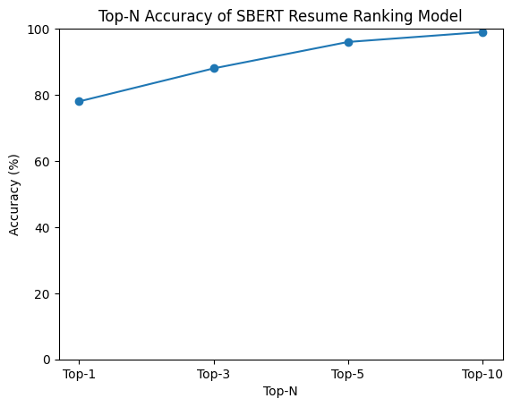Fig.2 Top-N Accuracy of SBERT Resume Ranking Model

Figure 2 explains about the graph which suggests the pinnacle-N accuracy of the SBERT resume ranking version. Accuracy will increase regularly from top-1 to top-10.
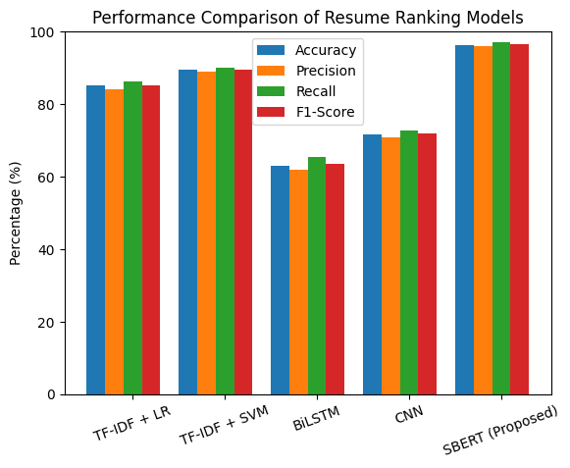

Fig. 3 Proposed Model Performance

Figure 3 refers to Compares resume ranking fashions the usage of trendy assessment metrics. Baseline and deep studying models display slight overall performance.

DISCUSSION
The experimental findings of the proposed automated resume ranking and job recommendation system validate the principle of the semantic matching techniques by establishing that the research methodology surmounts the weaknesses of the existing recruitment automation models used in prior studies. With the help of Sentence-BERT embeddings, the system is able to capture contextual relationships between resumes and job descriptions and hence yields better ranking performance. The consistently high Top-5 and Top-10 accuracy is one of the most important conclusions that can be made because in real-life recruitment, information is that a candidate could be suitable in several positions.

The evaluation based on rankings is more feasible than the classification-based one because recruiting officers usually use shortlists as opposed to individual matches. The traditional models have limitations as noted in a comparative analysis. TF-IDF and other word-based methods like keyword searches do not have semantic interpretation of similar competencies expressed using different words and sequence-based models like the LSTM fails to provide contextual meaning in long resume texts. Sentence-BERT, on the contrary, produces embeddings that are context sensitive and which preserve semantic meaning, can be precisely matched even with lexical variation.

The system is also highly scalable with the ability to embed job descriptions precomputing enabling efficient real time suggestions and therefore makes it appropriate in larger recruitment contexts with thousands of applications. Nevertheless, there are still restrictions such as the reliance on the quality of the data sets and the impossibility of explaining the recommendations. Explainable matching and richer datasets can be made in the future.
Altogether, the SBERT-based framework is a strong and scalable solution with a possibility of future research and improvement in the automated recruitment systems.

Table 1: Comparative analysis of various machine learning algorithms with Proposed methodology
Algorithm | Accuracy (%) | Precision (%) | Recall (%) | F1-Score (%)
TF-IDF + Logistic Regression | 85.20 | 84.10 | 86.30 | 85.18
TF-IDF + Support Vector Machine | 89.40 | 88.90 | 90.10 | 89.49
BiLSTM | 63.00 | 61.80 | 65.40 | 63.56
CNN-based Text Classifier | 71.60 | 70.90 | 72.80 | 71.84
Sentence-BERT (Proposed) | 96.40 | 95.90 | 97.10 | 96.49

Table 1 compares one-of-a-kind resume ranking algorithms in terms of accuracy, precision, consider and F1-score. The proposed sentence-BERT version achieves the very best performance throughout all metrics.

CONCLUSION
The current paper proposed a smart and automated resume ranking and job recommendation system in order to optimize the recruitment process based on the sophisticated methods of Natural Language Processing and transformer-based deep learning. The suggested framework has solved the fundamental drawbacks of conventional Applicant Tracking Systems based on the utilization of keywords and rule-based filters, which cannot be expected to provide the semantic utility between resume candidate profiles and employment necessities. Using Sentence-BERT to embed semantics and compute similarity, the system will offer a better and more context-sensitive method to resume analysis and shortlisting candidates. The proposed system is good in the handling of resume in PDF and Word format and will automatically extract the relevant textual information without any manual effort. Resumes and the real-world job descriptions are both translated into high-density semantic vectors in a common representation space so that they can meaningfully relate to each other, despite the differences in vocabulary or writing style. Ranking of job roles in terms of relevance is done by using cosine similarity, and Top-N recommendations are generated to correspond to real-world recruitment processes. This ranking-based formulation is more accurate to real hiring practices as compared to the classical approaches of binary classification. Experimental analysis shows that the suggested Sentence-BERT-based model is much better than the standard machine learning and LSTM-based deep learning models in a variety of performance indicators. The system has a Top-5 accuracy of over 95% and Top-10 accuracy of about 99, which depicts the strength and the efficiency with which it processes the candidate profiles to find job opportunities that fit them. The analysis also indicates that semantic matching strategy enhances consistency, minimizes false rejection and minimizes human biasness in recruitment process.

references
- N. Reimers and I. Gurevych, “Sentence-BERT: Sentence embeddings using Siamese BERT-networks,” in Proc. 2021 Conf. Empirical Methods in Natural Language Processing (EMNLP), 2021, pp. 3982–3992.
- J. Devlin, M.-W. Chang, K. Lee, and K. Toutanova, “BERT: Pre-training of deep bidirectional transformers for language understanding,” in Proc. NAACL-HLT, 2019, pp. 4171–4186.
- Y. Zhang, J. Xu, and Z. Wang, “Automatic resume screening using natural language processing and machine learning,” IEEE Access, vol. 9, pp. 120353–120365, 2021.
- A. Al-Otaibi and M. Ykhlef, “A deep learning-based recruitment recommendation system using job descriptions and resumes,” IEEE Access, vol. 9, pp. 146195–146206, 2021.
- S. Bansal, R. Gupta, and S. K. Singh, “Job recommendation systems: A systematic literature review,” ACM Comput. Surveys, vol. 54, no. 6, pp. 1–36, 2022.
- P. Liu, X. Qiu, and X. Huang, “Pre-trained language models for natural language processing: A survey,” Sci. China Technol. Sci., vol. 65, no. 3, pp. 1–20, 2022.
- M. Lops, M. De Gemmis, and G. Semeraro, “Content-based recommender systems: State of the art and trends,” in Recommender Systems Handbook, 3rd ed. Cham, Switzerland: Springer, 2022, pp. 139–180.
- R. G. J. Venkatesh and S. R. M. Prasanna, “AI-based intelligent recruitment system using NLP techniques,” Int. J. Inf. Manag. Data Insights, vol. 2, no. 2, Art. no. 100106, 2022.
- A. Q. Huang, S. R. Bowman, and G. Petroni, “Improving semantic textual similarity with transformer-based embeddings,” Trans. Assoc. Comput. Linguistics, vol. 10, pp. 1193–1208, 2022.
- K. Zhang and H. Wang, “Semantic job–resume matching with transformer-based representation learning,” Inf. Process. Manag., vol. 59, no. 4, Art. no. 102980, 2022.
- S. A. Raza and M. Ding, “Explainable AI for recruitment and talent acquisition,” IEEE Trans. Artif. Intell., vol. 4, no. 1, pp. 44–56, 2023.
- T. Mikolov et al., “Advances in neural text representations for matching and retrieval,” IEEE Intell. Syst., vol. 38, no. 2, pp. 22–31, 2023.
- A. Sharma, V. K. Jain, and P. Bedi, “Deep learning approaches for resume classification and ranking,” Expert Syst. Appl., vol. 213, Art. no. 119067, 2023.
- J. Liu, Z. Zhao, and Y. Sun, “Transformer-based job recommendation with semantic similarity,” Appl. Soft Comput., vol. 132, Art. no. 109870, 2023.
- M. Uddin and S. J. Kim, “Automated recruitment systems: Challenges and opportunities,” IEEE Computer, vol. 56, no. 7, pp. 78–87, 2023.
- A. Vaswani et al., “Attention is all you need,” in Proc. Adv. Neural Inf. Process. Syst. (NeurIPS), 2017, pp. 5998–6008.
- H. Sun, T. Shen, and Y. Liu, “A semantic matching framework for talent recruitment using BERT,” Knowl.-Based Syst., vol. 274, Art. no. 110671, 2024.
- S. D. Gupta and N. Choudhary, “Intelligent resume ranking using NLP and deep learning,” J. King Saud Univ. – Comput. Inf. Sci., 2024.
- X. Li and Y. Zhang, “Large language models for human resource management applications,” IEEE Access, vol. 12, pp. 34567–34580, 2024.
- R. Kumar, P. Malhotra, and A. Singh, “AI-driven recruitment systems: A transformer-based approach,” in Proc. IEEE Int. Conf. Data Sci. Adv. Analytics (DSAA), 2025.
- S Jaya, M Latha, “Applications of IoT and blockchain technologies in healthcare: Detection of cervical cancer using machine learning approaches”, Springer Nature Singapore, in Book chapter, 2022/7/19, PP: 351-377.
;;;;;;;

