**PROJECT 08**

**PUBLIC TRANSPORTATION EFFICIENCY ANALYSIS**

**INNOVATION METHODS**

We can use data from station sensors and ticketing systems to monitor passenger flow at public places. We can implement crowd management strategies to distribute passengers efficiently among available vehicles like public bus, train etc.

Preventing overcrowding and ensure passenger safety by installing image sensing programs that can analysis for crowd in public transport.

Implementation of chat bots or AI-powered virtual assistants to assist passengers with inquiries and issues

**MACHINE LEARNING ALGORITHMS**

We can use some of the machine learning algorithms like Time series Analysis, Natural language processing

**Time Series Analysis:** Public transport data often involves time series data, and algorithms like ARIMA (Auto Regressive Integrated Moving Average) can be used to forecast ridership and traffic patterns

**Neural Networks:** Deep learning models, such as recurrent neural networks (RNNs) can be used for time series forecasting and sequence-to-sequence tasks like predicting arrival times.

**Natural Language Processing (NLP):** NLP techniques can be used for sentiment analysis of user feedback or for chat bots to assist passengers with inquiries and issues.

**DEVELOPMENT PART 1**

**LOADING AND PREPROCESSING THE DATASET**

Import pandas as pd

df = pd.read_csv(‘Transport data’)

df.style

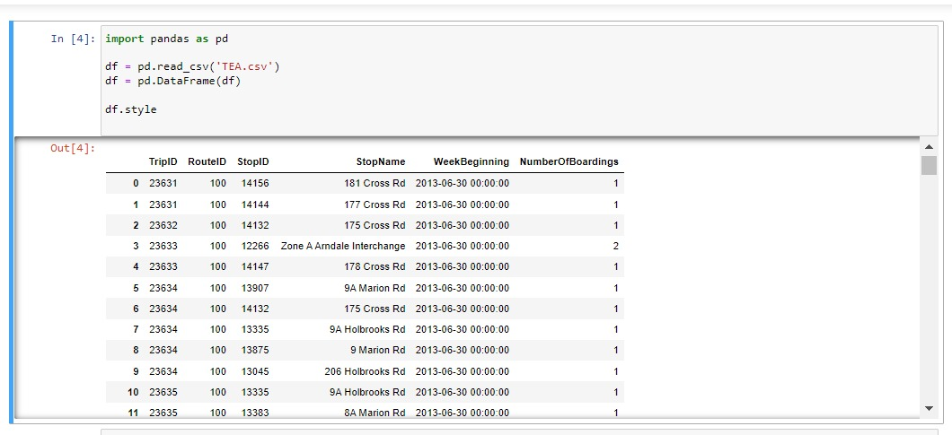

Reading of data set for cleaning and preprocessing of data to ensure the accuracy and its quality**.**

**CLEANING OF DATA AND ENSURING NO REPLICATION’S AND DUPLICATE DATA**

For cleaning of a data set we are going to use the pandas as following:

df.fillna(df)

df.dropna()

df.drop_duplicates()

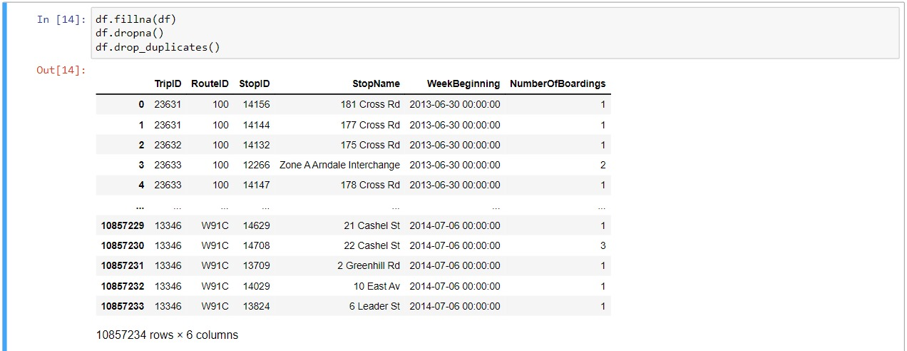

**TO FIND THE DATA TYPES OF THE DOMAINS IN THE DATA SET**

Print(df.dtypes)



**TO GATHER INFORMATIONS ADOUT THE DATA AND DESCRIBING THE DATA SET**

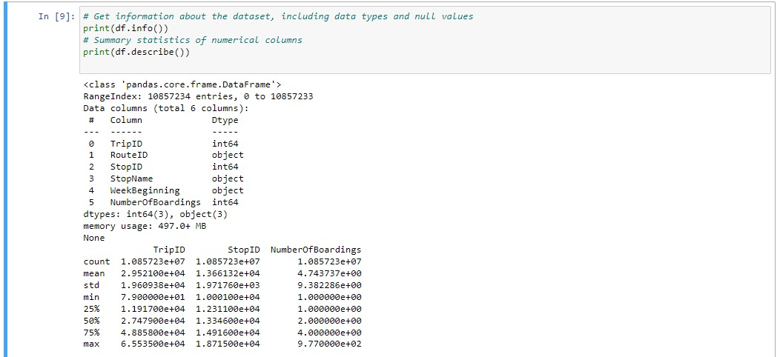

**VISUALIZATION OF THE DATA SET USING IBM COGNOS FOR VISUALIZATION**

**1) NO OF BOARDING BY STOP NAME**

Stop Name W1 North Tce has the highest total Number of Boardings due to Stop ID 13297.

Number Of Boardings is unusually high when Stop Name is W1 North Tce and I1 North Tce.

Across all values of Stop Name, the sum of Number of Boardings is over 4.3 million.

Number Of Boardings ranges from 1, when Stop Name is 11 East Av, to over 122 thousand, when Stop Name is W1 North Tce.

For Number Of Boardings, the most significant values of Stop Name are W1 North Tce and I1 North Tce, whose respective Number Of Boardings values add up to over 238 thousand, or 5.5 % of the total.

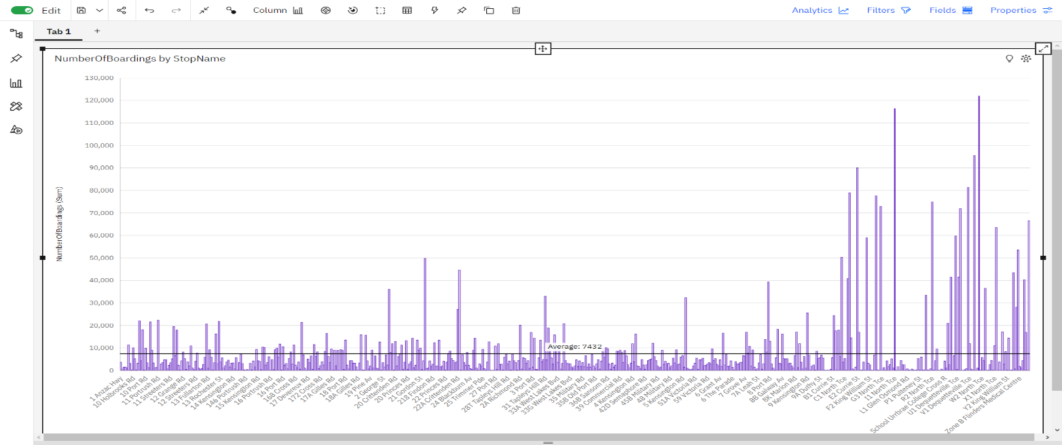

**2) NO OF BOARDING BY WEEK BEGINNING**

Number Of Boardings is unusually low when Week Beginning is 12/22/2013 0:00 and 12/29/2013 0:00.

Across all values of Week Beginning, the sum of Number Of Boardings is over 4.3 million.

Number Of Boardings ranges from over 37 thousand, when Week Beginning is 12/22/2013 0:00, to almost 99 thousand, when Week Beginning is 3/2/2014 0:00

.

**3)NO OF BOARDINGS BY ROUTE ID**

Route ID 150 has the highest total Number of Boarding due to Stop ID 13297.

Number of Boardings is unusually high when Route ID is 150.

Stop ID 13297 has the highest Number of Boardings at over 122 thousand, out of which Route ID 150 contributed the most at over 45 thousand.

Across all values of Route ID, the sum of Number of Boardings is over 4.3 million.

Number of Boardings ranges from 260, when Route ID is 100S, to nearly 425 thousand, when Route ID is 150

**4) NO OF BOARDING BY STOP ID**

Number of Boardings is unusually high when Stop ID is 13297 and 13278.

150 Route ID accounted for 37% of 13297 Number of Boardings compared to 0% for 13278.

Route ID 150 has the highest Number of Boardings at nearly 425 thousand, out of which Stop ID 13297 contributed the most at over 45 thousand.

Stop ID 13297 has the highest total Number of Boardings due to Route ID 150.

Across all values of Stop ID, the sum of Number of Boardings is over 4.3 million.

Number of Boardings ranges from 1, when Stop ID is 13277, to over 122 thousand, when Stop ID is 13297.

For Number of Boardings, the most significant values of Stop ID are 13297 and 13278, whose respective Number of Boardings values add up to over 238 thousand, or 5.5 % of the total.

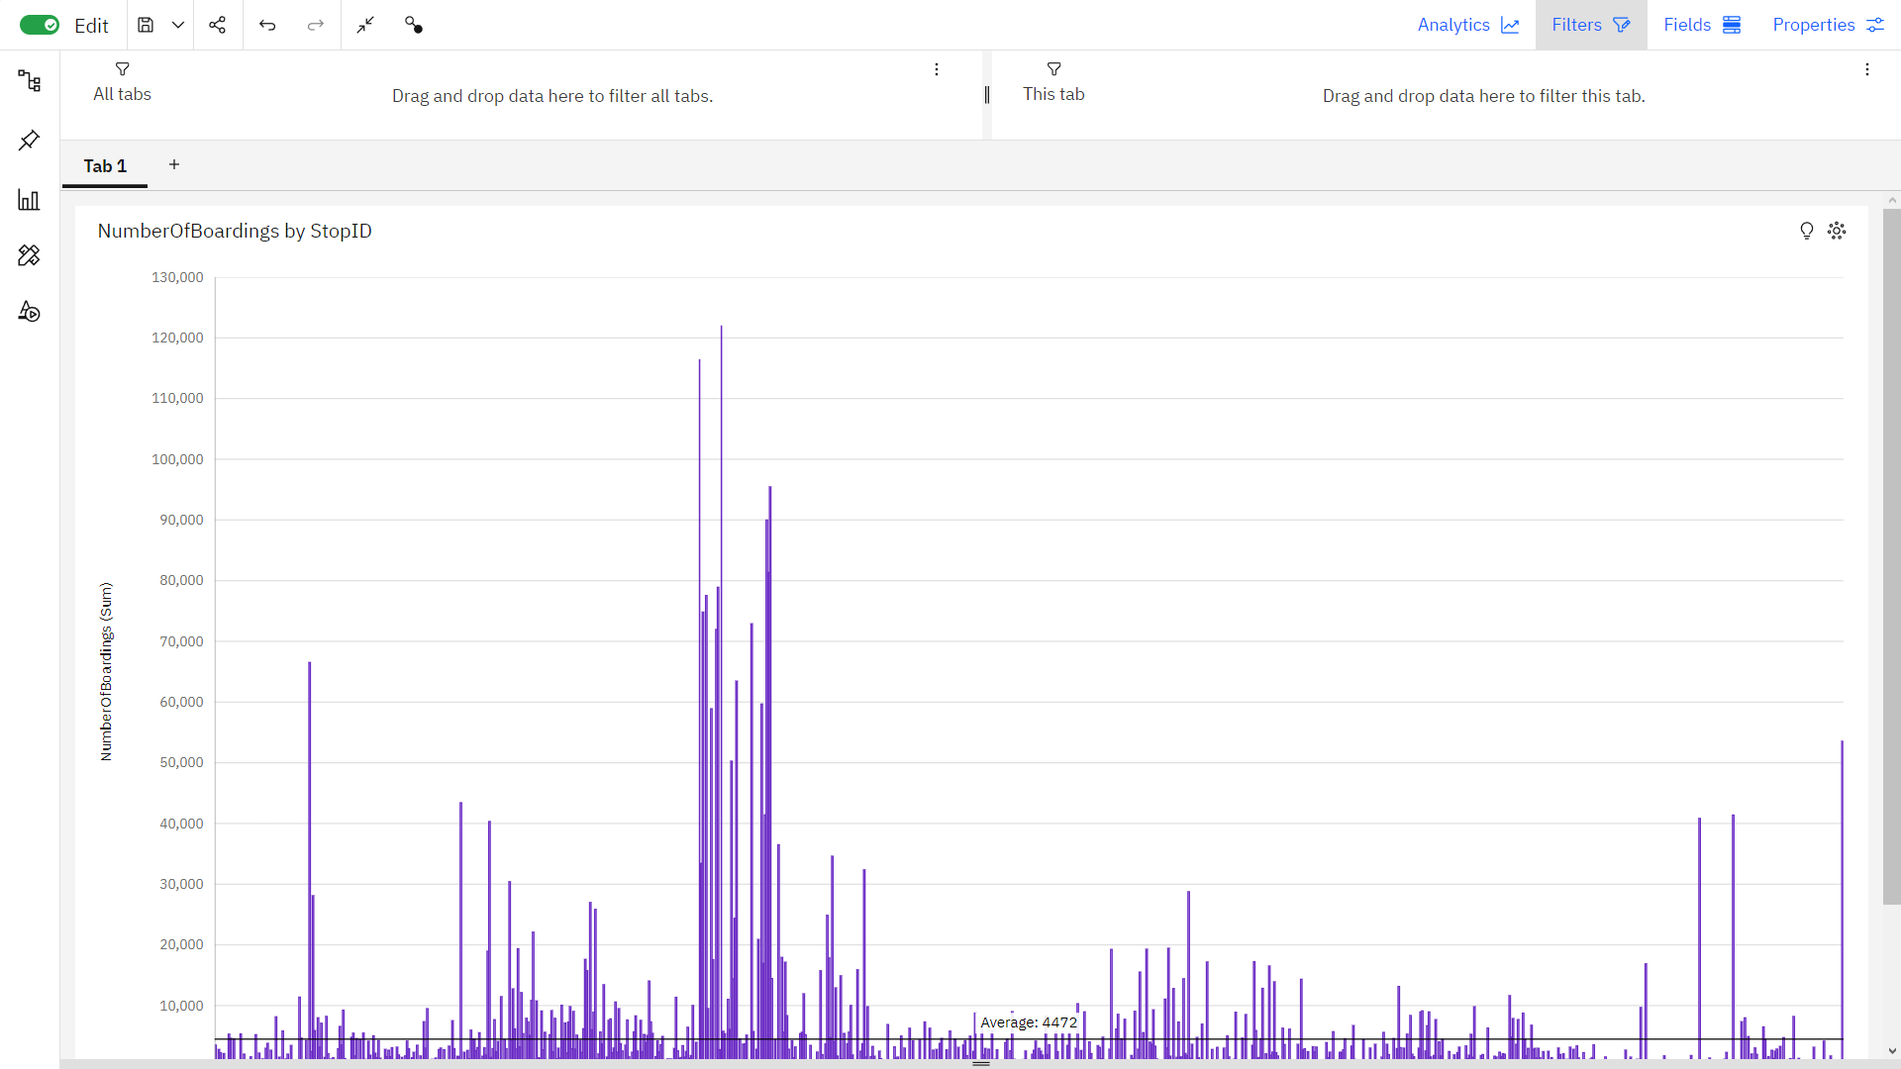

**5) NO OF BOARDINGS BY TRIP ID**

**Development Part 2**

Analysis by creating visualizations using IBM Cognos and integrating code for data analysis.

* **Designing dashboards**

**NUMBER OF BOARDINGS BY WEEK BEGINING**

* Number Of Boardings is unusually low when Week Beginning is 12/22/2013 0:00 and 12/29/2013 0:00.
* Across all values of WeekBeginning, the sum of NumberOfBoardings is over 4.3 million.
* NumberOfBoardings ranges from over 37 thousand, when WeekBeginning is 12/22/2013 0:00, to almost 99 thousand, when WeekBeginning is 3/2/2014 0:00.

**NO OF BOARDING BY STOP NAME**

* StopName W1 North Tce has the highest total NumberOfBoardings due to StopID 13297.
* NumberOfBoardings is unusually high when StopName is W1 North Tce and I1 North Tce.
* Across all values of StopName, the sum of NumberOfBoardings is over 4.3 million.
* NumberOfBoardings ranges from 1, when StopName is 11 East Av, to over 122 thousand, when StopName is W1 North Tce.
* For NumberOfBoardings, the most significant values of StopName are W1 North Tce and I1 North Tce, whose respective NumberOfBoardings values add up to over 238 thousand, or 5.5 % of the total.

**NO OF BOARD BY ROUTE ID**

* RouteID 150 has the highest total NumberOfBoardings due to StopID 13297.
* NumberOfBoardings is unusually high when RouteID is 150.
* StopID 13297 has the highest NumberOfBoardings at over 122 thousand, out of which RouteID 150 contributed the most at over 45 thousand.

**TRIP ID BY STOP NAME**

* StopName 2 Port Rd has the highest TripID due to StopID 13205.
* R1 North Tce has a TripID of 853 for StopID 13279.
* I1 North Tce is the most frequently occurring category of StopName with a count of 12,678 items with TripID values (1.2 % of the total).
* The total number of results for TripID, across all StopName, is over 1.0 million.
* **SENTIMENTAL ANALYSIS**
* Installation of the TextBlob library and pandas

pip install textblob

pip install pandas

* **IMPORT THE REQUIRED LIBRARIES**

* Importing the required libraries for sentimental analysis

import pandas as pd

from textblob import TextBlob

* **LOADING TRANSPORTATION DATASET INTO A PANDAS DATA FRAME**

data = pd.read_csv("your_transportation_data.csv")

* **PERFORM SENTIMENT ANALYSIS:**
* Assuming we have a 'Comments' column containing passenger feedback, we can analyze the sentiment of each comment and create a new column with sentiment scores.

def analyze_sentiment(comment):

analysis = TextBlob(str(comment))

sentiment_score = analysis.sentiment.polarity # Ranges from -1 (negative) to 1 (positive)

return sentiment_score

data['Sentiment'] = data['Comments'].apply(analyze_sentiment)

* **OUTPUT**
* The output of the program I for sentiment analysis won't be a typical text output; instead, it will update your Data Frame with a new 'Sentiment' column that contains sentiment scores for each comment in our dataset. The scores will indicate the sentiment of the feedback as a numerical value.
* The 'Sentiment' column will contain sentiment scores ranging from -1 (indicating a negative sentiment) to 1 (indicating a positive sentiment). Scores close to 0 suggest a more neutral sentiment.
* **OUTPUT FOR THE FOLLOWING PROGRAM OF SENTIMENTAL ANALYSIS**

**TripID RouteID StopID ... WeekBeginning NumberOfBoardings Sentiment**

0 1 101 101 2023-01-01T00:00:00-08:00 50 0.3

1 2 101 102 2023-01-01T00:00:00-08:00 60 -0.2

2 3 102 201 2023-01-01T00:00:00-08:00 30 0.7

3 4 102 202 2023-01-01T00:00:00-08:00 40 -0.5

4 5 103 301 2023-01-01T00:00:00-08:00 70 0.1

...