1. The Docker creation, ECR, Amazon ECS cluster, task definition and AWS Fargate service definition is done in earlier paper. Here only the steps for creating AWS CloudFormation tasks are defined.
2. AWS S3 creation with bucket

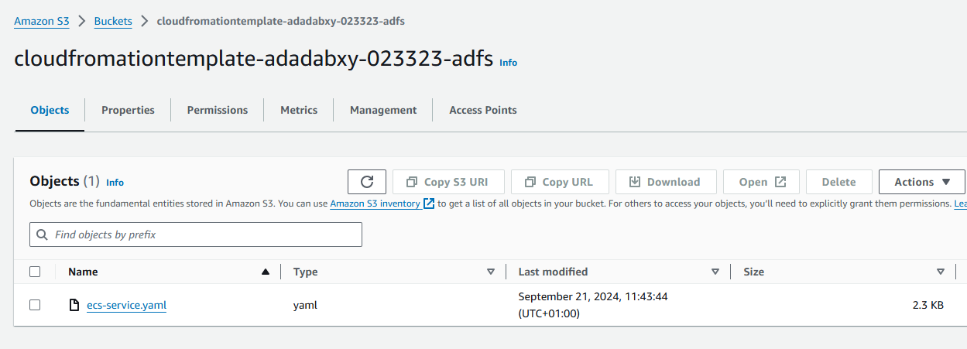

1. AWS Lambda creation
2. AWS IAM roles

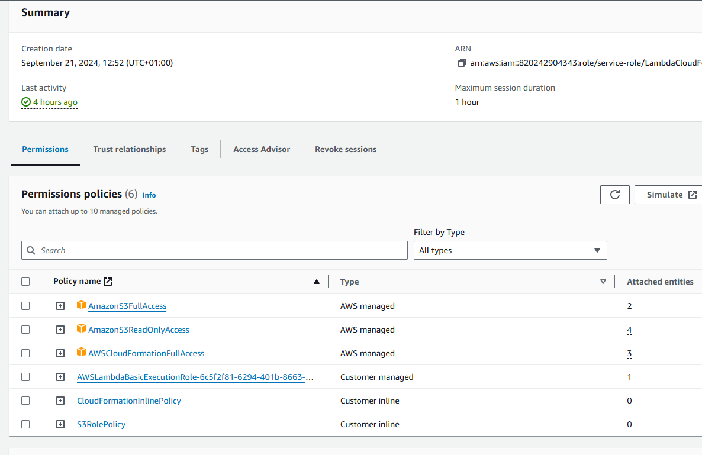

1. AWS EventBridge Schedule

Add EventBridge schedule for Start

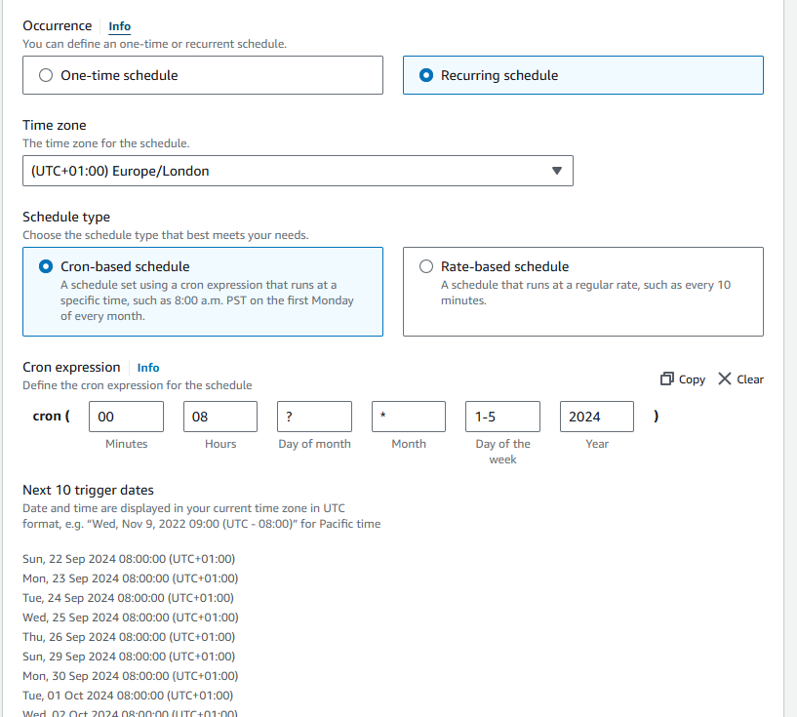

1. Add Stop schedule for Amazon EventBridge schedule

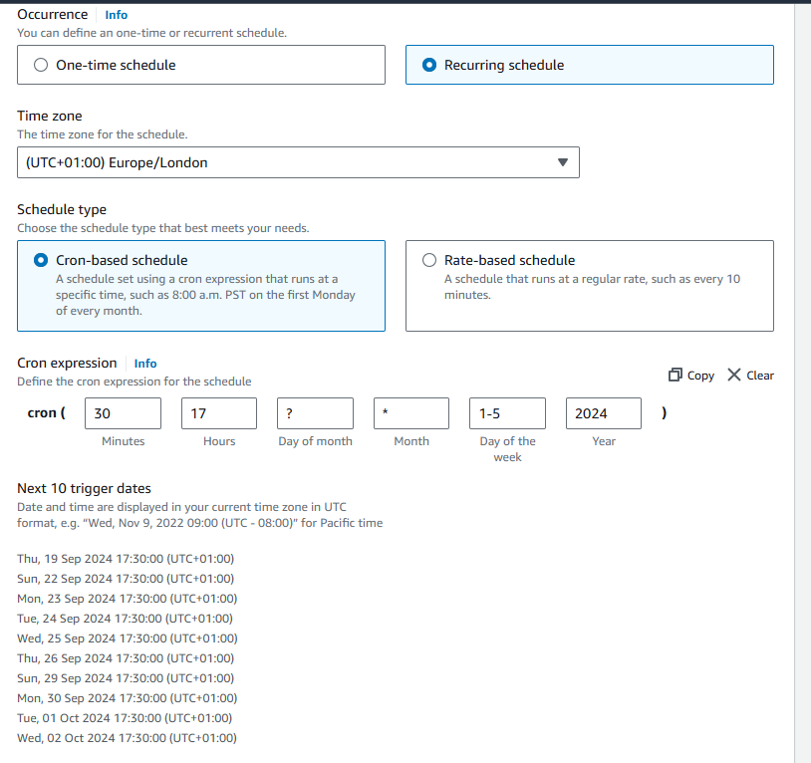

1. The PayLoad for passing the values for Amazon EventBridge schedule

