1. Create a python file which will work as dummy service

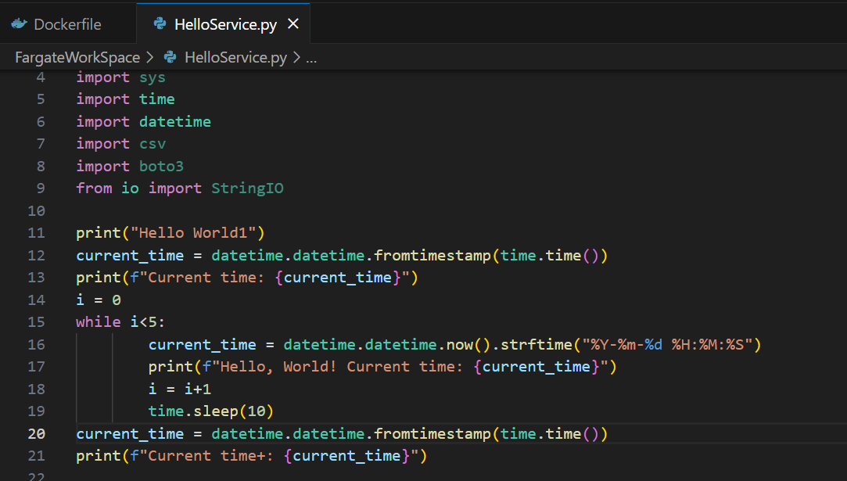

1. Create a DockerFile

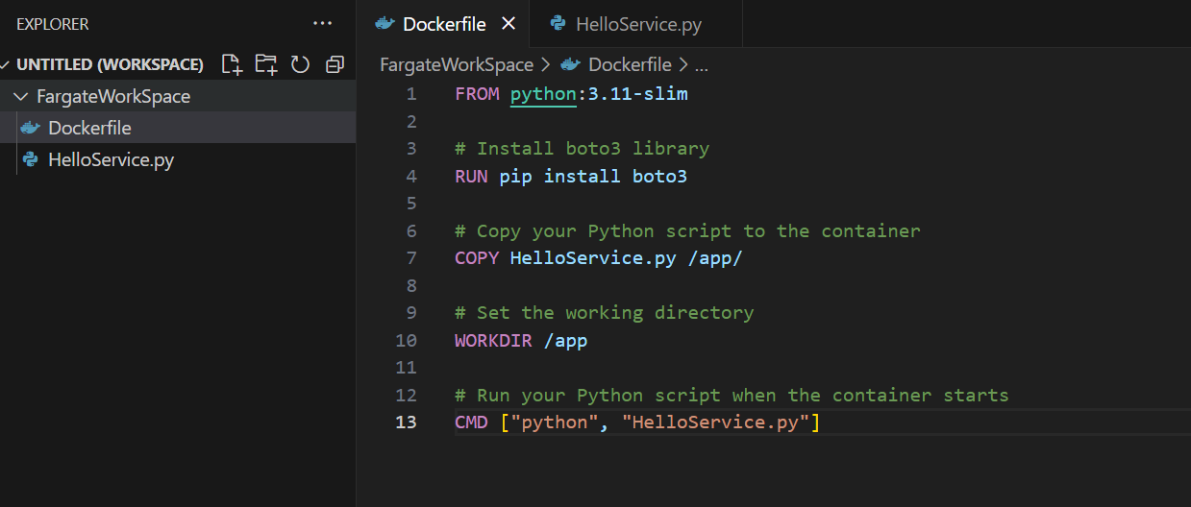

1. Create an ECR repository, and access key for access key and password

Use the following commands for docker build and push to ECR repository

docker build -t helloservicefargate .

docker run helloservicefargate

aws ecr get-login-password --region us-east-1 | docker login --username AWS --password-stdin <ecr repsitory>

docker build -t helloservicefargate .

docker tag helloservicefargate:latest <ECR repository URI>

docker push <ECR repository URI>/helloservicefargate:latest

1. The image is uploaded in ECR repository which will be used to get non-production environment services

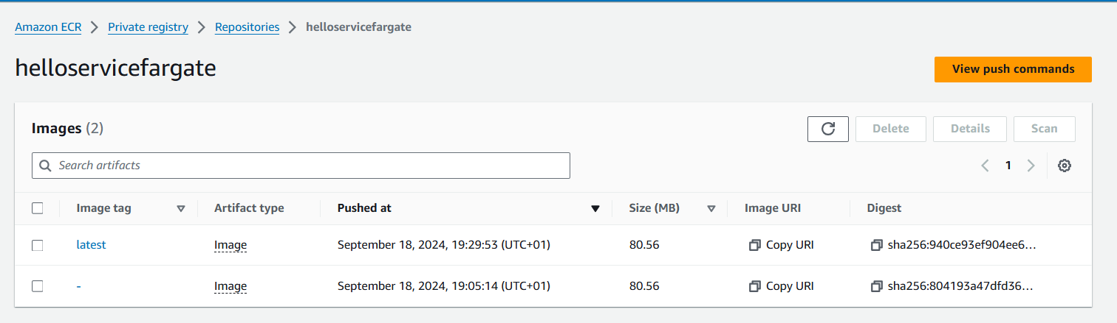

1. Creation of ECS Cluster with Fargate capacity
2. Create a ECS Task definition with ECR image created

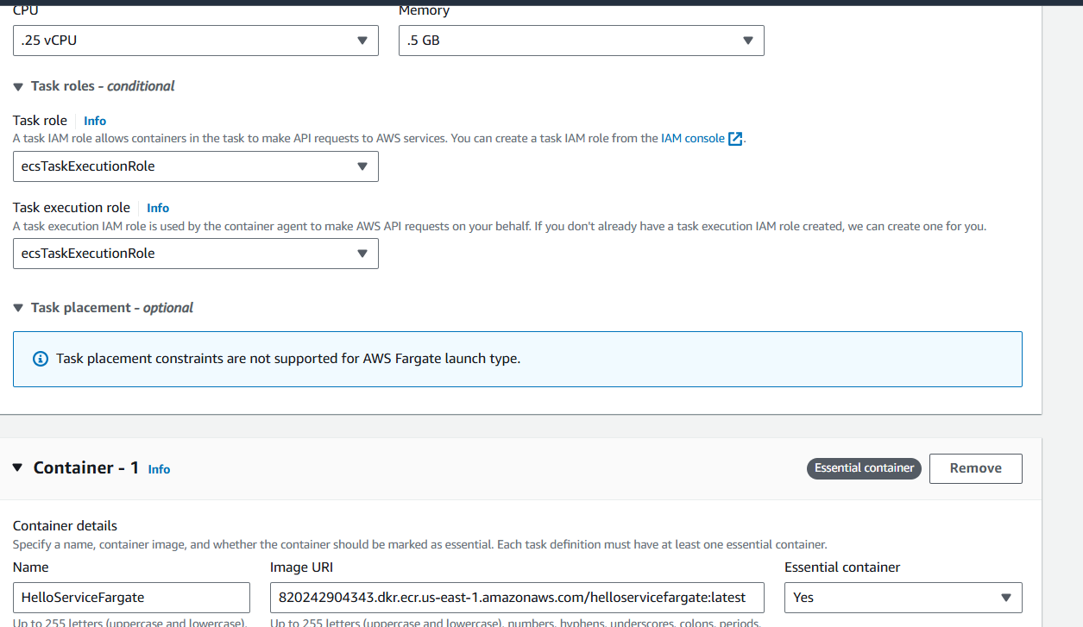

1. Creation of ECS service Dev with tags

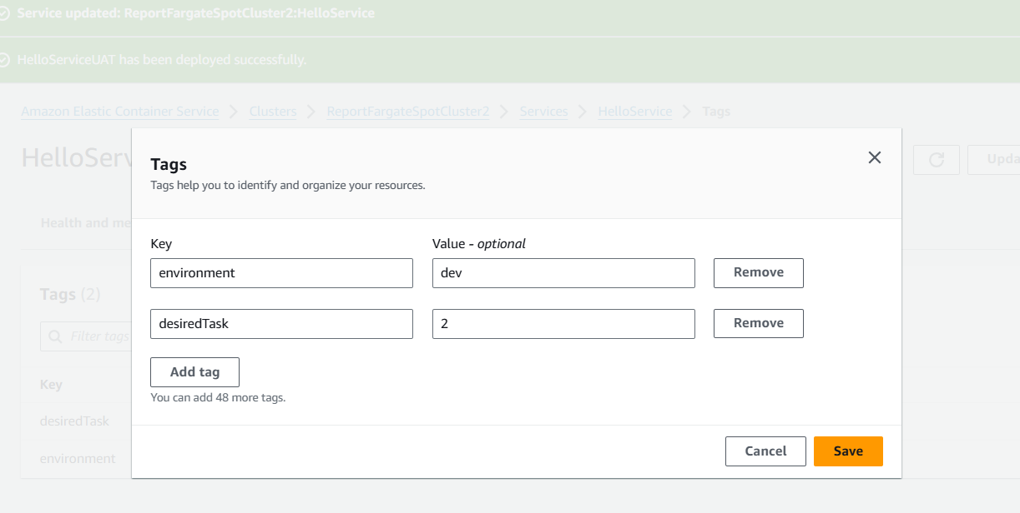

1. Creation of ECS Service UAT with tags

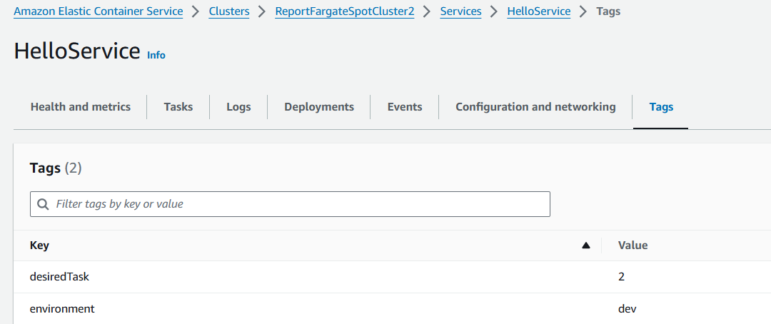

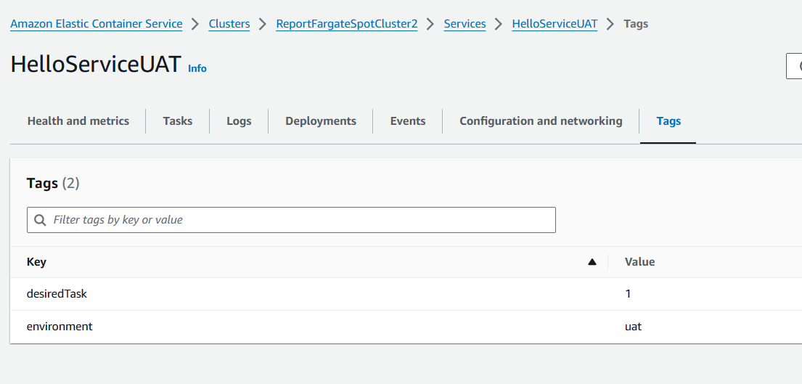

1. Write the code which will be invoked from EventBridge
2. Add EventBridge schedule for Start

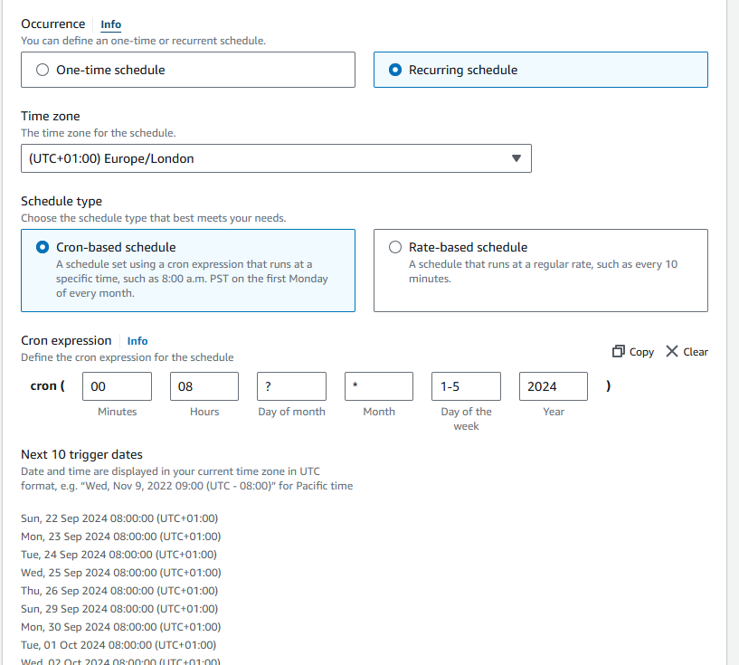

1. Add EventBridge schedule for Stop

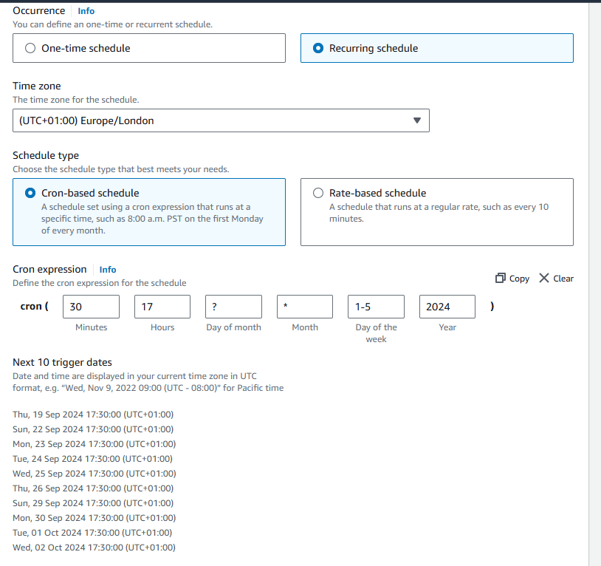

1. Update the Payload with required values

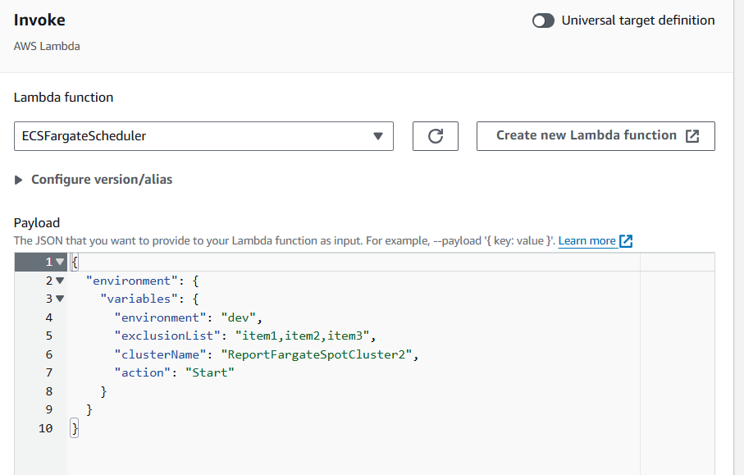

1. Attach the policy to Lambda execution role

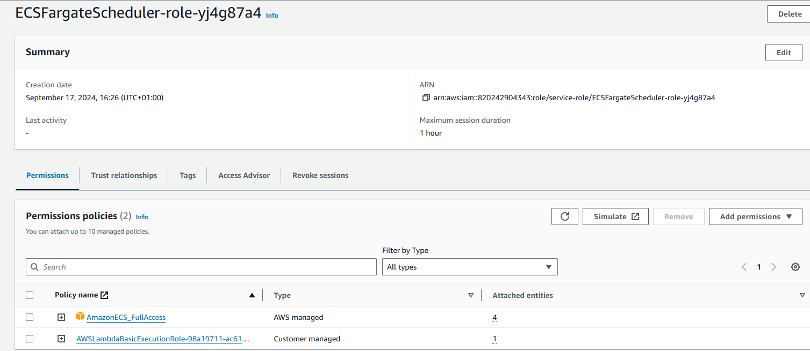

1. The lambda is executed from EventBridge

Dev service is started and UAT not started

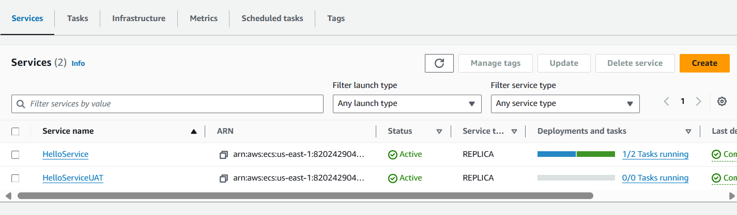

1. Task draining after stop executed from EventBridge scheduler payload

