ARM64 EC2

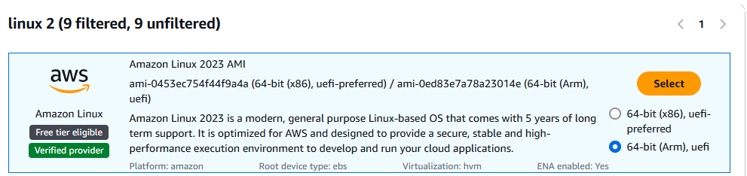

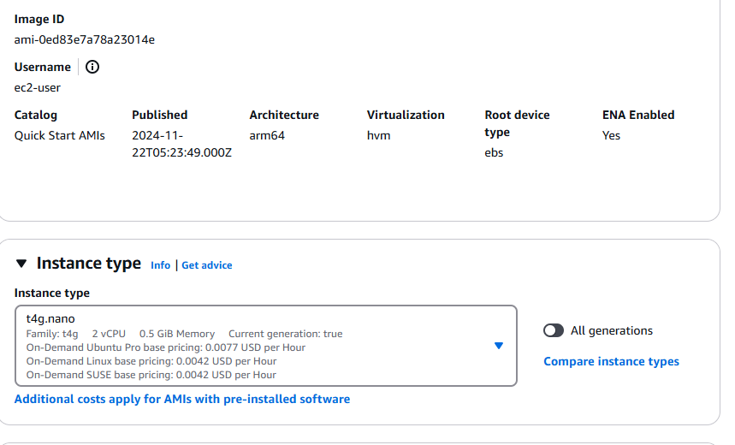

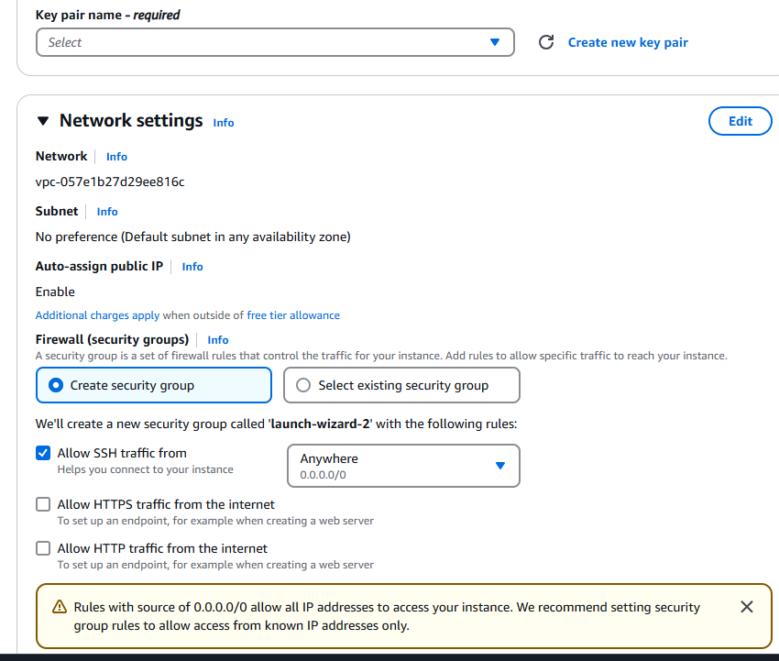

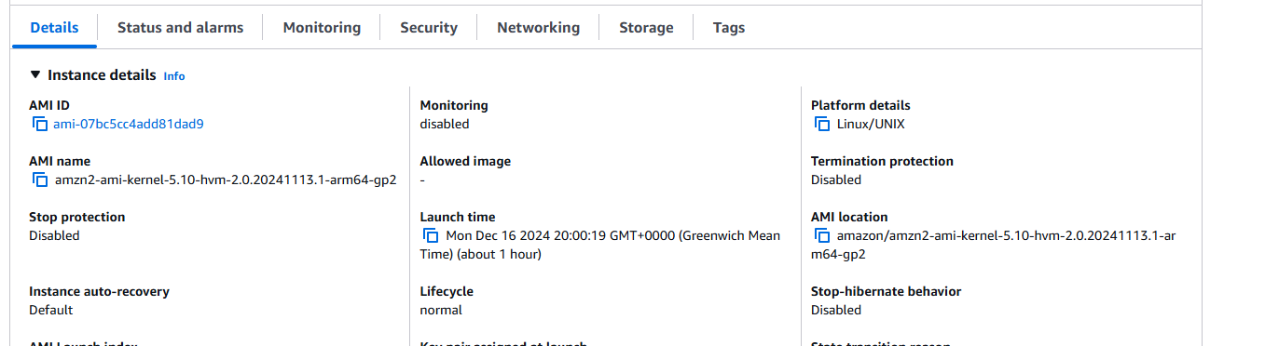

===========================================================================

1. Login to EC2 using ssh using pem



1. Command sudo yum update -y

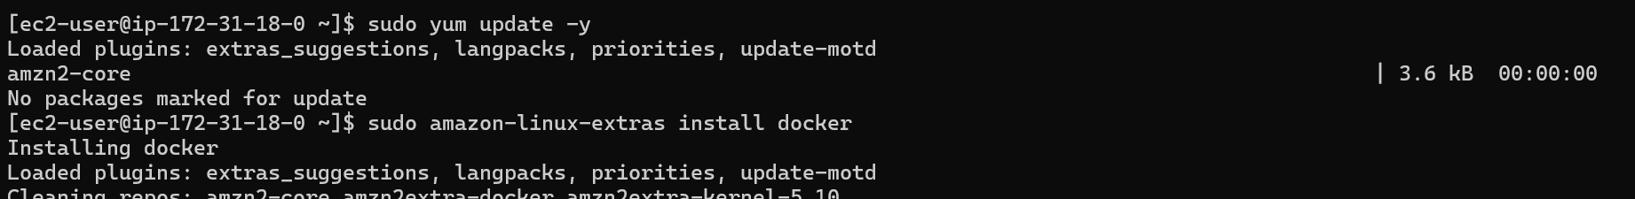

1. Command sudo amazon-linux-extras install docker

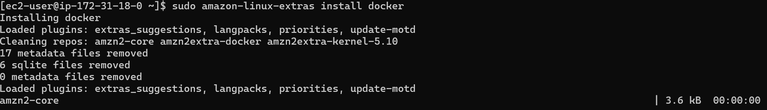

1. Command

sudo systemctl start docker

sudo systemctl enable docker

sudo usermod -aG docker $USER

cd my-docker-project

1. vim Dockerfile
2. vim HelloWorld.py
3. Command sudo usermod -aG docker $USER
4. Command newgrp docker
5. Command docker build -t hello-world-arm64 .

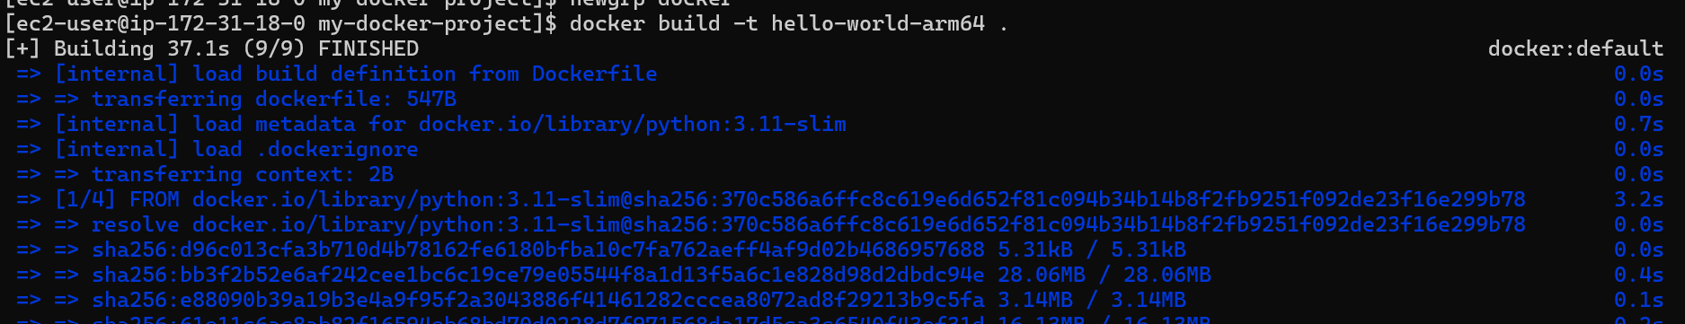

1. Command docker images



1. Command docker run hello-world-arm64

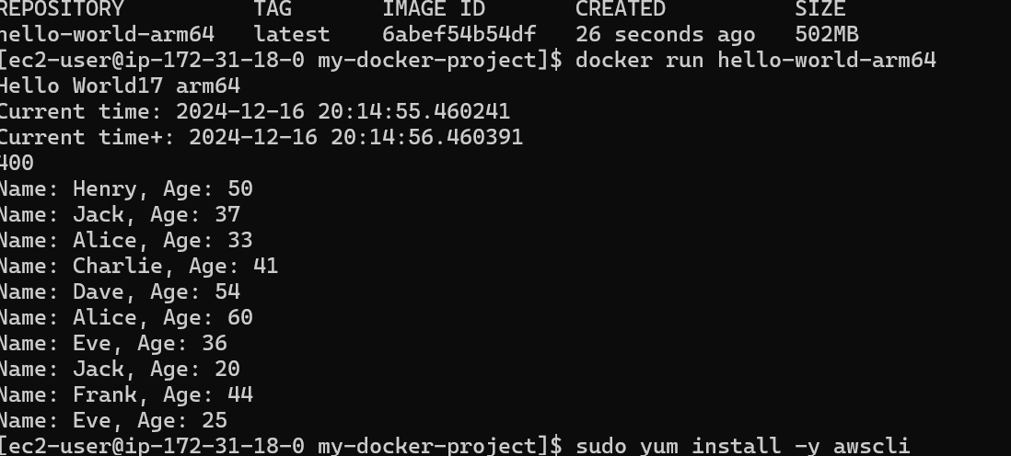

1. Command docker tag hello-world-arm64:latest <accountid>.dkr.ecr.us-east-1.amazonaws.com/helloworldfargategraviton
2. Command docker push <accounted>.dkr.ecr.us-east-1.amazonaws.com/helloworldfargategraviton

