1. Api Gateway http api which will connect with Lambda

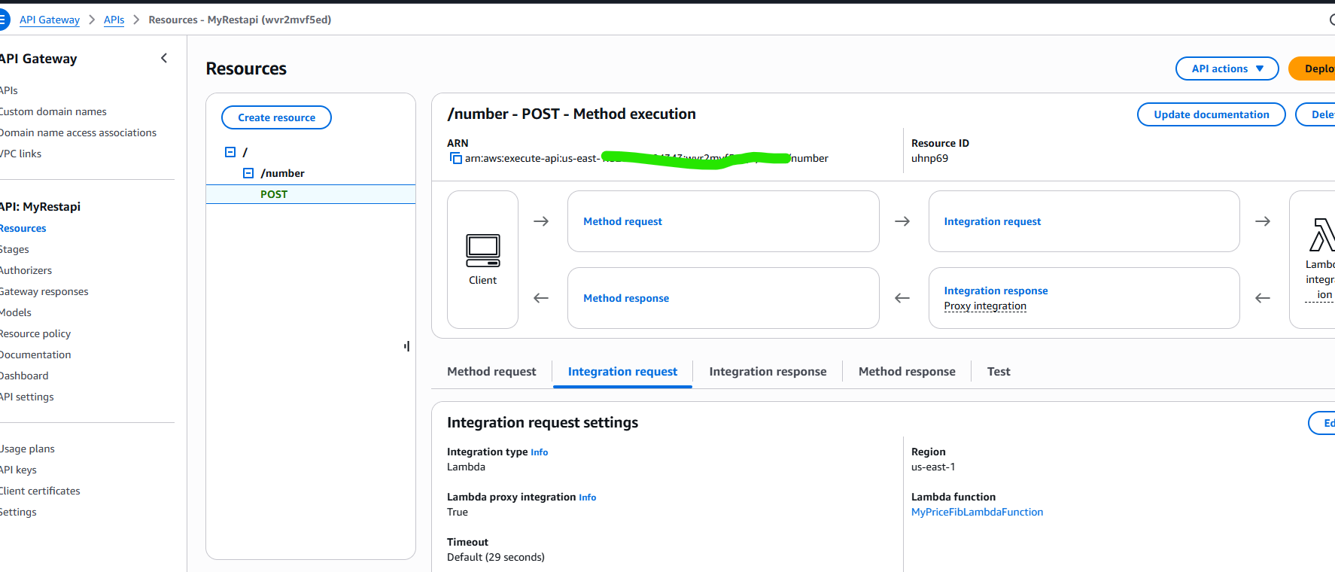

1. Create an EC2 which can be used by Apache Bench

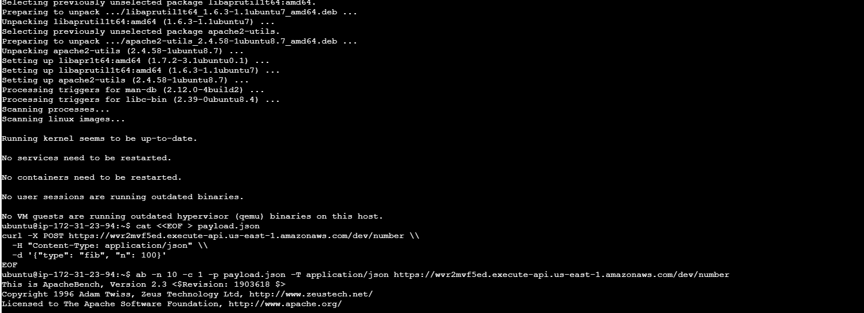

1. Log files created in S3 bucket

