1. Create main Lambda function that will work as microservice

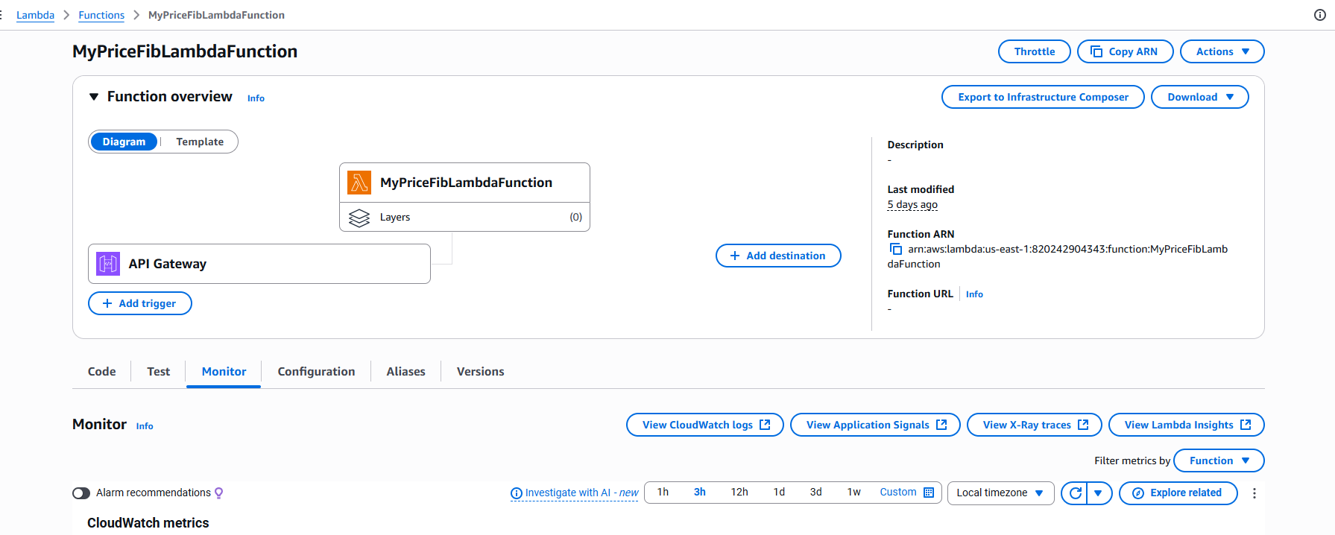

1. Update the Log to send to Firehose

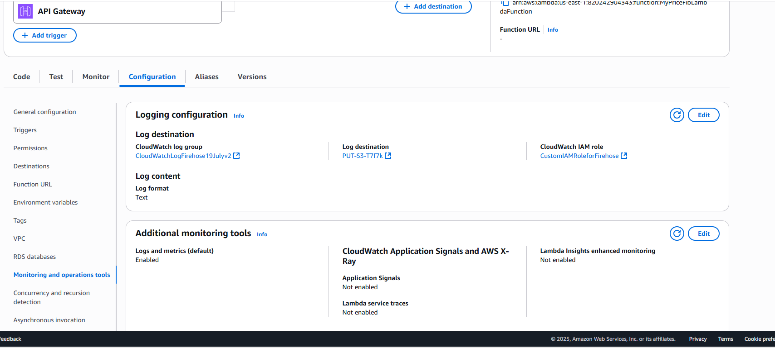

1. Create New log group. Attache the firehose and role.

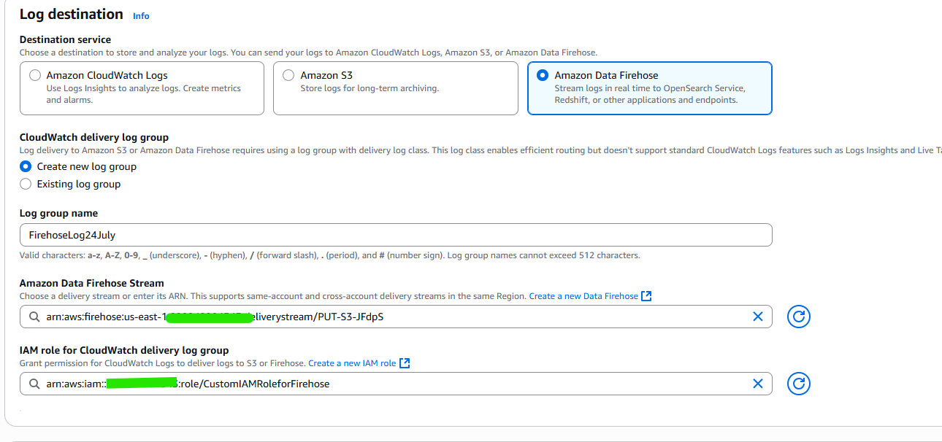

1. Update the role used by Lambda to push to right Firehose. Update the policy with Firehose ARN in the role.

