1. Create an event notification on S3 bucket where new logs coming will the trigger the lambda.

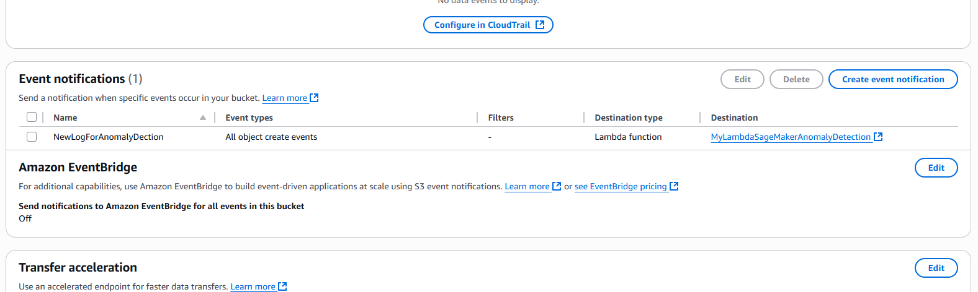

1. **Lambda c**reated which will invoke the endpoint for anomaly detection.

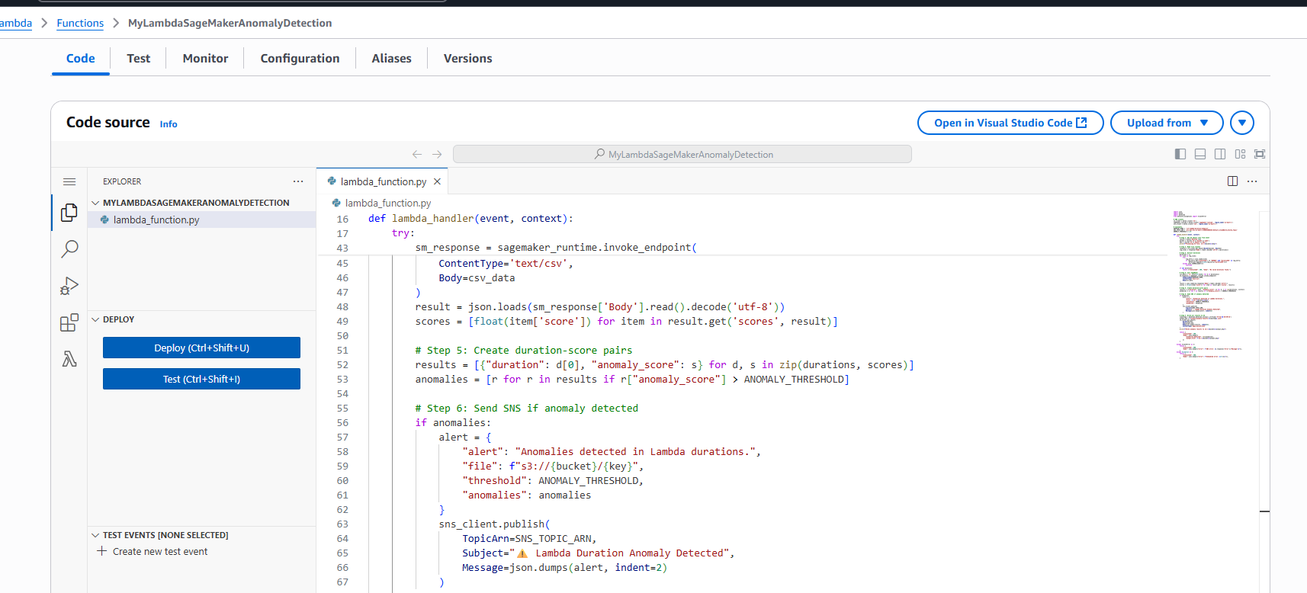

1. **New file with loggers loaded in bucket**

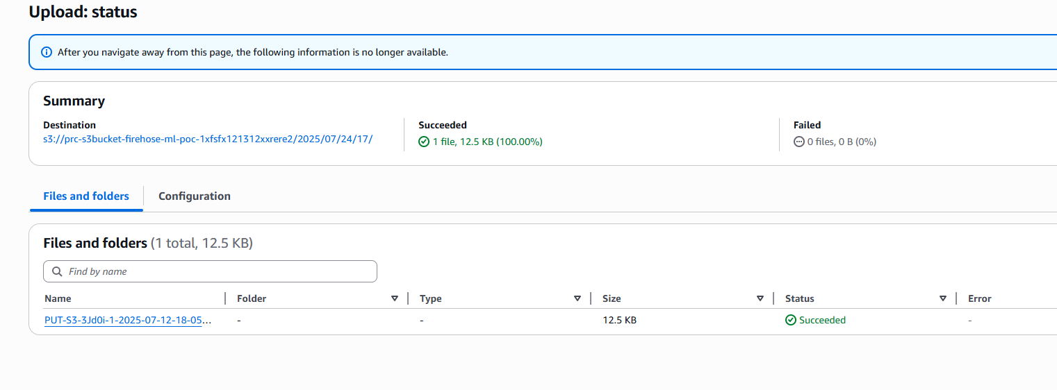

1. **Lambda duration anamoly detection done**

