1. Create Sagemaker AI

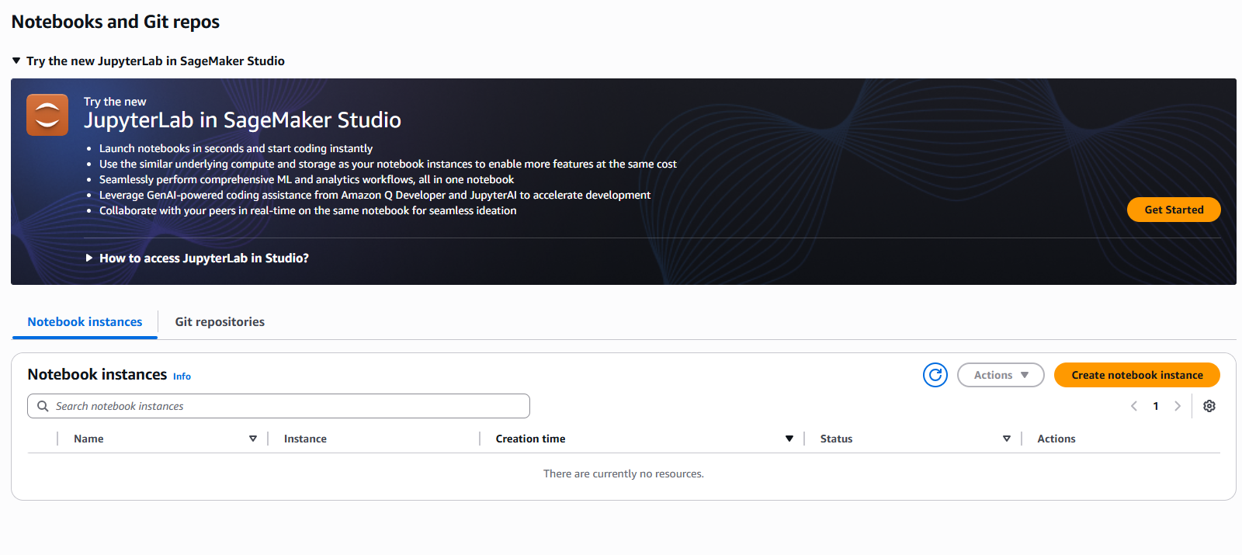

1. Select Instance Model

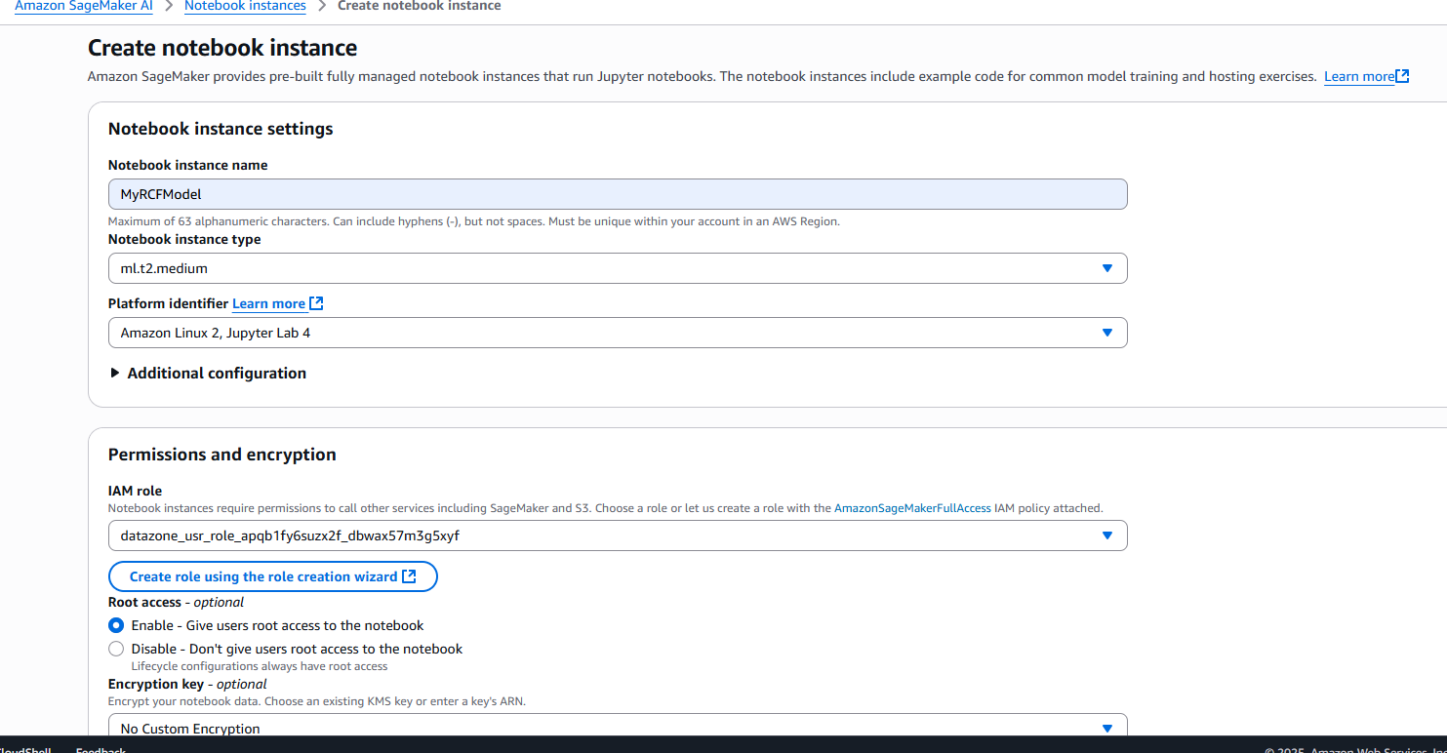

1. Wait for the status to complete from pending

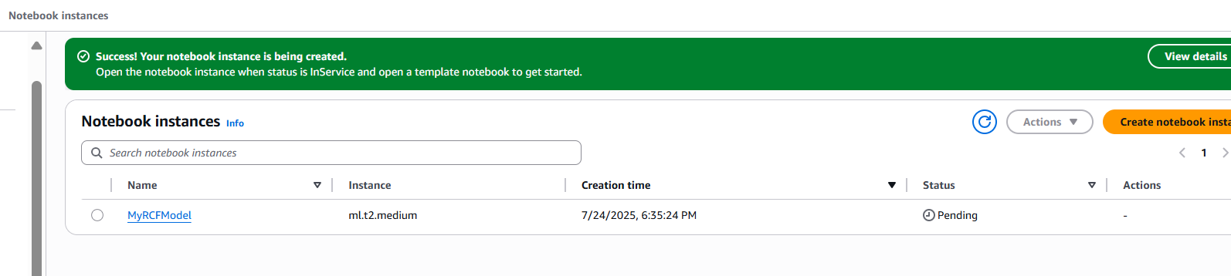

1. RCFModel Sagemaker AI

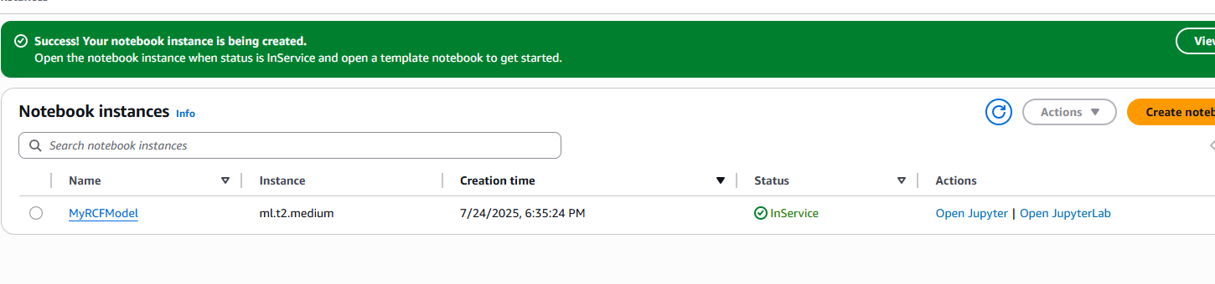

1. The IAM access

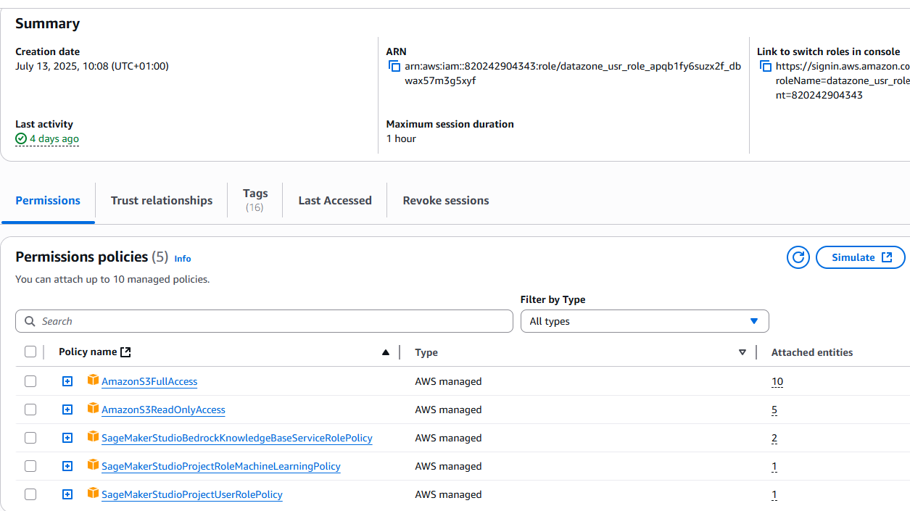

1. Create the sagemaker AI notebook with python

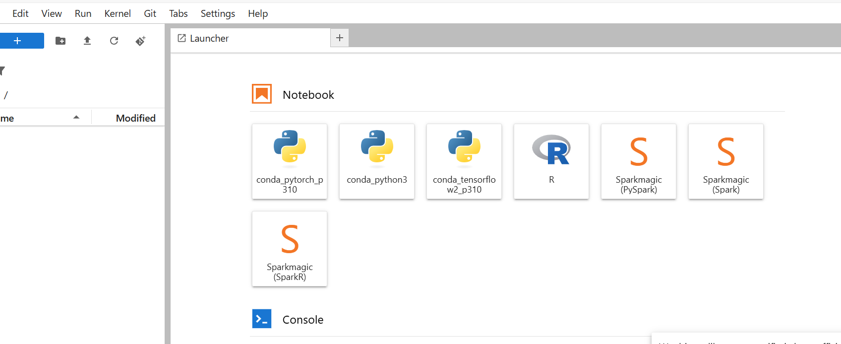

1. Train the job

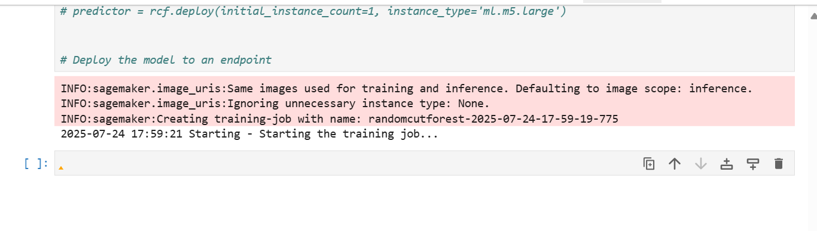

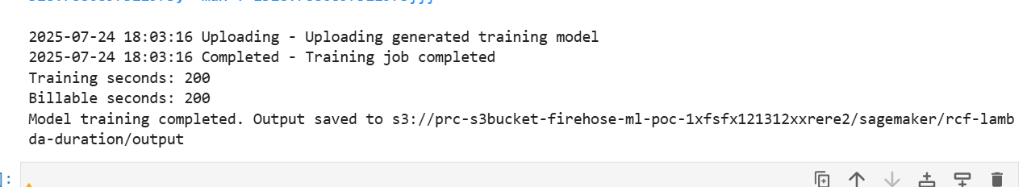

1. The output is stored in following S3 location

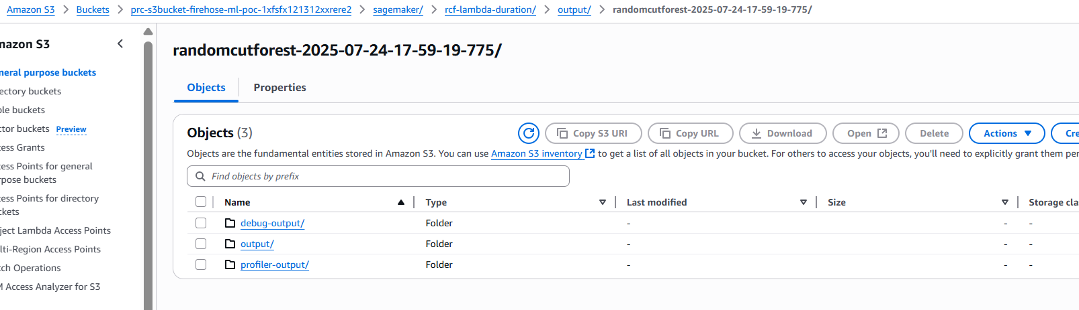

1. Endpoint is getting deployed

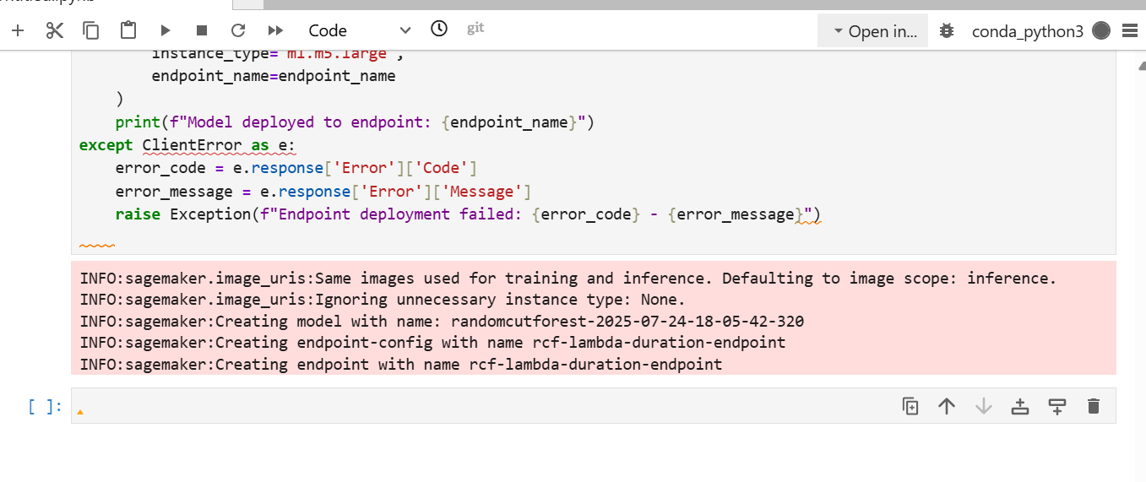

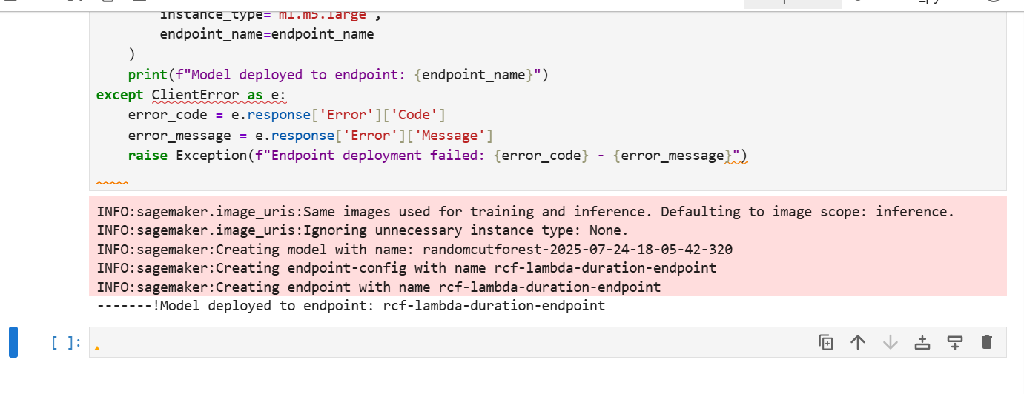

1. The endpoint is validated

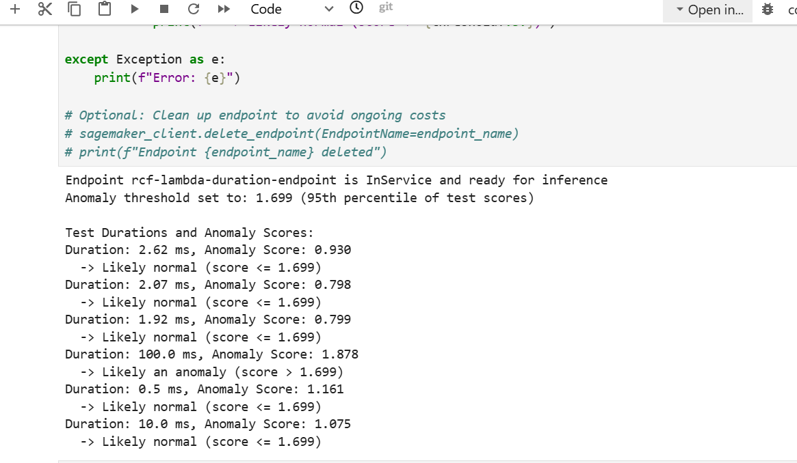

1. Sagemaker resources cleanup

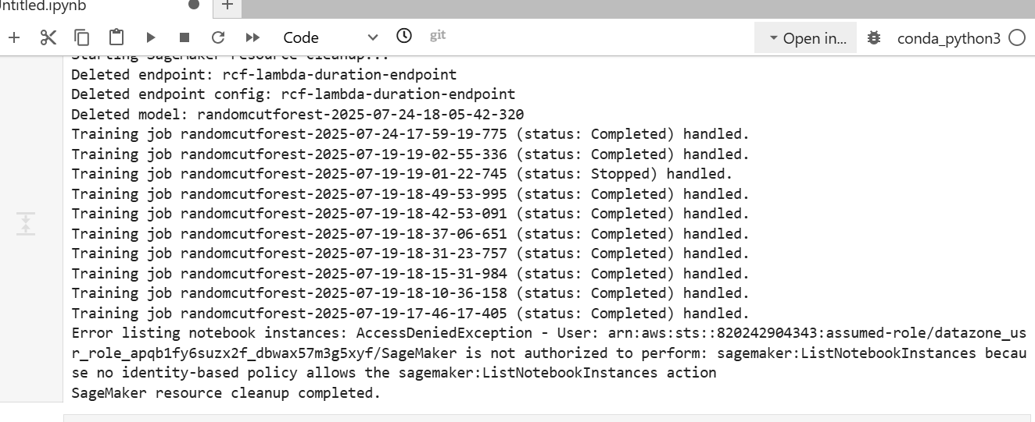

1. Stop the Jupyter Lab

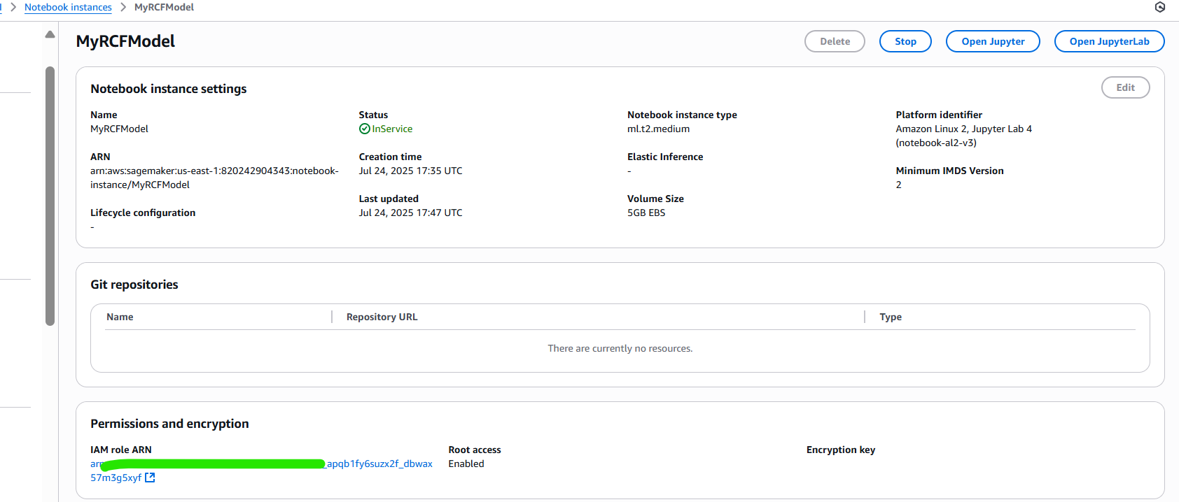

1. Delete the Notebook

