1. Create transformative lambda that will get invoked from Firehose to place the data in S3.

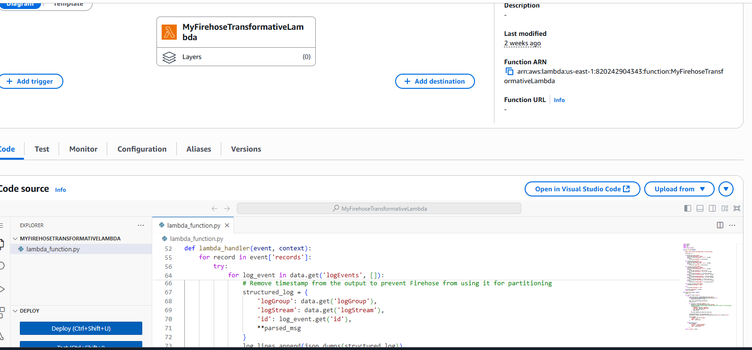

1. Timeout set at 5 mins

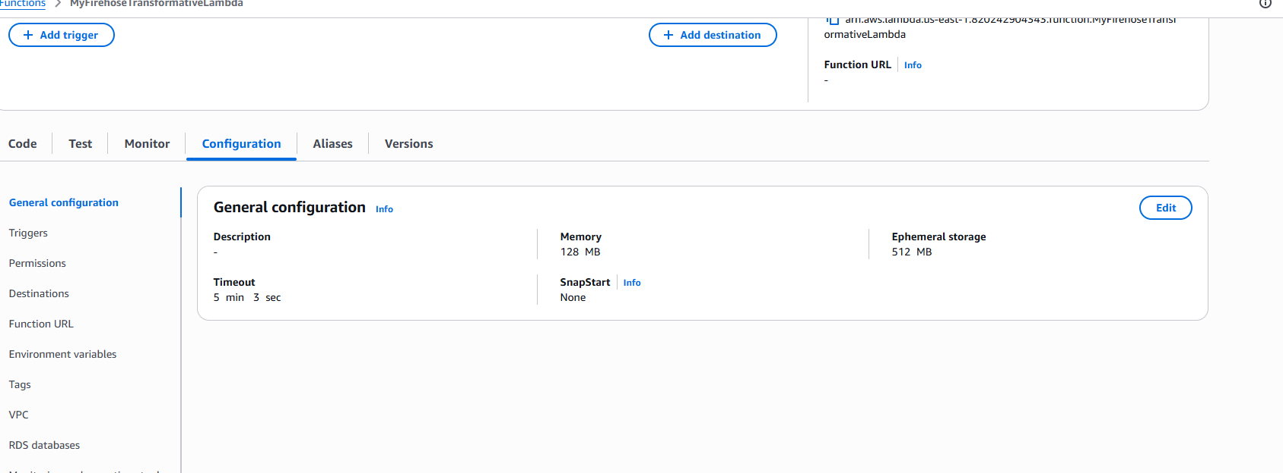

1. Lambda should have following access

