# Problem 1

## Objective

Develop a program capable of rasterizing circles.

## Requirements

* The user interface should show a single window containing a 20x20 grid of points.

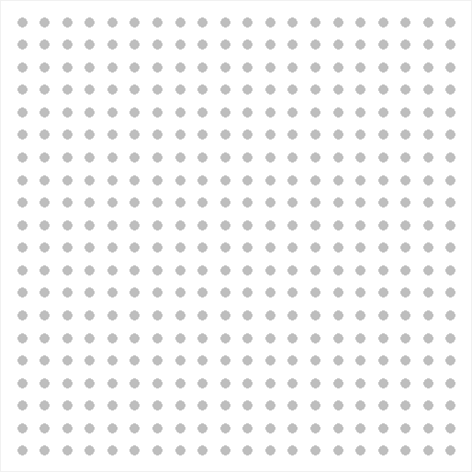

* All points should start out colored gray.
* The user should be able to click and drag to define a circle center and its boundary. The mouse left button down event sets the circle center and dragging updates the circle radius.
* On release of the left mouse button, erase the circle and highlight in blue the points that nearest represent the circle.
* Draw three circles: one representing the original, user specified circle (draw this one in blue with a thick pen) and two representing the inner and outer circles for the set of highlighted points (draw these in red with a thin pen).

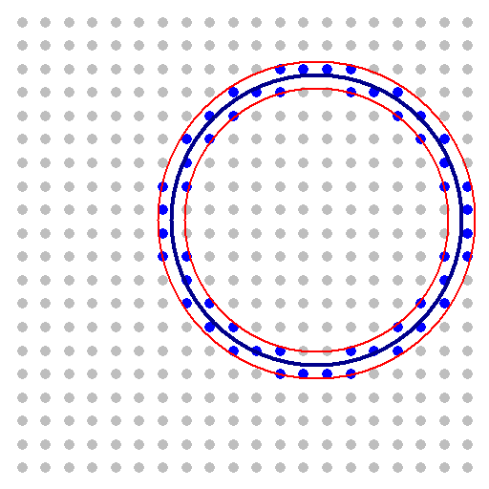

* Maintain a separation between the logical space of the canvas and the logical space of the 20x20 grid. Don't “snap” your circle center to a grid point. Give some thought to what it means for a point to qualify as the nearest neighbor to the circle.
* If the user clicks and drags again, return the grid to its original state and allow the user to draw a new circle.

# Problem 2

## Objective

Develop a new program similar to the first one that allows the user to click grid points and then generates the best fit circle.

## Requirements

* Start out with a 20x20 grid, as above.
* Allow the user to click to toggle grid points between the colors blue and gray.
* If the user hits “G” on the keyboard, display the circle that best fits the set of points selected.
* If the user hits “C” on the keyboard, return the grid to its original state.

## Extra Credit

Modify your solution for Problem 2 to generate the best fit ellipse.