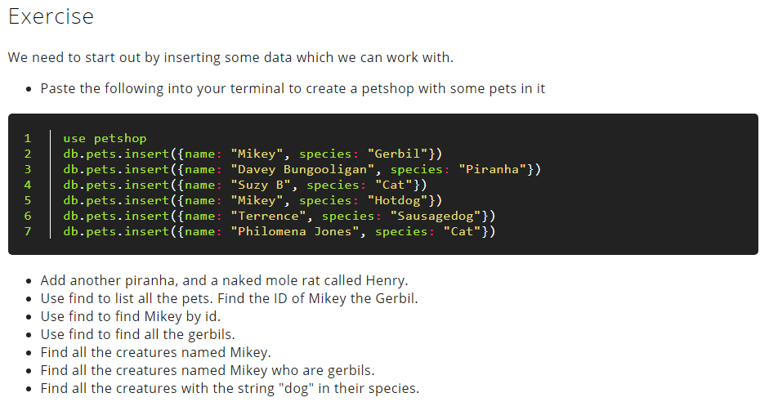

Insert the following documents into a movies collection.

title : Fight Club

writer : Chuck Palahniuk

year : 1999

actors : [

Brad Pitt

Edward Norton

]

title : Pulp Fiction

writer : Quentin Tarantino

year : 1994

actors : [

John Travolta

Uma Thurman

]

title : Inglorious Basterds

writer : Quentin Tarantino

year : 2009

actors : [

Brad Pitt

Diane Kruger

Eli Roth

]

title : The Hobbit: An Unexpected Journey

writer : J.R.R. Tolkein

year : 2012

franchise : The Hobbit

title : The Hobbit: The Desolation of Smaug

writer : J.R.R. Tolkein

year : 2013

franchise : The Hobbit

title : The Hobbit: The Battle of the Five Armies

writer : J.R.R. Tolkein

year : 2012

franchise : The Hobbit

synopsis : Bilbo and Company are forced to engage in a war against an array of combatants and keep the Lonely Mountain from falling into the hands of a rising darkness.

Query / Find Documents

query the movies collection to

1. get all documents
2. get all documents with writer set to "Quentin Tarantino"
3. get all documents where actors include "Brad Pitt"
4. get all documents with franchise set to "The Hobbit"
5. get all movies released in the 90s
6. get all movies released before the year 2000 or after 2010