
College of Engineering, Environment and Computing
School of Science

MSc Data Science and Computational Intelligence
7005SCN Individual Research Project

Project Report

NumGuard-Fin: Certified Provenance-Constrained Decoding for Verifiable Numerical Reasoning in Financial Question Answering

By

Prasanth Balisetty
SID: 16262865

1st Supervisor: Dr Kuda Dube
2nd Supervisor: N/A

Submitted in partial fulfilment of the requirements for the Degree of Master of Science in Data Science and Computational Intelligence

Academic Year: 2025/26

Declaration of Originality
I declare that this project is all my own work and has not been copied in part or in whole from any other source except where duly acknowledged. As such, all use of previously published work (from books, journals, magazines, internet etc.) has been acknowledged by citation within the main report to an item in the References or Bibliography lists. I also agree that an electronic copy of this project may be stored and used for the purposes of plagiarism prevention and detection.

Statement of copyright
I acknowledge that the copyright of this project report, and any product developed as part of the project, belong to Coventry University. Support, including funding, is available to commercialize products and services developed by staff and students. Any revenue that is generated is split with the inventor/s of the product or service. For further information please see www.coventry.ac.uk/ipr or contact ipr@coventry.ac.uk.

Statement of ethical engagement
I declare that a proposal for this project has been submitted to the Coventry University ethics monitoring website (https://ethics.coventry.ac.uk/) and that the application number is listed below (Note: Projects without an ethical application number will be rejected for marking).
Signed: Prasanth Balisetty
Date: 3 August 2026
First Name: | Prasanth
Last Name: | Balisetty
Student ID number | 16262865
Ethics Application Number | P195198
1st Supervisor Name | Dr Kuda Dube
2nd Supervisor Name | N/A

This form must be completed and included with your project submission to Turnitin (paste it at the beginning of your dissertation). Failure to append these declarations may result in your project being rejected for marking.

Generative AI use statement
Generative AI was used as a support tool for literature discovery, source comparison, code and evidence checking, document restructuring and language refinement. The student verified the primary sources, implementation artefacts, calculations, tables, figures, interpretations and final wording, and remains responsible for the originality and accuracy of the submitted work.
Main-report word count: 7,526 (computer count from Abstract through Conclusion, including table text; references and appendices excluded).

Contents
Abstract 5
1. Introduction and research focus 6
2. Critical literature review and theoretical framework 9
3. Research design and methodology 12
4. Artefact design, implementation and technical assurance 16
5. Results 21
6. Discussion and critical evaluation: the cost of structural certainty 29
7. Project management and reflective adaptation 32
8. Legal, ethical, professional and societal considerations 34
9. Conclusion 35
References 36
Appendices 39

Abstract
Financial question answering requires the correct value for the intended metric, period and operation, not merely a plausible number. This project developed NumGuard-Fin, an inference-time framework in which google/flan-t5-base remained frozen while a lightweight candidate-ranking component was trained on 6,093 numerical FinQA training examples. A typed Evidence Ledger and bounded proof lattice supplied direct and derived candidates, and whole-answer trie decoding restricted committed outputs to certified candidates or refusal. Thirteen methods were evaluated on 871 numerical FinQA development examples, yielding 11,323 prediction records. The unconstrained baseline produced 46 complete numerical outputs rejected by the implemented certificate policy, whereas selector-guided ProofLock produced none; this is evidence that the whole-answer lock instantiated the encoded admissibility invariant, not evidence of semantic truth or exhaustive documentary provenance. The more consequential result was the cost of that structural control: selector-guided ProofLock answered all 871 cases but was correct on only 14 (1.61%), while post-hoc verification achieved zero policy-invalid complete answers by abstaining on 579/871 cases. Candidate recall was 424/871 (48.68%) and correct selection conditional on recall was 14/424 (3.30%). In addition, 870/871 candidate-rich prompts exceeded the model's 512-token input budget, making context loss a major confound. No semantic-risk threshold met the predefined release criteria, so the public test was withheld. Because five implementation iterations were informed by the same development split, the reported statistics are development evidence rather than an independent estimate of future performance. The contribution is therefore a tested provenance-control artefact, a failure decomposition, and an empirical demonstration that formal output admissibility remains distinct from correct financial reasoning.
Keywords: financial question answering; numerical reasoning; constrained decoding; provenance; selective prediction; calibration; FinQA.

1. Introduction and research focus

1.1 Problem definition and significance
Financial reports combine tables, narrative text, periods, units and accounting concepts. Numerical QA can fail through wrong-period retrieval, incorrect operands, percentage/amount confusion or an unsupported value even when arithmetic is well formed. Such errors are difficult to audit because fluent output can conceal where the evidential link was lost.
FinQA provides questions, evidence and executable programs over financial reports (Chen et al., 2021), but final-answer accuracy alone does not reveal whether a wrong number was copied, derived under a declared rule, or produced outside the available evidence. Conversely, a source-linked value can still answer the wrong question. This study therefore separates provenance validity—membership in an explicitly defined source-derived numeric policy—from semantic correctness. Throughout the report, “certified” means certificate-policy membership under the implemented verifier; it does not certify financial truth or exhaustive documentary provenance.
The research asks whether inference-time decoding can prevent complete numerical outputs outside that certificate policy without changing the language model, and what is lost when the policy is enforced. The central evaluation therefore concerns a trade-off among structural admissibility, answer availability, semantic accuracy and execution cost rather than a claim of practical financial-QA superiority.

1.2 Aim, research questions and objectives
The aim was to design, implement and critically evaluate a source-conditioned proof-locking artefact for numerical financial QA that separates enforceable provenance validity from semantic answer correctness.
The approved proposal’s central research question was retained:
Primary RQ: Can derivation-aware provenance constraints, applied directly at the decoding stage, reduce unsupported numerical generation in financial question answering without requiring model fine-tuning?
Unsupported generation is operationalised in this study as a certificate-invalid complete numerical answer under the declared proof policy.
Three evidence-led evaluation subquestions made the final analysis more precise:
1. SQ1: To what extent does whole-sequence proof locking reduce certificate-invalid complete numerical answers relative to unconstrained generation and fragment-level masking on the FinQA development set?
2. SQ2: What trade-offs arise among provenance validity, semantic accuracy, candidate availability, non-abstention and latency across the evaluated controls?
3. SQ3: Which retrieval, interpretation, construction, ranking and calibration failures explain the gap between valid provenance and correct financial reasoning?
Six measurable objectives operationalised these questions:
1. construct a typed ledger of source numbers and permitted derivations without using reference answers at inference time;
2. implement whole-answer constrained decoding that can emit only a certified candidate or a refusal;
3. compare hard locks with an unconstrained baseline, prompting controls, post-hoc verification, soft constraints and a fragment-lock ablation;
4. quantify accuracy, certificate-invalid output rate, proof validity, candidate recall, non-abstention and latency using paired development-set evidence;
5. apply separate provenance and semantic calibration gates before any public-test execution; and
6. analyse failure stages using automatic decomposition and a blinded, stratified 120-case manual review.

1.3 Scope and contribution
The study used one small frozen open model, one benchmark and development evidence only. It did not fine-tune the language model, provide financial advice, evaluate real decisions or claim public-test generalisation. Five implementation iterations were informed by the same FinQA development split, so the final results are engineering-development evidence rather than an unbiased estimate of future performance.
Within that boundary, the project contributes an Evidence Ledger and typed proof lattice, a whole-answer trie that prevents fragment recombination from escaping the authorised numeric language, explicit direct/derivation certificates, separate provenance and semantic release gates, and a reproducible failure analysis. The strongest justified result is enforcement of the encoded certificate-membership invariant with no observed hard-lock escape; semantic reliability was not achieved.

2. Critical literature review and theoretical framework

2.1 Financial numerical question answering
FinQA established a benchmark for numerical reasoning over financial reports with expert-annotated questions and executable programs (Chen et al., 2021). TAT-QA and ConvFinQA extend the challenge across hybrid table/text and conversational contexts (Zhu et al., 2021; Chen et al., 2022). These benchmarks measure answer or program accuracy, but do not by themselves distinguish a wrong source-linked number from a wrong number with no evidential path.
Benchmark labels are also fallible. FinanceReasoning corrected or expanded public financial-reasoning data (Tang et al., 2025), while source checking in this study identified two stored-answer inconsistencies and two malformed programs; all four model outputs remained wrong. Reference annotations are therefore strong measurement instruments, not infallible ground truth.
Long-document settings increase retrieval difficulty. DocFinQA and related evaluations show that locating the right evidence remains a major source of error (Reddy et al., 2024; Srivastava et al., 2024). This directly constrains NumGuard-Fin: decoding cannot select the correct result when the necessary evidence or operation never enters the candidate set.

2.2 Program-aided and retrieval-based reasoning
Program-aided methods and Program of Thoughts separate natural-language reasoning from deterministic calculation by generating code for an interpreter (Chen et al., 2023; Gao et al., 2023). This improves arithmetic transparency, but cannot establish that selected operands correspond to the intended metric, period, entity or scale; a correctly executed program can still be semantically wrong.
FINDER combines generative retrieval with Program of Thoughts and shows how missing or incorrect retrieved facts propagate into program errors (Khatuya et al., 2025). NumGuard-Fin adopts the same pipeline view but focuses on a narrower question: whether the final numerical surface can be restricted to a finite, source-conditioned candidate language. Candidate recall is therefore essential because an absent reference answer is unreachable regardless of decoding quality.

2.3 Attribution, grounding and numeric provenance
Attribution concerns whether generated content is supported by identified sources (Rashkin et al., 2023), while groundedness work shows that retrieval does not automatically make generated content well supported (Stolfo, 2024). The converse also matters here: a genuine source number can answer the wrong year or metric. Provenance and semantic correctness must therefore be evaluated separately.
The hallucination literature spans factual inconsistency and unsupported generation (Ji et al., 2023), but that term is broader than this study's dependent variable. “Certificate-invalid complete answer” denotes a parseable numerical response whose complete normalised form is outside the implemented direct/derivation certificate policy. Because the final lattice recalled only 48.68% of reference answers, rejection by this policy is not proof that no defensible support exists elsewhere in the document.

2.4 Constrained decoding and formal admissibility
Grammar-constrained decoding can guarantee membership in a formal language (Geng et al., 2023), but the guarantee is only as strong as the grammar. Park et al. (2024) show that constraints can preserve form while harming quality. This is the central theoretical boundary for NumGuard-Fin: a source-conditioned numeric language may be enforced exactly while the model selects the wrong legal candidate.
PICARD enforces incremental SQL/schema admissibility (Scholak et al., 2021); ITI steers hidden activations toward truth-associated directions (Li et al., 2023); and KCTS uses discriminator-guided tree search for grounding (Choi et al., 2023). ProofLock intervenes at a different layer: complete-output admissibility under a question-specific source lattice. These systems therefore differ in intervention location and guarantee type rather than forming direct accuracy baselines.
Fragment-level masking is insufficient because allowed numeric tokens can recombine into an unauthorised completion. ProofLock instead constructs a trie over complete authorised answer strings and permits termination only at a certified leaf. This enforces complete-string membership in the implemented lattice; it does not establish that the selected leaf is semantically appropriate.

2.5 Selective prediction and fail-closed evaluation
Selective prediction studies the risk–coverage trade-off when a model may abstain (Geifman & El-Yaniv, 2017). Recent work emphasises that confidence is useful only when calibration assumptions and evidence support it (Wang et al., 2025; Wen et al., 2025). High confidence can coexist with high error.
NumGuard-Fin therefore used separate provenance and semantic gates. The provenance gate assessed certificate-policy violations; the semantic gate assessed answer correctness. One-sided confidence bounds, minimum coverage and sample-size requirements were applied separately. Only the provenance gate was feasible, so the public test remained blocked.

2.6 Contemporary verifiable financial reasoning and research gap
Recent work sharpens this positioning. FinChain evaluates answer correctness and step consistency over executable symbolic templates (Xie et al., 2026), while graph-bounded financial reasoning constrains derivations through a financial metric graph and safe abstention (Jiang et al., 2026). ProofLock addresses a narrower mechanical property: whether the complete emitted number belongs to a question-specific source-derived language. It is complementary to richer semantic reasoning systems rather than superior to them.
The research gap is therefore specific. Financial QA largely optimises answer/program accuracy or retrieval-enhanced reasoning; deterministic execution does not validate operand meaning, attribution is often post-hoc, formal decoding guarantees only its encoded language, and selective release depends on calibration. This study tests hard source-conditioned numeric admissibility while measuring semantic error independently under a fail-closed release protocol.

3. Research design and methodology

3.1 Research strategy
The project combined artefact-centred design science (Hevner et al., 2004) with a paired quantitative experiment. Design science suited an engineered intervention that required iterative construction and evaluation. Every method processed the same 871 development examples, allowing paired comparisons while controlling for question difficulty.
google/flan-t5-base remained frozen at revision 7bcac572ce56db69c1ea7c8af255c5d7c9672fc2. The checkpoint was chosen for open reproducibility, modest compute requirements and token-level logit access, not state-of-the-art FinQA performance (Chung et al., 2024). Training was limited to the lightweight candidate-ranking component on FinQA train data. Development data were used for candidate gating, method comparison and calibration; reference answers and programs were excluded from inference-time retrieval, prompting, candidate construction and decoding. The public test was reserved for a gated execution and was not run because semantic calibration was infeasible.
This design prevents direct reference-label use at inference time but does not provide an independent final evaluation. Because V1–V5 were adapted using diagnostics from the same development split, the retained statistics are exploratory development evidence rather than confirmatory estimates for future data.

3.2 Dataset, sample and experimental controls
FinQA was selected for its hybrid table/text evidence and executable numerical programs (Chen et al., 2021). Of 883 development records, 871 had reference answers parseable as single numerical values under the frozen loader. Thirteen methods therefore produced 11,323 prediction rows. The retained manifest records configuration 4c6099853873, seed 42, the FinQA development hash, Python 3.12.13, PyTorch 2.11.0+cu128, Transformers 4.57.6 and a Tesla T4; implementation and evidence identifiers are listed in Appendix B.
The model used a 512-token input limit, 24-token output limit and beam width four. Retrieval was capped at 48 evidence items and the lattice at 48 direct, 192 derived and one abstention candidate. A major confound was truncation: 870/871 selector/candidate prompts exceeded 512 tokens; baseline prompts were truncated in 93.69% of cases and candidate-rich methods in 99.89%. Semantic failure therefore cannot be attributed cleanly to reasoning or ranking because relevant context may have been removed. Reported latency is partial generation/control timing and excludes ledger construction, retrieval, candidate generation and tokenisation.

3.3 Experimental methods and variables
The 13 methods covered an unconstrained baseline; provenance and candidate-menu prompts; a post-hoc verifier; fragment locking and four soft-bias settings; direct and derivation whole-answer locks; a fixed 0.55 diagnostic risk filter; and selector-guided ProofLock. The risk-controlled method was diagnostic rather than a validated deployment policy because the later semantic gate was infeasible.
The independent variable was control method. Primary outcomes were normalised numerical-answer accuracy and certificate-invalid complete-answer rate. Supporting outcomes included numeric-response/refusal rates, proof validity, candidate recall, conditional selection accuracy, proof-operation agreement and partial generation/control latency. Non-abstention was not treated as useful coverage unless paired with correctness or risk.
Direct certificates bind an emitted number to a normalised source span; derivation certificates record authorised operands and operations. Proof validity means that the complete normalised response matches this implemented policy. Semantic correctness is measured separately against the FinQA reference answer under frozen numeric tolerances. The two outcomes can therefore disagree by design.

3.4 Candidate construction and selector protocol
Question-intent analysis extracted operation, metric, period, entity, scale and percentage cues. Retrieval reserved slots for relevant rows, columns, operand roles and periods before broader context completion. Numeric spans became typed ledger entries, and the bounded proof language added authorised additions, differences, ratios, percentage changes, aggregates and selected two-stage forms. Summary-cell exclusions and typed scale rules limited duplicate or nonsensical derivations.
The selector was trained on 6,093 numerical FinQA train examples and 1,086,171 candidate rows grouped by source report into five folds, with up to 24 strong negatives per positive. A deterministic heuristic was blended with a pairwise linear ranker; the blend weight was searched from 0.00 to 1.00 in 0.05 steps with ties favouring less learned influence. The final 0.05 weight was a conservative safeguard: the learned ranker alone performed poorly and the selector could only reorder legal candidates, never admit an answer outside the trie.

3.5 Statistical analysis and release gates
Paired binary differences over the 871 shared examples were summarised with exact McNemar tests; 2,000-repetition percentile paired bootstrap intervals with seed 42 were used as sensitivity evidence. Rate confidence intervals reported in the method summaries, including candidate recall, are 2,000-repetition percentile bootstrap intervals. Calibration used one-sided 95% Clopper–Pearson upper bounds. Because V1–V5 were adaptively developed on the same split, these inferential quantities describe the retained development comparison and are not preregistered confirmatory evidence for future data.
The frozen candidate gate required at least 30% overall recall and 75% recall on a 35-example aggregate-operation subset (sum, average, minimum or maximum). The small denominator is reported explicitly; passing this gate was an engineering progression rule rather than strong evidence of robust operation coverage.
Semantic calibration targeted risk ≤20% with 95% one-sided confidence, ≥5% coverage and at least 30 accepted examples; provenance calibration targeted ≤1% risk under the same coverage/sample gates. These thresholds were fixed operational go/no-go criteria rather than universal safety standards. Because thresholds were searched and assessed on the same development evidence, resulting confidence bounds are descriptive of this calibration exercise rather than deployment guarantees. A future study should reserve an independent calibration split or use a procedure with valid post-selection risk control.

3.6 Manual review and validity safeguards
Automatic errors were decomposed into candidate-generation, retrieval, operation-schema, pruning and selector stages. A separate 120-case review workbook sampled across methods and automatic strata with seed 42. “Blinded” means the review sheet omitted method identity and pre-filled manual labels while retaining the question, reference answer, model response and candidate/proof evidence needed for diagnosis. The sample contained 101 unique examples, so category counts are descriptive rather than prevalence estimates. Seventy-seven judgements were high confidence, 40 medium-confidence cases received a second pass and three low-confidence annotation/program cases required source checking; no independent second annotator or agreement coefficient was available.
Counts were recomputed from the 120 raw review rows. Source checking corrected stored values in GS (25.67, not 29) and BLL (58,864,176.24, not 56,864,176) and identified malformed programs with source-supported labels for CB and JPM. All four model outputs remained wrong; BLL retained under-refusal as its primary category.
Construct validity is limited because the certificate lattice is an implemented policy rather than an exhaustive oracle of documentary support. Internal validity is threatened by adaptive development-set reuse, severe truncation and a weak baseline; external validity is restricted to one benchmark and frozen model; and statistical validity is constrained by very few correct answers. These limitations define the appropriate claim boundary.

4. Artefact design, implementation and technical assurance

4.1 System architecture
NumGuard-Fin is a staged inference pipeline. FinQA evidence enters the Evidence Ledger; bounded constructors create a typed proof lattice; a selector ranks legal candidates; and a whole-answer trie controls token emission. Accepted answers carry direct or derivation certificates, while provenance-policy compliance and semantic release risk are evaluated separately (Figure 1).
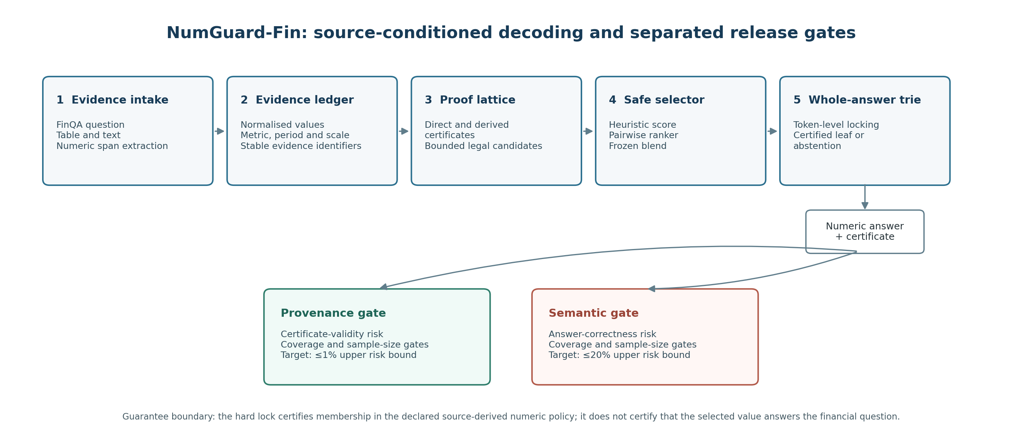
Figure 1. NumGuard-Fin architecture and guarantee boundary. The hard lock enforces membership in the declared source-derived numeric policy; provenance-policy compliance and semantic correctness are evaluated separately. Source: final validated implementation and retained development evidence.
The Evidence Ledger stores each number's surface form, normalised value, location, inferred type, period, metric and scale. Direct certificates reference ledger evidence; derivation certificates preserve the operation and operand identifiers. This makes the encoded evidence path inspectable without requiring an opaque chain-of-thought reconstruction.
The proposal's three core deliverables remain visible in the final system: the Numeric Evidence Ledger supplies source values, the Provenance Checker constructs/validates certificates, and the constrained LogitsProcessor implements the complete-sequence trie. The selector only changes candidate ordering. Thus the system separates candidate availability, output admissibility and release decisions rather than treating them as one property.

4.2 Typed lattice and whole-answer locking
The bounded proof language includes direct values that survive extraction/type checks and authorised derivations. Percentage normalisation, scale handling, bidirectional aggregates and summary-cell exclusions address common financial-table ambiguities. The deployment lattice is capped at 48 direct, 192 derived and one abstention candidate, keeping enforcement finite and inspectable.
Table 1
Operational numeric and derivation policy
Rule family | Implemented rule | Boundary or safeguard
Numeric parsing | Complete integers, decimals, comma groups, signs, accounting negatives, currencies, percentages and thousand–trillion scales | Years and long integers are not split into digit fragments
Equality | Absolute tolerance 0.01 and relative tolerance 0.005 | Percentage type must normally match; unit/scale mismatch is not hidden by tolerance
Direct proof | Retrieved value plus stable source identifier and available row, column, period, metric, currency and scale fields | Period-only agreement is insufficient when a metric is named
Change/ratio | Later-minus-earlier; (new − old) / old × 100; numerator/denominator; percentage-of-total and margin roles | Division by zero forbidden; operand roles licensed from question intent
Aggregate | Sum, average, minimum and maximum over compatible question-conditioned rows/columns and bounded windows | Existing total/average/min/max cells excluded from recomputing the same aggregate
Product/constants | Product for compatible quantity/rate roles; constants such as 100, 12, 4 or period count when licensed | Cross-scale operands converted through base units; free constants prohibited
Two-stage proof | Typed subtract-then-divide, add-then-divide, aggregate comparison and percentage conversion | Every stage records operation and evidence identifiers

A missing percent symbol is accepted only for independently percentage-typed candidates within frozen tolerances; for example, 0.279 is not equated with 27.9. Percentages remain percentage magnitudes for answer comparison and become fractions only within licensed multiplication.
Table 2
Worked certificate outcomes from selector-guided ProofLock
Development case | Certificate path | Semantic outcome / failure stage
SYY/2019/page_9.pdf-2 | Derived percentage-change certificate used Restaurants 62% (2019) and 62% (2018), emitting 0%. | Policy-valid and reference-matched. This is the intended success condition.
V/2008/page_17.pdf-1 | Direct certificate selected American Express payment volume 637 and emitted 637. | Policy-valid but semantically wrong: the question required an average, 637 / 5 = 127.40. Operation omission.
DVN/2007/page_58.pdf-2 | Direct certificate selected Canada total oil and gas 60 and emitted 60%. | Policy-valid but wrong: the required share was 60 / 243 x 100 = 24.69%. Wrong operation.
LMT/2013/page_74.pdf-4 | Derived subtraction used 2013 diluted shares 326.5 and 2012 basic shares 323.7, emitting 2.8. | Policy-valid operands, but the 2012 metric role was wrong; the reference change in diluted shares was -1.9. Metric-role mismatch.
STT/2011/page_83.pdf-1 | Direct certificate selected 317 from the same disclosure and emitted 317. | Policy-valid source value but wrong period: 317 is the 2010 after-tax figure; the 2011 tax amount was 303 - 189 = 114. Period mismatch.
APTV/2014/page_49.pdf-3 | Derived subtraction used Delphi 2012 return 179.33 and initial value 100.00, emitting 79.33. | Policy-valid calculation but wrong scope: the question asked for the highest-to-lowest first-year return difference; reference 68.92%. Scope/operation mismatch.

Table 2 intentionally includes one reference-matched success and five certificate-valid semantic failures. The cases are illustrative rather than prevalence estimates. Together they show that source membership, metric/period alignment, operation choice and answer correctness can diverge even when the emitted number terminates at a certified leaf.
Whole-answer control addresses a failure of fragment masking: legal numeric pieces can recombine into an unauthorised completion. ProofLock stores complete authorised strings in a trie, masks non-child tokens and permits termination only at certified leaves. The fragment ablation produced 92 certificate-invalid completions, whereas the evaluated whole-answer locks produced none under the same verifier policy.

4.3 Ranking, confidence and refusal
The selector uses question/metric overlap, period, type, proof-family and retrieval features. Grouped out-of-fold top-one accuracy conditional on recall was 14.17% for the heuristic, 0.52% for the learned ranker and 14.36% for the 0.05 blend (446 versus 440 correct candidates). The learned component therefore did not constitute a successful reasoning model; the small blend weight mainly prevented it from degrading the heuristic.
Refusal is an explicit candidate. Several proof-lock and post-hoc variants may abstain when no acceptable certificate survives, whereas selector-guided ProofLock returned a number for all 871 development questions but only 14 were correct. Structural admissibility and semantic release therefore require separate evidence.

4.4 Development across V1–V5
Development was evidence-triggered. V1 established sequence-lock enforcement but had poor semantic quality. V2 failed candidate gates at 27.44% overall and 45.71% aggregate recall; V3 improved to 43.40% and 68.57% but still missed the 75% aggregate threshold. V4 added broader aggregates, composite proofs and a learned ranker, yet final recall was 32.03%, aggregate recall 71.43%, and the learned ranker underperformed the heuristic.
V5 introduced bounded aggregate windows, cross-axis grouping, percentage/margin corrections, expanded frozen bounds and conservative selector blending. It passed the engineering candidate gates at 48.68% overall and 28/35 (80%) aggregate recall. Thresholds were not lowered after earlier failures; however, because all iterations used the same development split, the sequence is a design-decision record rather than independent evidence of generalisable improvement.

4.5 Engineering assurance and reproducibility
Engineering validation was kept separate from benchmark evaluation. The validated release records 145 automated tests across normalisation, retrieval, proof construction, trie enforcement, evaluation and calibration. Twelve transparent fixtures produced 156 paired method records; all 11 supported answers were recalled and the deliberately unsupported fixture abstained. Fifty-two candidate-mechanism counterfactual checks also passed. These checks validate implementation behaviour, not semantic performance on FinQA.
No hard-lock escape was observed in fixtures or retained development predictions, as expected if the trie and verifier implement the same policy correctly. Reproducibility controls include a frozen plan, 57-file source manifest, exact model revision, configuration identifier, dependencies, result hashes and deterministic evidence packaging. Validation regenerated method summaries and paired comparisons from predictions, matched selector/calibration hashes, checked strict JSON and passed a fresh-extraction smoke test.

5. Results

5.1 Candidate availability and failure stages
Candidate availability was the first semantic bottleneck. The final lattice contained the normalised reference answer for 424/871 development questions (48.68%; 2,000-repetition bootstrap 95% CI 45.46%–52.01%). Pre-selector recall was 425/871; using the same retrieval without bounded pruning gave 477/871; and an expanded-ledger diagnostic reached 507/871. These diagnostics localise lost availability rather than represent deployable settings. On the small prespecified aggregate subset, recall was 28/35 (80%).
Automatic stage attribution recorded 424 successes and 447 failures: 191 candidate-generation, 120 operation-schema, 66 bounded-context, 37 pruning, 27 extraction/constant, five retrieval and one selector-ranking failure. Most reference answers were therefore lost before final ranking, limiting any downstream selector or decoder.
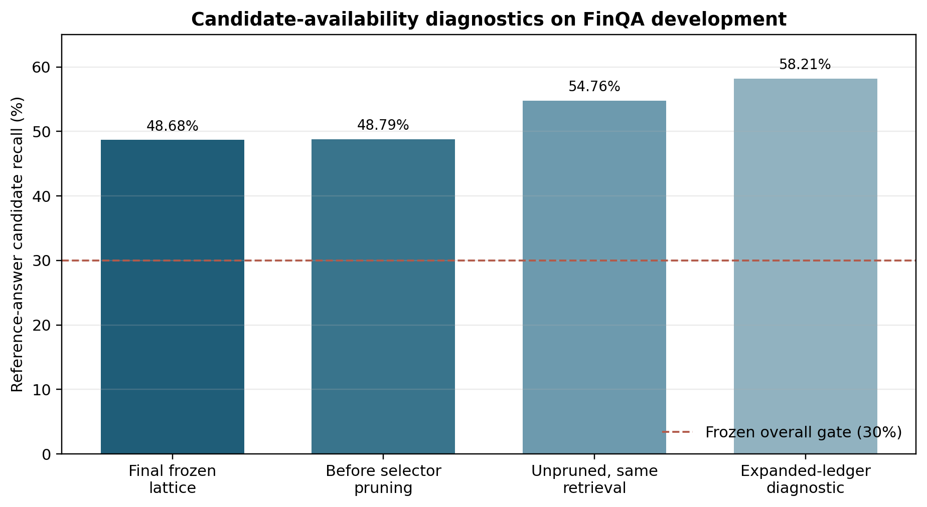
Figure 2. Candidate availability under the frozen lattice, pre-selector and diagnostic constructions on FinQA development (n = 871). Diagnostic values are not deployable configurations. Source: retained development evidence.

5.2 Method comparison
Table 3 summarises the main development comparison. The baseline was intentionally a controlled frozen-model baseline with retrieved evidence, not a competitive FinQA system; it achieved 6/871 correct answers and was severely affected by the 512-token prompt limit.
Table 3
Selected development-set outcomes (n = 871 per method)
Method | Correct, n (%) | Valid numeric, n (%) | Abstained | Invalid | Certificate-invalid complete numeric, n (%)
Baseline | 6 (0.69) | 338 (38.81) | 0 | 533 | 46 (5.28)
Candidate-menu prompt | 3 (0.34) | 340 (39.04) | 58 | 473 | 44 (5.05)
Post-hoc verifier | 5 (0.57) | 292 (33.52) | 579 | 0 | 0 (0.00)
Fragment-token ablation | 6 (0.69) | 484 (55.57) | 99 | 288 | 92 (10.56)
Soft prefix bias 10 | 6 (0.69) | 759 (87.14) | 112 | 0 | 1 (0.11)
Direct ProofLock | 9 (1.03) | 725 (83.24) | 146 | 0 | 0 (0.00)
Derivation ProofLock | 6 (0.69) | 759 (87.14) | 112 | 0 | 0 (0.00)
Risk-controlled ProofLock (fixed 0.55 diagnostic filter) | 13 (1.49) | 729 (83.70) | 142 | 0 | 0 (0.00)
Selector-guided ProofLock | 14 (1.61) | 871 (100.00) | 0 | 0 | 0 (0.00)

Selector-guided ProofLock produced 14 correct answers versus six for baseline, a system-level difference of 0.92 percentage points. Because selector-guided ProofLock also changes candidate construction, ranking and hard decoding, this comparison does not isolate the causal effect of the trie. The prespecified exact McNemar test had four baseline-only and 12 selector-only successes (p = .0768); a positive paired bootstrap interval is reported as sensitivity evidence. Given sparse disagreements and adaptive development-set reuse, the accuracy difference is directional rather than confirmatory.
Under the implemented certificate policy, baseline produced 46 verifier-rejected complete numbers and selector-guided ProofLock produced zero; the fragment ablation produced 92. These counts verify that whole-answer enforcement implemented the encoded admissibility invariant in the retained run. Exact paired tests and bootstrap differences are retained as development-set descriptors, but the zero-escape property is primarily an engineering invariant because the trie and verifier share the same policy; it does not establish exhaustive documentary provenance.
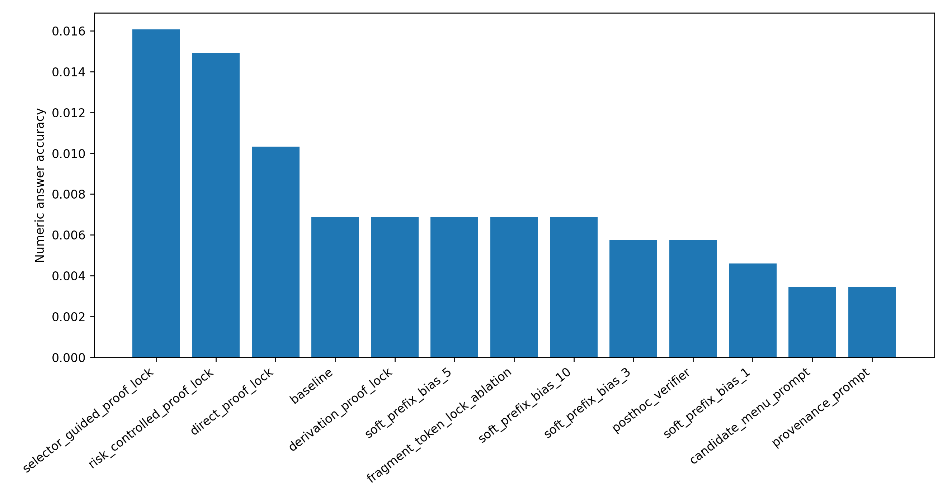
Figure 3. Normalised numerical-answer accuracy for all 13 methods on 871 development examples. Matching used the frozen tolerance and percentage rules in Table 1. Source: retained development predictions.
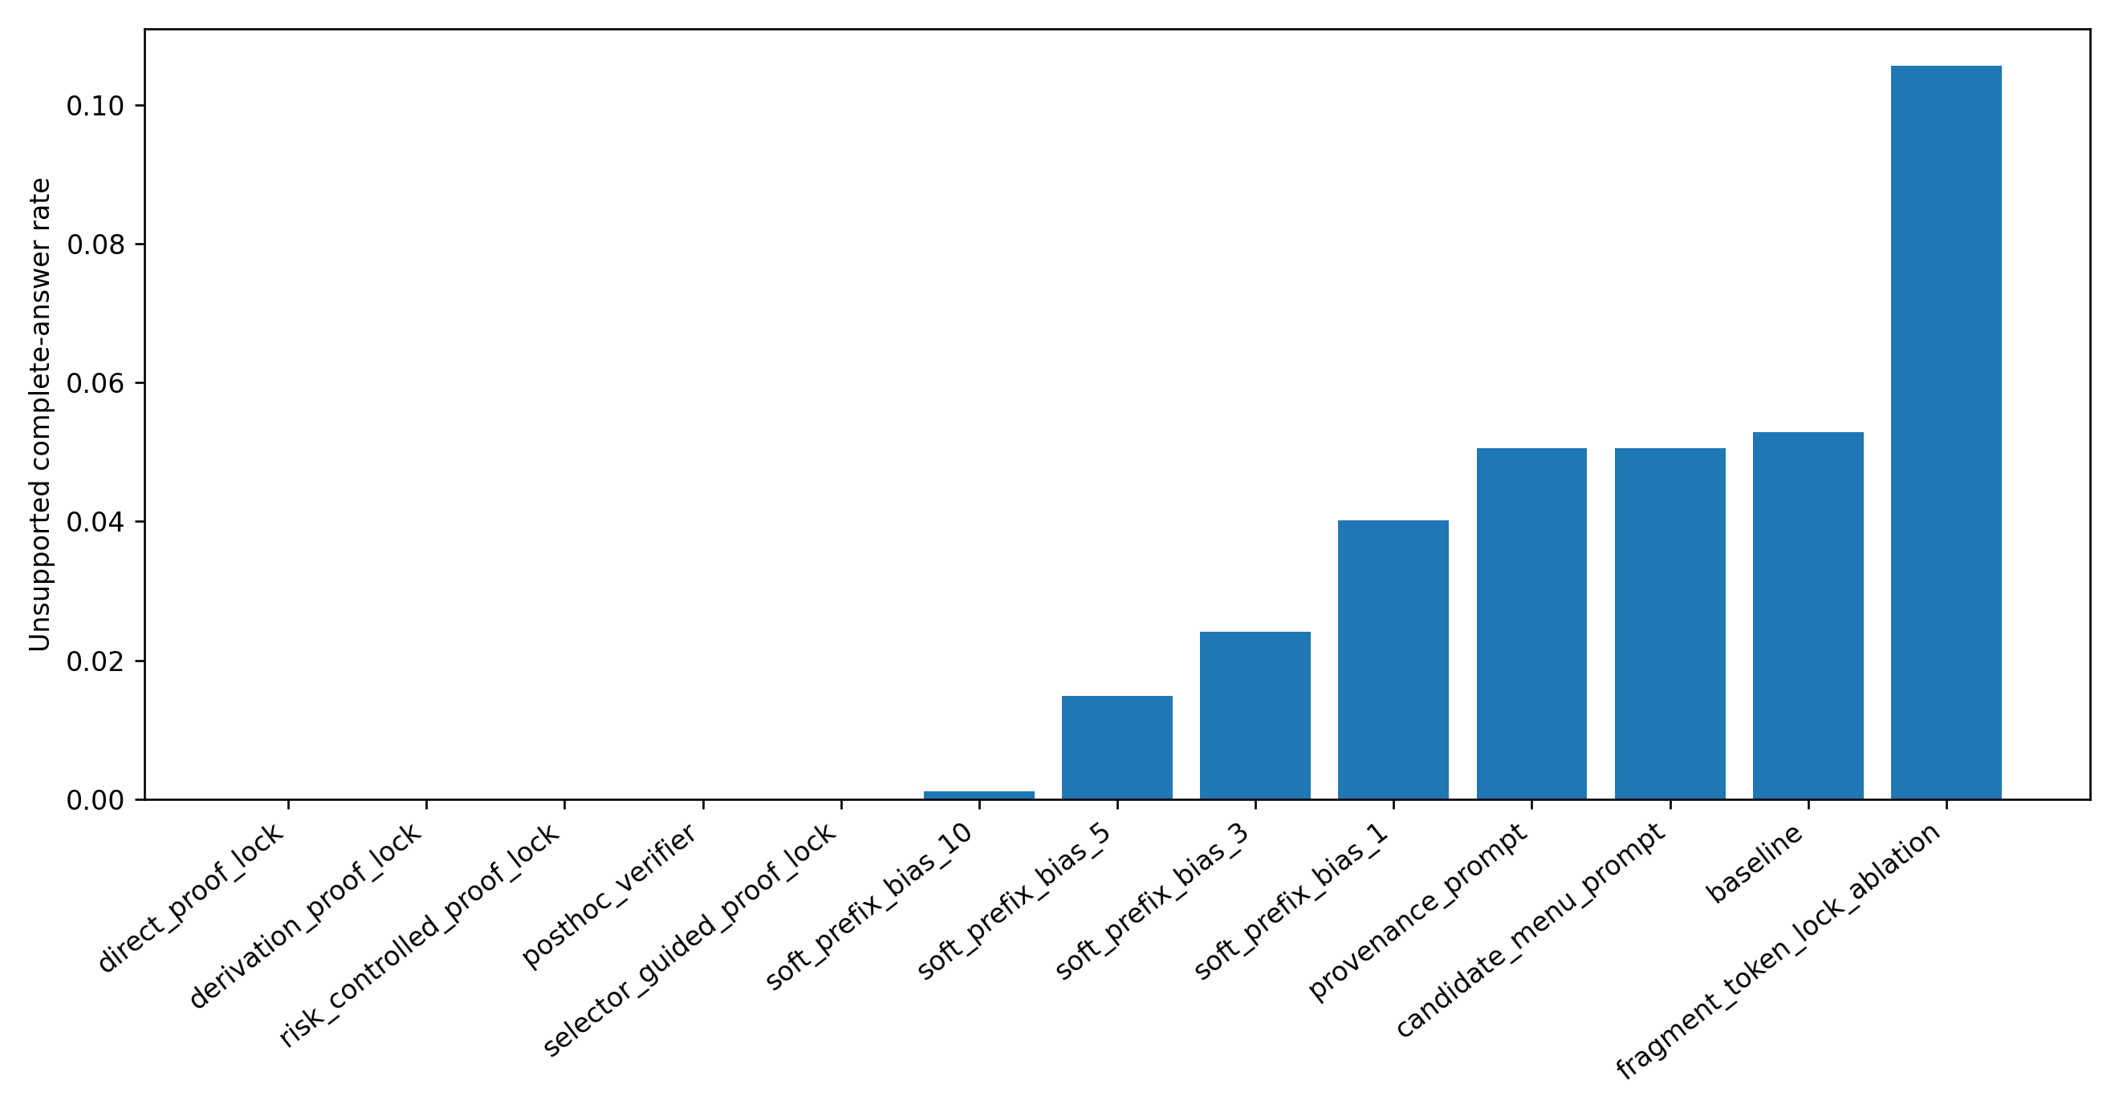
Figure 4. Rate of complete numerical outputs rejected by the implemented certificate verifier. Zero denotes compliance with the encoded lattice, not semantic correctness or exhaustive documentary support. Source: retained development predictions.

5.3 Provenance-control–availability trade-off and selector behaviour
Increasing soft-prefix bias reduced verifier-rejected complete outputs from 35 cases at bias 1 to one at bias 10, showing that probabilistic steering can approach but not guarantee the invariant. Whole-answer locks removed residual escapes by construction, while the post-hoc verifier achieved the same verifier-defined property by abstaining on 579 questions.
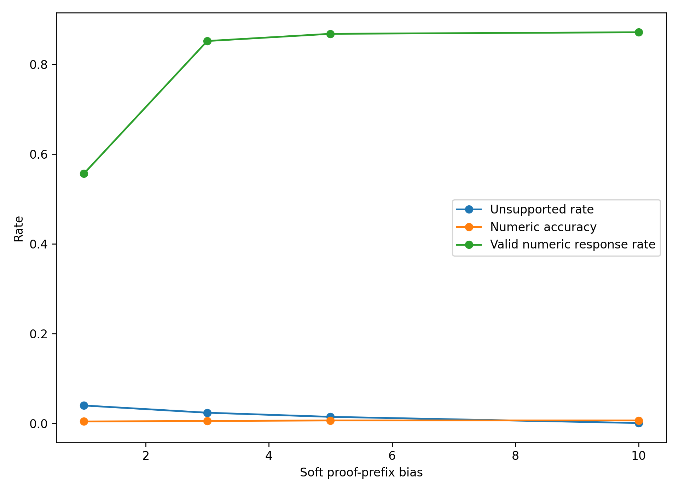
Figure 5. Accuracy and verifier-defined certificate-policy behaviour across soft-bias strengths. The ablation contrasts probabilistic steering with whole-answer enforcement. Source: retained development predictions.
Selector-guided ProofLock returned a certificate-valid number for all 871 examples but only 14 were correct. Candidate recall was 424/871 and conditional selection accuracy only 14/424 (3.30%); coarse proof-operation agreement was 193/871 (22.16%). Semantic failure therefore reflected both upstream candidate absence and poor choice among available legal candidates. Full-coverage semantic error risk was 857/871 (98.39%).
Taken together, these operating points quantify the cost of enforcement. Post-hoc verification achieved the verifier-defined zero-escape outcome by refusing 579/871 questions (66.48%), whereas selector-guided ProofLock refused none but incurred 857/871 semantic errors (98.39%). Direct and derivation locks occupied intermediate availability points, but none combined useful semantic accuracy with a defensible release profile. The trade-off, rather than the mechanically expected zero-escape property alone, is therefore the more informative empirical result.

5.4 Calibration and stopping decision
For provenance-policy compliance, zero verifier-defined errors were observed among 871 committed selector-guided outputs; the corresponding one-sided 95% Clopper–Pearson upper bound was 0.343%. This empirical bound supplements, rather than creates, the deterministic trie invariant. Semantic threshold search found no setting satisfying the prespecified ≤20% risk, ≥5% coverage and ≥30-answer requirements. At the best eligible threshold (0.813245), 186 answers were accepted and 178 were wrong (95.70% observed risk; 97.84% one-sided upper bound). Because threshold selection and assessment used the same development data, these bounds are calibration diagnostics, not deployment guarantees.
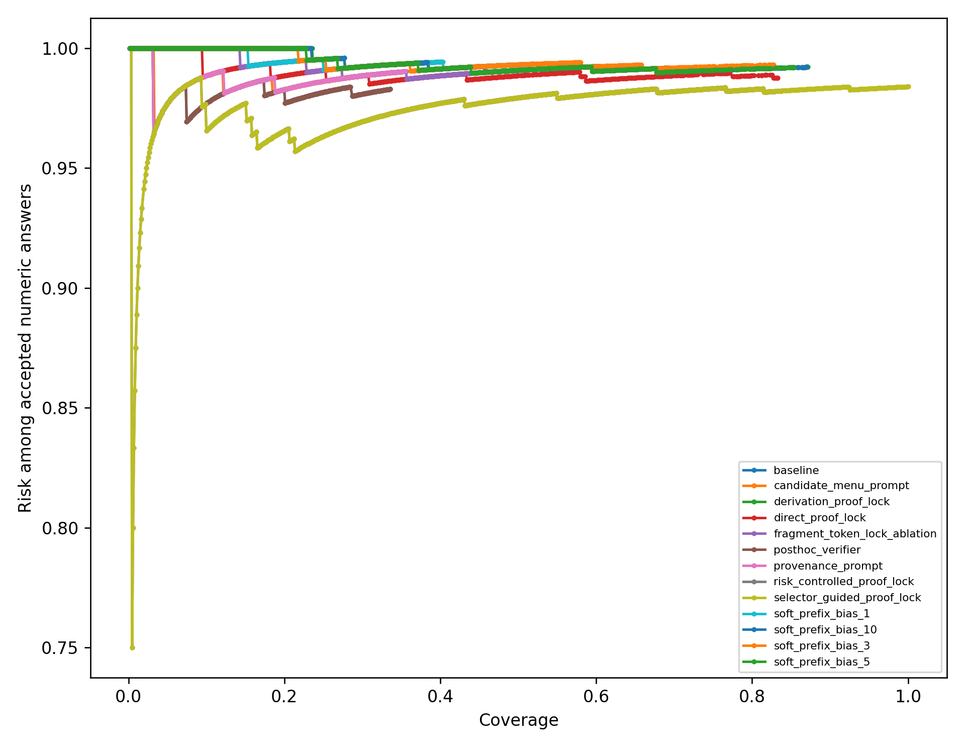
Figure 6. Risk–coverage curves for the evaluated methods, showing empirical risk among accepted numerical answers across confidence thresholds. Selector-guided ProofLock never reaches the predefined semantic-risk target under the coverage/sample rules; its separate provenance-policy calibration records zero observed verifier-defined errors at full development coverage. Source: retained development evidence.
The public test was therefore withheld under the predefined release protocol. This preserves the test set and makes clear that no independent test-performance estimate is claimed.

5.5 Manual failure analysis
The 120-case stratified review was dominated by candidate-recall failure (26 cases) and operation-schema error (25), followed by over-refusal (16) and invalid/fragmentary response (14). Smaller categories covered under-refusal, missing support, metric role, span extraction, period, scale and rounding. Because the sample contains only 101 unique examples, these counts describe the reviewed cases rather than development-set prevalence.
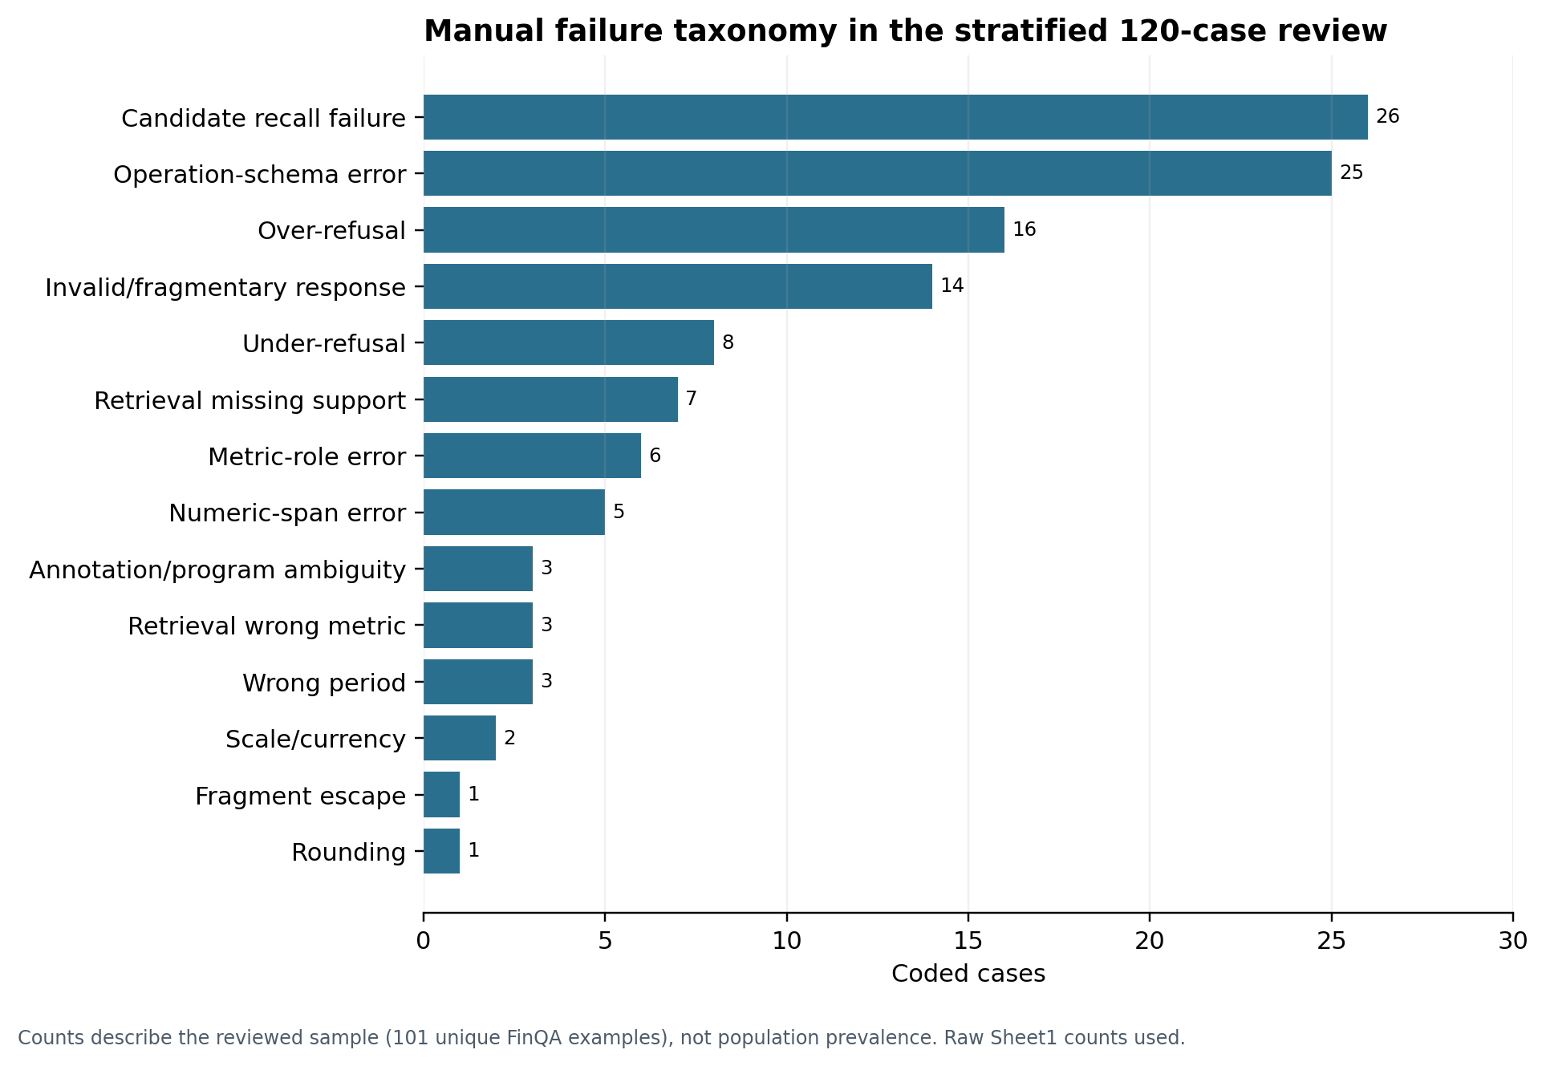
Figure 7. Manual failure-taxonomy counts for 120 reviewed predictions (101 unique examples). Counts are descriptive of the reviewed sample and are not prevalence estimates. Source: blinded failure-review workbook.
The review illustrates why certificate validity is insufficient: a genuine number can be taken from the wrong period or metric, or valid operands can be combined with the wrong operation. The single 117.5% fragment escape occurred only in the fragment ablation. Four source/annotation anomalies were checked directly; all associated model outputs remained wrong.
The failure evidence supports a four-stage model (Figure 8). Stage 1 concerns evidence access and context loss; Stage 2 concerns candidate construction and whether the correct answer is represented; Stage 3 concerns semantic selection among legal candidates; and Stage 4 concerns output-language enforcement. The distinction is causal as well as descriptive: a perfect Stage-4 lock cannot recover evidence lost at Stage 1, construct an operation missing at Stage 2, or identify the right legal branch at Stage 3.
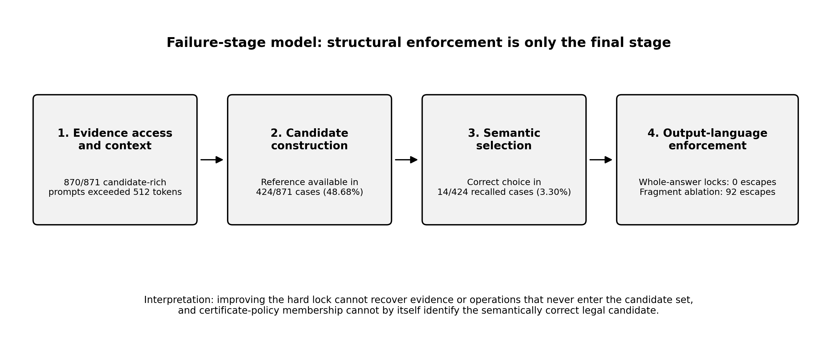
Figure 8. Four-stage failure model for the retained development study. The model separates context/evidence access, candidate construction, semantic selection and final-surface enforcement. Source: synthesis of retained development diagnostics and predictions.
The worked cases in Table 2 instantiate the same stages. The V/2008 and DVN examples show that an admissible source value can still omit the operation required by the question; LMT and STT show metric-role and period errors among source-linked values; and APTV shows that a legal calculation may still use the wrong comparison scope. The previously observed 117.5% IPG fragment-ablation escape belongs to Stage 4, because locally permitted fragments recombined into a complete value outside the authorised lattice.

5.6 Research-question synthesis
Table 4 synthesises the research questions while separating the achieved certificate-membership invariant from the semantic capability that was not achieved.
Table 4
Research-question synthesis
Question | Evidence-led answer
Primary RQ | Yes for enforcement of the encoded certificate-membership invariant: the retained hard-lock run produced no complete output outside the implemented policy. This does not establish exhaustive documentary provenance or semantic correctness; selector-guided ProofLock was correct on only 14/871 cases.
SQ1 | Whole-answer locks produced 0 observed policy escapes, compared with 92 for fragment masking. This supports the need for complete-sequence rather than fragment-level enforcement under the same certificate policy.
SQ2 | Post-hoc verification obtained 0 escapes by abstaining on 579/871 cases. Selector-guided ProofLock answered 871/871 but only 14 were correct, and semantic calibration remained infeasible. Provenance control therefore occupied different availability and risk trade-offs.
SQ3 | Of 447 automatic failures, 191 were candidate-generation, 120 operation-schema, 66 bounded-context, 37 pruning and 27 extraction/constant failures. Candidate recall was 48.68% and conditional selection accuracy 3.30%, locating the main gap upstream of final decoding and in semantic ranking.

6. Discussion and critical evaluation: the cost of structural certainty

6.1 Research-question answers
The primary research question is answered only for the encoded certificate-membership property. With the language model frozen, whole-answer constraints prevented complete outputs outside the implemented policy in the retained development run. That outcome is principally an implementation invariant because the hard lock and verifier share the same admissibility policy. The more consequential research finding is the cost of enforcing that invariant: policy-valid output could be obtained either with substantial refusal, as in post-hoc verification, or with full numerical coverage but extremely high semantic error, as in selector-guided ProofLock. Neither operating point supports deployment.
SQ1 shows that enforcement granularity mattered: fragment masking produced 92 policy escapes while whole-answer tries produced none. SQ2 shows distinct availability/risk trade-offs: post-hoc verification achieved zero verifier-defined escapes through heavy abstention, whereas selector-guided ProofLock answered every case but remained semantically unreliable. SQ3 locates failure first in candidate availability—only 424/871 references were represented—and then in selection, where only 14/424 recalled references were chosen.

6.2 The cost of enforcement and provenance-correctness separation
The findings support the formal-decoding boundary in prior work: constraints can guarantee membership in a defined output language without establishing that the selected legal sequence is true or relevant (Geng et al., 2023; Park et al., 2024). Deterministic program execution similarly removes arithmetic execution error without validating operand meaning (Chen et al., 2023; Gao et al., 2023). In NumGuard-Fin this distinction is quantitatively large: 100% certificate-policy compliance for selector-guided outputs coexisted with 98.39% semantic error at full coverage. The experiment therefore turns a conceptual distinction into an observed systems trade-off rather than treating provenance as a synonym for correctness.
PoT/PAL, PICARD, ITI, graph-bounded reasoning and ProofLock intervene at different layers—program execution, schema filtering, activation steering, graph-constrained derivation and final-surface admissibility—so they are not direct accuracy baselines. ProofLock's contribution is narrower: a mechanically testable output-language invariant that can complement stronger reasoning systems.
Candidate recall of 48.68% is the first semantic bottleneck: more than half of reference values were unreachable under the final lattice. Among recalled references, only 3.30% were selected correctly. The learned ranker also added little beyond the heuristic. Semantic failure therefore cannot reasonably be attributed mainly to the language model; candidate construction, severe truncation and ranking all contribute.
The failed semantic gate is substantive because selective release is useful only when confidence separates lower-risk answers (Wen et al., 2025). Here the best eligible threshold still accepted 178 wrong answers out of 186. The stopping rule therefore prevented a structural proxy from being presented as readiness evidence.

6.3 Theoretical and practical contribution
The theoretical contribution is the empirical separation of formal admissibility from semantic correctness in financial numerical QA, sharpened by the four-stage failure model. A typed ledger, finite proof language, complete-answer trie and explicit certificate can make final-surface admissibility mechanically enforceable, but reliability also depends on evidence access, candidate sufficiency and semantic selection. A legal candidate may therefore remain wrong because of context loss, metric/period mismatch or an inappropriate operation.
Practically, NumGuard-Fin is an audit/control layer rather than a financial-QA solution. It can expose whether a number followed the implemented policy and provide evidence claims or refusal, but it is unsuitable for financial decisions on the reported evidence. Interfaces must not present “certified” as meaning “true”.

6.4 Threats to validity and future evaluation
The principal internal-validity threats are adaptive reuse of the same FinQA development split across five builds and severe context truncation: 870/871 candidate prompts exceeded 512 tokens. The weak frozen baseline, small model and only six versus 14 correct answers further limit inference. Nominal p-values and confidence intervals therefore quantify the retained development comparison rather than confirm future-data effects.
Measurement is also constrained. “Certificate-invalid” means rejection by the implemented verifier, which shares its policy with the hard lock and whose lattice recalled less than half of references; it is not an independent oracle of documentary provenance. The existing 120-case manual review supplies partial semantic inspection, but it was designed as a failure taxonomy rather than an independent certificate-validation study and lacks dual independent coding. Recorded latency also excludes ledger construction, retrieval, candidate generation and tokenisation. Appendix D therefore specifies a future independent certificate-audit protocol rather than retrospectively claiming evidence that was not collected.
These limitations also bound causal interpretation. The 14-versus-6 accuracy comparison is a system-level contrast because selector-guided ProofLock changes candidate construction, ranking and decoding together. The 46-versus-zero certificate-policy comparison is more directly attributable to enforcement, but it measures compliance with the policy used to construct the lock. Accordingly, the dissertation treats counts, failure stages and trade-offs as primary development evidence and treats nominal significance tests as descriptive support rather than confirmatory future-data inference.
Future work should first reduce context loss through evidence compression or a longer-context open model, then improve typed retrieval, operation coverage and semantic ranking. Evaluation should freeze an independent calibration split, measure true end-to-end latency and execute the Appendix D certificate audit with independent reviewers before stronger documentary-provenance claims are made. A stronger open model with logit access should then be compared under the same evidence budget. The untouched public test should be run only after a new semantic gate passes.

7. Project management and reflective adaptation

7.1 Plan versus actual lifecycle
The CW1 proposal, which received PASS across all three assessed criteria, set a ten-week sequence from ledger construction through baseline, constrained decoding, evaluation and reporting. The dependencies remained appropriate, but empirical diagnostics required five implementation iterations rather than one linear build.
Table 5
Ten-week plan-to-actual project control
Proposed milestone | Actual v1–v5 milestone | Gate/evidence | Variance, response and outcome
Weeks 1-2: Evidence preprocessing | Typed ledger and protected retrieval | Regression tests | Normalisation/table-axis ambiguity required extra iterations
Weeks 3-4: Baseline and verifier | Frozen baseline and certificates | Paired control retained | Weak baseline reported, not presented as state of the art
Weeks 5-7: Constrained decoding | Soft bias, fragment ablation, trie and selector lock | Fragment: 92 escapes; hard locks: 0 | Whole-string invariant replaced fragment legality
Weeks 8-9: Evaluation | V2–v4 gates failed; v5 passed candidate gates | 871 × 13 records | Thresholds stayed frozen; adverse versions archived
Week 10: Release/write-up | Provenance gate passed; semantic gate failed | 178/186 accepted wrong at best threshold | Public test blocked; contribution reframed as a negative result

Table 6
Compact realised risk log
Risk | Probability / impact | Mitigation | Realised outcome
Prompt truncation | High / high | Compact prompts and external trie | 870/871 candidate prompts still exceeded 512 tokens
Candidate unavailability | High / high | Frozen gates and staged diagnostics | V2–v4 stopped; v5 final recall 48.68%
Weak learned selector | High / high | Grouped OOF safe blend | Weight limited to 0.05; semantic selection remained poor
Structural proxy mistaken for safety | High / high | Separate provenance and semantic gates | Provenance passed; semantic failed; public test blocked
Constraint overhead | Medium / medium | Bounded precomputed lattice | Partial generation/control latency remained measurable

Constraint overhead was mitigated through bounded precomputed candidates, but semantic proxy failure became the dominant realised risk. Separate provenance and semantic gates converted that risk into a stopping decision; the post-hoc verifier remained a fallback comparison showing the abstention cost of post-generation control.
Table 7
Evidence-triggered implementation and release decisions
Note. Evidence timestamps in Table 7 are taken from retained ZIP-entry timestamps and execution/calibration logs. They are used as traceability evidence and are not presented as complete working-time records.
Gate/review and retained evidence timestamp | Evidence available at the decision | Decision | Consequence
V2 candidate gate  31 Jul 2026 17:31 (V2 archive) | 27.44% overall recall; 45.71% aggregate-operation recall | Retain thresholds and expand the proof language | V3 developed rather than redefining success
V3 candidate gate  31 Jul 2026 18:25 (V3 archive) | 43.40% overall; 68.57% aggregate-operation recall | Keep the 75% aggregate gate and broaden aggregate construction | V4 developed with additional structural changes
V4 gate and ranker review  31 Jul 2026 19:27 (V4 archive) | 32.03% overall; 71.43% aggregate recall; learned ranker below heuristic | Do not lower gates; revise construction and use a conservative safe blend | Final system limited learned influence to weight 0.05
Final candidate gate  1 Aug 2026 12:07 (final run) | 48.68% overall recall; 28/35 aggregate cases (80%) | Proceed to the full 871 x 13 development comparison | Method comparison and calibration executed
Semantic release gate  1 Aug 2026 12:44 (calibration output) | Best eligible threshold accepted 186 answers, 178 wrong | Withhold the public test; retain the failed gate | No independent test-performance claim was made

7.2 Governance, milestones and reflection
Governance used frozen gates, configuration identifiers, manifests, test logs and retained iteration artefacts. Table 7 now links the principal decisions to archived evidence timestamps: V2-V4 snapshots were retained on 31 July 2026, while the final candidate-gated development execution and calibration outputs were recorded on 1 August 2026. These timestamps identify preserved decision artefacts rather than the full duration of the underlying development work. Failed gates triggered redesign rather than threshold relaxation; the weak learned ranker was constrained through a conservative blend; and the semantic release failure stopped progression to the public test.
The main reflective lesson was that prespecified gates functioned as project-management controls as much as statistical devices. They converted disappointing evidence into explicit decisions about redesign, continuation or stopping, reducing the temptation to weaken criteria after V2-V4 failures. The second lesson was conceptual: a deterministic safeguard means only the encoded invariant. Reproducibility controls and an explicit decision trail made it possible to retain the adverse semantic result without converting structural success into an unsupported deployment claim.

8. Legal, ethical, professional and societal considerations
The project used secondary benchmark data and collected no personal or primary human data. Coventry University ethics approval was granted as Low Risk under application P195198 on 1 July 2026. The official FinQA repository is MIT-licensed (FinQA, 2021), while google/flan-t5-base is Apache-2.0 licensed (Google, n.d.). The validated implementation does not redistribute raw benchmark data or model weights and retains third-party notices.
The EU AI Act and NIST Generative AI Profile provide relevant principles for traceability, oversight, robustness and lifecycle governance (European Parliament & Council of the European Union, 2024; Autio et al., 2024). NumGuard-Fin is not automatically a legally high-risk system; classification depends on intended use. The artefact therefore supports an audit objective but does not establish regulatory compliance.
Deployment in finance could cause monetary loss or misleading decisions. The observed 98.39% semantic error rate on repeatedly used development data rules out deployment on this evidence. Certificates also create automation-bias risk if “verified” is read as “correct”; any future interface should state the narrow guarantee, expose evidence/calculations and require qualified human review (BCS, 2022).
A real deployment processing customer documents would require purpose limitation, access controls, retention limits, security testing and meaningful human oversight. The Data (Use and Access) Act 2025 commenced in stages; relevant data-protection provisions and automated-decision safeguards were in force by June 2026 (Department for Science, Innovation and Technology, 2026; Information Commissioner’s Office, 2026). These are deployment considerations rather than evidence that this benchmark artefact is compliant.
Generative AI assistance is declared at the beginning of this report. Responsibility for source verification, implementation evidence, calculations, interpretation and the submitted work remains with the student.

9. Conclusion
NumGuard-Fin answers the research question with a deliberately bounded result. On the repeatedly used FinQA development split, whole-answer constraints enforced membership in the implemented certificate policy: baseline produced 46 verifier-rejected complete numbers, while the evaluated hard locks produced none. This is an implementation/policy result, not independent certification of documentary provenance. The more important empirical finding is the cost of that structural certainty. Post-hoc verification reached the same verifier-defined zero-escape outcome by abstaining on 579/871 questions, whereas selector-guided ProofLock answered every question but was correct on only 14/871. Candidate recall was below half, selection conditional on recall was 3.30%, and almost every candidate-rich prompt exceeded the model's 512-token input budget. No threshold met the predefined semantic release requirements, so the public test remained untouched and no independent test-performance claim is made.
The contribution is therefore not a claim that provenance constraints solve financial QA. It is a tested separation among three distinct problems: candidate sufficiency, semantic selection and output-language enforcement. A typed lattice, whole-answer trie and explicit certificates can make the last property auditable, while the failure taxonomy shows why the first two remain unresolved. Future work should reduce context loss, expand typed evidence and operation coverage, improve semantic ranking, introduce independent certificate review and reserve new calibration evidence before any public-test or deployment claim.

References
Autio, C., Schwartz, R., Dunietz, J., Jain, S., Stanley, M., Tabassi, E., Hall, P., & Roberts, K. (2024). Artificial intelligence risk management framework: Generative artificial intelligence profile (NIST AI 600-1). National Institute of Standards and Technology. https://doi.org/10.6028/NIST.AI.600-1
BCS. (2022). Code of conduct for BCS members (Version 8). https://www.bcs.org/media/2211/bcs-code-of-conduct.pdf
Chen, W., Ma, X., Wang, X., & Cohen, W. W. (2023). Program of thoughts prompting: Disentangling computation from reasoning for numerical reasoning tasks. Transactions on Machine Learning Research. https://openreview.net/forum?id=YfZ4ZPt8zd
Chen, Z., Chen, W., Smiley, C., Shah, S., Borova, I., Langdon, D., Moussa, R., Beane, M., Huang, T.-H., Routledge, B., & Wang, W. Y. (2021). FinQA: A dataset of numerical reasoning over financial data. In Proceedings of the 2021 Conference on Empirical Methods in Natural Language Processing (pp. 3697–3711). https://doi.org/10.18653/v1/2021.emnlp-main.300
Chen, Z., Li, S., Smiley, C., Ma, Z., Shah, S., & Wang, W. Y. (2022). ConvFinQA: Exploring the chain of numerical reasoning in conversational finance question answering. In Proceedings of the 2022 Conference on Empirical Methods in Natural Language Processing (pp. 6279–6292). https://doi.org/10.18653/v1/2022.emnlp-main.421
Choi, S., Fang, T., Wang, Z., & Song, Y. (2023). KCTS: Knowledge-constrained tree search decoding with token-level hallucination detection. In Proceedings of the 2023 Conference on Empirical Methods in Natural Language Processing (pp. 14035–14053). Association for Computational Linguistics. https://doi.org/10.18653/v1/2023.emnlp-main.867
Chung, H. W., Hou, L., Longpre, S., Zoph, B., Tay, Y., Fedus, W., Li, Y., Wang, X., Dehghani, M., Brahma, S., Webson, A., Gu, S. S., Dai, Z., Suzgun, M., Chen, X., Chowdhery, A., Castro-Ros, A., Pellat, M., Robinson, K., … Wei, J. (2024). Scaling instruction-finetuned language models. Journal of Machine Learning Research, 25(70), 1–53. https://www.jmlr.org/papers/v25/23-0870.html
Department for Science, Innovation and Technology. (2026, February 5). Data Use and Access Act 2025: Plans for commencement. GOV.UK. https://www.gov.uk/guidance/data-use-and-access-act-2025-plans-for-commencement
European Parliament, & Council of the European Union. (2024). Regulation (EU) 2024/1689 laying down harmonised rules on artificial intelligence. Official Journal of the European Union. https://eur-lex.europa.eu/eli/reg/2024/1689/oj/eng
FinQA. (2021). FinQA: Data and code for “FinQA: A dataset of numerical reasoning over financial data” [GitHub repository]. https://github.com/czyssrs/FinQA
Gao, L., Madaan, A., Zhou, S., Alon, U., Liu, P., Yang, Y., Callan, J., & Neubig, G. (2023). PAL: Program-aided language models. In Proceedings of the 40th International Conference on Machine Learning (pp. 10764–10799). PMLR. https://proceedings.mlr.press/v202/gao23f.html
Geifman, Y., & El-Yaniv, R. (2017). Selective classification for deep neural networks. In Advances in Neural Information Processing Systems 30. https://papers.nips.cc/paper/7073-selective-classification-for-deep-neural-networks
Geng, S., Josifoski, M., Peyrard, M., & West, R. (2023). Grammar-constrained decoding for structured NLP tasks without finetuning. In Proceedings of the 2023 Conference on Empirical Methods in Natural Language Processing (pp. 10932–10952). https://doi.org/10.18653/v1/2023.emnlp-main.674
Google. (n.d.). FLAN-T5 base model card. Hugging Face. Retrieved August 3, 2026, from https://huggingface.co/google/flan-t5-base
Hevner, A. R., March, S. T., Park, J., & Ram, S. (2004). Design science in information systems research. MIS Quarterly, 28(1), 75–105. https://doi.org/10.2307/25148625
Information Commissioner’s Office. (2026, June 19). The Data (Use and Access) Act 2025 (DUAA)—What does it mean for organisations? https://ico.org.uk/about-the-ico/what-we-do/legislation-we-cover/data-use-and-access-act-2025/the-data-use-and-access-act-2025-what-does-it-mean-for-organisations/
Ji, Z., Lee, N., Frieske, R., Yu, T., Su, D., Xu, Y., Ishii, E., Bang, Y., Chen, D., Dai, W., Chan, H. S., Madotto, A., & Fung, P. (2023). Survey of hallucination in natural language generation. ACM Computing Surveys, 55(12), Article 248. https://doi.org/10.1145/3571730
Jiang, A., Hong, L., Liu, H., & Wang, R. (2026). Achieving multi-hop calculation and safe abstention in financial numerical reasoning by metric graph constrained LLMs. In Proceedings of the 64th Annual Meeting of the Association for Computational Linguistics (Volume 1: Long Papers) (pp. 27575–27595). Association for Computational Linguistics. https://doi.org/10.18653/v1/2026.acl-long.1273
Khatuya, S., Naidu, S., Goyal, P., & Ganguly, N. (2025). Program of thoughts for financial reasoning: Leveraging dynamic in-context examples and generative retrieval. In Proceedings of the 2025 Conference on Empirical Methods in Natural Language Processing (pp. 31006–31018). https://doi.org/10.18653/v1/2025.emnlp-main.1577
Li, K., Patel, O., Viégas, F., Pfister, H., & Wattenberg, M. (2023). Inference-time intervention: Eliciting truthful answers from a language model. In Advances in Neural Information Processing Systems, 36 (pp. 41451–41530). https://proceedings.neurips.cc/paper_files/paper/2023/hash/81b8390039b7302c909cb769f8b6cd93-Abstract-Conference.html
Park, K., Wang, J., Berg-Kirkpatrick, T., Polikarpova, N., & D’Antoni, L. (2024). Grammar-aligned decoding. In Advances in Neural Information Processing Systems, 37 (pp. 24547–24568). https://proceedings.neurips.cc/paper_files/paper/2024/hash/2bdc2267c3d7d01523e2e17ac0a754f3-Abstract-Conference.html
Rashkin, H., Nikolaev, V., Lamm, M., Aroyo, L., Collins, M., Das, D., Petrov, S., Tomar, G. S., Turc, I., & Reitter, D. (2023). Measuring attribution in natural language generation models. Computational Linguistics, 49(4), 777–840. https://doi.org/10.1162/coli_a_00486
Raspanti, F., Ozcelebi, T., & Holenderski, M. (2025). Grammar-constrained decoding makes large language models better logical parsers. In Proceedings of the ACL 2025 Industry Track (pp. 485–499). https://doi.org/10.18653/v1/2025.acl-industry.34
Reddy, V., Koncel-Kedziorski, R., Lai, V. D., Krumdick, M., Lovering, C., & Tanner, C. (2024). DocFinQA: A long-context financial reasoning dataset. In Proceedings of the 62nd Annual Meeting of the Association for Computational Linguistics (pp. 445–458). https://doi.org/10.18653/v1/2024.acl-short.42
Scholak, T., Schucher, N., & Bahdanau, D. (2021). PICARD: Parsing incrementally for constrained auto-regressive decoding from language models. In Proceedings of the 2021 Conference on Empirical Methods in Natural Language Processing (pp. 9895–9901). https://doi.org/10.18653/v1/2021.emnlp-main.779
Srivastava, P., Malik, M., Gupta, V., Ganu, T., & Roth, D. (2024). Evaluating LLMs’ mathematical reasoning in financial document question answering. In Findings of the Association for Computational Linguistics: ACL 2024 (pp. 3853–3878). https://doi.org/10.18653/v1/2024.findings-acl.231
Stolfo, A. (2024). Groundedness in retrieval-augmented long-form generation: An empirical study. In Findings of the Association for Computational Linguistics: NAACL 2024 (pp. 1537–1552). https://doi.org/10.18653/v1/2024.findings-naacl.100
Tang, Z., E, H., Ma, Z., He, H., Liu, J., Yang, Z., Rong, Z., Li, R., Ji, K., Huang, Q., Hu, X., Liu, Y., & Zheng, Q. (2025). FinanceReasoning: Benchmarking financial numerical reasoning more credible, comprehensive and challenging. In Proceedings of the 63rd Annual Meeting of the Association for Computational Linguistics (Volume 1: Long Papers) (pp. 15721–15749). Association for Computational Linguistics. https://doi.org/10.18653/v1/2025.acl-long.766
Wang, Z., Wang, Q., Zhang, Y., Chen, T., Zhu, X., Shi, X., & Xu, K. (2025). SConU: Selective conformal uncertainty in large language models. In Proceedings of the 63rd Annual Meeting of the Association for Computational Linguistics (pp. 19052–19075). https://doi.org/10.18653/v1/2025.acl-long.934
Wen, B., Yao, J., Feng, S., Xu, C., Tsvetkov, Y., Howe, B., & Wang, L. L. (2025). Know your limits: A survey of abstention in large language models. Transactions of the Association for Computational Linguistics, 13, 529–556. https://doi.org/10.1162/tacl_a_00754
Xie, Z., Orel, D., Thareja, R., Sahnan, D., Madmoun, H., Zhang, F., Banerjee, D., Georgiev, G. N., Peng, X., Qian, L., Huang, J., Su, J., Singh, A., Xing, R., Elbadry, R., Xu, C., Li, H., Koto, F., Koychev, I., … Nakov, P. (2026). FinChain: A symbolic benchmark for verifiable chain-of-thought financial reasoning. In Proceedings of the 64th Annual Meeting of the Association for Computational Linguistics (Volume 1: Long Papers) (pp. 14529–14553). Association for Computational Linguistics. https://doi.org/10.18653/v1/2026.acl-long.662
Zhu, F., Lei, W., Huang, Y., Wang, C., Zhang, S., Lv, J., Feng, F., & Chua, T.-S. (2021). TAT-QA: A question answering benchmark on a hybrid of tabular and textual content in finance. In Proceedings of the 59th Annual Meeting of the Association for Computational Linguistics (pp. 3277–3287). https://doi.org/10.18653/v1/2021.acl-long.254

Appendices

Appendix A. Additional development figures
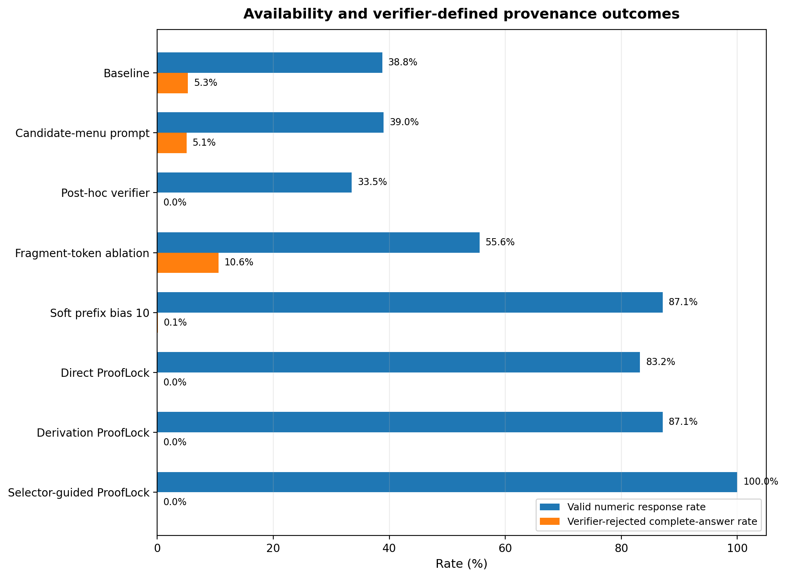
Figure A1. Valid-numeric-response rate and verifier-rejected complete-answer rate for selected methods. Availability is not useful coverage unless paired with correctness. Source: retained development evidence.
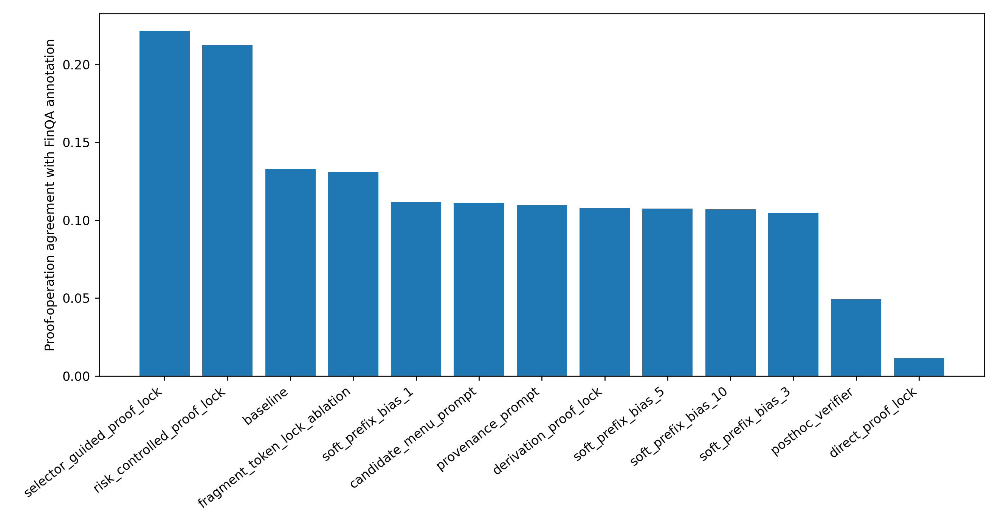
Figure A2. Coarse agreement between emitted proof family and reference operation. Non-null method-specific denominators range from 384 for the baseline to 871 for the hard locks. This is not program accuracy and is affected by malformed reference programs. Source: retained development evidence.
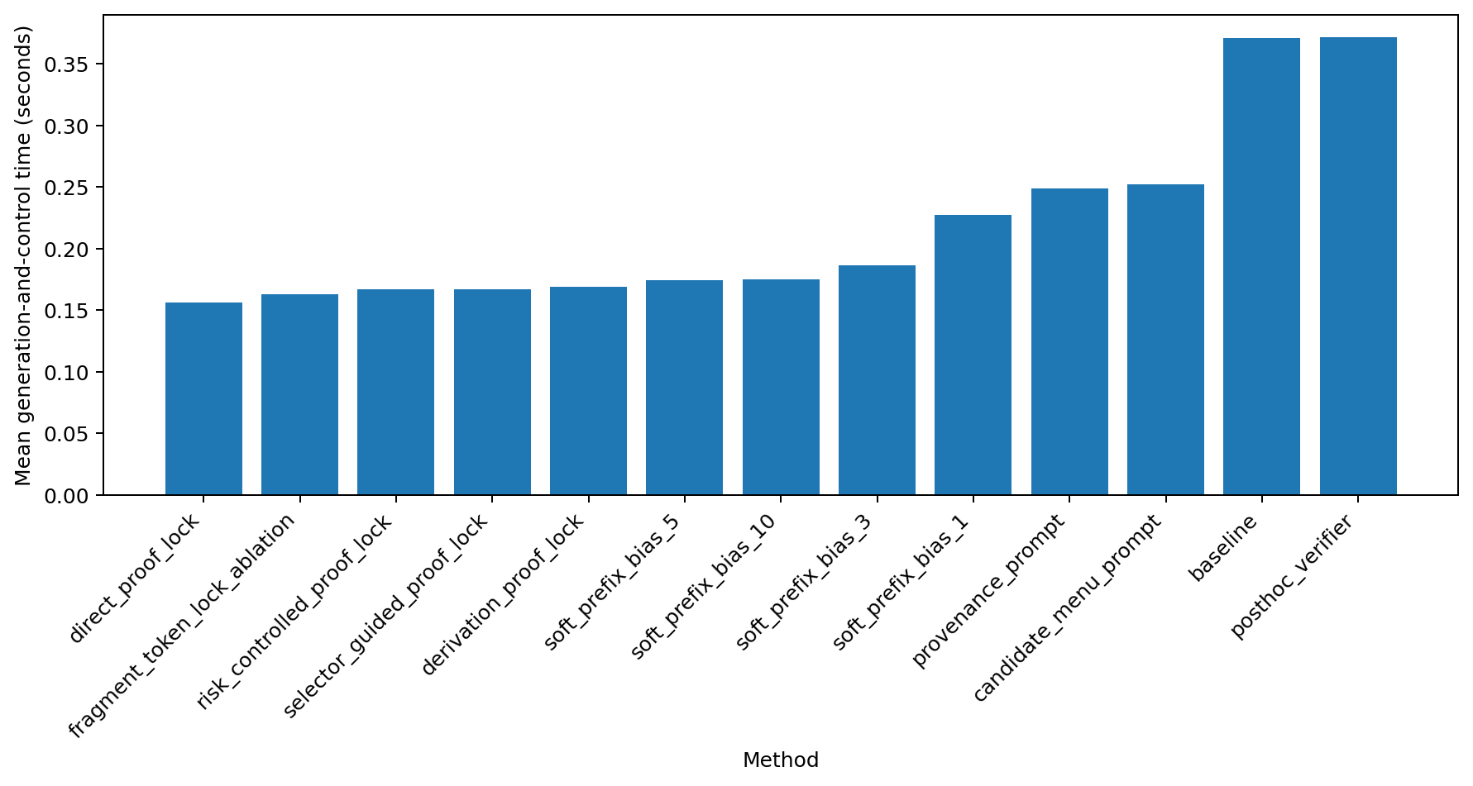
Figure A3. Mean generation-and-control time by method. Values exclude Evidence Ledger construction, retrieval, candidate generation and tokenisation and therefore are not end-to-end pipeline latency. Source: retained development predictions.

Appendix B. Validated implementation and evidence inventory
• Validated implementation release: NumGuard-Fin-Implementation-Audited.zip; SHA-256 f30273c7b18cde2036115e74b6849159491a229b16787a3aad528e4e65f1f624.
• Release inventory: 108 files, 19 directories and a 57-file source manifest.
• Retained evidence: 11,323 prediction rows from 871 FinQA development examples under 13 methods, with complete method coverage and no duplicate method–example pairs.
• Environment: google/flan-t5-base revision 7bcac572ce56db69c1ea7c8af255c5d7c9672fc2; Tesla T4; Python 3.12.13; PyTorch 2.11.0+cu128; Transformers 4.57.6.
• Experiment identity: configuration 4c6099853873; seed 42; FinQA development SHA-256 a847fb7e0d61a3125a1e2909852df6b89f1ee64d2c5ff1bf689e332214deee51.
• Engineering validation: 145 tests passed; 12 transparent fixtures; 156 paired fixture records; 52/52 candidate-mechanism checks passed; no hard-lock escape observed.
• Evidence integrity: summaries and paired comparisons regenerated from predictions; selector/calibration hashes matched; strict JSON and package-hygiene checks passed.
• Validation boundary: the implementation ZIP passed fresh-extraction validation. Retained GPU development evidence is reported here; any fresh rerun should replace it only after checksum and numerical-equivalence checks.
• Public test: not executed because the semantic calibration gate was infeasible.

Appendix C. Quality-assurance traceability
The table below maps the principal methodological and submission requirements to the sections and retained evidence that address them.
Quality-assurance concern | Where addressed
Full provenance–accuracy–refusal trade-off, significance and CIs | Sections 3.5 and 5.2–5.6; Tables 3–4; Figures 3–6
Operational derivation, normalisation and tolerance rules | Sections 3.3–3.4 and 4.1–4.2
Justification and limits of FLAN-T5 | Sections 3.1–3.2 and 6.4
Avoid compliance and generalisation overclaims | Sections 1.3, 6.3–6.4 and 8
Artefact components traced to RQ | Sections 1.2 and 4; Figure 1
Failure taxonomy and worked examples | Sections 3.6 and 5.5; Figure 7
Ethics approval and FinQA licence | Cover declaration, Section 8 and Appendix B
Running evidence/decision log | Sections 4.4–4.5 and 7; Appendix B

Appendix D. Prespecified independent certificate-validation protocol
The retained study did not include an independent certificate-validation experiment. The following protocol is specified to make the evidence required for a stronger provenance claim explicit and reproducible, rather than treating verifier agreement as independent validation.
Sampling frame: Draw 60 accepted hard-lock certificates before inspection: 30 direct and 30 derived. Within each proof type, stratify by semantic correctness and confidence band, and record the random seed and sampled example identifiers.
Reviewer information: Provide the question, source document/table context, emitted answer and certificate evidence/operation. Hide the automatic verifier verdict, method label, reference answer and failure category during the first-pass certificate judgement.
Certificate criteria: Score source-span existence, entity/metric match, period match, scale/type consistency, operand appropriateness, operation legitimacy, arithmetic reproducibility and an overall documentary-validity judgement.
Independence: Use two reviewers working independently. Report raw agreement and Cohen’s kappa for categorical judgements; adjudicate disagreements only after the independent ratings are frozen.
Analysis: Report direct and derived certificate validity separately with counts, denominators and 95% confidence intervals. After first-pass judgements are locked, reveal the reference answer to analyse how documentary-valid certificates can still be semantically wrong.
Decision rule: Treat this audit as validation of certificate meaning, not model accuracy. A failure of documentary validity would require revising the certificate policy before any claim stronger than encoded-policy membership is made.
Relation to the current evidence. The existing 120-case manual failure review remains useful for diagnosing candidate, semantic-choice and enforcement failures, but it should not be re-labelled as the independent audit above. This distinction preserves the evidential boundary of the submitted study.

