Assignment No. 01
Name : Pravin Nitin Gondane
Roll no : 04 Branch: SY SEDA Email : pravin.1252010004@vit.edu PRN No : 1252010004

Implement basic vector and matrix operations in C.
Vector Program Code:- #include<stdio.h> #include<conio.h>
int main()
{
int n;
printf("Enter the Vector size->\n"); scanf("%d",&n);
int m[n];
int m2[n];
printf("Enter the elements of the Vector 1->\n"); for(int i=0;i<n;i++)
{
scanf("%d",&m[i]);
}
printf("Enter the elements of the Vector 2->\n"); for(int i=0;i<n;i++)
{
scanf("%d",&m2[i]);
}
printf("Enter your choice->\n1.Sum of Vector\n2.Substraction of Vector\n3.Multiplication of Vector\n4.Scaling of Vector\n");
int ch; scanf("%d",&ch); switch(ch)

{
case 1:
printf("Sum of Vector is->\n"); for(int i=0;i<n;i++)
{
printf("%d",m[i]+m2[i]); printf("\n");
}
break; case 2:
printf("Substraction of Vector is->\n"); for(int i=0;i<n;i++)
{
printf("%d ",m[i]-m2[i]); printf("\n");
}
break; case 3:
printf("Multiplication of Vector is->\n"); for(int i=0;i<n;i++)
{
for(int j=0;j<n;j++)
{
int sum = 0;
for(int k=0;k<n;k++)
{
sum+=m[i]*m2[k];
}
printf("%d",sum);
printf("\n");

}
printf("\n");
}
break; case 4:
{
int s;
printf("Enter the scalar value->\n"); scanf("%d", &s);
printf("Scaling of first Vector is->\n"); for(int i=0;i<n;i++)
{
printf("%d",m[i]*s); printf("\n");
}
printf("\n");
printf("Scaling of second Vector is->\n"); for(int i=0;i<n;i++)
{
printf("%d",m2[i]*s); printf("\n");
}
}
break; default:
printf("Invalid choice\n");
}
return 0;
}

Output:
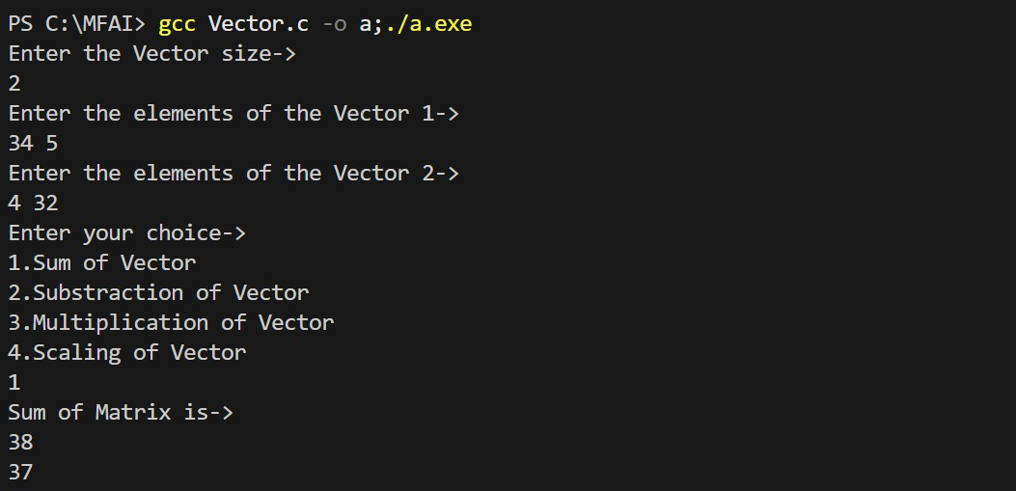
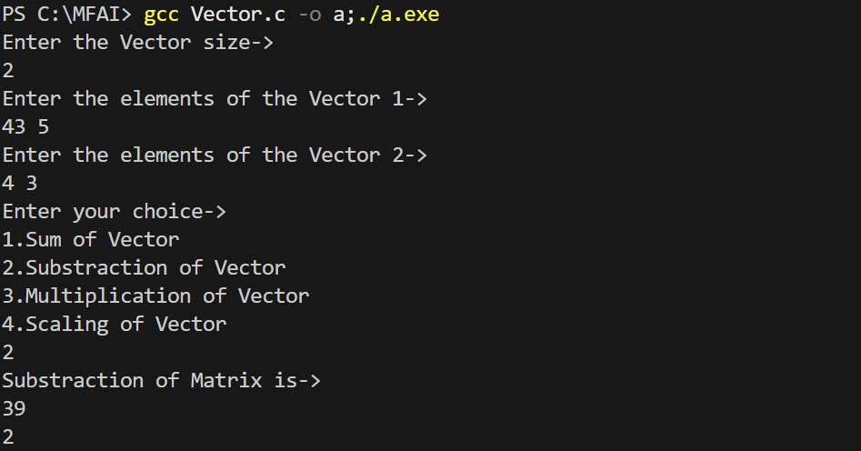

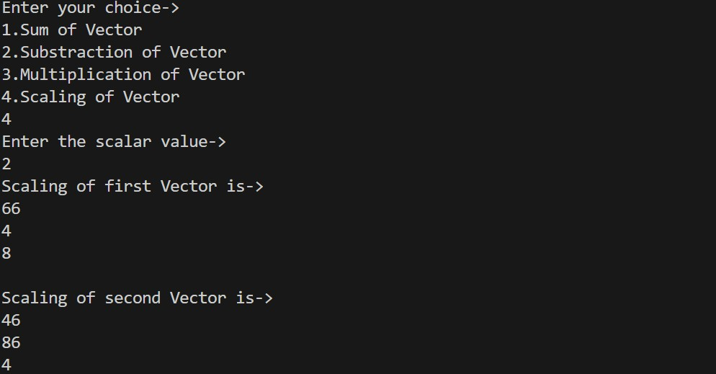

Matrix Program Code:- #include<stdio.h> #include<conio.h>
int main()
{
int r,c;
printf("Enter the Matrix size->\n"); scanf("%d%d",&r,&c);
int m[r][c];
int m2[r][c];
printf("Enter the elements of the Matrix 1->\n"); for(int i=0;i<r;i++)
{
for(int j=0;j<c;j++)
{
scanf("%d",&m[i][j]);
}
}
printf("Enter the elements of the Matrix 2->\n"); for(int i=0;i<r;i++)
{
for(int j=0;j<c;j++)
{
scanf("%d",&m2[i][j]);
}
}
printf("Enter your choice->\n1.Sum of Matrix\n2.Substraction of Matrix\n3.Multiplication of Matrix\n4.Scaling of Matrix\n");
int ch; scanf("%d",&ch); switch(ch)

{
case 1:
printf("Sum of Matrix is->\n"); for(int i=0;i<r;i++)
{
for(int j=0;j<c;j++)
{
printf("%d",m[i][j]+m2[i][j]); printf("\t");
}
printf("\n");
}
break; case 2:
printf("Substraction of Matrix is->\n"); for(int i=0;i<r;i++)
{
for(int j=0;j<c;j++)
{
printf("%d ",m[i][j]-m2[i][j]); printf("\t");
}
printf("\n");
}
break; case 3:
printf("Multiplication of Matrix is->\n"); for(int i=0;i<r;i++)
{
for(int j=0;j<c;j++)

{
int sum = 0;
for(int k=0;k<c;k++)
{
sum+=m[i][k]*m2[k][j];
}
printf("%d",sum);
printf("\t");
}
printf("\n");
}
break; case 4:
{
int s;
printf("Enter the scalar value->\n"); scanf("%d", &s);
printf("Scaling of first Matrix is->\n"); for(int i=0;i<r;i++)
{
for(int j=0;j<c;j++)
{
printf("%d",m[i][j]*s); printf("\t");
}
printf("\n");
}
printf("Scaling of second Matrix is->\n"); for(int i=0;i<r;i++)
{

for(int j=0;j<c;j++)
{
printf("%d",m2[i][j]*s); printf("\t");
}
printf("\n");
}
}
default:
printf("Invalid choice\n");
}
return 0;
}
Output:
