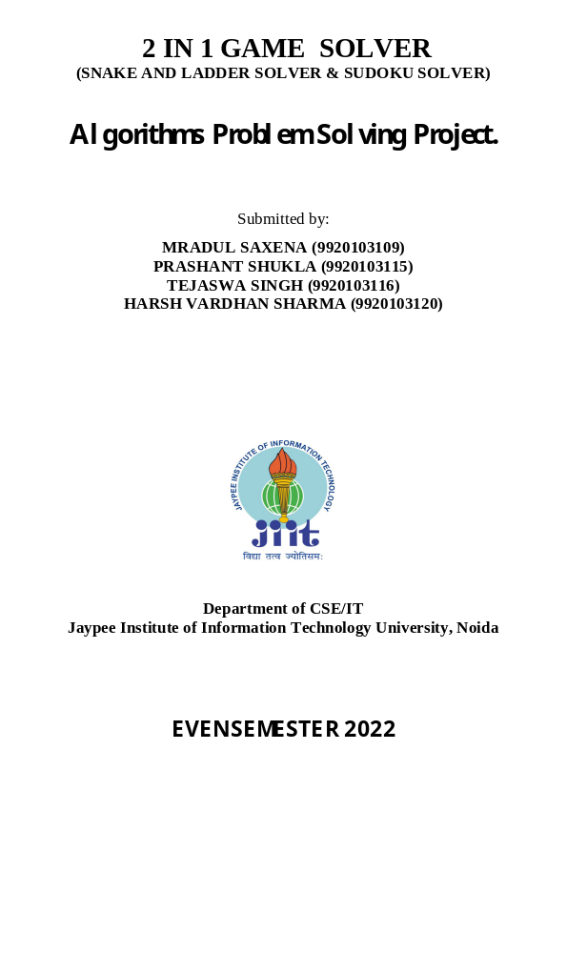
PROBLEM STATEMENT:
SNAKE AND LADDER
We are given a snake and ladder board, and asked to find the minimum number of dice throws required to reach the destination or last cell from source or 1st cell. This is done by considering that the player can determine which number appears in the dice being biased.
SUDOKU :
We are given a 9 X 9 sudoku board where some cells are filled. To solve the sudoku following constraints are to be followed:
- Each row must contain all integers from 1 to 9.
- Each column must contain all integers from 1 to 9.
- Each of the nine 3 X 3 sub-boxes must contain all integers from 1 to 9.
DATA STRUCTIRES AND ALGORITHM USED:
SNAKE AND LADDER:
- Queue data structure has been used. Queues are a type of container adaptors that operate in a first in first out (FIFO) type of arrangement. Elements are inserted at the back (end) and are deleted from the front. Queues use an encapsulated object of deque or list (sequential container class) as its underlying container, providing a specific set of member functions to access its elements.
- The idea is to consider the given snake and ladder board as a directed graph with number of vertices equal to the number of cells in the board. The problem reduces to finding the shortest path in a graph. Every vertex of the graph has an edge to next six vertices if next 6 vertices do not have a snake or ladder. If any of the next six vertices has a snake or ladder, then the edge from current vertex goes to the top of the ladder or tail of the snake. Since all edges are of equal weight, we can efficiently find shortest path using Breadth First Search of the graph.
COMPLEXITY ANALYSIS
TIME COMPLEXITY: Time complexity of the above solution is O(N) as every cell is added and removed only once from queue. And a typical enqueue or dequeue operation takes O(1) time.
SPACE COMPLEXITY: O(N)

SUDOKU
- BACKTRACKING ALGORITHM IS USED IN MAKING SUDOKU SOLVER
In this project Sudoku be solved by one by one assigning numbers to empty cells. Before assigning a number, check whether it is safe to assign. Check that the same number is not present in the current row, current column and current 3X3 sub grid. After checking for safety, assign the number and recursively check whether this assignment leads to a solution or not. If the assignment doesn’t lead to a solution, then try the next number for the current empty cell. And if none of the number (1 to 9) leads to a solution, return false and print no solution exists.
TIME COMPLEXITY
Complexity Analysis:
- Time complexity: O(9^(n*n)).
For every unassigned index, there are 9 possible options so the time complexity is O(9^(n*n)). The time complexity remains the same but there will be some early pruning so the time taken will be much less than the naive algorithm but the upper bound time complexity remains the same.
- Space Complexity: O(n*n).
To store the output array a matrix is needed.

PROJECT CODE:
#include<bits/stdc++.h>
using namespace std;
#define N 9
int snake_and_ladder()
{
int snakes;
int ladders;
cout<<"Enter the number of ladders in game"<<endl;
cin>>ladders;
map<int,int>lad;
map<int,int>snak;
cout<<"Choose starting point and end point of ladders respectively"<<endl;
for(int i=0;i<ladders;i++)
{
int u,v; cin>>u>>v;
lad[u]=v;
}
cout<<"Enter the number of snakes"<<endl;
cin>>snakes;
cout<<"Enter the head position and tail position of snake respectively"<<endl;
for(int i=0;i<snakes;i++)
{
int u,v; cin>>u>>v;
snak[u]=v;
}
int moves=0;
queue<int>q;
q.push(1);
bool found=false;
vector<int>vis(101,0);
vis[1]=true;
while(!q.empty() && !found)
{
int sz=q.size();
while(sz--)
{
int t=q.front();
q.pop();
for(int die=1;die<=6;die++)
{
if(t+die==100)
found=true;
if(t+die<=100 and lad[t+die] and !vis[lad[t+die]])
{
vis[lad[t+die]]=true;
if(lad[t+die]==100)
{
found=true;
}
q.push(lad[t+die]);
}
else if(t+die<=100 and snak[t+die] and !vis[snak[t+die]])
{
vis[snak[t+die]]=true;
if(snak[t+die]==100)
{
found=true;
}
q.push(snak[t+die]);
}
else if(t+die<=100 and !vis[t+die] and !snak[t+die] and !lad[t+die])
{
vis[t+die]=true;
q.push(t+die);
}
}
}
moves++;
}
if(found)
cout<<moves;
else
{
return -1;
}
return 0;
}
//SUDOKU SOLVER
int grid[N][N] = {
{3, 0, 6, 5, 0, 8, 4, 0, 0},
{5, 2, 0, 0, 0, 0, 0, 0, 0},
{0, 8, 7, 0, 0, 0, 0, 3, 1},
{0, 0, 3, 0, 1, 0, 0, 8, 0},
{9, 0, 0, 8, 6, 3, 0, 0, 5},
{0, 5, 0, 0, 9, 0, 6, 0, 0},
{1, 3, 0, 0, 0, 0, 2, 5, 0},
{0, 0, 0, 0, 0, 0, 0, 7, 4},
{0, 0, 5, 2, 0, 6, 3, 0, 0}
};
//Rows and columns are represented using i and j respectively...
bool InCol(int j, int num){
for (int i = 0; i < N; i++)
if (grid[i][j] == num)
return true;
return false;
}
bool InRow(int i, int num){
for (int j = 0; j < N; j++)
if (grid[i][j] == num)
return true;
return false;
}
bool InBox(int boxStartRow, int boxStartCol, int num){
for (int i = 0; i < 3; i++)
for (int j = 0; j < 3; j++)
if (grid[i+boxStartRow][j+boxStartCol] == num)
return true;
return false;
}
void sudokuGrid(){
for (int i = 0; i < N; i++){
for (int j = 0; j < N; j++){
if(j == 3 || j == 6)
cout << " | ";
cout << grid[i][j] <<" ";
}
if(i == 2 || i == 5){
cout << endl;
for(int i = 0; i<N; i++)
cout << "---";
}
cout << endl;
}
}
bool findEmptyPlace(int &i, int &j){
for (i = 0; i < N; i++)
for (j = 0; j < N; j++)
if (grid[i][j] == 0)
return true;
return false;
}
bool isValidPlace(int i, int j, int num){
return !InRow(i, num) && !InCol(j, num) && !InBox(i - i%3 ,j - j%3, num);
}
bool solveSudoku(){
int i, j;
if (!findEmptyPlace(i, j))
return true;
for (int num = 1; num <= 9; num++){
if (isValidPlace(i, j, num)){
grid[i][j] = num;
if (solveSudoku())
return true;
grid[i][j] = 0;
}
}
return false;
}
int main()
{
while(true){
cout<<"Welcome to 2 in 1 games solver"<<endl;
cout<<"Press 1 for snakes and laddder solver"<<endl;
cout<<"Press 2 for Sudoku solver"<<endl;
cout<<"Press 0 for Exit"<<endl;
int choice;
cin>>choice;
if(choice==0){cout<<"Thanks for playing !"<<endl;break;}
switch(choice){
case 1:{snake_and_ladder();cout<<endl;break;}
case 2: {
cout<<"The solved sudoku be: "<<endl;
cout<<endl;
if (solveSudoku() == true)
sudokuGrid();
else
cout << "No solution exists";
} break;
default: cout<<"Enter correct choice!"<<endl;
}
}
}

PROJECT SCREENSHOT:

