Hogwarts Booking System
Final Version – Software Developer Documentation
Prepared by: Development Team
Date: August 2025

Table of Contents
1. Introduction
2. System Overview
3. Project Objectives
4. System Architecture
5. Technology Stack
6. Features
7. Database Design
8. API Endpoints
9. User Interface Flow
10. Installation & Setup Guide
11. Deployment Instructions
12. Security Considerations
13. Problems Faced & Solutions
14. Future Enhancements
15. Conclusion

1. Introduction
The Hogwarts Booking System is a web-based application designed to manage facility reservations within a campus environment. This documentation provides a comprehensive overview of the system’s architecture, design decisions, database structure, and implementation details. It is intended for software developers, system administrators, and future contributors.

2. System Overview
The Hogwarts Booking System allows students, teachers, and administrators to reserve and manage facilities such as classrooms and sports venues. The application provides a user-friendly interface for booking management, a secure authentication system, and an administrative dashboard for monitoring usage and blocking timeslot for facilities maintenance.

3. Project Objectives
- Provide an easy-to-use platform for facility reservations.
- Ensure role-based access control (student, teacher, admin).
- Implement secure login with password hashing.
- Enable data persistence with SQLite.
- Provide analytics and reporting through the admin dashboard.
- Ensure scalability for future features.

4. System Architecture
The system follows a client-server model. The frontend is built with HTML, CSS, and JavaScript, served via an Express.js backend. The backend handles API requests, authentication, and database operations. SQLite is used as the database engine for persistent storage.

5. Technology Stack
- **Frontend:** HTML5, CSS3, JavaScript (Vanilla JS)
- **Backend:** Node.js with Express.js
- **Database:** SQLite3
- **Authentication:** bcrypt password hashing
- **Version Control:** Git + GitHub
- **Deployment:** Localhost / Cloud hosting options

6. Features
- User registration and login with role-based access control.
- Facility booking system with start and end times.
- Admin dashboard with booking statistics and charts.
- Blocking and unblocking of facilities.
- Cancel and update booking options.
- Responsive design for desktop and mobile use.

7. Database Design
The system uses an SQLite database with the following core tables:
- **Users:** Stores user credentials, roles, and metadata.
- **Facilities:** Defines available facilities.
- **Bookings:** Tracks reservations with timestamps and user references.
- **Blocked Facilities:** Maintains records of unavailable facilities.
Entity-Relationship diagrams were designed to ensure normalization and efficient querying.

8. API Endpoints
- `POST /api/register` → Register a new user
- `POST /api/login` → Authenticate user
- `GET /api/facilities` → Retrieve available facilities
- `POST /api/book` → Create a booking
- `GET /api/bookings` → View user bookings
- `DELETE /api/cancel/:id` → Cancel a booking
- `POST /api/block` → Admin blocks a facility
- `POST /api/unblock` → Admin unblocks a facility

9. User Interface Flow
1. User logs in with Hogwarts ID and password.
2. Role-based redirection occurs (student → booking page → booking-display page, admin → dashboard).
3. Student/Teachers selects facility, date, and time slot to book.
4. Admin monitors bookings, views statistics, and manages blocked facilities.

10. Installation & Setup Guide
1. Install Node.js and npm.
2. Clone the repository from GitHub.
3. Navigate to the server folder and run `npm install`.
4. Ensure SQLite3 is installed.
5. Run `node app.js` to start the backend.
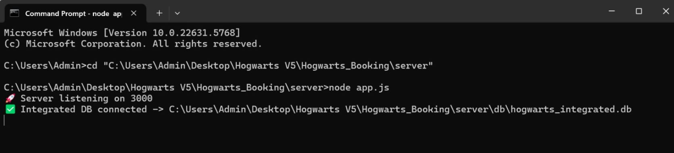
6. Open the client folder in a browser (or use `localhost:3000`).

11. Deployment Instructions
The system can be deployed on platforms such as Heroku, Vercel, or any VPS with Node.js support. Database migration scripts are included for setting up SQLite in production. Environment variables are used for configuring ports and database paths.

12. Security Considerations
- All passwords are hashed with bcrypt before storage.
- Role-based access ensures restricted functionality.
- Input validation is applied to prevent SQL injection.
- CORS is configured to allow safe API consumption.

13. Problems Faced & Solutions
- **Database Path Issues:** Different environments caused SQLite path errors. Solution: Use `path.join()` and ensure proper relative paths.
- **Authentication Errors:** Mismatched column names led to login issues. Solution: Standardized schema across backend and database.
- **UI Misalignment:** Elements were not centered across browsers. Solution: Adjusted CSS grid and flexbox alignment.
- **Deployment Failures:** Dependencies caused crashes on some platforms. Solution: Added explicit package-lock.json and documented installation steps.

14. Future Enhancements
- Implement JWT authentication.
- Add email notifications for bookings.
- Expand facility types and approval workflows.
- Add analytics dashboard with trends and usage heatmaps.
- Enable mobile app integration.

15. Conclusion
The Hogwarts Booking System successfully provides a robust and scalable solution for managing campus facility reservations. With a secure authentication system, a clear user flow, and an admin dashboard, the system is production-ready. This documentation ensures that future developers and maintainers can easily understand and extend the system.

