## A SUMMER INTERNSHIP REPORT ON

##### “STUDY OF CONSUMER’S PERCEPTION AND LIFE INSURANCE POLICIES IN LIFE INSURANCE CORPORATION OF INDIA”



**School of Banking, Financial Services and Insurance**

**Batch 2017- 2020**

**Faculty Mentor Submitted By:**

**Dr. Kapil Shrimal Anurag Chincholikar   
 BBA-BFSI 5th Sem (A)**

**Symbiosis University of Applied Sciences, Indore**

**TO WHOMSOEVER IT MAY CONCERN**

This is to certify that the Summer Project Study Report, Titled “STUDY OF CONSUMER’S PERCEPTION AND LIFE INSURANCE POLICIES IN LIFE INSURANCE CORPORATION OF INDIA**”** submitted by **Mr Anurag Chincholikar** as partial fulfillment of requirement of the three year BBA (2017-2020) is a bonafide work carried out by the student at our Institute.

This Summer Project Study is his/her original work and has not been submitted to any other University/Institute.

**. ………………………… ………………………….**

Faculty mentor Director

**Date:**

**Place:**

**Summer Internship Completion Certificate**

**Date:**

**To**

**The Director**

**School of Banking, Financial Services and Insurance**

**Symbiosis University of Applied Sciences**

**Indore**

This is to certify that Mr Anurag Chincholikar student Batch BBA 2017–2020 at Symbiosis University of Applied Sciences, Indore **Department**: School of Banking, Financial Services and Insurance has successfully completed his/her Summer Internship from…………………… to ……………………. in our organization.

During this period his/her performance was **Satisfactory/ Good/ Very Good** (Kindly tick one).

Remarks:

……………………………………………………………………………………………………………………………………………………………………………………………………………………………………………………………………………………………………………………………………………………………………………………………………………………………………………………………………………………………………………………………………………………………………………………………………………………………………………………………………………………………………………………………………………………………………………………………………………………………………………

( )

**Signature**

Name of the Issuing Authority: Mr. Girish Kumar Shukla

Designation: Development Officer

**DECLARATION BY THE STUDENT**

I Anurag Chincholikar student of BBA batch (2017-2020) declare that the project entitled STUDY OF CONSUMER’S PERCEPTION AND LIFE INSURANCE POLICIES IN LIFE INSURANCE CORPORATION OF INDIA**,** is my own work conducted under the supervision of Mr. Girish Kumar Shukla as a partial fulfillment of Summer Internship Program for the course of BBA submitted to …………………………………………………… and Symbiosis University of Applied Sciences, Indore **Department** : School of Banking, Financial Service and Insurance

I further declare that to the best of my knowledge the project does not contain any part of any work which has been submitted for any other project either in this institute or in any other without proper citation.

**Place : Indore**

**Date:………………………….. Signature of the Candidate**

## ACKNOWLEDGEMENT

A internship report is a result not only of the student who prepared it, but also the combine effort of the faculty guide, staffs and members of the institute where the project is done and most importantly the advisor who gives the final touch. On the successful completion of my internship, I would like to express my heartfelt gratitude to the people without whose help and kind co- operation this work would not have been possible.

First and foremost I want to thank The Almighty for blessings with which I was able to complete my work without much difficulty.

I express my deep sense of gratitude to esteemed Mr. Girish Kumar Shukla, Development Officer, Life Insurance Corporation of India, Indore for permitting me to work as trainee in the esteemed organization. I also wish to thank for his guidance and co-operation during the training.

A special thank to Ms. Vandana Shukla, Master Trainer, Life Insurance Corporation of India, Indore for her help and guidance.

I would like to express my sincere gratitude towards my faculty guide, Mr. Kapil Shrimal, for guiding me throughout the internship and providing me constant moral support & invaluable feedback.

I have deep admiration for my teachers at SUAS, Indore for nurturing my interest in the subject. Their dedication has instilled my faith in academics and has continued to inspire me.

Last but not the least love, care and support of parents, sibling and friends is indeed valuable. Finally, I thank to one and all, who helped me directly or indirectly in completing the internship.

-Anurag Chincholikar

## CONTENTS

|  |  |  |
| --- | --- | --- |
| **S.No.** | **Particulars** | **Page No.** |
| 1 | List of Figures and Tables | 1 |
| **Chapter No.** |  |  |
| 1 | Abstract and Introduction | 1-13 |
| 2 | Research Methodology | 14-19 |
| 3 | Data Analysis | 20-29 |
| 4 | Findings and Conclusions | 30-32 |
| 5 | Recommendations/Suggestions | 33-35 |
| 6 | Limitations | 36-37 |
|  | Bibliography | 39 |
|  | Annexure | 40-43 |

**LIST OF FIGURES AND TABLES**

|  |  |  |
| --- | --- | --- |
| **Fig. and Table No.** | **Particulars** | **Page No.** |
| 1 | Awareness of consumers | 21 |
| 2 | Purpose for buying an insurance policy | 21-22 |
| 3 | Amount of money want to invest | 22-23 |
| 4 | Buying behaviour influenced by | 23 |
| 5 | Company in which you believe | 24 |
| 6 | Way to pay the premium | 25 |
| 7 | Mode to pay the premium | 25-26 |
| 8 | Plans which consumers want | 26-27 |
| 9 | Satisfaction level with return | 27-28 |
| 10 | Reasons for not taking policy | 28-29 |

**CHAPTER 1**

**ABSTRACT AND INTRODUCTION**

**Company Profile**

The Life Insurance Corporation of India popularly known as “LIC of India” was incorporated on September 1, 1956 by nationalizing 245 Indian as well as foreign companies. It was established 66 years ago with a view to provide an insurance cover against various risks in life. The luminaries who spearheaded this move at that time visualized an entity that will provide life insurance to Indians, especially the vast rural people, at an economical cost and channel the savings for the betterment of the nation. It is the largest life insurance company in India and also the country’s largest investor.

It is fully owned by the Government of India and headquarter is Mumbai. Today LIC function with 2048 fully computerized branch offices, 100 divisional offices, 7 Zonal offices and the corporate office. LIC’s wide area Network covers 100 divisional offices and connects all the branches through a Metro area network. LIC has tied up with some Banks and service providers to offer on- line premium collection facility in selected cities. LICs ECS and ATM premium payment facility is an addition to customer convenience. Apart from on-line kiosks and IVRS, info centers have been commissioned at Mumbai, Ahmedabad, Bangalore, Chennai, Hyderabad, Kolkata, New Delhi, 74 Pune and many other cities.

LIC has crossed many milestones and has set unprecedented performance records in various aspect of life insurance business.

## Vision

A trans-nationally competitive financial conglomerate of significance to societies and Pride of India.

## Mission

Ensure and enhance the quality of life of people through finance security by providing products and services of aspired attributes with competitive returns, and by rendering resources for economic development.

## Our Goal

Life Insurance Corporation of India would strive hard to achieve the 3 goals mentioned below:

* + - Spread Life Insurance widely and in particular to the rural areas and to the socially and economically backward classes with a view to reaching all insurable persons in the country and providing them adequate financial cover against death at a reasonable cost.
    - Maximize mobilization of people's savings by making insurance-linked savings adequately attractive.
    - Meet the various life insurance needs of the community that would arise in the changing social and economic environment.

## Organizational Structure of LIC of India

## The Life Insurance Corporation Act, 1956 gives broadly the pattern of its organization which is given below -

## Image result for organization structure of lic

## Abstract

India is a country where the average selling of Life insurance policies is still lower than many Western and Asian countries, with the second largest population in world the Indian insurance market is looking very prospective to many multinational and Indian insurance companies for expanding their business and market share. Before the opening of Indian market for Multinational Insurance Companies, Life Insurance Corporation (LIC) was the only company which dealt in Life Insurance and after opening of this sector to other private companies, all the world leaders of life insurance have started their operation in India. With their world market experience and network, these companies have offered many good schemes to lure all type of Indian consumers but unfortunately failed to get the major share of market. Still the LIC is the biggest player in the life insurance market with approx 65% market share. But why Indian consumers do not trust on many companies and why the major population of India does not have any life insurance policy or what are the factors plays major role in buying behavior of consumers towards life insurance policies.

## Introduction

Life is full of risk and uncertainties. Since we are the social human being we have certain responsibilities too. Indian consumers have big influence of emotions and rationality on their buying decisions. They believe in future rather than the present and desire to have a better and secured future, in this direction life insurance services have its own value in terms of minimizing risk and uncertainties. Indian economy is developing and having huge middle class societal status and salaried persons. Their money value for current needs and future desires here the pendulum moves to another side which generate the reasons behind holding a policy. Here the attempt has been made in this research paper to study the buying behavior of consumers towards life insurance services. Life insurance is one of the best known insurance products today. People buy these products as investment tools and also as protection for themselves and their families. All the insurance companies the world over are looking at attracting the eye balls of customer and positioning their solutions innovatively to cater to niche and specific markets. One of the most critical aspects both from the view point of the customer and the insurer is getting important and relevant leads that can be beneficial for both.

## Origin of Insurance

Almost 4,500 years ago, in the ancient land of Babylonia, traders used to bear risk of the caravan trade by giving loans that had to be later repaid with interest when the goods arrived safely. In 2100 BC, the Code of Hammurabi granted legal status to the practice that, perhaps, was how insurance made its beginning. Life insurance had its origins in ancient Rome, where citizens formed burial clubs that would meet the funeral expenses of its members as well as help survivors by making some payments. As European civilization progressed, its social institutions and welfare practices also got more and more refined. With the discovery of new lands, sea routes and the consequent growth in trade, medieval guilds took it upon themselves to protect their member traders from loss on account of fire, shipwrecks and the like.

Since most of the trade took place by sea, there was also the fear of pirates. So these guilds even offered ransom for members held captive by pirates. Burial expenses and support in times of sickness and poverty were other services offered. Essentially, all these revolved around the concept of insurance or risk coverage. In 1347, in Genoa, European maritime nations entered into the earliest known insurance contract and decided to accept marine insurance as a practice.

## In India

Insurance in India can be traced back to the Vedas. For instance, Yogakshema, the name of Life Insurance Corporation of India's corporate headquarters, is derived from the Rig Veda. The term suggests that a form of "community insurance" was prevalent around 1000 BC and practiced by the Aryans. Burial societies of the kind found in ancient Rome were formed in the Buddhist period to help families build houses, protect widows and children.

Bombay Mutual Assurance Society, the first Indian life assurance society, was formed in 1870. Other companies like Oriental, Bharat and Empire of India were also set up in the 1870- 90s. It was during the Swadeshi movement in the early 20th century that insurance witnessed a big boom in India with several more companies being set up.

As these companies grew, the government began to exercise control on them. The Insurance Act was passed in 1912, followed by a detailed and amended Insurance Act of 1938 that looked into investments, expenditure and management of these companies' funds. By the mid- 1950s, there were around 170 insurance companies and 80 provident fund societies in the country's life insurance scene. However, in the absence of regulatory systems, scams and irregularities were almost a way of life at most of these companies.

As a result, the government decided nationalize the life assurance business in India. The Life Insurance Corporation of India was set up in 1956 to take over around 250 life companies. For years thereafter, insurance remained a monopoly of the public sector. It was only after seven years of deliberation and debate – after the RN Malhotra Committee report of 1994 became the first serious document calling for the re-opening up of the insurance sector to private players that the sector was finally opened up to private players in 2001.

The Insurance Regulatory & Development Authority, an autonomous insurance regulator set up in 2000, has extensive powers to oversee the insurance business and regulate in a manner that will safeguard the interests of the insured.

## Meaning of Insurance:

Insurance may be described as a social device to reduce or eliminate risk of loss to life and property. Insurance is a collective bearing of risk. Insurance spreads the risks and losses of few people among a large number of people as people prefer small fixed liability instead of big uncertain and changing liability. Insurance is a scheme of economic cooperation by which members of the community share the unavoidable risks.

Insurance can be defined as a legal contract between two parties whereby one party called Insurer undertakes to pay a fixed amount of money on the happening of a particular event, which may be certain or uncertain. The other party called Insure or Insurant pays in exchange a fixed sum known as premium. The insurer and the insurant are also known as Assurer or Underwriter and Assurant, respectively. The document which embodies the contract is called the policy.

## Types of insurance contract

### Life insurance

* + - * General insurance
      1. **Life Insurance**

Life insurance is a contract for payment of money to the person assured (or to the person entitled to receive the same) on the occurrence of an event insured against.

Usually the contract provides for –

Payment of an amount may be on the date of maturity or at specified periodic intervals or after death, if it occurs earlier.

Periodical payment of insurance premium can be done by the assured to the corporation who provides the insurance.

## Who can buy a life insurance policy?

Any person above 18 years of age and who is eligible to enter into a valid contract. Subject to certain conditions, a policy can be taken on the life of a spouse or children.

## What is a Whole Life Policy?

When most people think of life insurance, they think of a traditional whole life policy. These are the simplest policies to understand: You pay a fixed premium every year based on your age and other factors, you earn interest on the policy's cash value as the years roll by, and your beneficiaries get a fixed benefit after you die.

The policy takes you into old age for the same premium you started out with. Whole life insurance policies are valuable because they provide permanent protection and accumulate cash values that can be used for emergencies or to meet specific objectives. The surrender value gives you an extra source of retirement money if you need it.

## What is an Endowment Policy?

Unlike whole life, an endowment life insurance policy is designed primarily to provide a living benefit and only secondarily to provide life insurance protection. Therefore, it is more of an investment than a whole life policy. Endowment life insurance pays the face value of the policy either at the insured's death or at a certain age or after a number of years of premium payment.

Endowment life insurance is a method of accumulating capital for a specific purpose and protecting this savings program against the saver's premature death. Many investors use endowment life insurance to fund anticipated financial needs, such as college education or retirement. Premium for an endowment life policy is much higher than those for a whole life policy.

## What is a Money Back Policy?

This is basically an endowment policy for which a part of the sum assured is paid to the policyholder in the form of survival benefits, at fixed intervals, before the maturity date. The risk cover on the life continues for the full sum assured even after payment of survival benefits and bonus is also calculated on the full sum assured. If the policyholder survives till the end of the policy term, the survival benefits are deducted from the maturity value.

## Why does one need Life Insurance?

Life insurance is designed to protect you and your family against financial uncertainties that may result due to unfortunate demise or illness.

## Choosing the right plan

Identifying the right plan basis your needs is the first crucial step towards insurance planning. At LIC we help customer by identifying their various needs and offering plans that are customized for you. You may also choose a plan by identifying the life stage you are at.

The following needs of a person can be fulfilled by insurance:

##### Protection

Need for a sound income protection in case of your unfortunate demise.

##### Investment

Need to ensure long-term real growth of your money.

##### Saving

Save for the milestones and protect your savings too.

##### Pension

Need to save for a comfortable life post retirement.

Once customers have analyzed their needs as per above classification, customers need to then ascertain important factors such as type of cover, insurance amount as per one's income, life stage and dependents

## Objectives of Life Insurance

* + - * 1. To spread life insurance and provide life insurance protection to the masses at reasonable cost.
        2. To mobilize peoples savings through insurance-linked savings schemes.
        3. To invest the funds to serve the best interests of both the policy holders and the nation.
        4. To conduct business with maximum economy, always remembering that the money belongs to the policy holders.
        5. To act as trustees of the policy holders and protect their individual and collective interests.
        6. To innovate and adapt to meet the changing life insurance needs of the community.

## Objective of Insurance Policy

1. Life Insurance policy for the rural areas and the socially and economically backward classes with a view to reach all insurable persons in the country and providing them adequate financial cover of reasonable cost.
2. Conduct business with utmost economy and with the full realization that the money to the public.
3. Meet the various life insurance need of the community that would arise in the changing social and economical environment.
4. Maximize mobilization of peoples’ saving by making insurance – linked securing adequately attractive.
5. Involve all people working in the corporation to the best of their capability in furthering the interests of the insurance public by providing efficient service with courtesy.
6. Bear in mind, the investment of funds, the primary obligation to its policy holders, whose money it holder in trust, without losing sight of the interest of the community as a whole; the fund is to be deployed to the best advantage of the investors as the community as whole, keeping in view national as well as the community attractive return.

## Benefits to Insurance Policy Holder

##### Tax Benefits:

Relief in income tax is available for amount paid by way of premium for life insurance.Investment qualifying for rebate viz. insurance premia, premium paid toward annuity plans for life insurance are specified under section 88(2) of the income tax Act.

##### Safety:

In life insurance, on death, the full sum assured is payable (with bonuses wherever applicable) whereas in other saving scheme, only the amount (saved with interest) is payable.

##### Liquidity:

Loans can be raised on sole security of the policy which has acquired a paid-up value. Besides, a Life Insurance policy is also generally accepted as security for even a commercial loan/housing loan.

##### Aid to Thrift:

Life Insurance encourages ‘thrift’ Long term saving can be made in a relatively painless manner because of ‘easy installment facility’ (Premium can be made through monthly, quarterly, half- yearly or yearly installment). The Salary Saving Scheme, popularly known as SSS provide a convenient method if paying premium each month through deduction from one’s salary. The Salary Saving Scheme can be introduced in an institution of establishment subject to specified terms and condition.

##### Money at the time of Requirements:

A suitable insurance plan or a combination of different plans can be taken to meet specific needs that are likely to arise in future such as children’s education, start in-life or marriage provision or even periodical needs for cash ones a predetermined stretch of time. Alternatively, policy money can be so arranged to be used for other investments subject to certain conditions, loans are granted to policy holders for house or for purchase of flats.

##### Insurance affords peace of mind:

The security is the prime motivating factor. The security ends the tension and finally leads to peace to mind.

##### Insurance Eliminate Dependency

At the death of husband or the father or any lead person, the family would suffer a lot. The insurance is here to assist then like to provide adequate amount at the time of suffering. The economic dependency if the family is reduced.

##### Insurance encourages savings:

In most of the life policies, element of saving is predominant, this policies combine of programme of Insurance and saving. Saving with insurance has certain extra advantage.

##### Economic Growth of the country:

For the growth of the country insurance provides string hand and mid to protect against loss of death. From the insurance government get more financial resource and utilize strengthen the economic condition of the country.

## OBJECTIVES OF THE STUDY

Following are the main objectives of the study are

1. To know the customers awareness regarding the life insurance.
2. To know the customers awareness regarding the various life insurance companies in the insurance sector.
3. To know the customers preference towards the private or public insurance sector.
4. To know the different promotion strategy used by companies to aware their customers.
5. To evaluate the factors underlying consumer perception towards investment in life insurance policies.
6. To develop and standardize a measure to evaluate investment pattern in life insurance services.

# CHAPTER 2

**RESEARCH METHODOLOGY**

**Research Methodology**

Research is a common language refers to a search of knowledge. Research is scientific & systematic search for pertinent information on a specific topic, in fact research is an art of scientific investigation. Research Methodology is a scientific way to solve research problem. It may be understood as a science of studying how research is doing scientifically. In it we study various steps that are generally adopted by researchers in studying their research problem. It is necessary for researchers to know not only know research method techniques but also technology.

The research problem consists of series of closely related activities. At times, the first step determines the native of the last step to be undertaken. Why a research has been defined, what data has been collected and what a particular methods have been adopted and a host of similar other questions are usually answered when we talk of research methodology concerning a research problem or study.

## Research Design

A research design is defined as the specific methods and procedures for acquiring the information needed. It is a plant or organizing framework for doing the study and collecting the data. Designing a research plan requires decisions all the data sources, research approaches, research instruments, sampling plan and contact methods.

Research design is mainly of following types:

* + - 1. Exploratory research
      2. Descriptive research

##### Exploratory Research

The major purposes of exploratory studies are the identification of problems, the more precise formulation of problems and the formulations of new alternative courses of action. The design of exploratory studies is characterized by a great amount of flexibility and ad-hoc veracity.

##### Descriptive Research

Descriptive research in contrast to exploratory research is marked by the prior formulation of specific research questions. The investigator already knows a substantial amount about the research problem. Perhaps as a result of an exploratory study, before the project is initiated. Descriptive research is also characterized by a preplanned and structured design.

## Data Collection Method

##### DATA COLLECTION METHOD

PRIMARY SECONDARY

Direct personal Interview

Indirect personal Interview Published Sources Unpublished Sources

Information from correspondents Govt. Publication

Mailed questionnaire Report Committees &

Question filled by enumerators

Commissions Private Publication Research Institute

**Period of Study**: This study has been carried out for a maximum period of 8 weeks.

**Area of study**: The study is exclusively done in the area of marketing. It is a process requiring care, sophistication, experience, business judgment, and imagination for which there can be no mechanical substitutes.

**Sampling Design**: The random sampling is done because any probability sampling procedure would require detailed information about the universe, which is not easily available further, as it is being an exploratory research.

**Sample Procedure**: In this study random sampling procedure is used. Random sampling is preferred because of some limitation and the complexity. Area sampling is used in combination with random sampling so as to collect the data from different regions of the city.

**Sampling Size**: The sampling size of the study is 100.

## Method of the Sampling:

**Probability Sampling**

It is also known as random sampling. Here, every item of the universe has an equal chance or probability of being chosen for sample.

Probability sampling may be taken inform of:

##### Simple Random Sampling

A simple random sample gives each member of the population an equal chance of being chosen. It is not a haphazard sample as some people think. One way of achieving a simple random sample is to number each element in the sampling frame (e.g. give everyone on the Electoral register a number) and then use random numbers to select the required sample.

Random numbers can be obtained using your calculator, a spreadsheet, and printed tables of random numbers,

**Systematic Random Sampling**

This is random sampling with a system from the sampling frame, a starting point is chosen at random, and thereafter at regular intervals.

##### Stratified Random Sampling

With stratified random sampling, the population is first divided into a number of parts or 'strata' according to some characteristic, chosen to be related to the major variables being studied. For this survey, the variable of interest is the citizen's attitude to the redevelopment scheme, and the stratification factor will be the values of the respondents' homes. This factor was chosen because it seems reasonable to suppose that it will be related to people's attitudes

##### Cluster and Area Sampling

Cluster sampling is a sampling technique used when "natural" groupings are evident in a statistical population. It is often used in marketing research. In this technique, the total population is divided into these groups (or clusters) and a sample of the groups is selected.

Then the required information is collected from the elements within each selected group. This may be done for every element in these groups or a subsample of elements may be selected within each of these groups.

**Non Probability Sampling**

It is also known as deliberate or purposive or judgmental sampling. In this type of sampling, every item in the universe does not have an equal, chance of being included in a sample.

It is of following type:

##### Convenience Sampling

A convenience sample chooses the individuals on the basis of easiness to reach or convenience. Convenience sampling does not represent the entire population so it is considered bias.

##### Quota Sampling

In quota sampling the selection of the sample is made by the interviewer, who has been given quotas to fill form from specified sub-groups of the population.

##### Judgment Sampling

The sampling technique used here in probability > Random Sampling.

## Data Collection

Data is collected from various customers through personal interaction. Specific questionnaires are prepared for collecting data. Data is collected with mere interaction and formal discussion with different respondents and face to face contact with the persons from whom the information is to be obtained (known as informants). I ask them questions pertaining to the survey and collect the desired information. I contact the workers of Life Insurance Corporation of India to obtain some of the information. The information obtained is first hand and original in character.

# CHAPTER 3 DATA ANALYSIS

## Data Analysis

* + 1. **Awareness of life insurance in consumer.**

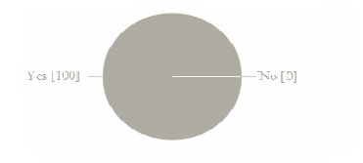

### Fig.1

Table no. 1

|  |  |  |
| --- | --- | --- |
|  | No. of respondents | Percentage of respondents |
| Yes | 100 | 100% |
| No | 0 | 0% |

Interpretation 1:

According to the data maximum no. of people are aware with life insurance policy (here 100% people are aware with it). Today Indians are aware with this investment because it covers risk of the life as well as gives better return on maturity.

## What is your purpose for buying an insurance policy?

Table no. 2

|  |  |  |
| --- | --- | --- |
|  | No. of respondents | Percentage of respondents |
| For old age saving | 51 | 51% |
| Family needs | 14 | 14% |
| Time to time needs | 21 | 21% |
| Opposite circumstances | 14 | 14% |

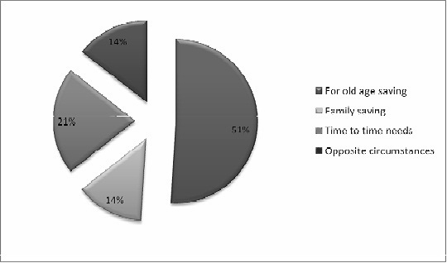

Fig. 2

Interpretation 2:

Most of the people buy insurance policy for their old age saving because they want to save money or back up for old age and only 21% people buy insurance for time to time needs.

## How much money you want to invest in insurance?

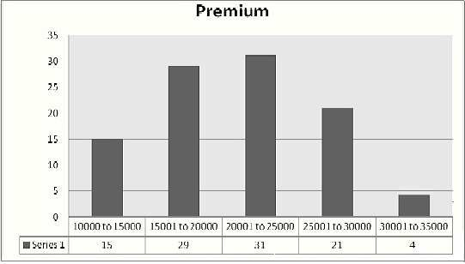

Fig. 3

Table no. 3:

|  |  |
| --- | --- |
| Premium amount | No. of respondents |
| Rs. 10,000 to 15,000 | 15 |
| Rs. 15,001 to 20,000 | 29 |
| Rs. 20,001 to 25,000 | 31 |
| Rs. 25,001 to 30,000 | 21 |
| Rs. 30,001 to 35,000 | 4 |

Interpretation 3:

Mostly people invest in insurance on the basis of their saving and according to their saving they purchase insurance policies. Here most of the people invest 20001 Rs. to 25000 Rs. and very less number of people invest huge amount in insurance.

## When you are buying an insurance policy, your decision is influenced by?

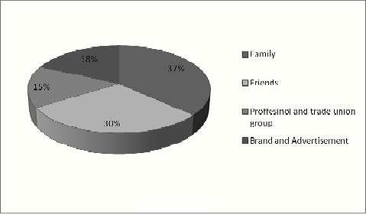

Fig. 4

Table no. 4

|  |  |
| --- | --- |
|  | No. of respondents |
| Family | 37 |
| Friends | 30 |
| Professional and trade union group | 15 |
| Brand and advertisement | 18 |

Interpretation 4:

Insurance is now basic investment for consumers. But this is tradition of India that we do not believe on unknown people so when any one buy insurance policy then his or her decision is depend on family, friends and on other factors. In the study i found that 37% of respondents believe on their family to buy insurance policy but only 18% respondent’s decision depend on brand and advertisement of the company. So, a/c to study, we see that family and friends play a big role to buy an insurance policy.

## In which company you believe most?

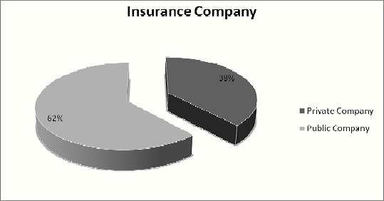

Fig.5

Table no. 5

|  |  |
| --- | --- |
| Company | No. of respondents |
| Private company | 38 |
| Public company | 62 |

Interpretation 5:

Most of the people want to invest their money in public insurance company. In private insurance company only 38 respondents want to invest their money. Most of the people buy insurance from LIC and there are more than 20 private insurance companies in India.

#### How do you want to pay your premium?

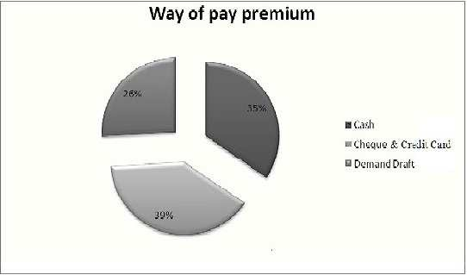

Fig. 6

Table no. 6

|  |  |
| --- | --- |
| Mode | No. of respondents |
| Cash | 35 |
| Cheque & Credit card | 39 |
| Demand draft | 26 |

Interpretation 6:

Most of the respondents (i.e. 39) pay their premium through cheque & credit card because of easiness and convenience. 35 respondents pay their premium through cash and 26 of them pay their premium through demand draft.

#### In what mode you want to give premium?

Table no. 7

|  |  |  |
| --- | --- | --- |
| Mode | No. of respondents | Percentage of respondents |
| Monthly | 26 | 26% |
| Half-yearly | 39 | 39% |
| Yearly | 35 | 35% |

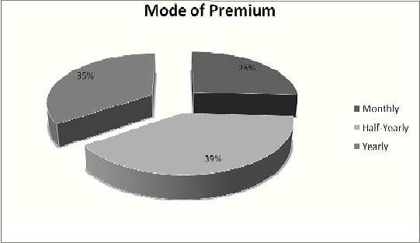

Fig.7

Interpretation 7:

Insurance companies give a lot of facility to their loyal customers for payment of premium. Costumer also pays the premium in three modes monthly, half yearly and yearly. Here 39 % respondents pay in half yearly mode and 35% respondents pay yearly mode premium.

## Do you want which type of insurance plan?

Table no. 8

|  |  |
| --- | --- |
| Plans | No. of respondents |
| ULIP | 21 |
| Traditional plans | 40 |
| Health plans | 23 |
| Term plans | 16 |

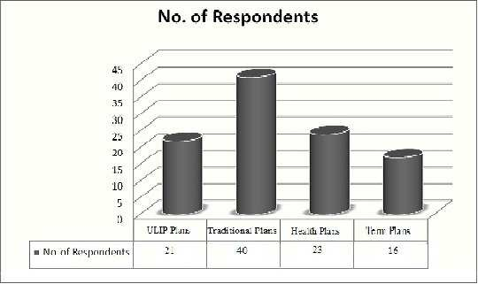

Fig. 8

Interpretation 8:

Most of respondents want mostly traditional plan. 40% respondents use traditional plan and 21% respondents want to buy ULIP Plan. People show their interest towards ULIP’s because it provides both risk coverage for life and investment opportunity in securities.

## Are you satisfied with the return on investment which you getting from policy?

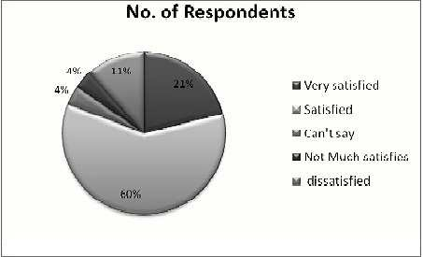

Fig. 9

Table no. 9

|  |  |  |
| --- | --- | --- |
| Satisfaction level | No. of respondents | Percentage of respondents |
| Very Satisfied | 21 | 21% |
| Satisfied | 60 | 60% |
| Can’t say | 4 | 4% |
| Not much satisfied | 4 | 4% |
| Dissatisfied | 11 | 11% |

Interpretation 9:

According to data, 60% of respondent are satisfied with the return. About 21% are very satisfied on their investment’s return and 11% are dissatisfied with return on investment.

## If you are not taking any insurance policy then please tell us the reason, why?

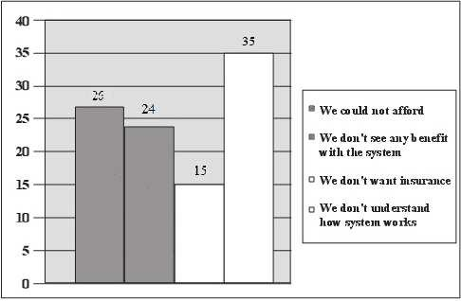

Fig. 11

Table no. 10

|  |  |
| --- | --- |
| Reasons | No. of respondents |
| We could not afford. | 26 |
| We don’t see any benefit .with it. | 24 |
| We don’t want insurance. | 15 |
| I don’t understand that how it works? | 35 |

Interpretation 10:

As the evident shows that as most as 35 of the total respondents don’t understand the working of the insurance system and nearly 24 of the respondents don’t see any benefit with the system, 15 and 26 of the respondents don’t want insurance and could not afford respectively.

# CHAPTER 4

# FINDINGS AND CONCLUSIONS

## Findings

* + 1. Now life insurance has become generic. People believe in Life Insurance Company only and therefore, everybody wants to go in for a policy with LIC. It will take time to private companies to win the confidence of the people.
    2. As far as future decision making about the policy is concerned most of the policy would go in for saving plan.
    3. People are turning towards the ULIP as a good investment option but ULIP is in its starting phase so customers prefer only big brands like LIC, RLIC etc.
    4. LIC is the oldest player in the Insurance market, so people are more aware of i.e., as compared to new players.
    5. This clearly comes out from the survey conducted that most of the people come to know about Life Insurance Corporation through print media.
    6. It has clearly come out that most of the people like to go in for a policy, which gives them tax benefit.
    7. According to survey it is cleared that most of the people don’t take insurance policy because they don’t understand that how insurance policy works?
    8. Most of People influenced by family and friends when they are buying insurance policies.

## Results

Life Insurance Corporation of India is an Indian state-owned [insurance](https://en.wikipedia.org/wiki/Insurance) group and [investment](https://en.wikipedia.org/wiki/Investment) corporation owned by the [Government of India](https://en.wikipedia.org/wiki/Government_of_India) and it has awakened many new hopes and aspiration for human kind, just based on a noble human passion of law, compassion tolerance and mutual understanding.

Globalization has opened new formalities of technology, knowledge, communication and information. LIC is a gift of globalization to maintain development of these formalities there before is a daunting challenge i.e. the utilization of these facilities to create a brave new worlds in which a qualitative and a clear change between yesterdays and hormones can easily perceived.

I have done a detailed the comparative study of Life Insurance Corporation of India with other life insurance companies and concluded that most of the people preferred to deal with nationalized insurance companies.

People used to buy Insurance for tax exemption but time has changed now, advertising has made the people understand the need of Life Insurance in their lives and people are taking initiatives to buy it. Urge of people to have Insurance and strong marketing can really make the industry reach the sky.

Life Insurance Corporation of India has set all the strategies and mission after proper vision and is achieving the largest by working in co-operative and co-ordinate manner and giving the people full services and facilities and making easy. So I would like to conducted by saying that Life Insurance Corporation of India is a wonderful gift given to the mankind in the new are for people development and maintenance of the world as well as India.

# CHAPTER 5 RECOMMENDATIONS/SUGGESTIONS

## RECOMMENDATIONS

Followings are the recommendations and the suggestions not only for the Life Insurance Corporation of India but also for private life insurance companies if they want to compete with public/government life insurance companies.

##### Creating positive image:

Private companies should try their level best to create positive and favorable image in the minds of people i.e. in the minds of their target customers.

##### Training and development to agents:

Company must provide training to their agents and financial so that they can satisfy customer and doubts effectively.

##### Concern towards customers:

Serious concern must be given to the customers as in today’s scenario it regarded as “Customer is a king”. In formal words we can say that if can customers more loyal towards the company.

##### Co-operation with agents and branch managers:

The Company must full co-operate with branch managers and agents.

##### Availability of branch offices:

There must be the branch offices in each 20-30 Km. diameter.

##### Efficient management:

The management appointed must be that much capable that it can control the whole team and improve the goodwill and image of the company.

##### Sales promotion and marketing:

The marketing department must be so aggressive that it can have a close watch on the competitors’ activities. Not only this but also it must take care of the need and wants of the customers also.

##### Incentive schemes and permanency in job:

There must be good incentive schemes to be designed as these can acts as good motivators for the agents. The scheme of permanent job placement must be introduce for those agents who have shown extra ordinary performance.

# CHAPTER 6 LIMITATIONS

## 6.1 Limitations

Although every effort has been in to collect the relevant information through the sources available, still some relevant information could not be gathered.

##### Busy Schedule of Concerned Executives:

The concerned executives were having very busy schedule because of which they were reluctant to give appointment.

##### Time:

The time duration could not provide ample opportunity to study every detail of the company.

##### Unawareness:

Customers were unaware of many terms related to same while asking to them.

##### Confidential Information:

As the company on account of confidential report has not disclosed some figures. Moreover, in some cases separate accounts of division are not separately maintained thereby, leading to restrictions in study.

##### Area:

Area of study chosen was not large.

# BIBLIOGRAPHY

## Books Referred

* Marketing Management by Philip Kotler
* Business Research by N.K. Malhotra

## Internet Resources

* + Search Sites [www.google.co.in](http://www.google.co.in/)
  + Websites of the organization www.licindia.in
  + Other sites [www.bimaonline.com](http://www.bimaonline.com/), [www.irdaindia.gov](http://www.irdaindia.gov/) , [www.yahooanswer.com](http://www.yahooanswer.com/), [www.wikipedia.com](http://www.wikipedia.com/)

## Company Resources

* + Product Brochures
  + Inputs from company personnel’s.

# ANNEXURES

**QUESTIONNAIRES**

Declaration: It is purely for academic purposes and the data given will not be passed to anyone. Please tick (√) out for appropriate option.

1. Personal Information:

....................................................................................................................................................................

a. Name: ...................................................................................

* 1. Gender: a) Male b) Female
  2. Age (in years) a) Below 18 b)18-35
  3. 35-50 d) Above 50

d. Educational qualification: .......................................................

e. Occupation: .............................................................................

f. Annual Income: a) Less than Rs. 1,00,000

b) Rs. 1, 00,001 to Rs. 3, 00,000

c) Rs 3, 00,001 to Rs. 5, 00,000

* 1. Rs. 5, 00,001 and Above

1. Questions:

....................................................................................................................................................................

* 1. Do you aware with Life Insurance?
     1. Yes b) No
  2. Are you interested in investing your money?
     1. Yes b) No
  3. Where do you want to invest your money?
     1. Shares b) Mutual funds

c) Insurance d) Fixed Deposits

* 1. What is the purpose for buying insurance Policy?
     1. For old age saving b) Family needs

c) Time to time needs d) Opposite circumstances

* 1. When you are buying an insurance policy then your decision influenced by?
     1. Family b) Friends

c) Professional & Union groups d) Brand & Advertisement

* 1. What is your saving as percentage (%) of annual income?

a) 10 to 20 b) 21 to 30

c) 31 to 40 d) 41 to 50

* 1. How much money do you want to invest in insurance plans?

a) Rs. 10,000 to Rs. 15,000 b) Rs. 15,001 to Rs. 20,000

c) Rs. 20,000 to Rs. 25,000 d) Rs. 25,001 t0 Rs. 30,000

e) Rs. 30,001 to Rs. 35,000

* 1. On which company do you believe most?
     1. Private insurance company
     2. Public insurance company
  2. How do you want to pay your premium?
     1. Cash
     2. Cheque & Credit card
     3. Demand draft
  3. Do you think that insurance policy is necessity of today’s life?
     1. Yes b) No
  4. In what interval do you want to give your premium?
     1. Monthly
     2. Half yearly
     3. Yearly
  5. Do you want which type of insurance policy?
     1. ULIP (Unit Linked Insurance Plan)
     2. Traditional
     3. Health
     4. Term Plan
  6. Are you satisfied with the return on investment which you getting from policy?
     1. Very Satisfied
     2. Satisfied
     3. Can’t say
     4. Not much Satisfied
     5. Dissatisfied
  7. If you are not taking any insurance policy then please tell us the reason, why?
     1. I could not afford.
     2. I don’t see any benefit with it.
     3. I don’t want insurance.
     4. I don’t understand that how it works?