PROJECT REPORT
Game-Theoretic Analysis of Renewable Energy Trading Among Microgrids
MultiGrid: a reproducible Python simulator comparing a utility-only baseline, a cooperative market (LP allocation with Nash bargaining) and a competitive market (seller price game with verified Nash equilibria)
Submitted by
Team member | Student ID
Krishna Tyagi | 2427030085
Prasham Jain | 2427030155
Hrishi Bhalaria | 2427030162
Lakshya Srivastava | 2427030611
Software MultiGrid simulator v0.4.0 (Python 3.13, HiGHS LP, Streamlit)
Source code github.com/PrashamJ17/MultiGrid-Game-Theoretic-Renewable-Energy-Trading-Among-Microgrids
Date November 2026
All energy profiles in this report are synthetic and all tariffs (retail INR 8/kWh, export INR 3/kWh) are illustrative assumptions. Every number was produced by the simulator from saved, reproducible runs; the results describe the behaviour of the model, not of any real community or utility.

Abstract
Microgrids with rooftop solar produce surplus energy around midday and run deficits in the morning and evening. With only a utility connection, they export surplus at a low export price and import deficits at a much higher retail price, so the spread between the two prices is lost whenever one microgrid exports while another imports in the same hour. Direct peer-to-peer (P2P) trading among microgrids can keep part of that spread locally, but it raises two game-theoretic questions: how should the benefit be shared, and what prices would self-interested sellers actually choose?
This report presents MultiGrid, a reproducible Python simulator that compares three ways of organising local trade on identical, frozen energy profiles: (i) a utility-only baseline; (ii) a cooperative market in which a welfare-maximising linear program allocates energy and every trade is priced by bilateral weighted Nash bargaining; and (iii) a competitive market in which sellers post prices in a finite simultaneous game, where every reported pure Nash equilibrium is verified by exhaustive enumeration of unilateral deviations. All three mechanisms share one settlement that checks energy conservation, capacities, payment cancellation and voluntary participation.
On a synthetic 24-hour day for four microgrids, the cooperative market lowers the community’s net cost from INR 8,633.60 to INR 7,373.66 (−14.6%), reaches the LP optimum and spreads gains fairly evenly (Jain index 0.830). The competitive market lowers it to INR 7,771.52 (−10.0%, efficiency 0.684) and concentrates the gains on sellers (Jain index 0.467). The entire shortfall comes from two oversupplied midday hours in which capacity-constrained sellers undercut each other in a cycle and no pure equilibrium exists; in every hour with an equilibrium, the competitive market trades exactly the LP-optimal volume. Across ten synthetic days, the cooperative gain is stable (INR 1,284.80 ± 30.72) while the competitive gain varies widely (INR 898.80 ± 124.02). Seven controlled experiments examine the tariff spread, fees, solar availability, market size, price resolution and day-to-day variation. The software passes 345 automated tests and an independent 22-check export audit. All data are synthetic and all tariffs illustrative, so the findings describe the model, not a real community.
Keywords: peer-to-peer energy trading; microgrids; game theory; Nash bargaining; Nash equilibrium; linear programming; Bertrand–Edgeworth competition; reproducible simulation.

Contents
1 Introduction 1
1.1 Background and motivation 1
1.2 Problem statement 1
1.3 Research questions 1
1.4 Objectives and scope 2
1.5 Approach at a glance 2
1.6 Contributions 3
1.7 Organisation of the report 4
2 Background and related work 5
2.1 Microgrids and peer-to-peer energy trading 5
2.2 Cooperative games and Nash bargaining 5
2.3 Non-cooperative games and Nash equilibrium 5
2.4 Price competition with capacity constraints 6
2.5 Tools and data sources 6
2.6 Position of this work 6
3 System model 7
3.1 Players, time and units 7
3.2 Energy balance 7
3.3 Tariffs and fees 8
3.4 Utility-only baseline 8
3.5 Shared settlement 8
3.6 Golden one-hour fixture 9
3.7 Modelling assumptions 10
4 Cooperative market 11
4.1 Stage A: welfare-maximising allocation 11
4.2 Tie rule on the optimal face 11
4.3 Stage B: bilateral weighted Nash bargaining 12
4.4 Properties of the cooperative outcome 12
4.5 The golden fixture under the cooperative market 12
5 Competitive market 14
5.1 Players and strategies 14
5.2 Buyer response rule 14
5.3 Payoffs 14
5.4 Pure Nash equilibrium and exhaustive verification 14
5.5 Selection, missing equilibria and the enumeration cap 15
5.6 Worked example 1: the golden hour 16
5.7 Worked example 2: a price war without a pure equilibrium 16
5.8 Three price regimes: scarcity, Edgeworth cycles and Bertrand 17
6 Performance metrics 18
6.1 Community metrics 18
6.2 Distribution and efficiency 18
6.3 Equilibrium diagnostics 18
6.4 Handling of undefined values 19
7 Software design and implementation 20
7.1 Architecture and data flow 20
7.2 Module responsibilities 20
7.3 Data contracts and validation 20
7.4 Synthetic data generation 21
7.5 Simulation controller and experiment runner 21
7.6 Command-line interface 22
7.7 Interactive dashboard 22
7.8 Error handling 26
8 Verification and validation 27
8.1 Test strategy and coverage 27
8.2 Blueprint critical tests 28
8.3 Independent export audit 28
8.4 Requirement traceability 30
8.5 Reproducibility 30
9 Experimental design 31
9.1 Base scenario 31
9.2 Design rules 31
9.3 Experiment matrix 32
9.4 Interpretation rules 32
10 Results 33
10.1 E1: reference day 33
10.2 E2: tariff spread 38
10.3 E3: fees 39
10.4 E4: solar availability 40
10.5 E5: market size 41
10.6 E6: strategy resolution 42
10.7 E7: ten synthetic days 43
10.8 Summary of findings 44
11 Discussion 45
11.1 Efficiency versus distribution 45
11.2 Why pure equilibria disappear in oversupplied hours 45
11.3 The role of modelling choices 45
11.4 Implications for local market design 46
11.5 Threats to validity 46
12 Limitations and future work 47
12.1 Limitations 47
12.2 Future work 47
13 Conclusion 48
References 49
Appendix A. Reproduction guide 50
Appendix B. Base configuration 51
Appendix C. Output data contracts 52
Appendix D. Glossary 53

List of Figures
Figure 1. The MultiGrid pipeline: inputs, validation, the hourly energy model, the three market mechanisms, the shared settlement and the controller that feeds every output. 3
Figure 2. Golden fixture: (a) under the baseline every flow goes through the utility; (b) both P2P markets trade the same 30 kWh, the cooperative market at INR 5.50/kWh and the competitive market at INR 7.50/kWh. 13
Figure 3. Dashboard Overview tab on the seed-42 day. The sidebar holds all controls; the banner reports the two intervals without a pure equilibrium. 23
Figure 4. Game analysis tab, hour 12: the NO PURE EQUILIBRIUM FOUND banner and each seller’s utility as it changes its own price, with the other held at the NOT NASH diagnostic profile. 24
Figure 5. Game analysis tab, hour 12: maximum unilateral regret over all 100 price profiles. No profile has zero regret, so there is no pure equilibrium. 24
Figure 6. Comparison tab: the metric table for the three mechanisms on the seed-42 day, as produced by the shared settlement. 25
Figure 7. Network tab: contracted P2P energy of the cooperative market over the day, from sellers (left) to buyers (right). 25
Figure 8. Synthetic 24-hour generation and demand per microgrid on the reference day (seed 42). 33
Figure 9. Hourly community totals of surplus (up) and deficit (down) on the reference day. 34
Figure 10. Community net cost over the 24-hour reference day by mechanism (signed; positive means the community pays). 35
Figure 11. P2P energy per seller → buyer pair over the whole day (left) and hourly P2P volume (right) for the two markets. 36
Figure 12. Gain over the baseline per microgrid over the reference day, with the Jain fairness index of each market. 37
Figure 13. Competitive seller utility as one seller changes its own price, with the other held fixed. Large markers show the held prices: hour 8 is a verified pure equilibrium; hour 11 has none. 38
Figure 14. Community gain against the retail–export spread (left) and the number of competitive hours without a pure equilibrium (right), E2. 38
Figure 15. Sensitivity of P2P volume (left) and community gain (right) to the total seller + buyer fee, E3. The vertical line marks fees equal to the spread. 39
Figure 16. Energy position (left), P2P volume (centre) and community net cost (right) against the solar scale, E4. 41
Figure 17. Competitive intervals by status (left), the worst NOT NASH regret (centre) and solve time (right) against market size, E5. 42
Figure 18. Volume-weighted average P2P price (left), Jain fairness (centre) and competitive solve time (right) for price ticks of 1.0, 0.5 and 0.25 INR/kWh, E6. 43
Figure 19. Community gain (left) and Jain fairness (right) per synthetic day, seeds 42–51; lines show the means, E7. 43

List of Tables
Table 1. Notation used in this report 7
Table 2. Checks enforced by the shared settlement on every result 9
Table 3. Golden one-hour fixture (day 0, hour 12): inputs and utility-only baseline 9
Table 4. Golden fixture: trade logs produced by the two markets 13
Table 5. Golden fixture: net cost and gain per microgrid under each mechanism 13
Table 6. Payoff bimatrix of the golden-hour seller price game (price tick 1.00 INR/kWh) 16
Table 7. Payoff bimatrix of hour 12 on the seed-42 day (price tick 1.00 INR/kWh): no pure equilibrium 16
Table 8. Package modules and their responsibilities 20
Table 9. Input data contracts 21
Table 10. Synthetic profile parameters per microgrid 21
Table 11. Command-line interface (python -m microgrid.cli <command>) 22
Table 12. Dashboard tabs 23
Table 13. Errors and warnings and their effect 26
Table 14. Automated test suite: tests collected per module and what each module covers 27
Table 15. Blueprint critical tests T01–T16 and their coverage 28
Table 16. Independent export audit: the 22 checks re-derived from the E1 CSV exports 29
Table 17. Blueprint MVP requirements and evidence 30
Table 18. Base scenario shared by all experiments 31
Table 19. The seven controlled experiments 32
Table 20. E1 reference day: energy position and baseline cost per microgrid (24 h totals) 34
Table 21. E1 reference day (seed 42, 24 h): community metrics by mechanism 34
Table 22. E1 reference day: every hour with surplus, cooperative volume and competitive equilibrium status 36
Table 23. E1 reference day: P2P energy sold and bought, and gain, per microgrid 37
Table 24. E2 tariff spread: community gain and competitive equilibrium existence (export price a = 3 INR/kWh) 39
Table 25. E3 fees: P2P volume, community gain and operator fees as total fees rise 40
Table 26. E4 solar scale: energy position, volume, gain and equilibrium existence 41
Table 27. E5 market size: gains, competitive interval status and fairness for N = 2, 4, 6 microgrids 42
Table 28. E5 market size: wall-clock solve time for the 24-hour day (this machine, one run) 42
Table 29. E6 strategy resolution: competitive outcomes for price ticks of 1.0, 0.5 and 0.25 INR/kWh 43
Table 30. E7 ten synthetic days: results for every seed 44
Table 31. E7 summary across seeds 42–51 (mean ± sample standard deviation, n = 10) 44
Table 32. Answers to the research questions (synthetic data; model-based) 44
Table 33. Environment of the run reported here 50
Table 34. Files written for every experiment (results/experiments/<ID>/) 52

1 Introduction

1.1 Background and motivation
Rooftop and community-scale solar photovoltaics have turned many energy users into prosumers: in some hours they generate more electricity than they consume, and in others they consume more than they generate. A microgrid groups such loads and distributed energy resources so that they can be managed as a single controllable unit that operates connected to, or islanded from, the wider grid [1]. This report studies a community of grid-connected microgrids, each with its own solar generation and demand.
With only a utility connection, a microgrid with surplus energy exports it at the export price a, and a microgrid with a deficit imports at the retail price b. Retail prices are usually well above export prices. Whenever one microgrid exports while another imports in the same hour, the community as a whole pays the spread b − a on that energy for nothing. Trading the energy directly between the two microgrids keeps that spread inside the community: every kilowatt-hour traded locally, instead of being exported by one member and imported by another, saves exactly b − a, less any fees charged by a market operator. Peer-to-peer (P2P) energy trading among prosumers and microgrids has been studied extensively for this reason [2]–[4].
Local trading creates value, but it does not say who should receive it, or which prices will actually form. Game theory offers two complementary views:
- In the cooperative view, the community acts jointly. It first chooses the allocation that maximises the total benefit, and then splits the benefit of each trade by a bargaining rule that both sides can accept.
- In the non-cooperative view, every seller chooses its own price to maximise its own gain, buyers respond to the posted prices, and the market settles only if the prices form an equilibrium that no seller wants to leave.
The two views can produce the same total benefit but distribute it very differently, and the non-cooperative view can fail to settle at all when no stable set of prices exists. Making these differences measurable is the purpose of this project.

1.2 Problem statement
Problem. Given hourly generation and demand for a set of grid-connected microgrids and the utility’s retail and export tariffs, determine, under exact energy and money accounting: (a) how much energy should be traded locally, at what prices, and with what benefit for each microgrid, when the community cooperates; (b) which prices self-interested sellers would post, whether those prices form a pure-strategy Nash equilibrium, and what allocation results; and (c) how both compare with utility-only operation and how the comparison changes with tariffs, fees, solar availability and market size.

1.3 Research questions
The project blueprint [21] sets five research questions, which structure the analysis and are answered explicitly in Section 10.8 and Section 13:
- RQ1. How much financial benefit can local trading create compared with no P2P trading?
- RQ2. How is that benefit distributed under bilateral cooperative Nash bargaining?
- RQ3. How do selfish seller prices change buyer choices and individual utility?
- RQ4. Is a reported competitive price profile really a pure-strategy Nash equilibrium?
- RQ5. How do fees, renewable availability and market size change the outcomes?

1.4 Objectives and scope
The objectives of the project are to:
- build a modular, typed and tested Python simulator with explicit data contracts and descriptive validation errors;
- implement three market mechanisms that differ only in which trades happen and at which prices, and route all of them through one shared settlement that accounts for every kilowatt-hour and every rupee;
- verify every competitive equilibrium claim exhaustively, and report intervals without a pure equilibrium honestly instead of guessing;
- run controlled, reproducible experiments that change one parameter family at a time;
- provide an interactive dashboard and command-line tools for demonstration and inspection; and
- document assumptions, limitations and results without presenting synthetic outputs as real-world evidence.
The minimum viable product (MVP) covers four microgrids (scalable to six), 24 hourly intervals (96 microgrid-hour observations per day), energy in kWh per interval and money in Indian rupees (INR). Storage, network constraints, power flow, losses, forecasting, real measured profiles and real utility tariffs are out of scope; they are discussed as extensions in Section 12.

1.5 Approach at a glance
Figure 1 summarises the approach. Validated input profiles are converted once into one immutable state per hour, holding each microgrid’s surplus or deficit. The three mechanisms receive identical states, and each of them only produces a trade log: who sells how much energy to whom, at what price and with which fees. A single shared settlement then derives every grid import and export, payment, fee, net cost and gain, and validates the result. Metrics are computed on top of the settled results, and the same pipeline drives the command-line interface, the seven experiments, the dashboard and the report figures.
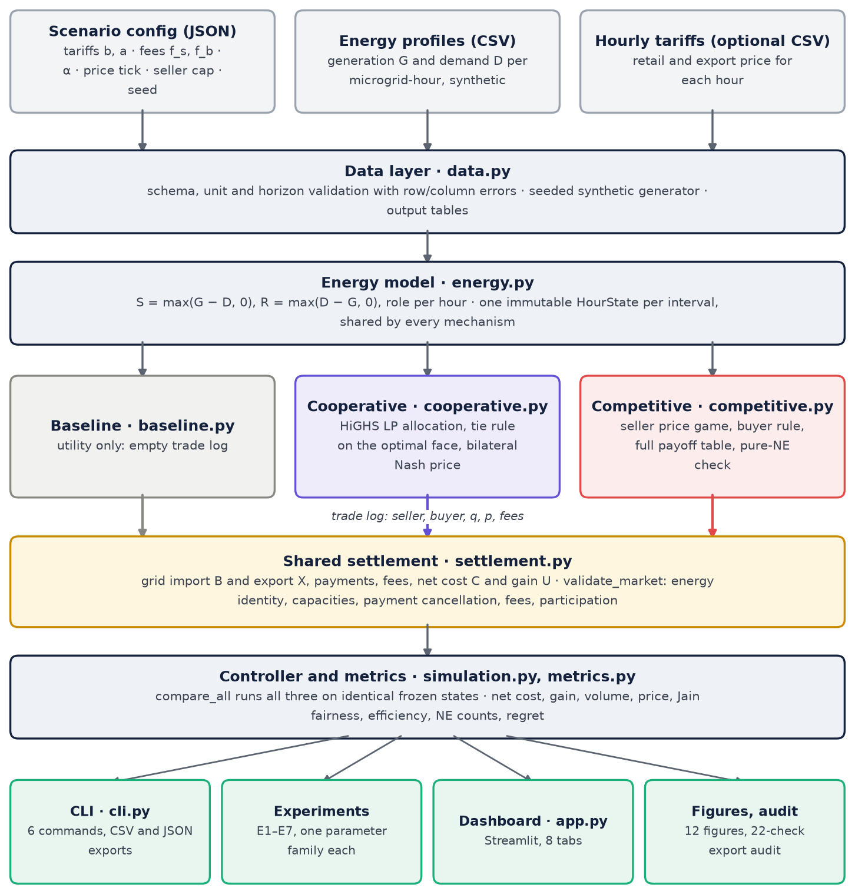
Figure 1. The MultiGrid pipeline: inputs, validation, the hourly energy model, the three market mechanisms, the shared settlement and the controller that feeds every output.

1.6 Contributions
- One shared settlement. Mechanisms decide only trades and prices. Energy flows and money are derived and checked in one place, so all three markets are accounted for identically and cannot hide errors in their own bookkeeping.
- A rigorous cooperative benchmark. A HiGHS linear program allocates energy, a duality-based lexicographic tie rule makes the reported optimum deterministic, a greedy cross-check guards against solver errors, and bilateral weighted Nash bargaining prices each trade in closed form.
- A verified competitive game. Sellers post prices on a discrete grid; the complete payoff table is enumerated and every unilateral deviation of every seller is checked. Intervals without a pure equilibrium are labelled NO_PURE_NE and are never settled at an unverified profile.
- Controlled experiments and an explanation. Seven experiments (E1–E7) on frozen, hash-tracked profiles show that, in this model, the competitive market loses efficiency only in oversupplied hours without a pure equilibrium, which is a discrete instance of Bertrand–Edgeworth price cycling.
- Verification and tooling. 345 automated tests, an independent export audit, a Streamlit dashboard and a command-line interface make every number in this report reproducible.

1.7 Organisation of the report
Section 2 reviews the background and related work. Section 3 defines the system model and the shared settlement. Section 4 and Section 5 present the cooperative and competitive markets, including worked payoff matrices. Section 6 defines the performance metrics. Section 7 describes the software design and the dashboard, and Section 8 its verification. Section 9 sets out the experimental design, Section 10 reports the results of E1–E7, and Section 11 discusses them. Section 12 lists limitations and future work, and Section 13 concludes. The appendices give the reproduction commands, the configuration, the data contracts and a glossary.

2 Background and related work

2.1 Microgrids and peer-to-peer energy trading
The U.S. Department of Energy describes a microgrid as a local group of interconnected loads and distributed energy resources that is controlled as one entity with respect to the grid and can operate either grid-connected or islanded [1]. This project models only the grid-connected mode: every microgrid can always import from and export to the utility, so the utility is the outside option of every market participant.
P2P energy trading lets prosumers sell surplus directly to neighbours instead of to the utility. Zhang et al. [2] study peer-to-peer energy trading in a microgrid; Paudel et al. [3] formulate P2P trading in a prosumer-based community microgrid as a game-theoretic model; and a 2019 Energy Procedia paper [4] proposes a game-theoretic approach to P2P energy trading. These works motivate the setting of this project: prosumers that trade surplus locally under a grid connection, with game theory used to describe how prices and allocations form. Their models and empirical conclusions are not reproduced or tested here, and no result in this report should be read as confirming or contradicting them.

2.2 Cooperative games and Nash bargaining
In a two-player bargaining problem, the players choose an agreement from a set of feasible utility pairs; if they fail to agree, each receives its disagreement payoff $d_{k}$. Nash [12] showed that exactly one solution satisfies Pareto efficiency, symmetry, invariance to affine rescaling of utilities and independence of irrelevant alternatives: the agreement that maximises the product of the gains over the disagreement point, $(u_{1}−d_{1})(u_{2}−d_{2})$. Dropping symmetry gives the weighted (asymmetric) Nash solution, which maximises $(u_{1}−d_{1})^{α}(u_{2}−d_{2})^{1−α}$ for a bargaining weight $α∈(0,1)$ [14].
In this project, the disagreement point of a seller–buyer pair is trading with the utility: the seller exports at $a$ and the buyer imports at $b$. The bargaining solution therefore splits the bilateral trade surplus between the two parties according to $α$ (Section 4.3). Multilateral solution concepts such as the Shapley value [20] are not used; they are discussed as an extension.

2.3 Non-cooperative games and Nash equilibrium
A finite game in normal form consists of a set of players, a finite strategy set for each player and a payoff function for each player defined on strategy profiles. A strategy is a best response to the other players’ strategies if no alternative strategy gives a strictly higher payoff. A profile is a pure-strategy Nash equilibrium if every player’s strategy is a best response to the others [13], [19], so that no player can gain by changing its own strategy alone. Every finite game has at least one equilibrium in mixed strategies [13], but a pure-strategy equilibrium need not exist.
The unilateral regret of a player at a profile is the extra payoff it could obtain by its best unilateral deviation. A profile is a pure Nash equilibrium exactly when every player’s regret is zero. For small finite games, the regret of every profile can be computed by enumerating the complete payoff table. This turns the question “is this a Nash equilibrium?” into an exhaustive, verifiable computation rather than a claim, which is how the competitive market in this project is analysed (Section 5.4).

2.4 Price competition with capacity constraints
When identical sellers without capacity limits compete on price, Bertrand competition drives the price down to marginal cost: any seller above the lowest price sells nothing, so undercutting continues until no profit remains. Edgeworth [15] observed that this logic breaks down when sellers have limited capacity. If a rival cannot serve the whole market, a seller can raise its price and still sell to the residual demand. Undercutting and price increases then alternate, and a pure-strategy price equilibrium may not exist; Vives [16] gives a modern treatment of such Bertrand–Edgeworth markets.
The competitive market of this project is a small, discrete and finite version of this setting: sellers have hard capacities (their hourly surplus), buyers have finite demand (their deficits) and prices move on a tick grid. Section 5.7, Section 5.8 and Section 11.2 show that the Edgeworth mechanism is exactly what removes the pure equilibria in oversupplied hours.

2.5 Tools and data sources
The cooperative allocation is a linear program solved through SciPy’s linprog interface [5] with the HiGHS solver [18]. CVXPY [6] is named by the blueprint as an optional alternative solver and is not used. The dashboard is a Streamlit application [7], and the automated tests use pytest [8].
The blueprint also points to the Ausgrid solar home electricity dataset [9]–[11] as a source of measured household generation and demand. The MVP deliberately uses seeded synthetic profiles instead, so that every experiment runs offline and is exactly reproducible; replacing them with measured data is listed as future work (Section 12).

2.6 Position of this work
The contribution of this project is methodological rigour on a small and transparent model rather than new theory: exact energy and money accounting through one shared settlement, equilibrium claims backed by exhaustive enumeration, explicit reporting of intervals where the game makes no pure-strategy prediction, and experiments that change one parameter at a time on frozen data. The aim is a simulator whose every number can be traced, re-derived and audited.

3 System model

3.1 Players, time and units
The players are microgrids $i∈\{MG1,…,MGN\}$; the MVP has $N=4$ and up to six are supported. Time is divided into hourly intervals $t=(\text{day},\text{hour})$ with $\text{hour}∈\{0,…,23\}$ and $Δt=1$ h; the MVP horizon is one day of 24 intervals. Every energy quantity is in kWh per interval, money is in INR, and unit prices and fees are in INR/kWh. A numerical tolerance $\text{tol}={10}^{−8}$ is used for classification and checks. Table 1 lists the notation.
Table 1. Notation used in this report
Symbol | Meaning | Unit
$G_{i,t}$, $D_{i,t}$ | Generation and demand of microgrid $i$ in interval $t$ | kWh
$S_{i,t}$, $R_{i,t}$ | Surplus $max(G−D,0)$ and deficit $max(D−G,0)$ | kWh
$B_{i,t}$, $X_{i,t}$ | Grid import and grid export | kWh
$q_{ij,t}$ | Energy sold by seller $i$ to buyer $j$ through P2P trade | kWh
$p_{ij}$, $p_{i}$ | P2P unit price of a trade; posted price of seller $i$ | INR/kWh
$b_{t}$, $a_{t}$ | Retail import price and export price | INR/kWh
$f_{s}$, $f_{b}$ | Seller fee and buyer fee per traded kWh | INR/kWh
$g$ | Unit trade surplus $b−a−f_{s}−f_{b}$ | INR/kWh
$C_{i,t}^{base}$, $C_{i,t}$ | Baseline cost and net cost (signed: positive = pays) | INR
$U_{i,t}$ | Gain over the baseline, $C^{base}−C$ | INR
$α$ | Seller bargaining weight, $0<α<1$ | –
$Δ$ | Price tick of the seller game | INR/kWh
$P_{i}$, $u_{i}$ | Strategy set and payoff of seller $i$ in the price game | INR/kWh, INR
$ρ_{i}$ | Unilateral regret of seller $i$ | INR
$W_{t}^{*}$ | LP-optimal welfare (community gain) in interval $t$ | INR

3.2 Energy balance
Without storage, each microgrid is either in surplus or in deficit in an interval, never both:
$$S_{i,t}=max(G_{i,t}−D_{i,t}, 0), R_{i,t}=max(D_{i,t}−G_{i,t}, 0).$$
A microgrid is a seller if $S_{i,t}>\text{tol}$, a buyer if $R_{i,t}>\text{tol}$, and balanced otherwise; the identity $S−R=G−D$ holds exactly. Whatever the market does, every player’s energy must balance, with all flows non-negative:
Gi,t+Bi,t+j​qji,t=Di,t+Xi,t+j​qij,t.
The simulator enforces this identity for every player and interval with tolerance $\text{tol}⋅max(1,∑|\text{flows}|)$. It also forbids simultaneous grid import and export, and simultaneous P2P buying and selling.

3.3 Tariffs and fees
A tariff schedule holds the retail price $b_{t}$ and the export price $a_{t}$ for every hour of the day. The default is flat, with $b=8$ and $a=3$ INR/kWh; these values are illustrative assumptions, not the tariffs of any real utility. An optional hourly tariff table can replace the flat schedule, and an EconomicWarning is raised if $b_{t}<a_{t}$.
Seller and buyer fees $f_{s}$ and $f_{b}$ are flat per traded kWh and are paid to an external market operator. A seller therefore nets $p−f_{s}$ per kWh sold, a buyer pays $p+f_{b}$ per kWh bought, and each traded kWh creates the unit trade surplus
$$g=b−a−f_{s}−f_{b}.$$
Trading is worthwhile only while $g>0$, that is, while the fees are smaller than the tariff spread.

3.4 Utility-only baseline
Without P2P trading, all surplus is exported and all deficits are imported ($B=R$, $X=S$), so the signed baseline cost of each microgrid is
$$C_{i,t}^{base}=b_{t} R_{i,t}−a_{t} S_{i,t}.$$
Positive values are payments to the utility; negative values are net export income. The baseline is the disagreement point of cooperative bargaining and the outside option of the competitive game: no microgrid can be made to accept an outcome worse than trading with the utility.

3.5 Shared settlement
Every mechanism produces only a trade log $\{(i,j,q_{ij},p_{ij},f_{s},f_{b})\}$. The shared settlement derives everything else:
Bi,t=Ri,t−j​qji,t, Xi,t=Si,t−j​qij,t,
Ci,t=btBi,t−atXi,t+j​pji qji,t−j​pij qij,t+fbj​qji,t+fsj​qij,t,
$$U_{i,t}=C_{i,t}^{base}−C_{i,t}.$$
Summing over players, every internal payment appears once as a purchase and once as a sale, so payments cancel. With Vt=(i,j)​qij,t, i​Bi,t=i​Ri,t−Vt and i​Xi,t=i​Si,t−Vt, the community gain is
i​Ui,t=(bt−at−fs−fb) Vt=g Vt.
This identity is central to the analysis. Prices never change the community gain; they only move gain between sellers and buyers. The total depends only on how much energy is traded locally and on the fees.
After settlement, validate_market re-derives every quantity from the trade log and enforces the checks in Table 2. A failed check raises an error, so an invalid result can never reach the metrics or the dashboard.
Table 2. Checks enforced by the shared settlement on every result
Check | Rule
Eligibility | Sellers have $S>\text{tol}$, buyers $R>\text{tol}$, quantities $q>\text{tol}$ (no phantom trades), at most one trade per pair
Capacity | j​qij≤Si+tol and i​qij≤Rj+tol
Energy | The energy identity holds for every player and interval
Money | Every component, net cost and gain matches its formula
Payment cancellation | i​purchasesi=i​salesi
Fee bookkeeping | i​feesi=trades​q (fs+fb)
Community gain | i​Ui=trades​q (b−a−fs−fb)
Voluntary participation | $p+f_{b}<b−\text{tol}$, $p−f_{s}≥a−\text{tol}$, and $U_{i}≥−\text{tol}$ for every player

3.6 Golden one-hour fixture
The blueprint defines a one-hour worked example, the golden fixture (day 0, hour 12, four microgrids), with expected outputs: a baseline community cost of INR 230, a cooperative cost of INR 80, a gain of INR 150 and trades of 15, 5 and 10 kWh at INR 5.50/kWh. The test suite reproduces these values exactly, and the fixture is used throughout this report to illustrate every mechanism. Table 3 gives its inputs and the baseline.
Table 3. Golden one-hour fixture (day 0, hour 12): inputs and utility-only baseline
Microgrid | G (kWh) | D (kWh) | S (kWh) | R (kWh) | Role | Baseline cost (INR)
MG1 | 40 | 20 | 20 | 0 | seller | -60.00
MG2 | 10 | 25 | 0 | 15 | buyer | 120.00
MG3 | 25 | 15 | 10 | 0 | seller | -30.00
MG4 | 5 | 30 | 0 | 25 | buyer | 200.00
Total | 80 | 90 | 30 | 40 |  | 230.00
Baseline cost C = b·R − a·S with b = 8 and a = 3 INR/kWh; negative values are export income.
MG1 and MG3 are sellers with 20 and 10 kWh of surplus; MG2 and MG4 are buyers with deficits of 15 and 25 kWh. Demand (40 kWh) exceeds supply (30 kWh), so all surplus can be traded locally. Without trading, the community exports 30 kWh at INR 3 and imports 40 kWh at INR 8, paying a net INR 230.

3.7 Modelling assumptions
- Grid-connected and lossless. Every microgrid can always import and export; there are no network constraints, power-flow limits or losses.
- No storage and no forecasting. Surplus must be sold or exported in the hour in which it occurs.
- Hourly intervals. Each interval is settled independently, with no coupling between hours.
- Flat per-kWh fees are paid to an external operator and do not stay in the community.
- Synthetic profiles and illustrative tariffs (Section 7.4).
- Deterministic tie rules based on microgrid IDs. These apply to the cooperative allocation on its optimal face and to buyers choosing between equally priced sellers. They are disclosed and tested because they affect individual outcomes.
- Bilateral bargaining, discrete prices and non-strategic buyers, specified in Section 4 and Section 5.

4 Cooperative market
The cooperative market answers the question “what is the best the community can do, and how should each trade’s benefit be shared?” It proceeds in two stages: a central allocation that maximises the community gain, followed by a bilateral bargaining price for each trade.

4.1 Stage A: welfare-maximising allocation
In interval $t$, an edge $(i,j)$ is eligible if $i$ is a seller, $j$ is a buyer and the pair’s unit surplus $g_{ij}=b_{t}−a_{t}−f_{s}−f_{b}$ exceeds the tolerance. The social planner solves the linear program
maxq≥0 (i,j)∈Et​gij qij subject to j​qij≤Si,t ∀i, i​qij≤Rj,t ∀j.
It is solved with scipy.optimize.linprog(method="highs") [5], [18]. A non-zero solver status raises a SolverError, so no result is ever produced from a failed solve. With flat tariffs and fees, $g$ is the same for every pair, and the optimal volume in each hour equals min(i​Si,t,j​Rj,t): every kWh that can be matched is matched. The general LP formulation is kept because it remains correct for pair-specific surpluses (for example pairwise fees), and because its dual values drive the tie rule.

4.2 Tie rule on the optimal face
When $g$ is uniform, many allocations are optimal. In the golden fixture, for example, MG2 can receive anywhere between 5 and 15 kWh in an optimal solution. To make the reported allocation deterministic, the simulator reports the lexicographic maximum of $q$ in (seller ID, buyer ID) order over the exact optimal face:
- The primary LP is solved, and the optimal face is identified from its duals by complementary slackness: constraints with a non-zero dual are binding in every optimum, and edges with a positive reduced cost are zero in every optimum.
- One LP per edge is then solved in lexicographic order, each maximising that edge’s quantity with the earlier edges fixed, while staying on the optimal face.
- Quantities are rounded to ${10}^{−9}$ kWh, any float-level capacity excess is trimmed, and the realised welfare is checked against the optimum.
- As an independent cross-check, under uniform $g$ the result must equal the sorted greedy allocation (seller ID, then buyer ID); otherwise the greedy welfare must not exceed the LP optimum. Any violation raises a SolverError.
The tie rule never changes the community gain, but it does change who trades on the long side of the market. In the golden fixture it gives MG2 the full 15 kWh. On the reference day (Section 10.1), in hours 11 and 12 the sellers are the long side: MG1, the lower ID, sells first, and MG3 exports the rest of its surplus to the grid (9.57 and 11.42 kWh).

4.3 Stage B: bilateral weighted Nash bargaining
Each allocated trade of $q$ kWh from seller $s$ to buyer $b$ is priced by bilateral weighted Nash bargaining, with the utility as the disagreement point. The seller’s reservation price is its export value plus its fee, $r_{s}=a+f_{s}$; the buyer’s is the retail price minus its fee, $r_{b}=b−f_{b}$. Relative to trading with the utility, the gains at price $p$ are
$$ΔU_{s}(p)=q (p−r_{s}), ΔU_{b}(p)=q (r_{b}−p).$$
The bargaining price maximises the weighted Nash product:
$$p^{*}=arg\max_{r_{s}≤p≤r_{b}} ΔU_{s}(p)^{α} ΔU_{b}(p)^{1−α}.$$
Taking logarithms gives the strictly concave objective $αln(p−r_{s})+(1−α)ln(r_{b}−p)$, whose first-order condition $α/(p−r_{s})=(1−α)/(r_{b}−p)$ has the unique solution
$$p^{*}=(1−α) r_{s}+α r_{b}=(1−α)(a+f_{s})+α (b−f_{b}).$$
At $p^{*}$, the seller receives the share $α$ of the bilateral surplus $q (r_{b}−r_{s})=q g$ and the buyer the share $1−α$. With the default $α=0.5$, $a=3$, $b=8$ and no fees, $p^{*}=5.50$ INR/kWh. A trade is rejected if $r_{b}−r_{s}≤\text{tol}$, because there is no surplus to share. The test suite checks that this closed form equals a numerical maximisation of the Nash product.

4.4 Properties of the cooperative outcome
- Efficient in quantities. The allocation reaches the LP optimum, so the community gain equals t​Wt* (efficiency 1.000 by construction).
- Individually rational. Because $r_{s}≤p^{*}≤r_{b}$, both parties of every trade gain relative to the utility, so no microgrid is worse off than under the baseline.
- The bargaining weight only redistributes. Changing $α$ moves the price between $r_{s}$ and $r_{b}$ and shifts gain between sellers and buyers, but it leaves the total $∑q g$ unchanged (tested).
- A benchmark, not an equilibrium. Quantities are allocated centrally, not chosen by the players. The cooperative outcome is an optimisation benchmark combined with bilateral bargaining. It is not a Nash equilibrium, and it is not a multilateral bargaining or coalition solution such as the Shapley value [20].

4.5 The golden fixture under the cooperative market
In the golden hour, the LP matches all 30 kWh of surplus, and the tie rule gives MG1 → MG2 15 kWh, MG1 → MG4 5 kWh and MG3 → MG4 10 kWh. MG4 imports its remaining 10 kWh from the grid (Figure 2). Every trade is priced at INR 5.50, which splits the INR 5 spread on each kWh equally between seller and buyer (Table 4). The community’s net cost falls from INR 230 to INR 80, a gain of INR 150 = 30 kWh × INR 5, divided 50 / 37.5 / 25 / 37.5 among MG1–MG4 (Table 5).
The blueprint’s fee fixture is also reproduced. With $f_{s}=f_{b}=1$, the bargaining price is $0.5(3+1)+0.5(8−1)=5.50$, the community gain falls to INR 90 = 30 × (5 − 2), and the operator collects INR 60 = 30 × 2. Once $f_{s}+f_{b}≥5$, no trade has positive surplus and both markets fall back to the baseline.
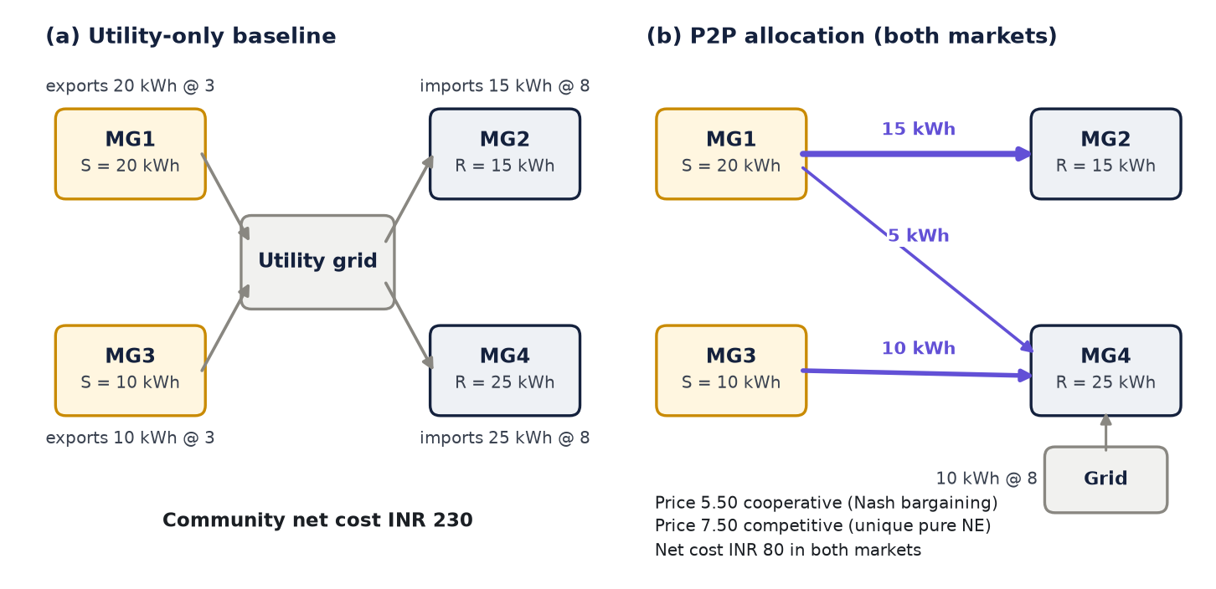
Figure 2. Golden fixture: (a) under the baseline every flow goes through the utility; (b) both P2P markets trade the same 30 kWh, the cooperative market at INR 5.50/kWh and the competitive market at INR 7.50/kWh.
Table 4. Golden fixture: trade logs produced by the two markets
Market | Trade | q (kWh) | Price (INR/kWh) | Payment (INR) | Seller gain (INR) | Buyer gain (INR)
Cooperative | MG1 → MG2 | 15 | 5.50 | 82.50 | 37.50 | 37.50
Cooperative | MG1 → MG4 | 5 | 5.50 | 27.50 | 12.50 | 12.50
Cooperative | MG3 → MG4 | 10 | 5.50 | 55.00 | 25.00 | 25.00
Competitive | MG1 → MG2 | 15 | 7.50 | 112.50 | 67.50 | 7.50
Competitive | MG1 → MG4 | 5 | 7.50 | 37.50 | 22.50 | 2.50
Competitive | MG3 → MG4 | 10 | 7.50 | 75.00 | 45.00 | 5.00
Seller gain = q(p − a) over exporting; buyer gain = q(b − p) over importing (no fees in this fixture).
Table 5. Golden fixture: net cost and gain per microgrid under each mechanism
Microgrid | Baseline cost | Cooperative cost | Cooperative gain | Competitive cost | Competitive gain
MG1 | -60.00 | -110.00 | 50.00 | -150.00 | 90.00
MG2 | 120.00 | 82.50 | 37.50 | 112.50 | 7.50
MG3 | -30.00 | -55.00 | 25.00 | -75.00 | 45.00
MG4 | 200.00 | 162.50 | 37.50 | 192.50 | 7.50
Community | 230.00 | 80.00 | 150.00 | 80.00 | 150.00
Jain fairness | N/A |  | 0.947 |  | 0.549
All values in INR for the single interval. Gain = baseline cost − net cost.

5 Competitive market
The competitive market replaces the planner with self-interested sellers. In each interval, the sellers simultaneously post prices, buyers respond with a fixed rule, and an interval is settled only at a profile that has been verified to be a pure Nash equilibrium.

5.1 Players and strategies
The players of interval $t$ are its sellers ($S_{i,t}>\text{tol}$); buyers are not strategic. Each seller posts a gross price on the tick grid $Δ$ (price_step_inr), restricted to individually rational prices:
$$P_{i}=\{ kΔ : k∈Z, kΔ−f_{s}≥a, kΔ+f_{b}<b−\text{tol} \}.$$
With the defaults ($a=3$, $b=8$, no fees, $Δ=0.5$), $P_{i}=\{3.0,3.5,…,7.5\}$, ten prices per seller. At the lowest price a seller earns exactly its export value, and the highest price is one tick below retail. If $P_{i}$ is empty, because fees absorb the whole spread, there is no game and no trade.

5.2 Buyer response rule
Buyers follow a deterministic, transparent rule:
- The delivered price of seller $i$’s offer is $p_{i}+f_{b}$. An offer is acceptable only if its delivered price is below $b−\text{tol}$.
- Each buyer sorts acceptable offers by (delivered price, seller ID).
- Buyers are processed in ascending ID order. Each takes as much as possible from its first offer, then from the next, never exceeding the seller’s remaining surplus or its own deficit.
- Unserved deficit is imported from the grid and unsold surplus is exported.
Because ties are broken by seller ID, the lower-ID seller is served first when prices are equal. This is a modelling choice that affects equilibria; it is disclosed and tested. Buyers are non-strategic followers, so the outcome is not a bi-level Stackelberg equilibrium.

5.3 Payoffs
A seller’s payoff is its gain over exporting the same energy:
ui(p)=(pi−a−fs)j​qij(p),
where $q_{ij}(p)$ is the allocation produced by the buyer rule at the price profile $p=(p_{1},…,p_{m})$. This equals the seller’s gain in the shared settlement for the interval.

5.4 Pure Nash equilibrium and exhaustive verification
For a profile $p$, the unilateral regret of seller $i$ and the equilibrium condition are
$$ρ_{i}(p)=\max_{p_{i^{′}}∈P_{i}}u_{i}(p_{i^{′}},p_{−i})−u_{i}(p), p\text{ is a pure NE}⇔\max_{i}ρ_{i}(p)≤\text{tol}.$$
The simulator computes the complete payoff table over $P_{1}×⋯×P_{m}$, simulating each profile exactly once (the payoff cache). It then takes the best payoff along every seller’s axis, so that every unilateral deviation of every seller in every profile is evaluated; nothing is sampled. The number of profiles examined, i​|Pi|, is recorded in the diagnostics: 10 for one seller and 100 for two sellers with the default grid. The procedure for one interval is:
Input: one interval (sellers, buyers, S, R), tariffs, fees, tick, cap
if there are no sellers or no buyers:
status <- no trade
else if the number of sellers m > cap:
status <- ENUMERATION_CAP_EXCEEDED # nothing claimed or settled
else:
build the price grid P_i of every seller i
for every profile p in P_1 x ... x P_m: # prod |P_i| profiles
q(p) <- buyer rule at p
u_i(p) <- (p_i - a - f_s) * sum_j q_ij(p) # payoff table (cache)
best_i(p_-i) <- max of u_i along seller i's axis # all deviations
regret(p) <- max_i [best_i(p_-i) - u_i(p)]
NE <- {p : regret(p) <= tol}
if NE is not empty:
settle the NE with the lowest price sum (then lexicographic)
else:
status <- NO_PURE_NE; record argmin_p regret(p) as NOT NASH
settle no P2P trade

5.5 Selection, missing equilibria and the enumeration cap
- Equilibrium selection. All pure equilibria are reported (equilibrium_count). The settled one has the lowest sum of posted prices, then the lexicographically smallest price vector. The settled trades pass through the shared settlement.
- No pure equilibrium. If no profile has zero regret, the interval is labelled NO_PURE_NE and no P2P trade is settled, because the game makes no pure-strategy prediction for that interval. The profile with the smallest maximum regret is recorded as a diagnostic, with its positive regret, and is labelled NOT NASH.
- Enumeration cap. If an interval has more sellers than max_competitive_sellers (default 3), it is labelled ENUMERATION_CAP_EXCEEDED, a CombinatorialWarning is issued, and nothing is claimed or settled.
Properties checked by the tests include:
- the one-seller game selects the top acceptable price (INR 7.50, utility 45 in the test case);
- every reported equilibrium and every payoff matches an independent reference enumeration;
- a capacity-constrained price war (two 10 kWh sellers, one buyer needing 12 kWh) has no pure equilibrium, and none is claimed;
- a Bertrand game (two 20 kWh sellers, 10 kWh of demand) has exactly three pure equilibria, and the selection is (3.0, 3.0);
- identical sellers have an asymmetric equilibrium set because of the ID tie rule;
- the competitive community gain never exceeds the LP optimum.

5.6 Worked example 1: the golden hour
In the golden hour, demand (40 kWh) exceeds supply (30 kWh). Whatever prices the two sellers post below the retail price, the buyers absorb every kWh offered, so each seller always sells its full surplus, and its payoff $(p_{i}−3) S_{i}$ depends only on its own price. Raising the price is a dominant strategy. Table 6 shows the payoff bimatrix with a coarse tick of 1.00 INR/kWh, chosen so that the complete game fits on the page. Each column contains MG1’s best response and each row MG3’s best response, and the only cell where both payoffs are best responses is (7.00, 7.00), which is the unique pure equilibrium.
Table 6. Payoff bimatrix of the golden-hour seller price game (price tick 1.00 INR/kWh)
MG1 ↓ · MG3 → | MG3 3.00 | MG3 4.00 | MG3 5.00 | MG3 6.00 | MG3 7.00
MG1 3.00 | 0.0 / 0.0 | 0.0 / 10.0 | 0.0 / 20.0 | 0.0 / 30.0 | 0.0 / 40.0
MG1 4.00 | 20.0 / 0.0 | 20.0 / 10.0 | 20.0 / 20.0 | 20.0 / 30.0 | 20.0 / 40.0
MG1 5.00 | 40.0 / 0.0 | 40.0 / 10.0 | 40.0 / 20.0 | 40.0 / 30.0 | 40.0 / 40.0
MG1 6.00 | 60.0 / 0.0 | 60.0 / 10.0 | 60.0 / 20.0 | 60.0 / 30.0 | 60.0 / 40.0
MG1 7.00 | 80.0 / 0.0 | 80.0 / 10.0 | 80.0 / 20.0 | 80.0 / 30.0 | 80.0 / 40.0
Each cell: MG1 payoff / MG3 payoff in INR (gain over exporting). Bold underlined = best response to the other seller’s price. Shaded cell = pure Nash equilibrium (both payoffs are best responses).
With the default tick of 0.5 INR/kWh, the game has 10 × 10 = 100 profiles, and the simulator finds a unique pure equilibrium at (7.50, 7.50), the highest price below retail. The competitive market therefore moves the same 30 kWh as the cooperative market and reaches the same community cost of INR 80. The distribution is very different: sellers keep INR 4.50 of the INR 5 spread on every kWh, and buyers keep INR 0.50, so the gains become 90 / 7.5 / 45 / 7.5 (Jain index 0.549 against 0.947 for the cooperative market; Table 5).

5.7 Worked example 2: a price war without a pure equilibrium
Hour 12 of the reference day (seed 42) behaves very differently. MG1 has 36.93 kWh and MG3 13.86 kWh of surplus, while MG2 and MG4 need 15.38 and 24.00 kWh. Total supply (50.79 kWh) exceeds total demand (39.37 kWh), but neither seller can serve all the demand alone. Table 7 shows the payoff bimatrix at the coarse tick of 1.00 INR/kWh.
Table 7. Payoff bimatrix of hour 12 on the seed-42 day (price tick 1.00 INR/kWh): no pure equilibrium
MG1 ↓ · MG3 → | MG3 3.00 | MG3 4.00 | MG3 5.00 | MG3 6.00 | MG3 7.00
MG1 3.00 | 0.0 / 0.0 | 0.0 / 2.4 | 0.0 / 4.9 | 0.0 / 7.3 | 0.0 / 9.8
MG1 4.00 | 25.5 / 0.0 | 36.9 / 2.4 | 36.9 / 4.9 | 36.9 / 7.3 | 36.9 / 9.8
MG1 5.00 | 51.0 / 0.0 | 51.0 / 13.9 | 73.9 / 4.9 | 73.9 / 7.3 | 73.9 / 9.8
MG1 6.00 | 76.6 / 0.0 | 76.6 / 13.9 | 76.6 / 27.7 | 110.8 / 7.3 | 110.8 / 9.8
MG1 7.00 | 102.1 / 0.0 | 102.1 / 13.9 | 102.1 / 27.7 | 102.1 / 41.6 | 147.7 / 9.8
Each cell: MG1 payoff / MG3 payoff in INR. Bold underlined = best response. No cell has two best responses, so the game has no pure Nash equilibrium.
No cell contains two best responses. Starting from (7, 6):
- MG1 best-responds to MG3’s 6 by matching it at 6. It then wins the tie by ID and sells its whole surplus (110.8 > 102.1).
- MG3 answers by undercutting to 5 (27.7 > 7.3).
- MG1 now prefers to jump back to 7 and serve only the residual demand at the high price (102.1 > 76.6).
- MG3 then raises its price to 6, just below MG1 (41.6 > 27.7), and the cycle (7, 6) → (6, 6) → (6, 5) → (7, 5) → (7, 6) starts again.
At every profile, at least one seller has a profitable unilateral deviation, so the game has no pure Nash equilibrium. With the default tick, the simulator again finds no pure equilibrium among the 100 profiles, and reports the NOT NASH diagnostic (MG1 7.00, MG3 6.00) with a maximum regret of INR 12.76. The interval is therefore settled without P2P trade. The dashboard’s Game analysis tab shows this case (Section 7.7).

5.8 Three price regimes: scarcity, Edgeworth cycles and Bertrand
The enumerated results across all experiments follow one pattern, which matches the Bertrand–Edgeworth theory of Section 2.4. For two sellers with surpluses $S_{L}≥S_{s}$ facing total demand $R$:
- Scarcity ($S_{L}+S_{s}≤R$). Every offer below retail is sold, so posting the top acceptable price is a dominant strategy and the unique equilibrium is $(b−Δ,b−Δ)$. This covers every trading hour of the reference day except hours 11 and 12, all of which settle at INR 7.50.
- Edgeworth cycles ($S_{L}+S_{s}>R$, with a large residual demand). If the smaller seller cannot cover the market, the larger seller can always fall back on the residual demand $R−S_{s}$ at the top price. Matching low prices then stops paying, and the cycle of worked example 2 appears with no pure equilibrium. This happens in hours 11–12 of the reference day; at 1.5 × solar in hours 8–10 and 13–14; and at 2.0 × solar in hours 7 and 15 (E4).
- Bertrand undercutting (strong oversupply). When the smaller seller’s capacity leaves almost no residual demand, matching a low price beats serving the residual, and pure equilibria exist again at low prices. At 1.5 × solar, hours 11–12 have a unique equilibrium at (3.50, 3.50). At 2.0 × solar, where either seller alone can cover demand in hours 9–13, there are three equilibria, (3.00, 3.00), (3.50, 3.00) and (3.50, 3.50), and the selected profile prices at the export value, so buyers capture the entire spread.
In these hours, the larger seller is MG1, which also wins price ties. It prefers matching a price one tick above the export price to serving the residual demand at the top price only if $Δmin(S_{L},R)≥(b−a−Δ)(R−S_{s})$. With the default parameters and $S_{L}≥R$, this means the residual demand $R−S_{s}$ is at most one ninth of total demand. In every E4 hour in which MG1 alone could cover the demand but MG3 could not, this condition separates the hours with a pure equilibrium from the hours without one. This is an analytical reading of the enumerated results, not an extra algorithm in the simulator: every equilibrium label in this report comes from exhaustive enumeration.

6 Performance metrics
Every mechanism is evaluated with the same metrics, computed from settled results only. The cooperative LP optimum t​Wt* serves as the efficiency reference for all mechanisms.

6.1 Community metrics
For a horizon of intervals $t$ and microgrids $i$:
C=i,t​Ci,t, U=Cbase−C, cost reduction=100 UCbase %,
V=trades​q, p=trades​q pV, operator fees=trades​q (fs+fb).
$C$ is the community net cost (signed), $U$ the total gain over the baseline, $V$ the P2P volume and $\overset{‾}{p}$ the volume-weighted average P2P price. The cost reduction is reported only when the baseline cost is positive, and the average price only when volume is positive.

6.2 Distribution and efficiency
How evenly the gain is shared is measured with Jain’s fairness index [17], computed over the microgrids’ gains for the whole horizon:
$$J=\frac{{\left(\sum_{i=1}^{n}{U_{i}}\right)}^{2}}{n\sum_{i=1}^{n}{U_{i}^{2}}}.$$
$J=1$ when every microgrid gains the same amount, and $J=1/n$ when a single microgrid receives all the gain. The index measures equality of absolute gains, not proportionality to contribution: a market that rewards large sellers in proportion to the energy they supply can still have a low $J$.
Efficiency compares a mechanism’s total gain with the best achievable gain:
η=Ut​Wt*.
The cooperative market has $η=1$ by construction, and the baseline has $η=0$.

6.3 Equilibrium diagnostics
For the competitive market, the simulator also counts the intervals with a verified pure equilibrium, the NO_PURE_NE intervals and the ENUMERATION_CAP_EXCEEDED intervals. It reports the maximum regret at the settled equilibria (zero when every settled profile is a verified equilibrium) and the worst regret among the NOT NASH diagnostic profiles. Every interval of every mechanism also produces a solver-diagnostics record, as the blueprint requires, exported as CSV and JSON. The record holds the status, whether a pure equilibrium was found, the equilibrium count, the selected profile, the maximum unilateral regret, the number of profiles examined, the NOT NASH profile, the LP-optimal welfare, the P2P volume and a plain-language message.

6.4 Handling of undefined values
A metric whose denominator is zero, or which does not apply to a mechanism, is reported as N/A (None in code, an empty cell in CSV), never as a misleading number. For example, the baseline has no average price and no Jain index, because there is no volume and every gain is zero, and only the competitive market has equilibrium counts.

7 Software design and implementation

7.1 Architecture and data flow
The simulator is a Python package (src/microgrid, version 0.4.0), plus a Streamlit dashboard (app.py) and two scripts. Dependencies flow in one direction:
models <- data <- energy <- settlement
settlement <- baseline, cooperative, competitive
mechanisms + metrics <- simulation <- experiments <- cli
simulation <- app (dashboard); scripts/ read saved results only
Only app.py and the scripts import plotting libraries, and a test checks this with a scan of the source’s syntax tree. All domain objects are frozen dataclasses holding tuples, which makes them immutable, hashable for caching, and safe to share between mechanisms. Functions copy data frames instead of modifying them, and the controller checks after every mechanism that the caller’s input frame is unchanged. Each mechanism decides only which trades happen and at what price, and all energy flows and money come from the single shared settlement (Figure 1).

7.2 Module responsibilities
Table 8. Package modules and their responsibilities
Module | Responsibility
models.py | Frozen, validated dataclasses (configuration, tariffs, hour states, trades, settlements, results, diagnostics); error and warning types; CSV column contracts
data.py | Configuration and tariff files; profile validation with row and column errors; seeded synthetic generator; trade, settlement and diagnostics tables
energy.py | Surplus and deficit, roles, the immutable HourState, energy-balance checks
settlement.py | The single shared settlement and validate_market (Table 2)
baseline.py | Utility-only market: the shared settlement with an empty trade log
cooperative.py | Status-checked HiGHS LP, duality-based lexicographic tie rule, greedy cross-check, bilateral Nash bargaining price
competitive.py | Price grid, buyer rule, full payoff table, regrets, all pure equilibria, NO_PURE_NE and cap reporting
metrics.py | compute_metrics (every blueprint metric, with explicit N/A) and jain_fairness
simulation.py | compare_all: every mechanism on identical frozen states, timing, input-mutation guard, metrics against the LP optimum
experiments.py | E1–E7 specifications and runner: one parameter family at a time, frozen or hash-tracked profiles, saved configs, deterministic tables
cli.py, app.py | Thin adapters (command line and dashboard), with no market mathematics
scripts/make_figures.py | Report figures drawn from saved CSV files only
scripts/audit_exports.py | Independent export audit; does not import the package

7.3 Data contracts and validation
Every input is validated before any simulation runs. Validation collects every problem and raises one DataValidationError whose message names the CSV line and the column of each problem, so a user can fix a file in one pass. Table 9 summarises the input contracts; the output files are described in Appendix C.
Table 9. Input data contracts
Input | Fields | Validation rules
Energy profiles (CSV) | day, hour, microgrid_id, generation_kwh, demand_kwh | Exact columns; non-empty; integer day ≥ 0 and hour 0–23; known, non-empty IDs (whitespace stripped); finite, non-negative energy; unique (day, hour, ID); every slot lists every microgrid; full 24-hour horizon when required
Scenario configuration (JSON) | Scenario ID, seed, days, IDs, tariffs, fees, price tick, bargaining weight, tolerance, enumeration cap, generator block | $0<α<1$; tol > 0; tick > 0; finite, non-negative prices and fees; unique, non-empty IDs; unknown keys rejected
Hourly tariffs (optional CSV) | hour, retail_price_inr_per_kwh, export_price_inr_per_kwh | Every hour present; warning if retail < export

7.4 Synthetic data generation
The reference profiles are generated, not measured. Solar generation follows a smooth sine between sunrise (06:00) and sunset (18:00), sampled at hour midpoints, and is exactly zero at night. Demand follows one of four 24-value templates scaled to a peak of 1: residential (morning and evening peaks), commercial (daytime and evening), campus (working hours) and industrial (flat with shifts). Each microgrid scales the templates by its own peaks (Table 10).
Multiplicative noise $max(0,1+ε)$ with $ε∼N(0,{0.05}^{2})$ is applied to both generation and demand. A dedicated NumPy generator seeded with 42 draws the values in a fixed order, and the global random state is never used. Values are rounded to four decimals. A test checks that the generator reproduces the committed table data/sample_24h.csv (96 rows), and running generate twice gives identical files.
Table 10. Synthetic profile parameters per microgrid
Microgrid | Demand template | Solar peak (kWh/h) | Demand peak (kWh/h) | Role on the reference day
MG1 | Residential | 45 | 25 | Seller around midday, buyer otherwise
MG2 | Commercial | 12 | 28 | Buyer in every hour
MG3 | Campus | 30 | 18 | Seller around midday, buyer otherwise
MG4 | Industrial | 6 | 32 | Buyer in every hour
MG5 (E5 only) | Residential | 20 | 22 | Used only in the six-microgrid run
MG6 (E5 only) | Commercial | 35 | 24 | Used only in the six-microgrid run

7.5 Simulation controller and experiment runner
compare_all(profiles, cfg) is the single entry point used by the CLI, the experiments and the dashboard. It:
- validates the profiles once and builds the hour states once;
- runs the baseline, cooperative and competitive mechanisms on those identical states, timing each;
- checks that the caller’s frame is unchanged after every mechanism; and
- computes each mechanism’s metrics against the cooperative LP optimum.
The experiment runner (experiments.py) defines E1–E7 as specifications that each vary one parameter family. For every run, it saves the exact configuration, the SHA-256 fingerprint of the validated profile table and the result tables (Appendix C).

7.6 Command-line interface
Table 11. Command-line interface (python -m microgrid.cli <command>)
Command | Purpose | Typical arguments
generate | Generate seeded synthetic profiles | --config configs/default.json --out data/sample_24h.csv
baseline | Utility-only settlement | --config … --profiles … --out-dir results/
cooperative | Cooperative market (LP + Nash bargaining) | --config … --profiles … --out-dir results/
competitive | Competitive market with equilibrium diagnostics | --config … --profiles … --out-dir results/
compare | All three mechanisms on identical states, every table | --config … --profiles … --out-dir results/
experiment | Run one, several or all of E1–E7 | all --out-dir results/experiments
Every command prints a per-microgrid and community summary. With --out-dir, it also writes the settlement, trade, diagnostics and summary tables together with the exact configuration used. An optional --tariffs file.csv replaces the flat tariffs. A validation or solver failure exits with code 2 and a message.

7.7 Interactive dashboard
The Streamlit dashboard (python -m streamlit run app.py) lets a user run, inspect, modify, compare and export every scenario. The sidebar holds every control:
- Scenario: the golden one-hour fixture, the committed seed-42 day, or a generated day with any seed, a solar scale of 0.5–2.0 × and four or six microgrids.
- Tariffs and fees: the retail and export prices, and the seller and buyer fees.
- Mechanism parameters: the bargaining weight $α$ and the price tick of the seller game.
Profiles depend only on the scenario controls, so changing tariffs or fees never regenerates them (tested). If a validation or solver step fails, the page shows a message and no numbers. Table 12 lists the eight tabs, and Figure 3–Figure 7 show the dashboard on the reference day.
Table 12. Dashboard tabs
Tab | Content
Overview | The model in brief, scenario facts, community net cost per mechanism, equilibrium banners
Profiles | Generation, demand and net position per microgrid; hourly community surplus and deficit
Simulate | Parameters in use, what each control changes, the full metric table, solve times
Transactions | Trade log and per-interval settlement; hourly P2P volume
Game analysis | Equilibrium status per interval. For a chosen interval: the verified equilibrium, or NO PURE EQUILIBRIUM FOUND with the NOT NASH diagnostic, utility curves, a regret heatmap and the full payoff table
Comparison | Metric table, net cost per mechanism, gains per microgrid, hourly gain, interpretation notes
Network | Sankey diagram of contracted seller → buyer energy
Downloads | Configuration (JSON); summary, per-microgrid, trade, settlement and diagnostics tables (CSV and JSON)
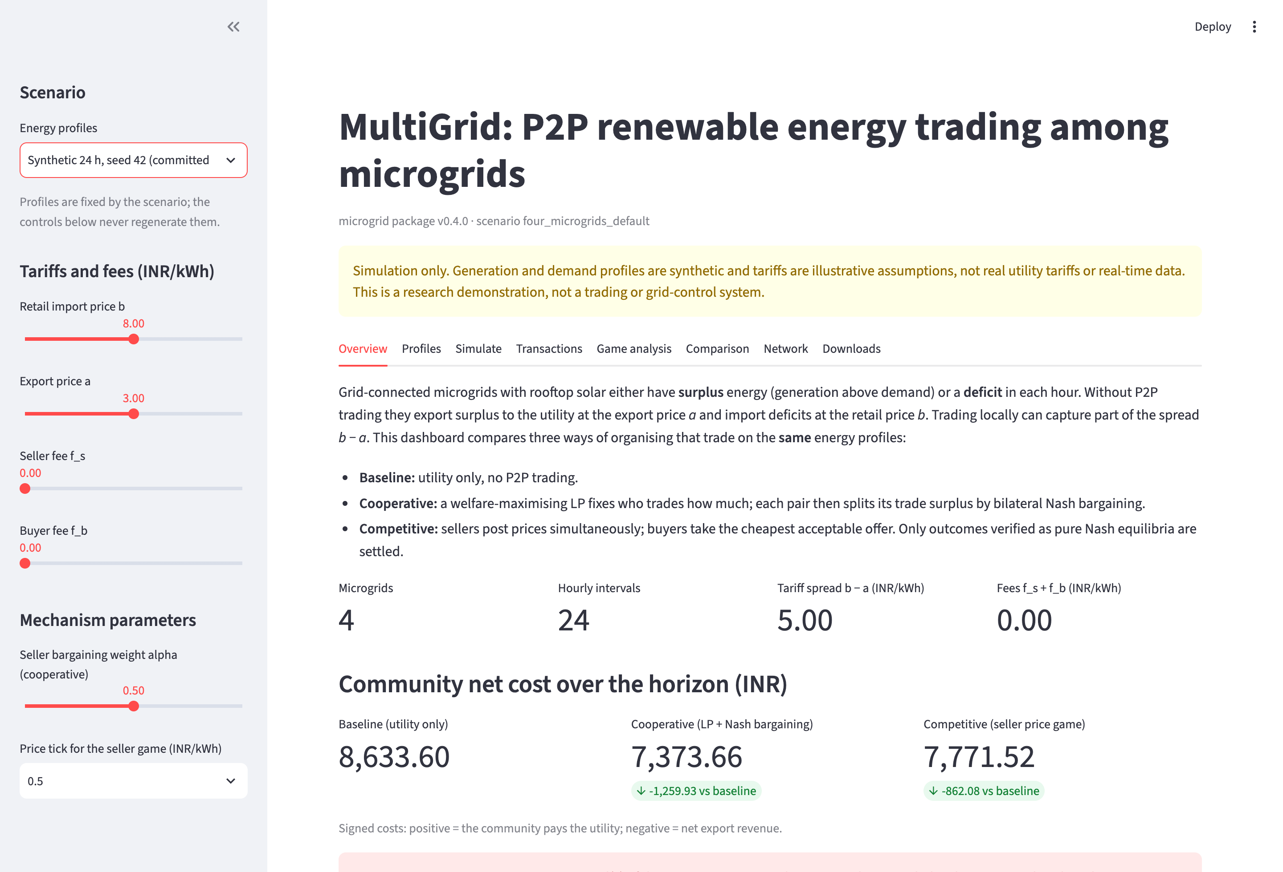
Figure 3. Dashboard Overview tab on the seed-42 day. The sidebar holds all controls; the banner reports the two intervals without a pure equilibrium.
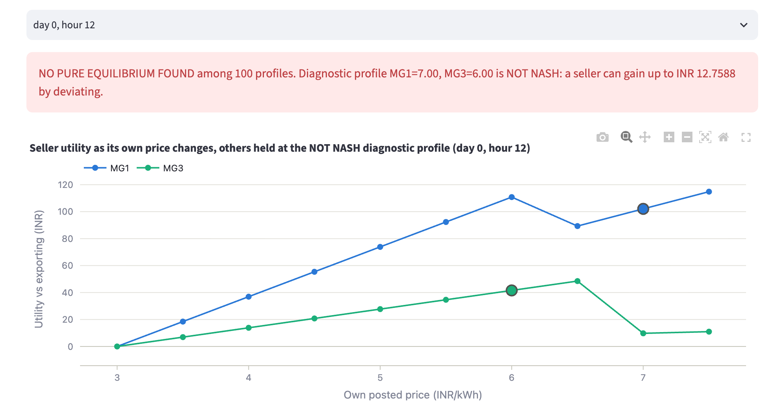
Figure 4. Game analysis tab, hour 12: the NO PURE EQUILIBRIUM FOUND banner and each seller’s utility as it changes its own price, with the other held at the NOT NASH diagnostic profile.
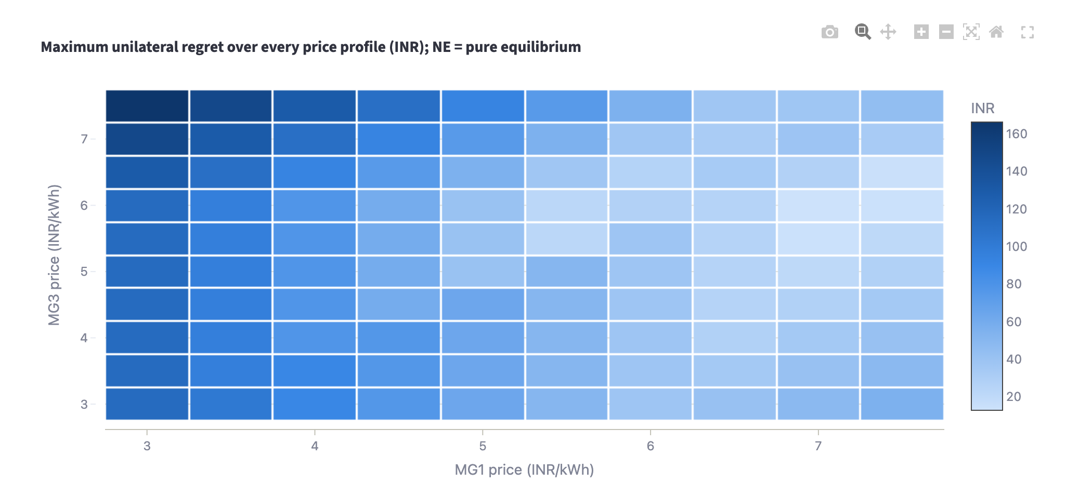
Figure 5. Game analysis tab, hour 12: maximum unilateral regret over all 100 price profiles. No profile has zero regret, so there is no pure equilibrium.
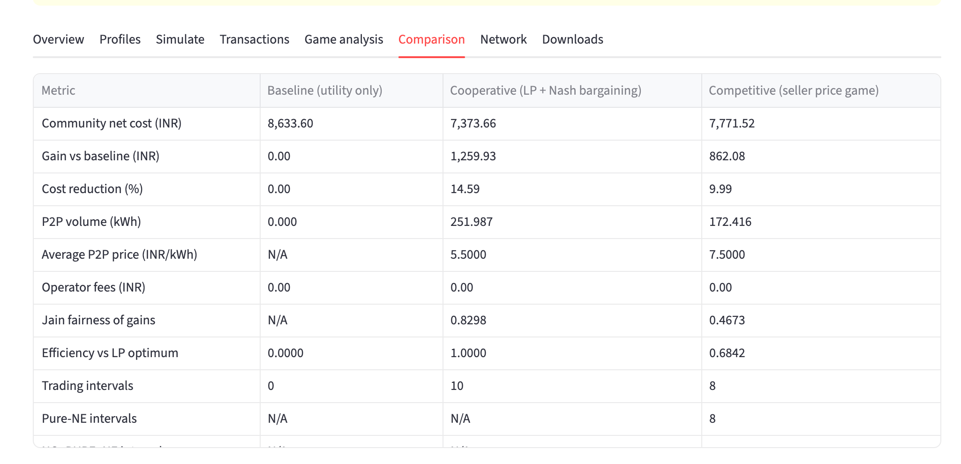
Figure 6. Comparison tab: the metric table for the three mechanisms on the seed-42 day, as produced by the shared settlement.
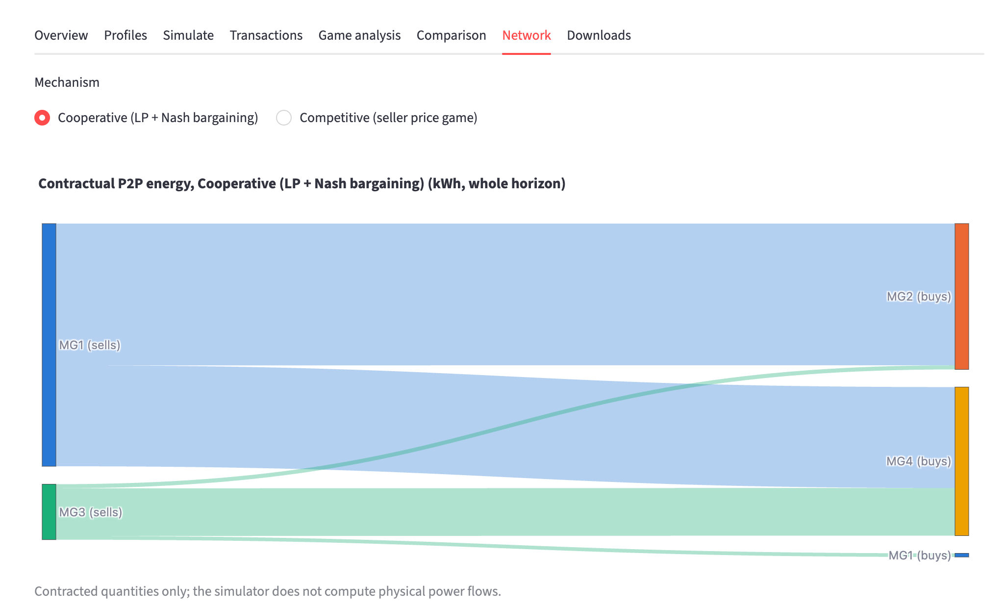
Figure 7. Network tab: contracted P2P energy of the cooperative market over the day, from sellers (left) to buyers (right).
The charts follow fixed conventions:
- one y-axis per chart, with units on every axis;
- a table view for every chart;
- colours that pass a colour-vision-deficiency check in light and dark mode;
- identity never shown by colour alone.

7.8 Error handling
Table 13. Errors and warnings and their effect
Error or warning | Raised when | Effect
DataValidationError | A profile, configuration or tariff file violates its contract | Every problem is reported with CSV line and column; nothing is simulated
EnergyBalanceError | An energy identity fails, or a value is negative beyond tolerance | The result is rejected
SettlementError | Any settlement check fails (Table 2) | The result is rejected
SolverError | LP status non-zero, missing duals, welfare lost in rounding, or greedy mismatch | No cooperative result is produced
EconomicWarning | The retail price is below the export price | A warning is shown; the run continues
CombinatorialWarning | An interval has more sellers than the enumeration cap | The interval is labelled ENUMERATION_CAP_EXCEEDED and not settled

8 Verification and validation
The blueprint’s completion standard is explicit: a project is not complete because the interface opens or charts appear, but when energy is conserved, settlement is correct, games are meaningful and equilibria are checked. This chapter documents how each of these requirements is verified.

8.1 Test strategy and coverage
The test suite combines several kinds of tests:
- Unit tests of every formula.
- Invariant tests on fixtures and random inputs: energy identities, payment cancellation and the community-gain identity.
- Fixture tests against the blueprint’s golden values.
- Reference tests: an independent, deliberately naive enumeration of the competitive game, written separately inside the tests.
- Failure-path tests: every bad-input case, plus solver failures.
- A regression snapshot of the seed-42 day.
- Integration tests of the controller, the CLI and the experiments.
- Dashboard tests driven through Streamlit’s AppTest.
Table 14 lists the 17 test modules. The full suite was run while this report was being prepared: 345 passed in 9.57 s.
Table 14. Automated test suite: tests collected per module and what each module covers
Module | Tests | Focus (blueprint critical tests in brackets)
test_bargaining.py | 24 | Nash bargaining: closed form = numerical argmax, α effects, positive-surplus rule (T03)
test_baseline.py | 19 | Baseline formula, golden costs −60/120/−30/200, sign convention, hourly tariffs, price scaling
test_competitive_equilibrium.py | 32 | Price grid, buyer rule, reference enumeration, price war with no NE, Bertrand game, ID tie rule (T11, T12)
test_cooperative.py | 28 | LP allocation, lexicographic tie rule, greedy cross-check, capacities, solver-failure handling (T13)
test_dashboard.py | 8 | Streamlit AppTest: golden view, fees, α, tariffs keep profiles, NO_PURE_NE and cap banners, warnings
test_data_validation.py | 44 | Every bad-input case of the profile CSV, with row, CSV-line and column in the message (T15)
test_edge_cases.py | 9 | Night hour, no sellers or buyers, balanced players, determinism, inputs not mutated (T06, T07, T16)
test_energy_invariants.py | 23 | Surplus/deficit, roles, player and community energy identities on fixtures and random inputs (T10)
test_experiments.py | 22 | E1–E7 design rules, frozen profiles, byte-identical tables, figures, export-audit tampering detection
test_golden_fixture.py | 23 | Blueprint golden fixture and fee fixtures for every mechanism (T01, T02, T04, T05)
test_metrics.py | 5 | Jain fairness: golden value, equal gains, one winner, N/A and invalid inputs
test_models.py | 44 | Config and dataclass validation: α range, prices, IDs, tolerances, unknown keys, retail < export warning
test_regression.py | 3 | Seed-42 24-hour snapshot of every headline metric
test_reproducibility.py | 12 | Seeded generator, global random state untouched, committed sample regenerates exactly (T14)
test_settlement.py | 24 | Shared settlement: blueprint trades, payment cancellation, fee bookkeeping, capacity (T08, T09)
test_simulation.py | 13 | compare_all on identical states, mutation guard, controller = individual mechanisms, N/A metrics
test_smoke.py | 12 | Package import, CLI commands on the golden fixture, app boot, plotting-import boundary
Total | 345
Counts are collected test cases (parametrised cases counted separately). Run: python -m pytest -q.

8.2 Blueprint critical tests
The blueprint names sixteen critical tests. Table 15 maps each one to the tests that cover it.
Table 15. Blueprint critical tests T01–T16 and their coverage
Test | Requirement | Covered by
T01 | Golden fixture: baseline 230, cooperative 80, gain 150 | test_golden_fixture.py
T02 | Golden cooperative allocation 15 / 5 / 10 kWh | test_golden_fixture.py
T03 | Bargaining price INR 5.50 | test_bargaining.py
T04 | Fees 1 + 1: gain 90, fees 60 (both markets) | test_golden_fixture.py
T05 | Fees at or above the spread stop all trade | test_golden_fixture.py
T06 | A night hour has no sellers | test_edge_cases.py
T07 | No sellers or no buyers | test_edge_cases.py, test_cooperative.py, test_competitive_equilibrium.py
T08 | A seller cannot sell more than its surplus | test_settlement.py
T09 | Internal payments cancel | test_settlement.py; export audit
T10 | Energy conservation for every player and hour | test_energy_invariants.py, test_cooperative.py; export audit
T11 | A reported pure NE is verified | test_competitive_equilibrium.py (reference enumeration)
T12 | A game without a pure NE is reported as such | test_competitive_equilibrium.py (price war)
T13 | Deterministic tie-breaking | test_edge_cases.py, test_cooperative.py
T14 | Seed reproducibility | test_reproducibility.py, test_experiments.py
T15 | Bad data are rejected with descriptive errors | test_data_validation.py (44 cases)
T16 | Inputs are never modified | test_edge_cases.py, test_simulation.py, test_dashboard.py

8.3 Independent export audit
The tests exercise the code from the inside. The export audit (scripts/audit_exports.py) checks the results from the outside. It does not import the microgrid package; instead, it re-derives every identity and every equilibrium label from the exported CSV files alone, including a re-check of each settled equilibrium and each NOT NASH profile from the exported unilateral-deviation curves. On the E1 exports used in this report, all 22 checks pass (Table 16). Tests also confirm that the audit fails on deliberately tampered copies of the exports (a shifted price, a false equilibrium label and an altered cost).
The audit script was written within the same project as the package. Its separation from the package code reduces the risk of shared mistakes, but it is not an external review; a fresh, independent review remains advisable before the results are relied on.
Table 16. Independent export audit: the 22 checks re-derived from the E1 CSV exports
# | Check | Evidence (this run) | Result
1 | profiles: complete unique grid | 96 rows, expected 96 | PASS
2 | profiles: non-negative finite energy | generation and demand ≥ 0 | PASS
3 | settlement covers every profile row per mechanism | 3 mechanisms × 96 rows | PASS
4 | energy identity G + B + in = D + X + out | max absolute residual = 7.11e-15 kWh | PASS
5 | no simultaneous grid import and export | per row | PASS
6 | no simultaneous P2P buying and selling | per row | PASS
7 | settlement P2P flows equal the trade log | per mechanism, hour, microgrid | PASS
8 | sellers never exceed surplus, buyers never exceed deficit | per row | PASS
9 | baseline mechanism has no trades and B = R, X = S | utility-only | PASS
10 | baseline cost = b·R − a·S in every row | max deviation 2.84e-14 INR | PASS
11 | gain = baseline cost − net cost | per row | PASS
12 | internal P2P payments cancel: community cost = grid bill + fees | max deviation 5.68e-14 INR | PASS
13 | community gain = sum of q·(b − a − f_s − f_b) | per mechanism and hour (no double-counted fees) | PASS
14 | voluntary participation: no negative gain | min gain 0.0000 INR | PASS
15 | voluntary prices: buyer pays < retail, seller nets ≥ export | every trade | PASS
16 | fees recorded on trades match the config | flat fees | PASS
17 | status success ⇒ pure NE found, ≥ 1 equilibrium, regret ≤ tol, a selected profile | 8 intervals | PASS
18 | NO_PURE_NE ⇒ no NE claimed, zero equilibria, regret > tol, NOT NASH profile, no trades | 2 intervals | PASS
19 | competitive trades are priced at the selected equilibrium | 20 trades | PASS
20 | baseline and cooperative never carry an equilibrium label | pure_ne_found empty | PASS
21 | every settled NE: no seller gains by any unilateral price change | 8 intervals re-checked from payoff_curves.csv | PASS
22 | every NOT NASH profile: some seller strictly gains by deviating | 2 intervals re-checked | PASS
Run with python scripts/audit_exports.py results/experiments/E1. The script does not import the microgrid package.

8.4 Requirement traceability
Table 17. Blueprint MVP requirements and evidence
ID | Requirement | Verdict | Evidence
M1 | 24 hourly observations for 4 microgrids | Pass | 96 unique rows from seed 42; test_reproducibility.py
M2 | Utility-only baseline | Pass | Golden −60 / 120 / −30 / 200 = 230; test_baseline.py
M3 | Lossless P2P allocation | Pass | Capacities checked in validate_market; capacity tests every hour
M4 | Cooperative bargaining prices | Pass | Closed form equals the numerical argmax; positive-surplus rule; test_bargaining.py
M5 | Discrete simultaneous seller-price game | Pass | price_grid and allocate_buyers in competitive.py
M6 | Pure Nash verification | Pass | Every deviation checked; matches the reference enumeration on 5 games and 10 trading hours
M7 | Full financial settlement | Pass | One settle_market; the audit’s money checks pass
M8 | Comparative metrics | Pass | compute_metrics: volume, gains, costs, fairness, regret, runtime, explicit N/A
M9 | pytest validations | Pass | 345 tests pass
M10 | Streamlit demonstration | Pass | Run, inspect, modify, compare and export; test_dashboard.py and live use (Section 7.7)

8.5 Reproducibility
- Seeded, isolated randomness. The generator uses a dedicated NumPy generator seeded from the configuration and never touches the global random state.
- Fingerprinted inputs. Every run records the SHA-256 fingerprint of its validated profile table. E1, E2, E3 and E6 share the fingerprint of the committed seed-42 table (ad4aa976…6a78d741), and E7’s seed-42 run reproduces it exactly.
- Deterministic outputs. Re-running the experiments in the same environment gives byte-identical result tables, which a test checks. Wall-clock runtimes are not reproducible, so they are kept in separate files.
- Across library versions. For this report, the experiments were re-run in a newer environment (NumPy 2.5.4, SciPy 1.18.1) than the one that produced the earlier saved results (NumPy 2.3.5, SciPy 1.16.3). Five result files differed, and only in the 15th–16th significant digit of a few floating-point values (for example 196.87300000000002 against 196.87300000000005). No value reported in this report changes, and all tables and figures here come from the newer run.

9 Experimental design

9.1 Base scenario
Table 18. Base scenario shared by all experiments
Item | Value
Base configuration | configs/default.json (scenario four_microgrids_default)
Frozen profiles | data/sample_24h.csv: seed 42, 96 rows, 4 microgrids, 24 hourly intervals
Profile fingerprint | SHA-256 of the validated table, recorded for every run
Tariffs | Retail $b=8$, export $a=3$ INR/kWh (flat, illustrative)
Fees | $f_{s}=f_{b}=0$ INR/kWh
Bargaining weight | $α=0.5$
Price tick | $Δ=0.5$ INR/kWh
Enumeration cap | 3 sellers
Tolerance | ${10}^{−8}$
Mechanisms | Baseline, cooperative and competitive, run by compare_all on identical states

9.2 Design rules
- One parameter family per experiment. Every other configuration field keeps its base value, which a test checks.
- Frozen profiles. E1, E2, E3 and E6 use the identical committed table. E4, E5 and E7 vary a generator parameter, so each of their runs regenerates the profiles with only that parameter changed.
- Saved configurations. The exact configuration of every run is saved next to its results.
- Deterministic results. Result tables are byte-identical on re-run; runtimes are kept separately.
- Every seed reported. For E7, every seed is reported together with the mean, the sample standard deviation and the range; no seed is singled out.
- Figures from saved files only. Figures are drawn from the saved tables and recompute nothing.

9.3 Experiment matrix
Table 19. The seven controlled experiments
ID | Question | Varied parameter (values) | Profiles | Results
E1 | How do the three mechanisms differ on the same day? | None (reference run) | Frozen | Section 10.1
E2 | How does welfare respond to the tariff spread? | Spread $b−a∈\{0,1,…,7\}$, with $a=3$ and $b = 3 + $ spread | Frozen | Section 10.2
E3 | Where do fees stop trading? | $f_{s}+f_{b}∈\{0,0.5,…,5.5\}$, split equally | Frozen | Section 10.3
E4 | How do surplus, volume and cost change with solar output? | Solar scale $∈\{0.5,1.0,1.5,2.0\}$ | Regenerated (seed 42) | Section 10.4
E5 | How do runtime, equilibrium existence and equity scale with market size? | Microgrids $N∈\{2,4,6\}$ | Regenerated (seed 42) | Section 10.5
E6 | How sensitive are equilibria to the strategy resolution? | Price tick $∈\{1.0,0.5,0.25\}$ INR/kWh | Frozen | Section 10.6
E7 | How much do results vary across synthetic days? | Seed $∈\{42,…,51\}$ | Regenerated | Section 10.7

9.4 Interpretation rules
- Prices redistribute gain. At fixed quantities and fees, changing prices moves gain between players without changing the total (Section 3.5).
- Equal totals are not the same outcome. When both markets trade the same quantity, total gains coincide; compare the distribution instead.
- Volume is not emissions. More P2P volume does not mean more renewable generation or less carbon; the model has no emissions or dispatch.
- Percentages need a positive baseline. The cost reduction is shown only when the baseline cost is positive.
- Missing equilibria count at baseline. A NO_PURE_NE interval adds zero P2P gain, so competitive totals must always be read together with the number of such intervals.
- Capped hours are not observations. ENUMERATION_CAP_EXCEEDED intervals are not market outcomes and are excluded from any claim about competitive behaviour.
- Runtimes depend on the environment. They are comparable only within one run on one machine.
- The data are synthetic. Findings describe the model’s behaviour, not any real community.

10 Results
Every number in this chapter is read from the result files of one run of the experiment protocol in the environment listed in Appendix A. The figures are drawn from those files by the project’s plotting functions.

10.1 E1: reference day

10.1.1 Energy profiles
The synthetic seed-42 day has 717.19 kWh of generation against 1,625.78 kWh of demand (Figure 8, Table 20). Surplus occurs only between 07:00 and 17:00 (hours 7–16): MG1 and MG3 are midday sellers for nine hours each, while MG2 and MG4 are buyers in every hour. Over the day, the community’s total surplus (272.98 kWh) is far smaller than its total deficit (1,181.57 kWh), so local trade can cover only part of demand, and the baseline cost is INR 8,633.60. In most hours with surplus, total deficit exceeds total surplus. The exceptions are hours 11 and 12, the only oversupplied hours of the day (Figure 9).
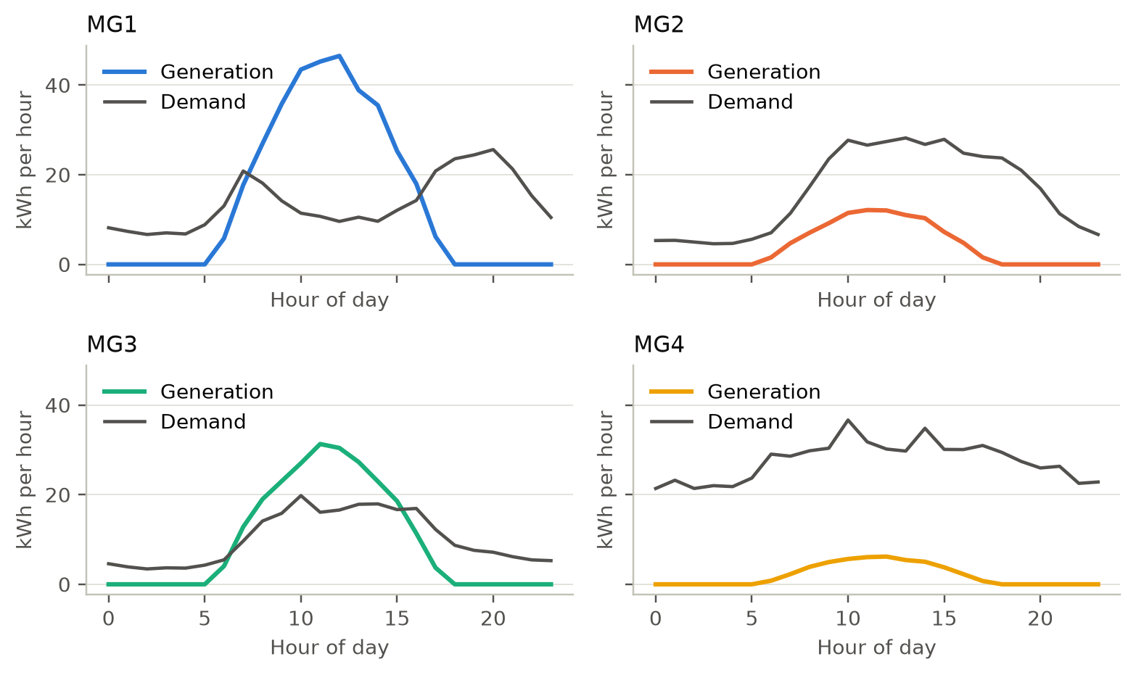
Figure 8. Synthetic 24-hour generation and demand per microgrid on the reference day (seed 42).
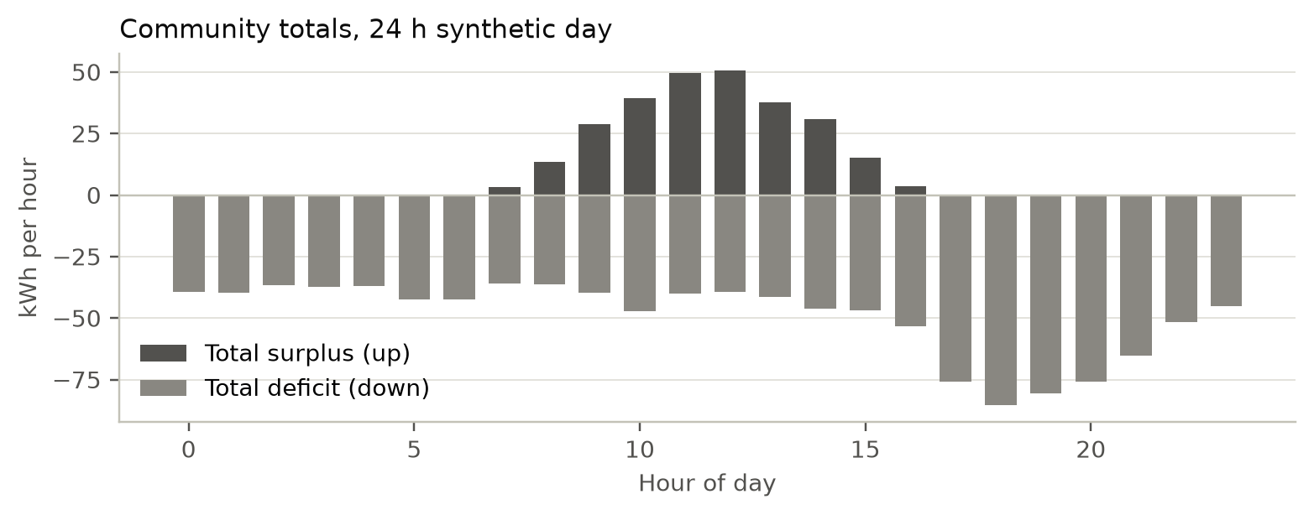
Figure 9. Hourly community totals of surplus (up) and deficit (down) on the reference day.
Table 20. E1 reference day: energy position and baseline cost per microgrid (24 h totals)
Microgrid | Generation (kWh) | Demand (kWh) | Surplus S (kWh) | Deficit R (kWh) | Surplus hours | Baseline cost (INR)
MG1 | 345.40 | 330.91 | 205.11 | 190.62 | 9 | 909.67
MG2 | 93.16 | 391.60 | 0.00 | 298.44 | 0 | 2,387.54
MG3 | 231.56 | 243.01 | 67.87 | 79.32 | 9 | 430.98
MG4 | 47.08 | 660.26 | 0.00 | 613.18 | 0 | 4,905.41
Total | 717.19 | 1,625.78 | 272.98 | 1,181.57 |  | 8,633.60

10.1.2 Community outcomes
Table 21 and Figure 10 compare the three mechanisms on identical states:
- The cooperative market lowers the community’s net cost by 14.6% (INR 1,259.93), trades 251.99 kWh at INR 5.50/kWh in all ten hours with surplus, and reaches the LP optimum (efficiency 1.000).
- The competitive market lowers it by 10.0% (INR 862.08). It trades 172.42 kWh at INR 7.50/kWh in eight hours, an efficiency of 0.684.
- Fairness differs sharply: the Jain index of the gains is 0.830 under cooperation and 0.467 under competition.
Table 21. E1 reference day (seed 42, 24 h): community metrics by mechanism
Mechanism | Net cost (INR) | Gain (INR) | Cost reduction | P2P volume (kWh) | Avg price (INR/kWh) | Jain | Efficiency | Trading hours
Baseline | 8,633.60 | 0.00 | 0.0% | 0.00 | N/A | N/A | 0.000 | 0
Cooperative | 7,373.66 | 1,259.93 | 14.6% | 251.99 | 5.50 | 0.830 | 1.000 | 10
Competitive | 7,771.52 | 862.08 | 10.0% | 172.42 | 7.50 | 0.467 | 0.684 | 8
Source: E1/runs.csv. Efficiency = gain / LP-optimal gain (INR 1,259.94). Jain fairness is computed over per-microgrid gains and is N/A for the baseline (all gains zero).
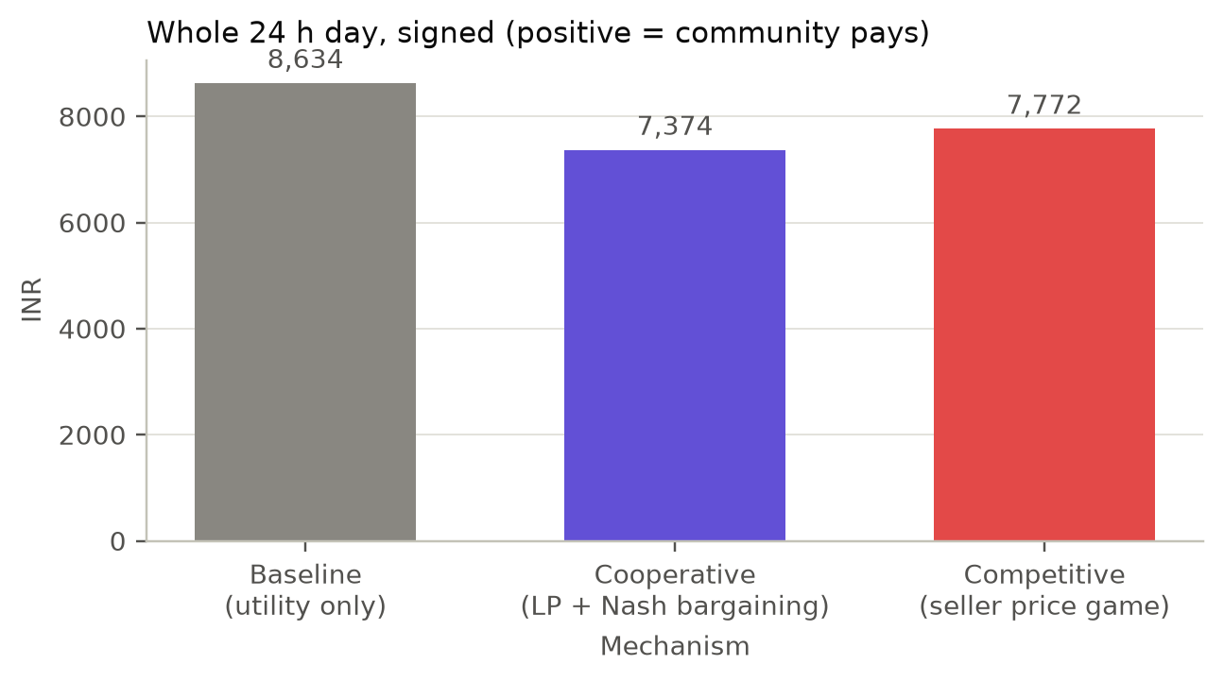
Figure 10. Community net cost over the 24-hour reference day by mechanism (signed; positive means the community pays).

10.1.3 Where competition falls short
Table 22 lists every hour with surplus.
- Hours with an equilibrium. In each of the eight trading hours other than 11 and 12, the competitive game has a unique, verified pure equilibrium, always at the top tick of INR 7.50/kWh (one seller in hours 7 and 16, two sellers otherwise). In each of these hours it trades exactly the LP-optimal volume.
- Hours 11 and 12. Total surplus exceeds total deficit, the capacity-constrained sellers undercut each other in the cycle of Section 5.7, and no pure equilibrium exists among the 100 profiles. Both hours are settled without P2P trade.
- The resulting gap. Those two hours remove 40.20 + 39.37 = 79.57 kWh of volume and 79.57 × 5 = INR 397.85 of gain. This is exactly the difference between the cooperative and competitive gains (1,259.93 − 862.08). The whole efficiency loss of the competitive market comes from the two hours without a pure equilibrium.
Table 22. E1 reference day: every hour with surplus, cooperative volume and competitive equilibrium status
Hour | Total S (kWh) | Total R (kWh) | Sellers (S, kWh) | Coop volume (kWh) | Competitive outcome (prices INR/kWh) | Profiles | Comp volume (kWh) | Max regret (INR)
7 | 3.16 | 36.10 | MG3 3.2 | 3.16 | Pure NE (1 of 10): MG3 7.50 | 10 | 3.16 | 0.00
8 | 13.64 | 36.19 | MG1 8.8, MG3 4.9 | 13.64 | Pure NE (1 of 100): MG1 7.50, MG3 7.50 | 100 | 13.64 | 0.00
9 | 28.79 | 39.75 | MG1 21.6, MG3 7.2 | 28.79 | Pure NE (1 of 100): MG1 7.50, MG3 7.50 | 100 | 28.79 | 0.00
10 | 39.29 | 47.23 | MG1 32.1, MG3 7.2 | 39.29 | Pure NE (1 of 100): MG1 7.50, MG3 7.50 | 100 | 39.29 | 0.00
11 | 49.77 | 40.20 | MG1 34.5, MG3 15.2 | 40.20 | NO_PURE_NE; NOT NASH diagnostic MG1 7.50, MG3 6.50 | 100 | 0.00 | 8.54
12 | 50.79 | 39.37 | MG1 36.9, MG3 13.9 | 39.37 | NO_PURE_NE; NOT NASH diagnostic MG1 7.00, MG3 6.00 | 100 | 0.00 | 12.76
13 | 37.79 | 41.54 | MG1 28.3, MG3 9.4 | 37.79 | Pure NE (1 of 100): MG1 7.50, MG3 7.50 | 100 | 37.79 | 0.00
14 | 30.91 | 46.25 | MG1 25.9, MG3 5.0 | 30.91 | Pure NE (1 of 100): MG1 7.50, MG3 7.50 | 100 | 30.91 | 0.00
15 | 15.12 | 46.97 | MG1 13.2, MG3 1.9 | 15.12 | Pure NE (1 of 100): MG1 7.50, MG3 7.50 | 100 | 15.12 | 0.00
16 | 3.71 | 53.37 | MG1 3.7 | 3.71 | Pure NE (1 of 10): MG1 7.50 | 10 | 3.71 | 0.00
Source: E1/intervals.csv and E1/diagnostics.csv. Hours without surplus have no sellers, no game and no trade. Profiles = joint price profiles enumerated. Regret is the largest gain any seller could obtain by a unilateral price change at the reported profile (0 at a verified NE).
Figure 11 shows the same result by trading pair and by hour:
- Trading pairs. Both markets use the same five seller–buyer pairs. The cooperative market moves more energy on the three largest: MG1 → MG2 119.81 against 89.95 kWh, MG1 → MG4 85.30 against 43.69 kWh, and MG3 → MG4 40.30 against 32.21 kWh.
- Hourly volumes. These coincide everywhere except the two gaps at hours 11 and 12.
- MG1 also buys. In hour 7, MG3 is the only seller and MG1 still has a deficit, so MG1 buys 3.11 kWh from MG3 in both markets.
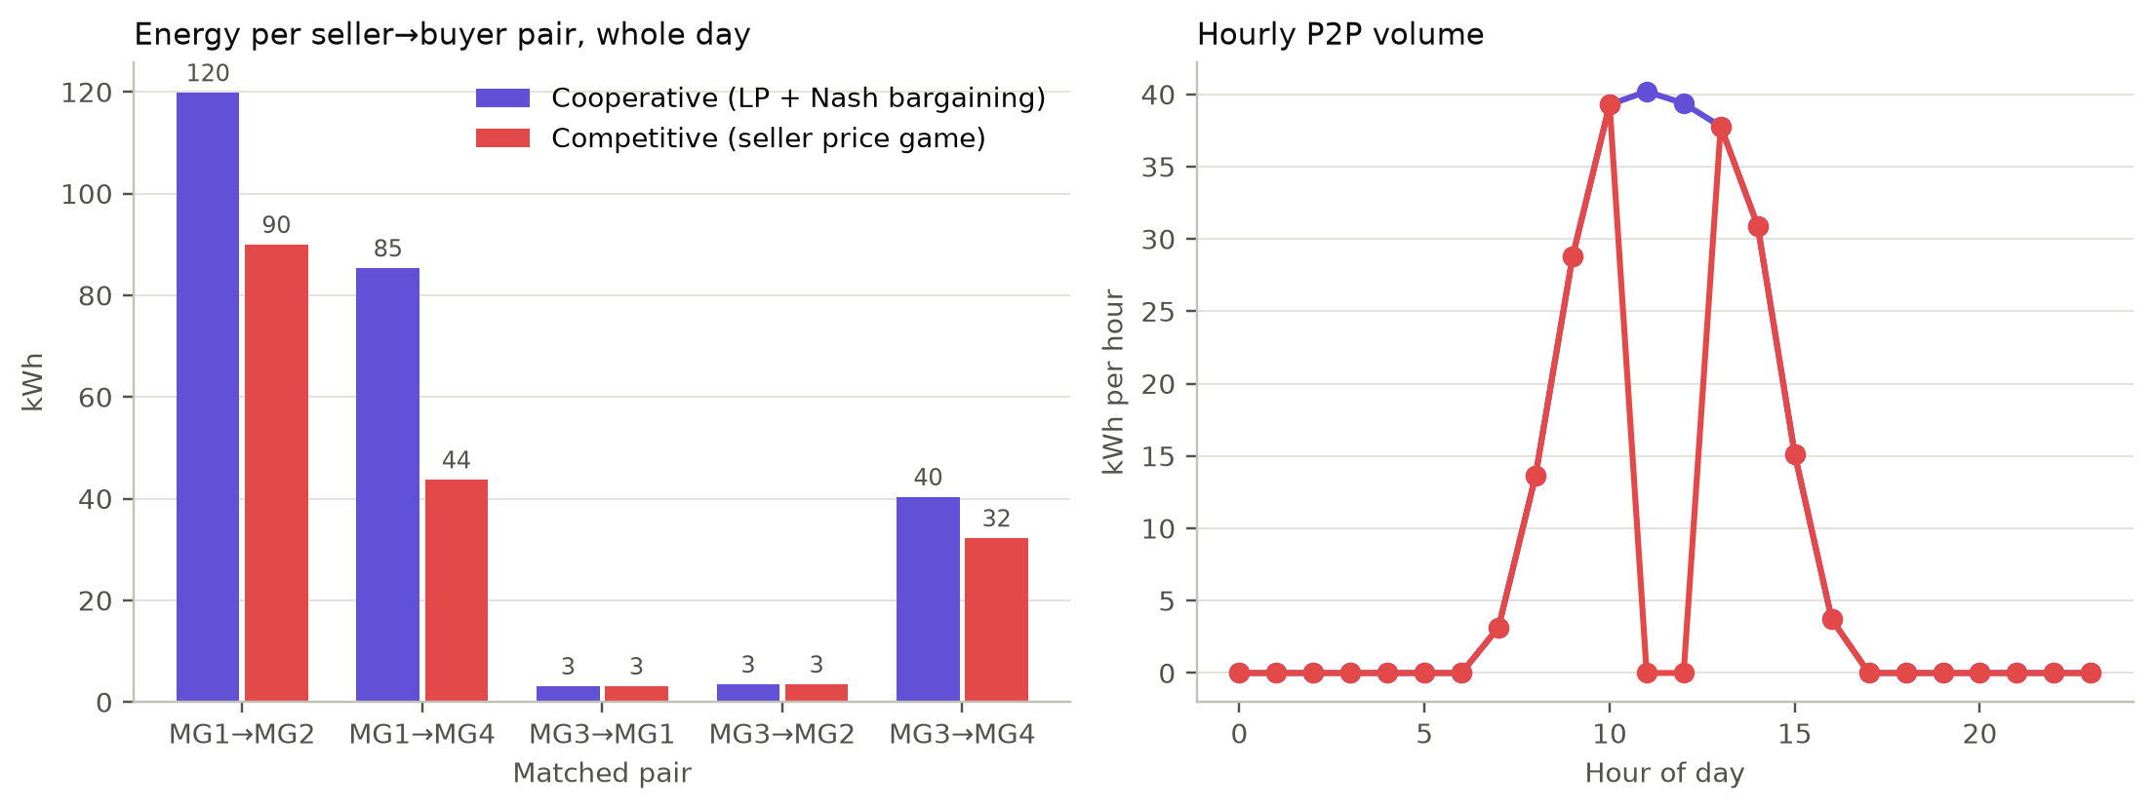
Figure 11. P2P energy per seller → buyer pair over the whole day (left) and hourly P2P volume (right) for the two markets.

10.1.4 Distribution of gains
Competition shifts the gains towards the sellers (Table 23, Figure 12). At the top-tick equilibria, buyers keep only INR 0.50 of the INR 5 spread on every kWh. MG1 gains INR 602.90 under competition against INR 520.54 under cooperation, and MG3 gains INR 174.53 against 117.19. The all-day buyers MG2 and MG4 gain only INR 46.71 and 37.95, against 308.18 and 314.02. The sellers earn more under competition even though they sell less energy (MG1 133.63 kWh against 205.11 kWh; MG3 38.78 kWh against 46.88 kWh), because the higher price more than compensates for the lost volume.
Table 23. E1 reference day: P2P energy sold and bought, and gain, per microgrid
Microgrid | Coop sold (kWh) | Coop bought (kWh) | Coop gain (INR) | Comp sold (kWh) | Comp bought (kWh) | Comp gain (INR)
MG1 | 205.11 | 3.11 | 520.54 | 133.63 | 3.11 | 602.90
MG2 | 0.00 | 123.27 | 308.18 | 0.00 | 93.41 | 46.71
MG3 | 46.88 | 0.00 | 117.19 | 38.78 | 0.00 | 174.53
MG4 | 0.00 | 125.61 | 314.02 | 0.00 | 75.90 | 37.95
Total | 251.99 | 251.99 | 1,259.93 | 172.42 | 172.42 | 862.08
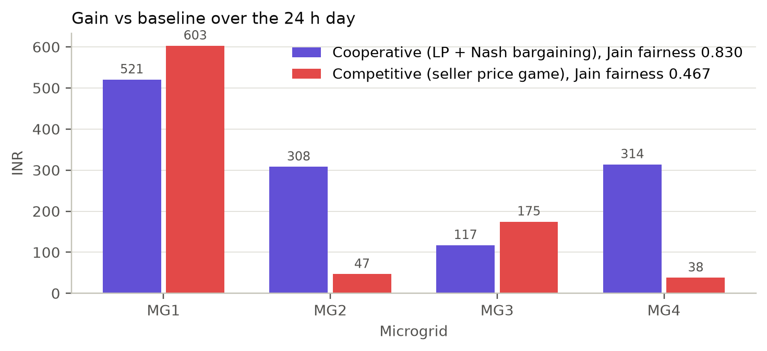
Figure 12. Gain over the baseline per microgrid over the reference day, with the Jain fairness index of each market.

10.1.5 Equilibrium verification
Figure 13 makes the equilibrium test visible for two intervals.
- Hour 8 (left). Each seller’s utility rises with its own price up to the top tick while the other seller is held at its equilibrium price, so (7.50, 7.50) is a best response for both: a verified pure equilibrium.
- Hour 11 (right). The profile is the NOT NASH diagnostic (MG1 7.50, MG3 6.50). MG1 could gain INR 8.54 by matching MG3 at 6.50 (120.91 against 112.37), and MG3 could gain INR 7.61 by raising its price to 7.00 (60.90 against 53.29), so the profile is not an equilibrium.
The export audit re-checks every settled equilibrium and every NOT NASH profile from these exported curves (checks 21–22 in Table 16).
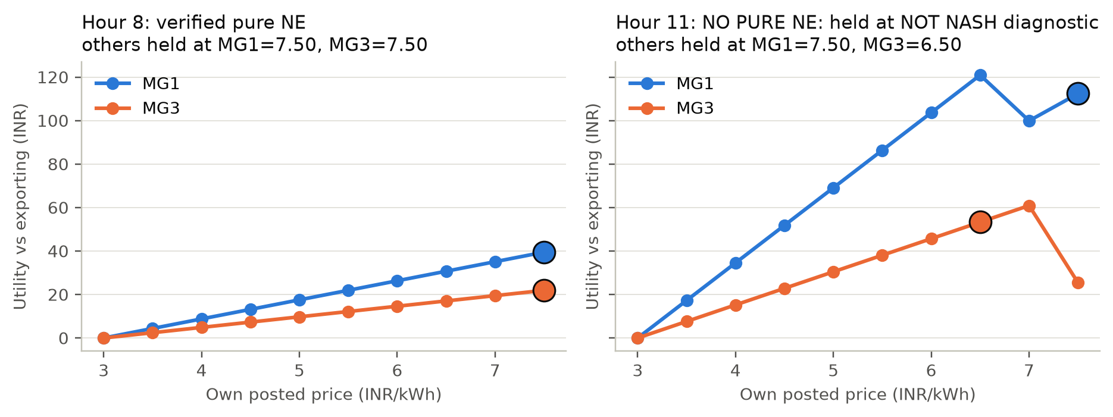
Figure 13. Competitive seller utility as one seller changes its own price, with the other held fixed. Large markers show the held prices: hour 8 is a verified pure equilibrium; hour 11 has none.

10.2 E2: tariff spread
E2 raises the retail price from 3 to 10 INR/kWh with the export price fixed at 3 INR/kWh (Figure 14, Table 24).
- Cooperative gain grows linearly with the spread, as $\text{gain}=(b−a)×251.99$ kWh, from zero at a spread of 0 to INR 1,763.91 at a spread of 7. The optimal volume does not depend on prices.
- Small spreads (1 and 2 INR/kWh). The competitive market matches the cooperative gain exactly. The price grid then has only two or four ticks, which leaves no room for the undercut-and-jump cycle, and every hour has a pure equilibrium.
- Spreads of 3 or more. Hours 11–12 lose their pure equilibrium and the competitive efficiency settles at 0.684, while the competitive average price stays one tick below retail.
A wider spread gives sellers more room to undercut each other and to jump back, which is what destroys the equilibrium.
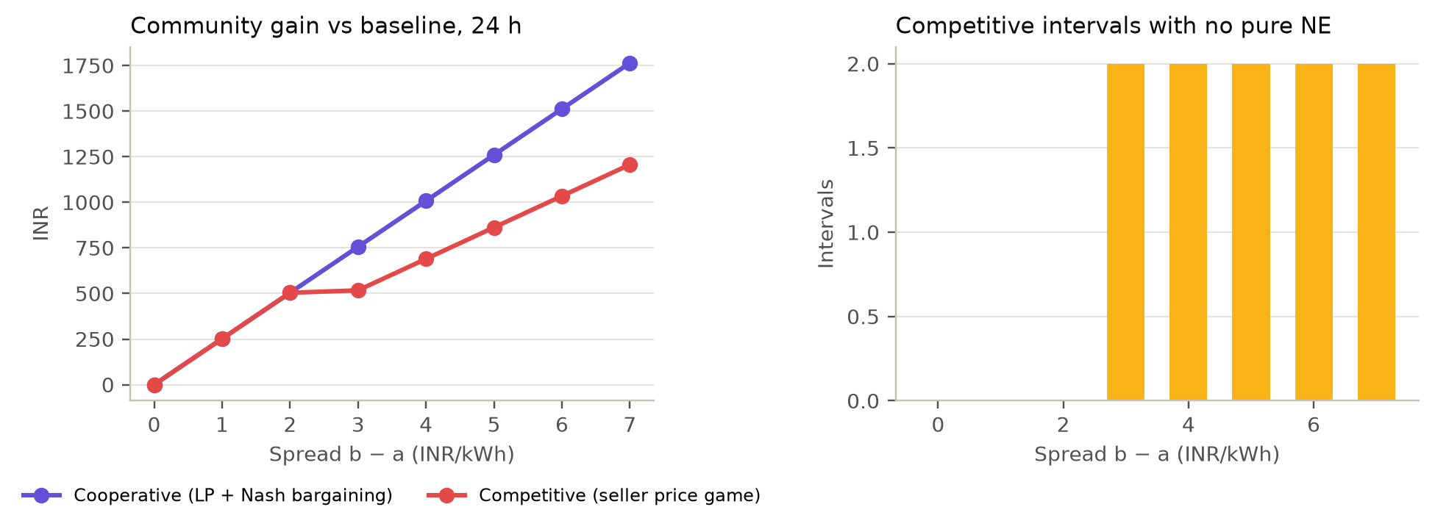
Figure 14. Community gain against the retail–export spread (left) and the number of competitive hours without a pure equilibrium (right), E2.
Table 24. E2 tariff spread: community gain and competitive equilibrium existence (export price a = 3 INR/kWh)
Spread b − a | Retail b | Coop gain (INR) | Comp gain (INR) | Comp efficiency | Comp avg price | No-pure-NE hours
0 | 3 | 0.00 | 0.00 | N/A | N/A | 0
1 | 4 | 251.99 | 251.99 | 1.000 | 3.50 | 0
2 | 5 | 503.97 | 503.97 | 1.000 | 4.44 | 0
3 | 6 | 755.96 | 517.25 | 0.684 | 5.50 | 2
4 | 7 | 1,007.95 | 689.67 | 0.684 | 6.50 | 2
5 | 8 | 1,259.93 | 862.08 | 0.684 | 7.50 | 2
6 | 9 | 1,511.92 | 1,034.50 | 0.684 | 8.50 | 2
7 | 10 | 1,763.91 | 1,206.91 | 0.684 | 9.50 | 2
Source: E2/runs.csv. Prices in INR/kWh.

10.3 E3: fees
E3 adds a total fee $f_{s}+f_{b}$ from 0 to 5.5 INR/kWh, split equally between seller and buyer (Figure 15, Table 25).
- Cooperative market. The gain falls linearly with the fees, as $(5−f_{s}−f_{b})×251.99$ kWh, while the operator collects $(f_{s}+f_{b})×251.99$ kWh. The volume stays at 251.99 kWh until the fees equal the spread (5 INR/kWh), where trading stops in both markets.
- The competitive gain is not monotone in fees. It falls from INR 862.08 without fees to INR 431.04 at total fees of 2.5 INR/kWh, then rises to INR 503.97 at 3.0.
- Why it rises. From total fees of 3.0 INR/kWh upward, the individually rational price range $[a+f_{s},b−f_{b})$ narrows to four or fewer ticks, the hour 11–12 price war disappears, and the competitive market matches the cooperative gain (efficiency 1.000) until trading stops at 5.
This effect is a property of the discrete game and of the rule that settles no trade without an equilibrium. It is not a general claim about real fees.
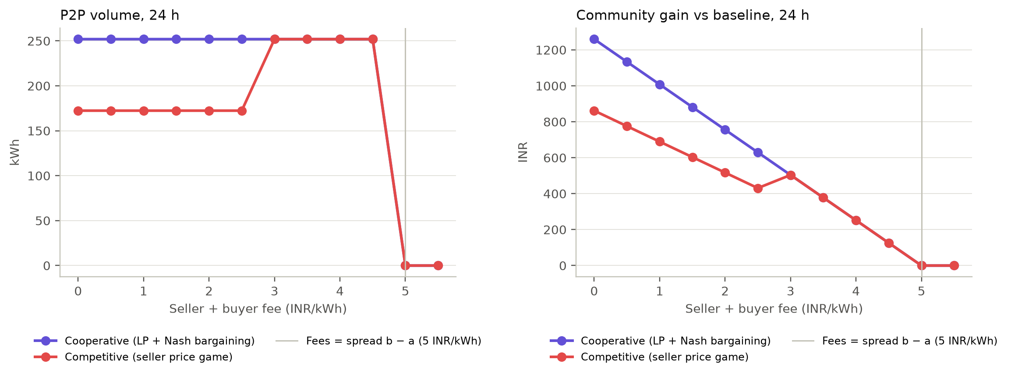
Figure 15. Sensitivity of P2P volume (left) and community gain (right) to the total seller + buyer fee, E3. The vertical line marks fees equal to the spread.
Table 25. E3 fees: P2P volume, community gain and operator fees as total fees rise
Fees $f_{s}+f_{b}$ (INR/kWh) | Coop volume (kWh) | Coop gain (INR) | Coop fees (INR) | Comp volume (kWh) | Comp gain (INR) | Comp efficiency | No-pure-NE hours
0.0 | 251.99 | 1,259.93 | 0.00 | 172.42 | 862.08 | 0.684 | 2
0.5 | 251.99 | 1,133.94 | 125.99 | 172.42 | 775.87 | 0.684 | 2
1.0 | 251.99 | 1,007.95 | 251.99 | 172.42 | 689.67 | 0.684 | 2
1.5 | 251.99 | 881.95 | 377.98 | 172.42 | 603.46 | 0.684 | 2
2.0 | 251.99 | 755.96 | 503.97 | 172.42 | 517.25 | 0.684 | 2
2.5 | 251.99 | 629.97 | 629.97 | 172.42 | 431.04 | 0.684 | 2
3.0 | 251.99 | 503.97 | 755.96 | 251.99 | 503.97 | 1.000 | 0
3.5 | 251.99 | 377.98 | 881.95 | 251.99 | 377.98 | 1.000 | 0
4.0 | 251.99 | 251.99 | 1,007.95 | 251.99 | 251.99 | 1.000 | 0
4.5 | 251.99 | 125.99 | 1,133.94 | 251.99 | 125.99 | 1.000 | 0
5.0 | 0.00 | 0.00 | 0.00 | 0.00 | 0.00 | N/A | 0
5.5 | 0.00 | 0.00 | 0.00 | 0.00 | 0.00 | N/A | 0
Source: E3/runs.csv. Fees in INR/kWh, split equally between seller and buyer. Gain is net of fees (fees are paid to an external operator).

10.4 E4: solar availability
E4 regenerates the profiles with the solar output scaled by 0.5–2.0 × (Figure 16, Table 26).
- Energy position. Total surplus rises from 57.24 to 824.19 kWh, total deficit falls from 1,324.42 to 1,015.59 kWh, and the baseline cost falls from INR 10,423.65 to INR 5,652.16.
- Cooperative volume is not monotone (57.24 → 251.99 → 301.17 → 272.19 kWh). Hourly volume is $min(S,R)$, and at 2.0 × more hours are oversupplied, so the binding side becomes the falling deficit.
- Competitive efficiency is 1.000, 0.684, 0.422 and 0.772, with 0, 2, 5 and 2 hours without a pure equilibrium.
The three price regimes of Section 5.8 explain the pattern:
- 0.5 ×. Every trading hour is a scarcity hour.
- 1.5 ×. The price war spreads to hours 8–10 and 13–14, while hours 11–12 have an equilibrium at (3.50, 3.50).
- 2.0 ×. Hours 9–13 are so oversupplied that either seller alone could cover demand. Bertrand equilibria at the export price appear, and the competitive average price falls to INR 3.78/kWh. The hours without an equilibrium move to the shoulders of the day (hours 7 and 15).
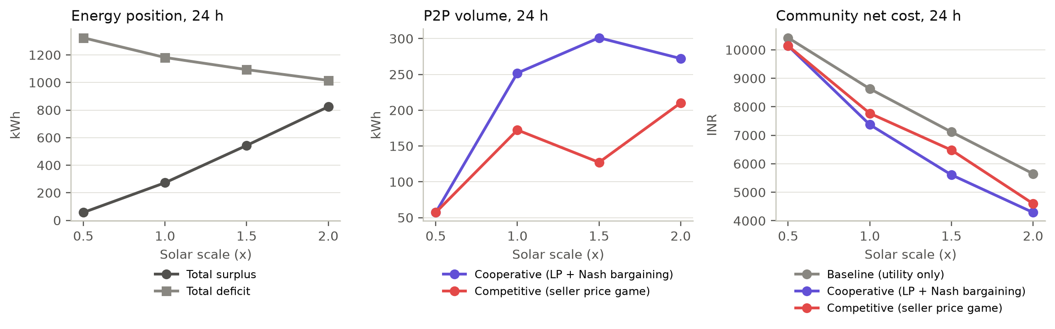
Figure 16. Energy position (left), P2P volume (centre) and community net cost (right) against the solar scale, E4.
Table 26. E4 solar scale: energy position, volume, gain and equilibrium existence
Solar scale | Total S (kWh) | Total R (kWh) | Baseline cost (INR) | Coop volume (kWh) | Coop gain (INR) | Comp gain (INR) | Comp efficiency | No-pure-NE hours
0.5× | 57.24 | 1,324.42 | 10,423.65 | 57.24 | 286.18 | 286.18 | 1.000 | 0
1.0× | 272.98 | 1,181.57 | 8,633.60 | 251.99 | 1,259.93 | 862.08 | 0.684 | 2
1.5× | 543.55 | 1,093.55 | 7,117.72 | 301.17 | 1,505.84 | 636.06 | 0.422 | 5
2.0× | 824.19 | 1,015.59 | 5,652.16 | 272.19 | 1,360.94 | 1,051.30 | 0.772 | 2
Source: E4/runs.csv. Profiles regenerated with seed 42 and only the solar scale changed.

10.5 E5: market size
E5 compares markets of two, four and six microgrids (Figure 17, Table 27, Table 28).
- N = 2 (MG1 and MG2). Both markets reach the same gain (INR 622.88), and every one of the nine game hours has a pure equilibrium. The cooperative Jain index of 1.000 is structural: with one seller and one buyer, every trade splits its surplus equally between the same two players. The competitive index is 0.610.
- N = 6. In hours 9–14, four sellers are active at once. That exceeds the default enumeration cap of three sellers, so those six hours are reported as ENUMERATION_CAP_EXCEEDED and not settled. The competitive N = 6 total (INR 257.02, efficiency 0.175) is therefore not a market outcome and must not be compared with the cooperative INR 1,466.18. Exact results would require raising the cap, which means ${10}^{4}$ profiles per hour with four sellers.
- Runtimes. For the 24-hour day, these are 10.6, 27.3 and 47.3 ms (cooperative) and 0.9, 2.6 and 7.3 ms (competitive) on the test machine. The cooperative time is dominated by the extra tie-break LPs.
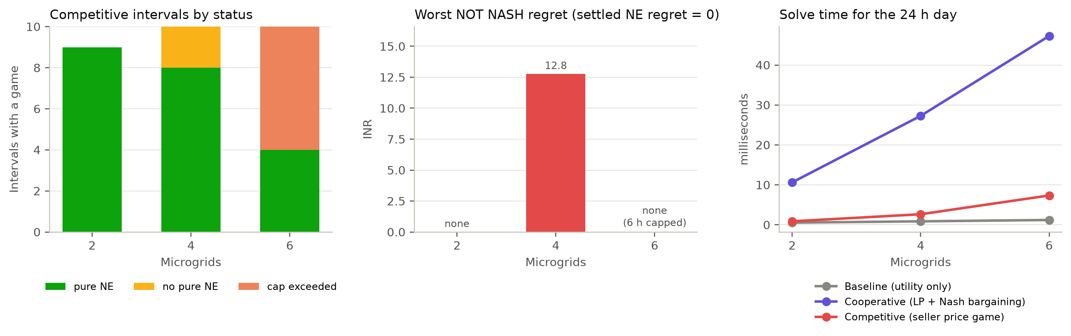
Figure 17. Competitive intervals by status (left), the worst NOT NASH regret (centre) and solve time (right) against market size, E5.
Table 27. E5 market size: gains, competitive interval status and fairness for N = 2, 4, 6 microgrids
N | Total S (kWh) | Total R (kWh) | Coop gain (INR) | Comp gain (INR) | Comp efficiency | NE / no NE / capped hours | Coop Jain | Comp Jain
2 | 214.28 | 487.63 | 622.88 | 622.88 | 1.000 | 9 / 0 / 0 | 1.000 | 0.610
4 | 272.98 | 1,181.57 | 1,259.93 | 862.08 | 0.684 | 8 / 2 / 0 | 0.830 | 0.467
6 | 381.91 | 1,505.06 | 1,466.18 | 257.02 | 0.175 | 4 / 0 / 6 | 0.649 | 0.490
Source: E5/runs.csv. Capped hours (more than 3 active sellers) are not enumerated and not settled, so the N = 6 competitive totals are not market outcomes.
Table 28. E5 market size: wall-clock solve time for the 24-hour day (this machine, one run)
N | Baseline (ms) | Cooperative (ms) | Competitive (ms)
2 | 0.5 | 10.6 | 0.9
4 | 0.9 | 27.3 | 2.6
6 | 1.2 | 47.3 | 7.3
Source: E5/runtimes.csv. Runtimes depend on the machine and are not reproducible; they are reported for scale only.

10.6 E6: strategy resolution
The price tick changes the price grid, and with it the top acceptable price (Figure 18, Table 29).
- Prices. The competitive average price is INR 7.00, 7.50 and 7.75/kWh for ticks of 1.0, 0.5 and 0.25 (5, 10 and 20 prices per seller; 25, 100 and 400 profiles per two-seller hour).
- Distribution. Competitive Jain fairness falls from 0.567 to 0.467 to 0.423.
- Unchanged. The total gain (INR 862.08) and the number of hours without an equilibrium (2) stay the same. Only the competitive solve time grows with the number of profiles (1.7, 2.6 and 6.1 ms).
Finer price grids let sellers capture more of the spread without changing efficiency.
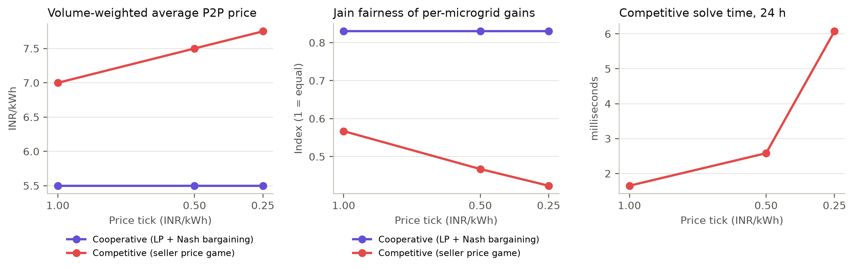
Figure 18. Volume-weighted average P2P price (left), Jain fairness (centre) and competitive solve time (right) for price ticks of 1.0, 0.5 and 0.25 INR/kWh, E6.
Table 29. E6 strategy resolution: competitive outcomes for price ticks of 1.0, 0.5 and 0.25 INR/kWh
Tick (INR/kWh) | Prices per seller | Profiles per 2-seller hour | Avg price (INR/kWh) | Comp gain (INR) | Comp Jain | No-pure-NE hours | Comp runtime (ms)
1.00 | 5 | 25 | 7.00 | 862.08 | 0.567 | 2 | 1.7
0.50 | 10 | 100 | 7.50 | 862.08 | 0.467 | 2 | 2.6
0.25 | 20 | 400 | 7.75 | 862.08 | 0.423 | 2 | 6.1
Source: E6/runs.csv and E6/runtimes.csv. Prices per seller = |P_i| on [a, b) with a = 3 and b = 8.

10.7 E7: ten synthetic days
E7 repeats the comparison on ten synthetic days, seeds 42–51 (Figure 19, Table 30, Table 31).
- Cooperative market. The gain is stable at INR 1,284.80 ± 30.72 (range 1,248.22–1,353.45), with a Jain index of 0.839 ± 0.020.
- Competitive market. The gain is INR 898.80 ± 124.02 (641.17–1,083.86), with a Jain index of 0.472 ± 0.022 and an efficiency of 0.699 ± 0.093 (0.514–0.846).
- The variation comes from the hours without an equilibrium. Every seed has between one and three such hours (mean 1.9), and the standard deviation of the competitive gain is four times that of the cooperative gain. The two seeds with a single such hour (45 and 50) have the highest competitive efficiency (0.840 and 0.846), and seed 51, with three, has the lowest (0.514).
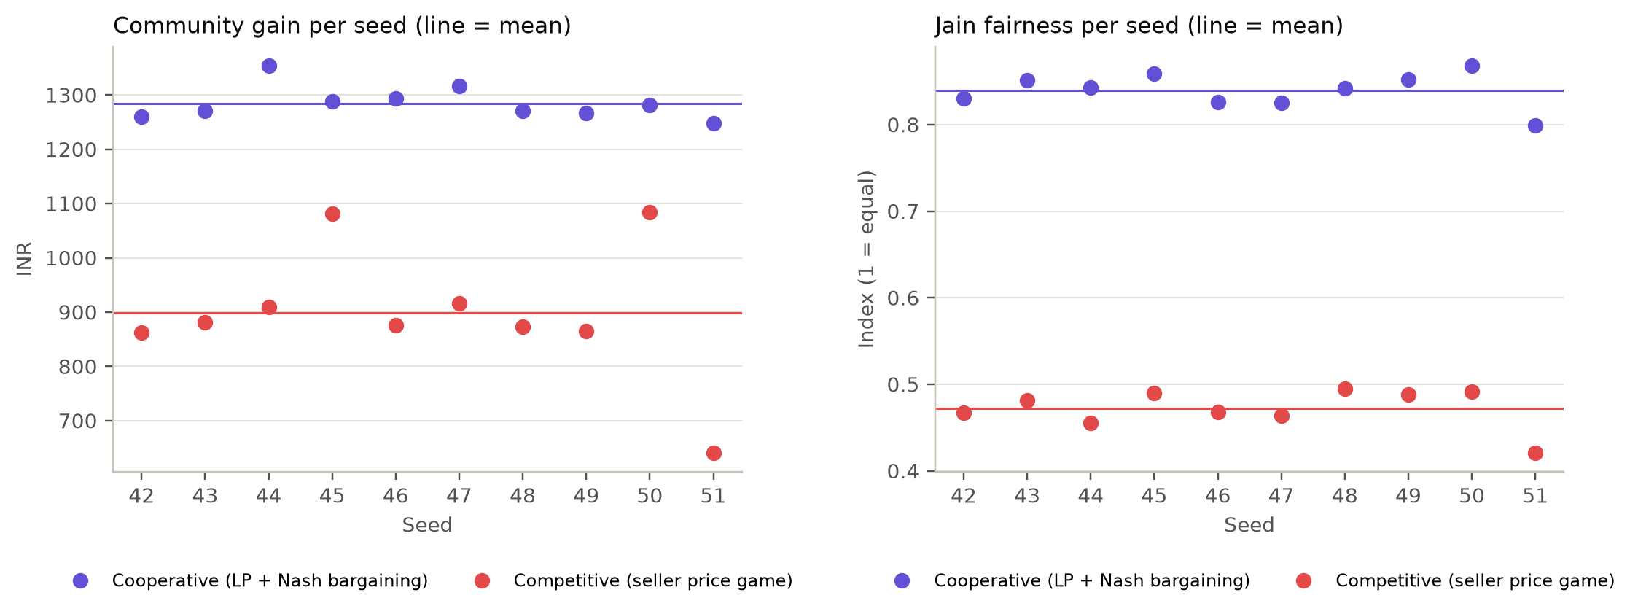
Figure 19. Community gain (left) and Jain fairness (right) per synthetic day, seeds 42–51; lines show the means, E7.
Table 30. E7 ten synthetic days: results for every seed
Seed | Baseline cost (INR) | Coop gain (INR) | Comp gain (INR) | Comp efficiency | No-pure-NE hours | Coop Jain | Comp Jain
42 | 8,633.60 | 1,259.93 | 862.08 | 0.684 | 2 | 0.830 | 0.467
43 | 8,661.16 | 1,270.32 | 880.72 | 0.693 | 2 | 0.852 | 0.481
44 | 8,713.43 | 1,353.45 | 908.76 | 0.671 | 2 | 0.843 | 0.455
45 | 8,821.32 | 1,288.16 | 1,081.57 | 0.840 | 1 | 0.859 | 0.489
46 | 8,677.51 | 1,293.73 | 875.79 | 0.677 | 2 | 0.826 | 0.468
47 | 8,684.23 | 1,316.04 | 915.88 | 0.696 | 2 | 0.825 | 0.464
48 | 8,569.98 | 1,270.31 | 873.54 | 0.688 | 2 | 0.842 | 0.495
49 | 8,584.47 | 1,266.77 | 864.60 | 0.683 | 2 | 0.852 | 0.488
50 | 8,681.28 | 1,281.04 | 1,083.86 | 0.846 | 1 | 0.868 | 0.492
51 | 8,537.43 | 1,248.22 | 641.17 | 0.514 | 3 | 0.799 | 0.421
Source: E7/runs.csv. Each seed regenerates the profiles with every other generator parameter fixed; seed 42 reproduces the committed reference table exactly (same SHA-256).
Table 31. E7 summary across seeds 42–51 (mean ± sample standard deviation, n = 10)
Mechanism | Gain (INR) | Gain range (INR) | Jain fairness | Efficiency (range) | Mean no-NE hours
Cooperative | 1,284.80 ± 30.72 | 1,248.22 – 1,353.45 | 0.839 ± 0.020 | 1.000 ± 0.000 (1.000 – 1.000) | N/A
Competitive | 898.80 ± 124.02 | 641.17 – 1,083.86 | 0.472 ± 0.022 | 0.699 ± 0.093 (0.514 – 0.846) | 1.9

10.8 Summary of findings
Table 32. Answers to the research questions (synthetic data; model-based)
Question | Finding
RQ1 Benefit of local trade | On the reference day, cooperative trade lowers the community’s net cost by 14.6% (INR 1,259.93, the LP optimum); competitive trade lowers it by 10.0% (INR 862.08). Across ten days the gains are INR 1,284.80 ± 30.72 and INR 898.80 ± 124.02.
RQ2 Cooperative distribution | Bilateral Nash bargaining with α = 0.5 splits each trade’s INR 5/kWh surplus equally; gains are fairly even (Jain 0.830 on the reference day, 0.947 in the golden hour). The weight α only redistributes.
RQ3 Selfish pricing | At the top-tick equilibria buyers keep INR 0.50/kWh: the all-day buyers gain INR 46.71 and 37.95 instead of 308.18 and 314.02, the sellers gain more, and Jain falls to 0.467.
RQ4 Verified equilibria | Every settled competitive profile is a verified pure equilibrium (zero regret after exhaustive enumeration, re-checked by the independent audit). Hours without one (11–12) are reported as NO_PURE_NE and settled without trade.
RQ5 Sensitivity | Fees reduce the gain linearly and stop all trade at the spread, and from 3 INR/kWh they remove the price war. Solar availability decides which price regime applies (competitive efficiency 1.000, 0.684, 0.422, 0.772). Exact enumeration stops beyond three active sellers.

11 Discussion

11.1 Efficiency versus distribution
The cooperative benchmark reliably captures the whole avoidable spread and shares it evenly. Whenever a pure equilibrium exists, the competitive market matches the cooperative total exactly. In scarcity hours every kWh offered is sold, and in strongly oversupplied hours all demand is served, so in both cases the traded volume is $min(S,R)$, as in the LP. The difference between the markets is therefore mainly a difference in who gains, not in how much is gained. With posted prices one tick below retail, sellers keep 90% of the spread, which is why the Jain index falls from about 0.83 to about 0.47 and buyers that are short of energy in every hour gain very little. Because prices never change the community total (Section 3.5), these distributional differences are pure transfers between members.

11.2 Why pure equilibria disappear in oversupplied hours
The competitive market loses efficiency only in hours where total supply exceeds demand but the smaller seller cannot cover the market. There, the larger seller always has a profitable fallback, selling the residual demand at the top price, and the smaller seller always has a profitable response, undercutting just below the larger seller. Undercutting and jumping back alternate, as Edgeworth described [15], [16], and no price profile is stable (Section 5.7).
The experiments show that this is not a fringe case. The hours in which local trade matters most, the sunny midday hours with surplus to spare, are exactly the hours in which competitive pricing becomes unstable. When the oversupply becomes extreme (E4 at 2.0 ×), stability returns in the Bertrand form: prices collapse to the export price, and buyers capture almost all of the spread.
A finite game always has a mixed-strategy equilibrium [13], so the NO_PURE_NE hours are not hours without any equilibrium; they are hours without a pure one. A mixed equilibrium would describe randomised pricing. Because it cannot be settled as a single, verifiable trade log, this project reports such hours instead of settling them.

11.3 The role of modelling choices
Five modelling choices shape the competitive results. Each is a choice, not an observation, and each is disclosed and tested:
- Buyer tie rule. Buyers break price ties by seller ID. This decides who wins a tie, so identical sellers can face asymmetric equilibria, and in the Edgeworth hours the lower-ID seller is the one that can afford to match.
- Discrete price grid. Prices move in ticks, and the top tick lies just below retail. The tick decides the equilibrium price in scarcity hours (E6) and, through the number of available prices, whether a price war can exist at all (E2, E3).
- No settlement without an equilibrium. Settling the NOT NASH diagnostic profile instead would raise competitive volume, but it would mix non-equilibrium outcomes into the totals and break the meaning of “competitive outcome”.
- Bargaining weight. α = 0.5 splits each cooperative trade’s surplus equally. Any α in (0, 1) leaves the cooperative total unchanged and only moves the distribution.
- Enumeration cap. Exact enumeration is limited to three active sellers by default. Beyond that, the simulator reports the interval as capped instead of approximating it, which is why the six-microgrid competitive total is not interpreted (E5).

11.4 Implications for local market design
Within the limits of this model, the results suggest three design considerations.
- A centrally cleared or cooperative design captures the full spread, keeps outcomes predictable from hour to hour, and offers a transparent lever, the bargaining weight, for deciding how gains are shared.
- A posted-price market concentrates gains on sellers when energy is scarce and can fail to settle precisely when energy is plentiful. An operator would need an explicit rule for those hours, such as a clearing auction or a uniform price; such rules are not modelled here and would need their own analysis.
- Fees transfer surplus to the operator one-for-one in the cooperative market, but in a discrete price game they can change the set of feasible prices enough to remove or create equilibria (E3). Fee levels should therefore be analysed together with the market rules, not separately.

11.5 Threats to validity
- Synthetic inputs. The profiles are synthetic and the tariffs illustrative; a real community may have different load shapes, more members and time-varying prices.
- Small markets. The markets are small (two to six microgrids) and are studied over single days.
- Results depend on the rules. The competitive results depend on the buyer rule, the tie rule and the price grid, as discussed above.
- Runtimes. These were measured once, on one machine.
- Same-project verification. Verification was done within the project. The audit is independent of the package code but not of the project, so an external review is advisable before the results are relied on.

12 Limitations and future work

12.1 Limitations
- No physics beyond energy accounting: the system is grid-connected and lossless, with no storage, network constraints, power flow or forecasting.
- Hourly intervals settled independently; synthetic profiles; flat illustrative tariffs (an hourly tariff table is supported but not studied).
- Flat per-kWh fees paid to an external operator.
- Bilateral bargaining on centrally allocated quantities, not multilateral bargaining or coalition solutions.
- No mixed-strategy equilibria. NO_PURE_NE intervals are settled without trade.
- Exact enumeration capped at three sellers by default.
- Buyers follow a fixed rule; the model is not a Stackelberg game.
- ID-based tie rules affect individual outcomes; microgrid IDs beyond nine must be zero-padded (MG01) to sort correctly.
- Higher P2P volume is not an emissions claim.

12.2 Future work
The blueprint suggests the following extensions:
- heterogeneous tariffs and pairwise fees;
- storage;
- forecast uncertainty;
- network-constrained power flow;
- multilateral bargaining or Shapley-value allocation [20];
- learning or repeated-game agents.
This study suggests three further directions:
- replacing the synthetic profiles with measured data such as the Ausgrid solar home dataset [9]–[11];
- computing mixed equilibria, or testing a clearing rule, for NO_PURE_NE hours;
- scaling the competitive analysis beyond three sellers with best-response dynamics or structured search, while keeping exhaustive verification wherever it is feasible.
Each extension would need updated equations, data contracts and test fixtures before its results could be compared with those reported here.

13 Conclusion
This project built MultiGrid, a reproducible simulator that compares utility-only operation, a cooperative P2P market and a competitive P2P market on identical, frozen energy profiles. All three are routed through one shared settlement that accounts exactly for energy and money, and every competitive equilibrium claim is backed by exhaustive enumeration.
On the synthetic reference day:
- local trading lowers the community’s net cost by up to 14.6% (RQ1);
- cooperative Nash bargaining shares that benefit evenly (RQ2);
- selfish posted prices transfer most of it to the sellers (RQ3).
Every settled competitive outcome is a verified pure Nash equilibrium, and hours without one are reported as such rather than guessed (RQ4). The competitive market is efficient whenever it has an equilibrium. Its entire shortfall comes from oversupplied hours where capacity-constrained sellers fall into Bertrand–Edgeworth price cycles. Fees, solar availability and market size change which of the three price regimes applies, and therefore both the size and the distribution of the gains (RQ5).
The results describe the model on synthetic data, not a real community. They show that a careful, verifiable treatment of a small model is enough to reveal a central tension of local energy markets: cooperation reliably captures and shares the value of local trade, while competition can leave value on the table precisely when renewable energy is most abundant.

References
[1] U.S. Department of Energy, Office of Electricity. Microgrid Systems. https://www.energy.gov/oe/microgrid-systems
[2] Zhang et al. (2018). Peer-to-peer energy trading in a microgrid. Applied Energy. https://doi.org/10.1016/j.apenergy.2018.03.010
[3] Paudel et al. (2019). Peer-to-peer energy trading in a prosumer-based community microgrid: a game-theoretic model. IEEE Transactions on Industrial Electronics. https://doi.org/10.1109/TIE.2018.2874578
[4] A game theoretic approach for peer to peer energy trading (2019). Energy Procedia. https://doi.org/10.1016/j.egypro.2018.12.075
[5] SciPy. scipy.optimize.linprog documentation. https://docs.scipy.org/doc/scipy/reference/generated/scipy.optimize.linprog.html
[6] CVXPY. Linear program example (optional alternative solver). https://www.cvxpy.org/examples/basic/linear_program.html
[7] Streamlit. Run your Streamlit app. https://docs.streamlit.io/develop/concepts/architecture/run-your-app
[8] pytest. Official documentation. https://docs.pytest.org/en/stable/contents.html
[9] IEEE PES Data Sharing portal. Ausgrid Solar Home Electricity Data. https://ieee-pes-data-sharing.org/datasets/detail/5795a399-f06e-4747-b518-cb9d961616a2
[10] UNSW DARTH. Ausgrid 300 Homes Solar Data: technical description. https://unsw-ceem.github.io/DARTH-docs/ausgrid300/
[11] Data parsing companion and archived dataset details (third party). https://github.com/pierre-haessig/ausgrid-solar-data
[12] Nash, J. F. (1950). The bargaining problem. Econometrica, 18(2), 155–162.
[13] Nash, J. F. (1951). Non-cooperative games. Annals of Mathematics, 54(2), 286–295.
[14] Kalai, E. (1977). Nonsymmetric Nash solutions and replications of 2-person bargaining. International Journal of Game Theory, 6(3), 129–133.
[15] Edgeworth, F. Y. (1925). The pure theory of monopoly. In Papers Relating to Political Economy, Vol. I. London: Macmillan.
[16] Vives, X. (1999). Oligopoly Pricing: Old Ideas and New Tools. Cambridge, MA: MIT Press.
[17] Jain, R., Chiu, D.-M., and Hawe, W. R. (1984). A Quantitative Measure of Fairness and Discrimination for Resource Allocation in Shared Computer Systems. DEC Research Report TR-301.
[18] Huangfu, Q., and Hall, J. A. J. (2018). Parallelizing the dual revised simplex method. Mathematical Programming Computation, 10(1), 119–142.
[19] Osborne, M. J., and Rubinstein, A. (1994). A Course in Game Theory. Cambridge, MA: MIT Press.
[20] Shapley, L. S. (1953). A value for n-person games. In Contributions to the Theory of Games II, Annals of Mathematics Studies 28, 307–317. Princeton University Press.
[21] MultiGrid project blueprint (2026). Game-Theoretic Analysis of Renewable Energy Trading Among Microgrids: complete project blueprint, MVP, execution plan, mathematical rules, tests and experiments, version 1.0, 27 October 2026.

Appendix A. Reproduction guide
All commands run from the repository root (https://github.com/PrashamJ17/MultiGrid-Game-Theoretic-Renewable-Energy-Trading-Among-Microgrids) with Python 3.10 or newer:
# set up a virtual environment and install the package
python3 -m venv .venv
source .venv/bin/activate
python -m pip install --upgrade pip
pip install -r requirements.txt
# run the 345 tests, then experiments E1-E7
python -m pytest -q
python -m microgrid.cli experiment all --out-dir results/experiments
# redraw the figures and run the independent 22-check audit
python scripts/make_figures.py --results results/experiments \
--out docs/figures
python scripts/audit_exports.py results/experiments/E1
# golden fixture comparison, then the dashboard
python -m microgrid.cli compare --config configs/golden_one_hour.json \
--profiles data/golden_one_hour.csv
python -m streamlit run app.py
On macOS, if the project sits in a folder synchronised by iCloud Drive, files inside .venv can be marked hidden, and Python 3.13 then ignores the editable install. Create the virtual environment outside iCloud (for example python3 -m venv ~/.venvs/multigrid), or prefix CLI commands with PYTHONPATH=src.
The figures in this report are the project’s result figures re-drawn for page width by the same plotting functions, from the same saved results. The two diagrams and the dashboard screenshots were produced for this report.
Table 33. Environment of the run reported here
Component | Version
Operating system | macOS 26.6 on Apple silicon (arm64)
Python | 3.13.9
microgrid package | 0.4.0
NumPy | 2.5.4
pandas | 2.3.3
SciPy (HiGHS solver) | 1.18.1
Streamlit | 1.66.1
Plotly | 6.9.0
Matplotlib | 3.11.2
pytest | 8.4.2

Appendix B. Base configuration
The base scenario configs/default.json:
{
"scenario_id": "four_microgrids_default",
"seed": 42,
"days": 1,
"hours_per_day": 24,
"microgrid_ids": ["MG1", "MG2", "MG3", "MG4"],
"retail_price_inr_per_kwh": 8.0,
"export_price_inr_per_kwh": 3.0,
"seller_fee_inr_per_kwh": 0.0,
"buyer_fee_inr_per_kwh": 0.0,
"price_step_inr": 0.5,
"bargaining_seller_weight": 0.5,
"tol": 1e-8,
"max_competitive_sellers": 3,
"require_full_horizon": true,
"generator": {
"solar_scale": 1.0, "demand_scale": 1.0, "noise_std_fraction": 0.05,
"sunrise_hour": 6.0, "sunset_hour": 18.0,
"microgrids": {
"MG1": {"demand_template": "residential",
"solar_peak_kwh": 45.0, "demand_peak_kwh": 25.0},
"MG2": {"demand_template": "commercial",
"solar_peak_kwh": 12.0, "demand_peak_kwh": 28.0},
"MG3": {"demand_template": "campus",
"solar_peak_kwh": 30.0, "demand_peak_kwh": 18.0},
"MG4": {"demand_template": "industrial",
"solar_peak_kwh": 6.0, "demand_peak_kwh": 32.0}
}
}
}

Appendix C. Output data contracts
Table 34. Files written for every experiment (results/experiments/<ID>/)
File | Content
runs.csv | One row per run and mechanism: the varied value, total surplus and deficit, profile hash and every metric except runtime
players.csv | Per run, mechanism and microgrid: P2P sold and bought, grid import and export, baseline cost, net cost, gain
intervals.csv | Per run, mechanism and hour: status, P2P volume, gain, net cost, equilibrium count, profiles examined, regret
summary.csv | Per mechanism and key metric: n, mean, standard deviation, minimum, maximum across runs
runtimes.csv | Wall-clock solve time per run and mechanism (environment-dependent)
configs/*.json, experiment.json | The exact configuration of every run; a manifest with the question, values, hashes, base configuration and environment
E1 only | profiles.csv, trades.csv, settlement.csv, diagnostics.csv and payoff_curves.csv (unilateral-deviation utilities)
The main tables have these columns:
- trades.csv: scenario_id, mechanism, day, hour, seller_id, buyer_id, quantity_kwh, price_inr_per_kwh, seller_fee_inr_per_kwh, buyer_fee_inr_per_kwh.
- settlement.csv: scenario_id, mechanism, day, hour, microgrid_id, grid_import_kwh, grid_export_kwh, p2p_import_kwh, p2p_export_kwh, baseline_cost_inr, p2p_cost_inr, gain_inr.
- diagnostics.csv: scenario_id, mechanism, day, hour, status, pure_ne_found, equilibrium_count, selected_profile, max_unilateral_regret_inr, examined_profiles, not_nash_profile, optimal_welfare_inr, p2p_volume_kwh, message.

Appendix D. Glossary
- Baseline (utility-only). Operation without P2P trade: every surplus is exported at $a$ and every deficit imported at $b$.
- Best response. A strategy that gives a player the highest payoff given the other players’ strategies.
- Bertrand–Edgeworth competition. Price competition between capacity-constrained sellers, in which a pure-strategy equilibrium may fail to exist.
- Disagreement point. The payoff each party receives if bargaining fails; here, trading with the utility.
- Efficiency. A mechanism’s community gain divided by the LP-optimal gain.
- Enumeration cap. The largest number of active sellers for which the payoff table is enumerated exactly (default 3).
- Golden fixture. The blueprint’s one-hour worked example with known expected outputs.
- Jain fairness index. $(∑U_{i})^{2}/(n∑U_{i}^{2})$; 1 for equal gains, $1/n$ when one player gains everything.
- NO_PURE_NE. The status of an interval whose seller price game has no pure Nash equilibrium; it is settled without P2P trade.
- NOT NASH. The label of the minimum-regret diagnostic profile in a NO_PURE_NE interval; it is recorded, never settled.
- Pure Nash equilibrium. A strategy profile at which no player can gain by changing only its own strategy.
- Regret. The payoff a player could gain by its best unilateral deviation from a profile.
- Shared settlement. The single routine that turns any trade log into energy flows, payments, fees, costs and gains, and validates them.
- Tie rule. The deterministic, ID-based rule used to choose among optimal allocations and among equally priced sellers.

