Edit log and Insert duty status
1) Log edit page
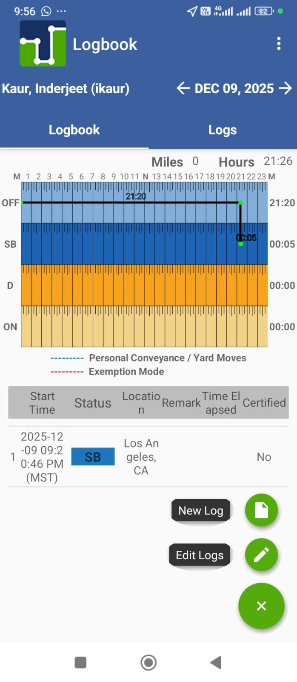
2) After clicking Log edit, option page will appear
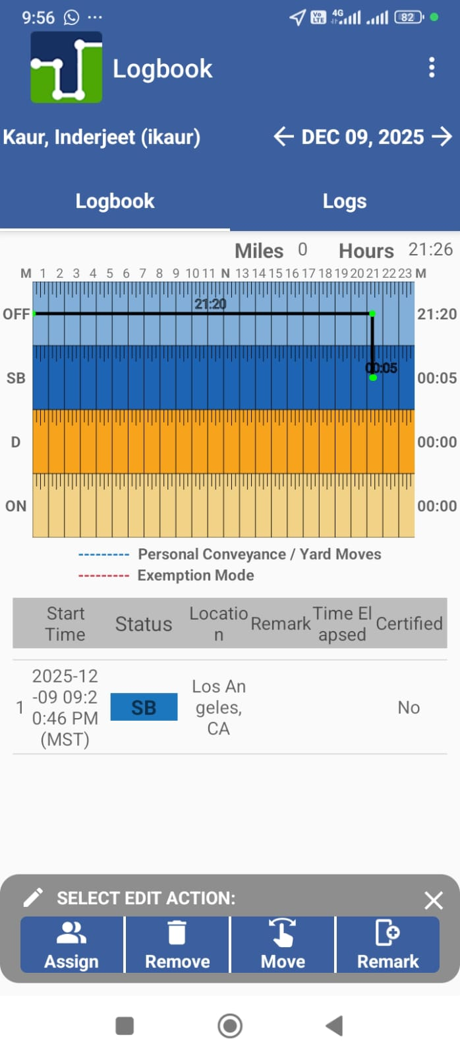
3) Edit log page will appear on clicking edit log
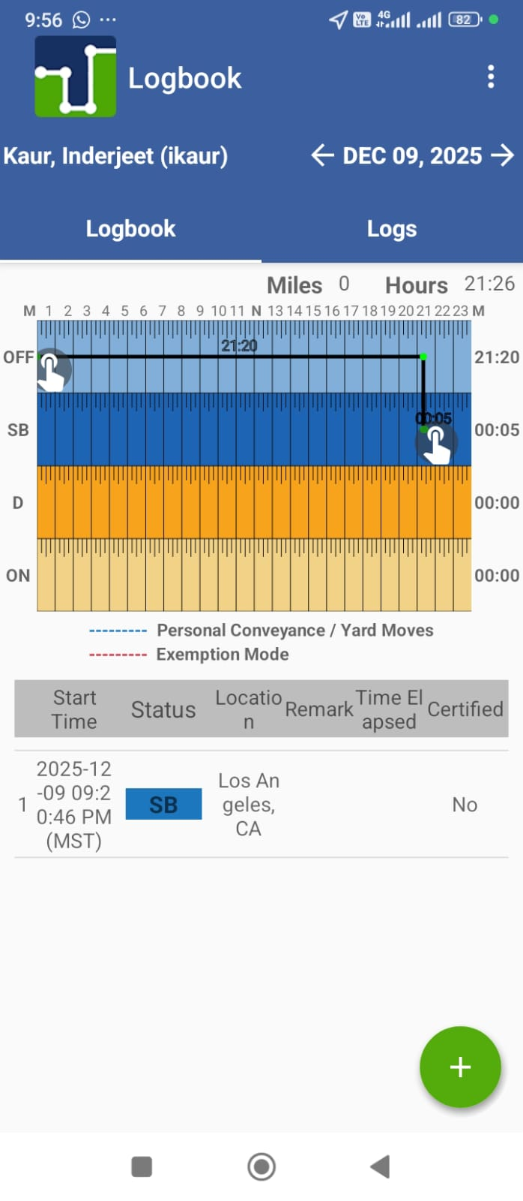
4) Log edit page modal appear after editing editing log
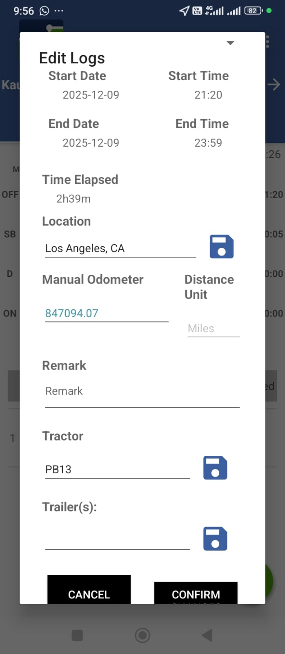
5) Delete log page will appear on clicking delete log
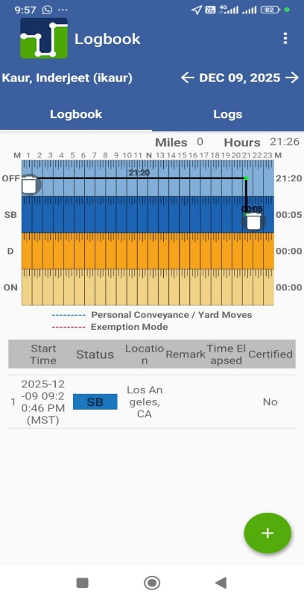
6) Insert duty status will appear on clicking new log
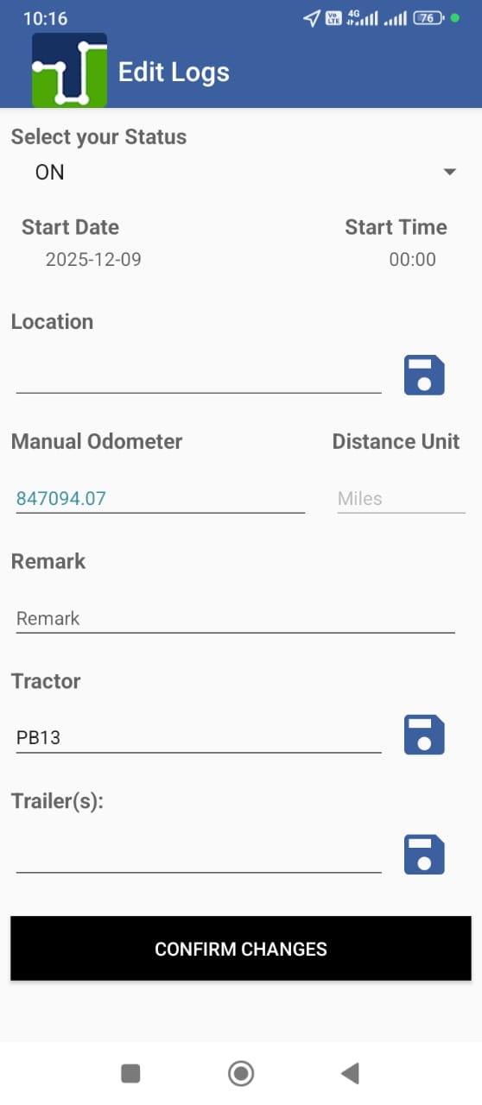
Click here for insert duty status
Click here for edit log
Add Remark on log
Assign log
Edit log
Delete log
Move this for edit log

