**Hands – On Lab Workshop 2**

*Note: It is mandatory for all students to draw the diagram in drawing tools as well as in a A4 paper describing the flow of each diagram in a paragraph.*

# Activity Diagram

* 1. Using an activity diagram, describe the process of student enrollment in an University

For the enrollment in an University, first the course to be studied is selected. Then after the selection, academic qualification is checked. If the academic qualification is fulfilled then personal statement is checked and if the application is approves then course fee is observed and if the fee is acceptable then the student information is taken and the enrollment is finished. If the academic qualification isn’t fulfilled then it is rejected and if the application is also not approved then it’s the same case of rejection. If the fee is too high then you can look for another course.

* 1. Consider the scenario of Order Processing. Once the order is received, the activities split into two parallel sets of activities. One side fills and sends the order while the other side handles the billing. On the Fill Order side, the method of delivery is decided conditionally. Depending on the condition either the Overnight Delivery activity or the Regular Delivery activity is performed. Finally, the parallel activities combine to close the order. With activity diagram, describes the processing of ordering

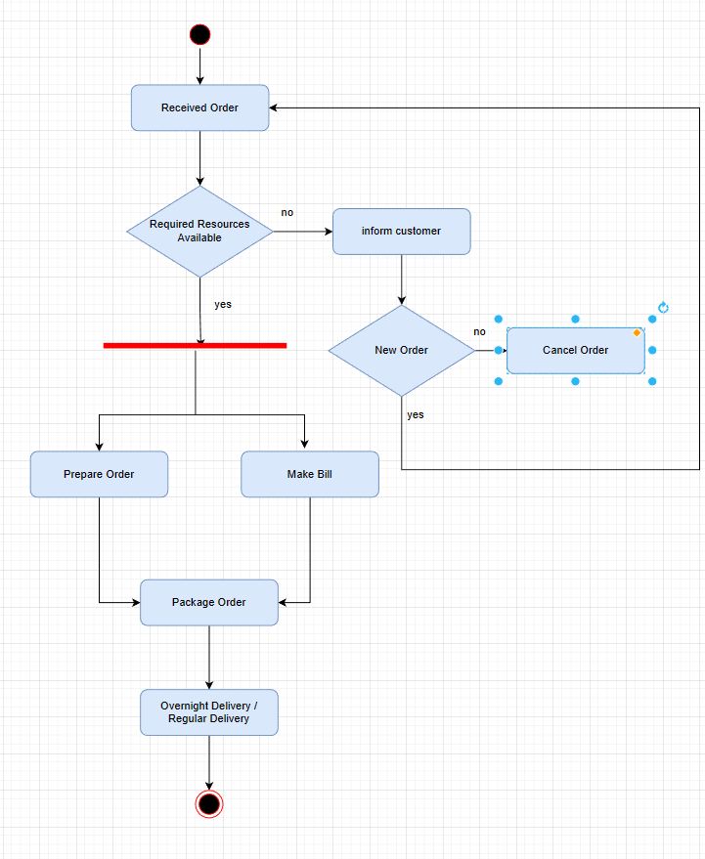

In the case of order processing, first the order is received by the manager. Then the resource is checked if it is available or not. If the resource isn’t available then the customer is informed and then the customer can order another item or cancel the order. If the resource is available, then the order and the bill is prepared and the order is packaged and the item is delivered in overnight or regularly.

* 1. Show the flow of word processing application software with the help of activity diagram

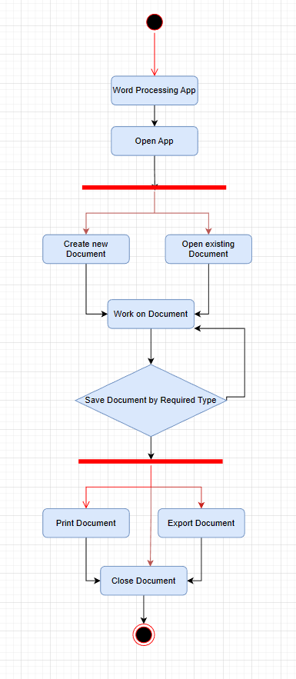

First of all, the application is opened and there comes two option: to open existing document or create a new document. Then after it, the work is done on it and the document can be saved by three methods(ways): by printing the document, by exporting or by closing the document. After the document is closed, it is ended.

# Sequence Diagram

* 1. Consider a Library Management System. Using sequence diagram, show the interaction of objects in the system to perform the function ‘Create new library user account’

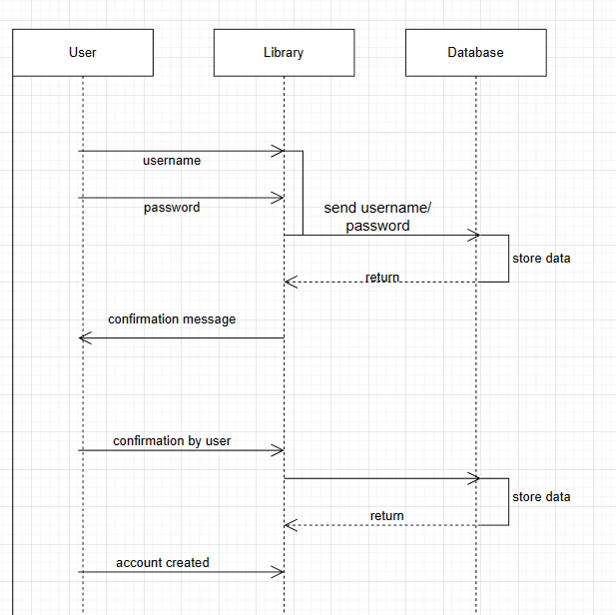

First of all, the user enters the username and password in the library. The library sends it to the database for confirmation and it stores and checks the data. After the confirmation from the database and the user confirms to create a account. The messege is sent to the database and it stores the data and creates new account and sends message to the user. Likethis, a new library user account is created.

* 1. In which sequence does the Online Exam System flow? Describes using sequence diagram

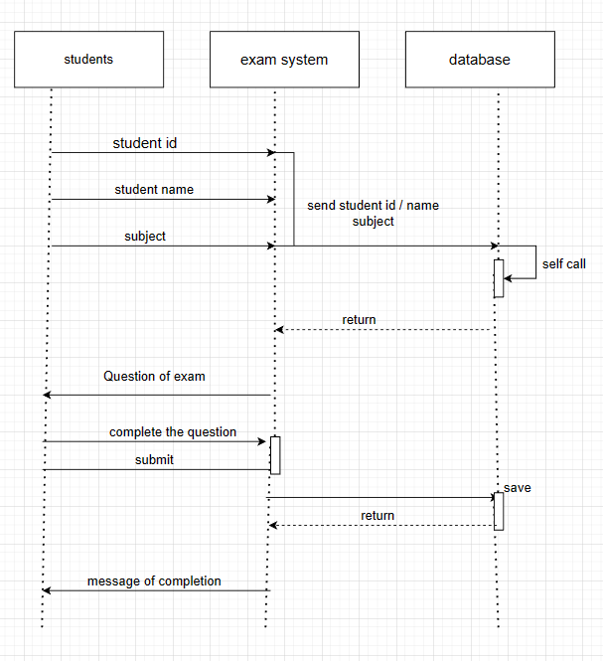

First of all, the student sends his student id, name and the subject to the exam system. The system sends it to the database and checks it. After checking, it sends the questions from the database to the student. The student completes the questions and submits it to the exam system and it is stored in the database. Then, the exam system sends the completion message to the student.

* 1. Represent the School Management System with sequence diagram

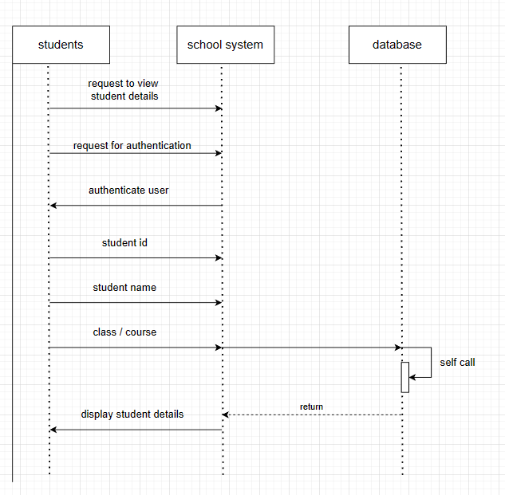

First of all, the student request to view student details and request for authentication. The school system authenticate user and the student sends student id, name and class or the course to the school system. The school system checks for the details in the database and self call it. Then it sends it to the school system and the school system displays the student details.

# Deployment Diagram

* 1. Show the necessary nodes, artifacts, associations and components required for Hospital Management System

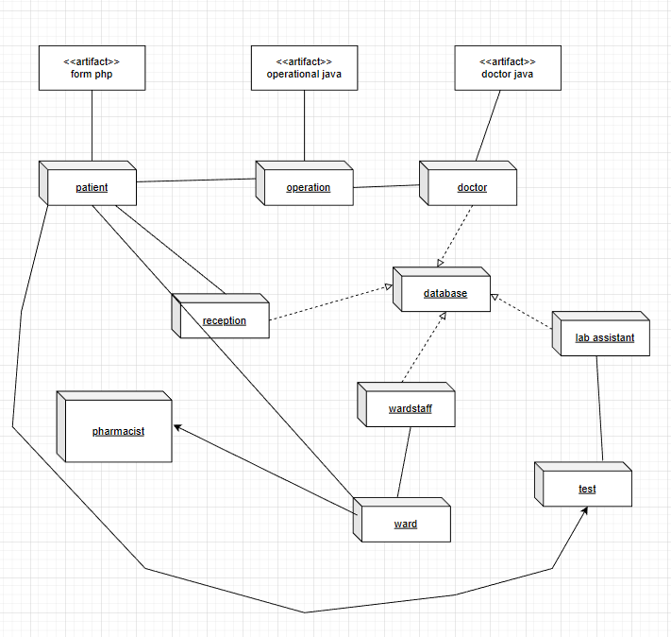

At first in the hospital management system, the patient fills forms and is sent to the reception for payment and confirmation from the database. Then he/she goes to the doctor for the operation and is conducted according the database. Then the patient is sent for the test by lab assistant and is also saved to the database. Then the patient is sent to the ward and is sent to the pharmacist for medicines necessary.

* 1. Draw a deployment diagram for Hotel Management System

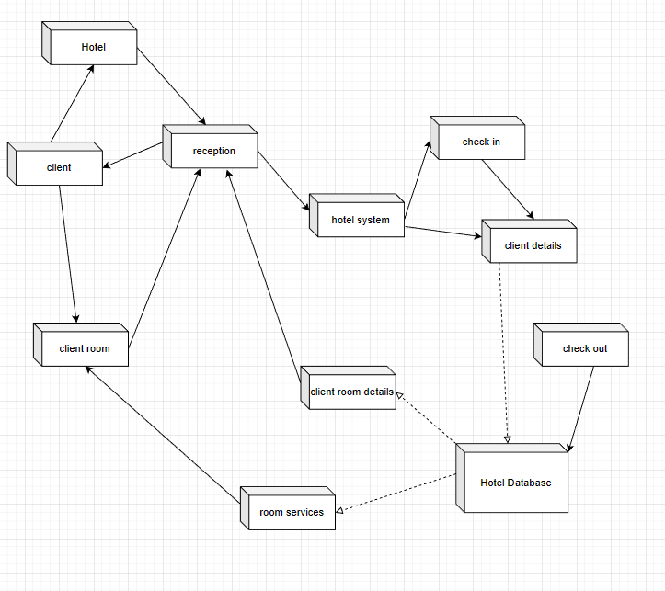

First of all the client goes to the hotel and goes to the reception. The reception access the hotel system and goes for check in. The system asks for the client details and is sent to the hotel database. Then the database provides client room details to the reception and also the room services to the client room. The reception gives room details to the client and the client gets the hotel room.