SUPERMARKET STATUS
Power BI Dashboard
Technical & Functional Documentation

Supply Chain & Planning Team
ERP: Epicor Kinetic

May 2026

1. Business Need
The Supermarket Status dashboard was built to give the Supply Chain, Planning, and Procurement team real-time visibility into part-level inventory demand. Before this dashboard, planners had no single view to distinguish parts that were urgently needed within the next 30 days from parts that were either built to maintain stock levels or tied to orders beyond the 30-day window.

The dashboard addresses the following core business problems:
- Inability to quickly identify which parts have active demand versus parts sitting in stock.
- Difficulty prioritising expediting efforts across a large parts catalogue.
- Lack of a consolidated view combining job supply, purchase orders, and on-hand stock quantities.
- No single metric to measure the overall health of the inventory in terms of demand coverage.

Primary Users:
- Supply Chain Manager
- Planning and Procurement Team

2. Data Sources
All data originates from Epicor Kinetic (ERP) and is surfaced through Power Platform Dataflows and a SharePoint-hosted CSV file. There are two dataflow workspaces in use.

Source | Type | Details
Epicor Kinetic (via Dataflow) | Power Platform Dataflow | Entity: Parts_Sply_Dmd — provides part demand, supply, job, and PO detail rows.
Part-BAQ Dataflow | Power Platform Dataflow | Business Activity Query returning part master data including ClassID, ProdCode, PartDescription, and MinimumQty.
StkStat.csv (SharePoint) | SharePoint CSV File | Stock status file containing part-level unit cost and extended cost used to calculate inventory dollar value.

Note: All workspace and dataflow identifiers (GUIDs) have been removed from this documentation for security. The SharePoint site URL has also been redacted.

3. Tables
The semantic model contains the following tables:

3.1 DemandInNext30Days / Stock (Fact — Primary)
This is the core table of the report. Each row represents a part with its demand or stock classification, quantities, supplier jobs, purchase orders, and inventory dollar value.

Column | Type | Description
value.PartDtl_PartNum | Text | Part number from Epicor Kinetic.
Demand/Stock | Text | 'Demand' if TargetQty > 0 and demand exceeds on-hand stock; otherwise 'Stock'.
Key | Text | Composite key: PartNum + '-' + Demand/Stock. Used for relationship joins.
PartDescription | Text | Part description pulled from Part-BAQ.
Custom Class ID | Text | Normalised class identifier (RAW, COMP, HANDLE, 0070).
Stock Qty | Number | Current on-hand quantity from Epicor.
MinimumQty | Number | Minimum stock threshold defined in Part-BAQ.
TotalDemandInNext30Days | Number | Sum of demand quantities due within the next 30 days.
TargetQty | Number | Quantity required to meet demand and minimum levels above on-hand.
SupplyQty | Number | Total supply quantity from open supplier jobs.
POSupplyQty | Integer | Total quantity from open purchase orders.
SupplierJobs | Text | Concatenated list of associated job numbers and operation codes.
PurchaseOrders.1 | Text | Concatenated list of associated PO line references.
SupplyQty / POQty | Text | Combined display field: SupplyQty / POSupplyQty.
SupplierJobs / PurchaseOrders | Text | Combined display field: SupplierJobs / PurchaseOrders.1.
AvgUnitPrice | Currency | Average unit cost from StkStat.csv.
Stock$ | Currency | Dollar value of on-hand stock (Stock Qty × AvgUnitPrice).

3.2 Demand / StockOperations
A supplementary operations table sourced from the same Epicor dataflow. It classifies supply job operations by Demand or Stock status and feeds the Operations matrix visual.

Column | Type | Description
value.PartDtl_PartNum | Text | Part number.
value.JobOper1_OpCode | Text | Operation code from the job; blank values replaced with 'Job Completed/Job Not Started'.
Demand/Stock | Text | 'Demand' if DemandInNext30Days exceeds on-hand quantity; otherwise 'Stock'.
Key | Text | Composite key: PartNum + '-' + Demand/Stock.
Count | Integer | Row count of jobs per part/operation/classification group.

3.3 Supporting Tables
Table | Purpose
DateTableTemplate_* | Auto-generated Power BI date template table. Hidden and private. Not directly used in visuals.
Refresh TimeStamp | Stores the last dataset refresh timestamp. Linked to a local date table via a date-only join relationship.
LocalDateTable_* | Auto-generated local date table linked to Refresh TimeStamp. Hidden and private.

4. Relationships
The model contains two relationships:

From Column | To Column | Cardinality | Cross-filter
Demand/StockOperations [Key] | DemandInNext30Days/Stock [Key] | Many-to-Many | Both Directions
Refresh TimeStamp [Refresh TimeStamp] | LocalDateTable [Date] | Many-to-One | Single (Date Part Only)

The Key-based relationship between Demand/StockOperations and DemandInNext30Days/Stock uses a composite key (PartNum-Demand/Stock) allowing the operations matrix to filter correctly by the same demand classification logic applied in the primary table.

5. Power Query (M) — Table Logic

5.1 DemandInNext30Days / Stock — Classification Logic
The core demand classification is determined by two computed columns:

TargetQty — How much needs to be sourced:
if [Demand In Next 30 Days] <> 0 and [Demand In Next 30 Days] > [OnHandQty]
then ([Demand In Next 30 Days] + [MinimumQty]) - [OnHandQty]
else if [MinimumQty] > [OnHandQty]
then [MinimumQty] - [OnHandQty]
else 0

Demand/Stock — Classification label:
if [TargetQty] > 0 and [Demand In Next 30 Days] > [OnHandQty]
then "Demand"
else "Stock"

Stock$ — Inventory dollar value:
if [Stock Qty] > 0 then [Stock Qty] * [AvgUnitPrice] else 0

5.2 Demand / StockOperations — Classification Logic
Uses a simpler demand rule based on raw demand vs. on-hand quantity:

DemandInNext30Days — Per-row demand flag:
if [value.PartDtl_DueDate] <= Date.AddDays(Date.From(DateTimeZone.UtcNow()), 30)
then [value.PartDtl_Quantity]
else 0

Demand/Stock — Classification:
if [DemandInNext30Days] > [value.PartQtyAttr_OnHandQty]
then "Demand"
else "Stock"

5.3 Part-BAQ — Custom Class ID Normalisation
Raw class IDs from Epicor are normalised to four standard categories:

if [ClassID] = "RAW" then "RAW"
else if [ClassID] = "COMP" then "COMP"
else if [ProdCode] = "200" then "HANDLE"
else if [ProdCode] = "602" then "HANDLE"
else if [ProdCode] = "603" then "HANDLE"
else if [ClassID] = "0070" then "0070"
else " " // excluded by subsequent filter step

Parts that do not match any of the above categories are filtered out of the dataset entirely.

5.4 SupplierJobs — Supply Aggregation
Supply job rows are grouped by part and demand classification. Job numbers and operation codes are concatenated into a single text field for display:
Location = JobNum + ";" + OpCode
SupplierJobs = Text.Combine([Location], " / ")

5.5 PurchaseOrders — PO Aggregation
Purchase order lines are similarly grouped and concatenated:
PurchaseOrders = Text.Combine([POLNRL], " / ")

5.6 StockConsumption — Stock Dollar Calculation
Consumption rows are joined to StockPrice to calculate dollar value of stock consumed vs. on-hand:
Stock$ = if [Quantity] < [value.PartQtyAttr_OnHandQty]
then [Quantity] * [AvgUnitPrice]
else 0

6. DAX Measures

6.1 InventoryHealth
Table: Demand/StockOperations

Purpose:
Calculates the proportion of unique parts that are classified as 'Stock' (sufficient inventory) out of the total distinct parts in the DemandInNext30Days/Stock table. A higher percentage indicates a healthier inventory where fewer parts have unmet demand.

Formula:
InventoryHealth =
VAR StockParts = CALCULATE(
DISTINCTCOUNT('DemandInNext30Days/Stock'[value.PartDtl_PartNum]),
'DemandInNext30Days/Stock'[Demand/Stock] = "Stock"
)
VAR DemandParts = CALCULATE(
DISTINCTCOUNT('DemandInNext30Days/Stock'[value.PartDtl_PartNum]),
'DemandInNext30Days/Stock'[Demand/Stock] = "Demand"
)
RETURN StockParts / (StockParts + DemandParts)

Format: 0%;-0%;0% | Example reading: 76% means 76% of parts have sufficient stock coverage.

7. Report Visuals
The Supermarket Status report contains one page with five visuals. Below is a screenshot of the full dashboard followed by a description of each visual.

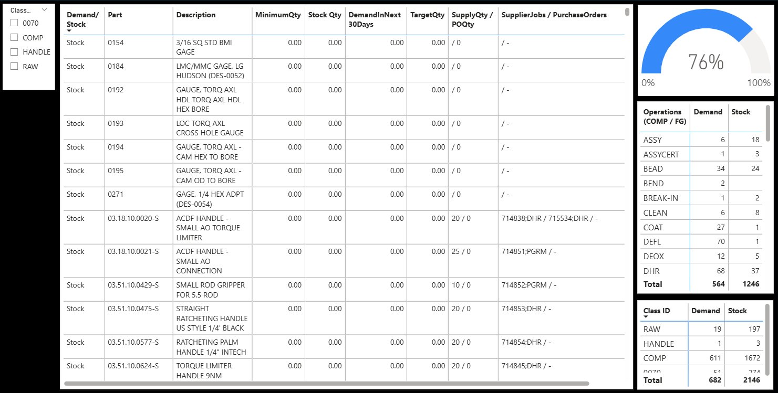
Figure 1 — Supermarket Status Dashboard (full view)
# | Visual Name | Type | Description
1 | Parts Detail Table | Table | Main visual. Shows each part with Demand/Stock status, Part Number, Description, MinimumQty, Stock Qty, DemandInNext30Days, TargetQty, SupplyQty/POQty, and SupplierJobs/PurchaseOrders. Planners use this to identify which parts need expediting.
2 | Inventory Health Gauge | Gauge | Displays the InventoryHealth DAX measure as a percentage gauge from 0% to 100%. A reading of 76% means 76% of parts have sufficient stock. The lower the percentage, the more parts are flagged as Demand.
3 | Operations Matrix (COMP/FG) | Matrix | Shows counts of Demand and Stock parts broken down by operation code (e.g. ASSY, BEAD, DEFL). Scoped to COMP and FG class parts. Helps identify which production operations are under demand pressure.
4 | Class ID Summary Matrix | Matrix | Aggregates Demand and Stock part counts by Custom Class ID (RAW, HANDLE, COMP, 0070). Provides a high-level inventory health view by part category.
5 | Class ID Slicer | Slicer | Filter panel on the left allowing users to filter all visuals by Custom Class ID (0070, COMP, HANDLE, RAW). Enables focused analysis on a specific part category.

8. Glossary
Term | Definition
Demand | A part classified as Demand has active requirements due within 30 days that exceed current on-hand stock and trigger a non-zero TargetQty.
Stock | A part classified as Stock has sufficient on-hand inventory to cover upcoming demand or is not required within the next 30 days.
TargetQty | The quantity needed to satisfy demand and minimum stock levels above what is currently on hand.
InventoryHealth | The ratio of Stock parts to total parts, expressed as a percentage. Higher is healthier.
SupplierJobs | Concatenation of Epicor job numbers and operation codes supplying a part.
PurchaseOrders | Concatenation of Epicor PO line references supplying a part.
Custom Class ID | Normalised part classification used in this model: RAW, COMP, HANDLE, or 0070.
Parts_Sply_Dmd | Epicor Kinetic dataflow entity combining part demand, supply, job, and PO detail.
Part-BAQ | Business Activity Query returning part master attributes from Epicor Kinetic.
StkStat.csv | SharePoint-hosted stock status file providing unit cost data for inventory valuation.

— End of Document —

