**>echo "Techstack"**

**Platform**

**OS : Ubuntu**

**Ubuntu** is the modern, open source operating system on Linux for the enterprise server, desktop, cloud, and IoT

**18.04 LTS**

The 'main' archive of Ubuntu 18.04 LTS will be supported for **5 years until April 2023**. Ubuntu 18.04 LTS will be supported for 5 years for Ubuntu Desktop, Ubuntu Server, and Ubuntu Core.

**20.04 LTS**

Ubuntu 20.04 (Focal Fossa) **feels stable, cohesive, and familiar**, which is not surprising given the changes since the 18.04 release, such as the move to to newer versions of the Linux Kernel and Gnome. As a result, the user interface looks excellent and feels smoother in operation than the previous LTS version.

**GPU : Graphics processing unit**, a specialized processor originally designed to accelerate graphics rendering.

**NVIDIA:**  designs and sells **GPUs** for gaming and professional applications, as well as chip systems for use in vehicles, robotics, and other tools. Some of the company's biggest competitors include Intel Corp.

known for **developing integrated circuits**, which are used in everything from electronic game consoles to personal computers (PCs). The company is a leading manufacturer of high-end graphics processing units (GPUs)

**CUDA Stack:** CUDA is a scalable parallel programming model and a software environment for parallel computing

Minimal extensions to familiar C/C++ environment Heterogeneous serial-parallel programming model

NVIDIA’s TESLA architecture accelerates CUDA Expose the computational horsepower of NVIDIA GPUs

Enable GPU computing.

**Programming Stack:**

**Python 3.6+**

Python is a popular programming language. Python can be used on a server to create web applications.

Python is a popular programming language. It was created by Guido van Rossum, and released in 1991.

It is used for:

* web development (server-side),
* software development,
* mathematics,
* system scripting.
* 3.6 bugfix update will be released

**Javascript ES5:**

**Javascript :**

JavaScript is a fun and flexible programming language. It’s one of the core technologies of web development and can be used on both the front-end and the back-end.

ECMA Script 2009 , aka ES5 was the first evision to Javascript.

• Versatile and robust

• Front-End friendly

• Back-End friendly

• Enables web applications

• Game Development

• Mobile Apps

**Node JS**

Node.js is an open-source, cross-platform, back-end JavaScript runtime environment that runs on the V8 engine and executes JavaScript code outside a web browser.

**V8** is the name of the JavaScript **engine** that powers Google Chrome. It's the thing that takes our JavaScript and executes it while browsing with Chrome.

It  is **used for server-side programming**, and primarily deployed for non-blocking, event-driven servers, such as traditional web sites and back-end API services, but was originally designed with real-time, push-based architectures in mind. Every browser has its own version of a JS engine, and node.

**C++**

C++ is a powerful general-purpose programming language. It can be used to develop operating systems, browsers, games, and so on. C++ supports different ways of programming like procedural, object-oriented, functional, and so on. This makes C++ powerful as well as flexible.

**HTML 5**

HTML5 is a markup language used for structuring and presenting content on the World Wide Web. It is the fifth and last major HTML version that is a World Wide Web Consortium recommendation.

 It is a system that **allows the modification of the appearance of web pages**, as well as making adjustments to their appearance. It also used to structure and present content for the web.

CSS3 :

Cascading style sheet

CSS3 is the latest evolution of the Cascading Style Sheets language and aims at extending CSS2. 1. It brings a lot of new features and additions, like rounded corners, shadows, gradients, transitions or animations, as well as new layouts like multi-columns, flexible box or grid layouts.

WebGL:

WebGL (Web Graphics Library) is the new standard for 3D graphics on the Web, It is designed for the purpose of rendering 2D graphics and interactive 3D graphics. It is derived from OpenGL's ES 2.0 library which is a low-level 3D API for phones and other mobile devices. WebGL provides similar functionality of ES 2.0 (Embedded Systems) and performs well on modern 3D graphics hardware.

It is a JavaScript API that can be used with HTML5. WebGL code is written within the <canvas> tag of HTML5. It is a specification that allows Internet browsers access to Graphic Processing Units (GPUs) on those computers where they were used.

Angular 10+

### fixes and enhancements to address performance regressions, core and router bugs.

AngularJS extends HTML with new attributes. AngularJS is perfect for Single Page Applications (SPAs). AngularJS is easy to learn , directives and models are used.

ng model ng directives

AI framework

Keras: eras is an open-source software library that provides a Python interface for artificial neural networks. Keras acts as an interface for the TensorFlow library. ... Designed to enable fast experimentation with deep neural networks, it focuses on being user-friendly, modular, and extensible.

Tensor Flow: TensorFlow is an end-to-end open source platform for machine learning. It has a comprehensive, flexible ecosystem of tools, libraries and community resources

Py torch: PyTorch is an open source machine learning library based on the Torch library, used for applications such as computer vision and natural language processing, primarily developed by Facebook's AI Research lab (FAIR).

**Message Interferences**

**Kafka :**

Kafka combines three key capabilities so you can implement [your use cases](https://kafka.apache.org/powered-by) for event streaming end-to-end with a single battle-tested solution:

1. To **publish** (write) and **subscribe to** (read) streams of events, including continuous import/export of your data from other systems.
2. To **store** streams of events durably and reliably for as long as you want.
3. To **process** streams of events as they occur or retrospectively.

**RabbitMQ:**

deployed open source message broker.

It gives your applications a common platform to send and receive messages, and your messages a safe place to live until received.

**ZeroMQ:**

ZeroMQ is an asynchronous messaging library, aimed at use in distributed or concurrent applications. It provides a message queue, but unlike message-oriented middleware, a ZeroMQ system can run without a dedicated message broker.

**Celery:**

**Celery is an asynchronous task queue**.

It can be used for anything that needs to be run asynchronously.

**RDBMS:**

The RDBMS provides an **interface between users and applications and the database**, as well as administrative functions for managing data storage, access, and performance.

**PostGreSQL:**

**Used as the the primary data store or data warehouse for many web, mobile, geospatial, and analytics applications**.

stores much more information not only information about tables and columns, but also information about data types, functions, access methods

**PostGIS:**

PostGIS is a spatial database extender for [PostgreSQL](https://postgresql.org/) object-relational database. It adds support for geographic objects allowing location queries to be run in SQL.

**NOSQL:**

**MongoDB:**

MongoDB is a source-available cross-platform document-oriented database program (document-oriented database program. )

makes it easy for **developers to store structured or unstructured data**.

* **Document Oriented Storage** − Data is stored in the form of JSON style documents.
* Index on any attribute
* Replication and high availability
* Auto-Sharing
* Rich queries
* Fast in-place updates
* Professional support by MongoDB

**Array DB :**

**Rasdaman**

a [Database Management System](https://en.wikipedia.org/wiki/Database_Management_System) which adds capabilities for storage and retrieval of massive multi-dimensional [arrays](https://en.wikipedia.org/wiki/Array_data_structure), such as sensor, image, simulation, and statistics data.

**Documentation**

**1. Mark down**

lightweight markup language for creating formatted text using a plain-text editor.

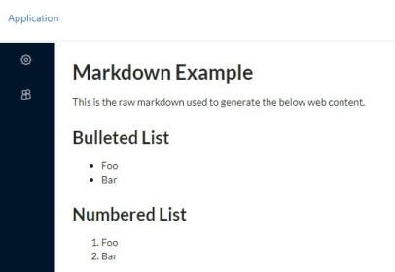

**2.ascidoc**

AsciiDoc is **a text document format** that was explicitly designed with the needs of publishing in mind, both print and web.

It supports all the structural elements necessary for writing notes, documentation, articles, books, ebooks, slideshows, web pages, technical manuals and blogs.

**TeX/LATeX**

**TeX:**

Giving commands to give every bit of information in the document to look good.

**LATeX** :

 create documents with text and formatting that would be difficult in a standard word processor.

 it features with a reliable program for typesetting, footnotes, bibliographic, images, captions, tables, cross-references.

**1.Version Management**

**git**

**.Global Information Tracker**

**.control system that lets us manage and keep our code history**

**.used to handle all kinds of project in a very efficient manner**

**.multiple users can use it at the same time.**

**github**

**Git repository hosting service**, but it adds many of its own features.

**open source version control software** that lets multiple people make separate changes to web pages at the same time.

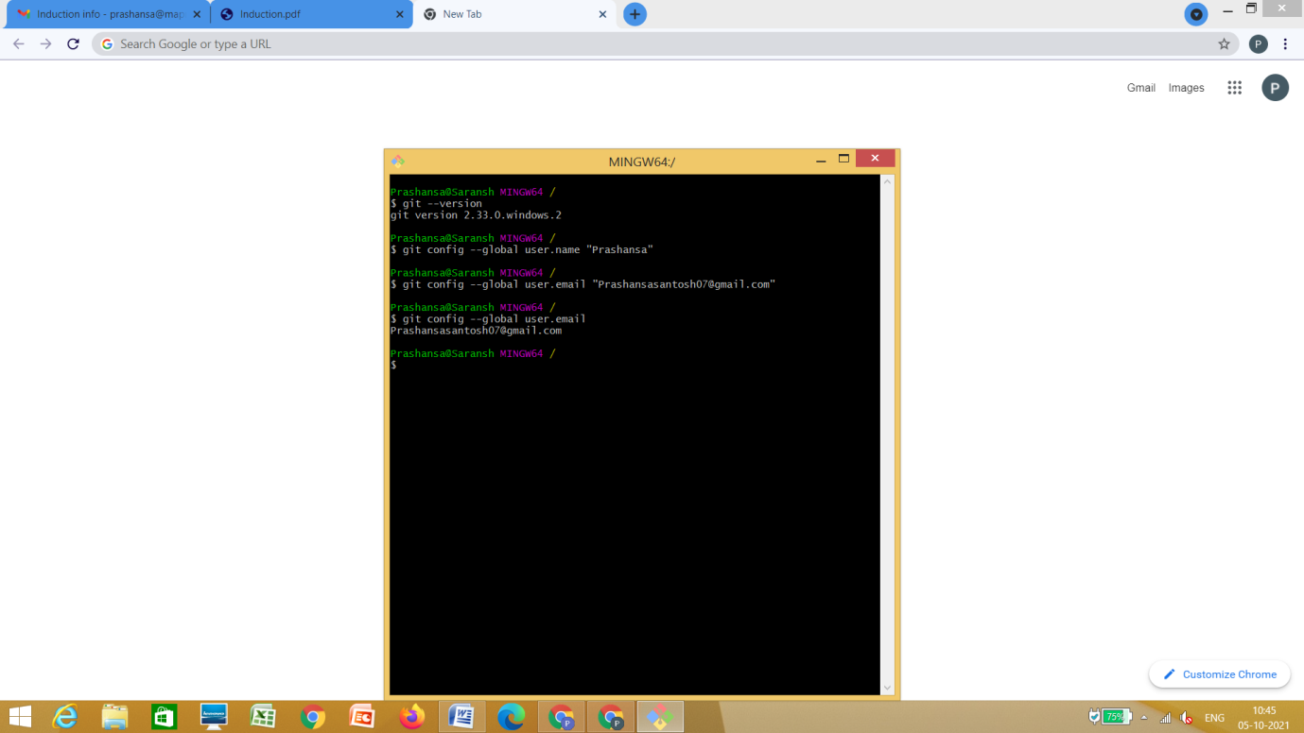

**echo Tools**

Linux Tools :

Command line tools: Command line tools are **scripts, programs, and libraries that have been created with a unique purpose**, typically to solve a problem that the creator of that particular tool .

* HTTPie. The first on my list is a tool called HTTPie. ...
* Icdiff. ...
* Pandoc. ...
* Moreutils. ...
* Babun

**Bash Shell Scripting**: Bash (Bourne Again Shell) is a shell program. It was written by Brian Fox as an enhanced version of the Bourne Shell program 'sh'. It is an open source GNU project. It provides functional improvements over Bourne Shell for both programming and interactive use.

Our Bash Shell tutorial includes all the Bash topics such as Bash Scripting, variables, loops, conditional statements, positional parameters, arithmetics, functions, strings, etc.

**Editors**:

CLI : processes [commands](https://en.wikipedia.org/wiki/Command_(computing)) to a computer program in the form of lines of text. The program which handles the interface is called a **command-line interpreter** or **command-line processor**.

 A CLI is used **whenever a large vocabulary of commands or queries**, coupled with a wide (or arbitrary) range of options, can be entered more rapidly as text than with a pure GUI. This is typically the case with operating system command shells.

**Vim**: Vim is **a text editor that** is upwards compatible to Vi. It can be used to edit all kinds of plain text. ... There are a lot of enhancements above Vi: multi level undo, multi windows and buffers, syntax highlighting, command line editing, filename completion, on-line help, visual selection, etc..

Vim is a highly configurable text editor built **to enable efficient text editing**. It is an improved version of the vi editor distributed with most UNIX systems. Vim is often called a "programmer's editor," and so useful for programming that many consider it an entire IDE .

**GUI**: A graphics-based operating system interface that uses icons, menus and a mouse (to click on the icon or pull down the menus) to manage interaction with the system. Developed by Xerox, the GUI was popularized by the Apple Macintosh in the 1980s.

This kind of **interface allows word processing or web design programs**, for example, to offer WYSIWYG (what you see is what you get) options.

**Sublime Text 3+ :**

**Sublime Text** is a sophisticated text editor for code, markup and prose.

A lightweight, cross-platform code editor known for **its speed, ease of use, and strong community support**. It's an incredible editor right out of the box, but the real power comes from the ability to enhance its functionality using Package Control and creating custom settings

**Sublime Text may be downloaded and evaluated for free**, however a license must be purchased for continued use.

**Vscode: Visual Studio code**  is **a streamlined code editor** with support for development operations like debugging, task running, and version control. It aims to provide just the tools a developer needs for a quick code-build-debug cycle and leaves more complex workflows to fuller featured IDEs, such as Visual Studio IDE.

**atom :** Atom is a free and open-source text and source code editor for macOS, Linux, and Microsoft Windows with support for plug-ins written in JavaScript, and embedded Git Control. Atom is a **good editor** for many coding fields, from software scripting to web development. Atom is cross platform for Window, Linux, and OSX. It's 100% free and open source. ... The editor calls itself the “hackable text editor for the 21st century,” and it lives up to that moniker

**Libre Office :** LibreOffice Editor is a Chrome extension that allows to create, edit and view any Microsoft Word document, Excel spreadsheet and Powerpoint slide. It is an integration with LibreOffice Online and a file manager in order to handle all your documents when online. It is a document, spreadsheet and presentation editor integrated with our file manager to manage only DOC, DOCX, XLS, XLSX, PPT and PPTX file types with this online app.

Its main features are:

1) It provides direct access to create a doc, xls or ppt document from scratch with this LibreOffice Editor.

2) It detects when you access to a doc, xls, ppt, txt, rtf, csv or odf document, and it opens it directly using this LibreOffice Editor.

**Cloud tools**

**Google colab :**  Colab **allows anybody to write and execute arbitrary python code through the browser**, and is especially well suited to machine learning, data analysis and education.

**Colab** notebooks allow you to combine executable code and rich text in a single document, along with images, HTML, LaTeX and more

**kaggle:** Kaggle allows **users to find and publish data sets, explore and build models in a web-based data-science environment**, work with other data scientists and machine learning engineers, and enter competitions to solve data science challenges.

**stackedit.io :** StackEdit provides very handy formatting buttons and shortcuts, thanks to PageDown, the WYSIWYG-style Markdown editor used by Stack Overflow.

StackEdit’s Markdown syntax highlighting is unique. The refined text formatting of the editor helps you visualize the final rendering of your files.

**overleaf:** Overleaf is a collaborative cloud-based LaTeX editor used for writing, editing and publishing scientific documents. It partners with a wide range of scientific publishers to provide official journal LaTeX templates, and direct submission links.

**Gitlab:** GitLab is a web-based DevOps lifecycle tool that provides a Git repository manager providing wiki, issue-tracking and continuous integration and deployment pipeline features, using an open-source license, developed by GitLab Inc

Git repository that **provides free open and private repositories, issue-following capabilities, and wikis**. It is a complete DevOps platform that enables professionals to perform all the tasks in a project—from project planning and source code management to monitoring and security.

**JIRA:** Jira is a proprietary issue tracking product developed by Atlassian that allows bug tracking and agile project management.

Add and change issue types, fields, and workflows as your team evolves. Jira Software is agile project management designed for teams of every shape and size.

**ubuntu tools**

Ubuntu and Programming. Ubuntu is a **great development platform**. You can easily program in C/C++, java, fortran, python, perl, php, ruby, tcl, lisp