**Git Practical**

**GitHub Repository Link:** [**Git_Practical**](https://github.com/Prashant-021/Git_Practical)

**Create an empty repository in GitHub.**

* In GitHub click on “+” sign and then New repository.

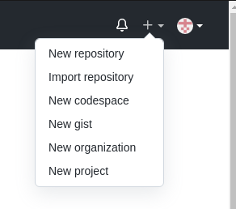

* Now, enter the repository name and create repository.

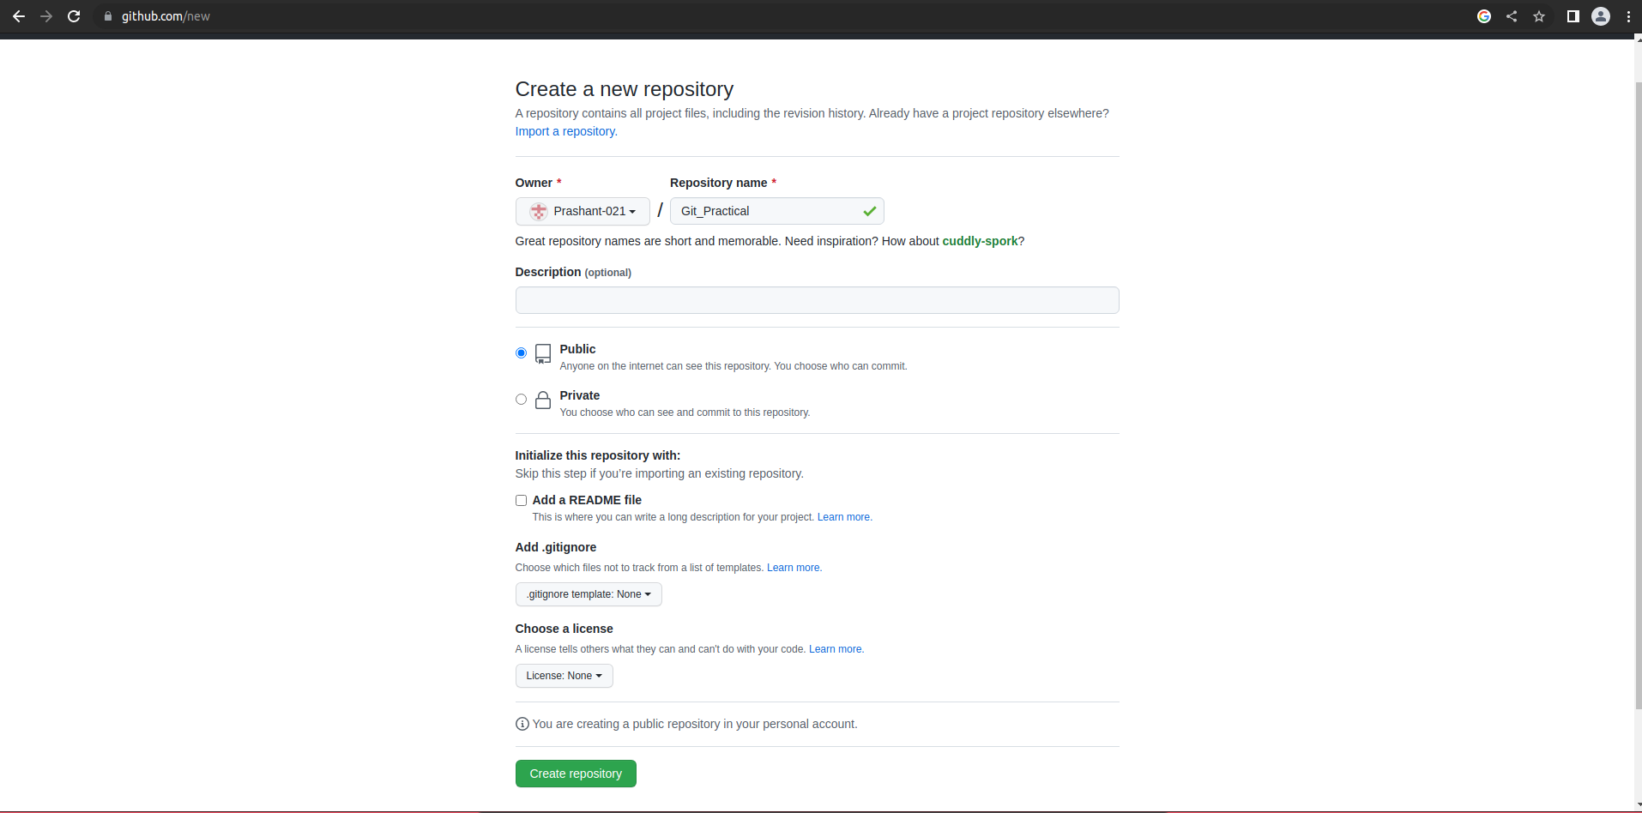

* New repository is created

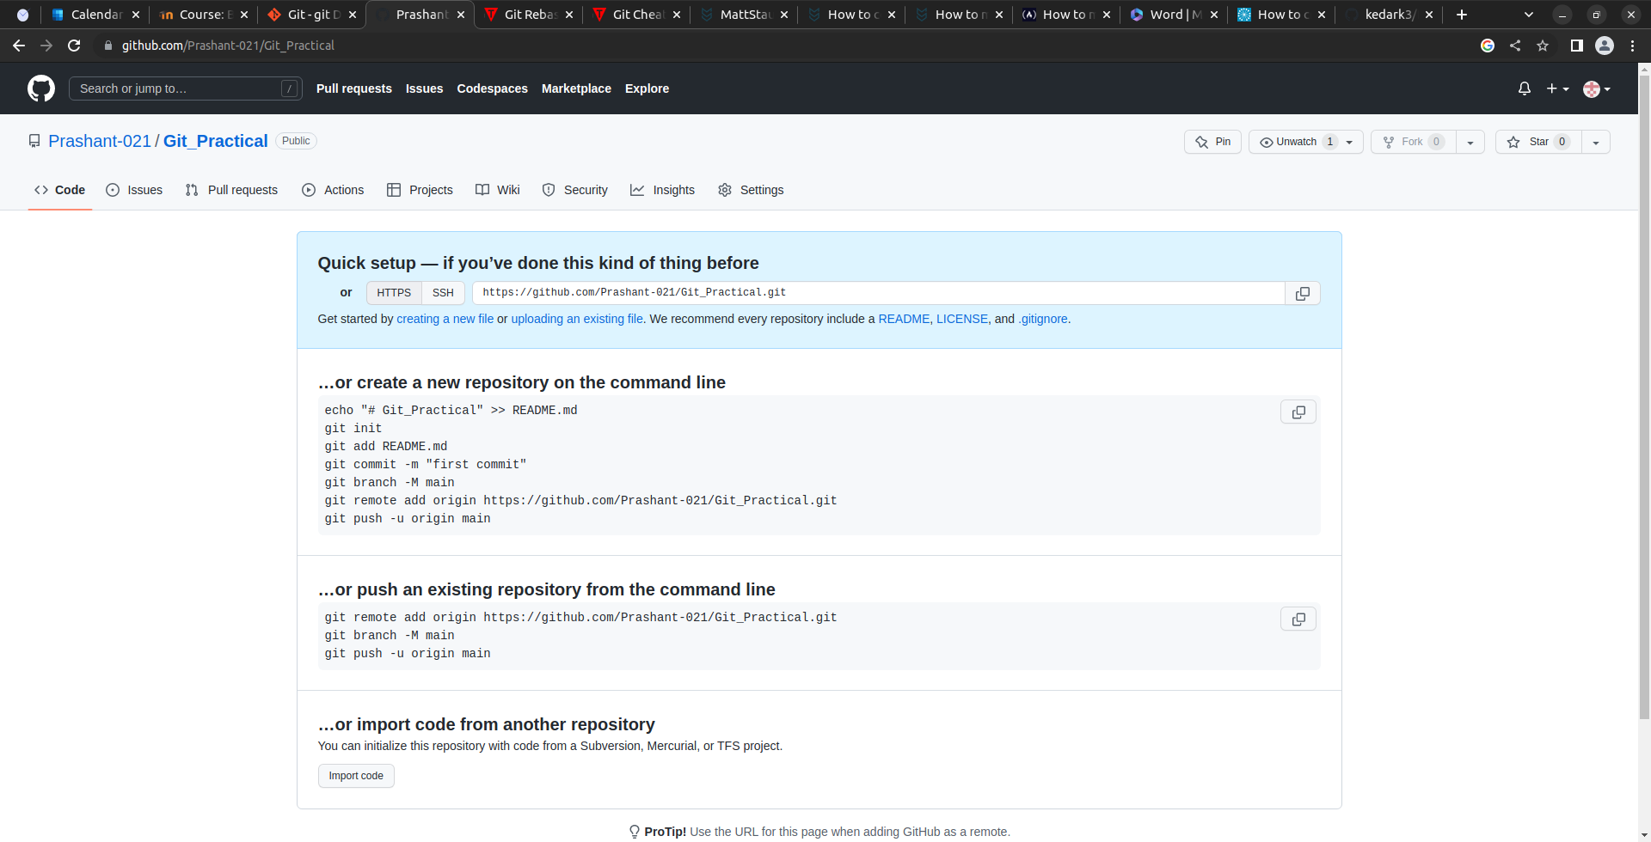

**Git Setup in Editor**

* Open an empty folder in VScode and open new terminal.

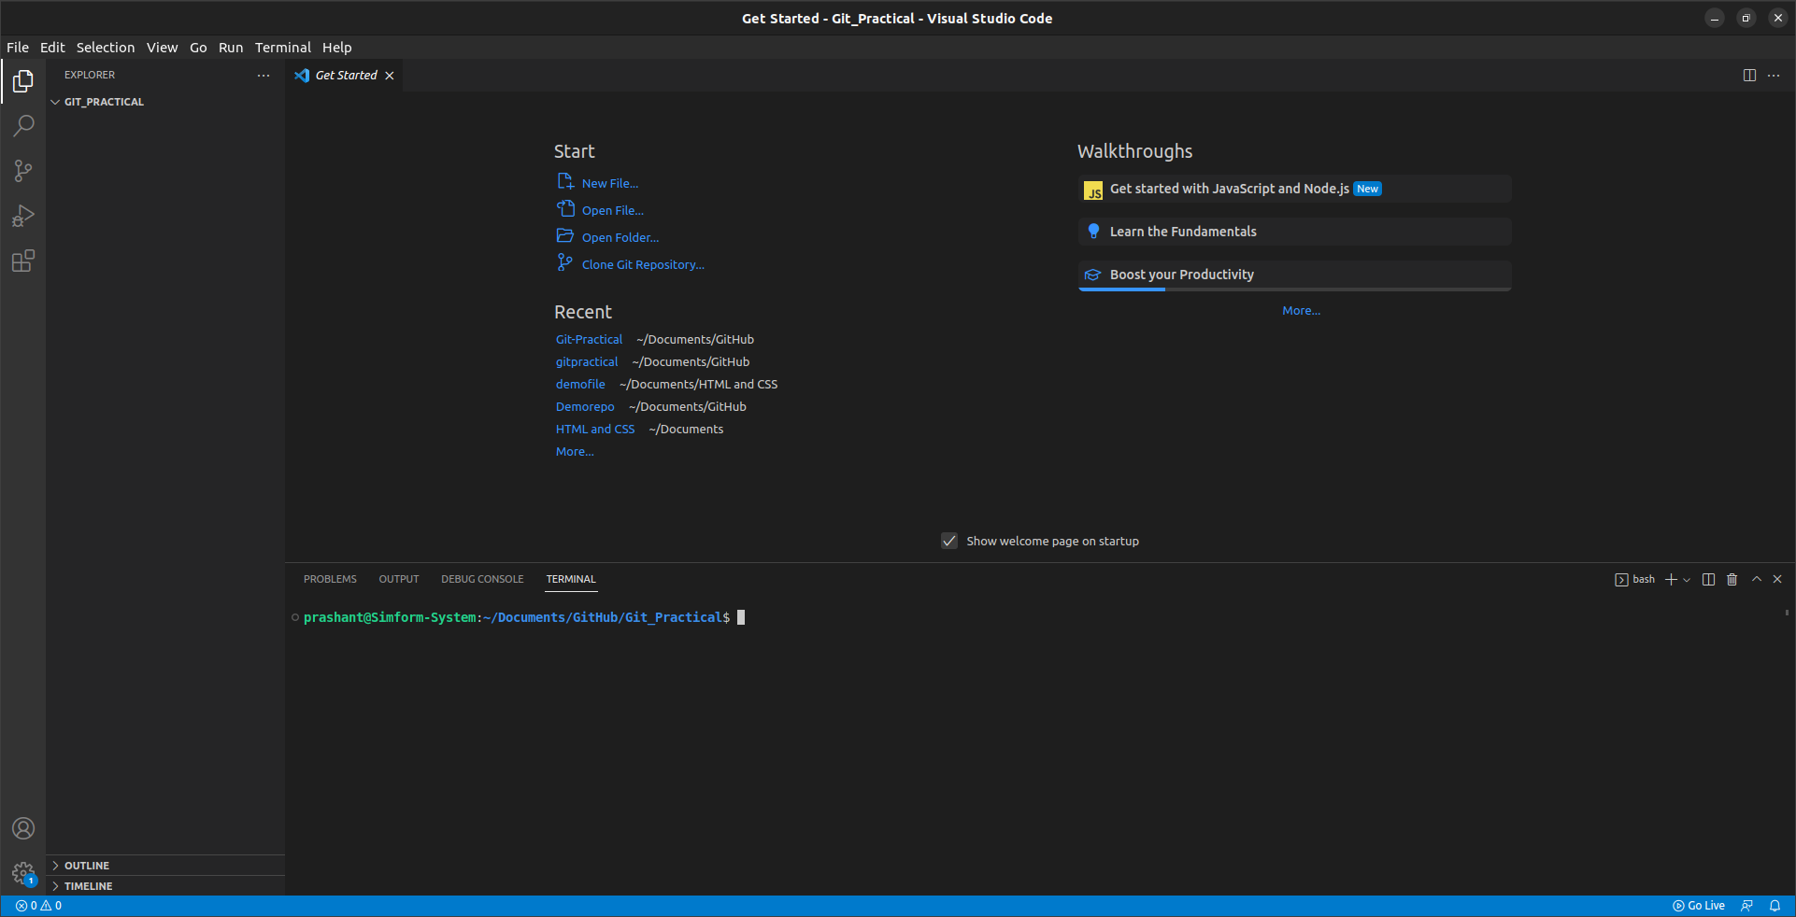

* After that type following commands in terminal:
  + Git init
  + git remote add origin <https://github.com/Prashant-021/Git_Practical.git>
  + Git config –global user.name <name>
  + Git config –global user.email <email>
  + Touch readme.md
  + Git add .
  + Git commit –m “message”
  + Git push –f origin branch name

After typing above commands in terminal repository in terminal and GitHub will look like below.

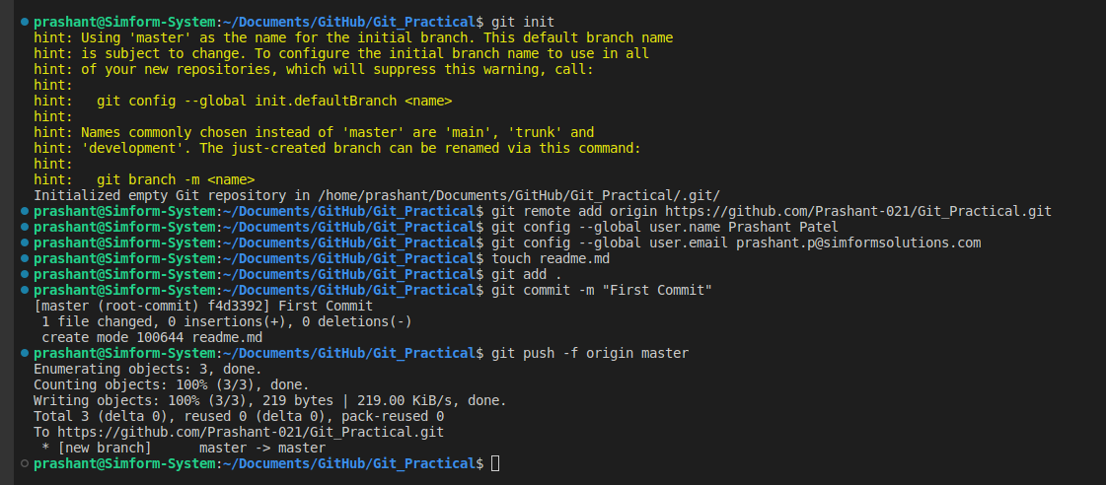

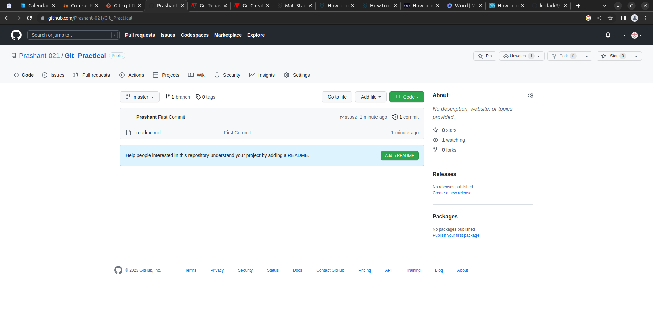

Create new branch and change branch using following commands:

* Git branch “branch name”
* Git checkout “branch name”

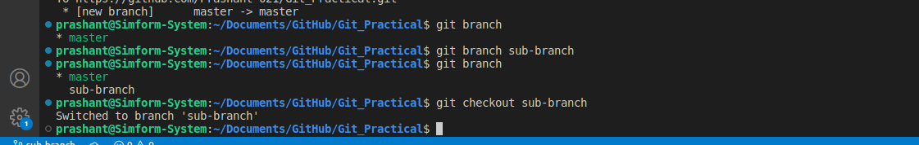

1. **Pull request and Merge branches**

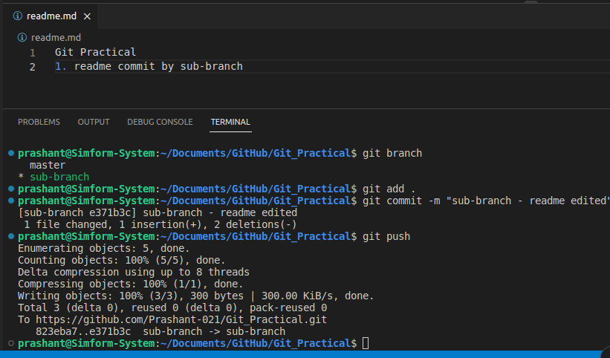

In GitHub repository click on **create pull request**

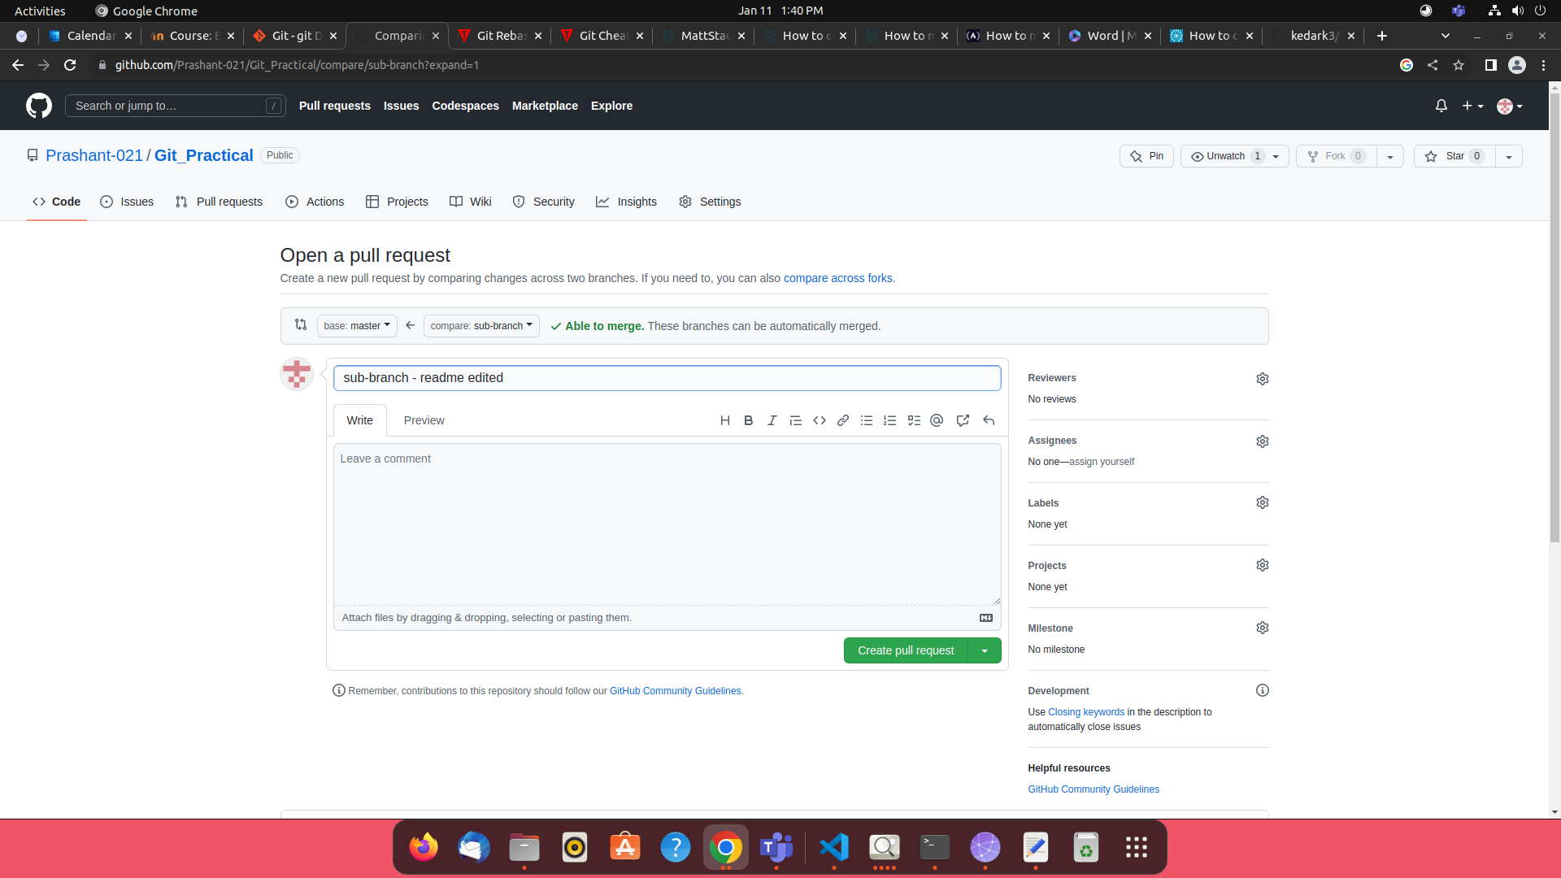

Pull request is generated, then click on **merge pull request**

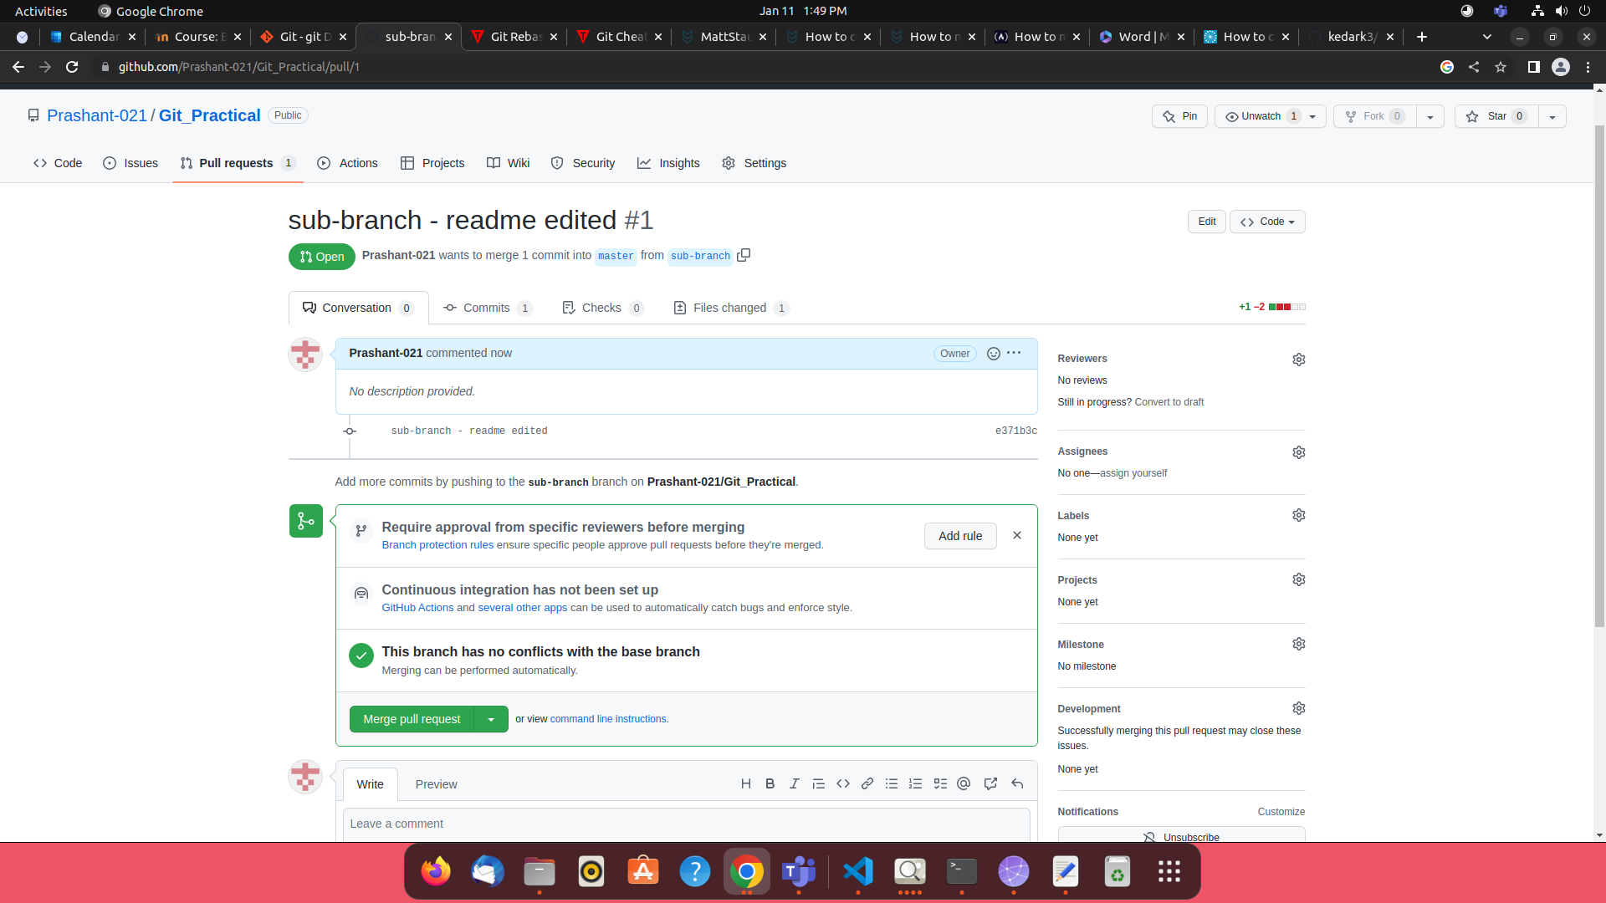

Now, the pull request is merged to master.

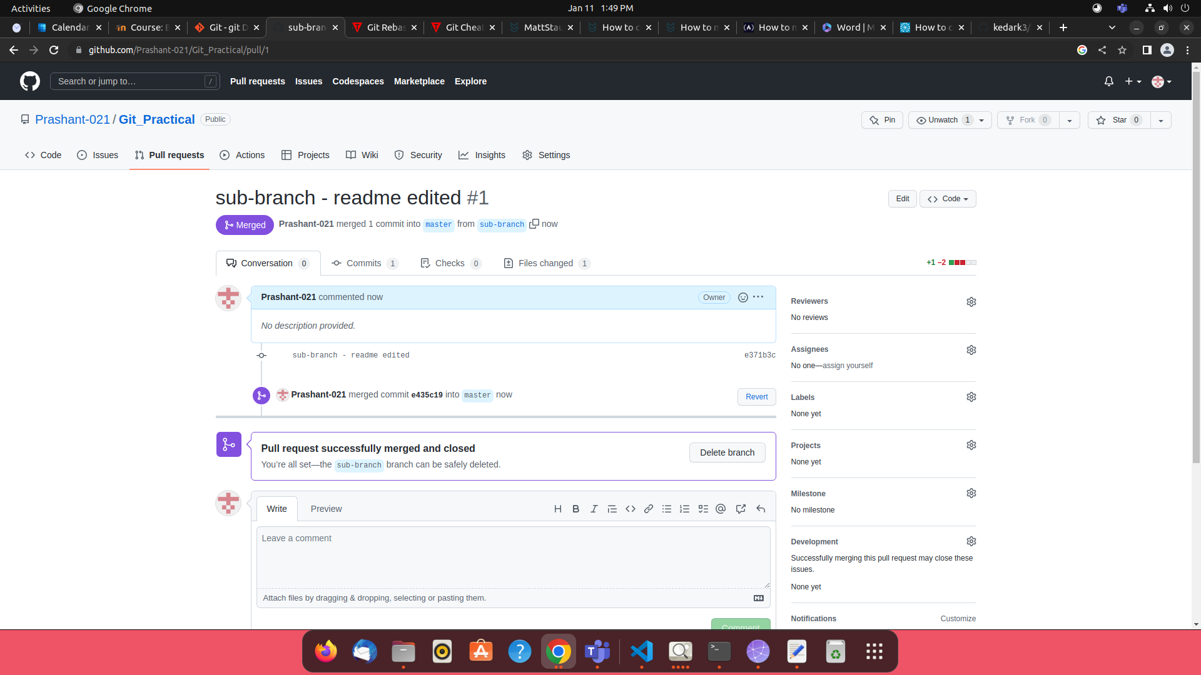

1. **Rebase**

Rebasing is the process of moving or combining a sequence of commits to a new base commit.

Go to the branch which you want to rebase and type command

**git rebase branch name,** here branch name is the branch you want to rebase from

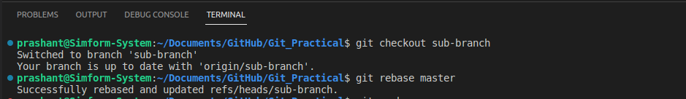

After successfully rebasing the write **git push** command.

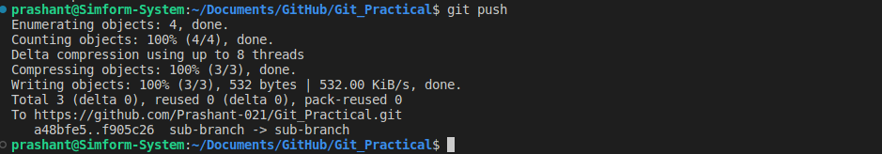

1. **Change commit message**

To get the log of commits type **git log** command.

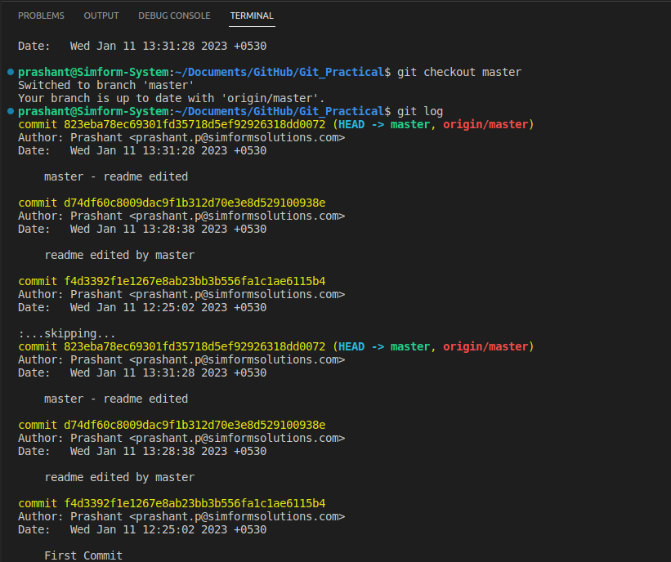

Type **git rebase -I HEAD~nth commit** command in terminal.

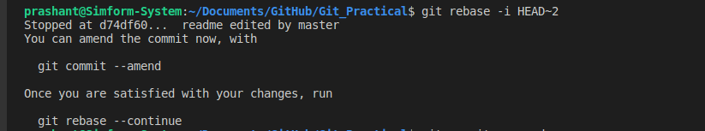

After typing above command all commits till the nth commit enter will be displayed and then change the pick to edit in whichever commit message you want to change and save and exit.

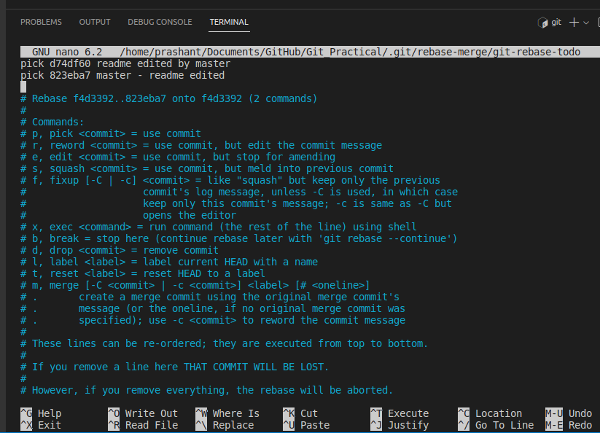

Then, type **git commit –amend** command to change commit message.



Now, change the commit message as per required and then save and exit.

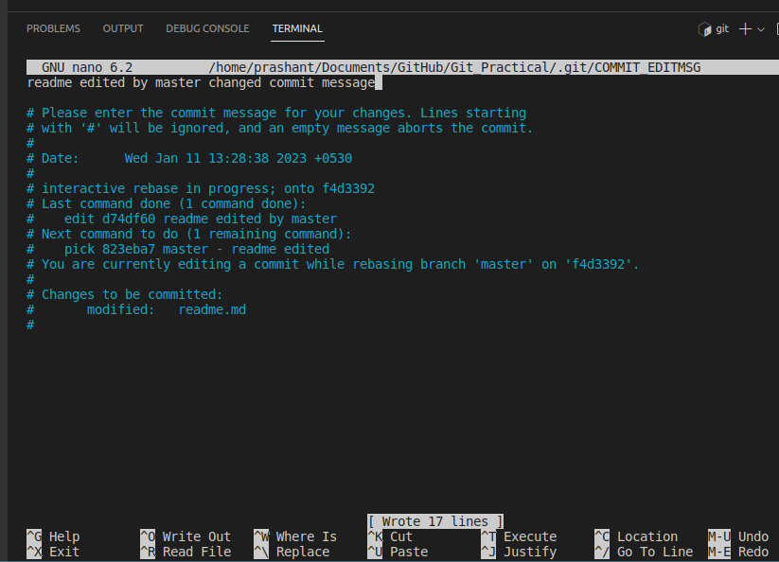

As, below image shows that the commit message is changed.

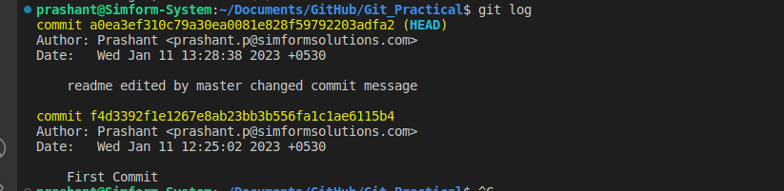

1. **Cherry-pick**

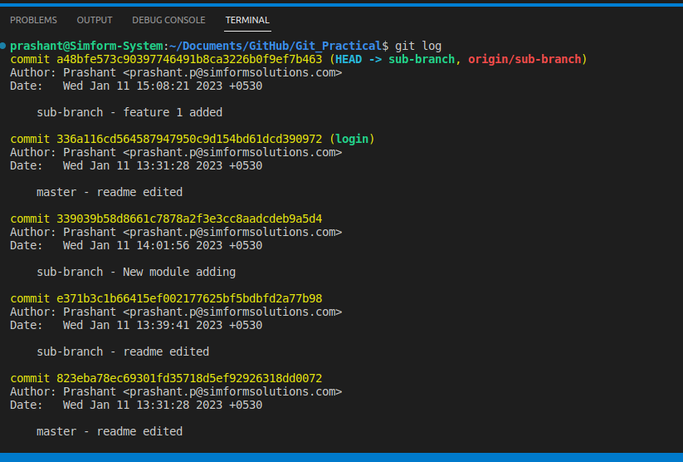

Type **git cherry-pick <<commit address>>** in the terminal.

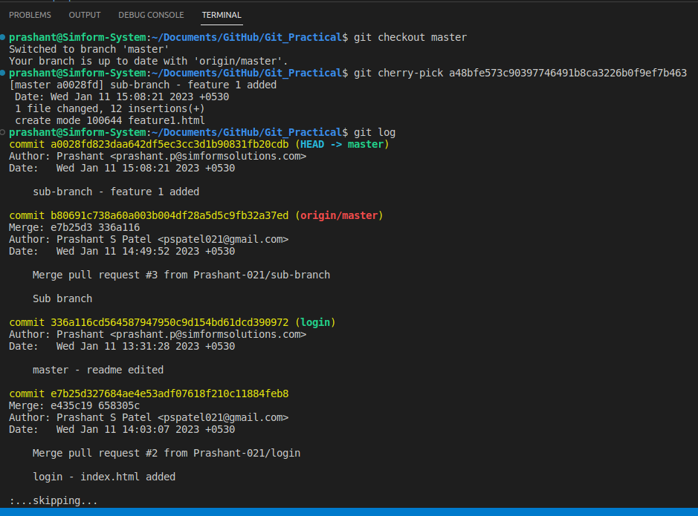

As shown in above image the commit of sub-branch is cherry picked in master branch.

1. **Drop commit**

Type **git rebase -I HEAD~nth commit** command.

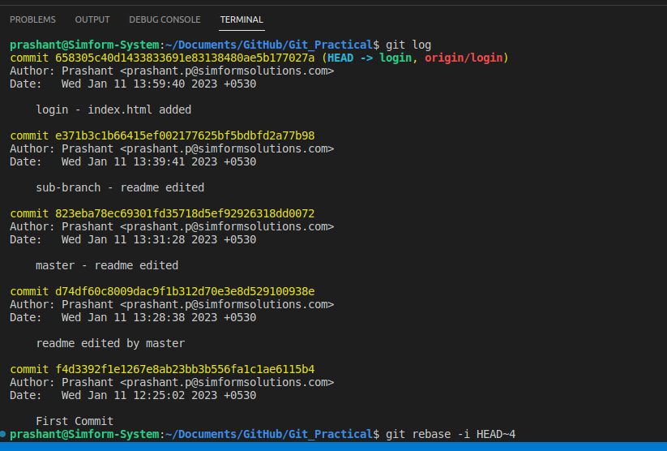

Change the **pick** to **drop** whichever commit you want to drop.

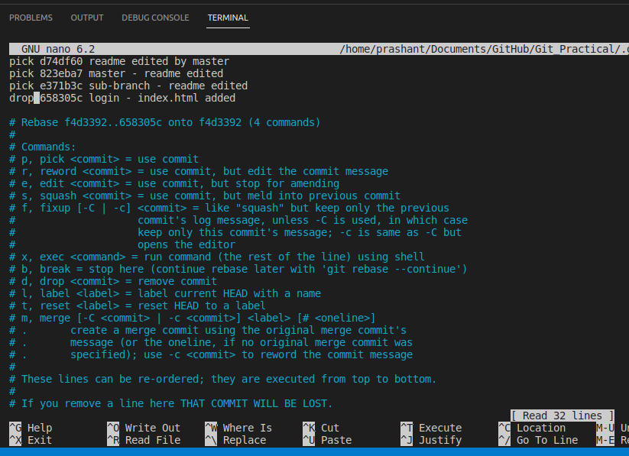

Then type **git log** to check whether the commit is deleted or not.

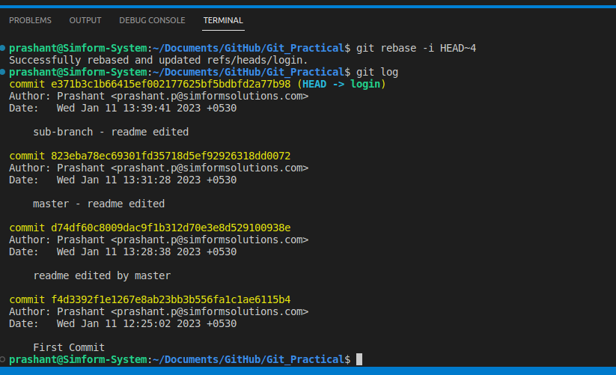

As in above image the commit is deleted with commit address **658305c**