DAY - 1 ( JAN. 6 2025)

TOPICS
- SDLC
- WATERFALL
- DEVOPS
- CI/CD
- SERVERS

FRONTEND | BACKEND
DISPLAYABLE CONTENT | API
 | ROUTES
WEBSOCKET CONNECTIONS (WHS protocol)
- Config. aginess
 | Https (GET, POST, PUT, DELETE)
DB
mongoDB
Postgres
Yugabyte
Maria
Redis
(cache/pub/sub/rabbiting)
messaging

# SDLC (Software Development Life Cycle)

- Client —-> Software (app, Website) —-> Vendor (WITS)
SDLC refers to the structured process or methodology used for developing software. It outlines the stages that software goes through from initial planning to final deployment and maintenance. The goal is to produce high-quality software that meets or exceeds customer expectations within a specified time frame.
Stages in SDLC:
- Planning: Discuss project requirements, timeline, budget, and resources.
- Design: Define system architecture, technology stack, and design UI/UX.
- Development: Coding of the software according to the design.
- Testing: Identifying bugs, errors, and verifying functionality.
- Deployment: Releasing the software for use in the production environment.
- Maintenance: Ongoing support and updates.

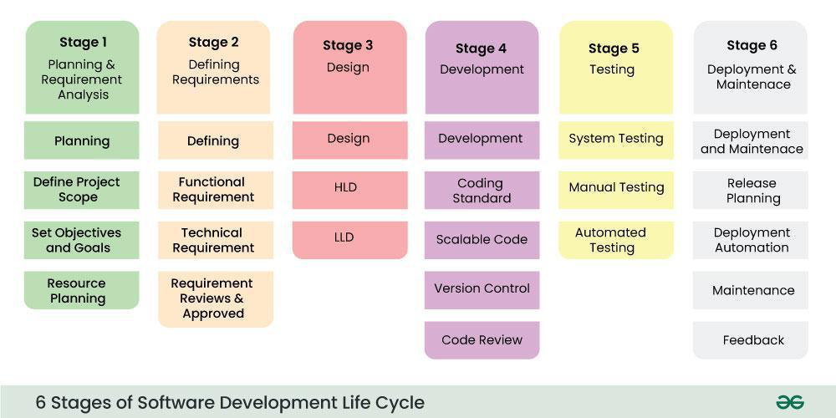

# WaterFall Model
- Here Requirements are already fixed and can not be changed.
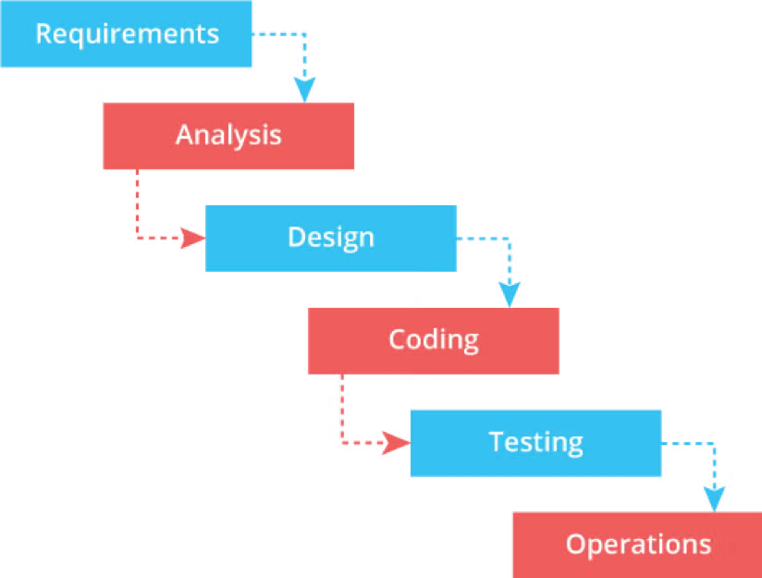

# Agile Methodology
Agile methodology is a project management framework that breaks projects into phases, called sprints, and encourages flexibility and change.

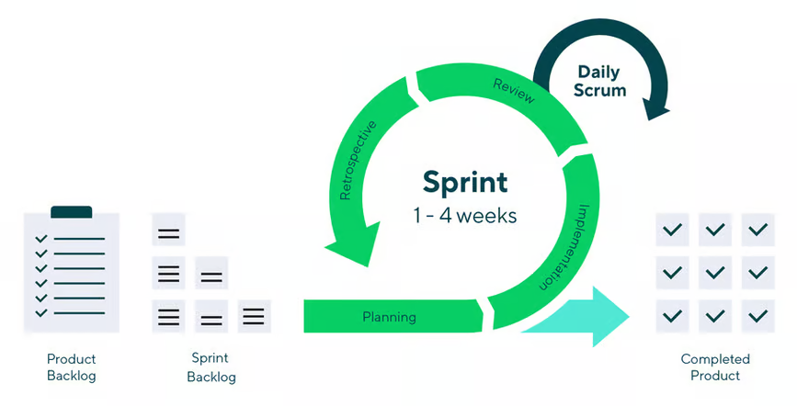

# GCP calculator

Used to calculate pricing of cloud
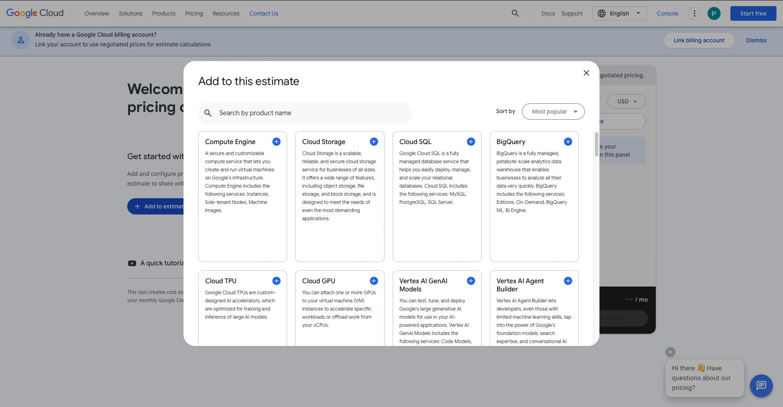

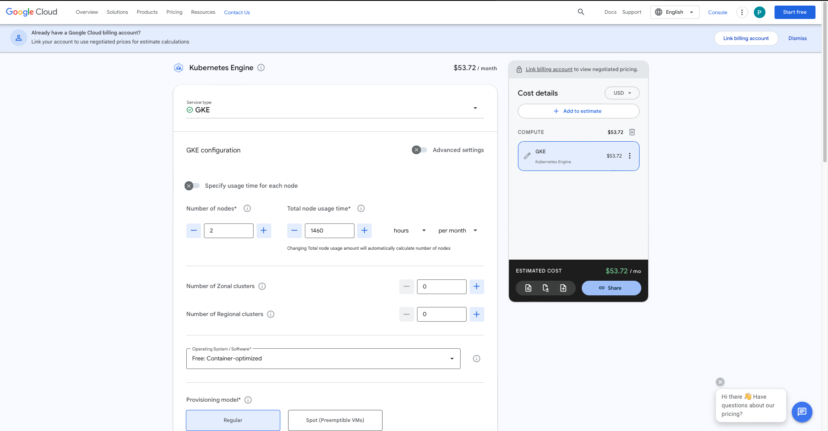

# Implementation

Planning (Discussion)
- Initial meetings and brainstorming sessions to define project requirements.

# Website
Redis
- Chrome
- Keys ( Api/ Developer)

# Testing
Postman
- Status Code
200 OK
300 redirecting
400 Not found/ Forbidden
500 server side error

- Code ✅ (by Developer)

- Lint
- Integration
- Alpha
- Beta
- Gamma
- Selenium (for Java)
- SonarQube
- Jmeter (load testing)

1) Linting
Linting is the process of using a linter tool to automatically analyze code for potential errors, coding style violations, and suspicious patterns. It helps maintain code quality and consistency across a project.
Benefits of Linting:
- Identifies syntax errors or potential bugs early.
- Enforces coding standards for consistency.
- Helps improve code readability and maintainability.
Popular Linters:
- ESLint for JavaScript.
- Pylint for Python.
- Rubocop for Ruby.

2) Integration Testing
Integration Testing involves testing the interactions between different modules or components of a system. Its goal is to ensure that the components work together as expected.
Key Points:
- Ensures that the integration points between components (e.g., databases, APIs, external services) function correctly.
- Typically done after unit testing (which focuses on individual components).
- Integration tests can be automated using tools like JUnit, TestNG, or Postman.

3) Alpha Testing
Alpha Testing is the first phase of user acceptance testing, usually done by internal developers or QA teams before releasing the product to external users.
Key Characteristics:
- Conducted in a controlled environment (e.g., development or staging server).
- Focuses on identifying major issues and bugs.
- Often involves direct feedback from developers or key stakeholders.
- Often includes a small group of end users or "power users" who test the system in a real-world scenario.

4) Beta Testing
Beta Testing is the second phase of user acceptance testing, where the software is released to a limited group of external users outside the development team. The goal is to gather feedback from real users and identify any remaining bugs.
Key Characteristics:
- Performed after alpha testing.
- The product is generally feature-complete but may still have minor issues.
- The testing environment is closer to the production environment.
- Feedback gathered from beta testers is used to make final adjustments before the software’s public release.

5) Gamma Testing
Gamma Testing is often considered the final phase of testing before the product’s release to the general public. It is typically performed in live or production-like environments.
Key Characteristics:
- Focuses on performance, security, and scalability under real-world conditions.
- It often involves monitoring the software for a longer period of time to ensure it behaves well in diverse conditions.
Note: Some might use Gamma testing interchangeably with Beta Testing in some contexts, but it generally involves more live feedback and post-deployment stress testing.

6) Selenium (for Java)
Selenium is a widely used tool for automating web browsers. It can simulate user interactions with web applications and verify their behavior, making it ideal for functional and regression testing.
Key Features:
- Supports multiple programming languages (e.g., Java, Python, Ruby, C#).
- Can be used to test web applications across different browsers (Chrome, Firefox, Edge, etc.).
- Integrates well with tools like TestNG, JUnit, and CI/CD pipelines for automated testing.
Use Cases:
- Automating repetitive test cases (e.g., form submissions, login/logout functionality).
- Validating UI elements like buttons, links, and inputs.
- End-to-end testing (E2E) for full application flow.

7) SonarQube
SonarQube is a tool that continuously inspects the code quality and security of applications. It provides static code analysis to detect code smells, bugs, vulnerabilities, and maintainability issues.
Key Features:
- Supports multiple programming languages (Java, JavaScript, C#, Python, etc.).
- Detects potential vulnerabilities and code smells (e.g., duplicated code, unused variables).
- Integrates with build systems like Jenkins, GitLab CI, and others.
- Provides a dashboard with detailed reports on code quality metrics.

8) JMeter (Load Testing)
JMeter is a tool designed for performance and load testing of web applications. It simulates heavy loads (e.g., hundreds or thousands of virtual users) to test how well the application performs under stress.
Key Features:
- Supports load testing, stress testing, and performance testing.
- Can be used to test web servers, databases, and other server-side applications.
- Provides detailed reports on response times, throughput, and error rates.
Common Use Cases:
- Testing how an application handles high traffic (e.g., during a product launch).
- Identifying bottlenecks and performance issues.
- Stress testing to see the breaking point of a system.

Summary of Tools and Concepts
Tool | Purpose | Use Case
Postman | API Testing | Send requests to APIs and inspect responses.
Lint | Code Quality Check | Ensures coding standards and syntax correctness.
Integration | Module Interactions Testing | Validates interaction between components or modules.
Alpha Testing | Early User Testing (Internal) | Detects major issues and gathers feedback.
Beta Testing | External User Testing (Pre-release) | Finds bugs and gathers feedback from real users.
Gamma Testing | Final Testing before Production Release | Focuses on performance, scalability, and security.
Selenium | Web Browser Automation | Automates repetitive browser-based tests for UI validation.
SonarQube | Static Code Analysis | Detects code quality issues, bugs, and vulnerabilities.
JMeter | Performance/Load Testing | Simulates user traffic to assess system performance.

# Deployment
When the project is ready, it will be deployed to the Gitlab environment.

# DevOps
- DevOps is a set of practices, tools, and cultural philosophies that integrate software development and IT operations.
- The term is a combination of the words "development" and "operations".
Dev
Ops
Configuration (cloud)/ Infra related
(On Premise)

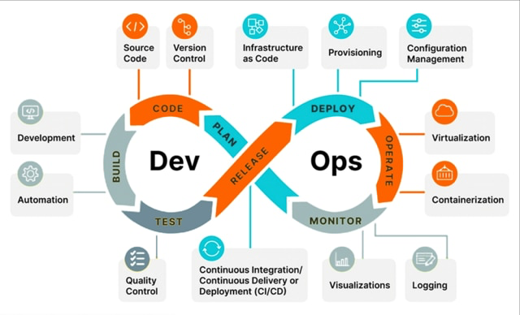
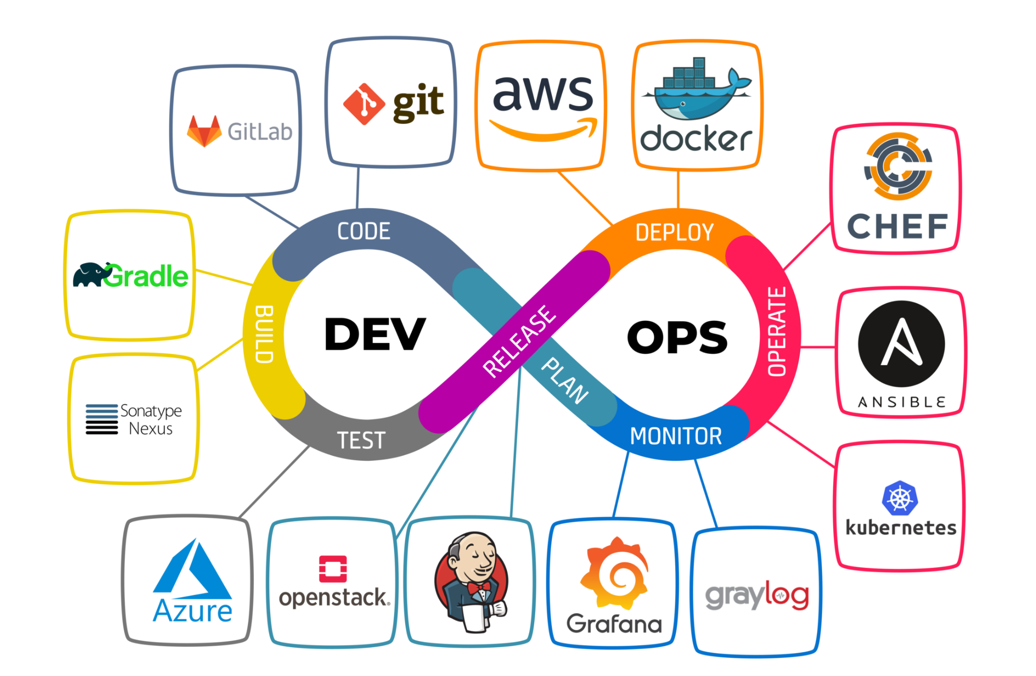

# CI/CD

Build Test Dev Stage Production
←—------------------>
CI
←—------------------------------------------------------------------------------------->
Continuous Delivery
←—------------------------------------------------------------------------------------->
Continuous Deployment

Continuous integration (CI)
Automatically integrates code changes into a shared source code repository. CI servers run builds and automated tests after each code change, providing feedback to address issues.
Continuous delivery (CD)
Automates the delivery of applications to infrastructure environments. CD ensures that software is packaged with everything it needs to deploy to any environment.
Continuous deployment
Automatically releases updates into the production environment. DevOps teams set criteria for code releases ahead of time, and when those criteria are met, the code is deployed.

# Server
- Servers are powerful computers or systems that provide resources, services, or data to other computers (clients) over a network. They play a crucial role in both frontend and backend systems, hosting websites, databases, APIs, etc.

Dev Stage Production
(on premise) ←—------------------------------------->
AWS

- On Premise
- Dev1 (Mac Mini)
- Dev2 (ubuntu)

- Cloud
- GitLab hosting (AWS)
- Runner GCP (Cloud)

# Runner
- A Runner is an environment used to execute CI/CD pipelines.
- Runners can be hosted on-premise or in the cloud, depending on where the code needs to be built, tested, and deployed.

- On premise
- Mac Mini (ios and android running)
- On premise
- Mac Studio
- GCP Cloud (node , frontend, Backend)

# Windows Server
- CRC (California Resource Corporation by Sumit Garg)

