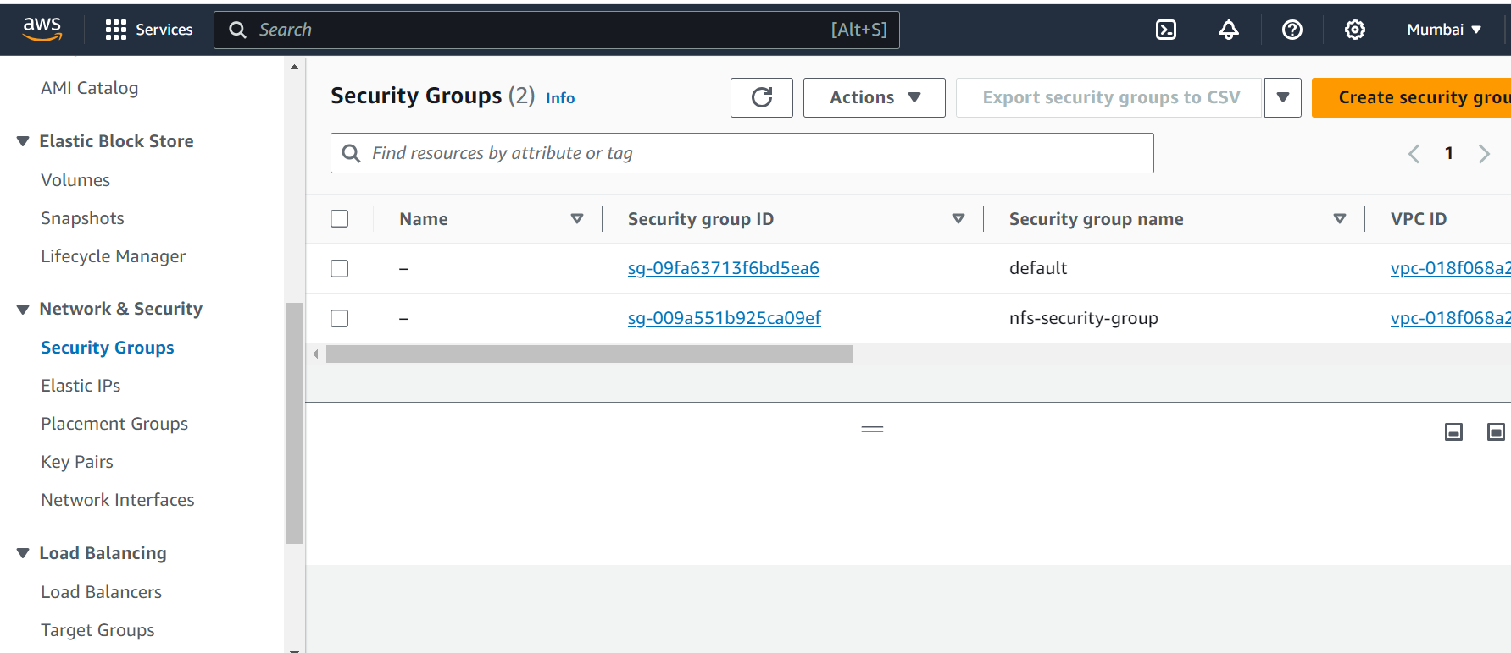

Create Security Group

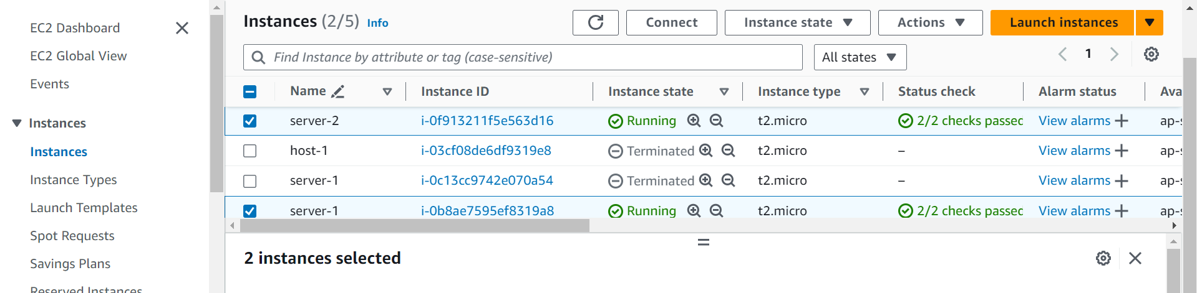

*Create instance in different zone*

*Create file system*

*Add security groups to each zones*

*Install nfs packages on aws service provider*

Check version and make directory

Copy the command

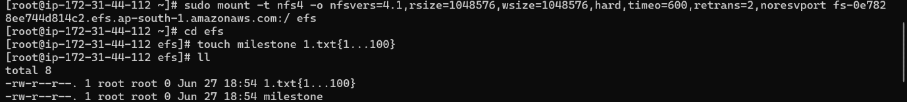Mount Aws file system

Create file

*Install nfs packages on red hat service provider*

Check version and create directory

Here u will see the text file that I have created on another zone