INTRODUCTION

Visual Basic is an interesting topic, which has different types. It has all the methods have their won features with each having merits and demerits which help in data processing. The topic includes their architecture representing the elements involved in it and their action is also specified.

Visual Basic 6.0 allows creating object-oriented applications. Visual Basic 6.0 profoundly concentrates on the Internet development features, Active X technology, enhanced controls, enhanced features of existing control, client/server, new language features development, data access, a few design enhancement etc.,

Relational databases are logical collection of inter-related data in tabular form relational databases have always been core to any management system. Its relevance is profound and hence the need to incorporate new functionalities, utilities becomes important. These are currently the predominant choice in storing financial records manufacturing and logistical information, personnel data and much more.
Relational databases are used in huge management systems like Post Office, Banking, Railway, Defence Logistics. Databases pertaining to Educational Institutions and other large collection of related data.
Relational databases have largely replaced hierarchical databases and network databases because they are easy to understand and use even though they are much less efficient. They have been however challenged by Object Databases and XML databases.
The three leading commercial relational database vendors are Oracle, Microsoft, and IBM.The three leading open Source implementations are MySQL,PostgreSQL, and SQLite.
The softwar components used in our project are as under:
- Microsoft Visual Basic 6.0
- Oracle 9 database

OVERVIEW

A “HOSPITAL MANAGEMENT SYSTEM’’ is a computerized
management system. This management system has been developed to form whole management system including Employees, Doctors (consultants), Nurses, Patients, Bills, and Complains etc. This system also keeps the records of hardware assets besides software of this organization. The proposed system will keep a track of Employees, Doctors, Patients, Accounts and generation of report regarding the present status. This project has GUI based software that will help in storing, updating and retrieving the information through various user-friendly menu-driven modules.

INTRODUCTION

Health of citizen is the wealth of Nation. India has contributed the most ancient Medical science “AYURVEDA” to the world besides other Medical sciences. This field had witnessed a rapid metamorphosis in all of its sections. With immensely increasing advancement in the field of technology, ambit of medical sciences has enlarged making it more sophisticated, diagnosis and cure-oriented. With the advent of 21st century, Health care has become an industry having tremendous potential.
This century witnessed a giant leap in information technology. Computers are not only used to diagnose the illness or for doing surgery with one hundred percent accuracy, but also they are used to increase the efficiency in all fields ranging from fixing the appointment with the Doctor to keeping the record of the Patient.
Software application can provide solution and services for the global health care
industry. By using the cutting edge technologies, Hospital Management can be improved with efficient work flow and communication. Any time any where facilities of the INTERNET have helped the Medical fields to integrate into a single unit. Various Hospitals across the globe can be connected together. They can share information and even services. Details of the Patients, their previous visits etc. are totally not perceptible without a computer. Relevant Informations are always stored in the computer and are available instantly in front of the user.
Medical Transcription, one of the latest technologies in health world provided
with Internet facilities helps patient’s interaction with different Health Experts of
the world for an astute clinical analysis as if treatment is going on at his home and
doorstep.

OBJECTIVES OF THE PROJECT

The project “Hospital Management System” is aimed to develop to maintain
the day-to-day state of admission/discharge of Patients, List of Doctors (Consultants), List of medicines, Bills etc.
There are following main objectives of the Hospital:

- Keeping records of admission of patient.

- Keeping patient-care as utmost priority.

- Scheduling the appointment of Patient with Doctor (Consultant) to make
it convenient for both.

- Scheduling the services of specialized Doctor (Consultant) and emergency
properly so that facilities provided by Hospital are fully utilized in effective and efficient manner.

- Keeping records of Medicine department in a meticulously arranged order so that the treatment of Patient becomes quick and satisfactory.

- Keeping details about the consultants, their Prescriptions and treatments, surgery reports etc.

- Keeping the best laboratory facilities and diagnostic tools for early and clear Diagnosis of the disease and early cure and disposal of the patient.

- Keeping explicit details about the patient’s diseases, diagnosis and management for comprehensive research.

- Keeping the records of salary structure of the employees of Hospital by billing
approach.

E-R DIAGRAM

CONVERTING ER DIAGRAM INTO TABLES

- Converting strong entity types

    - Each single valued attribute becomes a column
    - Derived attributes are ignored
    - Composite attributes are represented by components
    - Each entity type becomes a table
    - Multi-valued attributes are represented by a separate table
    - Key attributes of the entity type is the Primary Key

PATIENT_IDD
PAT_NAME
D_O_B
DEPT_ID
BLD_GRP
PHN_NO
FATHERS_NAME
DOC_FEE
SEX
PATIENT

- Converting weak entity types
- Converting relationships
Relationships are based on cardinalities and degree of the relation
- Binary n:1
IS APPOINTED
PATIENT
DOCTORS

so from this relation 1:n two separate tables will be formed named as doctor and patient and they will be joined by a foreign key dept_id.

- Binary 1:1
TRANSACTS
PATIENT
BILL
1
1

- Binary m:n

IS APPOINTED
PATIENT
DOCTOR
M
N

TABLE STRUCTURES

The structure of all tables included in the project is as under:-

1.PATIENT
Name Null? Type
----------------------------------------- -------- ----------------------------
*PATIENT_ID NOT NULL NUMBER(10)
PAT_NAME NOT NULL VARCHAR2(20)
D_O_B NOT NULL DATE
DOC_FEE NOT NULL VARCHAR2(10)
FATHERS_NAME NOT NULL VARCHAR2(20)
PHN_NO NOT NULL NUMBER(11)
BLD_GRP NOT NULL VARCHAR2(5)
$ DEPT_ID NOT NULL NUMBER(10)
SEX NOT NULL VARCHAR2(10)

CONSTRAINTS:
SQL> select column_name,constraint_name,position from User_cons_columns WHERE TABLE_NAME='PATIENT';
COLUMN_NAME
----------------------------------------------------------------------------------------------------
CONSTRAINT_NAME POSITION
------------------------------ ----------
PATIENT_ID
PATPK 1
DEPT_ID
PATFK 1

2.DOCTOR
Name Null? Type
----------------------------------------- -------- ----------------------------
DOCT_NAME NOT NULL VARCHAR2(25)
QUALIFICATION NOT NULL VARCHAR2(15)
D_O_B NOT NULL DATE
SALARY NOT NULL VARCHAR2(8)
FATHERS_NAME NOT NULL VARCHAR2(20)
PHN_NO NOT NULL NUMBER(11)
EMAIL_ID NOT NULL VARCHAR2(25)
*DOCTOR_ID NOT NULL NUMBER(10)
$ DEPT_ID NOT NULL NUMBER(10)

CONSTRAINTS:
SQL> select column_name,constraint_name,position from User_cons_columns WHERE TABLE_NAME='DOCTOR';
COLUMN_NAME
---------------------------------------------------------------------------------------------------
CONSTRAINT_NAME POSITION
------------------------------ ----------
DOCTOR_ID
DOCPK 1

DEPT_ID
DOCFK 1

3 . NURSE
Name Null? Type
----------------------------------------- -------- ----------------------------
NUR_NAME NOT NULL VARCHAR2(20)
QUALIFICATION NOT NULL VARCHAR2(20)
D_O_B NOT NULL DATE
SALARY NOT NULL VARCHAR2(8)
FATHERS_NAME NOT NULL VARCHAR2(20)
*NUR_ID NOT NULL NUMBER(10)
$DEPT_ID NOT NULL NUMBER(10)

CONSTRAINTS:
SQL> select column_name,constraint_name,position from User_cons_columns WHERE TABLE_NAME='NURSE';
COLUMN_NAME
-------------------------------------------------------------------------------------------------
CONSTRAINT_NAME POSITION
------------------------------ ----------
NUR_ID
NURPK 1
DEPT_ID
NURFK 1

- DEPARTMENT

Name Null? Type
----------------------------------------- -------- ----------------------------
*DEPT_ID NOT NULL NUMBER(10)
DEPT_NAME NOT NULL VARCHAR2(20)
DEPT_DOCTOR NOT NULL VARCHAR2(20)
DEPT_HEAD NOT NULL VARCHAR2(20)
DEPT_SALARY NOT NULL VARCHAR2(10)
PHN_NO NOT NULL NUMBER(11)

CONSTRAINTS:
SQL> select column_name,constraint_name,position from User_cons_columns WHERE TABLE_NAME='DEPARTMENT';
COLUMN_NAME
-------------------------------------------------------------------------------------------------------
CONSTRAINT_NAME POSITION
------------------------------ ----------
DEPT_ID
DEPTPK 1

5.BILL
Name Null? Type
----------------------------------------- -------- ----------------------------
* BILL_NO NOT NULL VARCHAR2(10)

$PATIENT_ID NOT NULL NUMBER(10)

MED_AMT NOT NULL NUMBER(10)

DIAGNOSIS_FEE NOT NULL NUMBER(10)

DOCT_FEE NOT NULL NUMBER(10)

BILL_DATE NOT NULL DATE

MODE_PAY NOT NULL VARCHAR2(20)

CONSTRAINTS:
SQL> select column_name,constraint_name,position from User_cons_columns WHERE TABLE_NAME='BILL';

COLUMN_NAME
------------------------------------------------------------------------------------------------
CONSTRAINT_NAME POSITION
------------------------------ ----------
BILL_NO
BILLPK 1

PATIENT_ID
BILLFK 1

6.SCHEDULE
Name Null? Type
----------------------------------------- -------- ----------------------------
*$EMP_ID NOT NULL NUMBER(10)
*SHIFT NOT NULL VARCHAR2(20)
*DATES NOT NULL DATE

CONSTRAINTS:
SQL> select column_name,constraint_name,position from User_cons_columns WHERE TABLE_NAME='SCHEDULE';
COLUMN_NAME
-----------------------------------------------------------------------------------------------------
CONSTRAINT_NAME POSITION
------------------------------ ----------
EMP_ID
SCPK 1
SHIFT
SCPK 2
DATES
SCPK 3
EMP_ID
SCFK 1

7.ROOMS
Name Null? Type
----------------------------------------- -------- ----------------------------
*,$PATIENT_ID NOT NULL NUMBER(10)
*BED_NO NOT NULL NUMBER(6)
TYPE CHAR(15)
CHARGES NUMBER(6)
ALLO_DATE DATE

CONSTRAINTS:
SQL> select column_name,constraint_name,position from User_cons_columns WHERE TABLE_NAME='ROOMS';
COLUMN_NAME
--------------------------------------------------------------------------------------------------
CONSTRAINT_NAME POSITION
------------------------------ ----------
PATIENT_ID
RMPK 1
BED_NO
RMPK 2
PATIENT_ID
RMFK 1

8.APPOINTMENT

Name Null? Type
----------------------------------------- -------- ----------------------------
*,$PATIENT_ID NOT NULL NUMBER(10)

*,$DOCTOR_ID NOT NULL NUMBER(10)

*APP_DATE NOT NULL DATE

PRESCRIPTION CHAR(40)

DESCRIPTION VARCHAR2(40)

CONSTRAINTS:
SQL> select column_name,constraint_name,position from User_cons_columns WHERE TABLE_NAME='APPOINTMENT';

COLUMN_NAME
--------------------------------------------------------------------------------------------------------
CONSTRAINT_NAME POSITION
------------------------------ ----------
PATIENT_ID
APPK 1
DOCTOR_ID
APPK 2
APP_DATE
APPK 3
DOCTOR_ID
APFK 1
PATIENT_ID
APPFK 1

9.MEDICINE
Name Null? Type
----------------------------------------- -------- ----------------------------
*MED_CODE NOT NULL NUMBER(10)

MED_NAME NOT NULL VARCHAR2(12)

MANUFACT_NAME NOT NULL VARCHAR2(12)

MFG_DATE NOT NULL DATE

MED_TYPE NOT NULL VARCHAR2(15)

EXP_DATE NOT NULL DATE

BATCH_NO NUMBER(10)

CONSTRAINTS:
SQL> select column_name,constraint_name,position from User_cons_columns WHERE TABLE_NAME='MEDICINE';

COLUMN_NAME
------------------------------------------------------------------------------------------------------
CONSTRAINT_NAME POSITION
------------------------------ ----------
MED_CODE
MEDPK 1

NORMALISATION

Normalisation is a method for organizing data elements in a database into tables.
It keeps track to keep the database less vulnerable to some types of logical inconsistencies and anomalies.Tablescan be normalized to varying degrees like first,second,BCNF.Greater the degree of normalization more is the protected from inconsistencies and anomalies.The tables may be normalized under the following guideline:

- 1NF
DEFINITION:
A relation schema is in 1NF if all of its attributes are:
- Single valued
- Restricted to assuming atomic values
- Functionally dependent on the primary key
All tables follows the above conditions and rules ,so they are in 1NF.All attributes are single valued.

- 2NF

DEFINITION:
A relational table is said to be in second normal form 2NF if it is in 1NF and every non-key attribute is fully functionally dependent upon primary key.
The criteria for second normale form(2NF) are:

- The table must be in !NF.
- Every non-key attributes of the table must be dependent upon the entire primary key.
- In “Patient”,”Doctor”,”Nurse”, tables all the attributes are totally dependent on the dept_id.
- In “Bill” table all attributes are dependent on bill_no.
- So all tables are in 2 NF

- 3NF
DEFINITION:
- A relation is in 3NF if and only if,it is in 2NF and there are no transitive functional dependencies.
- Transitive functional dependencies arise.
- When one non-key attribute is functionally dependent on another non-key attribute.
- Functional Dependency:non-key attribute>non-key attribute.
- When there is redundancy in the database.

“Schedule” table is in 3NF because all the attributes are primary key.
By definition transitive functional dependency can only occur if there is more than one non-key field,so we can say that a relation in 2NF with zero or one non-key field must automatically be in 3NF.All tables are in 3NF too.

CODE

FORM1-ADDDOCTOR
Private Sub doctor()
Set rs = New ADODB.Recordset
rs.CursorType = adOpenDynamic
rs.LockType = adLockOptimistic
rs.Open "doctor", cn, , , adCmdTable
Set rk = rs
Set Text2.DataSource = rk
Text2.DataField = "doct_name"
Set Text4.DataSource = rk
Text4.DataField = "qualification"
Set Text3.DataSource = rk
Text3.DataField = "d_o_b"
Set Text6.DataSource = rk
Text6.DataField = "salary"
Set Text7.DataSource = rk
Text7.DataField = "fathers_name"
Set Text8.DataSource = rk
Text8.DataField = "phn_no"
Set Text9.DataSource = rk
Text9.DataField = "email_id"
Set Text1.DataSource = rk
Text1.DataField = "doctor_id"
Set Text5.DataSource = rk
Text5.DataField = "dept_id"
Set Combo1.DataSource = rk
Combo1.DataField = "SEX"
End Sub
Private Sub cmd2_Click(Index As Integer)
Unload Me
End Sub
Private Sub cmd3_Click(Index As Integer)
On Error GoTo errordesc
rk.MoveFirst
Exit Sub
errordesc:
i = MsgBox(Err.Description, vbCritical)
Call doctor
End Sub
Private Sub cmd4_Click(Index As Integer)
On Error GoTo errordesc
If (rk.EOF = True) Then
rk.MoveFirst
Else
rk.MoveNext
End If
Exit Sub
errordesc:
i = MsgBox(Err.Description, vbCritical)
Call doctor
End Sub
Dim aid As String
aid = InputBox("Enter the doctor id to search", "search", "id")
sqk = "select * from doctor where doctor_id = " & Val(aid)
Set rk = New ADODB.Recordset
Set rs = New ADODB.Recordset
rk.CursorType = adOpenDynamic
rk.LockType = adLockOptimistic
rk.Open sqk, cn, , , adCmdText
rs.CursorType = adOpenDynamic
rs.LockType = adLockOptimistic
rs.Open "doctor", cn, , , adCmdTable
If rk.EOF = True Then
MsgBox " doctor id not exist"
Set rk = rs
End If
Set Text2.DataSource = rk
Text2.DataField = "doct_name"
Set Text4.DataSource = rk
Text4.DataField = "qualification"
Set Text3.DataSource = rk
Text3.DataField = "d_o_b"
Set Text6.DataSource = rk
Text6.DataField = "salary"
Set Text7.DataSource = rk
Text7.DataField = "fathers_name"
Set Text8.DataSource = rk
Text8.DataField = "phn_no"
Set Text9.DataSource = rk
Text9.DataField = "email_id"
Set Text1.DataSource = rk
Text1.DataField = "doctor_id"
Set Text5.DataSource = rk
Text5.DataField = "dept_id"
Set Combo1.DataSource = rk
Combo1.DataField = "SEX"
Exit Sub
errordesc:
i = MsgBox(Err.Description, vbCritical)
Call doctor
End Sub

FORM2-ADDMEDICINES
Private Sub cmd10_Click(Index As Integer)
Dim medicineno As Integer
medicineno = 1
sqk = "SELECT med_code FROM (SELECT med_code FROM medicine ORDER BY med_code desc) WHERE ROWNUM <= 1 "
Set rk = New ADODB.Recordset
rk.CursorType = adOpenDynamic
rk.LockType = adLockOptimistic
rk.Open sqk, cn, , , adCmdText
medicineno = rk.Fields(0)
Text1.Text = medicineno + 1
rk.Close
Text2.Text = " "
Text3.Text = " "
Text7.Text = " "
Text6.Text = " "
Text5.Text = " "
Text4.Text = " "
End Sub
Private Sub cmd2_Click(Index As Integer)
Unload addmedicines
End Sub
Private Sub cmd3_Click(Index As Integer)
On Error GoTo errordesc
rk.MoveFirst
Exit Sub
errordesc:
i = MsgBox(Err.Description, vbCritical)
Call medicine
End Sub
Private Sub cmd4_Click(Index As Integer)
On Error GoTo errordesc
If (rk.EOF = True) Then
rk.MoveFirst
Else
rk.MoveNext
End If
Exit Sub
errordesc:
i = MsgBox(Err.Description, vbCritical)
Call medicine
End Sub
Private Sub cmd5_Click(Index As Integer)
On Error GoTo errordesc
rk.MoveLast
Exit Sub
errordesc:
i = MsgBox(Err.Description, vbCritical)
Call medicine
End Sub
Private Sub cmd6_Click(Index As Integer)
On Error GoTo errordesc
If (rk.BOF = True) Then
rk.MoveLast
Else
rk.MovePrevious
Exit Sub
errordesc:
i = MsgBox(Err.Description, vbCritical)
Call medicine
End Sub
Private Sub cmd9_Click(Index As Integer)
On Error GoTo errordesc
rk.AddNew
rk.Update
Exit Sub
errordesc:
i = MsgBox(Err.Description, vbCritical)
Call medicine
End Sub
Private Sub medicine()
Set rs = New ADODB.Recordset
rs.CursorType = adOpenDynamic
rs.LockType = adLockOptimistic
rs.Open "medicine", cn, , , adCmdTable
Set rk = rs
Set Text2.DataSource = rk
Text2.DataField = "MED_NAME"
Set Text4.DataSource = rk
Text4.DataField = "MED_TYPE"
Set Text3.DataSource = rk
Text3.DataField = "MANUFACT_NAME"
Set Text6.DataSource = rk
Text6.DataField = "MFG_DATE"
Set Text7.DataSource = rk
Text7.DataField = "EXP_DATE"
Set Text1.DataSource = rk
Text1.DataField = "MED_CODE"
Set Text5.DataSource = rk
Text5.DataField = "batch_no"
End Sub

FORM3-ADDMISSIONPATIENT
Dim flag As Integer
Private Sub patient()
Set rs = New ADODB.Recordset
rs.CursorType = adOpenDynamic
rs.LockType = adLockOptimistic
rs.Open "patient", cn, , , adCmdTable
Set rk = rs
Set Text1.DataSource = rk
Text1.DataField = "patient_id"
Set Text2.DataSource = rk
Text2.DataField = "pat_name"
Set Combo2.DataSource = rk
Combo2.DataField = "sex"
Set Text4.DataSource = rk
Text4.DataField = "doc_fee"
Set Text5.DataSource = rk
Text5.DataField = "fathers_name"
Set Text6.DataSource = rk
Text6.DataField = "phn_no"
Set Text8.DataSource = rk
Text8.DataField = "dept_id"
Set Text9.DataSource = rk
Text9.DataField = "d_o_b"
Set Text10.DataSource = rk
Text10.DataField = "disease"
End Sub
Private Sub cmd10_Click(Index As Integer)
Dim patientno As Integer
patientno = 1
sqk = "SELECT patient_id FROM (SELECT patient_id FROM patient ORDER BY patient_id desc) WHERE ROWNUM <= 1 "
Set rk = New ADODB.Recordset
rk.CursorType = adOpenDynamic
rk.LockType = adLockOptimistic
rk.Open sqk, cn, , , adCmdText
patientno = rk.Fields(0)
Text1.Text = patientno + 1
rk.Close
Text2.Text = " "
Text8.Text = " "
Text9.Text = " "
Combo2.Text = " "
Text6.Text = " "
Text5.Text = " "
Text4.Text = " "
End Sub
errordesc:
i = MsgBox(Err.Description, vbCritical)
Call patient
End Sub
Private Sub cmd9_Click(Index As Integer)
Unload Me
End Sub
Private Sub Text1_LostFocus()
Dim aid As Integer
Dim z As Integer
aid = Text1.Text
sqk = "select * from patient where patient_id= " & Val(aid)
Set rs = New ADODB.Recordset
rs.CursorType = adOpenDynamic
rs.LockType = adLockOptimistic
rs.Open sqk, cn, , , adCmdText
If (rs.EOF = True) Then
Else
z = rs.Fields(0)
End If
If (z = aid) Then
MsgBox "Enter Different Id, this id already exist!!........"
Text1.Text = ""
Text1.SetFocus
End If
End Sub
FORM5-APPOINTMENT
Private Sub Command1_Click()
Set rk = New ADODB.Recordset
rk.CursorType = adOpenDynamic
rk.LockType = adLockOptimistic
rk.Open "appointment", cn, , , adCmdTable
rk.AddNew
rk.Fields(0) = Text1.Text
rk.Fields(1) = Text2.Text
rk.Fields(2) = Text3.Text
rk.Fields(3) = Text5.Text
rk.Update
Unload Me
End Sub
Private Sub Form_Load()
On Error Resume Next
Text1.Text = addmissionpatient.Text1.Text
Set cn = New ADODB.Connection
cn.ConnectionString = "Provider=OraOLEDB.Oracle.1;Password=tiger;Persist Security Info=True;User ID=scott"
cn.CursorLocation = adUseClient
cn.Open
Set rk = New ADODB.Recordset
rk.CursorType = adOpenDynamic
rk.LockType = adLockOptimistic
rk.Open "appointment", cn, , , adCmdTable
MsgBox "loading please wait !!.............. ", , "Loading Message......."
Text3.Text = Date
Set Text2.DataSource = rk
Text2.DataField = "doctor_id"
Set Text5.DataSource = rk
Text5.DataField = "prescription"
End Sub

FORM6-BEDS
Private Sub Command1_Click
Set rs = New ADODB.Recordset
rs.CursorType = adOpenDynamic
rs.LockType = adLockOptimistic
sqk = "select * from rooms"
rs.Open sqk, cn, , , adCmdText
rs.AddNew
rs.Fields(0) = addmissionpatient.Text1.Text
rs.Fields(1) = Text1.Text
rs.Fields(2) = Combo1.Text
rs.Fields(3) = 100
rs.Fields(4) = Date
rs.Update
DataGrid1.Refresh
End Sub
Private Sub Command2_Click()
Unload Me
End Sub
Private Sub Command3_Click()
DataGrid1.Refresh
End Sub
Private Sub Form_Load()
Dim roomno As Integer
roomno = 1
sqk = "SELECT bed_no FROM (SELECT bed_no FROM rooms ORDER BY bed_no desc) WHERE ROWNUM <= 1 "
Set cn = New ADODB.Connection
cn.ConnectionString = "Provider=OraOLEDB.Oracle.1;Password=tiger;Persist Security Info=True;User ID=scott"
cn.CursorLocation = adUseClient
cn.Open
Set rk = New ADODB.Recordset
rk.CursorType = adOpenDynamic
rk.LockType = adLockOptimistic
rk.Open sqk, cn, , , adCmdText
roomno = rk.Fields(0)
Text1.Text = roomno + 1
End Sub

FORM7-DEPARTMENTS
Private Sub department()
Set rs = New ADODB.Recordset
rs.CursorType = adOpenDynamic
rs.LockType = adLockOptimistic
rs.Open "department", cn, , , adCmdTable
Set rk = rs
Set Text1.DataSource = rk
Text1.DataField = "dept_id"
Set Text2.DataSource = rk
Text2.DataField = "DEPT_NAME"
Set Text4.DataSource = rk
Text4.DataField = "DEPT_DOCTOR"
Set Text5.DataSource = rk
Text5.DataField = "DEPT_HEAD"
Set Text6.DataSource = rk
Text6.DataField = "DEPT_SALARY"
Set Text7.DataSource = rk
Text7.DataField = "PHN_NO"
End Sub
Private Sub cmd3_Click(Index As Integer)
On Error GoTo errordesc
rk.MoveFirst
Exit Sub
errordesc:
i = MsgBox(Err.Description, vbCritical)
Call department
End Sub
Private Sub cmd4_Click(Index As Integer)
On Error GoTo errordesc
If rk.EOF = True Then
rk.MoveFirst
End If
rk.MoveNext
Exit Sub
errordesc:
i = MsgBox(Err.Description, vbCritical)
Call department
End Sub
Private Sub cmd6_Click(Index As Integer)
On Error GoTo errordesc
rk.MoveLast
Exit Sub
errordesc:
i = MsgBox(Err.Description, vbCritical)
Call department
End Sub
Private Sub cmd7_Click(Index As Integer)
On Error GoTo errordesc
Set rk = New ADODB.Recordset
rk.CursorType = adOpenDynamic
rk.LockType = adLockOptimistic
sqk = "select * from department "
rk.Open sqk, cn, , , adCmdText
rk.AddNew
rk.Fields(0) = Text1.Text
rk.Fields(1) = Text2.Text
rk.Fields(2) = Text4.Text
rk.Fields(3) = Text5.Text
rk.Fields(4) = Text6.Text
rk.Fields(5) = Text7.Text
rk.Update
Set Text1.DataSource = rk
Text1.DataField = "dept_id"
Set Text2.DataSource = rk
Text2.DataField = "DEPT_NAME"
Set Text3.DataSource = rk
Text3.DataField = "DEPT_SALARY"
Set Text4.DataSource = rk
Text4.DataField = "DEPT_DOCTOR"
Set Text5.DataSource = rk
Text5.DataField = "DEPT_HEAD"
Set Text6.DataSource = rk
Text6.DataField = "DEPT_SALARY"
Set Text7.DataSource = rk
Text7.DataField = "PHN_NO"
rk.MoveFirst
Exit Sub
errordesc:
i = MsgBox(Err.Description, vbCritical)
Call department
End Sub
Private Sub Form_Load()
Set cn = New ADODB.Connection
cn.ConnectionString = "Provider=OraOLEDB.Oracle.1;Password=tiger;Persist Security Info=True;User ID=scott"
cn.CursorLocation = adUseClient
cn.Open
Set rk = New ADODB.Recordset
rk.CursorType = adOpenDynamic
rk.LockType = adLockOptimistic
rk.Open "department", cn, , , adCmdTable
MsgBox "loading please wait !!.............. ", , "Loading Message......."
Set Text1.DataSource = rk
Text1.DataField = "dept_id"
Set Text2.DataSource = rk
Text2.DataField = "DEPT_NAME"
Set Text4.DataSource = rk
Text4.DataField = "DEPT_DOCTOR"
Set Text5.DataSource = rk
Text5.DataField = "DEPT_HEAD"
Set Text6.DataSource = rk
Text6.DataField = "DEPT_SALARY"
Set Text7.DataSource = rk
Text7.DataField = "PHN_NO"
rk.MoveFirst
End Sub
Private Sub cmd2_Click(Index As Integer)
Unload departments
End Sub

FORM8-DISCHARGEPATIENT
Public variable As String
Private Sub patient()
Set rs = New ADODB.Recordset
rs.CursorType = adOpenDynamic
rs.LockType = adLockOptimistic
rs.Open "patient", cn, , , adCmdTable
Set rk = rs
Set Text1.DataSource = rk
Text1.DataField = "patient_id"
Set Text2.DataSource = rk
Text2.DataField = "pat_name"
Set Text3.DataSource = rk
Text3.DataField = "sex"
Set Text4.DataSource = rk
Text4.DataField = "doc_fee"
Set Text5.DataSource = rk
Text5.DataField = "fathers_name"
Set Text6.DataSource = rk
Text6.DataField = "phn_no"
Set Text7.DataSource = rk
Text7.DataField = "bld_grp"
Set Text8.DataSource = rk
Text8.DataField = "dept_id"
Set Text9.DataSource = rk
Text9.DataField = "d_o_b"
Set Text10.DataSource = rk
Text10.DataField = "disease"
End Sub
Private Sub cmd10_Click(Index As Integer)
Text1.Text = " "
Text2.Text = " "
Text3.Text = " "
Text7.Text = " "
Text8.Text = " "
Text9.Text = " "
Text10.Text = " "
Text6.Text = " "
Text5.Text = " "
Text4.Text = " "
End Sub
Private Sub cmd2_Click(Index As Integer)
On Error GoTo errordesc
variable = Text1.Text
Unload Me
transaction.Show
Exit Sub
errordesc:
i = MsgBox(Err.Description, vbCritical)
Call patient
End Sub
Private Sub cmd3_Click(Index As Integer)
On Error GoTo errordesc
rk.MoveFirst
Exit Sub
errordesc:
i = MsgBox(Err.Description, vbCritical)
Call patient
End Sub
Private Sub cmd4_Click(Index As Integer)
On Error GoTo errordesc
If rk.EOF = True Then
rk.MoveFirst

End If
rk.MoveNext
Exit Sub
errordesc:
i = MsgBox(Err.Description, vbCritical)
Call patient
End Sub
Private Sub cmd5_Click(Index As Integer)
On Error GoTo errordesc
rk.MoveLast
Exit Sub
errordesc:
i = MsgBox(Err.Description, vbCritical)
Call patient
End Sub
Private Sub cmd6_Click(Index As Integer)
On Error GoTo errordesc
If (rk.BOF = True) Then
rk.MoveLast
Else
rk.MovePrevious
End If
Exit Sub
errordesc:
i = MsgBox(Err.Description, vbCritical)
Call patient
End Sub

Private Sub cmd8_Click(Index As Integer)
Dim aid As Integer
aid = InputBox("Enter the patientid to search", "search", "id")
sqk = "select * from patient where patient_id= " & Val(aid)
Set rk = New ADODB.Recordset
rk.CursorType = adOpenDynamic
rk.LockType = adLockOptimistic
rk.Open sqk, cn, , , adCmdText
If rk.EOF = True Then
MsgBox " patient id not exist"
Call patient
End If
Set Text1.DataSource = rk
Text1.DataField = "patient_id"
Set Text2.DataSource = rk
Text2.DataField = "pat_name"
Set Text3.DataSource = rk
Text3.DataField = "sex"
Set Text4.DataSource = rk
Text4.DataField = "doc_fee"
Set Text5.DataSource = rk
Text5.DataField = "fathers_name"
Set Text6.DataSource = rk
Text6.DataField = "phn_no"
Set Text7.DataSource = rk
Text7.DataField = "bld_grp"
Set Text8.DataSource = rk
Text8.DataField = "dept_id"
Set Text9.DataSource = rk
Text9.DataField = "d_o_b"
Set Text10.DataSource = rk
Text10.DataField = "disease"
End Sub
Private Sub cmd9_Click(Index As Integer)
Unload Me
End Sub
Private Sub Form_Load()
Set cn = New ADODB.Connection
cn.ConnectionString = "Provider=OraOLEDB.Oracle.1;Password=tiger;Persist Security Info=True;User ID=scott"
cn.CursorLocation = adUseClient
cn.Open
Set rk = New ADODB.Recordset
rk.CursorType = adOpenDynamic
rk.LockType = adLockOptimistic
rk.Open "patient", cn, , , adCmdTable
MsgBox "loading please wait !!.............. ", , "Loading Message......."
Set Text1.DataSource = rk
Text1.DataField = "patient_id"
Set Text2.DataSource = rk
Text2.DataField = "pat_name"
Set Text3.DataSource = rk
Text3.DataField = "sex"
Set Text4.DataSource = rk
Text4.DataField = "doc_fee"
Set Text5.DataSource = rk
Text5.DataField = "fathers_name"
Set Text6.DataSource = rk
Text6.DataField = "phn_no"
Set Text7.DataSource = rk
Text7.DataField = "bld_grp"
Set Text8.DataSource = rk
Text8.DataField = "dept_id"
Set Text9.DataSource = rk
Text9.DataField = "d_o_b"
Set Text10.DataSource = rk
Text10.DataField = "disease"
rk.MoveFirst
End Sub
Private Sub Label2_Click()
End Sub

FORM9-EMPLOYEEATTENDANCE
Private Sub cmd10_Click(Index As Integer)
Text1.Text = ""
Text7.Text = ""
Text5.Text = ""
Text2.Text = ""
Text3.Text = ""
End Sub
Private Sub cmd2_Click(Index As Integer)
Unload employeeattendance
End Sub
Private Sub cmd3_Click(Index As Integer)
On Error GoTo errordesc
rk.MoveFirst
End Sub
Private Sub cmd4_Click(Index As Integer)
If (rk.EOF = True) Then
rk.MoveFirst
Else
rk.MoveNext
End If
var = Text1.Text
sqlcmd = "select * from doctor where doctor_id=" & Val(var)
Set rs = New ADODB.Recordset
rs.CursorType = adOpenDynamic
rs.LockType = adLockOptimistic
rs.Open sqlcmd, cn, , , adCmdText
Set Text2.DataSource = rs
Text2.DataField = "doct_name"
Set Text3.DataSource = rs
Text3.DataField = "dept_id"
End Sub
Private Sub cmd5_Click(Index As Integer)
On Error GoTo errordesc
rk.MoveLast
rk.Update
End Sub
Private Sub cmd6_Click(Index As Integer)
On Error GoTo errordesc
If (rk.BOF = True) Then
rk.MoveLast
Else
rk.MovePrevious
End Sub
Private Sub cmd8_Click(Index As Integer)
Dim aid As String
aid = InputBox("Enter the doctor id to search", "search", "id")
sqk = "select * from doctor where doctor_id = " & Val(aid)
Set rk = New ADODB.Recordset
rk.CursorType = adOpenDynamic
rk.LockType = adLockOptimistic
rk.Open sqk, cn, , , adCmdText
Set Text1.DataSource = rk
Text1.DataField = "EMP_ID"
Set Text7.DataSource = rk
Text7.DataField = "DATES"
Set Text5.DataSource = rk
Text5.DataField = "SHIFT"
Set rs = New ADODB.Recordset
rs.CursorType = adOpenDynamic
rs.LockType = adLockOptimistic
rs.Open sqlcmd, cn, , , adCmdText
Set Text2.DataSource = rs
Text2.DataField = "doc_name"
Set Text3.DataSource = rs
Text3.DataField = "dept_id"
End Sub
Private Sub cmd9_Click(Index As Integer)
rk.AddNew
End Sub
Private Sub Form_Load()
Dim var As String
Set cn = New ADODB.Connection
cn.ConnectionString = "Provider=OraOLEDB.Oracle.1;Password=tiger;Persist Security Info=True;User ID=scott"
cn.CursorLocation = adUseClient
cn.Open
Set rk = New ADODB.Recordset
rk.CursorType = adOpenDynamic
rk.LockType = adLockOptimistic
rk.Open "schedule", cn, , , adCmdTable
MsgBox "loading please wait !!.............. ", , "Loading Message......."
Set Text1.DataSource = rk
Text1.DataField = "EMP_ID"
Set Text7.DataSource = rk
Text7.DataField = "DATES"
Set Combo1.DataSource = rk
Combo1.DataField = "SHIFT"
var = Text1.Text
sqlcmd = "select * from doctor where doctor_id=" & Val(var)
Set rs = New ADODB.Recordset
rs.CursorType = adOpenDynamic
rs.LockType = adLockOptimistic
rs.Open sqlcmd, cn, , , adCmdText
Set Text2.DataSource = rs
Text2.DataField = "doct_name"
Set Text3.DataSource = rs
Text3.DataField = "dept_id"
End Sub

FORM10-FRMLOGIN
Option Explicit
Public LoginSucceeded As Boolean
Private Sub cmdCancel_Click()
LoginSucceeded = False
Me.Hide
End Sub
Private Sub Label2_Click()
If Text1.Text = "" And Text2.Text = "" Then
LoginSucceeded = True
Me.Hide
frmSplash.Show
Else
MsgBox "Invalid Password, try again!", , "Login"
Text2.SetFocus
SendKeys "{Home}+{End}"
End If
End Sub

FORM11-FRMSPLASH
Private Sub Form_Load()
ProgressBar1.Value = ProgressBar1.Min
End Sub
Private Sub Timer1_Timer()
ProgressBar1.Value = ProgressBar1.Value + 10
If ProgressBar1.Value >= ProgressBar1.Max Then
Timer1.Enabled = False
End If
If ProgressBar1.Value = 100 Then
frmSplash.Hide
frmmain.Show
End If
End Sub

FORM12-FRMMAIN
Option Explicit
Public cn As ADODB.Connection
Public cmd1 As String
Public rs As ADODB.Recordset
Public rk As ADODB.Recordset
Public i, j, variable As Integer
Public sqlcmd, sqk, strsql, strname, str1, rate, a, b, c As String
Private Sub about_Click()
frmAbout.Show
End Sub
Private Sub addattendance_Click()
employeeattendance.Show
End Sub
Private Sub adddoctor_Click()
adddoctors.Show
End Sub
Private Sub addworktime_Click()
employeeattendance.Show
End Sub
Private Sub Adodc1_WillMove(ByVal adReason As ADODB.EventReasonEnum, adStatus As ADODB.EventStatusEnum, ByVal pRecordset As ADODB.Recordset)
End Sub
Private Sub deleteattendance_Click()
employeeattendance
End Sub
Private Sub deletedoctor_Click()
removedoctor.Show
End Sub
Private Sub deletemedicine_Click()
addmedicines.Show
End Sub
Private Sub deleteworktime_Click()
employeeworktime.Show
End Sub
Private Sub departmentdetail_Click()
departments.Show
End Sub
Private Sub detail_Click()
reportemployee.Show
End Sub
Private Sub dischargepatient_Click()
dischargpatient.Show
End Sub
Private Sub doctors_Click()
Set cn = New ADODB.Connection
cn.ConnectionString = "Provider=OraOLEDB.Oracle.1;Password=tiger;Persist Security Info=True;User ID=scott"
cn.CursorLocation = adUseClient
cn.Open
Dim aid As String
aid = InputBox("Enter the doctor id to search", "search", "id")
Set rk = New ADODB.Recordset
rk.CursorType = adOpenDynamic
rk.LockType = adLockOptimistic
sqk = " create or replace view reportdoctor as (select e.DOCT_NAME,e. D_O_B,e. SALARY,e.PHN_NO,e.EMAIL_ID,e.DOCTOR_ID,e. SEX,e.DEPT_ID from doctor e where e.doctor_ID = :Val(aid)) "
rk.Open sqk, cn, 2, 3
doctorReport.Show
End Sub
Private Sub exit_Click()
If MsgBox("Do you really want to exit? press yes or no", vbYesNo, "Hospital Management System") = vbYes Then
Unload frmmain
End If
End Sub
Private Sub medicine_Click()
reportmedicine.Show
End Sub
Private Sub patients_Click()
Set cn = New ADODB.Connection
cn.ConnectionString = "Provider=OraOLEDB.Oracle.1;Password=tiger;Persist Security Info=True;User ID=scott"
cn.CursorLocation = adUseClient
cn.Open
Dim aid As String
aid = InputBox("Enter the doctor id to search", "search", "id")
Set rk = New ADODB.Recordset
rk.CursorType = adOpenDynamic
rk.LockType = adLockOptimistic
sqk = " create or replace view report as (select e.PATIENT_ID,e.PAT_NAME,e.DOC_FEE,e.BLD_GRP,e.DISEASE,e.SEX,e.MED_CODE,b.BILL_NO,b.MED_AMT,b.DIAGNOSIS_FEE,b.MODE_PAY from patient e,bill b where e.PATIENT_ID = :aid And b.PAT_ID = : aid )"
rk.Open sqk, cn, 2, 3
PatientReport.Show
End Sub
Private Sub RemoveNurse_Click()
addnurses.Show
End Sub
Private Sub updateattendance_Click()
employeeattendance
End Sub
Private Sub updatedoctor_Click()
removedoctor.Show
End Sub
SNAPSHOTS

1.LOGIN FORM

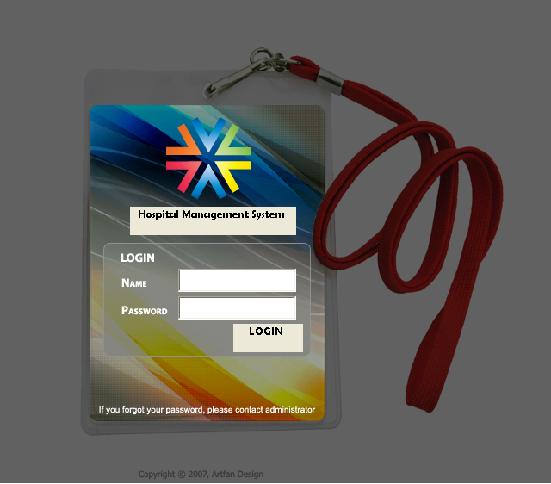
3.ADDPATIENT

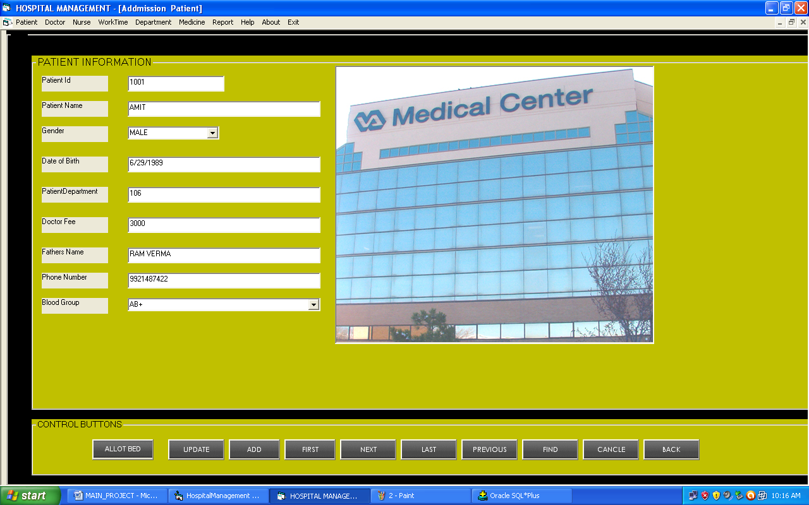

5.EMPLOYEESCHEDULE

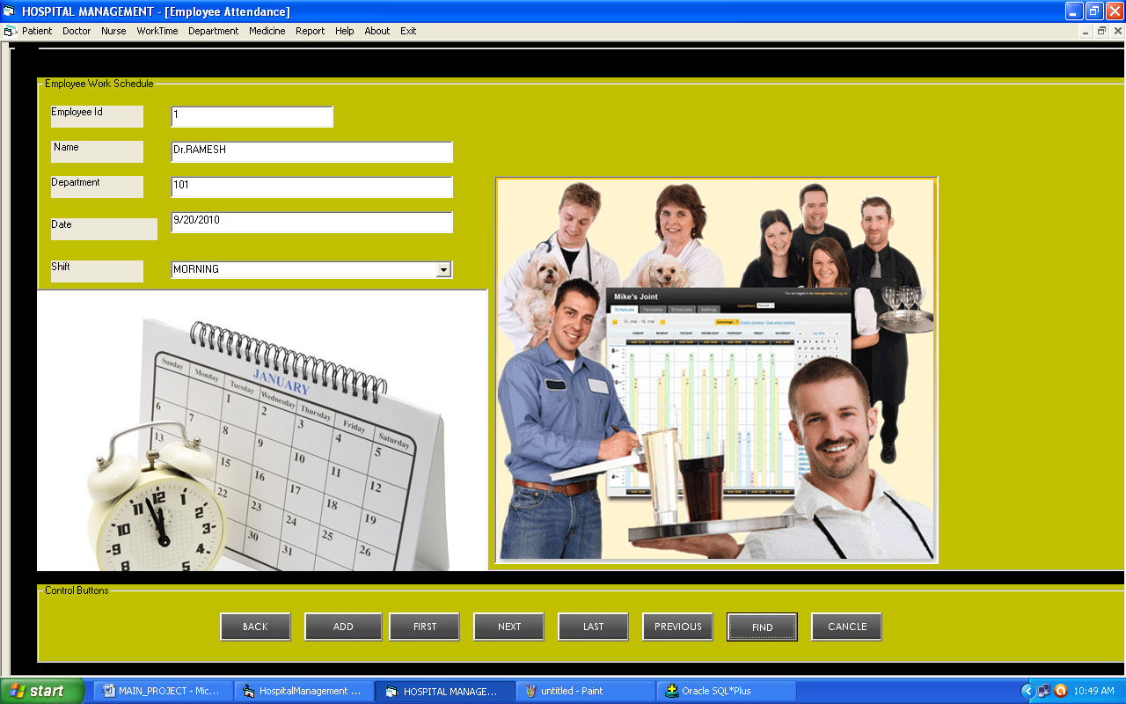

6.DEPARTMENT

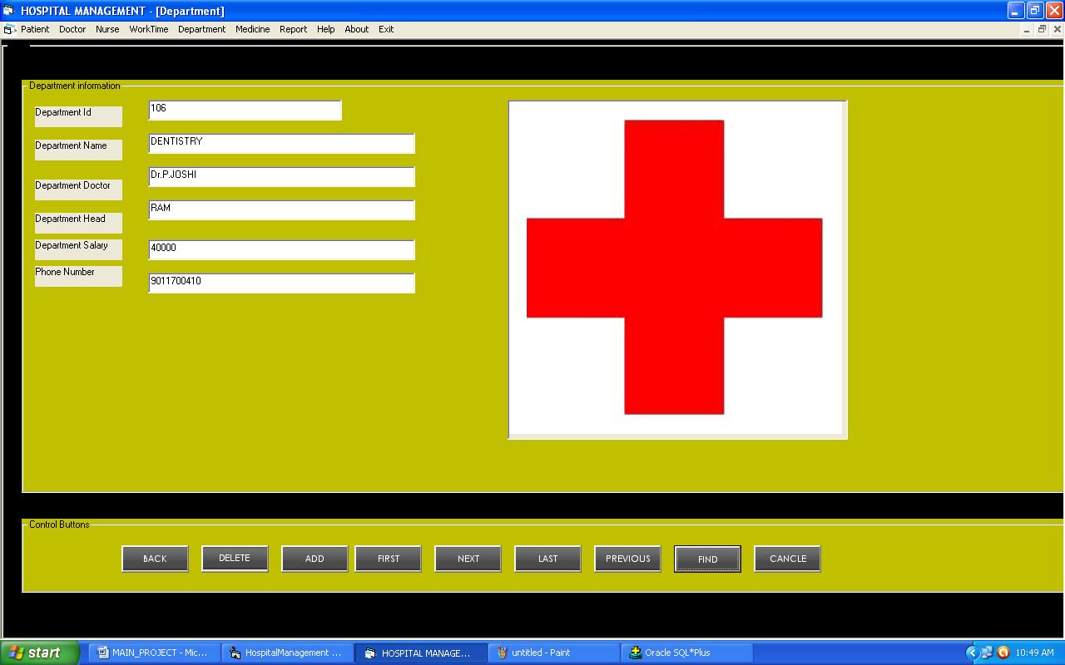

8.SPLASH SCREEN

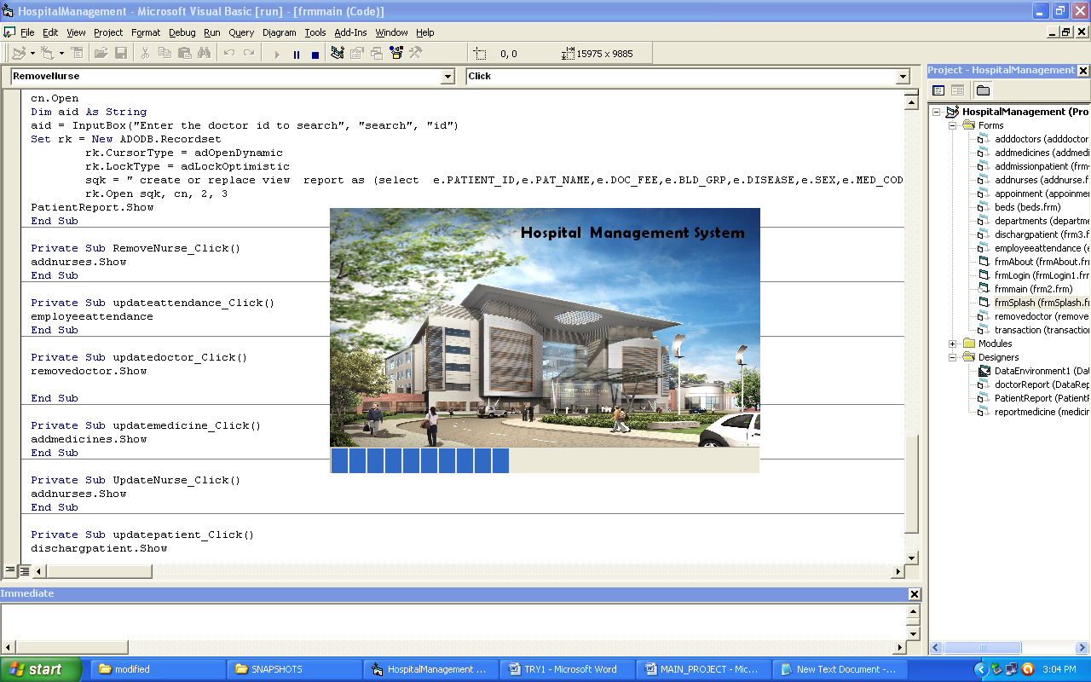

CONCLUSION

A “HOSPITAL MANAGEMENT SYSTEM’’ is a computerized management system.

This management system has been developed to form whole management system including Employees, Doctors (consultants), Nurses, Patients,Bills, and Appointments etc. This system also keeps the records of hardware assets besides software of this organization. The proposed system will keep a track of Employees, Doctors, Patients, Accounts and generation of report regarding the present status.

This project has GUI based software that will help in storing, updating and retrieving the information through various user-friendly menu-driven modules.

A computerized hospital management system has been developed and the system was tested with sample data.

The system results in regular timely preparations of required outputs. In comparison with manual system the benefits under a computer system are considerable in the saving of man power working hours .

Provision for addition and deletion of patients is there in the system it is possible to view that proper filling system has been adopted to slate date for future. The entire project runs on windows environments.

SCOPE OF ENHANCEMENT

The system may be further updated to handle more number of patients efficiently.

