


Module Code & Module Title
CS6P05NI Project
Proposal

5% Individual Coursework
Submission: Final Submission
AY 2025 2026
Academic Semester: Autumn Semester 2025

Credit: 30 Credit Year Long Module

Student Name: Prashant Rijal
London Met ID: 23048683
College ID: np01ai4a230142@islingtoncollege.edu.np
Assignment Due Date: Wednesday, December 3, 2025
Assignment Submission Date: Wednesday, December 3, 2025
Internal Supervisor: Roshan Shrestha
External Supervisor: Samrat Thapa

I confirm that I understand my coursework needs to be submitted online via MST Classroom under the relevant module page before the deadline for my assignment to be accepted and marked. I am fully aware that late submissions will be treated as non-submission and a mark of zero will be awarded.

Table of Contents
1. Introduction 1
1.1. Problem Statement: 1
1.2. Project Statement: 1
1.3. Project Features: 2
1.4. Future Features: 2
2. Aims and Objectives 3
3. Expected Outcomes and Deliverables 4
4. Project risks, threats and contingency plans 5
5. Methodology 10
6. Resource Requirements 13
1.1. Hardware 13
1.2. Software 13
1.3. Development Tools 13
7. Work Breakdown Structure 14
8. Milestone 15
9. Gantt Chart 16
10. Conclusion 17

Table Of Figures
Figure 1 Design Process 11
Figure 2 Work Breakdown Structure 14
Figure 3 Milestones 15
Figure 4 Gantt Chart (Part-1) 16
Figure 5 Gantt Chart (part-2) 17

Table Of Tables
Table 1 Project risks, threats and contingency plans 5
Table 2 Gantt Chart Timeline 18

- Introduction
Agriculture plays a hypercritical role in fulfilling food security and economic stability globally. However, as the global awareness and need is growing for organic and healthy products the demand for efficient and sustainable farming has become more critical. Traditional farming still heavily depends on manual monitoring of the field and its environment which is efficient for very small-scale farming but is almost impossible in large farms which in return delays any problem detection reducing crop yield.
With rapid advancement in IoT (Internet of Things) and AI (Artificial Intelligence), old agriculture can be transformed using real-time data collection and analysis of the said data to get insight on the status of the field. This project adheres to this principal proposing a comprehensive smart agriculture system for monitoring critical field parameters to enhance farm productivity and sustainability.

Problem Statement:
“Modern agriculture is still heavily dependent on manual monitoring and labor-intensive crop management. Farmers struggle to manage soil nutrient (mostly NPK) balance as it is either too expensive or just unavailable for them leading to inefficient yield.”

Project Statement:
“This project aims to create an intelligent IoT and AI powered Smart Agriculture Field Monitoring and Management System” and to so it certain goals need to be achieved that is:
- Monitor environment conditions
- Analyze data patterns using AI
- Provide real-time alerts via a dashboard.
- Provide suggestions for better yield of plants.
By integrating the capability of IoT to collect data and the analysis of AI the project visons to transform farms into precise agriculture system.

Project Features:
- Multi Parameter Environment Monitoring:
- Continuous monitoring of soil moisture levels at certain intervals to ensure plant hydration.
- Tracking temperature and humidity.
- Measure sunlight intensity.
- Soil Analysis:
- Measure soil PH levels to determine acidity or alkalinity for crops.
- Monitor Nitrogen Phosphorous Potassium (NPK) levels for precise fertilization for the field.
- AI-powered Analytics:
- Use ML model to predict optimal irrigation schedule based on historical and real time data.
- Analyze the NPK level for optimal fertilization rate for the field.
- Cloud based data storage and Visualization:
- Store all the data collected from sensors securely in cloud platforms.
- Intuitive dashboard for real time data, historical patterns and insights for user.
- Multiuser access for the platform.
- Scalable and modular architecture:
- Modular expansion support with additional sensors or actuators as per the need.
- Flexible communication protocol for farm’s in all sort of areas.

Future Features:
- Image Based Crop Health Analysis
- Livestock monitoring
- Mobile application with offline capabilities.
- Integration with agriculture marketplace

- Aims and Objectives
Aim: The aim of the project is to implement an IoT and AI enabled smart agriculture monitoring and management system that helps farmers with real time field monitoring, data analysis and insights to help maximize the resource optimization for the best possible growth of the crops.
Objectives:
- Deploy a comprehensive network of IoT sensors to continuously monitor critical parameters including soil moisture, temperature, humidity and soil PH and NPK value.
- Implement a microcontroller-based data acquisition system to safely transmit data into the cloud.
- Develop AI powered predictive analytics for identifying early crop stress level as well as give insights based on the data.
- Design a user-friendly UI/UX for to display real time reading and actionable insights for farmers.

- Expected Outcomes and Deliverables
Expected Outcomes:
- An operational smart agriculture system capable of accurately measuring multiple environment parameters.
- Significant reduction in use of fertilizers through precise fertilizer calculation and usage.
- Growth in plants yields achieved through optimal growing conditions.
- Reduced manual labor by automating field monitoring which helps farmers.
- Early problem detection enabling identification of potential issues 2-5 days earlier than traditional methods.
Deliverables:
    - Complete hardware setup
    - Software and AI model.
    - User interface.
    - Comprehensive system documentation.

- Project risks, threats and contingency plans
Table 1 Project risks, threats and contingency plans
Risk ID | Risk Description | Impact (1-5) | Likelihood (1-5) | Risk Level | Mitigation Strategy | Responsible Team | Contingency Plan
1 | Sensor Failure or Inaccuracy | 4 | 3 | 12 | Use high-quality, calibrated sensors; implement regular calibration schedules; deploy redundant sensors for critical parameters. | Hardware Engineering Team | Maintain spare sensor inventory for immediate replacement; implement software algorithms to detect and flag sensor anomalies.
2 | Internet Connectivity Issues in Remote Farms | 4 | 4 | 16 | Design system with local data storage capabilities; use LoRa or GSM/4G as backup communication; implement offline mode with data synchronization. | Network Engineering Team | Store data locally on microcontroller SD cards; sync automatically when connectivity restores; use SMS-based alerts as fallback.
3 | Power Supply Interruptions | 4 | 3 | 12 | Use solar panels with battery backup systems; implement low-power modes for microcontrollers; design power-efficient circuits. | Hardware Engineering Team | Deploy uninterruptible power supply (UPS) systems; implement automatic system restart protocols after power restoration.
4 | Harsh Weather Damage to Hardware | 5 | 3 | 15 | Use IP67/IP68 rated weatherproof enclosures; elevate sensors above flood levels; implement lightning protection circuits. | Hardware Engineering Team | Design modular hardware for easy component replacement; maintain emergency repair kits; establish rapid response maintenance protocols.
5 | AI Model Inaccuracy or Overfitting | 3 | 3 | 9 | Train models on diverse datasets from multiple farms and seasons; implement cross-validation; regularly update models with new data. | AI Development Team | Provide manual override options for farmers; implement confidence scoring for AI recommendations; allow user feedback to improve models.
6 | Data Security and Privacy Breaches | 4 | 2 | 8 | Implement encryption for data transmission and storage; use secure authentication; follow data protection regulations. | Security Team | Establish incident response protocols; implement regular security audits; maintain encrypted backups; notify users of breaches promptly.
7 | Cloud Service Downtime | 3 | 2 | 6 | Use reliable cloud providers with SLA guarantees; implement local backup servers; design system to function with cached data. | Cloud Engineering Team | Switch to backup cloud provider; use local Raspberry Pi as temporary server; maintain critical functions during downtime.
8 | Integration Challenges Between Components | 3 | 3 | 9 | Follow modular design principles; use standard communication protocols; conduct early integration testing. | Software Engineering Team | Allocate dedicated integration testing time; maintain detailed API documentation; use middleware for compatibility.
9 | Budget Overruns | 3 | 3 | 9 | Create detailed budget planning; prioritize essential features; explore cost-effective component alternatives; seek grants or subsidies. | Project Management Team | Implement phased development; use open-source software; partner with agricultural universities for equipment sharing.

Risk Level | Range | Indicator
Extreme Risk | 16-25
High Risk | 10-15
Medium Risk | 5-9
Low Risk | 1-4

- Methodology
The methodology chosen for the project after looking into different development approaches (models) like Agile, Waterfall etc. is Iterative Prototyping. It was chosen because it allows the system to be developed in small functions which is almost essential for a sensor heavy hardware project like this.
The model provides flexibility for both hardware and software integration as well as sensor calibration and environment testing which is critical for the features in the project as we need the approach of “test fix test improve” as it is needed not only to perfect the hardware design but also for the repeated tuning needed for the AI model.
- Phase 1: Requirement Gathering and Increment Planning
Identify system requirements and breakdown of the project based on features.
Actions:
- Identify main requirements for the user.
- Gather system requirement based on users needed features.
- Conduct assessment based on agriculture use cases (survey).
- Develop a product backlog of activity and tasks for the project.
- Divide features into clear increments and define goals and criteria for each increment.
- Phase 2: Initial System Design
Prepare a preliminary system architecture both hardware and software.
Activity:
      - Design a overall architecture for hardware and software component.
      - Create visual diagrams such as Data Flow Diagrams, Hardware wiring layout etc.
      - Plan for the integration between the increments.
      - Identify potential risks (mostly for the sensors and data from it).

- Phase 3: Incremental Development and Prototyping
Each increment follows the cycle:
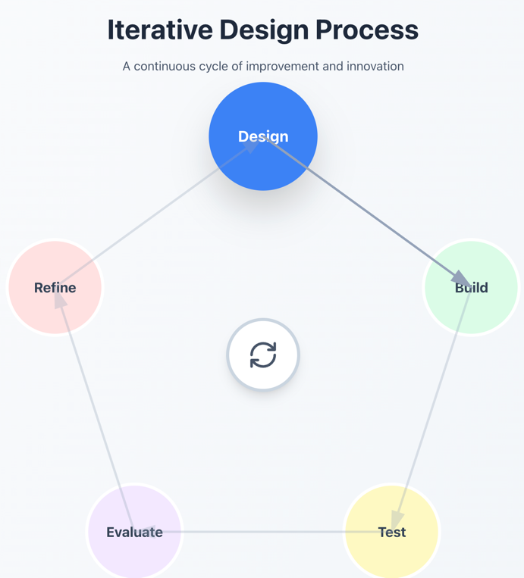
Figure 1 Design Process
Activity:
- Increment 1: Basic Sensor Integration
- Increment 2: Sensor calibration
- Increment 3:data processing
- Increment 4:Real time dashboard interface
- Increment 5: Alerts and Recommendation system
- Increment 6L Final Integrated prototype.
- Phase 4: Testing
Testing is performed at every increment and also at the final integration.
Actions:
- Unit Testing
- Integration Testing
- Field Testing
- Calibration Testing
- User Evaluation

- Phase 5: Review and Refine
Each increment’s result is reviewed and updated on next one based on its findings.
Actions:
- Review performance of each increment.
- Identify issues.
- Update the design and backlog for the next increment.
- Ensure each increments criteria is met before continuation of increment.
- Phase 6: Final Evaluation and Deployment
After completion of all the increments the system is validated.
Actions:
- Conduct full system testing.
- Validate accuracy and usability of the features.
- Prepare the final prototype.
- Documentation

- Resource Requirements

Hardware
- ESP32 Dev-Board
- Capacitive Soil Moisture Sensor
- DHT22 Humidity and Temperature Sensor
- BH1750 Sunlight sensor
- Analog Soil pH Sensor with Signal Conditioning Module
- Soil NPK Sensor (RS485/Modbus Type)
- RS485 to TTL Converter Module
- Lithium-Ion or LiPo Battery Pack (7.4V or 11.1V)
- MicroSD Card Module
- Sensor Mounting Rods / Soil Probes
- Breadboard / Prototype PCB
- Jumper Wires (Male–Male, Male–Female)
- USB Cable for ESP32 Programming

Software
- Arduino Ide
- ESP32 board drivers
- Python
- Flask API
- Sensor Libraries

Development Tools
- NumPy & Pandas
- Matplotlib
- REST API integration tools
- VS Code/ Arduino IDE
- Multimeter for hardware testing
- Soldering iron and wire.
- Jupyter notebook
- Draw.io
- Canva

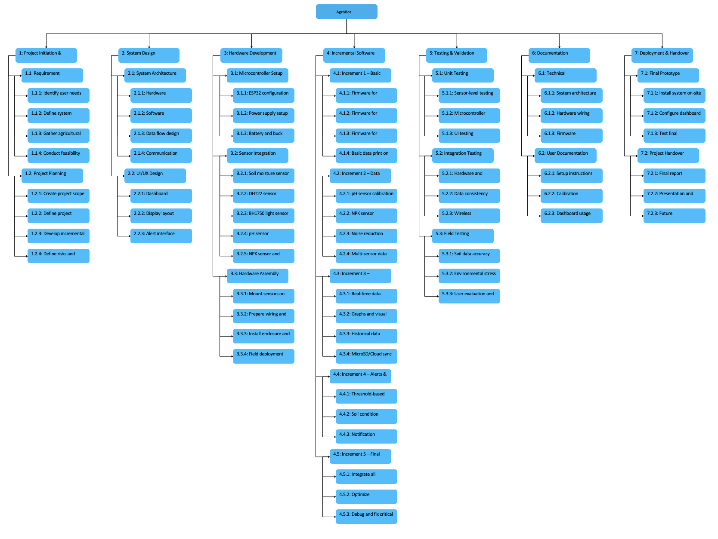
- Work Breakdown Structure
Figure 2 Work Breakdown Structure

- Milestone

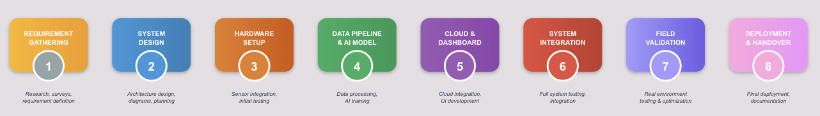
Figure 3 Milestones

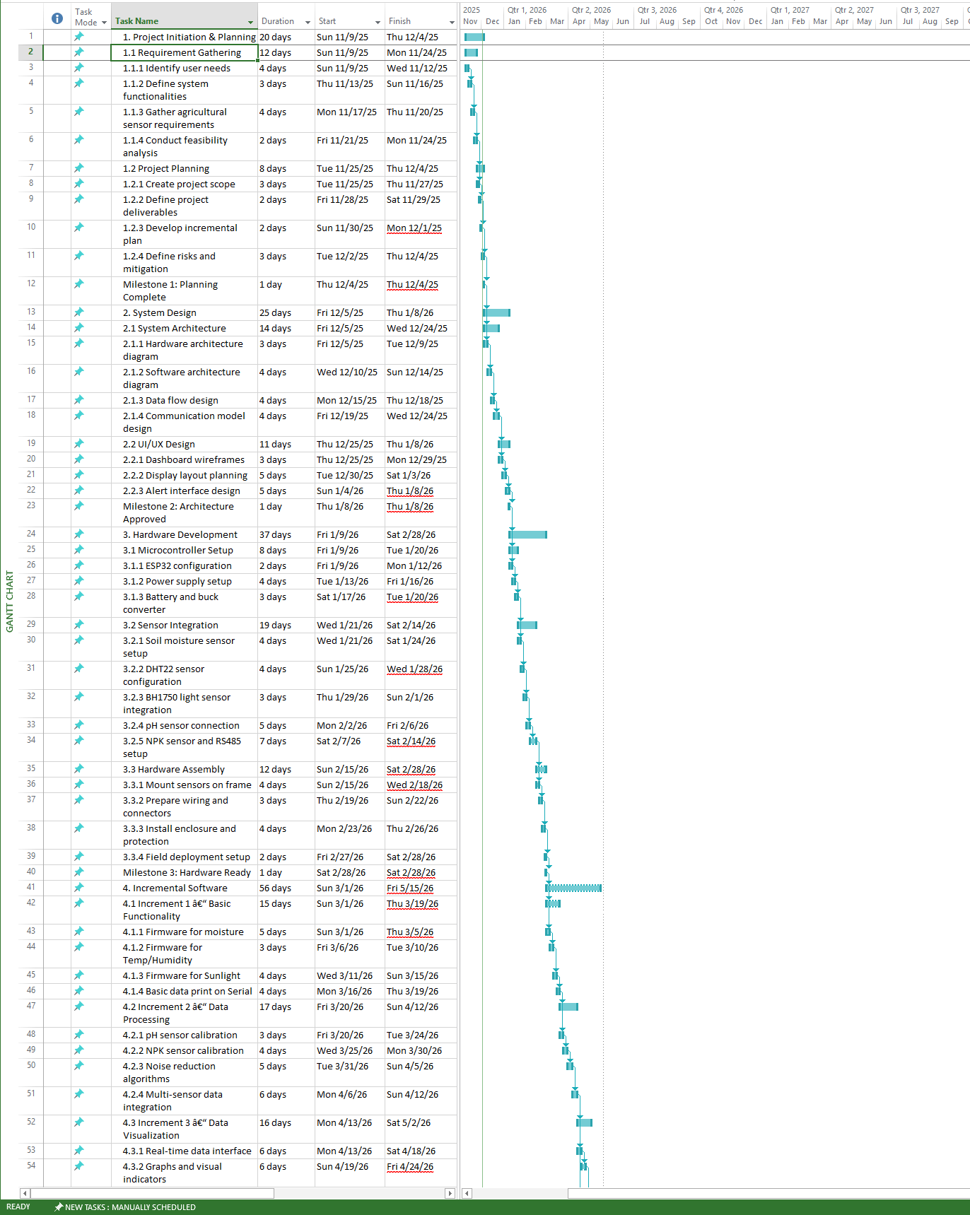
- Gantt Chart
Figure 4 Gantt Chart (Part-1)
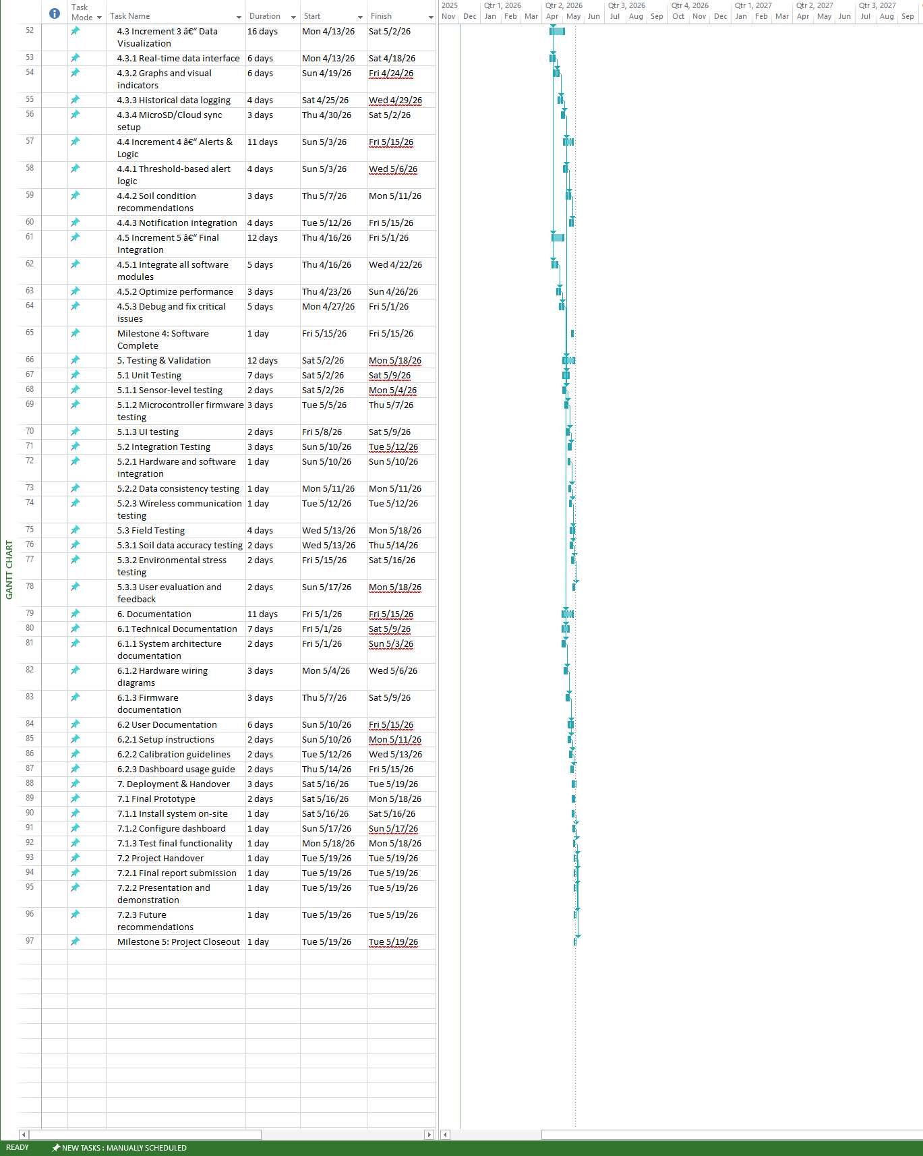
Figure 5 Gantt Chart (part-2)
Table 2 Gantt Chart Timeline
Name | Duration | Start Date | End Date
1. Project Initiation & Planning | 26 days | 9-Nov-25 | 4-Dec-25
1.1 Requirement Gathering | 12 days | 9-Nov-25 | 24-Nov-25
1.1.1 Identify user needs | 4 days | 9-Nov-25 | 12-Nov-25
1.1.2 Define system functionalities | 4 days | 13-Nov-25 | 16-Nov-25
1.1.3 Gather agricultural sensor requirements | 4 days | 17-Nov-25 | 20-Nov-25
1.1.4 Conduct feasibility analysis | 4 days | 21-Nov-25 | 24-Nov-25
1.2 Project Planning | 10 days | 25-Nov-25 | 4-Dec-25
1.2.1 Create project scope | 3 days | 25-Nov-25 | 27-Nov-25
1.2.2 Define project deliverables | 2 days | 28-Nov-25 | 29-Nov-25
1.2.3 Develop incremental plan | 2 days | 30-Nov-25 | 1-Dec-25
1.2.4 Define risks and mitigation | 3 days | 2-Dec-25 | 4-Dec-25
Milestone 1: Planning Complete | 0 days | 4-Dec-25 | 4-Dec-25
2. System Design | 35 days | 5-Dec-25 | 8-Jan-26
2.1 System Architecture | 20 days | 5-Dec-25 | 24-Dec-25
2.1.1 Hardware architecture diagram | 5 days | 5-Dec-25 | 9-Dec-25
2.1.2 Software architecture diagram | 5 days | 10-Dec-25 | 14-Dec-25
2.1.3 Data flow design | 4 days | 15-Dec-25 | 18-Dec-25
2.1.4 Communication model design | 6 days | 19-Dec-25 | 24-Dec-25
2.2 UI/UX Design | 15 days | 25-Dec-25 | 8-Jan-26
2.2.1 Dashboard wireframes | 5 days | 25-Dec-25 | 29-Dec-25
2.2.2 Display layout planning | 5 days | 30-Dec-25 | 3-Jan-26
2.2.3 Alert interface design | 5 days | 4-Jan-26 | 8-Jan-26
Milestone 2: Architecture Approved | 0 days | 8-Jan-26 | 8-Jan-26
3. Hardware Development | 51 days | 9-Jan-26 | 28-Feb-26
3.1 Microcontroller Setup | 12 days | 9-Jan-26 | 20-Jan-26
3.1.1 ESP32 configuration | 4 days | 9-Jan-26 | 12-Jan-26
3.1.2 Power supply setup | 4 days | 13-Jan-26 | 16-Jan-26
3.1.3 Battery and buck converter | 4 days | 17-Jan-26 | 20-Jan-26
3.2 Sensor Integration | 25 days | 21-Jan-26 | 14-Feb-26
3.2.1 Soil moisture sensor setup | 4 days | 21-Jan-26 | 24-Jan-26
3.2.2 DHT22 sensor configuration | 4 days | 25-Jan-26 | 28-Jan-26
3.2.3 BH1750 light sensor integration | 4 days | 29-Jan-26 | 1-Feb-26
3.2.4 pH sensor connection | 5 days | 2-Feb-26 | 6-Feb-26
3.2.5 NPK sensor and RS485 setup | 8 days | 7-Feb-26 | 14-Feb-26
3.3 Hardware Assembly | 14 days | 15-Feb-26 | 28-Feb-26
3.3.1 Mount sensors on frame | 4 days | 15-Feb-26 | 18-Feb-26
3.3.2 Prepare wiring and connectors | 4 days | 19-Feb-26 | 22-Feb-26
3.3.3 Install enclosure and protection | 4 days | 23-Feb-26 | 26-Feb-26
3.3.4 Field deployment setup | 2 days | 27-Feb-26 | 28-Feb-26
Milestone 3: Hardware Ready | 0 days | 28-Feb-26 | 28-Feb-26
4. Incremental Software | 67 days | 1-Mar-26 | 15-May-26
4.1 Increment 1 – Basic Functionality | 19 days | 1-Mar-26 | 19-Mar-26
4.1.1 Firmware for moisture | 5 days | 1-Mar-26 | 5-Mar-26
4.1.2 Firmware for Temp/Humidity | 5 days | 6-Mar-26 | 10-Mar-26
4.1.3 Firmware for Sunlight | 5 days | 11-Mar-26 | 15-Mar-26
4.1.4 Basic data print on Serial | 4 days | 16-Mar-26 | 19-Mar-26
4.2 Increment 2 – Data Processing | 24 days | 20-Mar-26 | 12-Apr-26
4.2.1 pH sensor calibration | 5 days | 20-Mar-26 | 24-Mar-26
4.2.2 NPK sensor calibration | 6 days | 25-Mar-26 | 30-Mar-26
4.2.3 Noise reduction algorithms | 6 days | 31-Mar-26 | 5-Apr-26
4.2.4 Multi-sensor data integration | 7 days | 6-Apr-26 | 12-Apr-26
4.3 Increment 3 – Data Visualization | 20 days | 13-Apr-26 | 2-May-26
4.3.1 Real-time data interface | 6 days | 13-Apr-26 | 18-Apr-26
4.3.2 Graphs and visual indicators | 6 days | 19-Apr-26 | 24-Apr-26
4.3.3 Historical data logging | 5 days | 25-Apr-26 | 29-Apr-26
4.3.4 MicroSD/Cloud sync setup | 3 days | 30-Apr-26 | 2-May-26
4.4 Increment 4 – Alerts & Logic | 13 days | 3-May-26 | 15-May-26
4.4.1 Threshold-based alert logic | 4 days | 3-May-26 | 6-May-26
4.4.2 Soil condition recommendations | 5 days | 7-May-26 | 11-May-26
4.4.3 Notification integration | 4 days | 12-May-26 | 15-May-26
4.5 Increment 5 – Final Integration | 16 days | 16-Apr-26 | 1-May-26
4.5.1 Integrate all software modules | 7 days | 16-Apr-26 | 22-Apr-26
4.5.2 Optimize performance | 4 days | 23-Apr-26 | 26-Apr-26
4.5.3 Debug and fix critical issues | 5 days | 27-Apr-26 | 1-May-26
Milestone 4: Software Complete | 0 days | 15-May-26 | 15-May-26
5. Testing & Validation | 17 days | 2-May-26 | 18-May-26
5.1 Unit Testing | 8 days | 2-May-26 | 9-May-26
5.1.1 Sensor-level testing | 3 days | 2-May-26 | 4-May-26
5.1.2 Microcontroller firmware testing | 3 days | 5-May-26 | 7-May-26
5.1.3 UI testing | 2 days | 8-May-26 | 9-May-26
5.2 Integration Testing | 3 days | 10-May-26 | 12-May-26
5.2.1 Hardware and software integration | 1 day | 10-May-26 | 10-May-26
5.2.2 Data consistency testing | 1 day | 11-May-26 | 11-May-26
5.2.3 Wireless communication testing | 1 day | 12-May-26 | 12-May-26
5.3 Field Testing | 6 days | 13-May-26 | 18-May-26
5.3.1 Soil data accuracy testing | 2 days | 13-May-26 | 14-May-26
5.3.2 Environmental stress testing | 2 days | 15-May-26 | 16-May-26
5.3.3 User evaluation and feedback | 2 days | 17-May-26 | 18-May-26
6. Documentation | 15 days | 1-May-26 | 15-May-26
6.1 Technical Documentation | 9 days | 1-May-26 | 9-May-26
6.1.1 System architecture documentation | 3 days | 1-May-26 | 3-May-26
6.1.2 Hardware wiring diagrams | 3 days | 4-May-26 | 6-May-26
6.1.3 Firmware documentation | 3 days | 7-May-26 | 9-May-26
6.2 User Documentation | 6 days | 10-May-26 | 15-May-26
6.2.1 Setup instructions | 2 days | 10-May-26 | 11-May-26
6.2.2 Calibration guidelines | 2 days | 12-May-26 | 13-May-26
6.2.3 Dashboard usage guide | 2 days | 14-May-26 | 15-May-26
7. Deployment & Handover | 4 days | 16-May-26 | 19-May-26
7.1 Final Prototype | 3 days | 16-May-26 | 18-May-26
7.1.1 Install system on-site | 1 day | 16-May-26 | 16-May-26
7.1.2 Configure dashboard | 1 day | 17-May-26 | 17-May-26
7.1.3 Test final functionality | 1 day | 18-May-26 | 18-May-26
7.2 Project Handover | 1 day | 19-May-26 | 19-May-26
7.2.1 Final report submission | 1 day | 19-May-26 | 19-May-26
7.2.2 Presentation and demonstration | 1 day | 19-May-26 | 19-May-26
7.2.3 Future recommendations | 1 day | 19-May-26 | 19-May-26
Milestone 5: Project Closeout | 0 days | 19-May-26 | 19-May-26

- Conclusion
The Smart Agriculture Monitoring & Management System (AgroBot) represents comprehensive integration of IoT and AI where the IoT sensors collect the data and AI analyses the data. The continuous real time data, insights and recommendations help farmers optimize resource while maximizing crop yield.
With global agriculture sector moving toward the new concept of precise agriculture farming and related techniques, this project presents itself as practical, cost-effective in the long run and a smart solution for the farmers. Upon successful implementation of the system and further development of its future adaptable features this system will serve as a foundation for smart farming initiative impacting livelihood for the farming community in our society all over the world.

