- Difference between ()=> {return() } and ()=>() ?
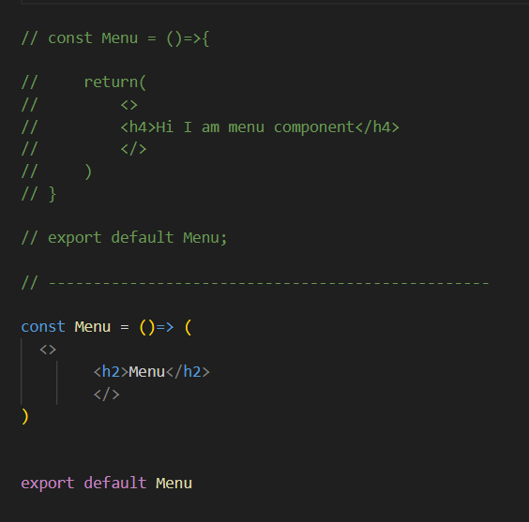
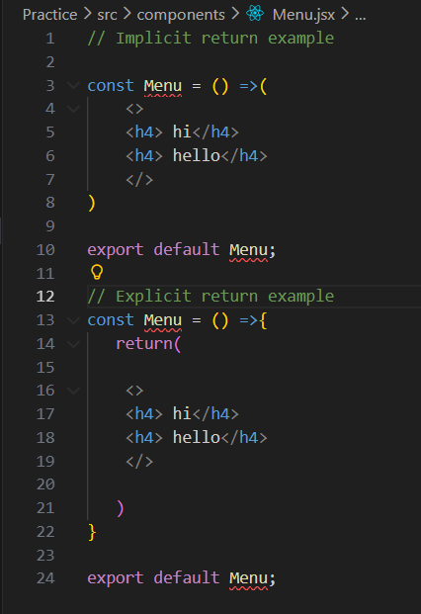

- Different way of writing components code, react elements and all.

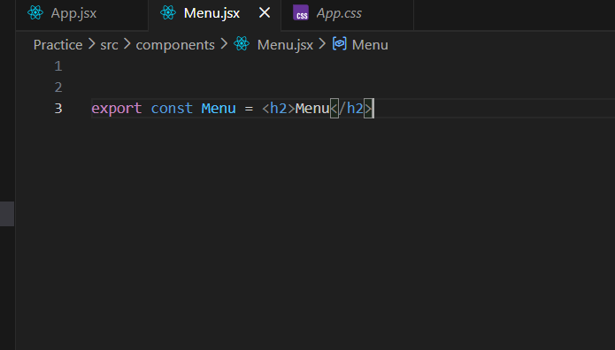
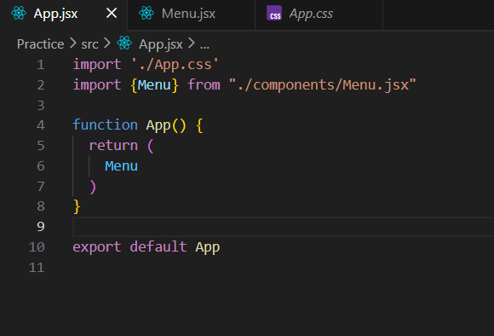

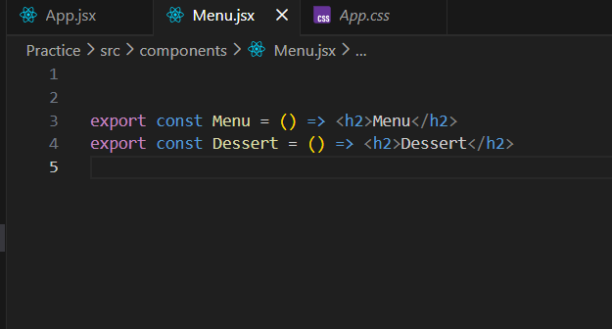

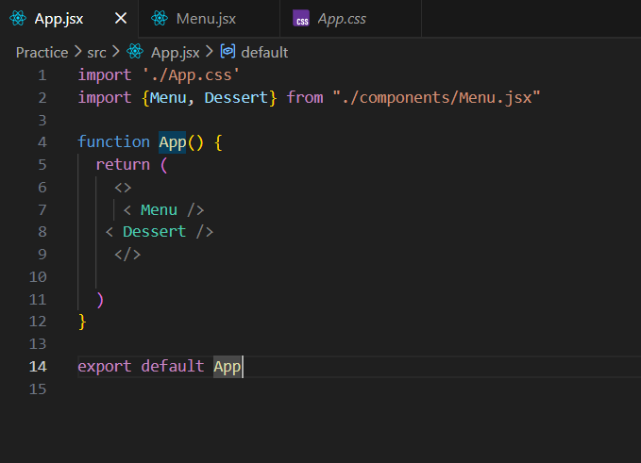

- useState code snippet
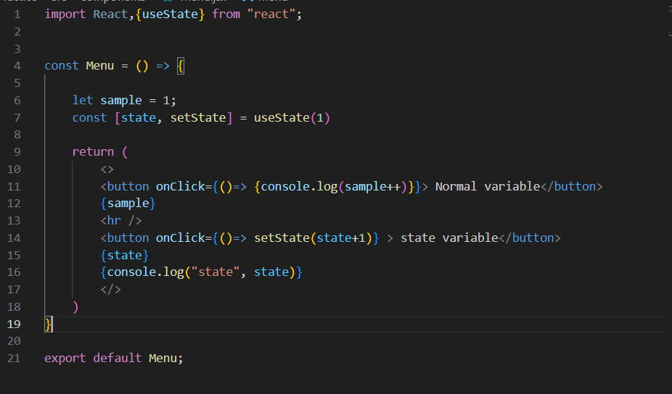

- useEffect code snippet

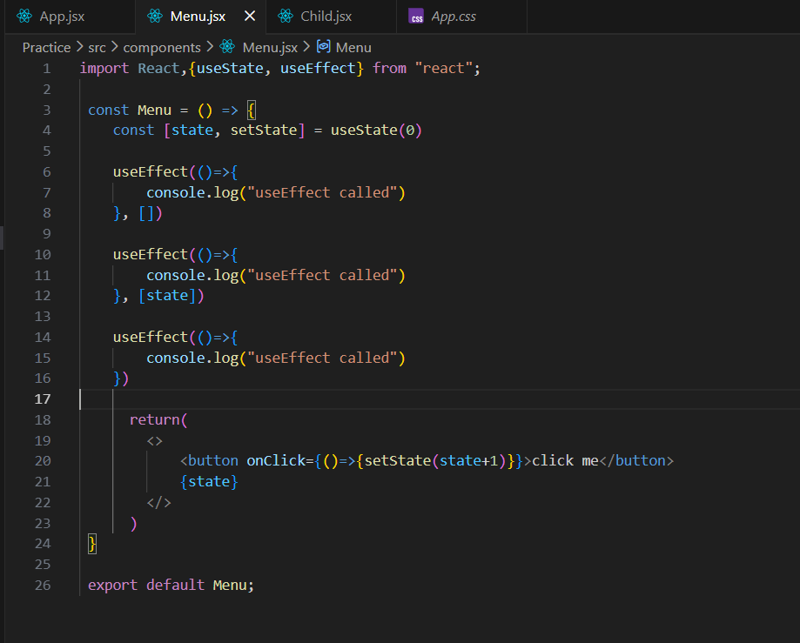
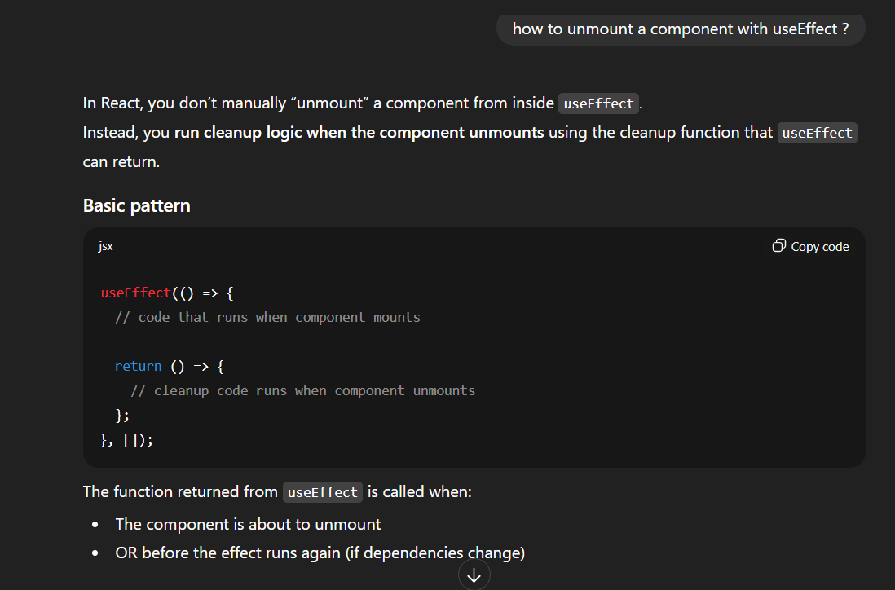
so when will return will run
1. When the component unmounts
That means:
- The component is removed from the UI
- Parent stops rendering it
- Route changes
- Component is destroyed
2. Before the effect runs again (when dependencies change)

- parent to child data passing (prop drilling)
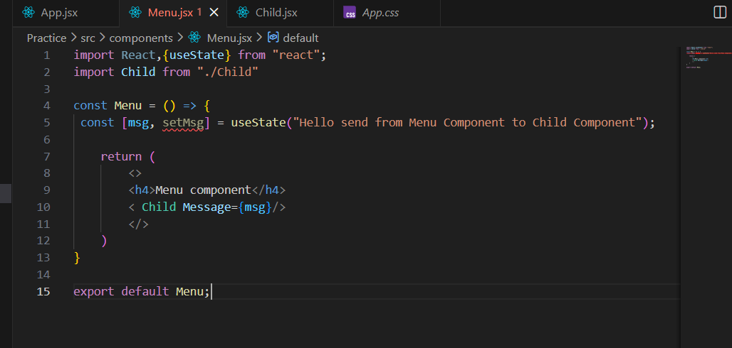

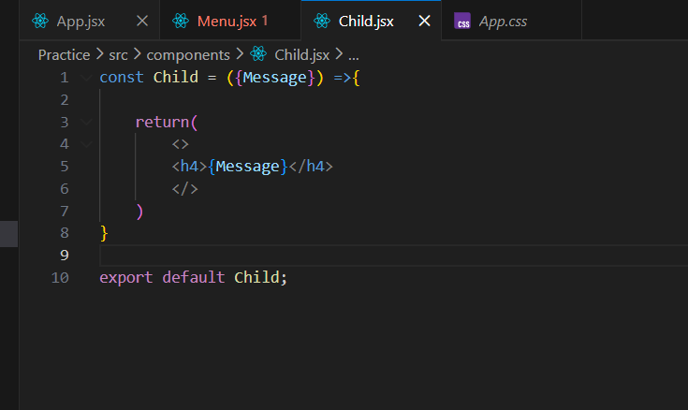

- child to parent data passing

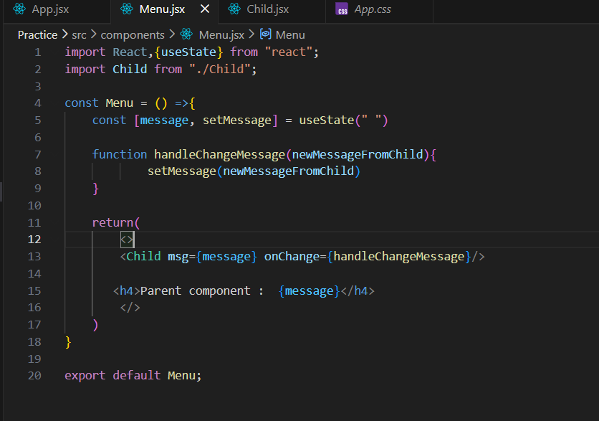

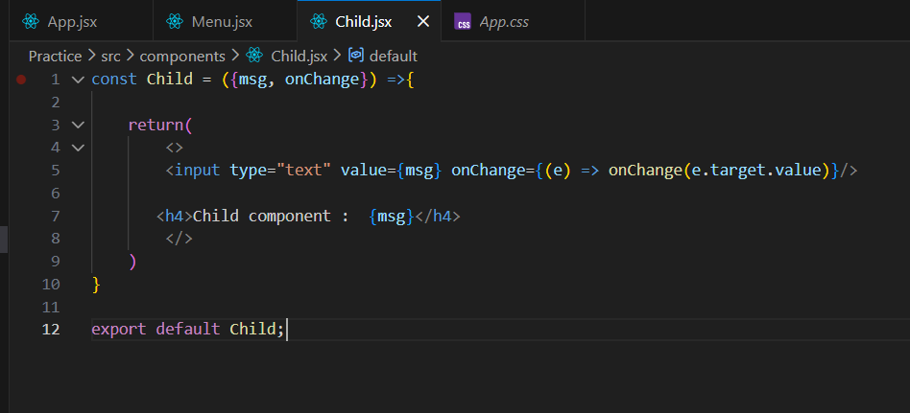

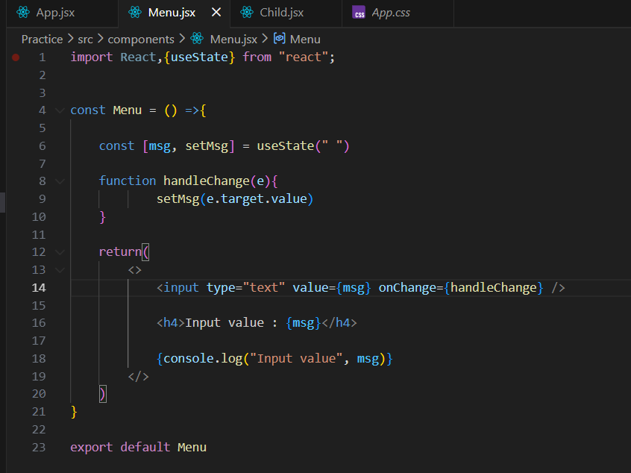

- Custom Hook
custom Hook usecase
- API Fetching Logic
(useFetch, useApi, useQuery)
- Form Handling
(useForm, handling inputs, validation, errors)
- Toggle / Boolean State (Dark mode and Light mode)
(useToggle for open/close, show/hide, etc.)
- LocalStorage or SessionStorage Sync
(useLocalStorage, useSessionStorage)
- Debounce & Throttle
(useDebounce, useThrottle for search inputs)
- Event Listeners
(scroll position, mouse movements, window resize)
- Timers & Intervals
(useInterval, useTimeout)
- Detecting Device or Screen Size
(useMediaQuery, useWindowSize)
- Authentication Helpers
(useAuth, token management, login/logout logic)
- Previous Value Tracking
(usePrevious — compare current vs previous state)

- Context API = createContext => provide that context to whole application through provider => useContext to use the data in any component

Context → Provider → useContext hook → Component
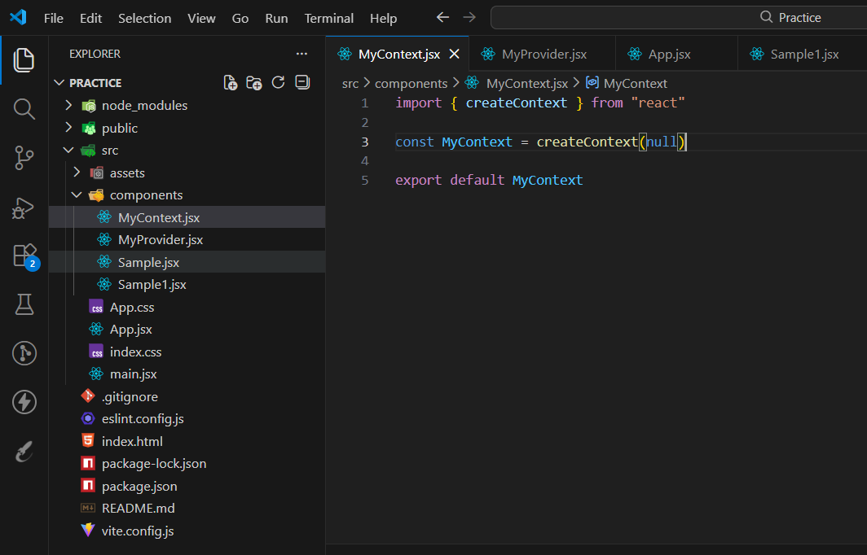

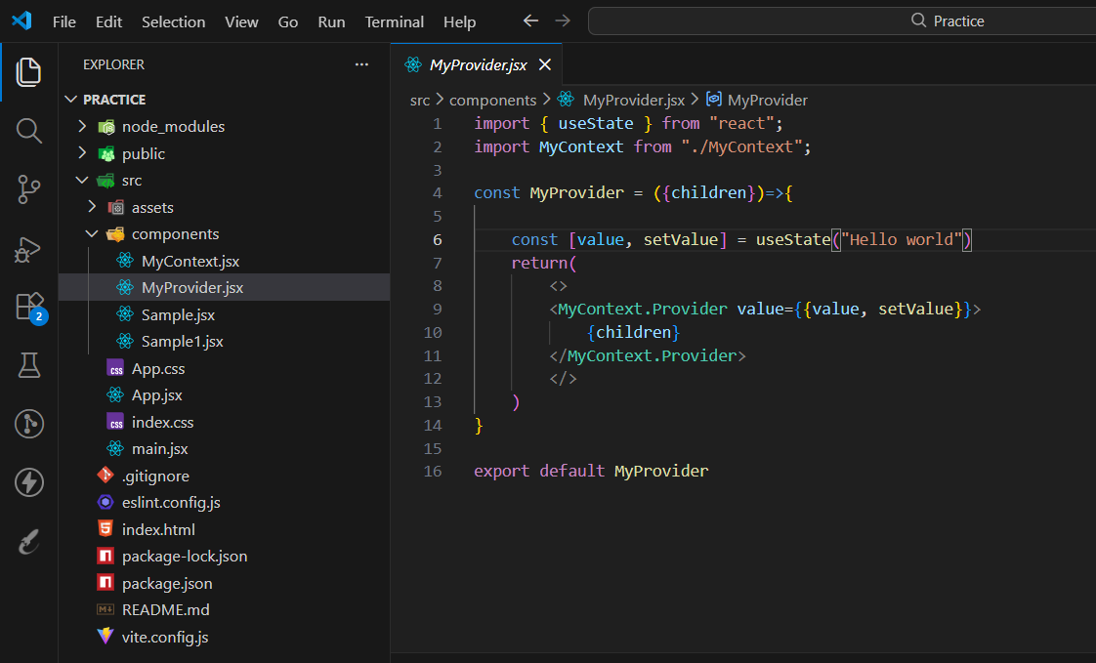

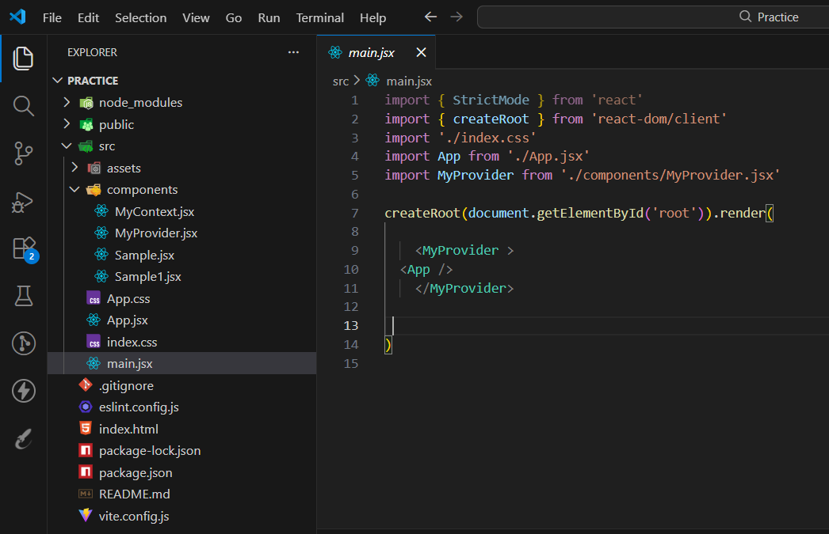
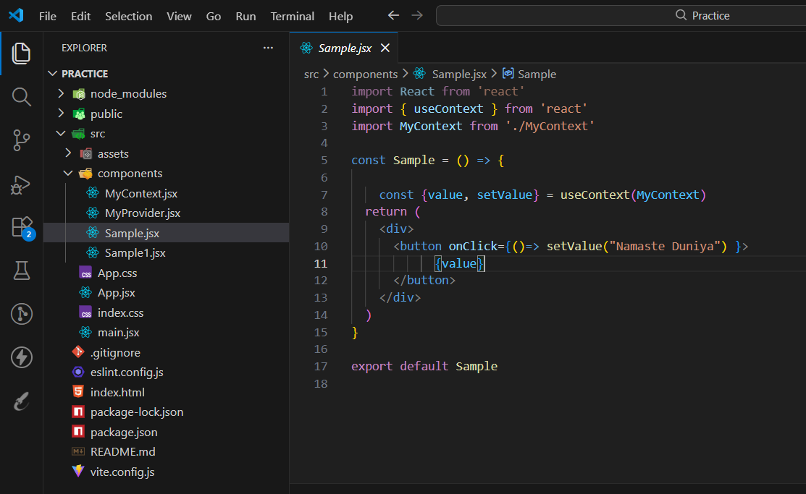

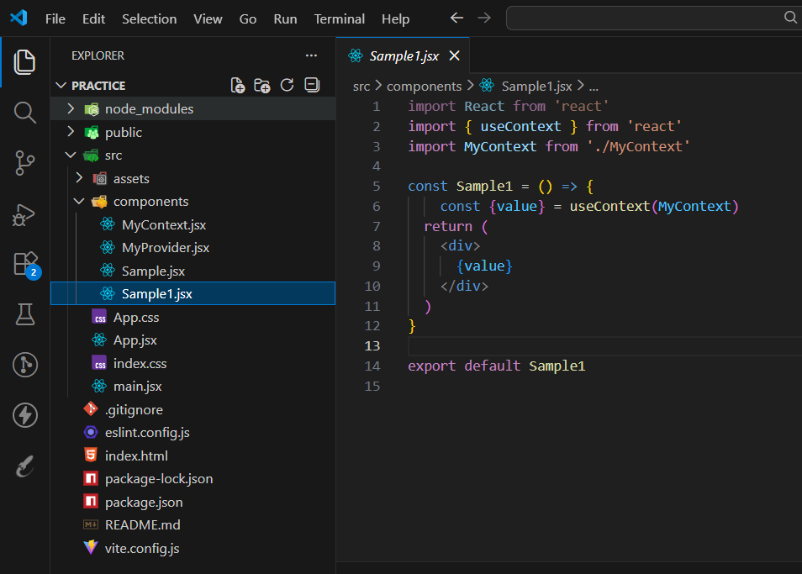

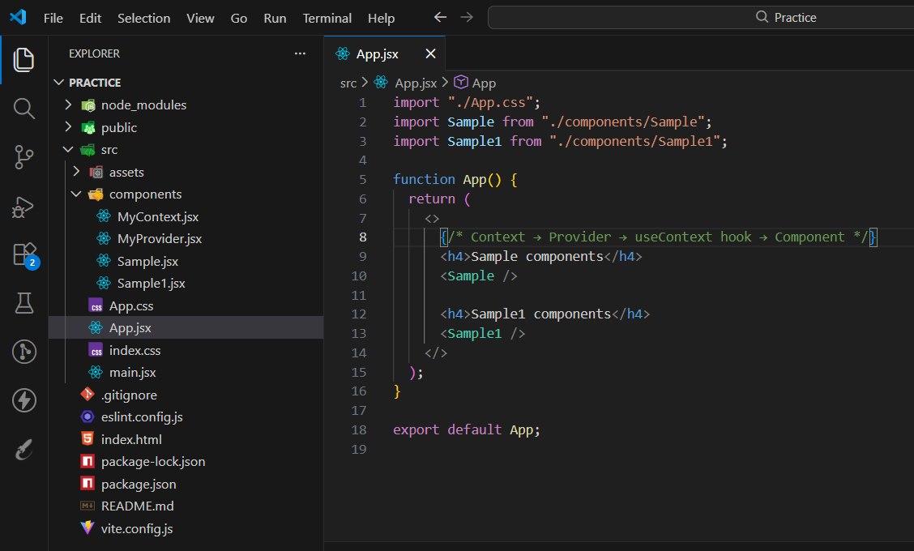

9 Redux, Redux tool-Kit
Redux Toolkit = Slice → Store → Provider→ useSelector / useDispatch

- created slice and exported actions and reducer
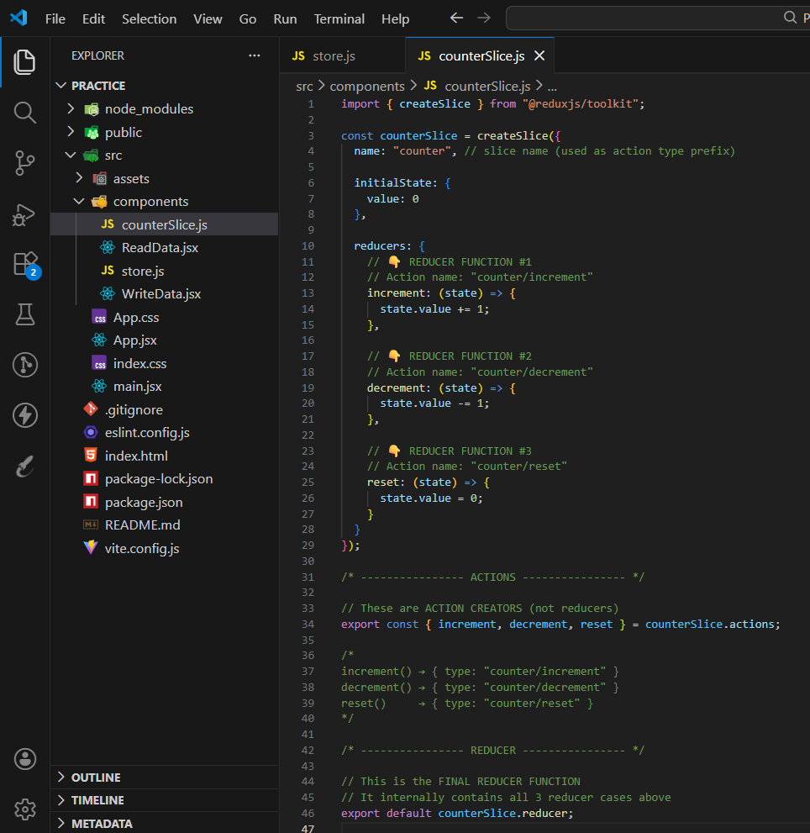

- Created store and added slice

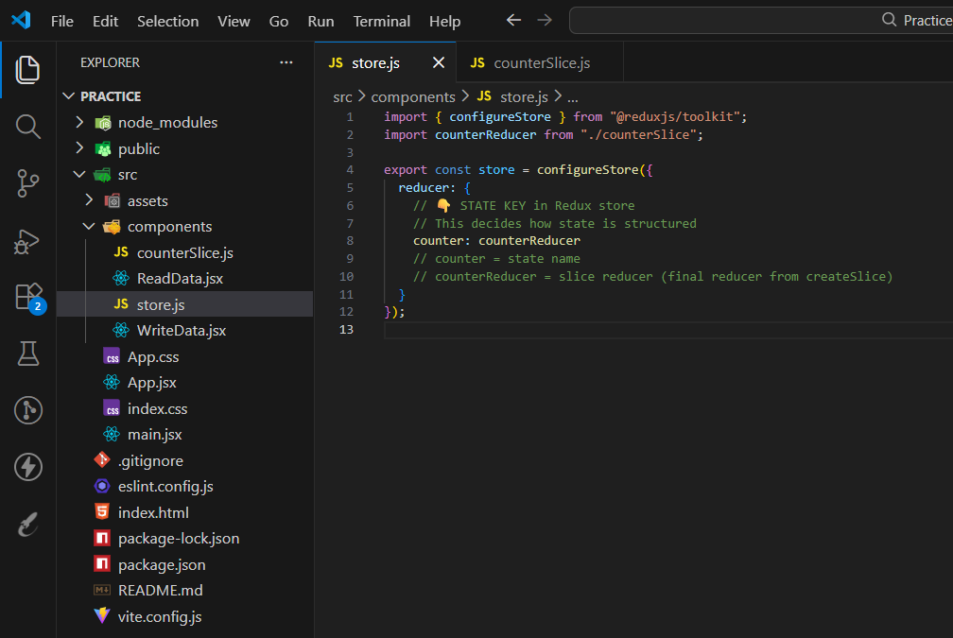

-> Provide store to our Application
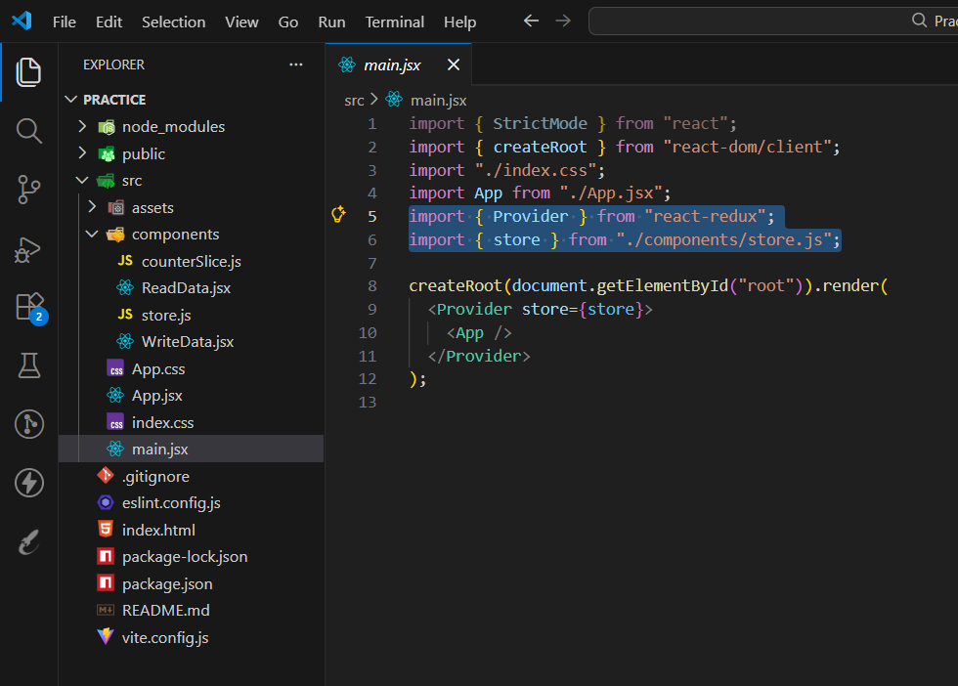

-> Reading Data through useSelector()
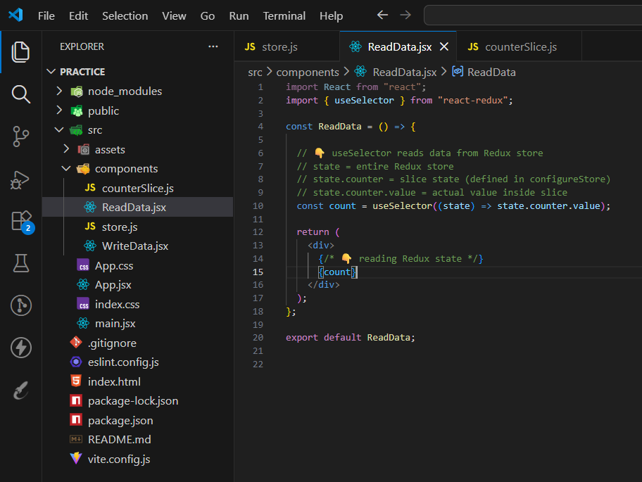

-> Writing on the Data through useDispatch()
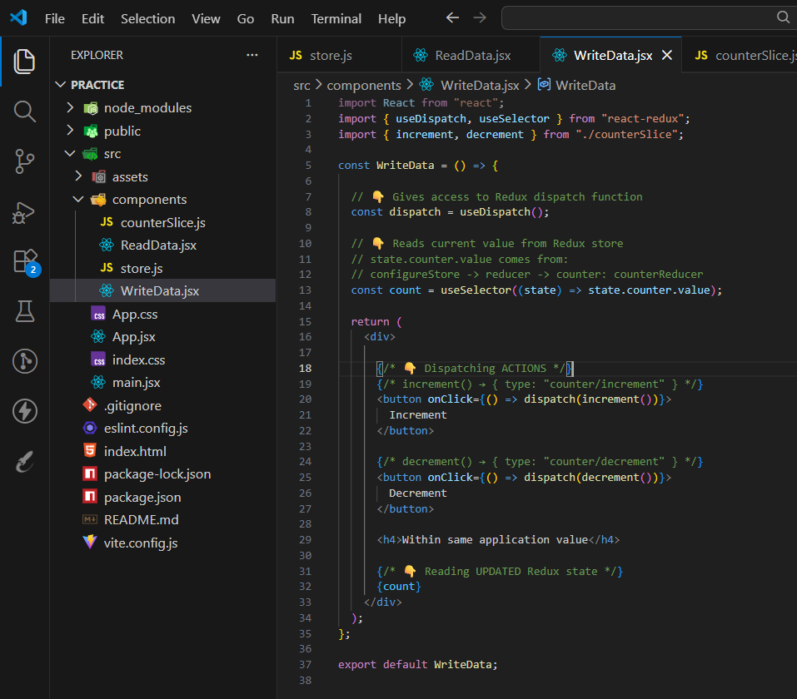

Full data flow (VERY IMPORTANT)

Button click
↓
dispatch(increment())
↓
Action { type: "counter/increment" }
↓
counterReducer runs
↓
state.counter.value changes
↓
Redux store updates
↓
useSelector detects change
↓
Component re-renders
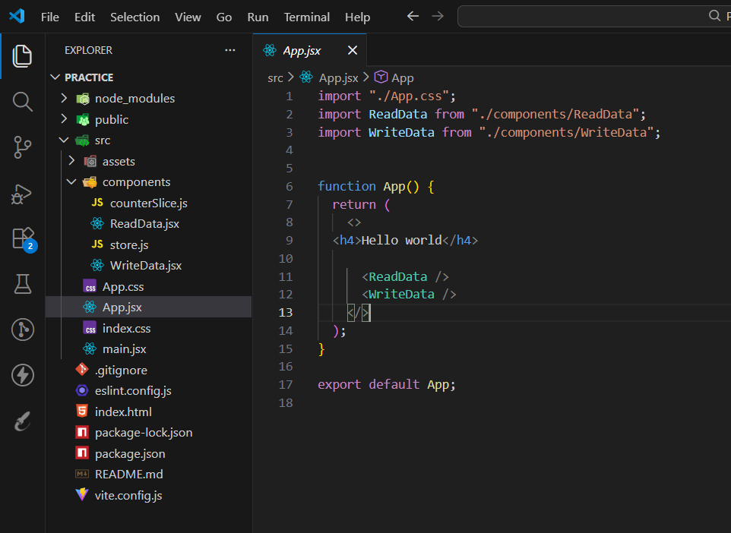

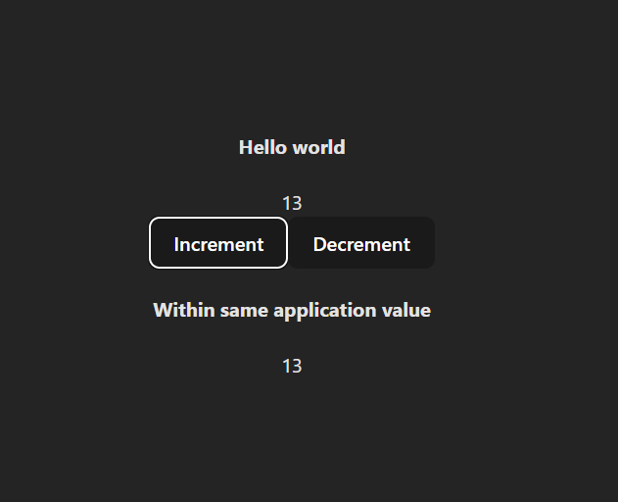

10 useMemo

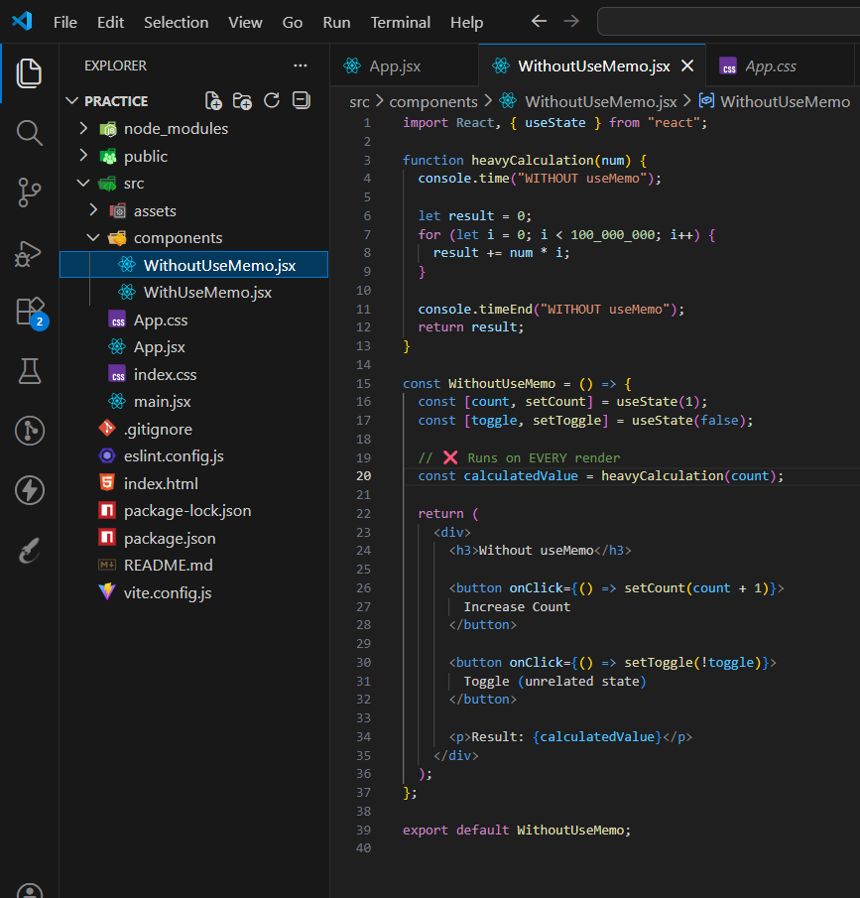

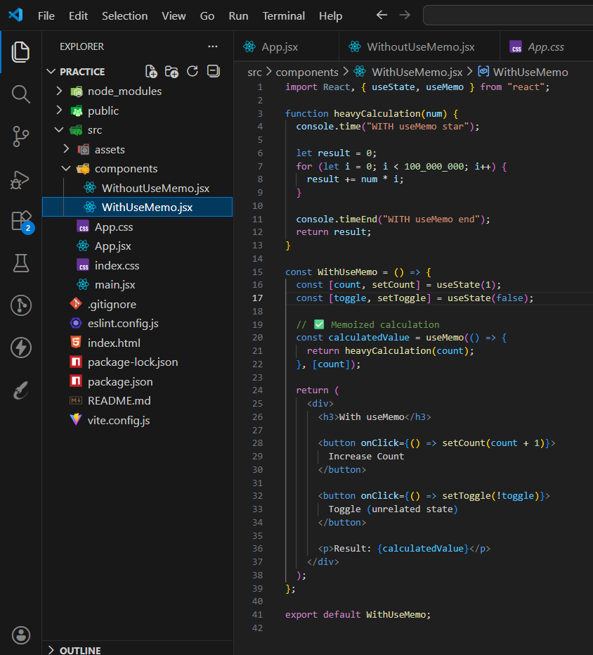

11 useCallback()
In JavaScript, functions are objects.
On every render, a new function object is created unless we memoize it.
useCallback keeps the same function reference between renders.

useCallback doesn’t prevent function creation —
it prevents reference change between renders.

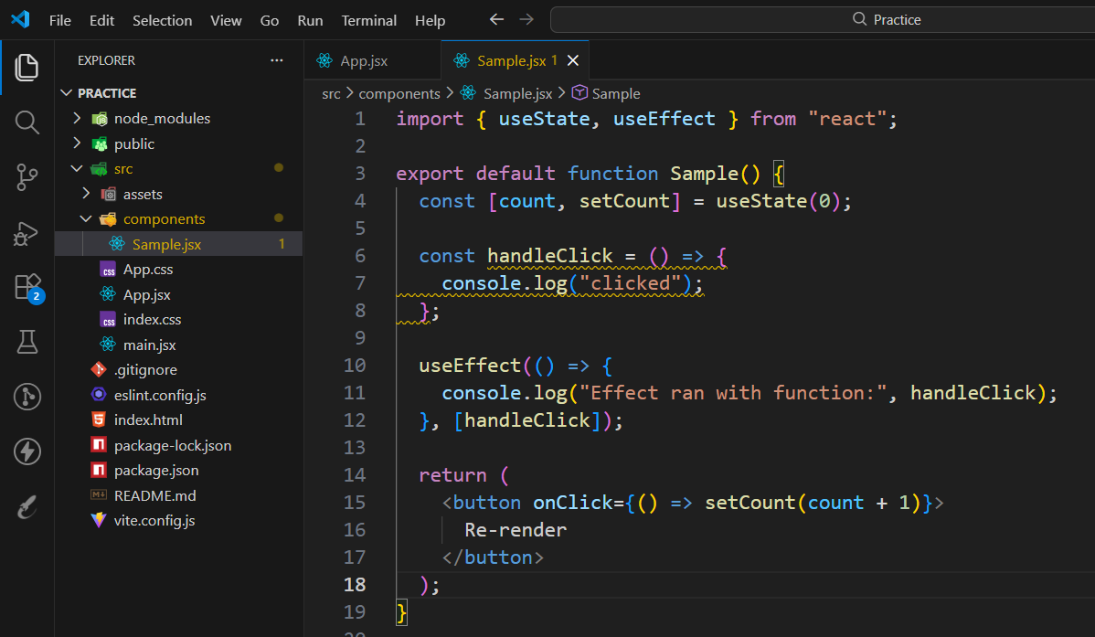

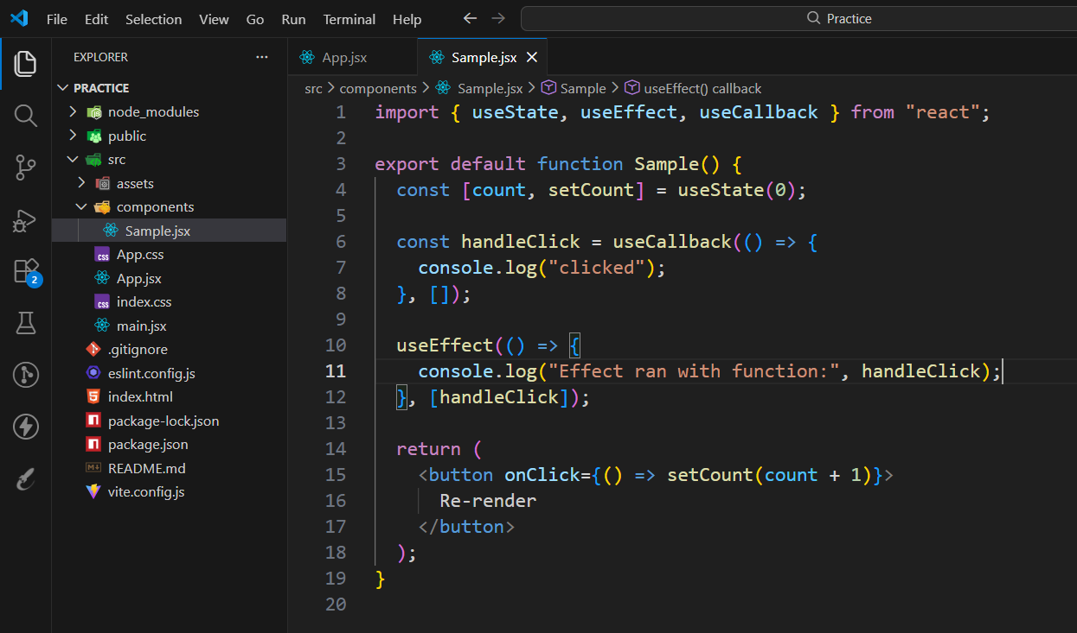

If a function’s identity changes, React treats it as a new dependency.
By putting the function in the dependency array, we can observe whether its identity changes across renders.

12 useRef() - State is for rendering, Ref is for remembering.
Need DOM access? | useRef

Persist value across renders? | useRef

Avoid re-render? | useRef

Side-effect logic only? useRef
