🤔 Window & this keyword ?
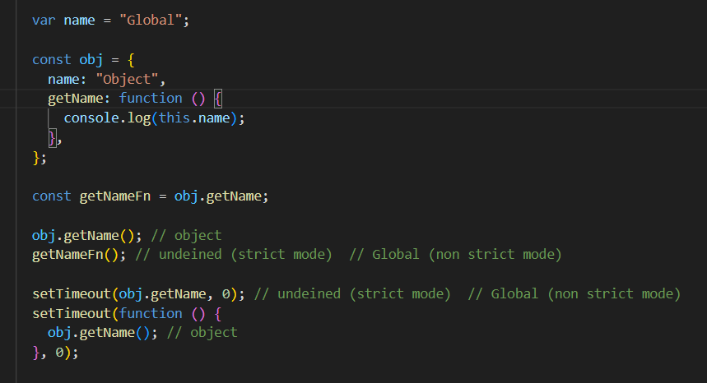
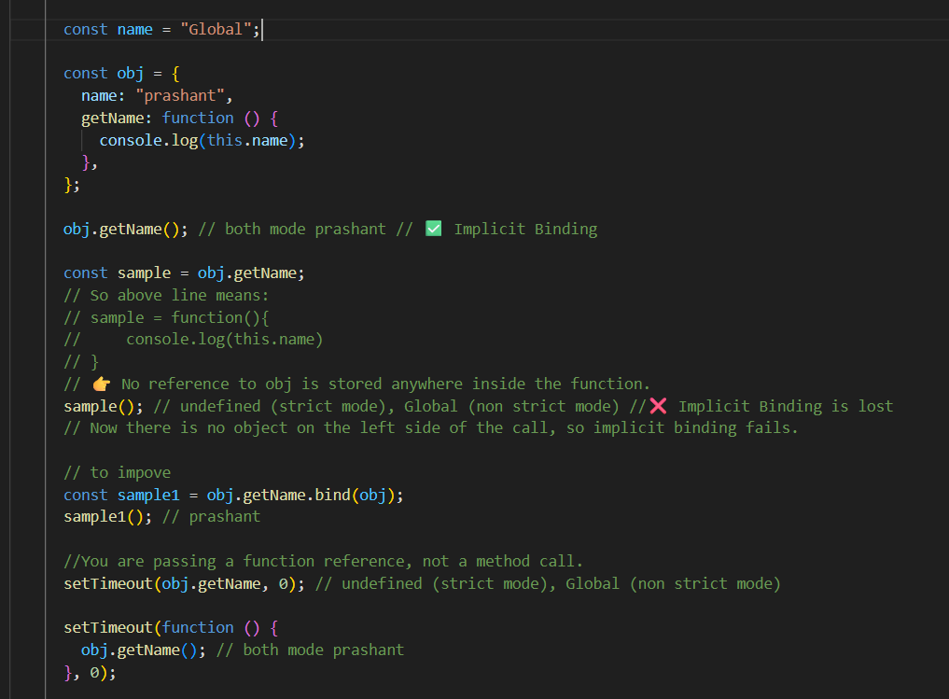
With this go through output based question given in Javascript1.txt file

🤔 pure vs Impure function ?
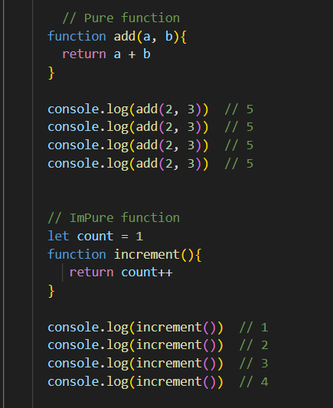

🤔 setTimeout, setInterval ?
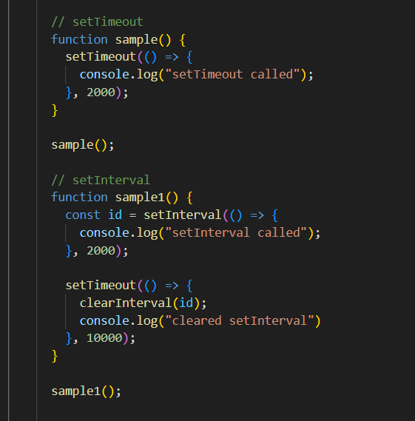

🤔 first class function ?
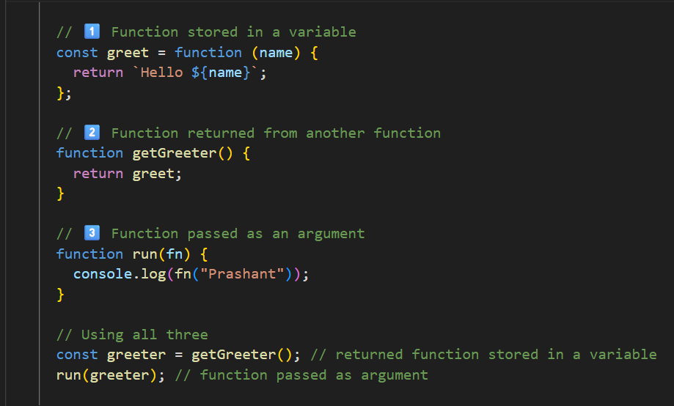

🤔 callback function ?
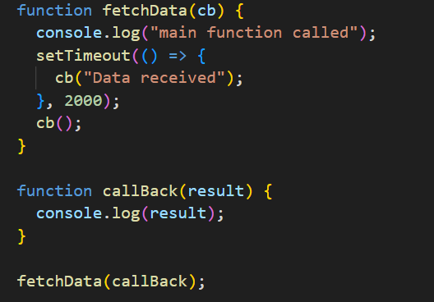
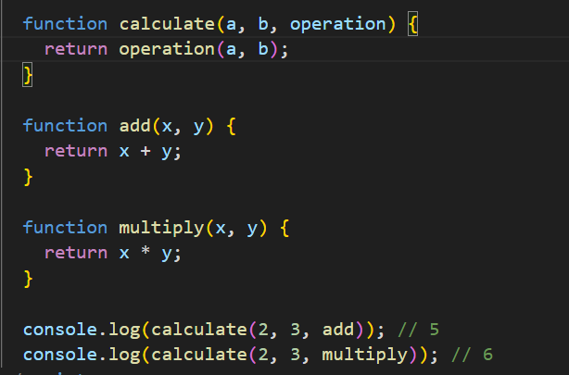

🤔 Higher order function ?
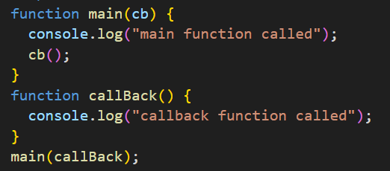
Here main is a HOF

🤔 map, reduce, filter ?
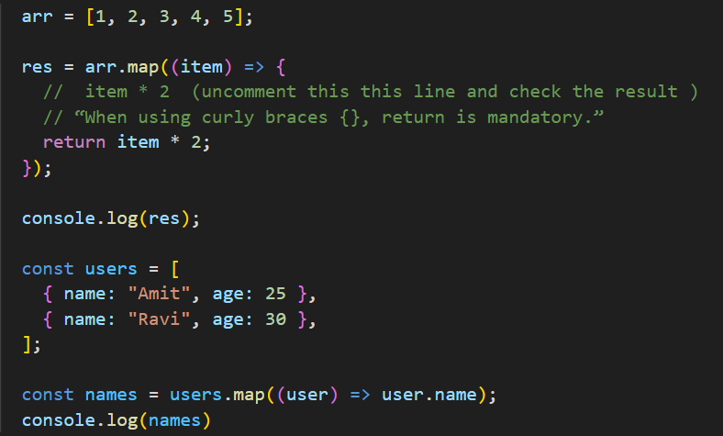
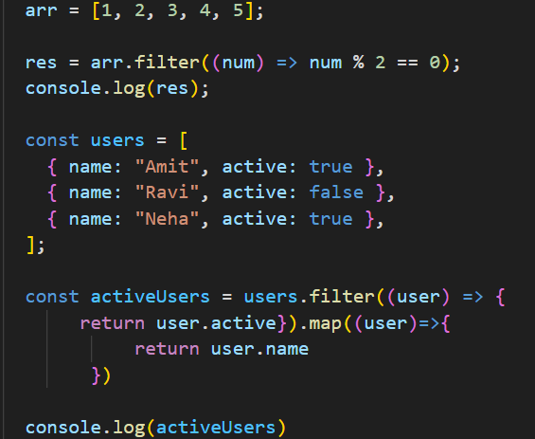
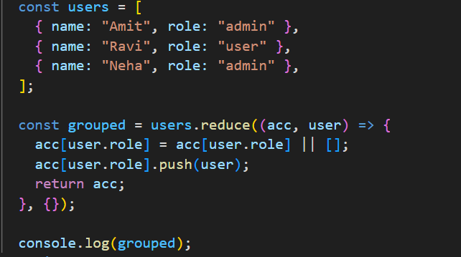

acc[key] = acc[key] || []
acc[key].push(value)

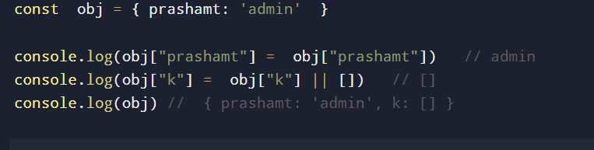
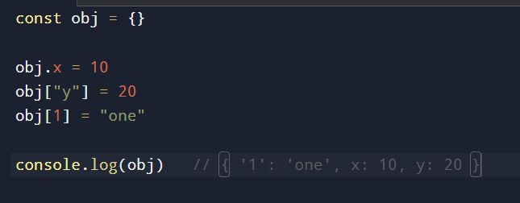

🤔 IIFE ?
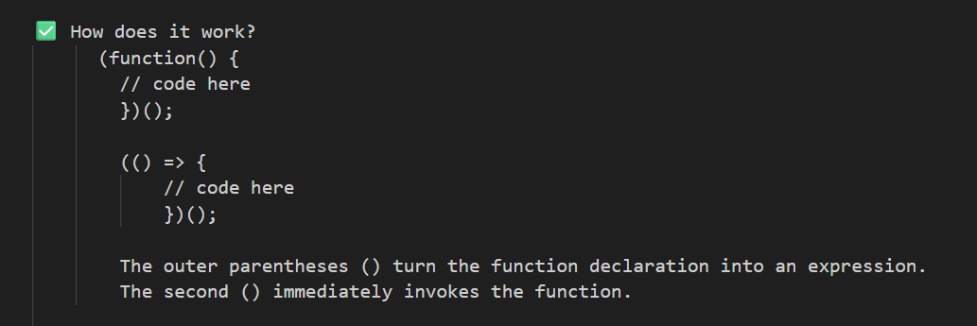
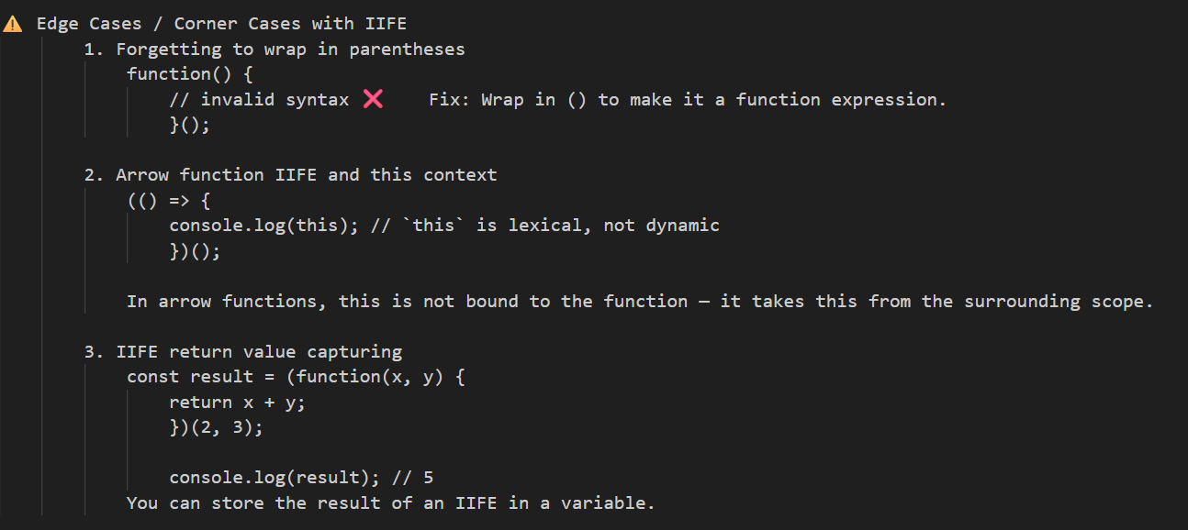

🤔 Currying function ?
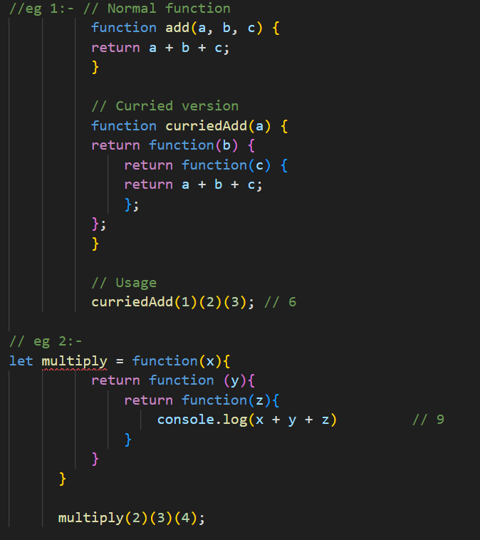
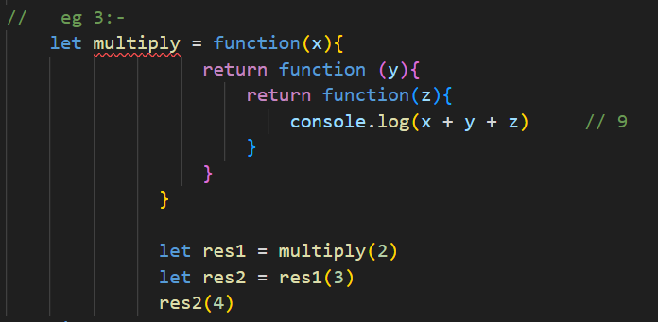

🤔 callback hell ?
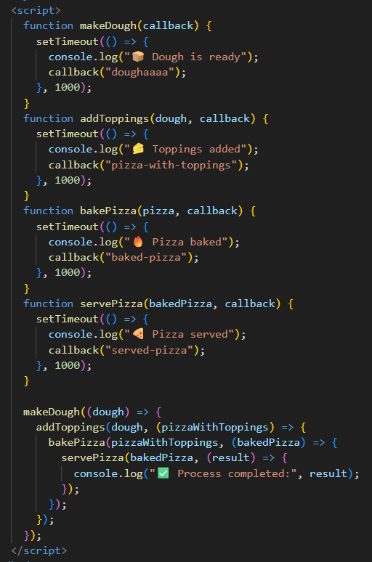
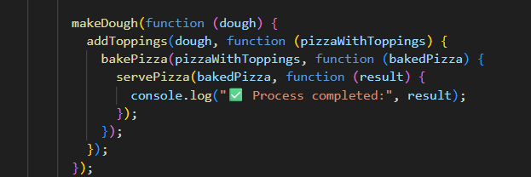

🤔 Promises, promises stage/state ? how to create custom Promises, implement proper error handling, and manage asynchronous operations effectively ?
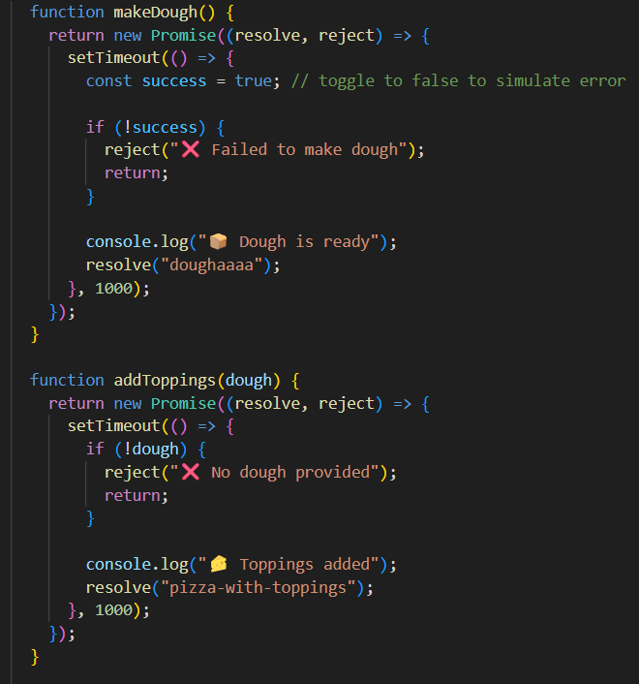
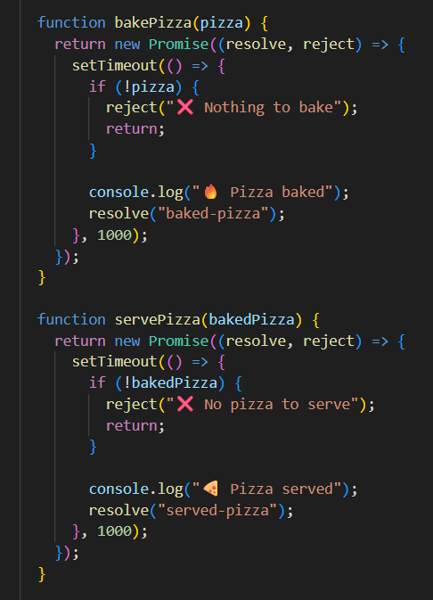
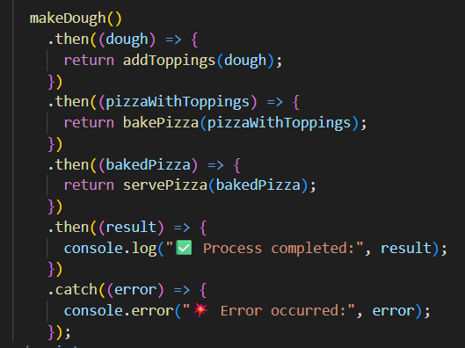
🤔 async await ?
above Whole same code, replace caller function with below caller function
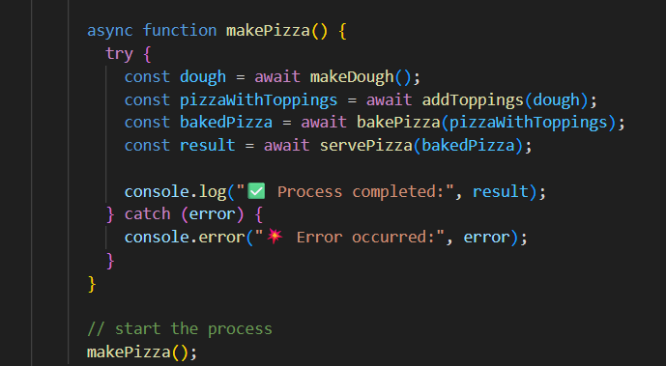

🤔 promise API ?
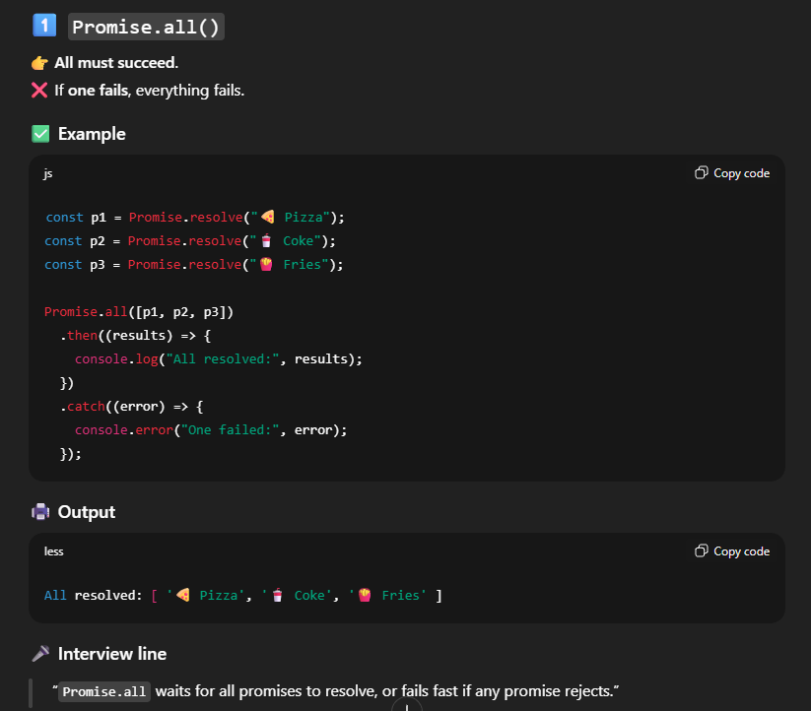
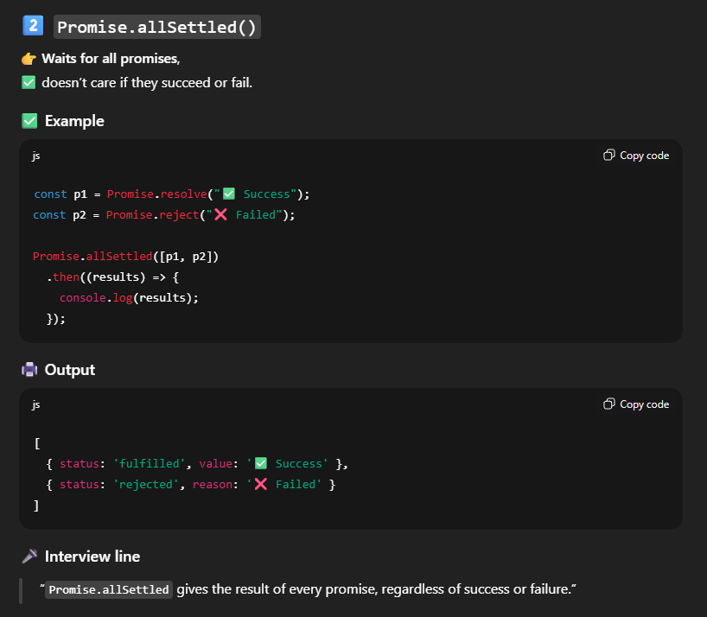
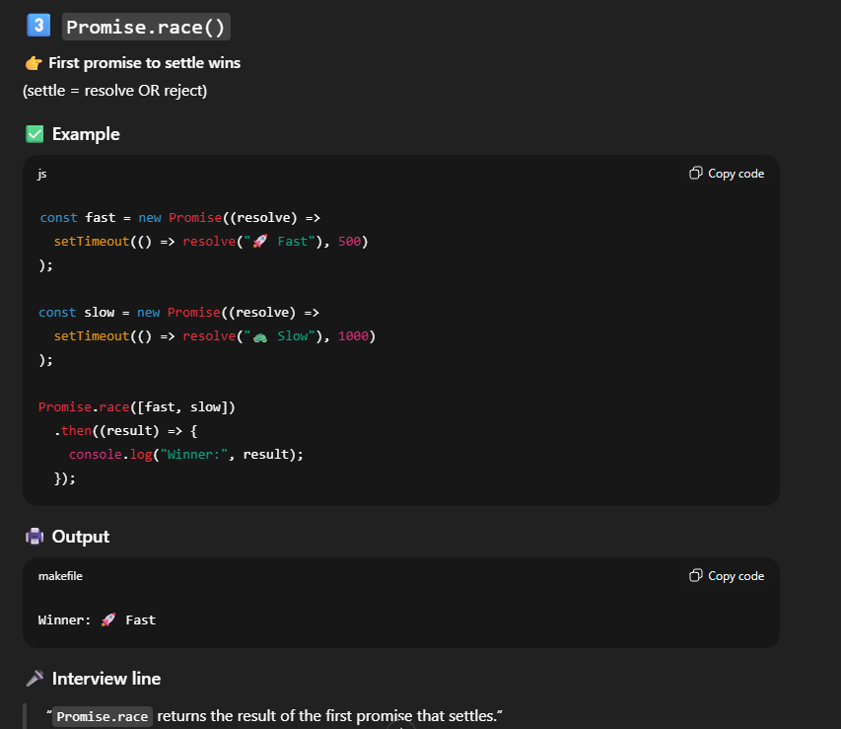
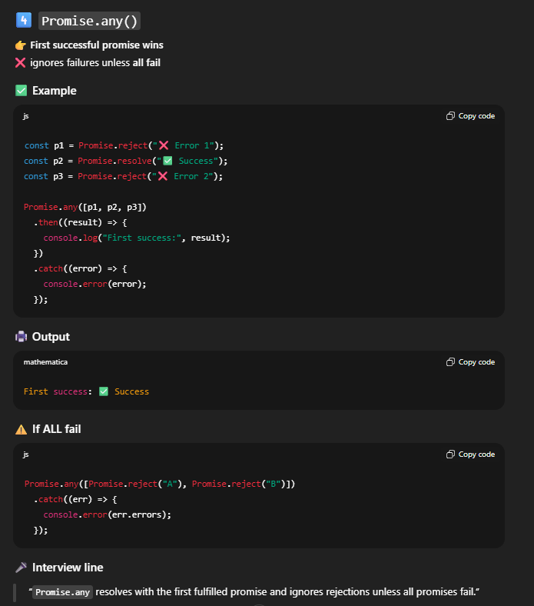

🤔 Difference between promise & async await ?
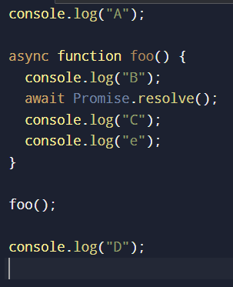
Flow wise, there is no difference between Promises and async/await.
Both use the same event loop and microtask queue.
async/await only changes how the code is written, not how it runs.

🤔 Template Literals, interpolation, mutability , Immutability ?
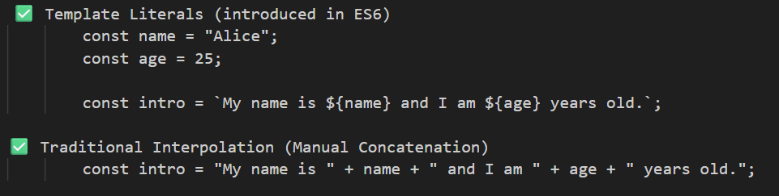
mutability , Immutability ?
In JavaScript, primitive values are immutable, while objects and arrays are mutable by default.
Mutability means changing the same memory reference, while immutability means creating a new value or object instead of modifying the original one.

🤔 Destructuring Assignment in object & array ?
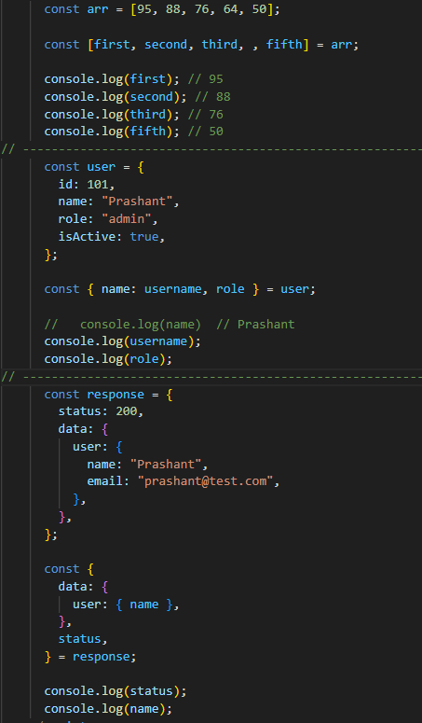

🤔 Spread and Rest Operator (...), optional chaining, nullish coalescing operator ?
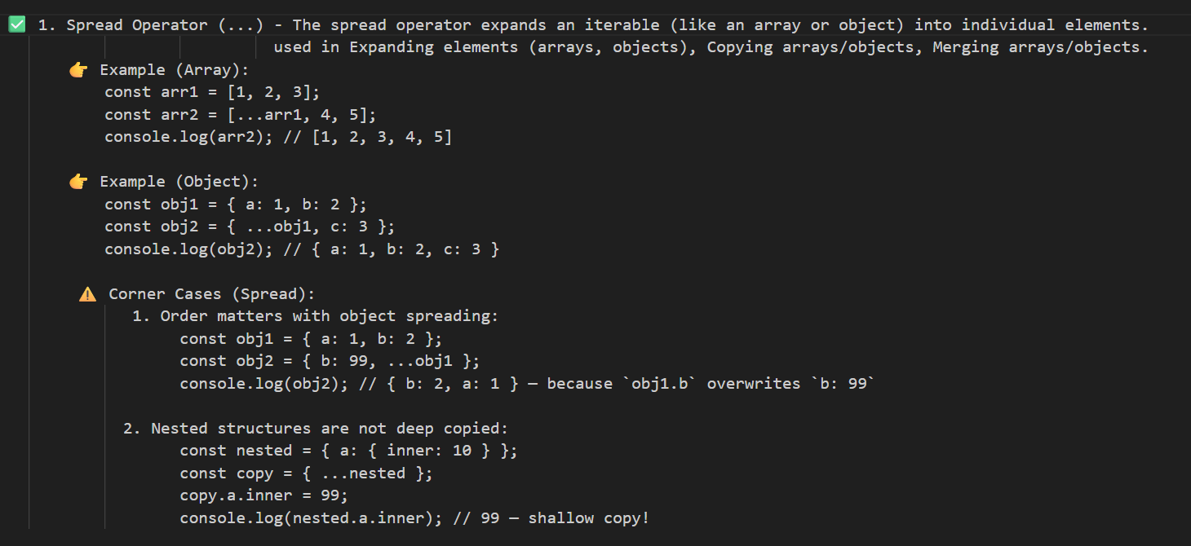
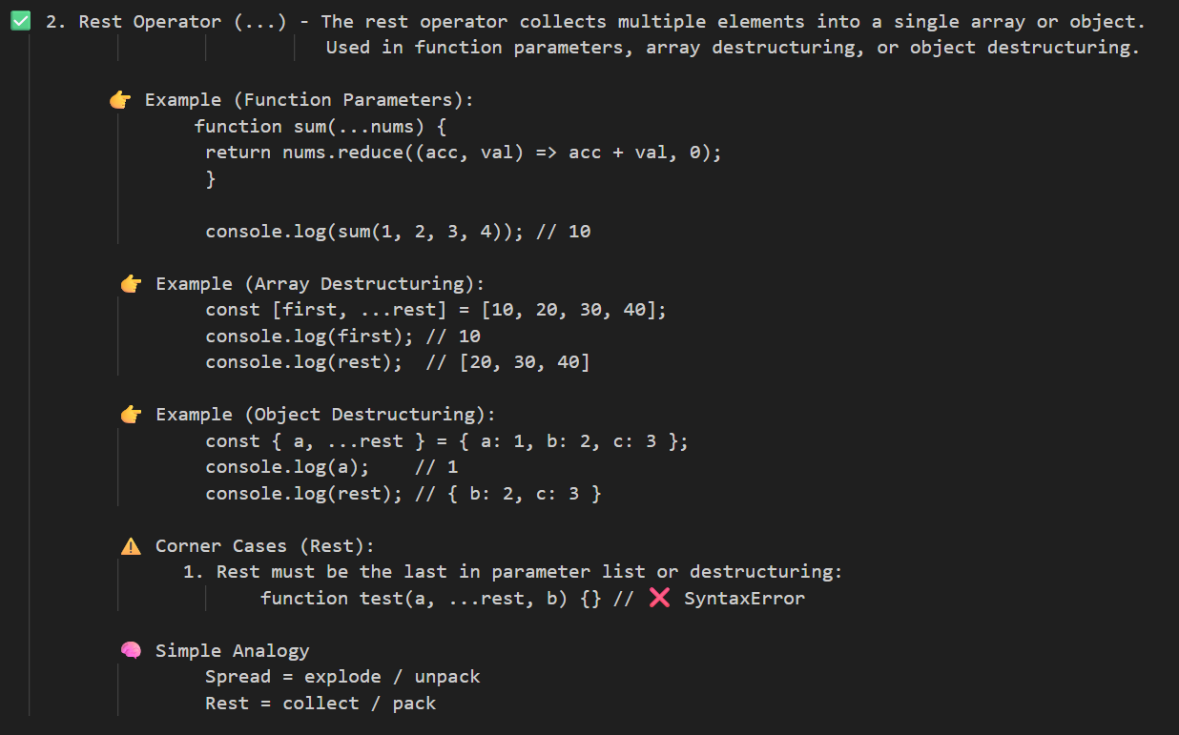
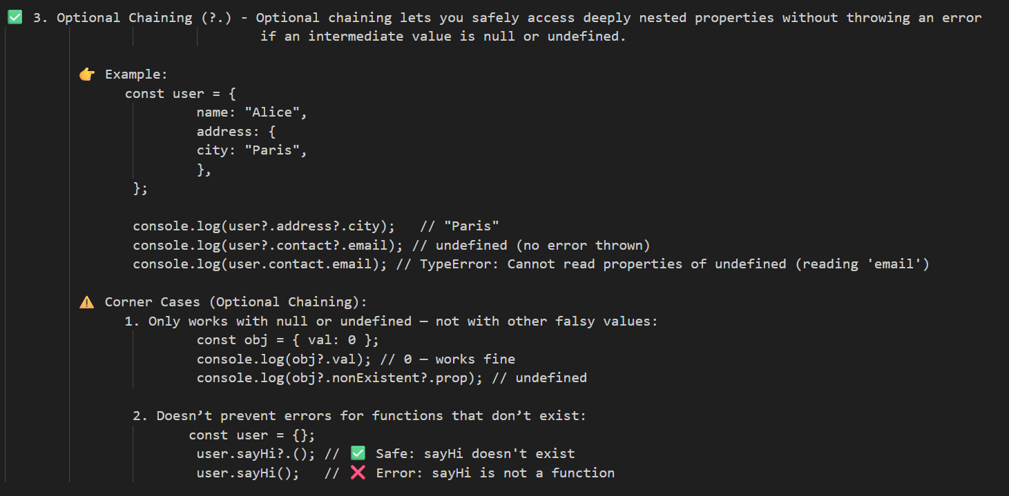
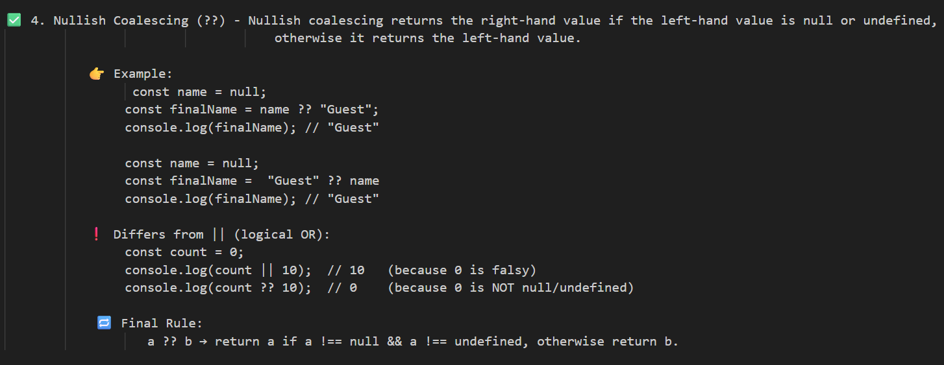

🤔 Deep copy vs shallow copy ?
Shallow copy of object and array
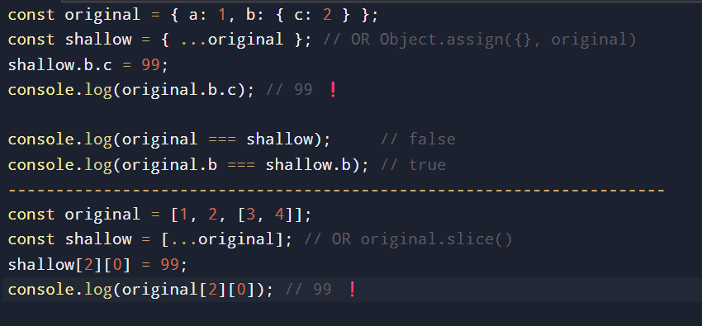
Deep copy of object and array
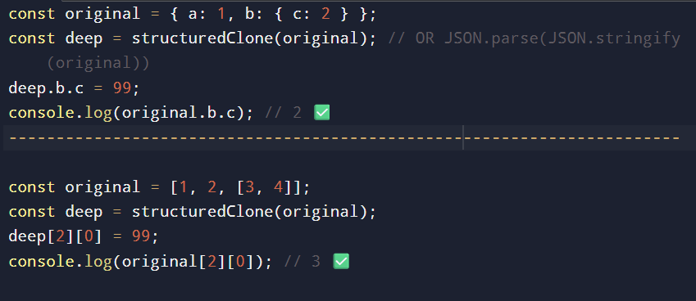

🤔 call, bind & apply ? [used for sharing methods of objects]
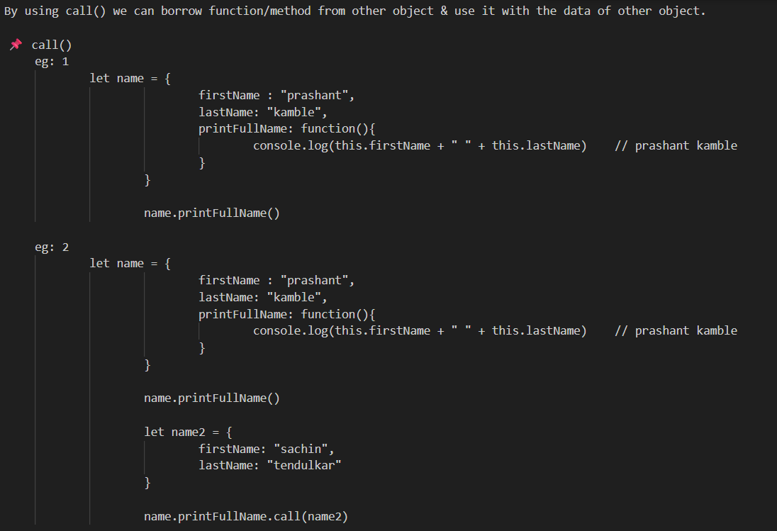
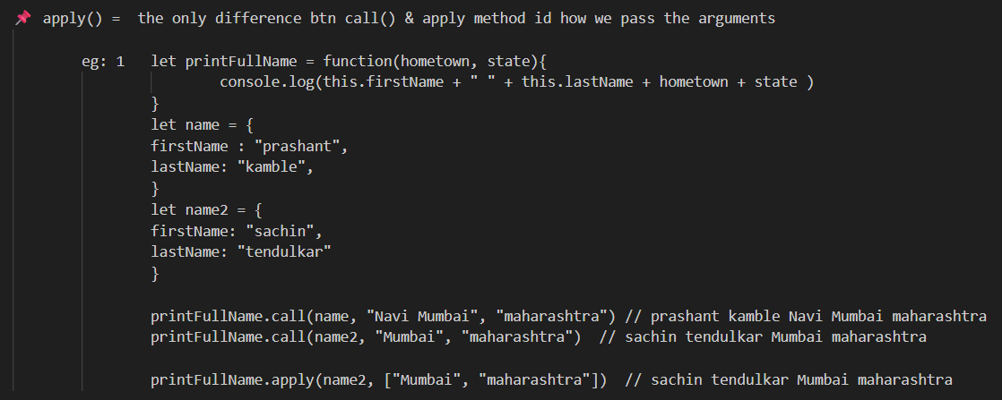
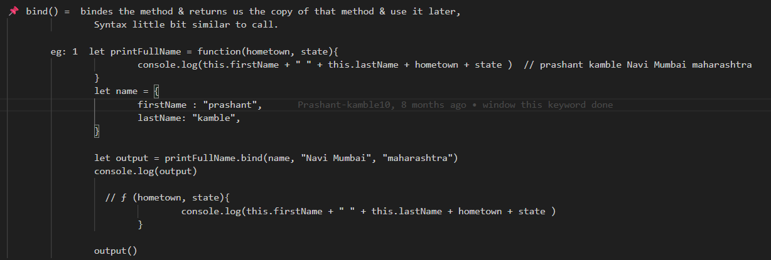

🤔 for loop, while loop, Do while, for...of, for...in, forEach loop, map function ?
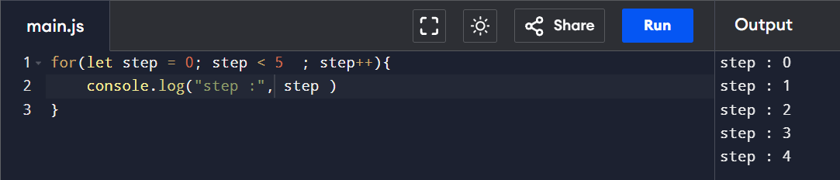
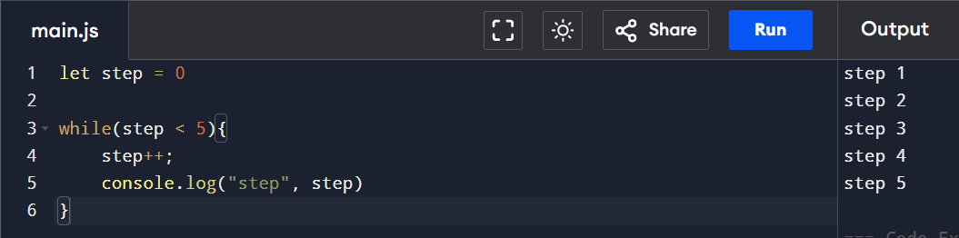
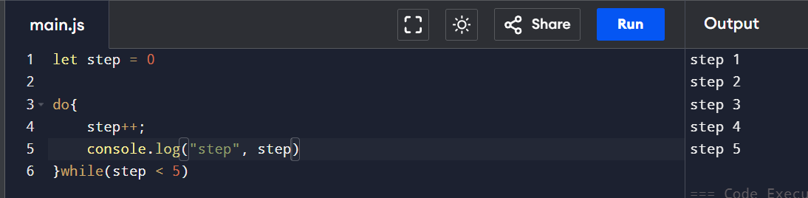
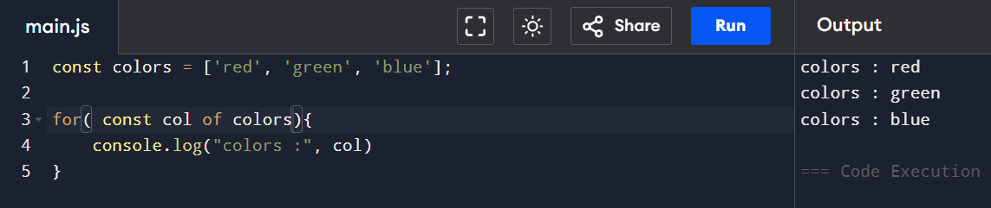
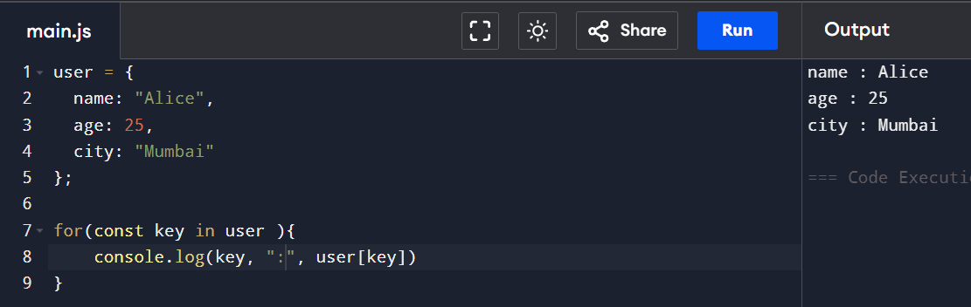
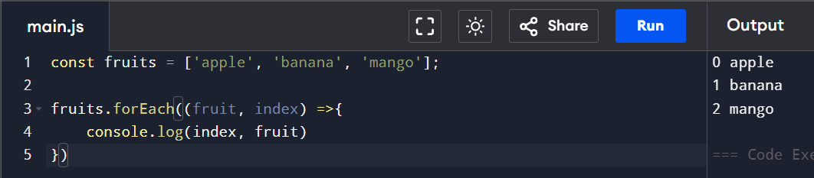

🤔 throw statement, try {} catch(){ }, finally{ };
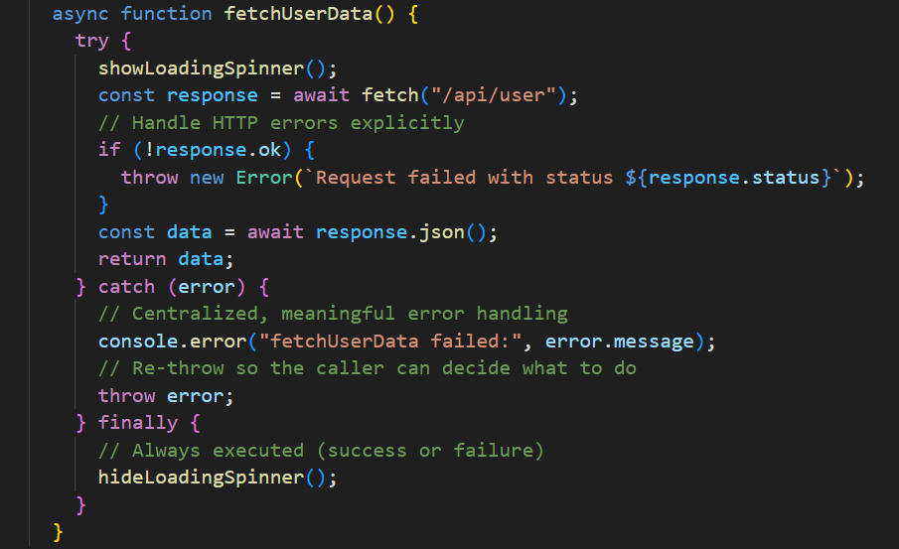

🤔 Imp Array Methods & String Methods
Array Methods
concat()
indexOf()
join()
lastIndexOf()
pop()
push()
reverse()
shift()
slice()
sort()
splice()
toString()
unshift()
valueOf()

String Methods
charAt()
charCodeAt()
concat()
fromCharCode()
indexOf()
lastIndexOf()
match()
replace()
search()
slice()
split()
substr()
substring()
toLowerCase()
toUpperCase()
valueOf()

🤔 How many ways to create Objects ?
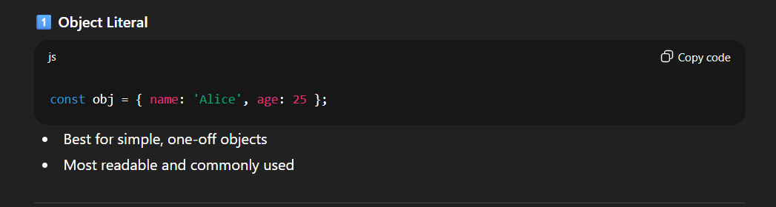
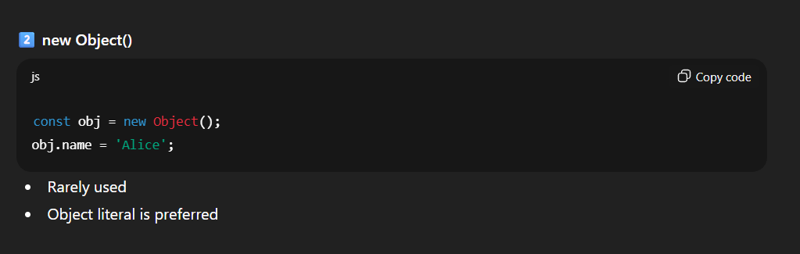
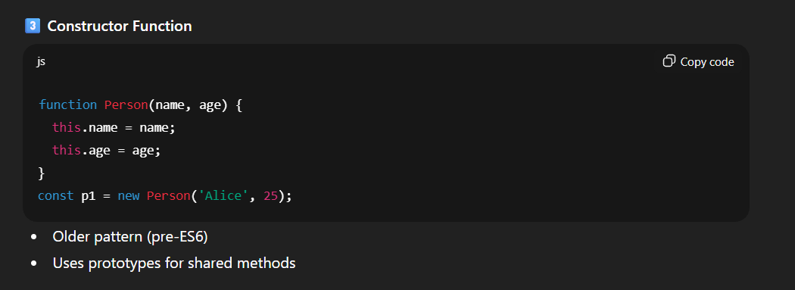
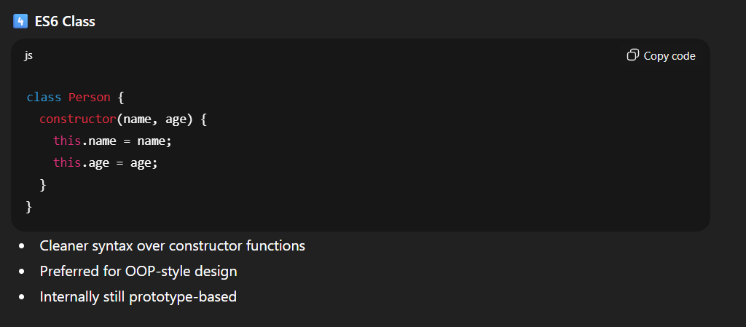
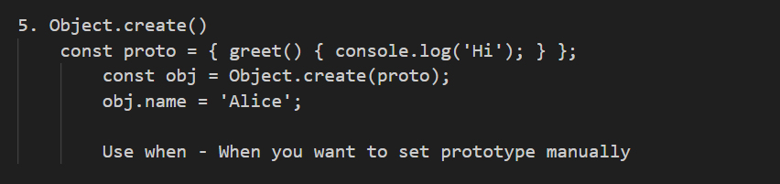
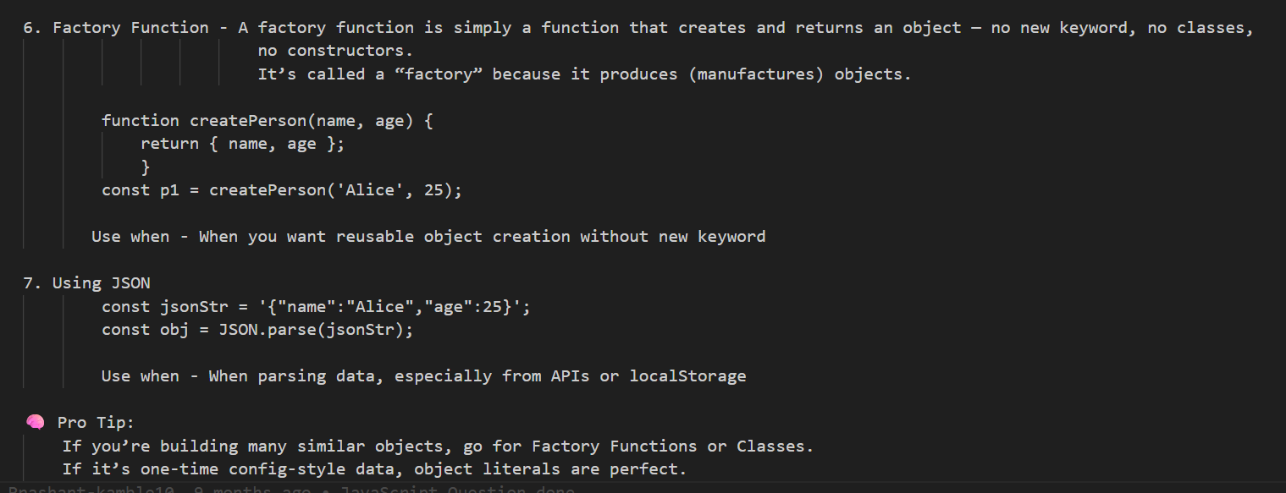
“In real projects, object literals are most common, factories are great for flexibility, and classes are used when an OOP structure is needed.”

🤔 How add, delete, modify properties in Object ?
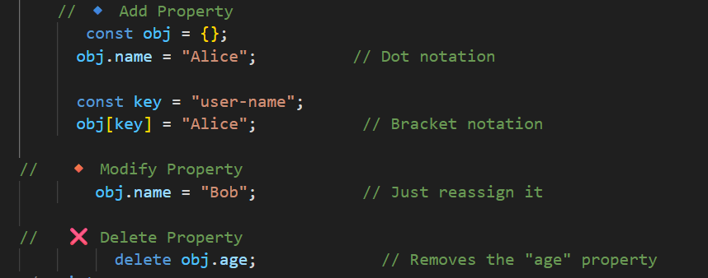

🤔 common methods to iterate over properties of object ?
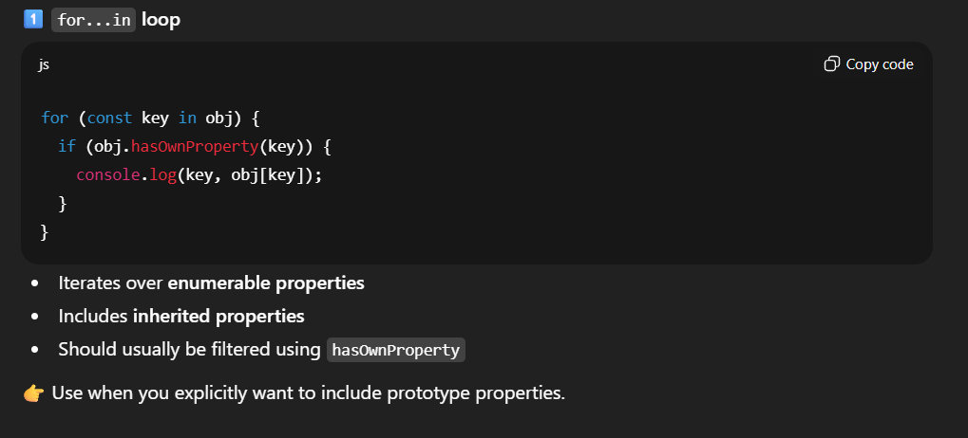
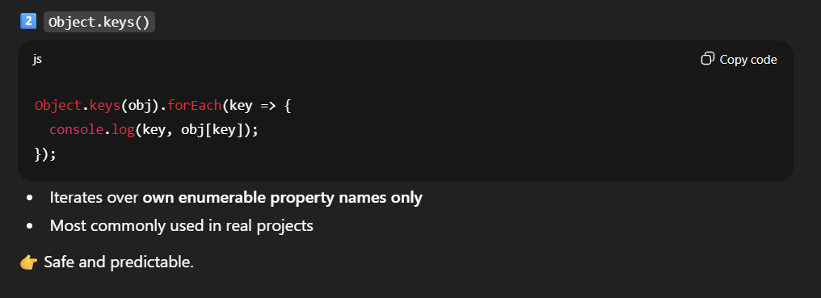
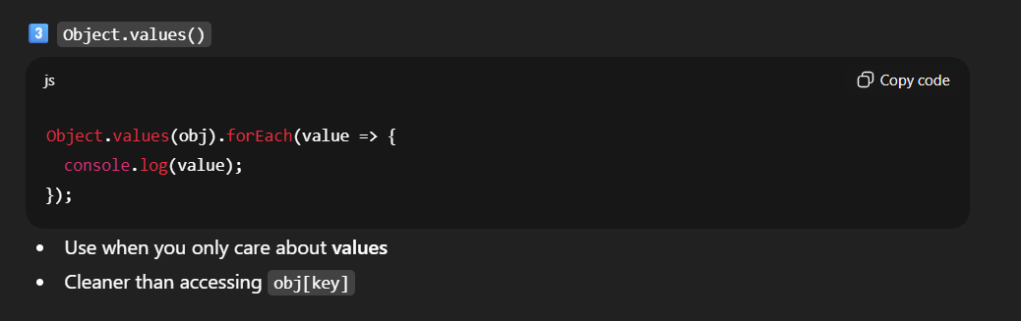
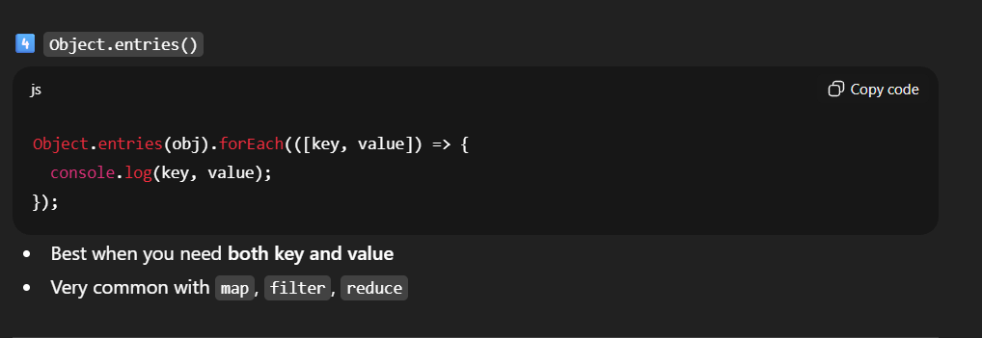
“In modern JavaScript, Object.entries() is the most flexible and commonly used approach.”
Or
“for...in should be used carefully because it iterates inherited properties.”

🤔 confirm property exist or not in object ?
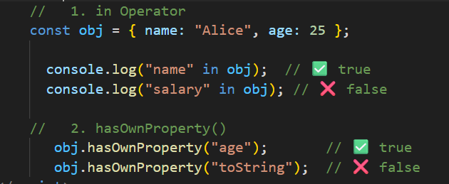

🤔 How add, delete, modify elements in array ?
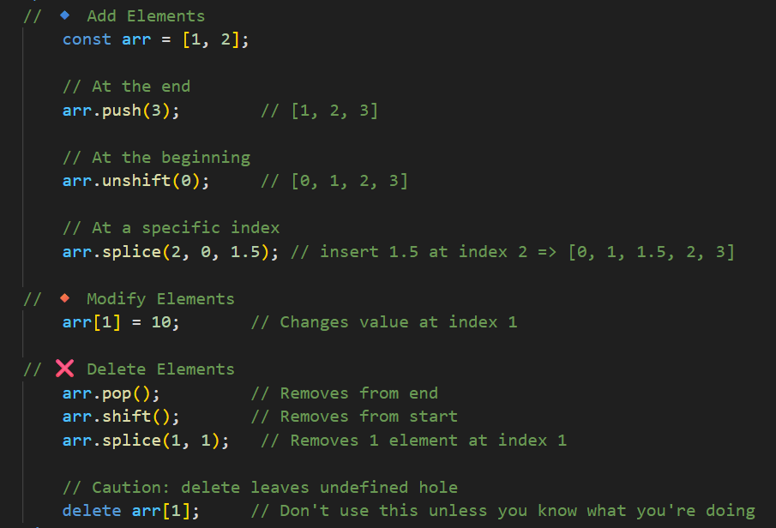

🤔 common methods to iterate over elements of array ?
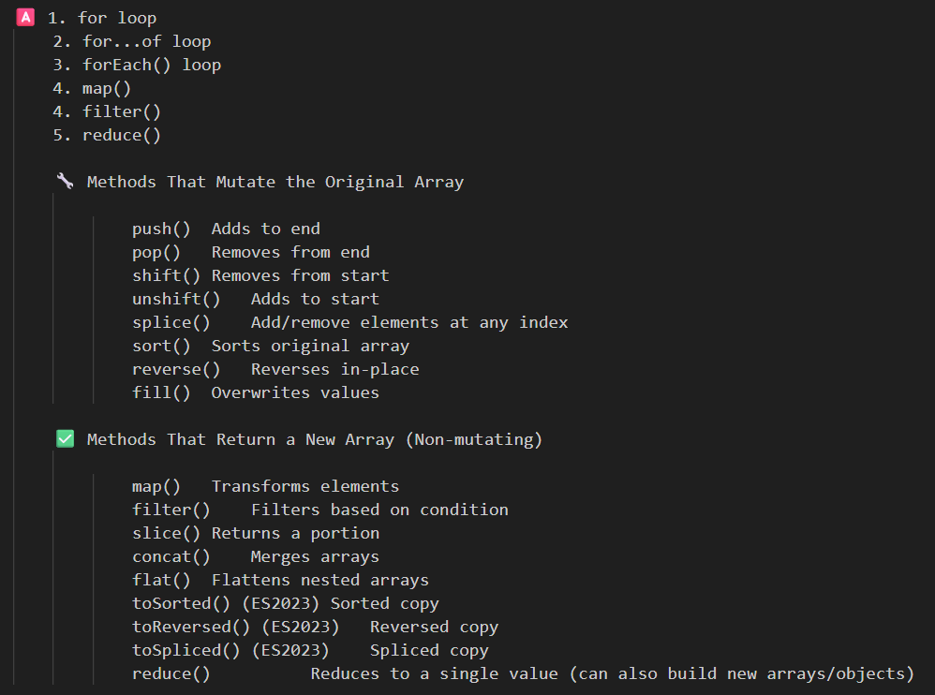

🤔 confirm elements exist or not in array ?
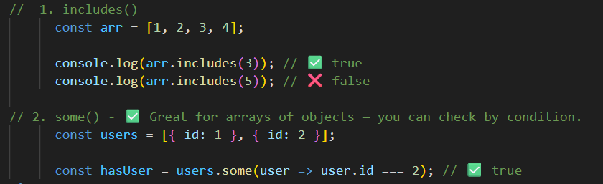

🤔 how to select, modify, create, remove DOM ?
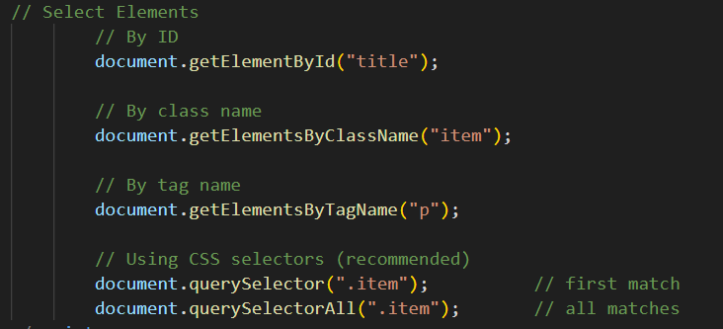
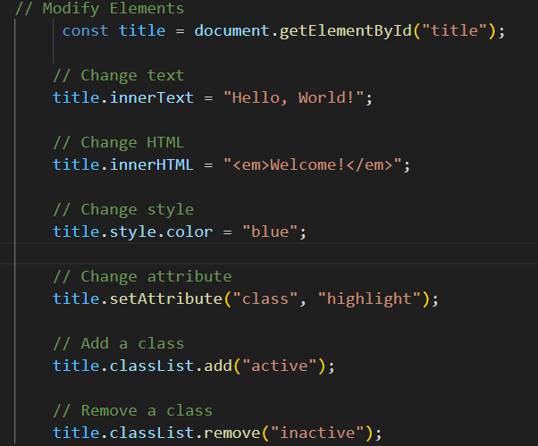
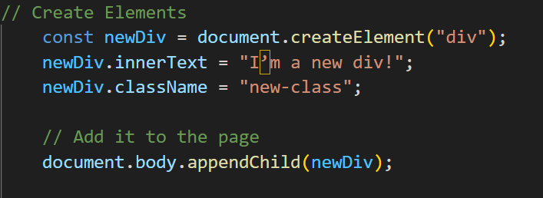
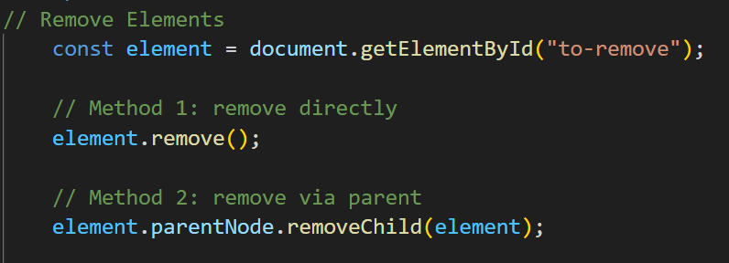
Use querySelector and querySelectorAll for most modern use cases — they support CSS-like selectors and are more flexible.

🤔 Debouncing ?
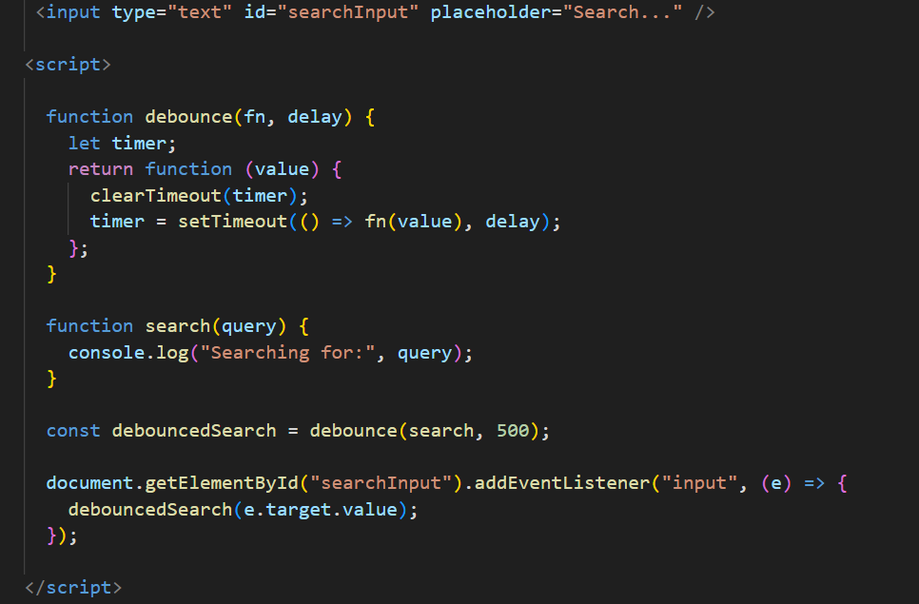

🤔 Throttling ?
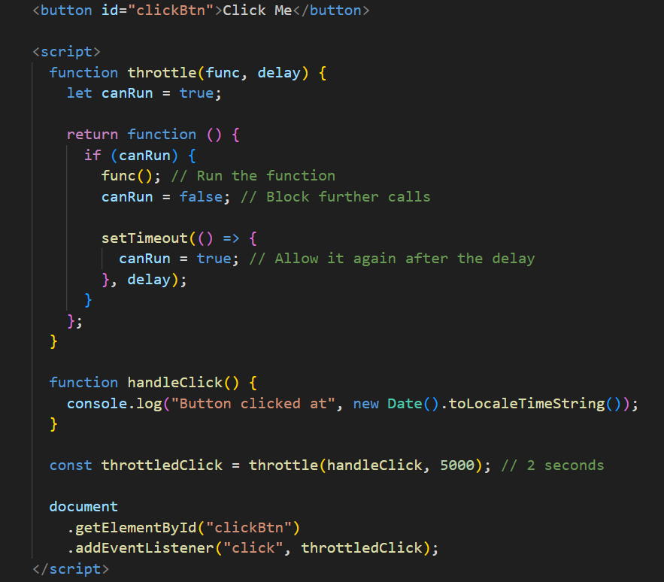

🤔 Recursion ?
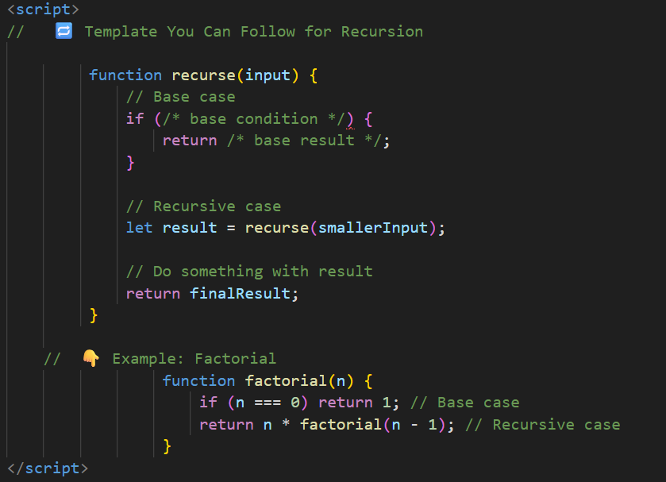

🤔 event-related concepts or mechanisms -> propogation , bubbling, capturing/trickling, delegation,?
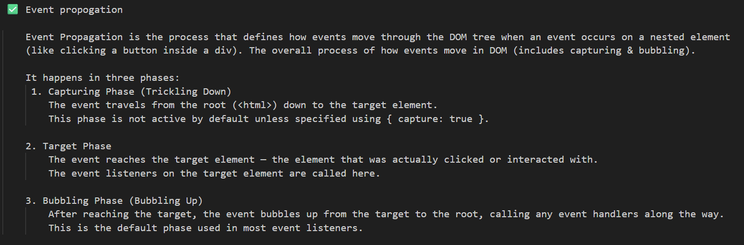

Event Bubbling
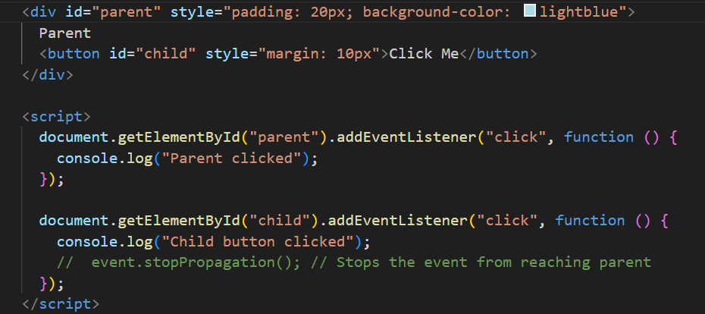
When you used event.stopPropogation(), so used function(event) { },
here you have missed it

Event capturing/trickling
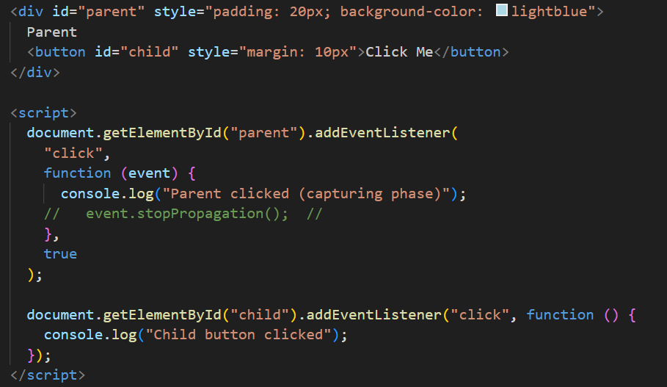

Event delegation
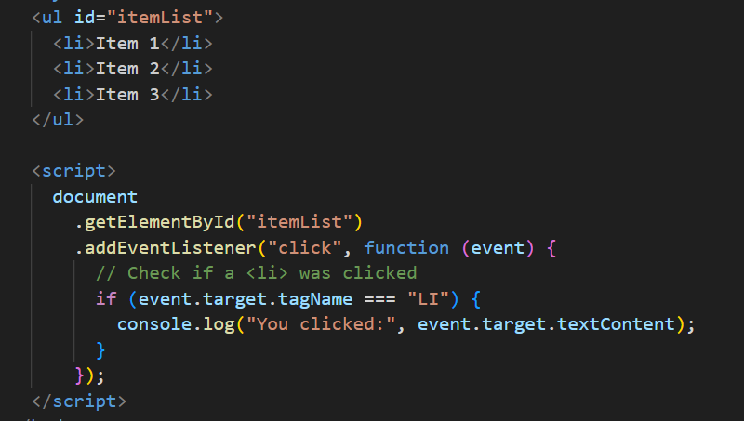

🤔 Arrow function can be used as a contructor ? If new keyword is used ?
No. Arrow functions cannot be used as constructors, even if you use the new keyword.
- No [[Construct]] internal method
- 2. Arrow functions don’t have this
- Arrow functions don’t have prototype
-------------------------------------------------------------------------------------------------------------------------------------

🤔 write h1 tag in html, js, reactsjs

🤔 React Element vs React functional component ?

🤔 JS statement vs JS Expression ?

🤔 Reconciliation

🤔 state, props ?

🤔 useState

🤔 one way vs two way - data binding ?

🤔 state lifting up, prop drilling ?

🤔 controlled vs uncontrolled component ?

🤔 useEffect, APIs call - fetch, axios ? class based vs functional based component ?

🤔 props & state in class based component ?

🤔 mounting phase -> componentDidMount(), render(),
updating phase -> shouldComponentUpdate(), componentWillUpdate(), componentDidUpdate(),
unmounting phase -> componentWillUnmount(),
compare above methods with useEffect() ?

🤔 custom hooks ?

🤔 HOC ?

🤔 useContext, createContext, context-provider, user-context-consumer ?

🤔 Redux, redux toolkit, Dispatch, slice, slicer, Action, Reducer, selector, subscribe, zustand ?

🤔 useMemo ,useCallback, useRef ?
-------------------------------------------------------------------------------------------------------------------------------------

