TECHNICAL ARCHITECTURE
Agentic Multi-Product Client Onboarding Platform
Best-in-Class, Scalable, In-House & Self-Hosted Design
Deployment: Hybrid (on-prem core + private-cloud Kubernetes) | Scale: Regional bank
Companion to the Business Requirements Document v1.0
Version 1.0 | Draft for Review | June 2026

Document Control
Attribute | Detail
Document title | Technical Architecture — Agentic Multi-Product Client Onboarding Platform
Version | 1.0 (Draft)
Companion to | BRD v1.0 — Agentic Multi-Product Client Onboarding Platform
Deployment model | Hybrid: on-prem systems of record + private-cloud Kubernetes platform
Target scale | Regional bank — ~5–20K onboardings/month, hundreds concurrent
Build posture | Built, owned, and operated in-house; self-hosted OSS building blocks
Audience | Architecture, Engineering, Platform, Security, Compliance, Risk

Table of Contents

1. Architecture Overview
This document defines the target technical architecture for the agentic, multi-product client onboarding platform specified in the BRD. It is designed to be best-in-class on four axes — scalability, resilience, security, and regulatory defensibility — while remaining fully in-house: every component is owned and operated by the bank and self-hosted on bank infrastructure, with no dependency on external managed/SaaS services. Mature open-source engines are self-hosted as internal building blocks rather than rebuilt from scratch.

1.1 Guiding Principles
- Declarative over hard-coded: agents, skills, and criteria are data in a registry; new agents are onboarded without redeploying the platform.
- Criteria-driven activation over a shared blackboard: agents are triggered by entry predicates against shared state, never by a fixed central graph.
- Control plane / execution plane separation: definitions and governance are isolated from runtime orchestration.
- Durable by default: long-running journeys (days–weeks) persist state and survive process and node failures.
- Event-driven and loosely coupled: components communicate via events; shared-core work is performed once and consumed many times.
- Zero-trust security and least privilege for every human and every agent/workload.
- Everything observable, auditable, and replayable from an immutable decision log.
- Right-sized for regional scale today, horizontally scalable to national scale without re-architecture.

1.2 High-Level Architecture (described)
Logically the platform is two planes over a shared data substrate. The control plane hosts the Agent Registry, Skill Catalog, the Criteria & Wiring Designer, and Lifecycle Governance. The execution plane hosts the Orchestrator, the Blackboard (shared context store), the Criteria/Rules Engine, the Durable Workflow Engine, the Event Bus, the Tool/MCP Gateway, the Policy & Guardrails service, the Human Task Service, and the Decision Log/Observability stack.
Request flow: a client request enters through the API gateway into the Client Portal and Onboarding API. The Orchestrator reads agent definitions from the registry and, as client state lands on the Blackboard, evaluates entry criteria and dispatches agents. Each agent executes inside a durable workflow, calls external systems only through the MCP Gateway, writes results back to the Blackboard, and emits events on the bus. The on-prem systems of record (core banking, plus existing decisioning) are reached over secure private links via the MCP Gateway; everything else runs in private-cloud Kubernetes.
Trust boundaries: (a) public edge → portal/API; (b) platform mesh (Kubernetes) where agents and services run; (c) the on-prem zone reached only through the audited MCP Gateway. All cross-boundary calls are authenticated, authorized, and logged.
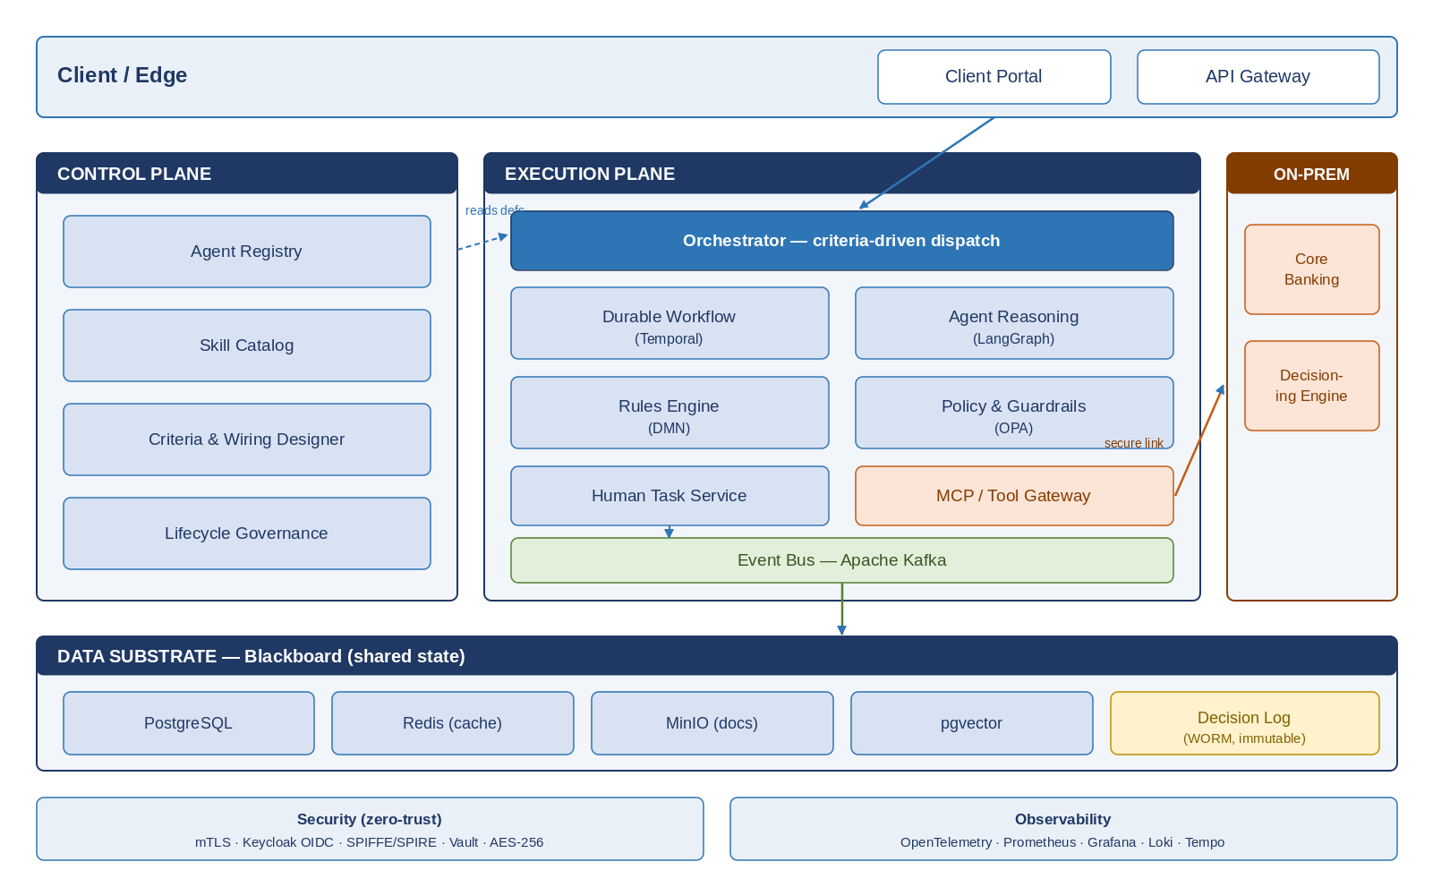
Figure 1 — Logical component architecture (control plane, execution plane, data substrate, and on-prem zone).

2. Component Architecture
Each component, its responsibility, the chosen self-hosted technology, and the rationale. (Plane: C = control, X = execution, P = platform/edge.)
Component | Responsibility | Technology | Why
Agent Registry (C) | Versioned declarative agent definitions; source of truth for the orchestrator. | Spring Boot service + PostgreSQL | Bespoke differentiator; relational integrity + versioning.
Skill Catalog (C) | Reusable skill (know-how) bundles referenced by agents. | Service + PostgreSQL + object store | Versioned content with binary artifacts.
Criteria & Wiring Designer (C) | UI for authoring skills, criteria, and wiring; DMN decision tables. | React UI + Camunda DMN (self-hosted) | Business-authorable rules without code.
Lifecycle Governance (C) | Validate, sandbox, approve, version, deprecate agents. | Workflow + GitOps approvals | Change control for a regulated environment.
Orchestrator (X) | Matches blackboard state to entry criteria; dispatches agents. | Spring Boot + Kafka consumers | Data-driven, horizontally scalable dispatcher.
Blackboard / shared store (X) | Client master, shared-core docs, check results; change events. | PostgreSQL + Redis + MinIO + pgvector | Strong-consistency core, fast cache, S3-compatible docs.
Criteria / Rules engine (X) | Evaluate entry/exit predicates and decision tables. | Camunda DMN + custom predicate evaluator | Declarative, testable, fast evaluation.
Durable Workflow engine (X) | Long-running state, timers, retries, recovery. | Temporal (self-hosted, Java/Python SDK) | Battle-tested durable execution; avoids rebuilding.
Agent Reasoning runtime (X) | Agent control flow and LLM reasoning. | Python services on LangGraph (self-hosted) | Cyclic agent graphs; rich AI ecosystem.
Event Bus (X) | Asynchronous hand-offs and event sourcing. | Apache Kafka (self-hosted) | High-throughput, durable, replayable log.
Tool / MCP Gateway (X) | Governed, audited access to integrations & on-prem core. | MCP servers + Spring Cloud Gateway | Single controlled egress with policy + audit.
Policy & Guardrails (X) | Authority limits and mandatory human checkpoints. | Open Policy Agent (OPA/Rego) | Decoupled, declarative, externally testable policy.
Human Task Service (X) | Review/approval queues with full context. | Spring Boot service + PostgreSQL | Bespoke ops UX and SLAs.
Decision Log & Observability (X) | Immutable audit + metrics/traces/logs. | Append-only store + OpenTelemetry, Prometheus, Grafana, Loki, Tempo | Explainability and operational insight.
API Gateway & Portal (P) | Edge entry, authN, rate limiting, client UX. | Kong / Spring Cloud Gateway + React | Secure, throttled edge.

3. Criteria-Driven Activation & Orchestration
The Orchestrator is stateless and horizontally scalable. It loads active agent definitions from the registry (cached in Redis, invalidated on registry change events) and subscribes to Blackboard change events on Kafka. On each relevant state change for a client, it evaluates the entry predicates of candidate agents via the Rules Engine. Predicates are indexed by the state attributes they reference, so evaluation is restricted to agents whose triggering attributes changed — avoiding a full scan and keeping evaluation O(matching-agents), not O(all-agents).
When an entry predicate is satisfied, the Orchestrator starts (or signals) a durable workflow in Temporal for that agent-and-client, guaranteeing exactly-once activation through an idempotency key of {clientId, productId, agentId, definitionVersion}. The agent executes its skills, calls tools only through the MCP Gateway, writes outputs to the Blackboard, and signals its exit criteria. Exit events re-enter the same evaluation loop, potentially satisfying downstream agents’ entry criteria. Parallelism across products is natural: independent product journeys are independent workflow executions sharing the same Blackboard.
On-the-fly onboarding: registering a new approved agent definition publishes a registry-change event; orchestrators refresh their cache and immediately begin evaluating the new entry criteria against existing state — no redeploy, no central graph edit. In-flight cases remain pinned to the agent version they started with.
First-to-complete go-live: a per-product Activation workflow watches each product’s activation criteria; the first product to satisfy them triggers provisioning via the MCP Gateway to on-prem core banking, while other product workflows continue independently.
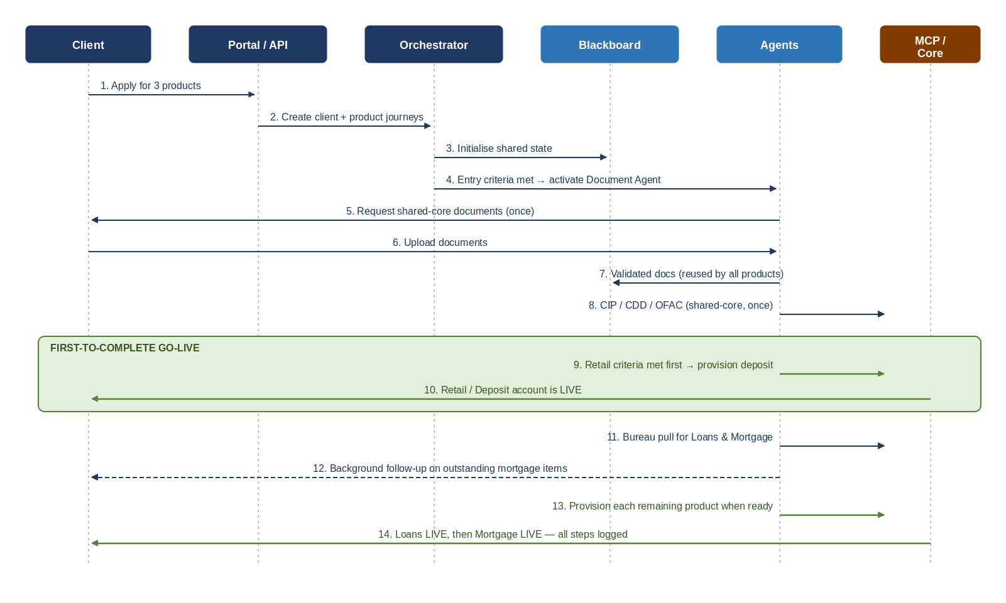
Figure 2 — Parallel onboarding sequence with first-to-complete go-live (deposit activates while loans/mortgage continue).

4. Data Architecture

4.1 Core Entities & Stores
Data | Store | Consistency | Notes
Client master & product journeys | PostgreSQL (primary) | Strong | Authoritative relational state; ACID.
Blackboard working state | PostgreSQL + Redis cache | Strong (DB), eventual (cache) | Cache for read-heavy predicate evaluation.
Documents (shared-core + specific) | MinIO (S3-compatible), encrypted | Strong (object) | Versioned; references stored in DB.
Events / hand-offs | Apache Kafka | At-least-once, ordered per key | Event sourcing & replay; keyed by clientId.
Decision log / audit | Append-only store (Postgres + WORM/object) | Strong, immutable | Tamper-evident; retention-governed.
Embeddings (optional retrieval) | pgvector / Qdrant | Eventual | Semantic lookup for skills/docs.
Workflow state | Temporal (its own persistence) | Strong/durable | Managed by the engine.

4.2 Consistency Model
Strong consistency is used where correctness is non-negotiable: the client master, product-journey state, activation decisions, and the audit log. Eventual consistency is accepted for caches, embeddings, and cross-service read projections, where a brief lag is harmless. Activation gating is always evaluated against the strongly consistent store, never the cache, so a product can never be activated on stale state.

4.3 Partitioning, Caching & Retention
- Partitioning: Kafka topics and workflows are keyed by clientId so all events and journeys for a client are ordered and co-located; this also gives a natural horizontal shard key as volume grows.
- Caching: agent definitions and hot blackboard reads are cached in Redis with event-driven invalidation; never cache activation-gating reads.
- Retention: BSA-aligned minimum 5-year retention on documents and audit records, enforced by retention class on each object; WORM storage for the audit log; US data residency on all stores.

5. Scalability & Performance
At regional scale (~20K onboardings/month ≈ ~700/business-day, low-hundreds concurrent, with multiplied agent activity per onboarding), the load is modest; the architecture is deliberately right-sized but horizontally scalable. The design avoids any single-writer bottleneck: stateless services scale by replica count, Kafka and Temporal scale by partitions/shards, and PostgreSQL scales via read replicas with a clear future path to logical sharding by clientId.
Layer | Scaling Strategy | Headroom
API/Portal & Orchestrator | Stateless pods behind HPA (CPU/queue-depth). | Linear with replicas.
Agent reasoning runtime | Stateless workers; scale by Temporal task-queue backlog. | Linear; GPU pool for models.
Durable workflow engine | Temporal horizontal scaling; partitioned task queues. | Tens of thousands of concurrent workflows.
Event bus | Kafka partitions keyed by clientId. | Repartition to grow throughput.
Primary database | Read replicas now; logical sharding by clientId later. | 10x growth before sharding needed.
Cache / object / vector | Redis cluster, MinIO scale-out, vector horizontal. | Independent scale-out.

5.1 Performance Targets
Metric | Target
Portal API latency (p95) | < 500 ms; < 2 s for composite views
Document validation feedback | < 5 s after upload (sync checks)
Entry-criteria evaluation to dispatch | < 1 s after state change (p95)
Sustained event throughput | ≥ 200 events/s with 5x burst headroom
Concurrent active onboardings | Hundreds, scalable to thousands
Back-pressure: producers respect consumer lag; the Orchestrator sheds load gracefully by queuing rather than dropping; long-running external calls are isolated behind bulkheads and timeouts so one slow integration cannot exhaust shared capacity.

6. Resilience & Reliability

6.1 Recommended Availability & DR Targets
Recommendation for regulated onboarding at regional scale: target 99.95% availability for the onboarding service (≈ 4.4 hours/year), delivered active-active across two availability zones in the primary private-cloud region, with active-passive disaster recovery to a secondary site. Set RTO ≤ 15 minutes and RPO ≈ 0 for critical stores (synchronous replication of the client master, workflow state, and audit log); RPO ≤ 5 minutes for non-critical projections. This balances cost against the regulatory and customer expectations of bank onboarding; 99.99%/multi-region active-active is reserved for a later phase if volumes justify it.

6.2 Reliability Mechanisms
- Idempotency everywhere: all agent activations, tool calls, and provisioning use idempotency keys so retries never double-create accounts.
- Durable execution: Temporal persists workflow state and resumes after failures exactly where it left off.
- Sagas & compensation: multi-step provisioning uses compensating actions to roll back partial work cleanly.
- Delivery semantics: at-least-once event delivery plus idempotent consumers yields effectively exactly-once processing.
- Isolation: circuit breakers, timeouts, retries with backoff, and bulkheads around every external integration.
- Self-healing: Kubernetes restarts/reschedules unhealthy pods; health and readiness probes gate traffic.
- DR drills: regular failover testing to the secondary site to validate RTO/RPO.

7. Security & Compliance Architecture

7.1 Security Controls
- Zero-trust: no implicit trust between services; every call is authenticated and authorized; mutual TLS across the service mesh.
- Human identity: OIDC SSO via Keycloak (self-hosted); RBAC/ABAC for staff and authoring roles.
- Workload & agent identity: SPIFFE/SPIRE issues short-lived identities to every service and agent; least-privilege scopes per agent definition.
- Secrets: HashiCorp Vault for credentials, keys, and dynamic secrets; no secrets in code or config.
- Encryption: TLS 1.3 in transit, AES-256 at rest on all stores; field-level encryption/tokenization for PII (SSN, account numbers).
- Egress control: all external and on-prem access flows through the MCP Gateway with allow-listing, policy checks, and full audit.
- Audit immutability: append-only, tamper-evident decision log on WORM storage.
- Network: segmented zones (edge, platform mesh, on-prem) with strict firewall/mesh policy between them.

7.2 Regulatory Enforcement (technical mapping)
Regulation | How the Architecture Enforces It
BSA / FinCEN; CIP | Compliance Agent runs identity/CIP via MCP Gateway; results gate activation; 5-year WORM retention.
CDD / beneficial ownership | Entity flows trigger BO collection/verification agents; risk tier drives EDD; all decisions logged.
OFAC screening | Mandatory sanctions check step on all parties; positive hits hard-block and escalate.
GLBA (privacy & Safeguards) | Encryption, access control, and PII tokenization; privacy-notice step in journey.
FCRA / ECOA | Credit Agent enforces permissible purpose; adverse-action records generated; reason codes captured.
TRID (mortgage) | Disclosure tasks with timing SLAs enforced by durable workflow timers.
SEC / FINRA (Reg BI, KYC) | Wealth suitability agent + RM/compliance checkpoints required before activation.
CCPA / CPRA | Consent and data-subject-request handling; data lineage in the decision log.

8. AI / Agent Layer
- Model serving: self-hosted/private-tenant LLMs behind an internal Model Gateway (e.g., vLLM-served models or a private-tenant enterprise model), so no client data leaves bank control.
- Prompt & skill management: skills (instructions) are versioned in the Skill Catalog; prompts are templated, reviewed, and version-pinned per agent definition.
- Tooling: agents access systems only via MCP servers behind the gateway — never directly — giving uniform auth, rate-limiting, and audit.
- Guardrails: OPA policy and authority limits bound what an agent may decide autonomously; mandatory human checkpoints for high-risk/EDD and over-limit approvals.
- Evaluation: an offline eval harness scores new agents/skills against synthetic and replayed cases in the sandbox before promotion; live sampling/QA continues in production.
- Hallucination & safety controls: structured outputs with schema validation, grounding against authoritative state, and confidence thresholds that escalate to humans on uncertainty.
- Cost & rate governance: per-agent token/cost budgets and rate limits at the Model Gateway; runaway loops are bounded by workflow step limits.
- Explainability: every agent decision logs its inputs, the skill/prompt version, tool calls, and rationale, so any decision is reproducible and reviewable.

9. Deployment & Operations

9.1 Hybrid Topology
Systems of record (core banking and existing decisioning) remain on-prem. The onboarding platform runs in private-cloud Kubernetes (e.g., OpenShift) across two AZs in the primary region, with a secondary DR site. The two zones are bridged by secure private connectivity; the MCP Gateway is the sole, audited path from the platform into the on-prem zone.
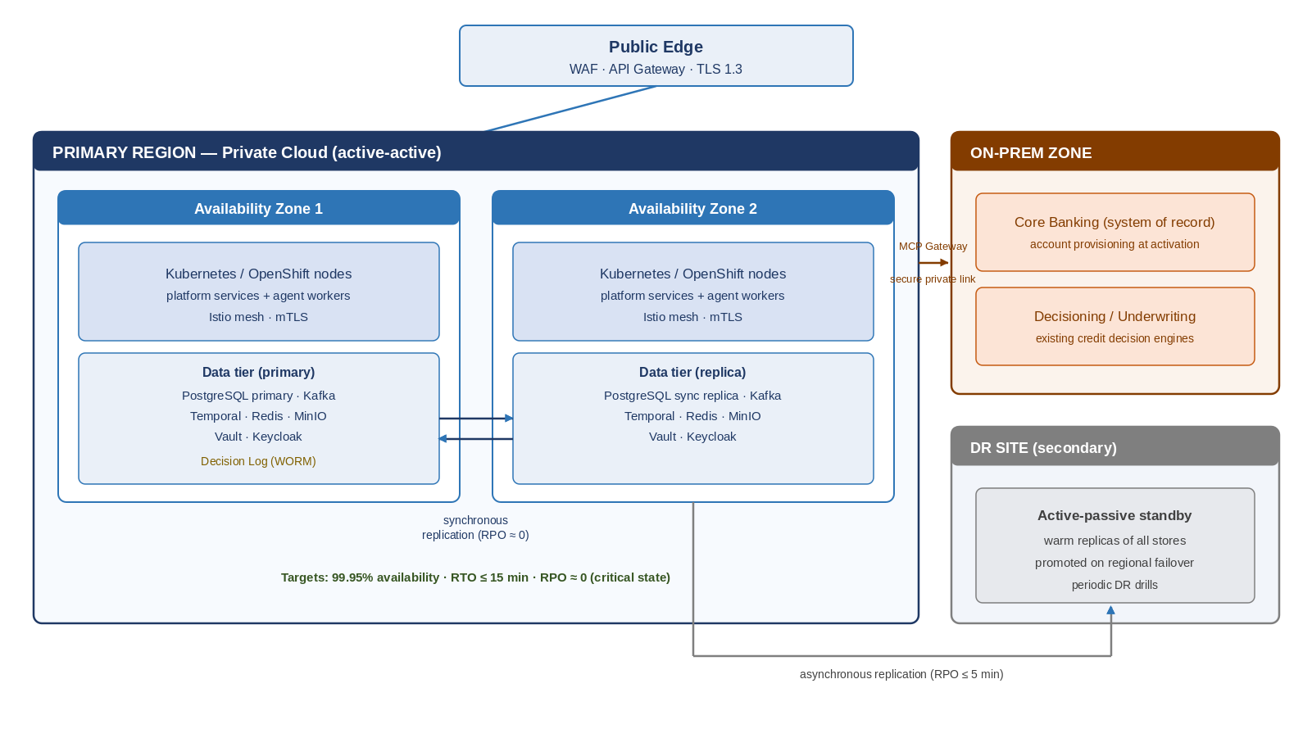
Figure 3 — Hybrid deployment topology (dual-AZ active-active primary region, on-prem zone, and active-passive DR site).

9.2 Engineering & Operations
Concern | Approach
Containers & orchestration | Kubernetes/OpenShift; Istio service mesh for mTLS and traffic policy.
CI/CD | Pipeline with automated tests, security scans, and image signing; GitOps via Argo CD.
Infrastructure as Code | Terraform for infra; Helm/Kustomize for workloads; everything versioned.
Environments | Dev → Test → Sandbox (agent eval) → Staging → Production, isolated.
Observability | OpenTelemetry instrumentation; Prometheus + Grafana (metrics), Loki (logs), Tempo (traces).
SLOs & alerting | Error-budget-based SLOs per service; alerting and runbooks; on-call rotation.
Backup & DR | Automated backups; periodic restore and failover drills.

10. Non-Functional Targets
Category | Target
Availability (onboarding service) | 99.95% (active-active, dual-AZ)
RTO / RPO | RTO ≤ 15 min; RPO ≈ 0 for critical stores
API latency (p95) | < 500 ms (simple); < 2 s (composite)
Event throughput | ≥ 200 events/s sustained; 5x burst
Durability | ≥ 99.999999999% for documents & audit (replicated/object)
Scalability | 10x volume growth before structural change
Security | Zero-trust, mTLS, AES-256 at rest, TLS 1.3 in transit
Auditability | 100% of decisions logged immutably; 5-year retention
Accessibility | Client portal WCAG 2.1 AA

11. Key Trade-offs & Risks
Decision | Rejected Alternative | Rationale / Mitigation
Self-host Temporal for durable execution | Build a custom workflow engine | Rebuilding distributed durable state is high-risk; self-hosting keeps it in-house while de-risking.
Blackboard + criteria activation | Static central agent graph | Enables on-the-fly onboarding and parallelism; mitigate complexity with strong predicate tooling/linting.
Polyglot (JVM core + Python AI) | Single-language stack | Best ecosystem per concern; mitigate with clear contracts and the MCP boundary.
99.95% dual-AZ (not multi-region) | Multi-region active-active | Right-sized for regional scale/cost; path to multi-region preserved for later.
Strong consistency on gating state | Fully eventual consistency | Prevents premature activation; accept slightly higher write latency.
MCP Gateway as sole egress | Direct service-to-system calls | Central auth/audit/policy; mitigate latency with connection pooling and caching.
Self-hosted private LLMs | External LLM APIs | Data never leaves bank control; mitigate ops burden with a managed internal model platform.

12. Reference Technology Stack
Capability | Technology (self-hosted) | Rationale
Durable workflow | Temporal | Proven durable execution; multi-language SDKs.
Agent reasoning | LangGraph (Python) | Cyclic agent graphs; rich AI tooling.
Core services | Java + Spring Boot | Enterprise-grade, well-supported on JVM.
Rules / decisioning | Camunda DMN + custom evaluator | Business-authorable decision tables.
Event streaming | Apache Kafka | Durable, replayable, high-throughput.
Relational store | PostgreSQL | ACID, mature, replicable, shardable.
Cache | Redis | Low-latency reads; cluster mode.
Object storage / ECM | MinIO (S3-compatible) | Self-hosted versioned document store.
Vector store | pgvector / Qdrant | Semantic retrieval when needed.
Policy engine | Open Policy Agent (Rego) | Decoupled, declarative guardrails.
Tool access | MCP servers + API gateway | Uniform, audited integration egress.
Identity (human) | Keycloak (OIDC) | Self-hosted SSO, RBAC/ABAC.
Identity (workload) | SPIFFE / SPIRE | Short-lived per-workload identity.
Secrets | HashiCorp Vault | Central secrets & dynamic credentials.
Orchestration | Kubernetes / OpenShift + Istio | Scaling, self-healing, mTLS mesh.
CI/CD & IaC | Argo CD + Terraform + Helm | GitOps, reproducible infra.
Observability | OpenTelemetry, Prometheus, Grafana, Loki, Tempo | Unified metrics/logs/traces.
Model serving | vLLM / private-tenant model gateway | In-house, data-resident inference.

13. Phased Build & Evolution
Phase | Architecture Focus | Outcome
P1 — Foundations | Kubernetes, mesh, Postgres, Kafka, Temporal, registry, blackboard, observability, security baseline. | Platform skeleton; Retail/Deposit live with criteria-driven activation.
P2 — Agents & rules | MCP Gateway, OPA guardrails, DMN designer, model gateway, sandbox eval. | On-the-fly agent onboarding; Loans in parallel.
P3 — Scale & resilience | Read replicas, dual-AZ active-active, DR site, autoscaling. | 99.95% SLA; Wealth/Mortgage; first-to-complete go-live at scale.
P4 — Optimize & extend | Sharding readiness, multi-region option, advanced analytics. | Headroom to national scale; new products added by definition.

Appendix A — Parallel Onboarding Sequence (described)
Illustrative end-to-end flow for a client onboarding to Retail/Deposit, Loans, and Mortgage simultaneously, ending in first-to-complete go-live.
1. Client applies via portal; Onboarding API creates the client master and three product journeys on the Blackboard.
2. Orchestrator evaluates entry criteria; the Document Collection Agent requests shared-core documents once.
3. On document upload, the Validation Agent verifies; results land on the Blackboard and are reused by all three products.
4. Compliance Agent runs CIP/CDD/OFAC (shared-core) once; risk tier set; EDD triggered if needed.
5. Retail/Deposit has no further requirements → its Activation workflow finds criteria met → provisions the deposit account via MCP Gateway to on-prem core → product goes LIVE.
6. In parallel, the Credit Agent pulls bureau data for Loans and Mortgage; affordability assessed; mortgage adds appraisal/title and TRID disclosure tasks (timer-bound).
7. Follow-up Agent continues nudging the client for outstanding mortgage items after deposit is already live.
8. As each remaining product meets its criteria, its Activation workflow provisions it independently; every step is written to the immutable decision log.

End of document.

