1. Exploring the Company Websites
366Pi Technologies



Key Takeaway 1: Technology with a Purpose
One thing that immediately stood out while exploring 366Pi Technologies was that the company is not focused only on technology solutions it focuses on solving real-world problems through technology. Their approach combines digital transformation with sustainability, which is something many companies talk about but very few actually integrate deeply into their products and services.
They emphasize helping organizations become more sustainable through digital systems, cloud solutions, data analytics, and automation. This shows that 366Pi is trying to build technology that creates long-term environmental and social impact rather than just business profits.

Key Takeaway 2: Strong Focus on Innovation and Future Technologies
The company is highly innovation-driven. While exploring the website, I noticed their interest in modern technologies like:
- Cloud Computing
- Blockchain/Web3
- AI & Analytics
- IoT (Internet of Things)
- Microsoft Ecosystem Solutions
This reflects that 366Pi is preparing for future digital ecosystems rather than staying limited to traditional IT services. Their products and solutions are designed to evolve with upcoming technological trends.

Key Takeaway 3: Sustainability is Built into Their Ecosystem
Another important observation was that sustainability is not treated as a separate project. Instead, it is integrated into the ecosystem of their products. Whether it is reducing paper waste through FloCard or supporting reforestation initiatives through the Tree Planters ecosystem, the company connects technology with environmental responsibility in a practical and measurable way.
This gives the impression that 366Pi wants businesses and individuals to participate in sustainability through everyday digital actions.

2. Exploring FloCard

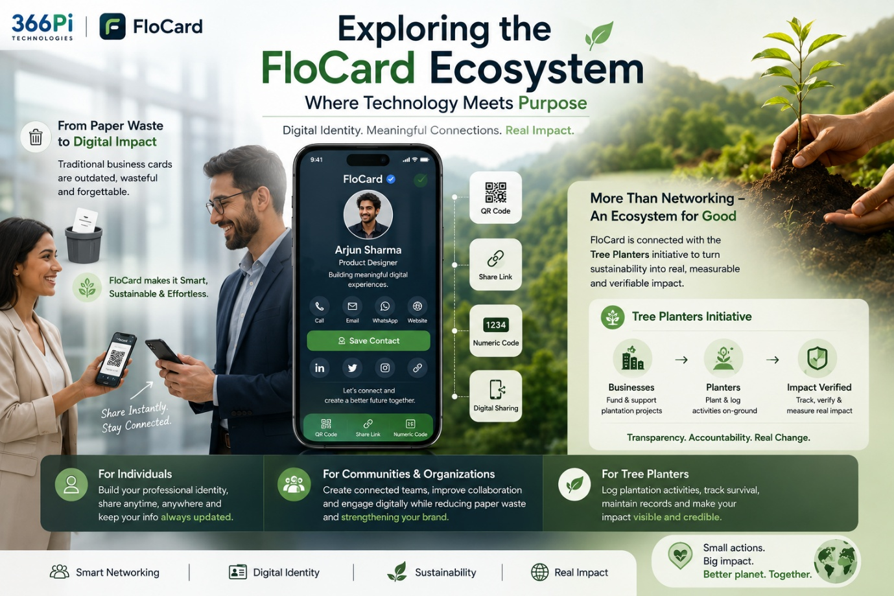
Key Takeaway 1: FloCard Modernizes Traditional Networking
Traditional business cards are expensive, easy to lose, difficult to update, and environmentally wasteful. FloCard solves this by creating digital business cards that can be shared instantly through:
- QR Codes
- Links
- NFC/Smart Sharing
- Unique Numeric Codes
The experience feels very modern and efficient. Instead of carrying stacks of paper cards, users can maintain a professional identity digitally and update information anytime without reprinting cards.

Key Takeaway 2: FloCard is More Than a Digital Card Platform
Initially, I thought FloCard was simply a digital visiting card app. But after exploring further, I realized it is part of a larger ecosystem focused on sustainability, networking, and environmental responsibility.
The integration with the Tree Planters ecosystem makes FloCard unique because every digital interaction indirectly promotes eco-friendly practices by reducing paper usage and supporting climate-focused initiatives.
This creates emotional value in addition to practical value.

Key Takeaway 3: User-Friendly and Accessible for Everyone
The platform is designed in a simple and accessible manner. Even users with very little technical knowledge can easily:
- Create a profile
- Customize cards
- Add social and professional details
- Share cards instantly
- Connect with others
The onboarding process is smooth, and the interface feels clean and professional. This makes the platform suitable for students, professionals, freelancers, entrepreneurs, and even large organizations.

3. My Experience Creating a FloCard
I signed up on FloCard and created my own digital business card. The process was smooth and intuitive from the beginning. After registering, I was able to customize my profile by adding my:
- Name
- Professional details
- Contact information
- Social media links
- Profile picture
What I liked most was the flexibility of the platform. Unlike traditional paper cards that become outdated after any small change, FloCard allows information to stay updated continuously.
I also explored the sharing feature and exchanged cards digitally with team members. The sharing process through QR codes and links felt very fast and convenient. It demonstrated how networking can become smarter, paperless, and more environmentally responsible at the same time.
Overall, the experience felt modern, practical, and aligned with the future of professional networking.

4. Understanding the FloCard Ecosystem Flow
Individual Flow
For individuals, the FloCard journey starts with creating a digital identity. A user signs up, customizes their profile, and creates a professional digital business card containing personal and professional information.
Once the card is created, it can be shared instantly through QR codes, links, or numeric codes. This removes the need for physical business cards and allows professionals to network more efficiently.
The platform also ensures that details remain updated permanently. If a user changes their phone number, designation, or company, they can update the information instantly without printing new cards.
From students and freelancers to entrepreneurs and working professionals, FloCard helps individuals build a smarter and more sustainable networking experience.

Community Flow
For communities and organizations, FloCard acts as a collaborative digital ecosystem. Teams and groups can use the platform to maintain connected networks where members can exchange information quickly and professionally.
Organizations can digitally onboard employees, improve networking during events, and create a more sustainable communication process by reducing dependency on paper-based interactions.
What makes the community flow interesting is that it creates both professional and environmental value simultaneously. Communities become digitally connected while also contributing toward eco-conscious practices.
This transforms networking from a simple exchange of information into a meaningful, purpose-driven interaction.

Tree Planter Flow
The Tree Planters ecosystem focuses on connecting sustainability initiatives with measurable action. Businesses or organizations that want to contribute toward environmental goals can support tree plantation projects through the ecosystem.
On the other side, actual planters working in the field use the platform to:
- Log plantation activities
- Track planted trees
- Maintain records
- Monitor survival rates
- Create transparent reports
This creates accountability and trust because companies can verify where their sustainability investments are going.

