

EXPENSE TRACKER APPLICATION

**Arpita Maravi1, Omprakash Dewangan2**

1UG Student, Kalinga University, Raipur (C.G.)

2Assistant Professor, Faculty of CS & IT, Kalinga University, Raipur (C.G.) Email – [arpitamaravi30@gmail.com](mailto:arpitamaravi30@gmail.com) [omprakash.dewangan@kalingauniversity.ac.in](mailto:omprakash.dewangan@kalingauniversity.ac.in)

***Abstract :*** The expense tracker app is designed for Android devices, offering users an intuitive interface to categorize and log expenses, monitor spending patterns, and generate informative reports. Combining user-friendly design with powerful features, the app streamlines expense tracking and encourages improved financial management practices. Users can effortlessly track their expenses on a daily, weekly, monthly, or yearly basis, with the app automatically generating comprehensive reports at the end of each month. This app provides essential tools for individuals looking to manage their finances effectively and gain greater control over their financial well-being. It majorly helps to achieve their financial goals. Expense tracker app is a software programe that will keeps track of a user's daily expenses and income. Now the society is very expensive, and everyone's are in a great rush to make money, so it helps user to divided all the daily costs are by using this technique. Overall, this app is a smart and automated solution for tracking their expense.

# *Keywords* - Expense Tracker, PyCharm, Python, Sqlite3

1. **INTRODUCTION**

Managing personal finances is paramount for individuals striving to maintain financial stability and realize their financial objectives. In today's dynamic landscape, navigating personal finances has grown increasingly intricate, with myriad expenses to track, budgets to manage, and goals to pursue. The ability to effectively monitor expenses serves as a linchpin for individuals seeking financial stability, forward planning, and the attainment of their financial aspirations. Traditional methods of expense tracking, including manual record-keeping and spreadsheet management, often prove cumbersome and prone to errors. However, the emergence of technology has heralded a proliferation of digital solutions aimed at simplifying personal finance management. Among these, expense tracker applications emerge as potent tools offering individuals the convenience and efficiency to monitor their expenses. These applications typically offer features such as real-time expense logging, categorization, budget allocation, and data analysis, empowering users to gain valuable insights into their spending habits and make well-informed financial decisions.

Even with numerous expense tracker applications saturating the market, there persists a demand for inventive solutions that not only simplify expense tracking but also furnish users with practical insights to enhance their financial well-being. This application is crafted to deliver an intuitive user experience, comprehensive features, and meaningful analytics. To transform it into a valuable asset for individuals striving to manage their finances effectively. Through a comprehensive analysis of user needs, requirements, and design considerations, the expense tracker application presented in this paper aims to offer a seamless user. Through a thorough examination of each aspect, we aim to provide insights into the design and development process of the application, with its potential impact on users financial well-being.

# LITERATURE REVIEW

Family Expense Manager Application

As a result, users seamlessly integrate this application into their daily routines. Once adopted, it becomes an integral aspect of their lives, facilitating the tracking and management of both individual and family expenses. This convenience enables users to effortlessly monitor their financial inflows and outflows, a task that may prove challenging amidst the demands of their daily schedules.

Personalized Expense Managing Assistant Using Android

The features like enabling users to register to the application using an existing email or social network account, it will synchronize the user's profile information to the application. Apart from this, the application can be used to gather samples of data related to user's expenses with consents and use those sample data as parameters to assess patterns of spending. Utilizing data mining techniques enables the classification of expenses, which in turn can inform market analysis and strategic planning efforts.

Personal Expense Tracker Application(2020*)*

A expense tracker app is a widely used application by most of the individuals for controlling and managing the expenses on day today or monthly or annually basis. The ultimate features like user can make transaction in the saving account and the page has href link to come back to the n dashboard, when the customer's expense information exceeds the limit, then alert will be automatically sent to user's mail id. These features makes this application user effectively to manage the expense.

Online Income and Expense Tracker

This project is work more efficient than the other income and expense tracker. The project successfully avoids the manual calculation for calculating the income and expense per month. The modules are developed efficiently and also in an attractive manner.

Researchers of Mother Terressa University(2019)

It stated an online income and budget tracker in a website mode but that project used csv mode to store data but that project had a drawback in its existing model as it can't handle the data efficiently in addition to that it wasn't user- friendly and an unpopulated data project.

All these researches above suggest some of the modern way of dealing with expense tracking. Many of the researches like these actually represents the evolution in ideas with time “evolution is not a necessity it’s more like change in thinking and time” in which we analyze estimate and evaluate the things according to new requirements. But still the kind of technology used in it is kind of projects were used in previous days there are certain android apps as well still they too also have different consequences as well as drawbacks in itself.

# Problem Identification

The Expense tracker app is an android app which helps all the user to manage their expenses in very efficient way. Even though there is availability of various digital tools and applications for personal finance management. Many individuals still struggle with effectively tracking their expenses and maintaining financial discipline. Traditional methods of expense tracking, such as pen and paper method, manual record-keeping or spreadsheet management, are often inconvenient, time-consuming, and imperfect.

In every one's life money plays a important role. A person who is not able to manage his expenses, or not able to successfully lead a household and fulfill his goals. Expense tracker applications may lack user-friendly interfaces, robust features, or personalized insights, limiting their effectiveness in helping users manage their finances efficiently. Users may encounter difficulties in navigating the application, categorizing expenses, setting budgets, or interpreting financial data, leading to frustration and disengagement. Such an application would empower individuals to track their expenses effectively, obtain practical insights regarding their financial habits, and ultimately, achieve greater financial stability and well-being.

# ARCHITECTURE OF AN EXPENSE TRACKER APP

This is the basic structure of the expense tracker app:

# User Interface

This is the front-end component that users interact with. It includes screens for adding new expenses, viewing previous records, visualizing expense distribution, managing custom tables, and generating expense reports. The UI should be intuitive and user-friendly to enhance the overall user experience.

# Back-End Services

The back-end of the app handles data storage, retrieval, and processing. It includes a database to store user records, expense categories, and other relevant information. Back-end services also manage authentication and authorization to ensure secure access to user data.

# Expense Recording Module

This module allows users to input new expenses into the app. The module should provide validation to ensure accurate and consistent data entry.

# Data Visualization Module

This module enables users to visualize their expense data through charts and graphs. The module should be capable of dynamically updating visualizations as users add or modify expenses.

# Reporting Module

The reporting module generates monthly expense reports for users. The module should offer options for filtering and sorting expenses, as well as exporting reports for further analysis or sharing.

Overall, the architecture of an Expense Tracker app is designed to provide users with a seamless and efficient experience for managing their expenses, tracking their financial activities, and gaining insights into their spending habits.

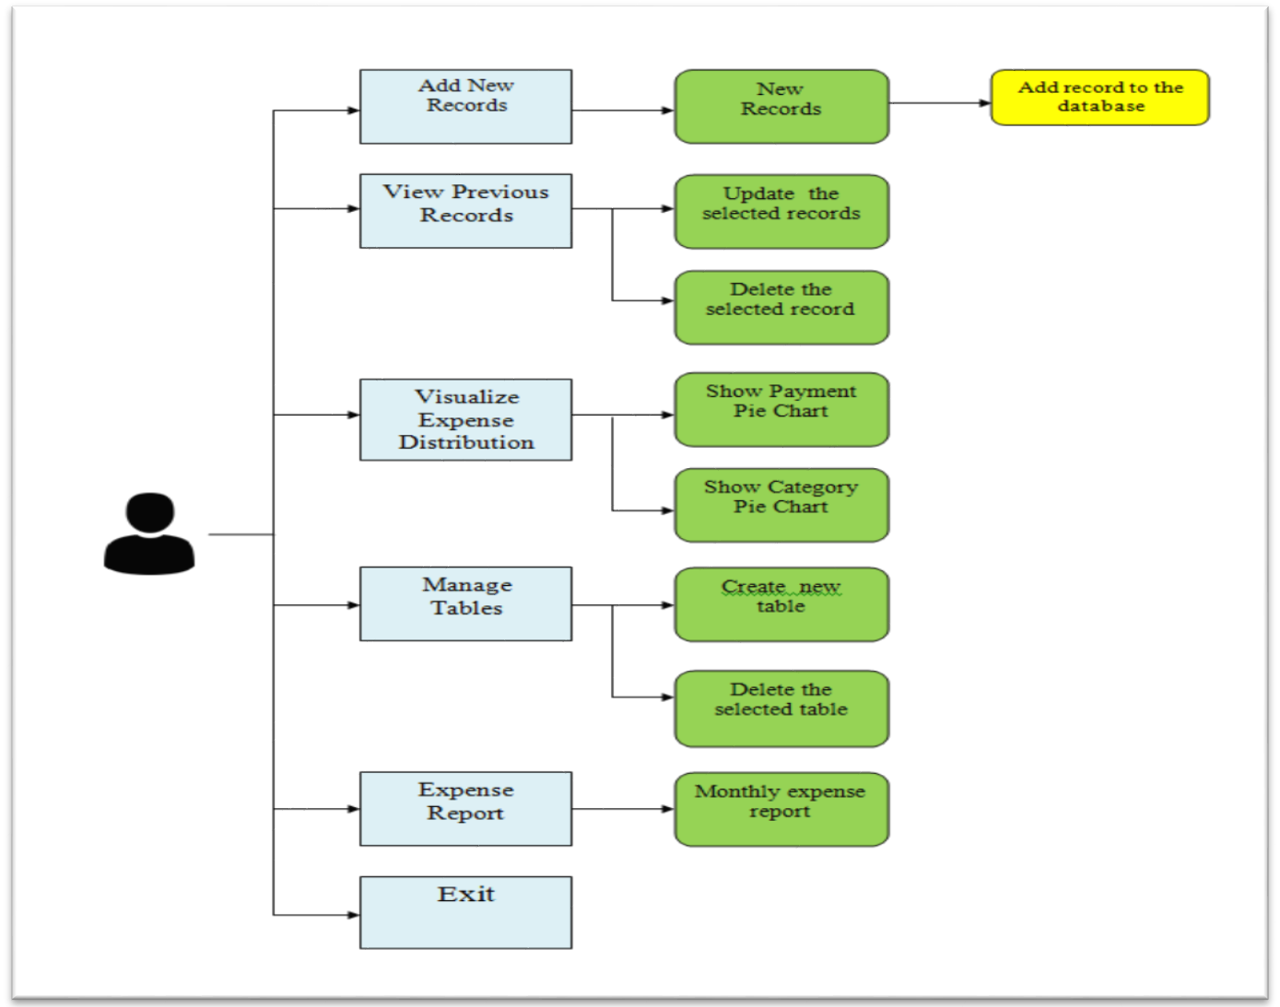

Fig. 3.1 Architecture of an expense tracker app

# METHODOLOGY

Technologies used in this project:

* + PyCharm - PyCharm is a comprehensive integrated development environment (IDE) for Python development, offering a rich set of features and tools to streamline the development process and enhance productivity for Python developers. It is developed by Jet Brains and offers a wide range of features to support Python developers in writing, testing, debugging, and deploying Python code efficiently.
  + Python - Python stands out as a programming language characterized by its high-level nature, interpretability, and renowned simplicity, readability, and adaptability. Python comes with a comprehensive standard library that provides built-in modules and functions for performing a wide range of tasks, from file I/O and networking to mathematical computations and data manipulation.
  + SQLite3 - SQLite3 stands out as a flexible and lightweight database engine ideal for diverse application scenarios, from embedded systems and mobile devices to desktop applications and web servers. Its simplicity, reliability, and performance make it a popular choice for developers seeking a lightweight and easy-to-use database solution.

# RESULTS AND OUTCOMES

* 1. **Summary of the home page of expense tracker app:**

The primary home screen comprises several buttons, including options to add new records, view previous entries, visualize expense distribution, manage tables, generate expense reports, and exit the application. Additionally, users can easily access their current total expense in rupees directly from the home screen.

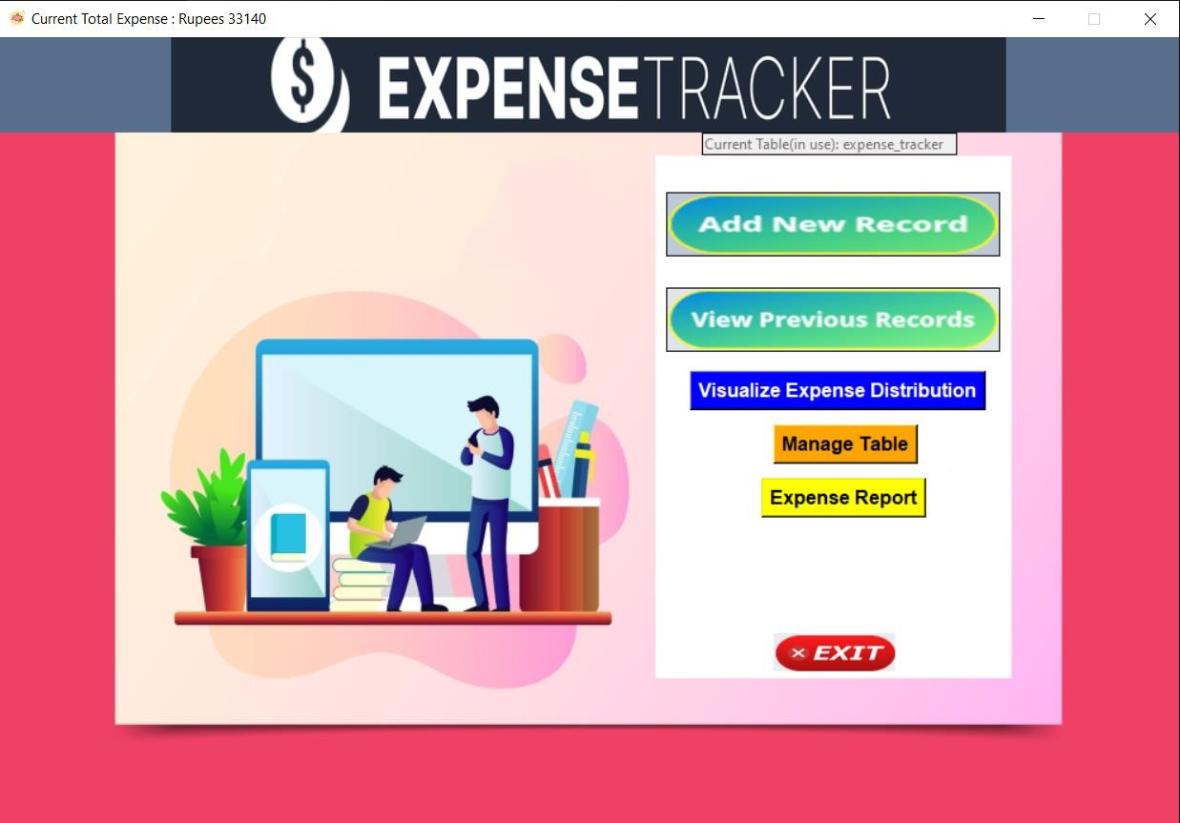

Fig. 5.1 Home Page

# Summary for adding new records:

Add new records helps user to add new records. An expenses like electricity bills, food, travelling, clothes, shopping, stationary, house rent etc. It captures details such as date, amount, category, and description, and stores them in the database. This process guarantees that users can record their transactions quickly and accurately.

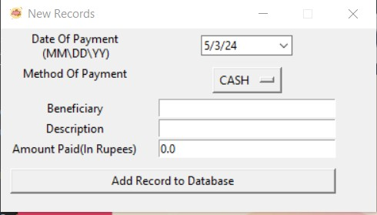

Fig. 5.2 Add New Records

# Summary of previous records:

Users possess the capability to access their past expense records, facilitating the tracking of income sources as well. This functionality empowers users to attain a holistic comprehension of their financial status by overseeing both the inflow and outflow of funds.

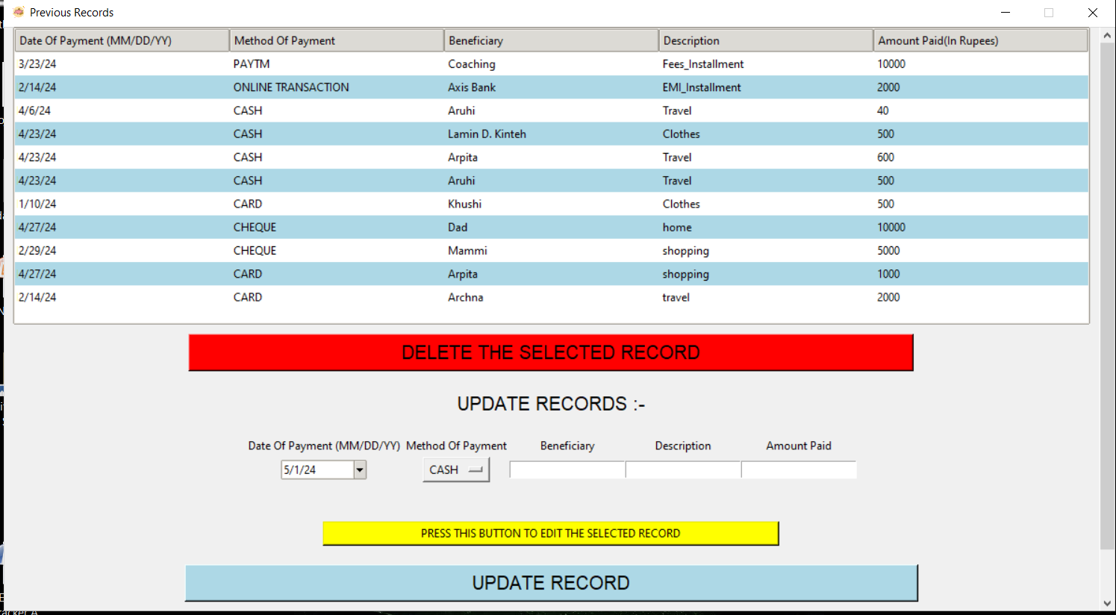

Fig. 5.3 Previous Record

# Summary of visualize of data distribution of an expense tracker app:

The visualize data distribution helps user to provide a clear understanding of how expenses are distributed across different categories of payment methods or description. By using these visualization techniques, user can gain valuable insights into the distribution of expenses, identify patterns and trends, and make more informed decisions about managing the finances.

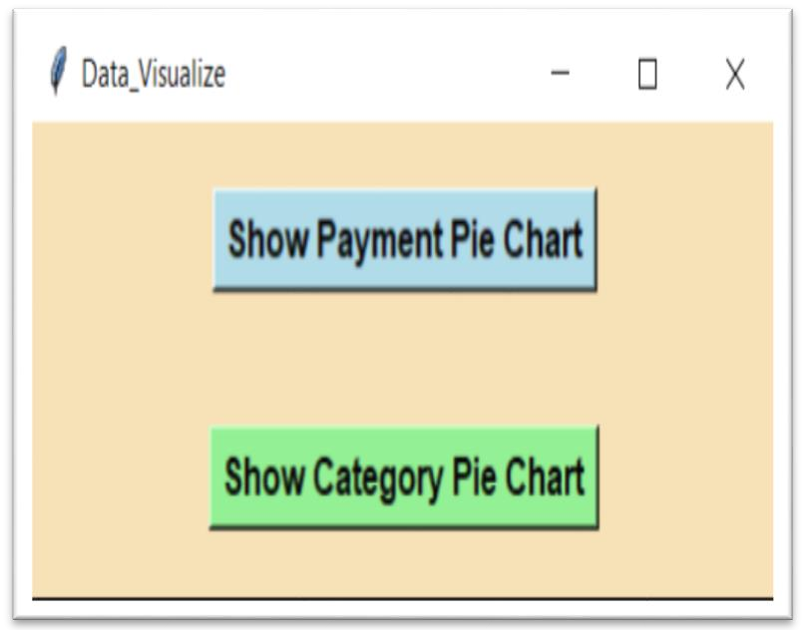

Fig. 5.4 Visualize Data Distribution

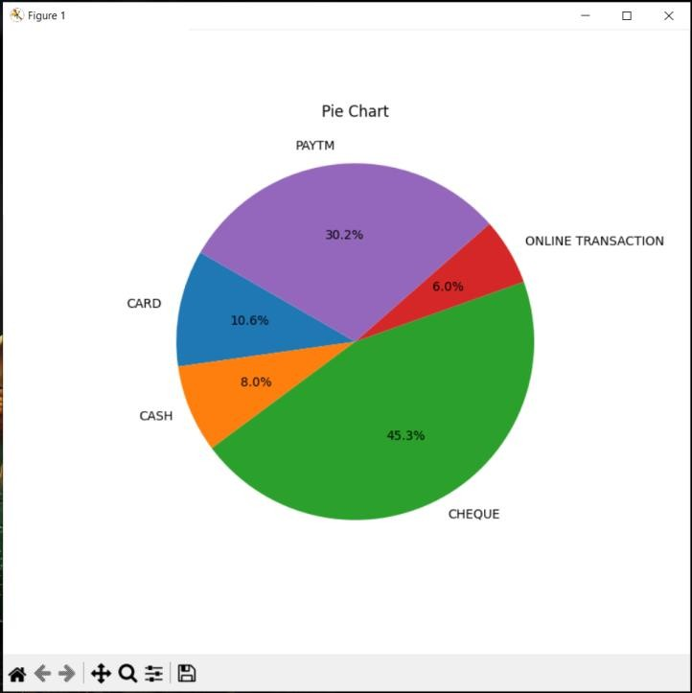 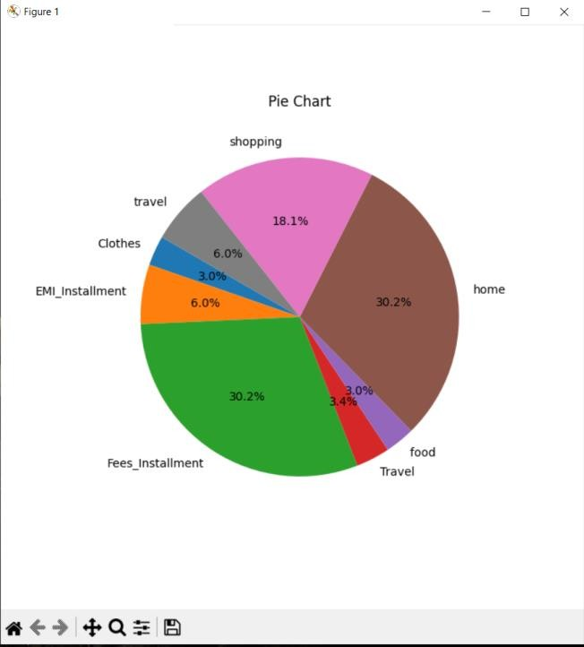

Fig. 5.5 Pie Chart of Payment methods Fig. 5.6 Pie Chart of Category Description

# Summary of manage table :

It helps user to manage the table, like creating new table and deleting a respective table. This functionality provides users with insights into their spending patterns, aiding in informed decision-making and budget optimization.

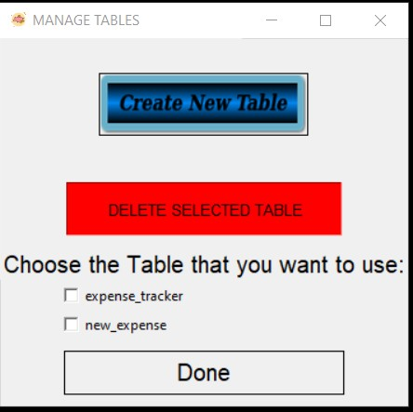

Fig. 5.7 Manage Records

# Summary of an Expense Report:

It helps user to see the expense report of a particular month. By tracking expenses month by month, user can produce a comprehensive budget. A monthly expense report tailored to a specific month serves as a valuable asset for financial management, offering invaluable insights that can guide budgeting choices, identify spending trends, control expenses, and facilitate long-term financial planning. e.g., expense report of april month as shown below:

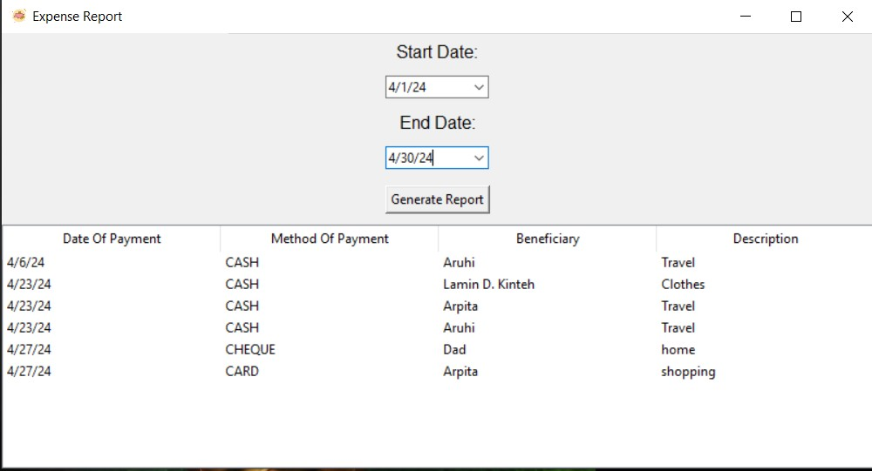

Fig. Monthly Expense Report

Database of the expense tracker app:

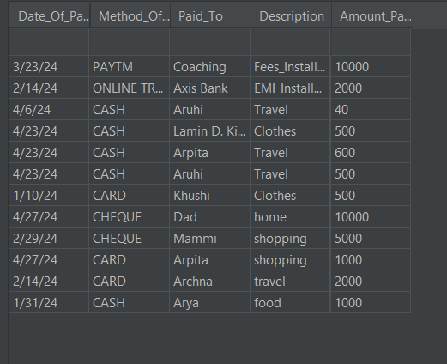

Fig. Database of Expense Tracker

# FUTURE SCOPE

1. Users can conveniently establish budgets for diverse categories like Salary, Food, and Travel within the app.
2. The application aids users in tracking their progress towards financial objectives, offering a clear overview of their financial well-being and encouraging adherence to set goals.
3. Within the app, users have the flexibility to modify budgets, goals, and investment strategies as per evolving priorities, ensuring alignment with long-term aspirations.
4. In today's fast-paced and costly lifestyle, many individuals find themselves struggling financially at the end of each month, often unknowingly spending money on unnecessary expenses.
5. Through vigilant monitoring of spending patterns, users can pinpoint areas where they can curtail expenses, enabling them to allocate more resources towards future endeavors such as homeownership, travel, or retirement savings.

# CONCLUSION

The creation and deployment of the expense tracker application represent a significant step towards empowering individuals to manage their finances and achieve financial well-being. Throughout this research paper, we have outlined the design process, key features, implementation details, testing methodologies, and potential impact of the application on personal finance management. Through this expense tracker application project, we present and offers a comprehensive solution for users to track their expenses, analyze spending patterns, set budgets, and make informed financial decisions. By applying modern technology and user-centered design principles, the application provides a user-friendly interface that sustain to the diverse needs and preferences of users. User feedback has been instrumental in shaping the development process, guiding iterative improvements, and enhancing the overall user experience. By promoting financial literacy, encouraging responsible spending habits, and facilitating budget management, the application contributes to improved financial health and stability at both the individual and community levels. This project must includes integrating additional features such as goal setting, expense categorization, financial forecasting, and personalized recommendations. Moreover, ongoing updates and maintenance are essential to address evolving user needs, technological advancements, and regulatory requirements. The expense tracker application represents a valuable resource for individual users seeking to achieve their financial goals, manage their expenses effectively, and build a secure financial future. By leveraging technology and promoting financial empowerment, we can contribute to the development of a financially savvy and resilient society.

**REFERENCES**

1. Expense Tracker Prof Miriam Thomas , Lekshmi P , and Dr. Mahalekshmi T Assistant Professor, Master of Computer Application ,Principal, Sree Narayana Institute of Technology Sree Narayana Institute of Technology, (September 2020)
2. EXPENDITURE MANAGEMENT SYSTEM Dr. V. Geetha, G. Nikhitha, H. Sri Lasya Dr. C.K.Gomathy, Dept. of CSE, SCSVMV(Deemed to be University), Kancheepuram ,TamilNadu, India , (March 2022)
3. Personal Expense Tracker Application Sakthivel .M, Roshini.P, Roja.K, Maha Lakshmi.P, Keerthi.V Assistant Professor, Department of Computer Science and Engineering, Vel Tech High Tech Dr. Rangarajan Dr. Sakunthala Engineering College, Chennai, India
4. Expense Tracker Subi James and Prof. Rajitha P. R. MCA Assistant Professor, Department of Computer Applications Sree Narayana Institute of Technology, Kollam, Kerala, India (September 2023)
5. A Novel Expense Tracker using Statistical Analysis Muskaan Sharma , Ayush Bansal , Dr. Raju Ranjan , Shivam Sethi4 School of Computer Science and Engineering, Galgotias University (June 2021)
6. https://[www.slideshare.net/slideshow/daily-expense-tracker-153160282/153160282](http://www.slideshare.net/slideshow/daily-expense-tracker-153160282/153160282)
7. https://omnicard.in/blogs/expense-tracking-software-260923
8. https://[www.scribd.com/document/369482136/Final-Report-Personal-Expense-Tracker-537](http://www.scribd.com/document/369482136/Final-Report-Personal-Expense-Tracker-537)
9. https://[www.spaceo.ca/blog/expense-tracking-apps-streamline-finance-management/](http://www.spaceo.ca/blog/expense-tracking-apps-streamline-finance-management/)
10. https://en.wikipedia.org/wiki/PyCharm#:~:text=PyCharm%20is%20an%20integrated%20development,supports%20web

%20development%20with%20Django.

1. https://[www.prismetric.com/expense-tracking-app-development-cost/](http://www.prismetric.com/expense-tracking-app-development-cost/)
2. https://[www.youtube.com/watch?time_continue=19&v=sYBDJ15dNVc&embeds_referring_euri=https%3A%2F%2Fww](http://www.youtube.com/watch?time_continue=19&v=sYBDJ15dNVc&embeds_referring_euri=https%3A%2F%2Fww) w.google.com%2Fsearch%3Fsa%3DX%26sca_esv%3Dfffcdfb985db331b%26sca_upv%3D1%26rlz%3D1C1RLNS_enI N915IN915%26tbm%3Dvid%26sxsrf%3DACQVn09ibI0d3Dp_Kpj&source_ve_path=Mjg2NjMsMjg2NjMsMjg2NjY &feature=emb_logo