Internet Protocol hierarchy contains several classes of IP Addresses to be used efficiently in various situations as per the requirement of hosts per network. Broadly, the IPv4 Addressing system is divided into five classes of IP Addresses. All the five classes are identified by the first octet of IP Address.

The first octet referred here is the left most of all. The octets numbered as follows depicting dotted decimal notation of IP Address:

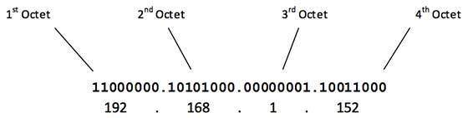

The number of networks and the number of hosts per class can be derived by this formula:

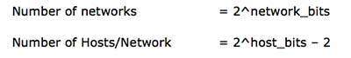

When calculating hosts' IP addresses, 2 IP addresses are decreased because they cannot be assigned to hosts, i.e. the first IP of a network is network number and the last IP is reserved for Broadcast IP.

Class A Address

The first bit of the first octet is always set to 0 (zero). Thus the first octet ranges from 1 – 127, i.e.

Class A Addresses

Class A addresses only include IP starting from 1.x.x.x to 126.x.x.x only. The IP range 127.x.x.x is reserved for loopback IP addresses.

The default subnet mask for Class A IP address is 255.0.0.0 which implies that Class A addressing can have 126 networks (27-2) and 16777214 hosts (224-2).

Class A IP address format is thus: **0NNNNNNN**.HHHHHHHH.HHHHHHHH.HHHHHHHH

## Class B Address

An IP address which belongs to class B has the first two bits in the first octet set to 10, i.e.

Class B Addresses

Class B IP Addresses range from 128.0.x.x to 191.255.x.x. The default subnet mask for Class B is 255.255.x.x.

Class B has 16384 (214) Network addresses and 65534 (216-2) Host addresses.

Class B IP address format is: **10NNNNNN.NNNNNNNN**.HHHHHHHH.HHHHHHHH

## Class C Address

The first octet of Class C IP address has its first 3 bits set to 110, that is:

Class C Addresses

Class C IP addresses range from 192.0.0.x to 223.255.255.x. The default subnet mask for Class C is 255.255.255.x.

Class C IP address format is: **110NNNNN.NNNNNNNN.NNNNNNNN**.HHHHHHHH

Class C gives 2097152 (221) Network addresses and 254 (28-2) Host addresses.

## Class D Address

Very first four bits of the first octet in Class D IP addresses are set to 1110, giving a range of:

11100000-11101111

Class D has IP address rage from 224.0.0.0 to 239.255.255.255. Class D is reserved for Multicasting. In multicasting data is not destined for a particular host, that is why there is no need to extract host address from the IP address, and Class D does not have any subnet mask.

## Class E Address

This IP Class is reserved for experimental purposes only for R&D or Study. IP addresses in this class ranges from 240.0.0.0 to 255.255.255.254. Like Class D, this class too is not equipped with any subnet mask.

**Subnetting**

## Class A Subnets

In Class A, only the first octet is used as Network identifier and rest of three octets are used to be assigned to Hosts (i.e. 16777214 Hosts per Network). To make more subnet in Class A, bits from Host part are borrowed and the subnet mask is changed accordingly.

For example, if one MSB (Most Significant Bit) is borrowed from host bits of second octet and added to Network address, it creates two Subnets (21=2) with (223-2) 8388606 Hosts per Subnet.

The Subnet mask is changed accordingly to reflect subnetting. Given below is a list of all possible combination of Class A subnets:

