Sinhgad College of Engineering
Department of Computer Engineering

Name : Prashant Kumar

Roll : 305139 PRN : 71813716H

Class : TE DIV : 2 BATCH : B

Name of Laboratory : Web Technology Lab

List of Assignments
Sr.No. | Title of Assignment | Remark | Signature
1 | TOMCAT SERVER installation
2 | HTML, CSS
3 | XML and XSL
4 | HTML, Java Script
5 | JSP, Servlet and MySQL (Backend)
6 | Add dynamic web application essence using PHP, HTML and MySQL
7 | Add dynamic web application essence using PHP, AJAX and MySQL.
8 | Design and develop any web application using Struts framework
9 | Design and develop any web application using AngularJS
10 | Web Application using EJB

Assignment No - 1

Title of Program - TOMCAT SERVER installation

Objective -
- Configure tomcat server
- Understand how to install tomcat server

Code of Program –

resume.html
<%--
Name: Prashant Kumar
Roll: 305139
--%>
<html>
<head> <title> Resume </title>
</head>

<body>
<style>
table, th, td {
border: 1px solid black;
border-collapse: collapse;
}
tr:nth-child(even) {
background-color: #dddddd;
}
</style>
<h2> <center> Resume </center> </h2>
<hr color="skyblue" width="75%">
<br>
<br>
<i> Profile : </i> <br> <br>
Name : Prashant Kumar <br>
Class : TE <br>
Roll : 305139 <br>
Dept : Comp <br>

<br>

<i>Academics :</i><br><br>
<table style="width:100%">

<tr>
<th>S.No</th>
<th>School Name</th>
<th>Address</th>
<th>Marks</th>
</tr>
<tr align="center">
<td>1</td>
<td>BD Public School</td>
<td>Patna</td>
<td>8.2</td>
</tr>
<tr align="center">
<td>2</td>
<td>DAV Public School</td>
<td>Patna</td>
<td>73.2%</td>
</tr>
</table>

<br>

<i>Skills :</i><br>
<ul>
<li>Python</li>
<li>C++</li>
<li>C</li>
<li>C#</li>
<li>Java</li>
</ul><br>

<i>Projects :</i>
<ul>
<li>Exam potral using Python</li>
<li>Cinema ticket billing system using java</li>
<li>Language Translator using python</li>
<li>Telephone Directory using pymongo</li>
</ul><br>

<i>Hobbies :</i>
<ul>
<li>Computer Games</li>
<li>Badminton</li>
<li>Cricket</li>
</ul>

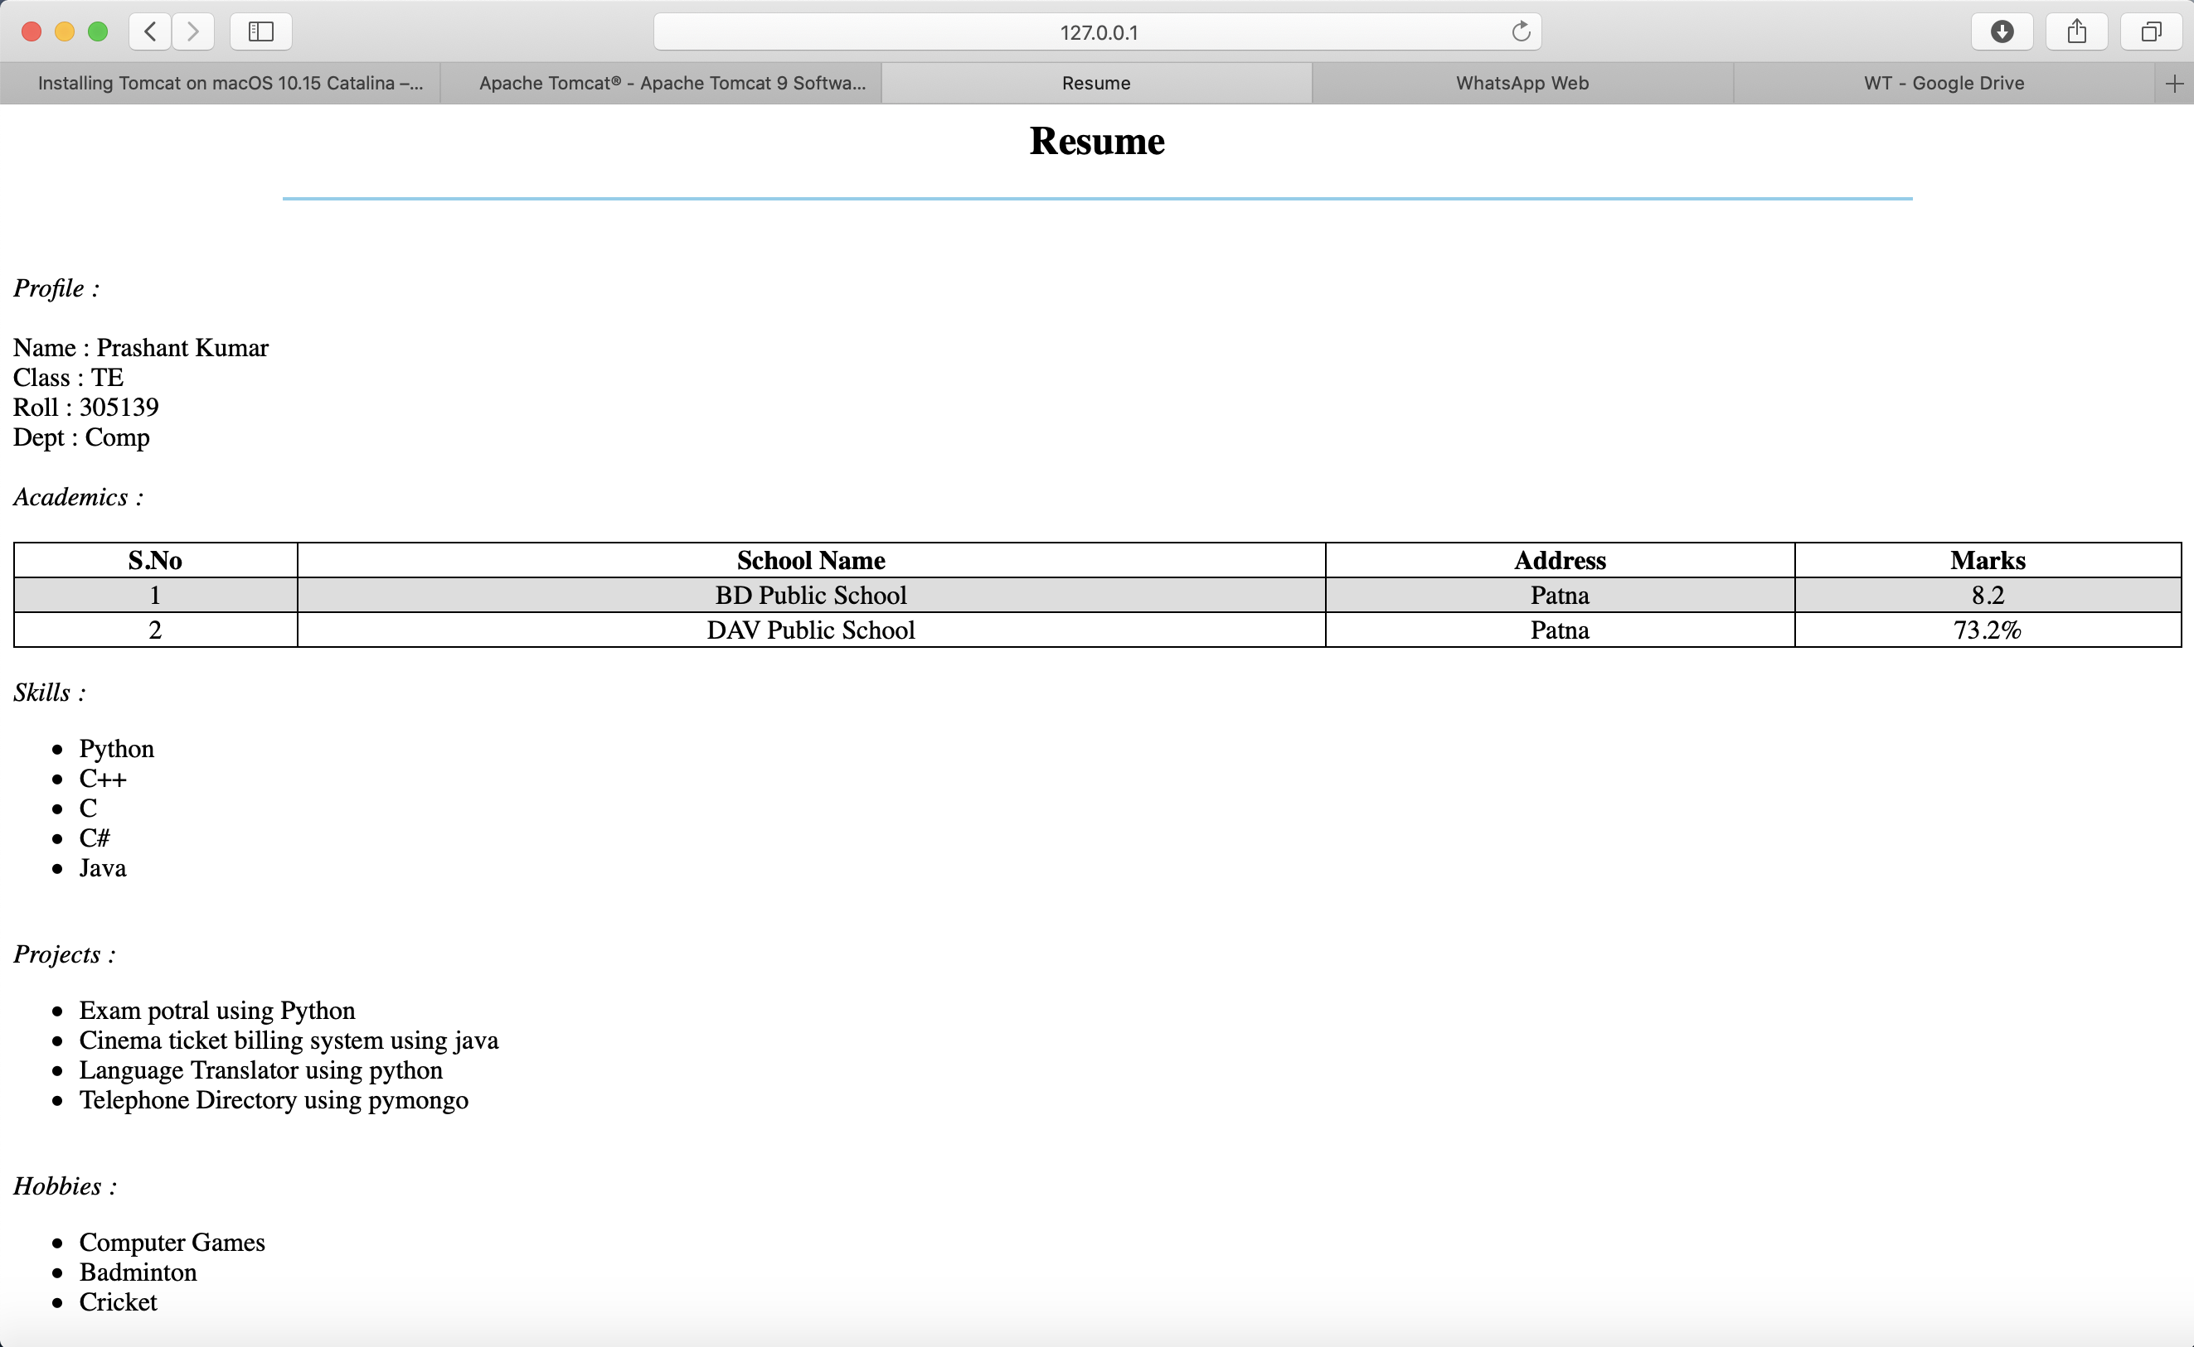
OUTPUT:

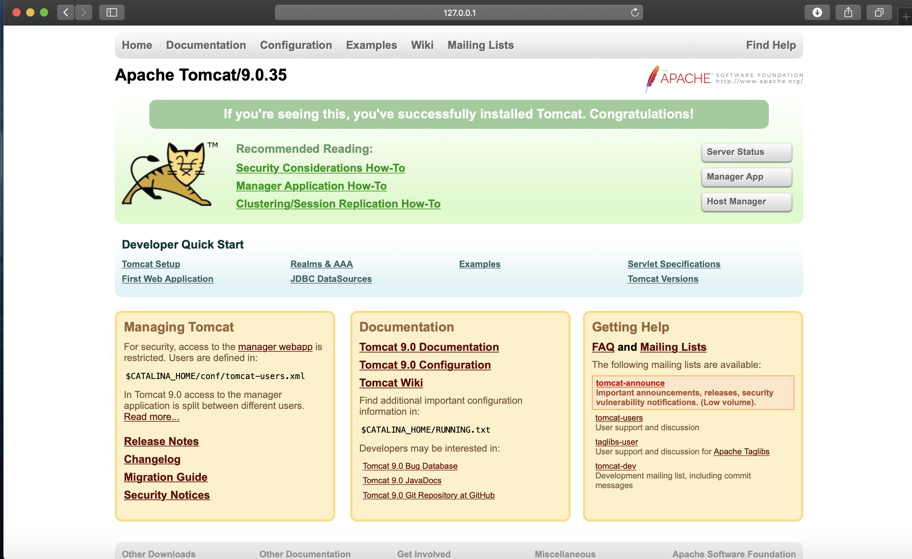

Assignment No - 2

Title of Program - HTML, CSS

Objective -
1. Understand about basic concepts of html
2. Understand the basic concepts of XML
3. Understand the basic concepts of CSS

Code of Program –

registration.html
<%--
Name: Prashant Kumar
Roll: 305139
--%>
<html>

<head>
<title>regform</title>

<link href="samp.css" rel="stylesheet"></link>
</head>

<body>

<div class="con">
<form action="display.html" method="get" align="center">

<div class="con2">
<img src="si-logo.png" width=100px height=100px >
</div>

<div class="main">
<table align="center">
<tr>
<td><b><br>Welcome to Registration Page<br><br></td>
</tr>
</table>

<div class="con1">
<table align="center">
<tr>
<td>Full Name:</td>
<td><input type="text" value=""></input></td>
</tr>

<tr>
<td>Class</td>
<td><input type="text" value=""></input></td>
</tr>

<tr>
<td>Department</td>
<td><input type="text" value=""></input></td>
</tr>

<tr>
<td>address:</td>
<td><textarea></textarea></td>
</tr>

<tr>
<td>email:</td>
<td><input type="text" value=""></input></td>
</tr>

<tr>
<td>phone:</td>
<td><input type="text" value=""></input></td>
</tr>

<tr></tr>
<tr></tr>
</table>

<table align="center">
<tr>
<td><input type="submit" value="SUBMIT"></td>
<td><input type="reset" value="CANCEL"></td>
</tr>
</table>

</div>
</div>

</form>
</div>
</body>

</html>

samp.css
<%--
Name: Prashant Kumar
Roll: 305139
--%>
.con
{
width:400px;
height:400px;
background-color:lightgray;
color:blue;
padding:0px 10px 0px 10px;
margin:auto;
}
.main
{
width:400px;
height:80px;
float:left;
padding:60px 10px 10px 10px;
margin: auto;
}
.con1
{
width:200px;
height:30px;
float:left;
margin:auto;
padding:0px 0px 0px 0px;
}
.con2
{
width:150px;
height:30px;
float:center;
margin:auto; <!--10px 10px 10px 10px-->
padding:0px 0px 0px 0px;
}

display.html
<%--
Name: Prashant Kumar
Roll: 305139
--%>
<html>

<head>
<title> display</title>
</head>

<body>

<h1 style="color:blue; margin-left:30px;">
You have submitted the form successfully...</h1>

</body>

</html>

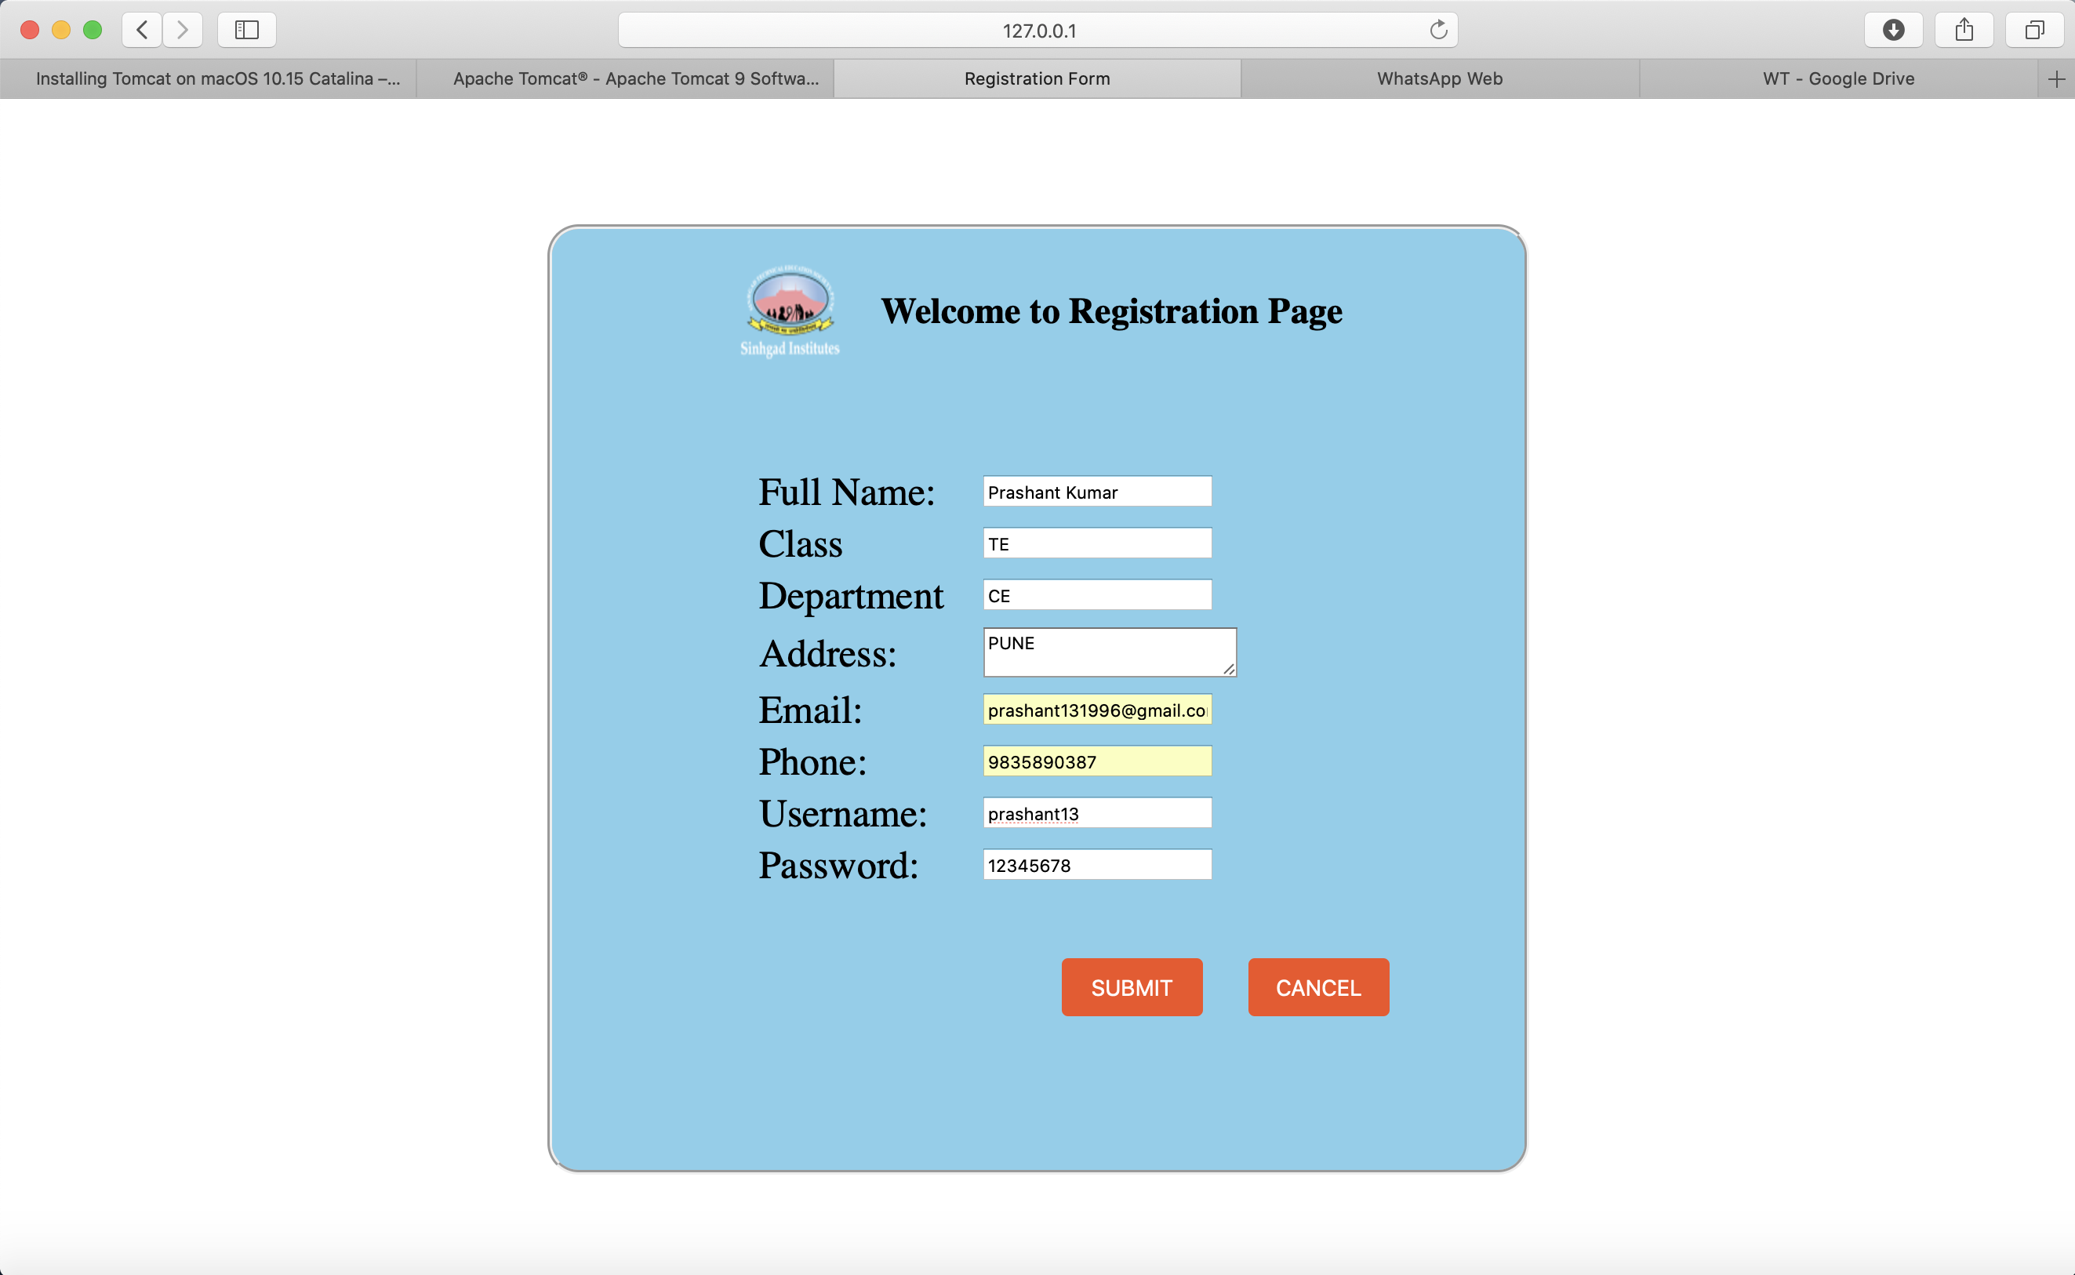
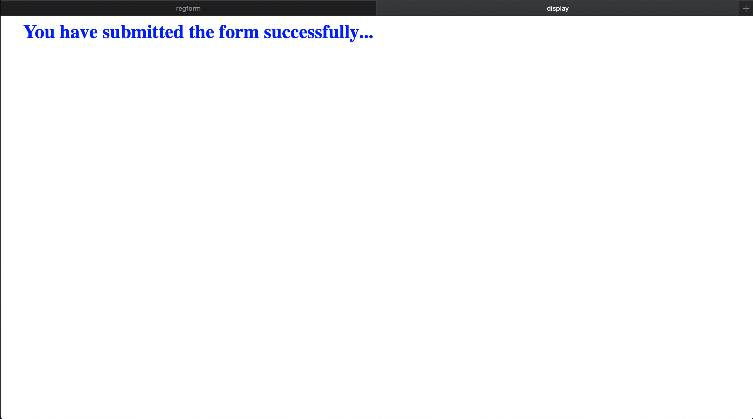
OUTPUT:

Assignment No - 3

Title of Program - XML and XSL

Objective -
To be able to,
1. Design static webpage using XML.
2. Apply CSS to XML pages.

Code of Program –

book.xml

<%--
Name: Prashant Kumar
Roll: 305139
--%>
<?xml version="1.0" encoding="UTF-8"?>

<?xml-stylesheet type="text/xsl" href="C:/Users/DELL/Desktop/XMLL/style.xsl"?>
<catalog>
<book>
<title>To Kill a Mockingbird</title>
<author>Harper Lee</author>
<price>300</price>
<year>1960</year>
</book>
<book>
<title>Harry Potter</title>
<author>J. K. Rowling</author>
<price>500</price>
<year>1997</year>
</book>
<book>
<title>The Lord Of The Rings</title>
<author>J.R.R. Tolkien</author>
<price>530</price>
<year>2000</year>
</book>
<book>
<title>The Shadow Of The Wind</title>
<author>Carlos Ruiz Zafon</author>
<price>300</price>
<year>1990</year>
</book>
<book>
<title>Station Eleven</title>
<author>St. John Mandel</author>
<price>800</price>
<year>2016</year>
</book>
<book>
<title>You</title>
<author>Caroline Kepnes</author>
<price>500</price>
<year>2014</year>
</book>
<book>
<title>The Golden Compass</title>
<author>Philip Pullman</author>
<price>1000</price>
<year>2010</year>
</book>
<book>
<title>The Picture of Dorian Gray</title>
<author>Oscar Wilde</author>
<price>1500</price>
<year>2015</year>
</book>
<book>
<title>Wolf Hall</title>
<author>Hilary Mantel</author>
<price>600</price>
<year>2010</year>
</book>
<book>

OUTPUT:

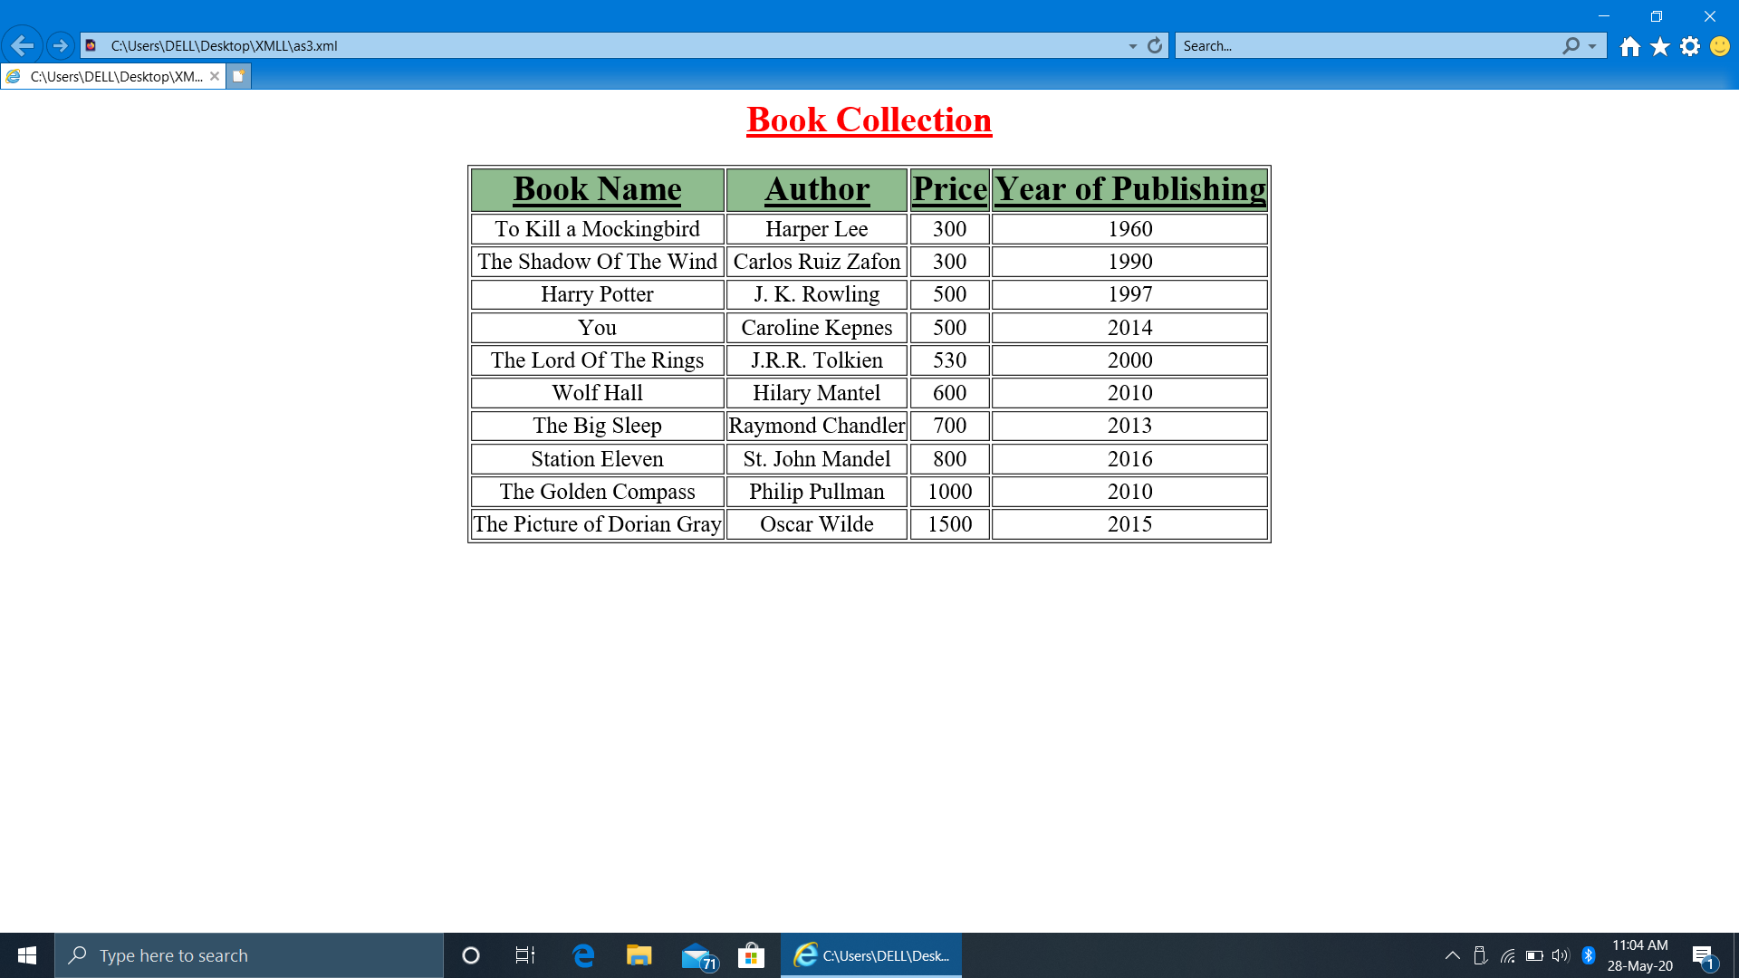

Assignment No - 4

Title of Program - HTML, Java Script

Objective -

1. Understand about basic concepts of JavaScript.
2. Use JavaScript for validation of data.

Code of Program –

registration.html

<%--
Name: Prashant Kumar
Roll: 305139
--%>
<html>

<head>
<title>regform</title>
<link href="samp.css" rel="stylesheet"></link>

<script type="text/javascript">
function Validation()
{
var emailID = document.myForm.EMail.value;
var num = document.myForm.ph.value;

atpos = emailID.indexOf("@");
dotpos = emailID.lastIndexOf(".");

if (atpos< 1 || ( dotpos - atpos < 2 ))
{
alert("Please enter correct email ID")
document.myForm.EMail.focus() ;
return false;
}
if (isNaN(num)){
alert("Please enter numeric only.")
document.myForm.ph.focus() ;
return false;
}
else{ return true;}
}
</script>
</head>

<body>

<div class="con">
<form name="myForm" action="display.html" method="get" align="center">

<div class="con2">
<img src="si-logo.png" width=100px height=100px></img>
</div>

<div class="main">
<table align="center">
<tr><td><b><br>Welcome to Registration Page<br><br></td></tr>
</table>

<div class="con1">
<table align="center">
<tr>
<td>Full Name:</td>
<td><input type="text" id="FirstName" value="" required></input></td>
</tr>
<tr>
<td>Class:</td>
<td><input type="text" id="Class" value="" required></input></td>
</tr>
<tr>
<td>Department:</td>
<td><input type="text" id="Department" value="" required></input></td>
</tr>
<tr>
<td>address:</td>
<td><textarea row="3" column="2" value="" required></textarea></td>
</tr>
<tr>
<td>email Id:</td>
<td><input type="text" value="" id="EMail" required></input></td>
</tr>
<tr>
<td>phone no:</td>
<td><input type="text" id="ph" value="" required></input></td>
</tr>
<tr>
<tr></tr><tr></tr></table>
<table align="center">
<td><input type="submit" value="SUBMIT" onclick = "return (Validation());"></td>
<td><input type="reset" value="CANCEL"></td>
</tr>
</table>
</div>
</div>
</form>
</div>
</body>
</html>

samp.css
<%--
Name: Prashant Kumar
Roll: 305139
--%>
.con
{
width:400px;
height:400px;
background-color:lightgray;
color:blue;
padding:0px 10px 0px 10px;
margin:auto;
}
.main
{
width:400px;
height:80px;
float:left;
padding:60px 10px 10px 10px;
margin: auto;
}
.con1
{
width:200px;
height:30px;
float:left;
margin:auto;
padding:0px 0px 0px 0px;
}
.con2
{
width:150px;
height:30px;
float:left;
margin:10px 10px 10px 10px;
padding:0px 0px 0px 0px;
}

display.html
<%--
Name: Prashant Kumar
Roll: 305139
--%>
<html>
<head>
<title> display</title>
</head>
<body>
<h1 style="color:blue;margin-left:30px;"> You have submitted the form successfully….</h1>
</body>
</html>

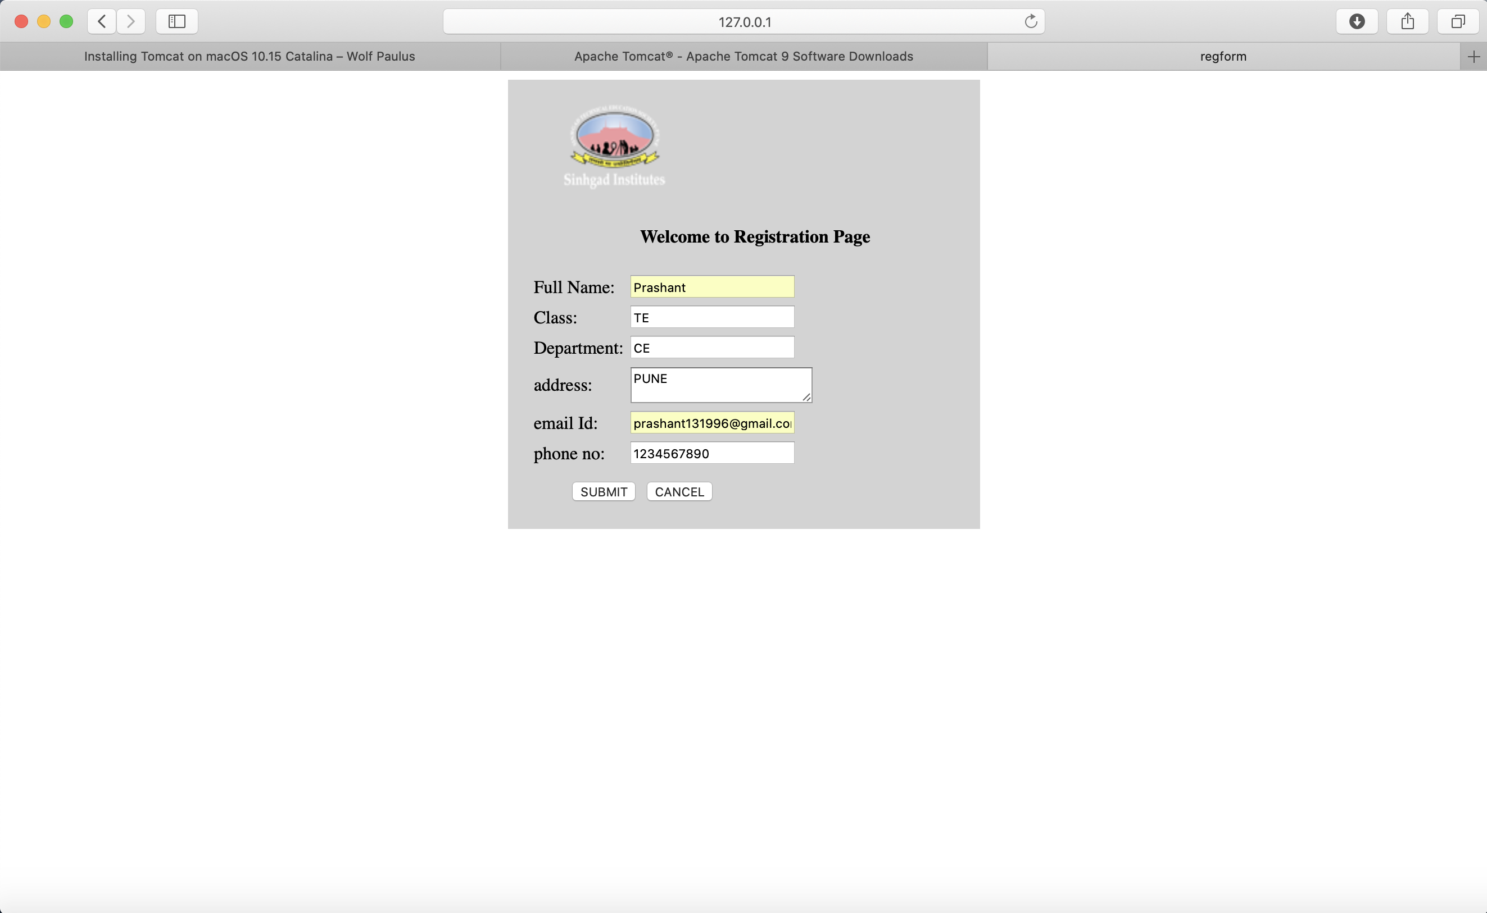
OUTPUT :


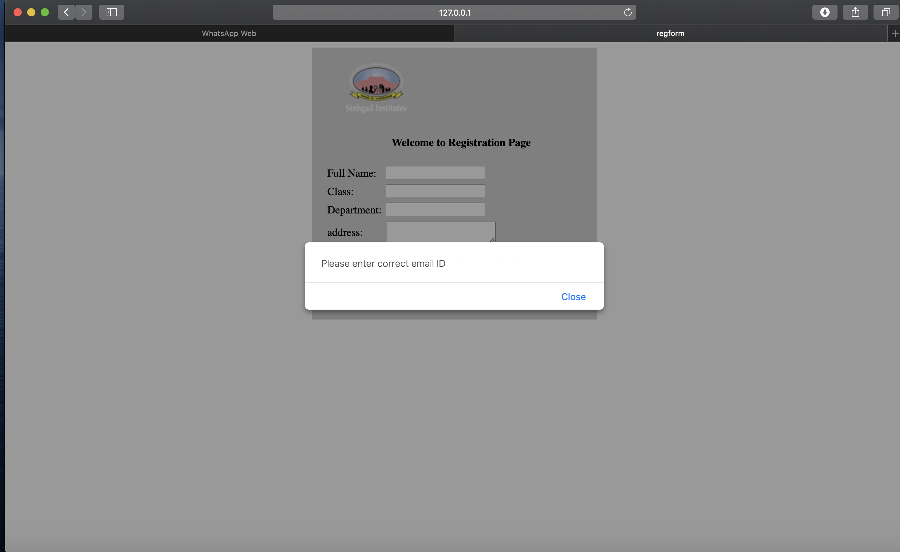

Assignment No - 5

Title of Program - JSP, Servlet and MySQL (Backend)

Objective -
1. Understand about basic concepts of html, CSS
2. Understand the basic functionalities of JSP
3. Having the knowledge of SQL query to create the database

Code of Program –

index.jsp

<%--
Name: Prashant Kumar
Roll: 305139
--%>
<%@page contentType="text/html" pageEncoding="UTF-8"%>
<!DOCTYPE html>
<html>
<head>
<meta http-equiv="Content-Type" content="text/html; charset=UTF-8">
<title> Login </title>
</head>
<body>
<table>
<tr>
<td width="300"></td>
<td> <font color="#339900" size="3.5">User Login</font>
<table>
<tr>
<td>
<form id="user1" method="post" action="User.jsp" name="s" onSubmit="return valid()">
<table border="2.0">
<tr>
<td>User Id</td>
<td><input type="text" name="user1"></td>
</tr>
<tr>
<td> Password</td>
<td><input type="password" name="pass"></td>
</tr>
<tr>
<td>
<center><input type="submit" name="user" value="Login"></center>
</td>
</tr></table>
<center><table>
<tr>
<td>
<a href="SignUp.jsp"><font color="#000000" size="2"><b>New User?</b></font></a></td></tr></table>
</td>
</tr></table></center>
</td>
</tr>
</table>
</form>
</body>
</html>

loginfailure.jsp

<%--
Name: Prashant Kumar
Roll: 305139
--%>
<%@page contentType="text/html" pageEncoding="UTF-8"%>
<!DOCTYPE html>
<html>
<head>
<meta http-equiv="Content-Type" content="text/html; charset=UTF-8">
<title>JSP Page</title>
</head>
<body>
<h1> <font color="Red"> Please Provide Correct Username or Password!..Retry Again!..</font> </h1>
<table>
<tr>
<td>
<form id="user1" method="post" action="User.jsp" name="s" onSubmit="return valid()">
<table>
<tr>
<td>User Id</td>
<td><input type="text" name="user1"></td>
</tr>
<tr>
<td>Password</td>
<td><input type="password" name="pass"></td>
</tr>
<tr>
<td>
</td>
<td>
<input type="submit" name="user" value="Login"></td>
</tr></table>
</form>
</td>
</tr>
</table>
</body>
</html>

loginServlet.jsp
<%--
Name: Prashant Kumar
Roll: 305139
--%>
//LoginServlet.jsp
<%@page import="java.sql.*"%>
<%@ page import="java.io.*"%>
<%@ page import = "java.util.Date,java.text.SimpleDateFormat,java.text.ParseException"%>
<%
String a = request.getParameter("uidd");
String x = request.getParameter("unn");
String b = request.getParameter("passs");
String c = request.getParameter("mobb");
String d = request.getParameter("eidd");
session.setAttribute("d",d);
//String f=request.getParameter("date");
//out.print(strDateNew1);
//out.print(x);
//out.print(b);
//out.print(c);
//out.print(d);
//out.print(f);
java.util.Date now = new java.util.Date();
String DATE_FORMAT = "yyyy-MM-dd";
SimpleDateFormat sdf = new SimpleDateFormat(DATE_FORMAT);
String strDateNew = sdf.format(now) ;
//response.sendRedirect("signup.jsp?message=success");
//String userid=null;
//String m="avl";
try
{
Class.forName("com.mysql.jdbc.Driver");
Connection con =
DriverManager.getConnection("jdbc:mysql://localhost:3306/loginpage","root","root");
PreparedStatement ps=con.prepareStatement("insert into
student(sname,suserid,spass,mobile,email,date) values(?,?,?,?,?,'"+strDateNew+"')");
//ResultSet rs=ps.executeQuery();
ps.setString(1,x);
ps.setString(2,a);
ps.setString(3,b);
ps.setString(4,c);
ps.setString(5,d);
ps.executeUpdate();
response.sendRedirect("SignUp.jsp?success");
}
catch(Exception e1)
{
out.println(e1.getMessage());
response.sendRedirect("SignUp.jsp?Failure");%>
}
%>

loginsuccess.jsp

<%--
Name: Prashant Kumar
Roll: 305139
--%>
<%@page contentType="text/html" pageEncoding="UTF-8"%>
<!DOCTYPE html>
<html>
<head>
<meta http-equiv="Content-Type" content="text/html; charset=UTF-8">
<title>JSP Page</title>
</head>
<body>
<h1> User Logged In Successfully!...</h1>
</body>
</html>
//LoginFailure.jsp
<%--
Document : LoginFailure
Created on : Dec 31, 2017, 2:42:21 PM
Author : Admin
--%>
<%@page contentType="text/html" pageEncoding="UTF-8"%>
<!DOCTYPE html>
<html>
<head>
<meta http-equiv="Content-Type" content="text/html; charset=UTF-8">
<title>JSP Page</title>
</head>
<body>
<h1> <font color="Red"> Please Provide Correct Username or Password!..Retry Again!..</font> </h1>
<table>
<tr>
<td>
<form id="user1" method="post" action="User.jsp" name="s" onSubmit="return valid()">
<table>
<tr>
<td>User Id</td>
<td><input type="text" name="user1"></td>
</tr>
<tr>
<td>Password</td>
<td><input type="password" name="pass"></td>
</tr>
<tr>
<td>
</td>
<td>
<input type="submit" name="user" value="Login"></td>
</tr></table>
</form>
</td>
</tr></table>
</body>
</html>

signup.jsp
<%--
Name: Prashant Kumar
Roll: 305139
--%>
<%@ page import="java.sql.*"%>
<%@ page import = "java.util.Date,java.text.SimpleDateFormat,java.text.ParseException"%>
<%--
Document : SignUp
Created on : Dec 30, 2017, 11:52:03 PM
Author : Admin
--%>
<%@page contentType="text/html" pageEncoding="UTF-8"%>
<!DOCTYPE html>
<html>
<head>
<meta http-equiv="Content-Type" content="text/html; charset=UTF-8">
<title>JSP Page</title>
</head>
<body bgcolor="Skyblue">
<%
java.util.Date now = new java.util.Date();
String DATE_FORMAT1 = "dd/MM/yyyy";
SimpleDateFormat sdf1 = new SimpleDateFormat(DATE_FORMAT1);
String strDateNew1 = sdf1.format(now);
%>
<table border="black" bgcolor=" black" align ="center" >
<tr>
<td> <strong><em><font color="#990000" size="+1" face="Times New Roman"
style="text-decoration:underline">User Registration</font></em></strong>
</td>
</tr>
</table>
<table border="black" align ="center">
<tr>
<td><form name="s" action="LoginServelt.jsp" method="get" onSubmit="return
valid()">
<table align="center" cellpadding="6" cellspacing="6" width="400" height="300">
<td>
<tr>
<td><font face="Times New Roman" size="+1"><strong>Name</strong></font></td>
<td>&nbsp;&nbsp;&nbsp;&nbsp; <input type="text" name="unn" class="b"></td>
</tr>
<tr>
<td><font face="Times New Roman" size="+1"><strong>User ID</strong></font></td>
<td>&nbsp;&nbsp;&nbsp;&nbsp; <input type="text" name="uidd" id="name"></td>
</tr>
<tr>
<td><font face="Times New Roman"
size="+1"><strong>Password</strong></font></td>
<td>&nbsp;&nbsp;&nbsp;&nbsp; <input type="password" name="passs" class="b"></td>
</tr>
<tr>
<td><font face="Times New Roman" size="+1"><strong>Mobile</strong></font></td>
<td>&nbsp;&nbsp;&nbsp;&nbsp; <input type="text" name="mobb" class="b"></td>
</tr>
<tr>
<td><font face="Times New Roman" size="+1"><strong>Email
ID</strong></font></td>
<td>&nbsp;&nbsp;&nbsp;&nbsp; <input type="text" name="eidd" class="b"></td>
</tr>
<tr>
<td><font face="Times New Roman" size="+1"><strong>Date</strong></font></td>
<td>&nbsp;&nbsp;&nbsp;&nbsp; <input type="text" name="date" class="b"
value="<%=strDateNew1%>"></td>
</tr>
<tr>
<td></td>
<td>&nbsp;&nbsp;&nbsp;&nbsp; <input type="submit" name="s" value="submit"
class="b1" >
&nbsp;&nbsp;&nbsp; <input type="reset" name="r" value="clear" class="b1"></td>
</tr></td>
<td></td>
</table>
</form></td>
</tr></table>
<center> <table><tr><td> <a href="index.jsp"><font color="#000000" size="2"><b>Login Here</b></font></a>
</td>
</tr></table></center>
</body>
</html>

user.jsp
<%--
Name: Prashant Kumar
Roll: 305139
--%>
<%@ page import="java.sql.*;"%>
<%
String a=request.getParameter("user1");
String b=request.getParameter("pass");
String id=null,name=null,userid=null,email=null;
try{
Class.forName("com.mysql.jdbc.Driver");
Connection con =
DriverManager.getConnection("jdbc:mysql://localhost:3306/loginpage","root","root");
//Connection con = databasecon.getconnection();
PreparedStatement ps=con.prepareStatement("select sid,sname,suserid,email from student where
suserid='"+a+"' && spass='"+b+"'");
ResultSet rs=ps.executeQuery();
if(rs.next())
{
id=rs.getString("sid");
name=rs.getString("sname");
userid=rs.getString("suserid");
email=rs.getString("email");
session.setAttribute("sid",id);
session.setAttribute("sname",name);
session.setAttribute("suserid",userid);
session.setAttribute("email",email);
//response.sendRedirect("user5.jsp");
response.sendRedirect("LoginSuccess.jsp?Success");
//out.print(name2);
}
else
{
response.sendRedirect("LoginFailure.jsp?Failure");
}
}
catch(Exception e2){
out.println(e2.getMessage());
}
%>

OUTPUT :
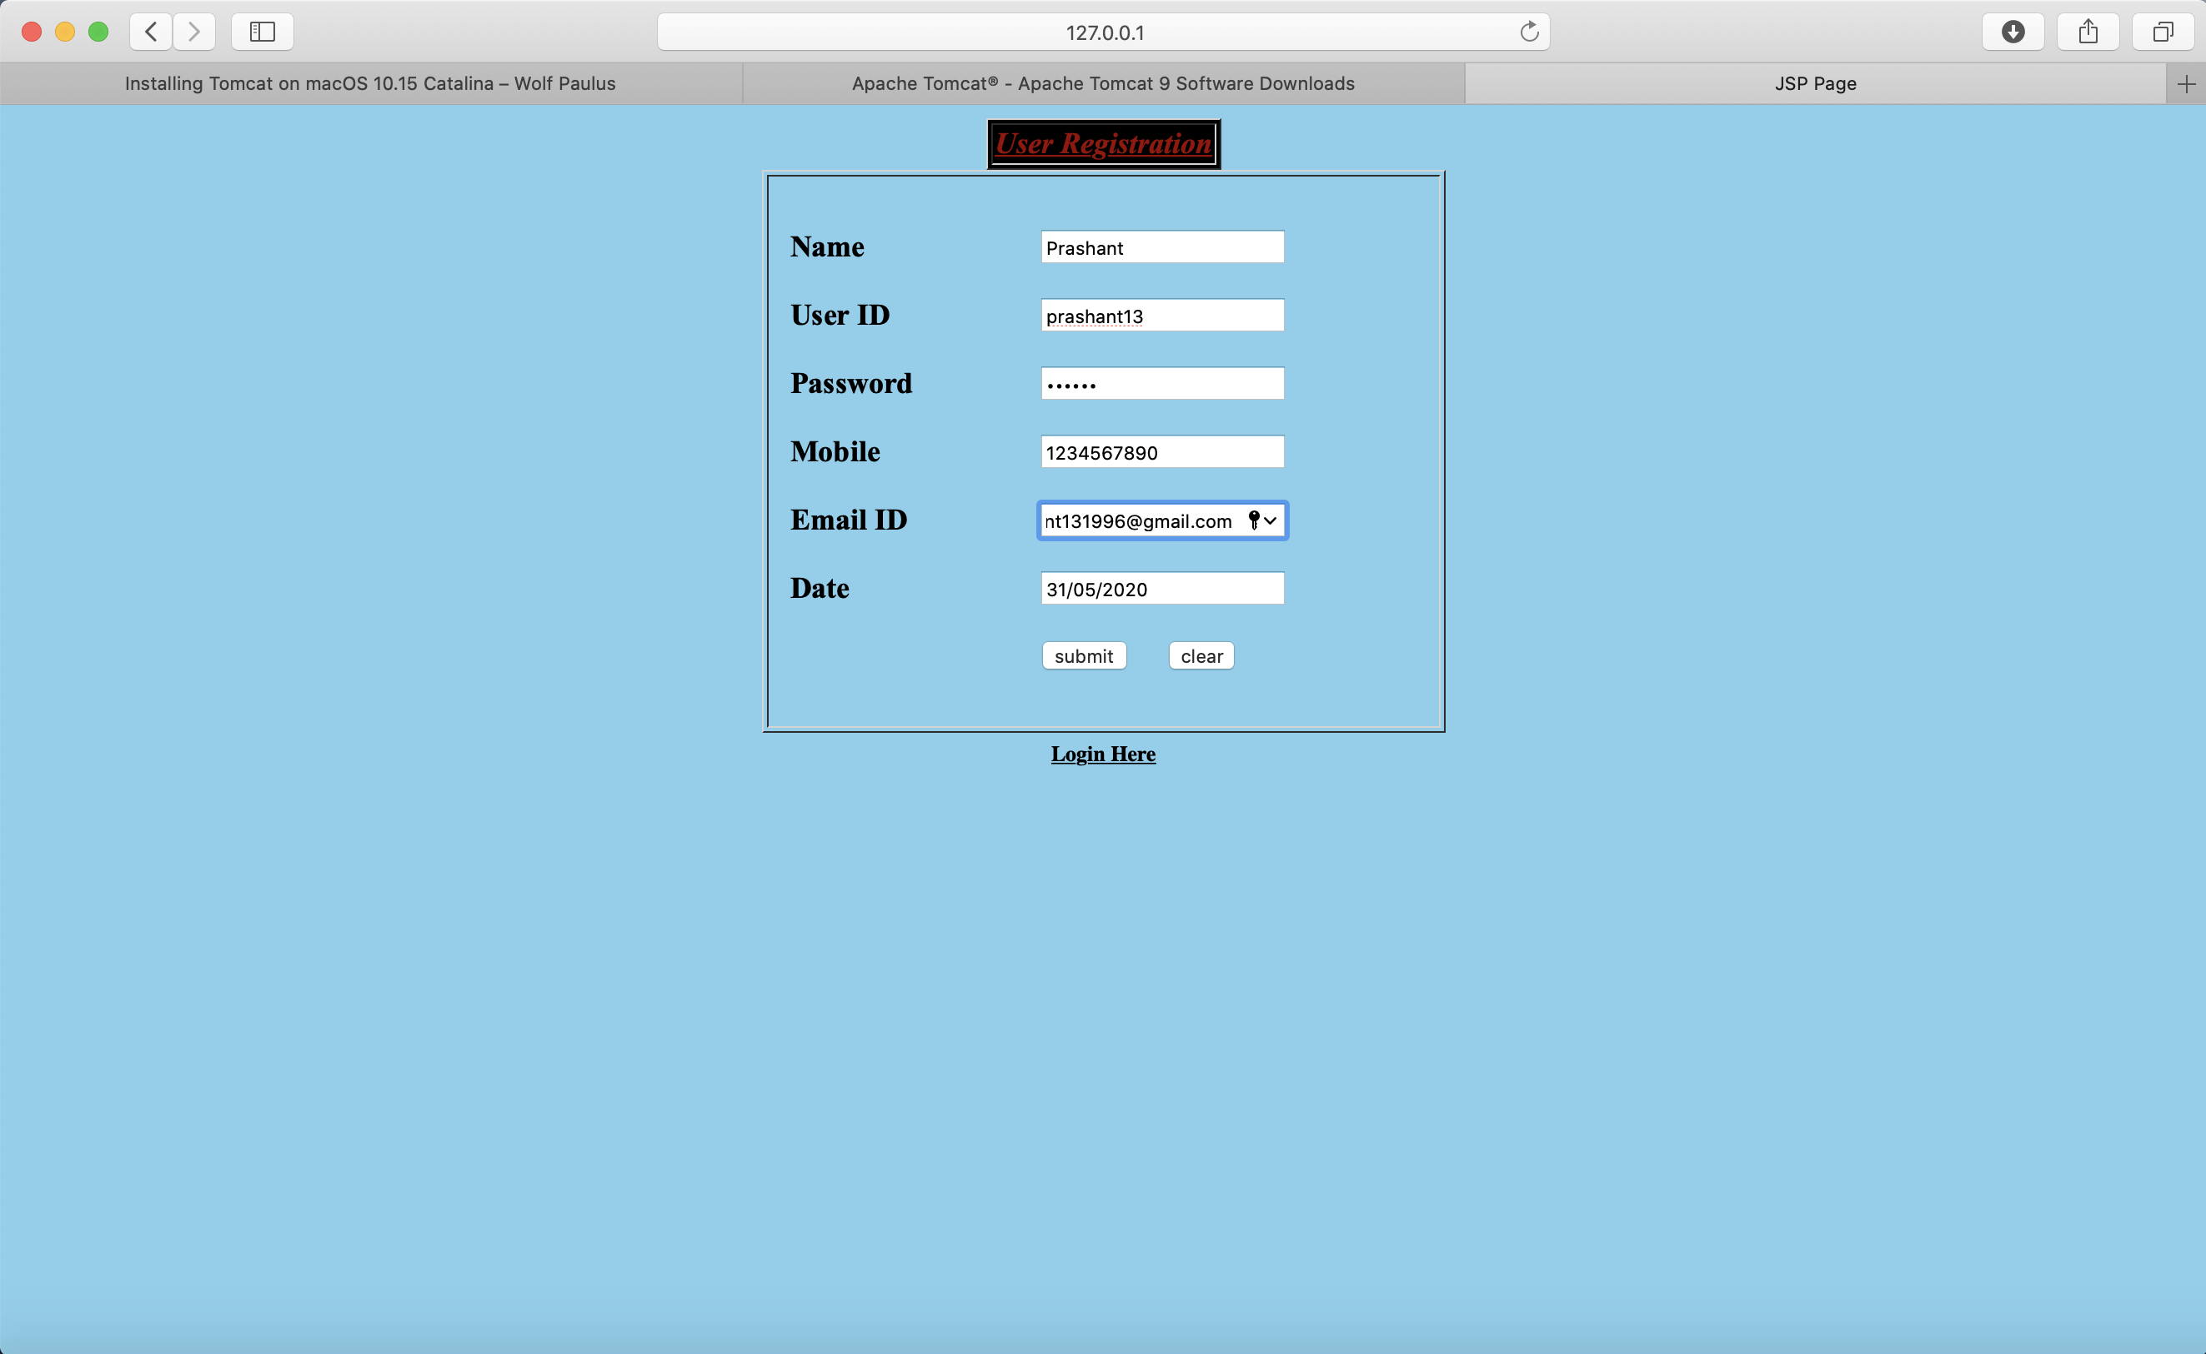

Assignment No - 6

Title of Program - Add dynamic web application essence using PHP, HTML and MySQL

Objective -
To understand the principles and methodologies of PHP web based applications development process.

Code of Program –

add.html
<%--
Name: Prashant Kumar
Roll: 305139
--%>
<html>
<head>
<title>Employee Data</title>
</head>

<body>
<a href="index.php">Home</a>
<br/><br/>

<form action="add.php" method="post" name="form1">
<table width="25%" border="0">
<tr>
<td>Name</td>
<td><input type="text" name="name"></td>
</tr>
<tr>
<td>Age</td>
<td><input type="text" name="age"></td>
</tr>
<tr>
<td>Email</td>
<td><input type="text" name="email"></td>
</tr>
<tr>
<td></td>
<td><input type="submit" name="Submit" value="Add"></td>
</tr>
</table>
</form>
</body>
</html>

add.php
<%--
Name: Prashant Kumar
Roll: 305139
--%>
<html>
<head>
<title>Add Data</title>
</head>

<body>
<?php
//including the database connection file
include_once("config.php");
if(isset($_POST['Submit'])) {
$name = mysqli_real_escape_string($mysqli, $_POST['name']);
$age = mysqli_real_escape_string($mysqli, $_POST['age']);
$email = mysqli_real_escape_string($mysqli, $_POST['email']);

// checking empty fields
if(empty($name) || empty($age) || empty($email)) {

if(empty($name)) {
echo "<font color='red'>Name field is empty.</font><br/>";
}

if(empty($age)) {
echo "<font color='red'>Age field is empty.</font><br/>";
}

if(empty($email)) {
echo "<font color='red'>Email field is empty.</font><br/>";
}

//link to the previous page
echo "<br/><a href='javascript:self.history.back();'>Go Back</a>";
} else {
// if all the fields are filled (not empty)

//insert data to database
$result = mysqli_query($mysqli, "INSERT INTO users(name,age,email) VALUES('$name','$age','$email')");

//display success message
echo "<font color='green'>Data added successfully.";
echo "<br/><a href='index.php'>View Result</a>";
}
}
?>
</body>
</html>

config.php
<%--
Name: Prashant Kumar
Roll: 305139
--%>
<?php

$databaseHost = 'localhost';
$databaseName = 'test';
$databaseUsername = 'root';
$databasePassword = '';
$mysqli = mysqli_connect($databaseHost, $databaseUsername, $databasePassword, $databaseName);

?>
delete.php
<?php
//including the database connection file
include("config.php");
//getting id of the data from url
$id = $_GET['id'];
//deleting the row from table
$result = mysqli_query($mysqli, "DELETE FROM users WHERE id=$id");
//redirecting to the display page (index.php in our case)
header("Location:index.php");
?>

edit.php
<%--
Name: Prashant Kumar
Roll: 305139
--%>
<?php
// including the database connection file
include_once("config.php");
if(isset($_POST['update']))
{
$id = mysqli_real_escape_string($mysqli, $_POST['id']);

$name = mysqli_real_escape_string($mysqli, $_POST['name']);
$age = mysqli_real_escape_string($mysqli, $_POST['age']);
$email = mysqli_real_escape_string($mysqli, $_POST['email']);

// checking empty fields
if(empty($name) || empty($age) || empty($email)) {

if(empty($name)) {
echo "<font color='red'>Name field is empty.</font><br/>";
}

if(empty($age)) {
echo "<font color='red'>Age field is empty.</font><br/>";
}

if(empty($email)) {
echo "<font color='red'>Email field is empty.</font><br/>";
}
} else {
//updating the table
$result = mysqli_query($mysqli, "UPDATE users SET name='$name',age='$age',email='$email' WHERE id=$id");

//redirectig to the display page. In our case, it is index.php
header("Location: index.php");
}
}
?>
<?php
//getting id from url
$id = $_GET['id'];
//selecting data associated with this particular id
$result = mysqli_query($mysqli, "SELECT * FROM users WHERE id=$id");
while($res = mysqli_fetch_array($result))
{
$name = $res['name'];
$age = $res['age'];
$email = $res['email'];
}
?>
<html>
<head>
<title>Edit Data</title>
</head>

<body>
<a href="index.php">Home</a>
<br/><br/>

<form name="form1" method="post" action="edit.php">
<table border="0">
<tr>
<td>Name</td>
<td><input type="text" name="name" value="<?php echo $name;?>"></td>
</tr>
<tr>
<td>Age</td>
<td><input type="text" name="age" value="<?php echo $age;?>"></td>
</tr>
<tr>
<td>Email</td>
<td><input type="text" name="email" value="<?php echo $email;?>"></td>
</tr>
<tr>
<td><input type="hidden" name="id" value=<?php echo $_GET['id'];?>></td>
<td><input type="submit" name="update" value="Update"></td>
</tr>
</table>
</form>
</body>
</html>
index.php
<%--
Name: Prashant Kumar
Roll: 305139
--%>
<?php
//including the database connection file
include_once("config.php");
//fetching data in descending order (lastest entry first)
//$result = mysql_query("SELECT * FROM users ORDER BY id DESC"); // mysql_query is deprecated
$result = mysqli_query($mysqli, "SELECT * FROM users ORDER BY id DESC"); // using mysqli_query instead
?>

<html>
<head>
<title>Homepage</title>
</head>

<body>
<a href="add.html">Add New Data</a><br/><br/>

<table width='80%' border=0>

<tr bgcolor='#CCCCCC'>
<td>Name</td>
<td>Age</td>
<td>Email</td>
<td>Update</td>
</tr>
<?php
//while($res = mysql_fetch_array($result)) { // mysql_fetch_array is deprecated, we need to use mysqli_fetch_array
while($res = mysqli_fetch_array($result)) {
echo "<tr>";
echo "<td>".$res['name']."</td>";
echo "<td>".$res['age']."</td>";
echo "<td>".$res['email']."</td>";
echo "<td><a href=\"edit.php?id=$res[id]\">Edit</a> | <a href=\"delete.php?id=$res[id]\" onClick=\"return confirm('Are you sure you want to delete?')\">Delete</a></td>";
}
?>
</table>
</body>
</html>

OUTPUT :

Assignment No - 7
Title of Program - Add dynamic web application essence using PHP, AJAX and MySQL.

Objective -
To understand the principles and methodologies of web based applications development process.

Code of Program –

Demo.html
<%--
Name: Prashant Kumar
Roll: 305139
--%>
<html>
<head>
<script>
var request;
function sendInfo()
{
var v=document.vinform.t1.value;
var url="index.php?val="+v;

if(window.XMLHttpRequest){
request=new XMLHttpRequest();
}

try
{
request.onreadystatechange=getInfo;
request.open("GET",url,true);
request.send();
}
catch(e)
{
alert("Unable to connect to server");
}

} //sendInfo() close

function getInfo()
{
if(request.readyState==4)
{
var val=request.responseText;
document.getElementById('amit').innerHTML=val;
}
}

</script>
</head>
<body>
<marquee><h1>This is an example of ajax</h1></marquee>
<form name="vinform">
Enter id:<input type="text" name="t1" onkeyup="sendInfo()">
</form>

<p id="amit"> </p>

</body>
</html>

index.php
<%--
Name: Prashant Kumar
Roll: 305139
--%>
<?php

$q = intval($_GET['val']);

$con = mysqli_connect("localhost","root","","test");

$result = mysqli_query($con,"SELECT * FROM ajax WHERE id = $q");

while($res=mysqli_fetch_array($result))
{
echo $res['id']." ".$res['name']."</br></br>";
}

?>
ajax.sql
<%--
Name: Prashant Kumar
Roll: 305139
--%>
-- phpMyAdmin SQL Dump
-- version 4.5.0.2
-- http://www.phpmyadmin.net
--
-- Host: 127.0.0.1
-- Generation Time: Apr 05, 2018 at 07:47 AM
-- Server version: 10.0.17-MariaDB
-- PHP Version: 5.6.14

SET SQL_MODE = "NO_AUTO_VALUE_ON_ZERO";
SET time_zone = "+00:00";

/*!40101 SET @OLD_CHARACTER_SET_CLIENT=@@CHARACTER_SET_CLIENT */;
/*!40101 SET @OLD_CHARACTER_SET_RESULTS=@@CHARACTER_SET_RESULTS */;
/*!40101 SET @OLD_COLLATION_CONNECTION=@@COLLATION_CONNECTION */;
/*!40101 SET NAMES utf8mb4 */;

--
-- Database: `test`
--

-- --------------------------------------------------------

--
-- Table structure for table `ajax`
--

CREATE TABLE `ajax` (
`id` int(3) NOT NULL,
`name` varchar(30) NOT NULL
) ENGINE=InnoDB DEFAULT CHARSET=latin1;

--
-- Dumping data for table `ajax`
--

INSERT INTO `ajax` (`id`, `name`) VALUES
(10, 'krushna'),
(20, 'rama'),
(10, 'kkkkkk'),
(10, 'hhhhh');

/*!40101 SET CHARACTER_SET_CLIENT=@OLD_CHARACTER_SET_CLIENT */;
/*!40101 SET CHARACTER_SET_RESULTS=@OLD_CHARACTER_SET_RESULTS */;
/*!40101 SET COLLATION_CONNECTION=@OLD_COLLATION_CONNECTION */;

OUTPUT :

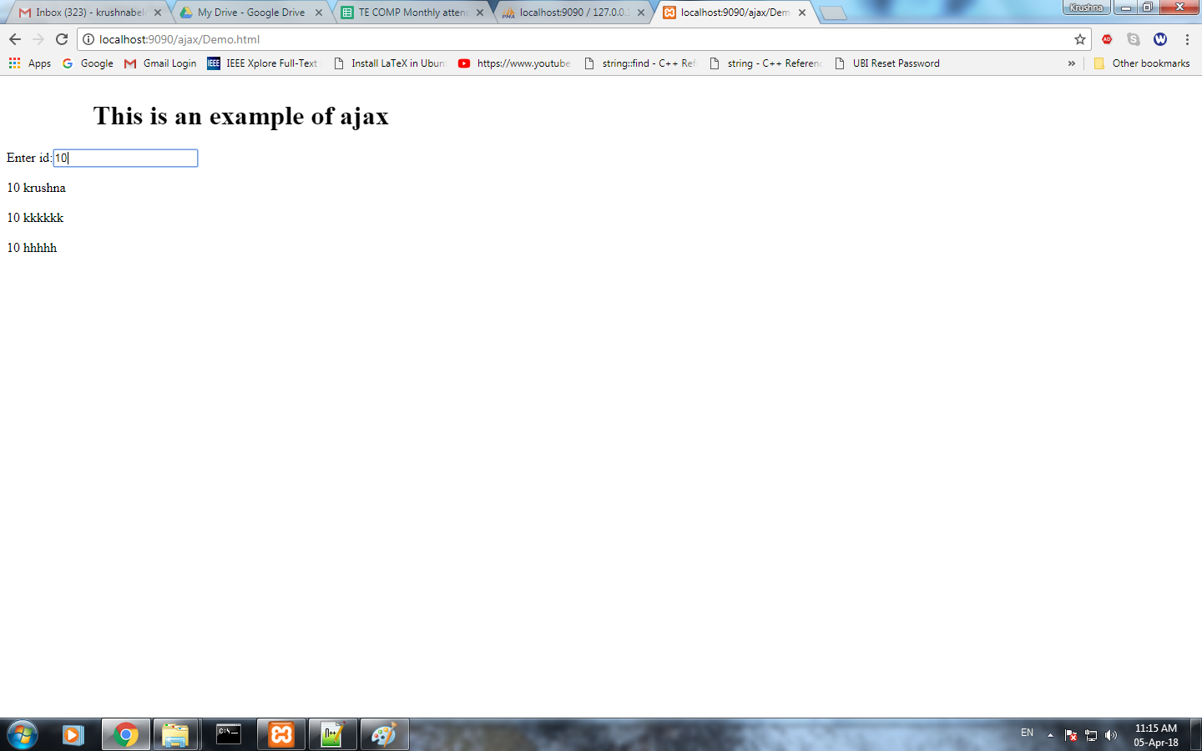

Assignment No - 8
Title of Program - Design and develop any web application using Struts framework

Objective -
1. To impart the efficient and available client side and server side technologies.
2. To implement the communication between computing nodes using client side and server side technologies.
3. To design and implement the web services with content management.

Code of Program –

welcomestruts.jsp
<%--
Name: Prashant Kumar
Roll: 305139
--%>
<%@page contentType="text/html"%>
<%@page pageEncoding="UTF-8"%>

<%@ taglib uri="http://struts.apache.org/tags-bean" prefix="bean" %>
<%@ taglib uri="http://struts.apache.org/tags-html" prefix="html" %>
<%@ taglib uri="http://struts.apache.org/tags-logic" prefix="logic" %>

<html:html lang="true">
<head>
<meta http-equiv="Content-Type" content="text/html; charset=UTF-8">
<title><bean:message key="welcome.title"/></title>
<html:base/>
</head>
<body style="background-color: white">

<logic:notPresent name="org.apache.struts.action.MESSAGE" scope="application">
<div style="color: red">
ERROR: Application resources not loaded -- check servlet container
logs for error messages.
</div>
</logic:notPresent>

<h3><bean:message key="welcome.heading"/></h3>
<p><bean:message key="welcome.message"/></p>

</body>
</html:html>

success.jsp

<%--
Name: Prashant Kumar
Roll: 305139
--%>
<%@page contentType="text/html" pageEncoding="UTF-8"%>
<!DOCTYPE html>
<html>
<head>
<meta http-equiv="Content-Type" content="text/html; charset=UTF-8">
<title>JSP Page</title>
</head>
<body>
<h1>success page</h1>
</body>
</html>

login.jsp

<%--
Name: Prashant Kumar
Roll: 305139
--%>
<%@page contentType="text/html" pageEncoding="UTF-8"%>
<!DOCTYPE html>
<html>
<head>
<meta http-equiv="Content-Type" content="text/html; charset=UTF-8">
<title>JSP Page</title>
</head>
<body>
<h1>login</h1>
<form action="loginform.do" method="post">
Username <input type="text" name="uname"/><br/>
password <input type="password" name="upass"/><br/>
<input type="submit" value="ok"><br/>

</form>
</body>
</html>

index.jsp

<%@page contentType="text/html"%>
<%@page pageEncoding="UTF-8"%>

<jsp:forward page=“Welcome.do"/>

failure.jsp

<%--
Name: Prashant Kumar
Roll: 305139
--%>
<%@page contentType="text/html" pageEncoding="UTF-8"%>
<!DOCTYPE html>
<html>
<head>
<meta http-equiv="Content-Type" content="text/html; charset=UTF-8">
<title>JSP Page</title>
</head>
<body>
<h1>failure</h1>
</body>
</html>

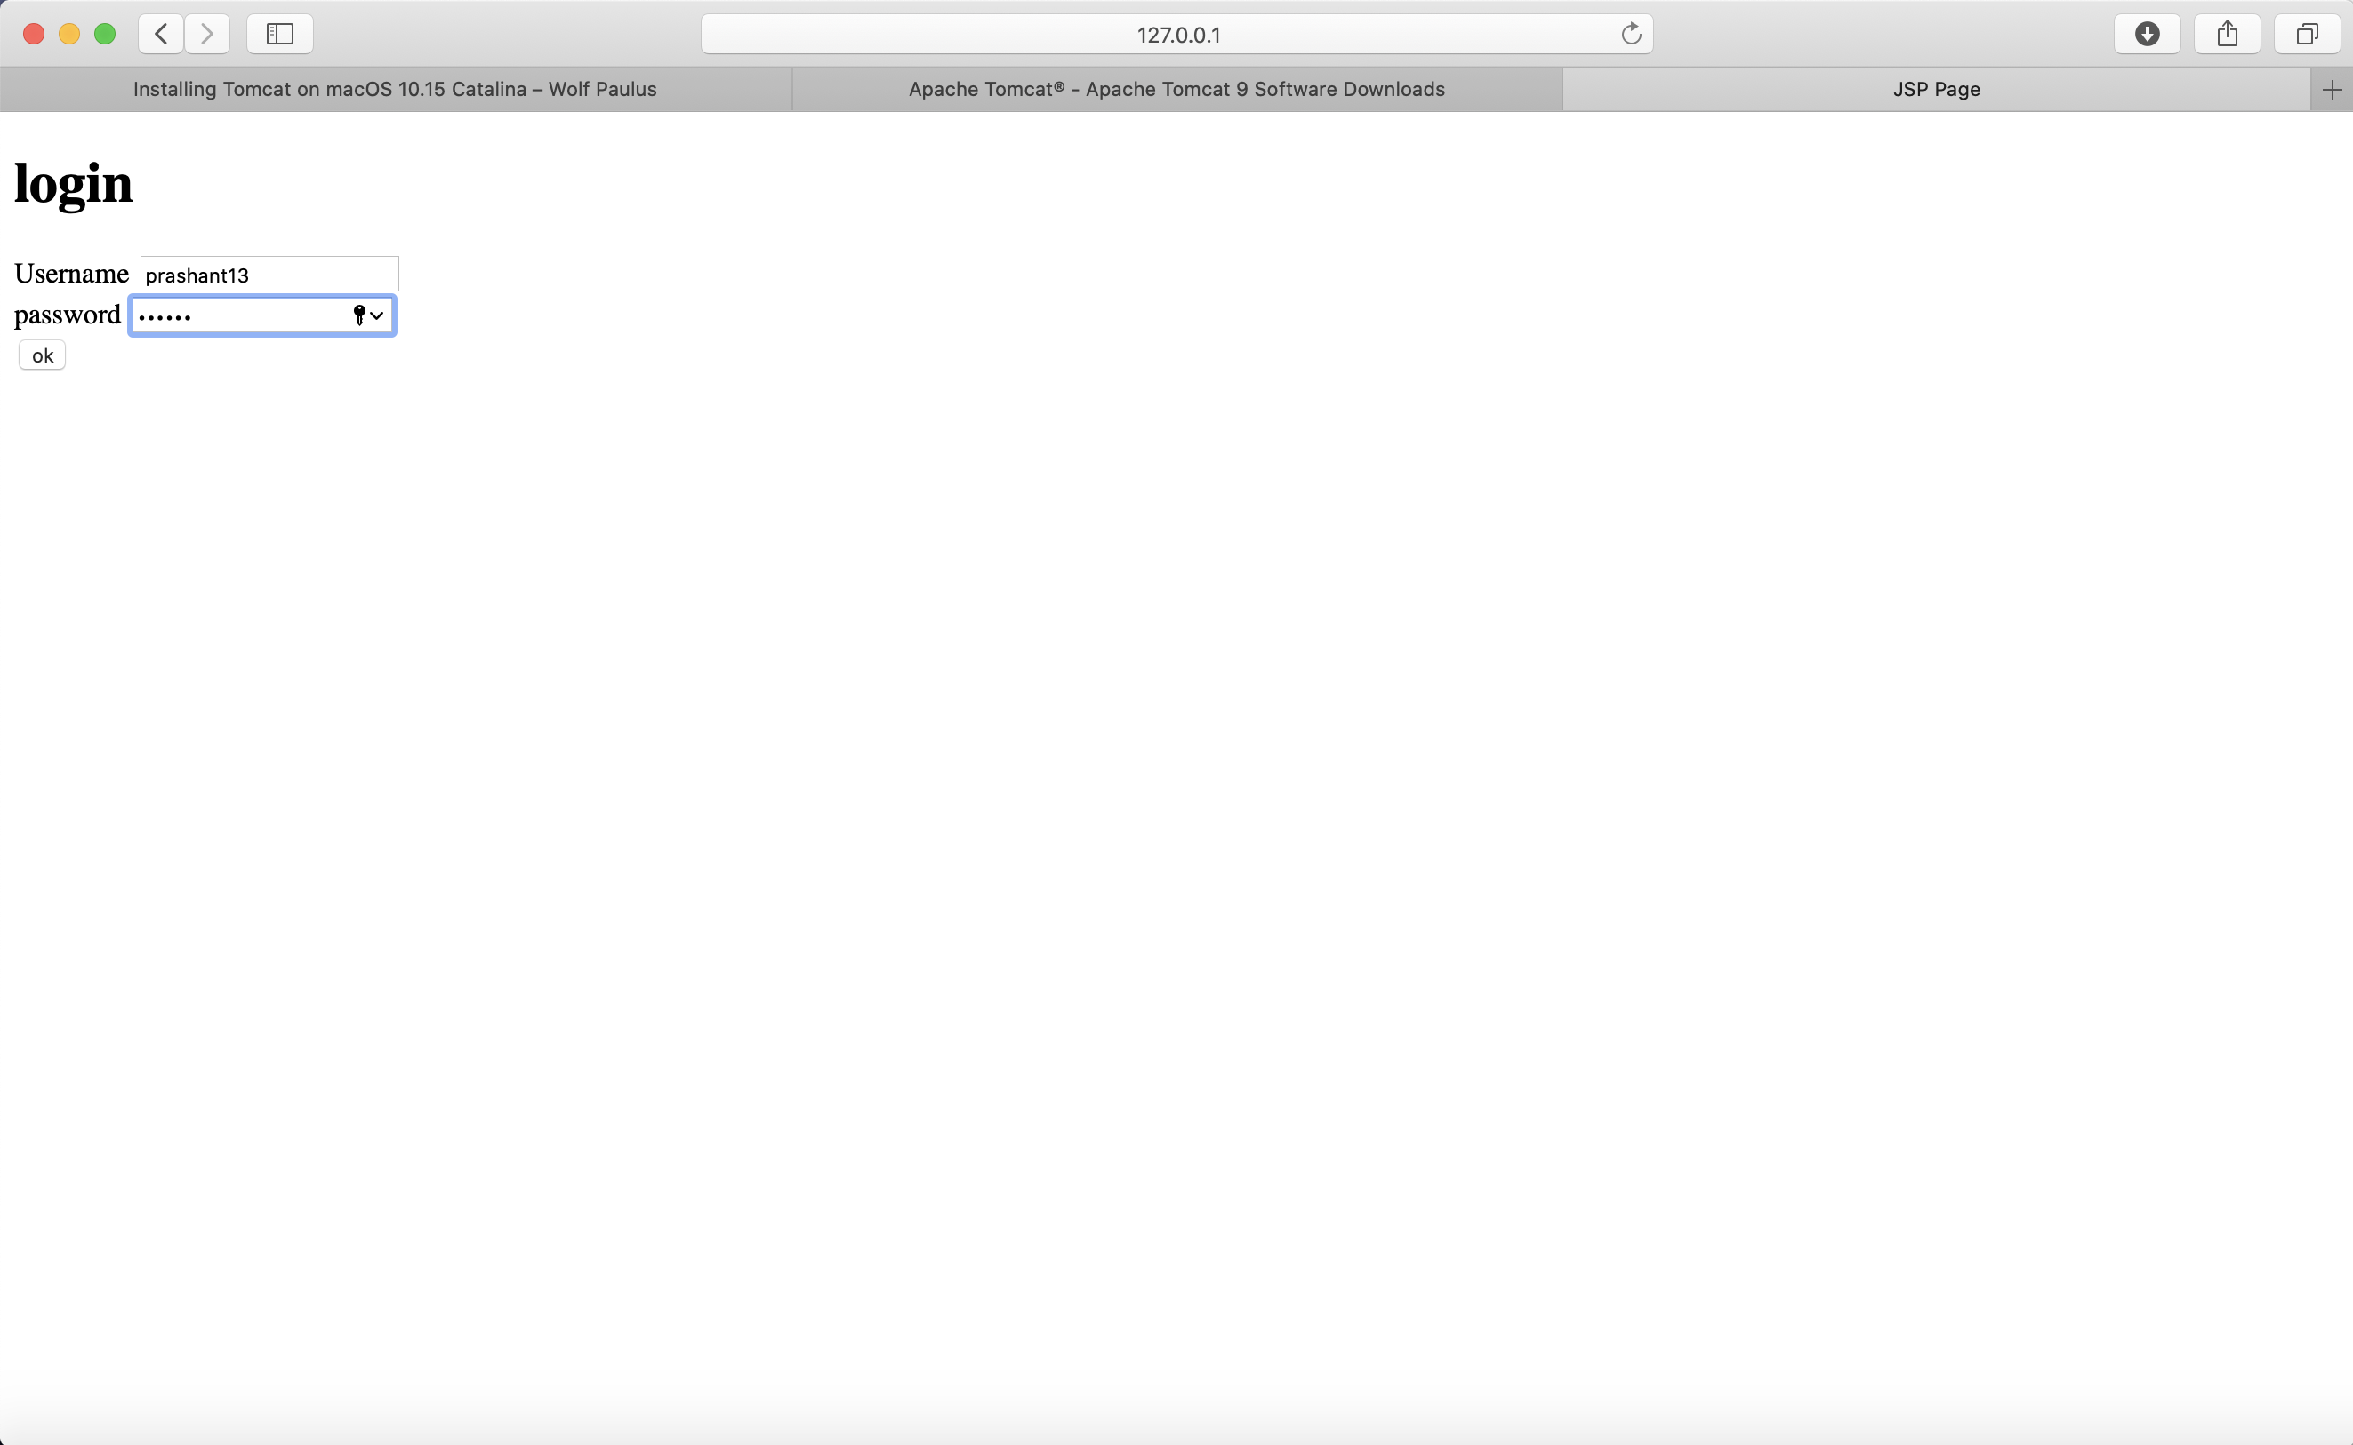
OUTPUT:

Assignment No - 9

Title of Program - Design and develop any web application using AngularJS

Objective -
1. Understand the design of single-page applications and how AngularJS facilitates their development.
2. Properly separate the model, view, and controller layers of your application and implement those using AngularJS.
3. Master AngularJS expressions, filters, and scopes
4. Build Angular forms
5. Elegantly implement Ajax in your AngularJS applications
6. Write AngularJS directives

Code of Program –

index.html
<%--
Name: Prashant Kumar
Roll: 305139
--%>
<!--index.html-->
<html>

<head>

<!--<script src="angular.min.js"></script> -->

<script src="angular.min.js"></script>

</head>

<body>

<h2>Shopping Card Example</h2>

<div data-ng-app="myapp" data-ng-controller="CartForm">

<table class="table" >

<table border="1">

<tr>

<th>Description</th>

<th>Qty</th>

<th>Cost</th>

<th>Total</th>

<th></th>

</tr>

<tr ng:repeat="item in cart.items">

<td><input type="text" ng:model="item.description"></td>

<td><input type="number" ng:model="item.qty" ng:required></td>

<td><input type="number" ng:model="item.cost" ng:required></td>

<td>{{item.qty * item.cost | currency:'Rs '}}</td>

<td>[<a href ng:click="removeItem($index)">X</a>]</td>

</tr>

<tr>

<td><a href ng:click="addItem()">add item</a></td>

<td></td>

<td>Total:</td>

<td>{{total() | currency:'Rs '}}</td>

</tr>

</table>
</div>

<script src="cart.js">
</script>
</body>

</html>

cart.js
<%--
Name: Prashant Kumar
Roll: 305139
--%>
var app=angular.module('myapp',[]);

app.controller('CartForm', function($scope)
{

$scope.cart =
{

items: [{ qty: '', description: '', cost: ''}]
}

$scope.addItem = function()
{

$scope.cart.items.push({ qty: '', description: '', cost: ''});

}

$scope.removeItem = function(index)
{

$scope.cart.items.splice(index, 1);

}

$scope.total = function()
{

var total = 0;

angular.forEach($scope.cart.items, function(item)
{

total += item.qty * item.cost;

})

return total;

}
}
);
OUTPUT :
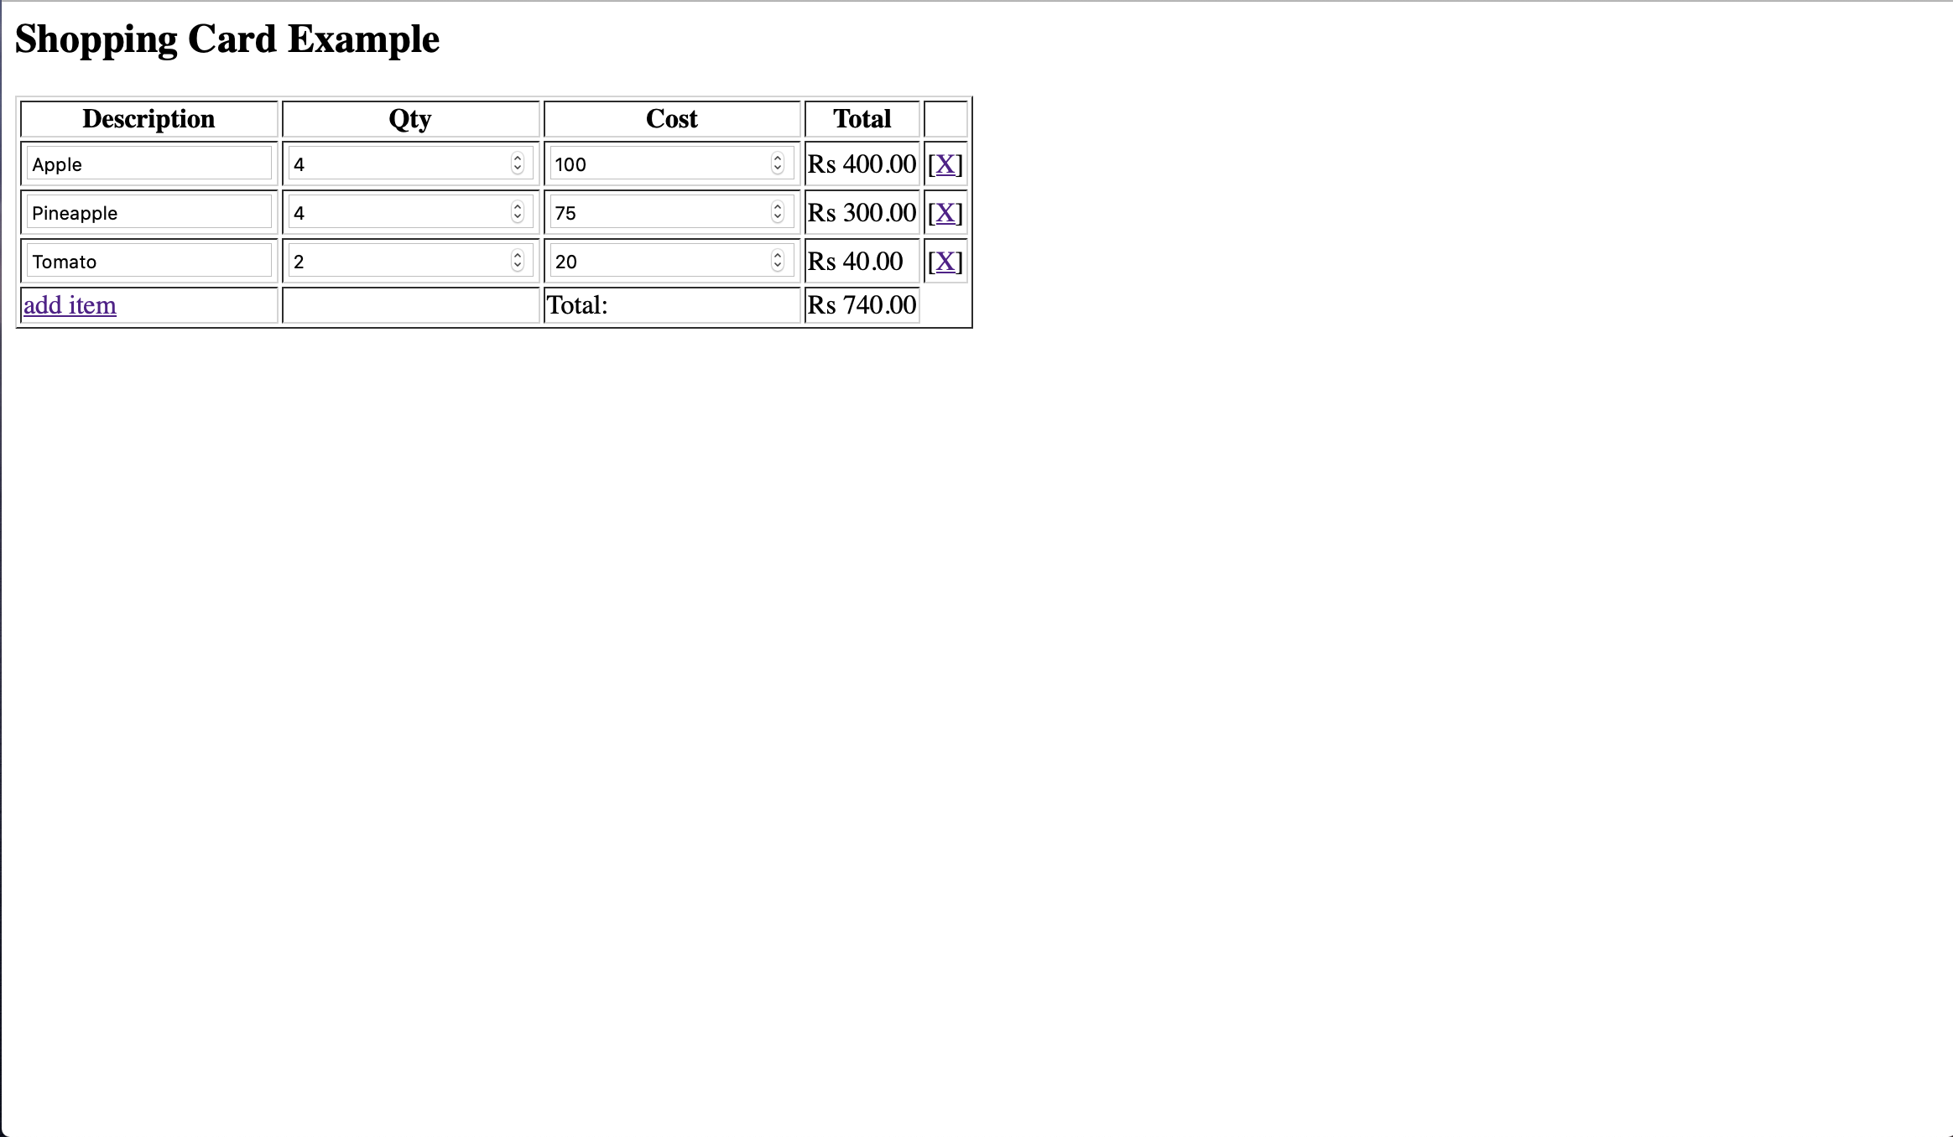

Assignment No - 10
Title of Program - Web Application using EJB

Objective -
1. Understand about basic concepts of java beans.
2. Understand the basic functionalities of JSP, HTML.
3. Having the knowledge of JBOSS server to deploy web application.

Code of Program –

form.css

<%--
Name: Prashant Kumar
Roll: 305139
--%>
body{
background-color: #eee;

}
form{

font-size:20px;
}
h1{
padding:10px;
text-align: center;
color:red;
}
div{
padding:20px;
background-color:white;
width:30%;
margin: auto;
border-radius: 20px;
}

p{
display:inline-block;
width:40%;
}
.pc{
color:red;
}
input[type=submit]{
background-color:red;
color:white;
width:80%;
border:none;
border-radius:20px;
padding:10px;
font-weight:bolder;
font-size:20px;

margin-left:10%;
}
input[type=submit]:hover{
background-color:blue;
}

index.jsp

<%--
Name: Prashant Kumar
Roll: 305139
--%>
<%@page contentType="text/html" pageEncoding="UTF-8"%>
<!DOCTYPE html>
<html>
<head>
<meta http-equiv="Content-Type" content="text/html; charset=UTF-8">
<title>JSP Page</title>
<link rel="stylesheet" type="text/css" href="form.css">
</head>
<body>
<!--form action="calcservlet" method="POST">
<input type="text" name="t1">
<input type="text" name="t2">
<input type="text" name="choice">

<select name="choice">
<option value="1">+</option>
<option value="2">-</option>
<option value="3">*</option>
<option value="4">/</option>
</select>

<input type="submit" value="ADD">

</form -->

<h1>Calculator</h1>
<div>
<form action="calcservlet" method="POST">
<p>First Number: </p><input type="text" name="t1">
<p>Second Number: </p><input type="text" name="t2"><br />
<!--<select name="option">
<option value="add()">Addition</option>
<option value="sub()">Addition</option>
<option value="mul()">Multiplication</option>
<option value="div()">Division</option>
</select>-->

<input type="radio" name="choice" value="1" /><p class="pc">Addition</p><br />
<input type="radio" name="choice" value="2" /><p class="pc">Subtraction</p><br />
<input type="radio" name="choice" value="3" /><p class="pc">Multiplication</p><br />
<input type="radio" name="choice" value="4" /><p class="pc">Division</p><br />
<input type="submit" value="Submit" />
</form>
</div>

</body>
</html>

web.xml

<%--
Name: Prashant Kumar
Roll: 305139
--%>
<?xml version="1.0" encoding="UTF-8"?>
<web-app version="3.1" xmlns="http://xmlns.jcp.org/xml/ns/javaee" xmlns:xsi="http://www.w3.org/2001/XMLSchema-instance" xsi:schemaLocation="http://xmlns.jcp.org/xml/ns/javaee http://xmlns.jcp.org/xml/ns/javaee/web-app_3_1.xsd">
<servlet>
<servlet-name>calcservlet</servlet-name>
<servlet-class>SessionBean.calcservlet</servlet-class>
</servlet>
<servlet-mapping>
<servlet-name>calcservlet</servlet-name>
<url-pattern>/calcservlet</url-pattern>
</servlet-mapping>
<session-config>
<session-timeout>
30
</session-timeout>
</session-config>
</web-app>

OUTPUT:

