GLOBAL OLYMPIC SPORTS
PERFORMANCE ANALYSIS
Tableau Project Report
Prepared by: Prashant Lalawat
Enrollment Number: EN25CA3020136
Email: en25ca3020136@medicaps.ac.in

Prepared as project documentation based on the Tableau workbook and project screenshots.

1. Project Overview
This project uses Tableau to explore Olympic athlete-level records and compare medal-winning records across countries, sports, Olympic seasons, age groups and gender. The work was developed as an interactive Tableau analysis with worksheets, dashboards and a story, then published to Tableau Public and shared through GitHub.

Project Objectives
- Explore medal-winning athlete records across National Olympic Committees (NOCs).
- Compare medal-winning records over Olympic years and across Summer and Winter seasons.
- Identify sports with larger medal-record counts in the available data.
- Compare medal records by gender and age group.
- Present the analysis in a shareable Tableau Story.

2. Tools and Project Links
Component | Tool / Link
Data analysis and visualization | Tableau Desktop
Public visualization | Tableau Public
Version control / project repository | GitHub
GitHub repository | https://github.com/Prashant1506-prog/global-olympic-sports-analysis
Published Tableau Story | https://public.tableau.com/views/Global_Olympic_Sports_Analysis_17935389764910/Story1
Packaged workbook | Global_Olympic_Sports_Analysis.twbx

3. Data and Interpretation
The workbook shown in the project screenshots uses an athlete-level Olympic dataset with fields including ID, Medal, Name, NOC, Season, Sport, Year, Sex, Age and Team. The dataset is used to create medal-filtered views and aggregate athlete records.
Important interpretation: the charts count athlete or medal-related records from this dataset. They should not automatically be interpreted as official medal-table totals. For example, COUNT(ID) counts records and COUNTD(ID) counts distinct athlete IDs. This report avoids claiming official country medal totals.
The exact date coverage should be reported according to the source dataset's actual minimum and maximum Year values. The workbook screenshots available for this report do not establish the full dataset year range.

4. Tableau Worksheets
Worksheet | Description / Measure
Top 10 Countries | Ranks NOCs using distinct athlete IDs in medal-filtered records; not an official medal tally.
Medal Trends | Shows changes by Year, with season comparison where configured.
Medals by Sport | Compares record counts by sport and season.
Average Medal Records per Athlete | Calculated record-count / distinct-athlete-count measure by sport; interpret as record frequency, not official medal efficiency.
Summer vs Winter | Compares medal-related records by Olympic season.
Medals by Gender | Compares medal-related record counts for sex categories.
Medals by Age | Shows counts across age bins (five-year bins were configured).
Medal Type Distribution | Visualizes medal category distribution (Gold, Silver, Bronze) based on selected medal records.

5. Dashboard 1 — Olympic Games Medal Analysis
Dashboard 1 brings together country performance, medal trends, sport-level records and the calculated average medal-record measure by sport. The dashboard includes filters for Season and NOC/country, as configured.
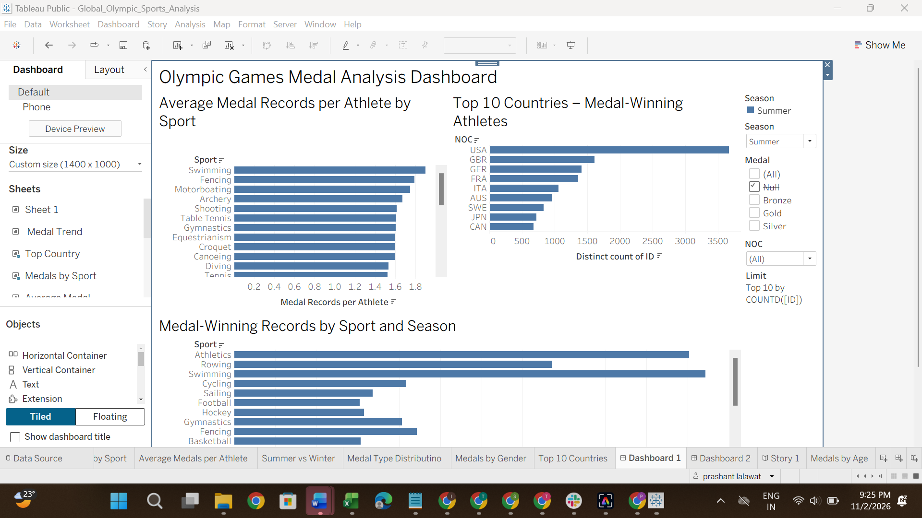
Figure 1. Tableau Desktop screenshot of Dashboard 1 — Olympic Games Medal Analysis.
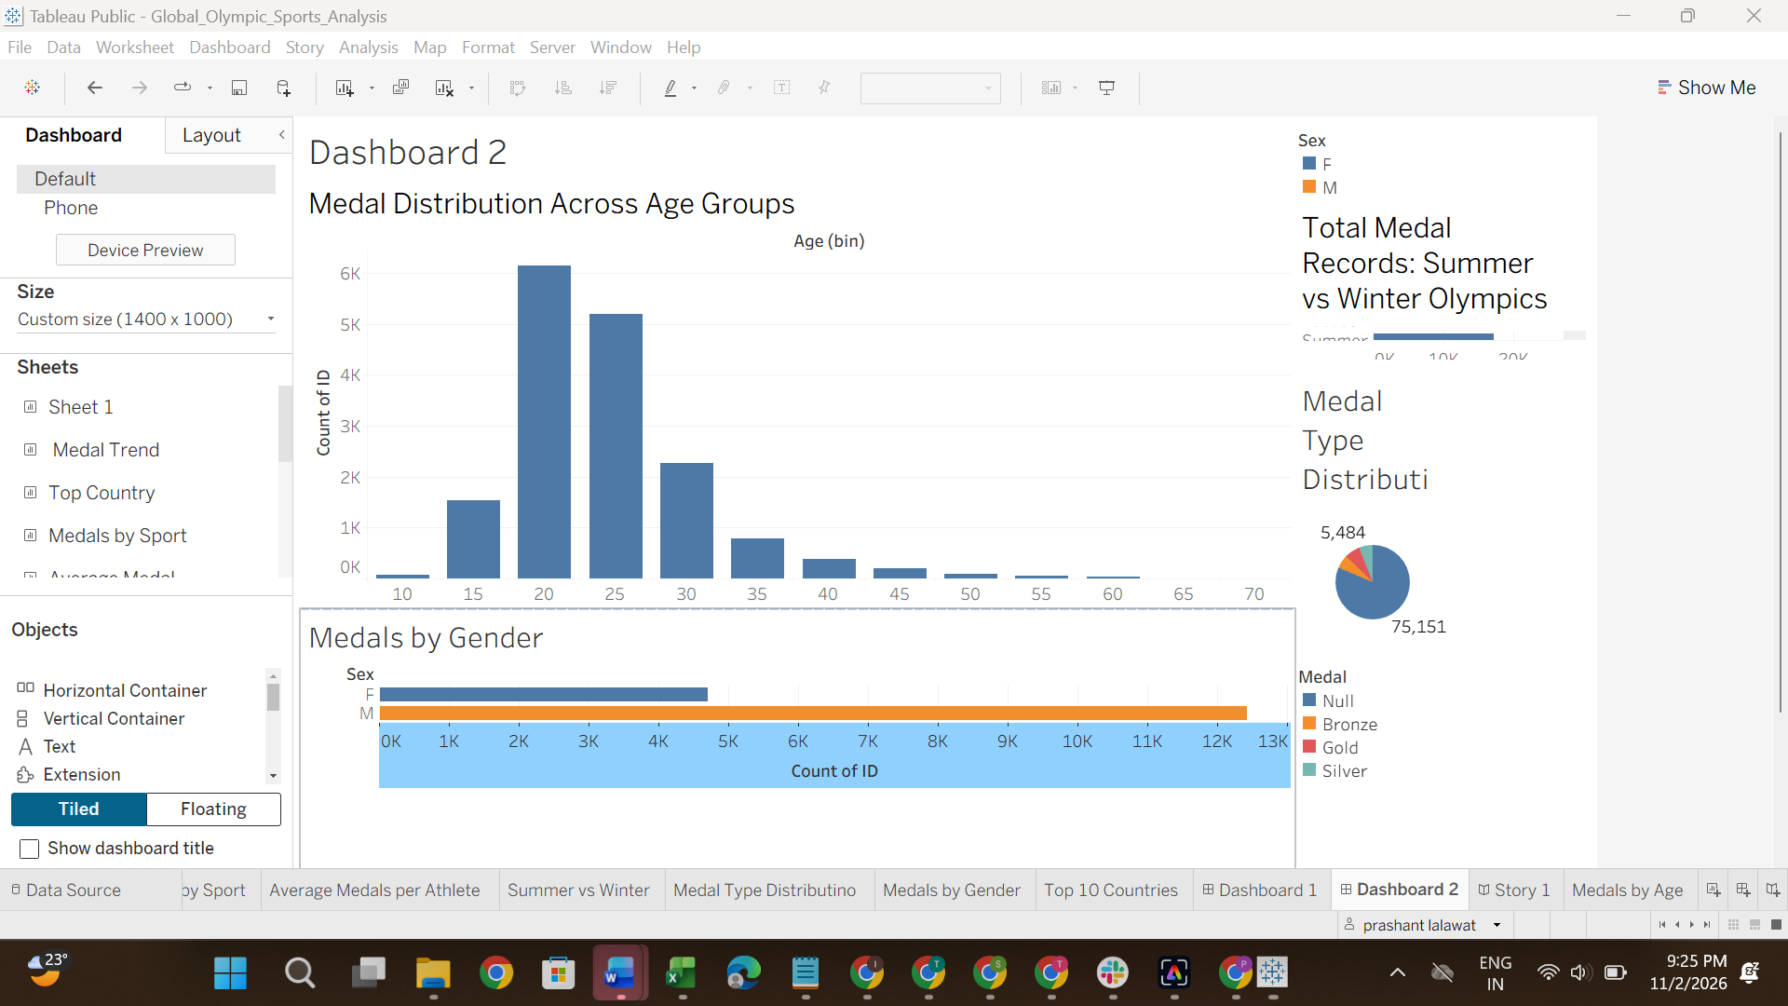
Figure 2. Tableau Desktop screenshot of Dashboard 2 — Athlete Performance Dashboard.

6. Dashboard 2 — Athlete Performance Dashboard
Dashboard 2 focuses on athlete-level comparisons. It combines medal records by gender, age group, Olympic season and medal type. This dashboard is intended to support exploration of demographic and seasonal patterns.
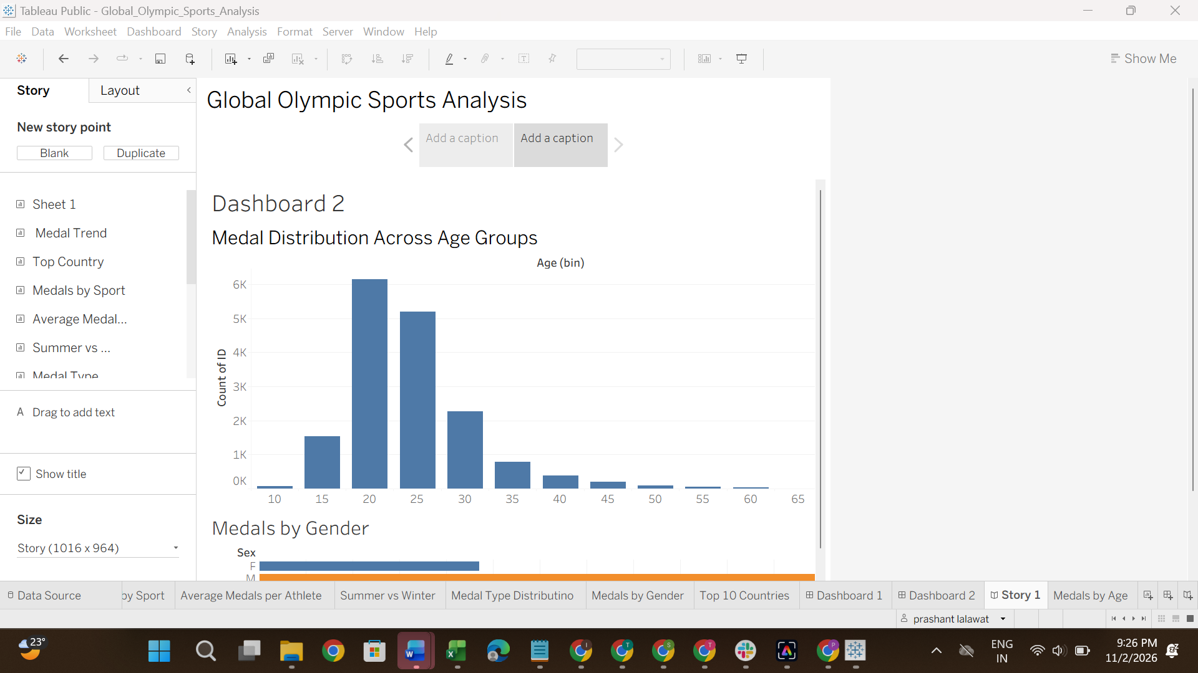
Figure 3. Tableau Story screenshot showing the Athlete Performance Dashboard.

7. Tableau Story
The Tableau Story named “Global Olympic Sports Analysis” contains story points for the two dashboards. The first story point presents the Olympic Games Medal Analysis Dashboard; the second presents the Athlete Performance Dashboard. Story points allow viewers to move between dashboard views.
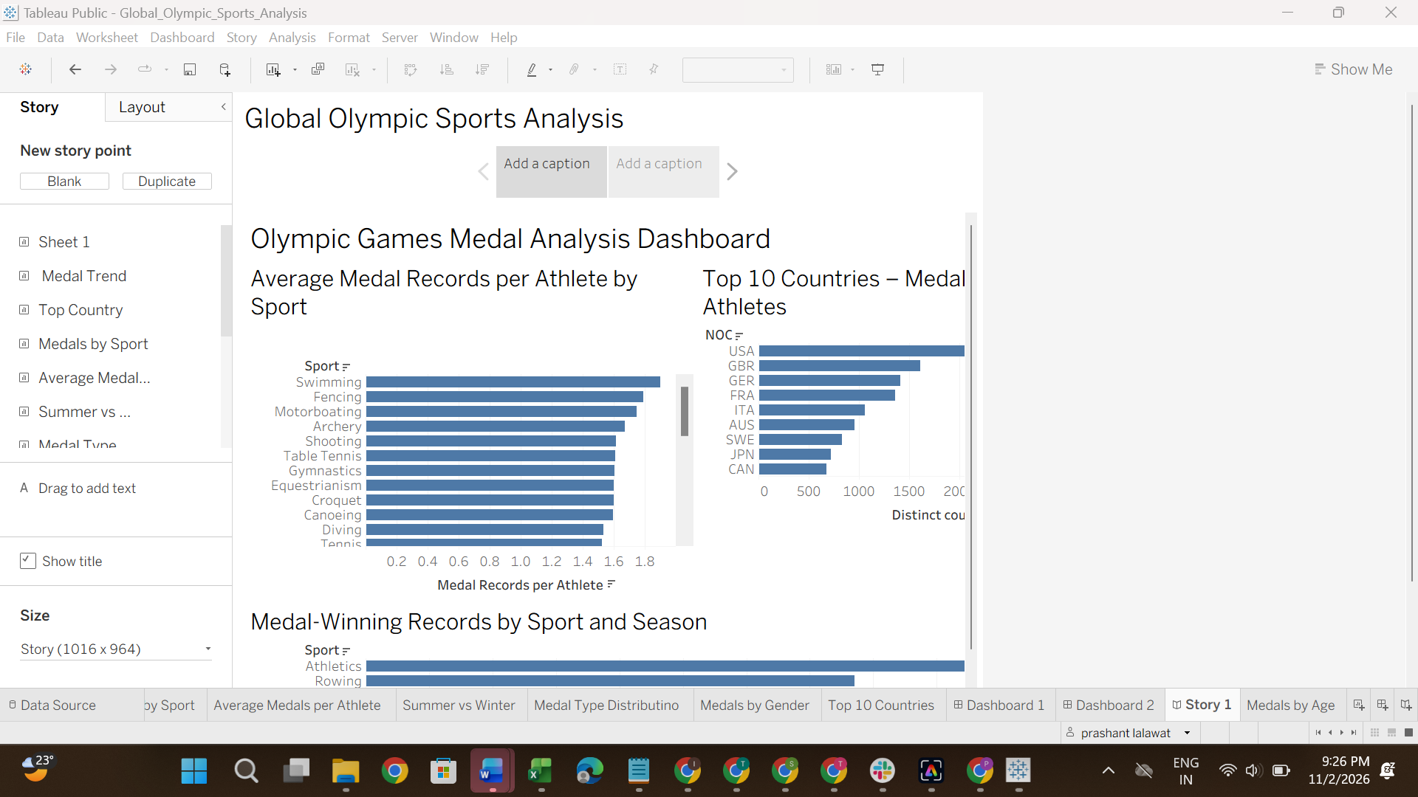
Figure 4. Tableau Story screenshot showing the Olympic Games Medal Analysis Dashboard.

8. Main Observations
- The country chart highlights NOCs with the highest distinct athlete counts among medal-filtered records.
- Sport-level record counts differ substantially across sports; comparisons depend on sport participation and dataset structure.
- Summer and Winter Olympic records have different volumes in the dataset.
- Age-group and gender charts provide descriptive comparisons of medal-related records.
- The medal-type chart provides a category-level view of Gold, Silver and Bronze records.
These are descriptive observations from the workbook's charts. They should not be treated as causal conclusions or official Olympic medal-table statements without validating the source and aggregation.

9. Publishing and Version Control
The workbook was published on Tableau Public and the packaged workbook was uploaded to GitHub.
- Tableau Public provides the interactive Story link for viewing the project online.
- GitHub stores the packaged Tableau workbook (.twbx) and README documentation.
- The README links to the published Tableau Story and explains the project.

10. Limitations and Future Improvements
- Confirm and document the exact source dataset, data dictionary and Year range.
- Validate chart aggregations against official Olympic medal tables before presenting medal totals as official statistics.
- Add a source citation and a data-refresh date to the README and report.
- Improve dashboard sizing and label readability for public viewing.
- If investment or host-country analysis is required, obtain suitable country-level investment and host datasets; those fields are not present in the currently described athlete-level field list.

11. Conclusion
The project demonstrates a Tableau workflow from athlete-level Olympic data to worksheets, dashboards, a Story, Tableau Public publication and GitHub documentation. The resulting interactive views support descriptive exploration of country, sport, season, gender, age and medal-category patterns.

