# EarthquakeOnMap

java project to display Earthquake on to the Google Map.

prerequisites:

1. system need to be connected to the internet so that it can access open source data which is need for this program to work as it was assumed to work.

2. this program is also need some external libraries to be added so that it can touch the mark which have been set for this program and return exact output as expected initially. For visual effects and visual objects like circle, triangles, squares and many more objects with the shades of different – different colours for this we need an external library called Processing library need to be attached. And some more library to attach to your IDE so no error occurs.

OUTPUT:

Without Zoom.

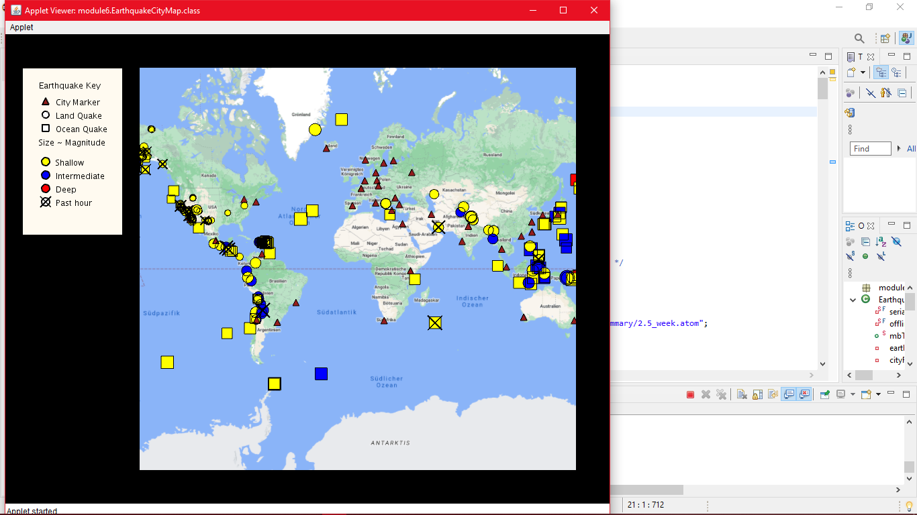

With Zoom.

